搭建ShowDoc文档工具

****1. 准备**Nginx**+**PHP**环境****

*安装 Nginx*

*添加源：*

sudo rpm -Uvh http://nginx.org/packages/centos/7/noarch/RPMS/nginx-release-centos-7-0.el7.ngx.noarch.rpm

使用 yum 安装 Nginx：

yum install nginx -y

修改 /etc/nginx/nginx.conf 文件为如下内容：

user nginx;

worker_processes auto;

error_log /var/log/nginx/error.log;

pid /run/nginx.pid;

include /usr/share/nginx/modules/*.conf;

events {

worker_connections 1024;

}

http {

log_format main '$remote_addr - $remote_user [$time_local] "$request" '

'$status $body_bytes_sent "$http_referer" '

'"$http_user_agent" "$http_x_forwarded_for"';

access_log /var/log/nginx/access.log main;

sendfile on;

tcp_nopush on;

tcp_nodelay on;

keepalive_timeout 65;

types_hash_max_size 2048;

include /etc/nginx/mime.types;

default_type application/octet-stream;

include /etc/nginx/conf.d/*.conf;

server {

listen 80;

server_name 127.0.0.1;

root /var/www/html;

index index.php index.html

error_page 404 /404.html;

location = /40x.html {

}

error_page 500 502 503 504 /50x.html;

location = /50x.html {

}

location ~ .php$ {

root /var/www/html;

fastcgi_pass 127.0.0.1:9000;

fastcgi_index index.php;

fastcgi_param SCRIPT_FILENAME $document_root$fastcgi_script_name;

include fastcgi_params;

}

location ~ /.ht {

deny all;

}

}

}

启动 Nginx 并设置为开机启动：

service nginx start

chkconfig nginx on

****2. 创建项目****

*下载安装 Composer*

Composer 是 PHP 的一个依赖管理工具，推荐使用 Composer 创建 ShowDoc 项目。

执行如下命令安装 Composer：

wget https://dl.laravel-china.org/composer.phar -O /usr/local/bin/composer

chmod a+x /usr/local/bin/composer

查看composer 是否安装

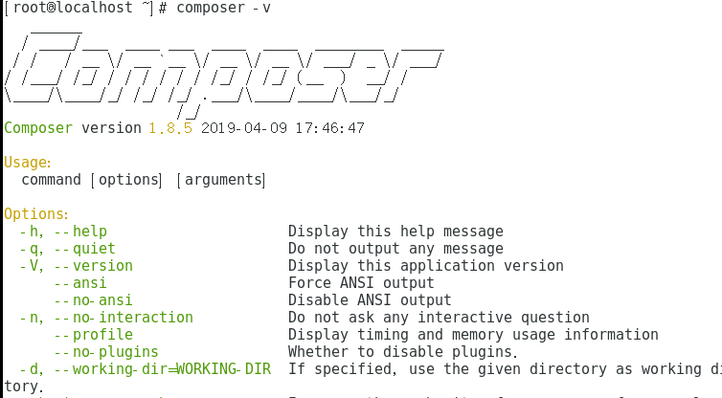

*设置 Composer 使用国内镜像*

执行命令设置 Composer 使用国内镜像：

composer config -g repo.packagist composer <https://packagist.phpcomposer.com>

*使用 Composer 创建项目*

执行命令创建项目：

cd /var/www/html/ && composer create-project showdoc/showdoc

*设置 showdoc 目录写权限*

执行命令赋予 showdoc 下部分目录的写权限

chmod a+w showdoc/install

chmod a+w showdoc/Sqlite

chmod a+w showdoc/Sqlite/showdoc.db.php

chmod a+w showdoc/Public/Uploads/

chmod a+w showdoc/Application/Runtime

chmod a+w showdoc/server/Application/Runtime

chmod a+w showdoc/Application/Common/Conf/config.php

chmod a+w showdoc/Application/Home/Conf/config.php

创建完毕，访问 <http://yourip/showdoc/install/> 或 <http://yourdomain.com/showdoc/install/> ，进行语言的选择以后即可通过 <http://yourip/showdoc> 或 <http://yourdomain/showdoc> 查看站点效果。