搭建WordPress个人博客

1. 装apache、mariadb

yum install httpd mariadb-server php php-mysql -y  
systemctl start httpd  
systemctl enable httpd  
systemctl start mariadb  
systemctl enable mariadb

1. mariadb配置

密码初始化

mysql_secure_installation

创建一个数据库wordpress

mysql -u root -p

MariaDB [(none)]> create database wordpress character set utf8 collate utf8_bin;

MariaDB [(none)]> grant all on wordpress.* to wordpress@'localhost' identified by 'wordpress';

MariaDB [(none)]> grant all on wordpress.* to wordpress@'%' identified by 'wordpress';

MariaDB [(none)]> exit

1. 安装wordpress

下载

wget https://cn.wordpress.org/wordpress-4.8.1-zh_CN.tar.gz

解压

tar -zxf wordpress-4.8.1-zh_CN.tar.gz

移动到html目录下

mv wordpress /var/www/html/

重启httpd服务

systemctl restart httpd

4、页面访问 ip/wordpress web端安装

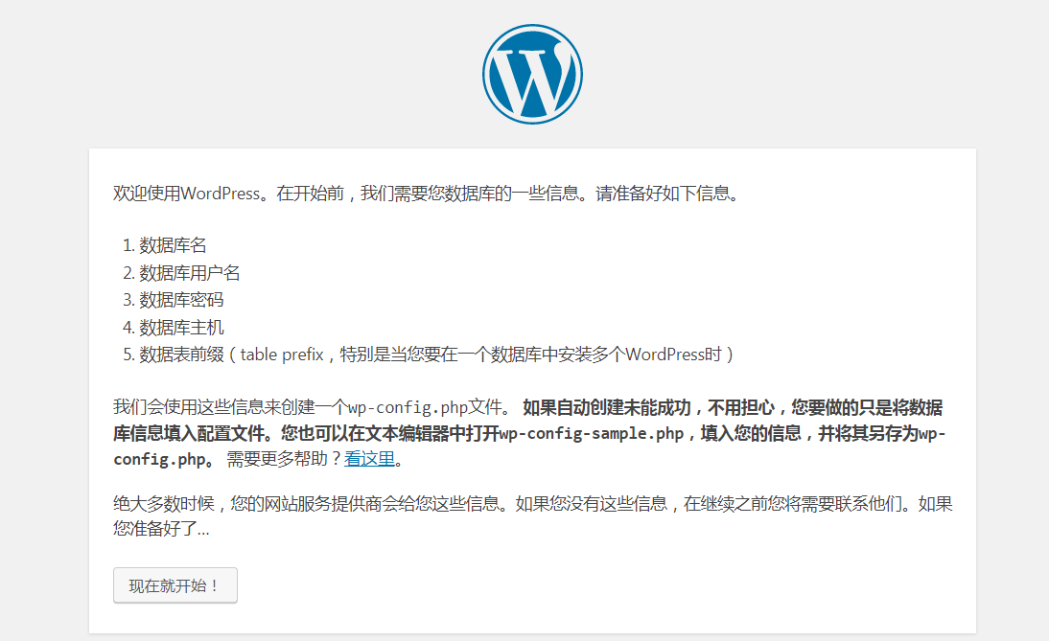

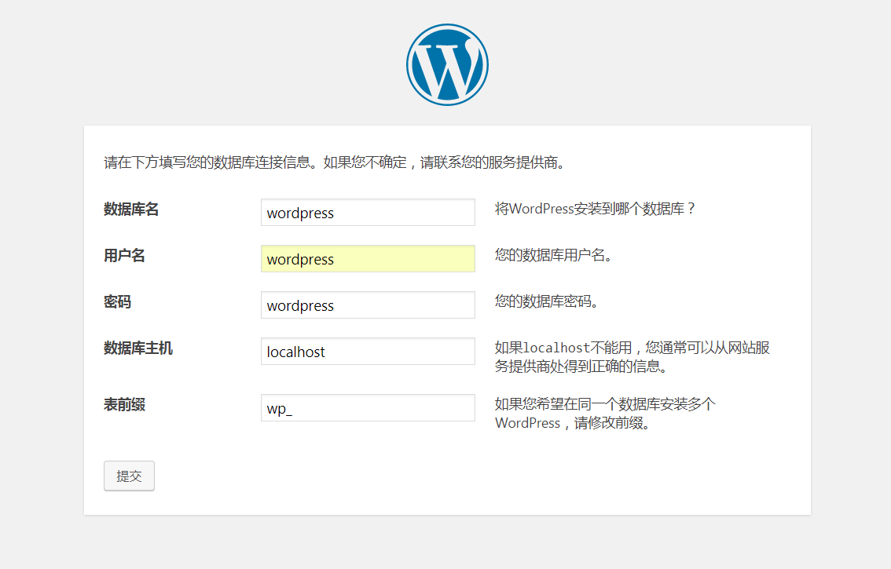

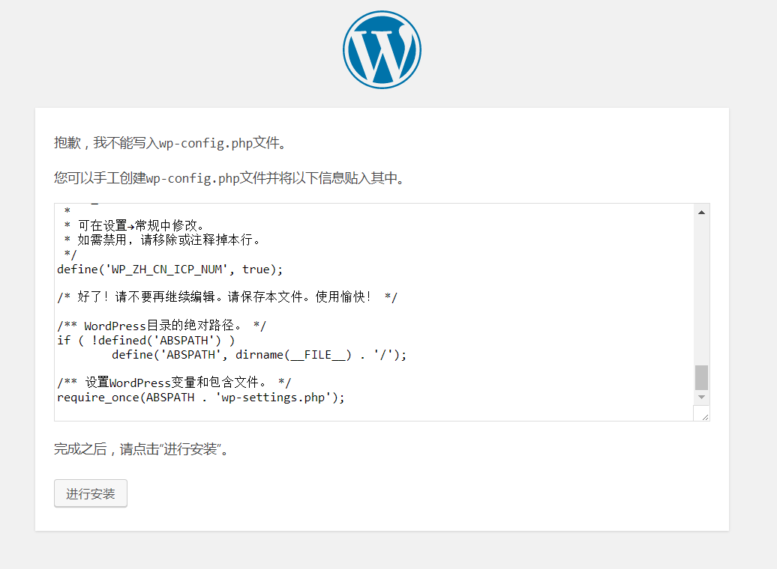

按照提示在 wordpress目录下创建wp-config.php并配置  
cd /var/www/html/wordpress/  
vi wp-config.php

最后面填入一些账号密码信息即可完成！

