FEASIBILITY STUDY OF A GRID-CONNECTED HYBRID PV–WIND–BATTERY ENERGY SYSTEM
Durban University of Technology — Steve Biko Campus, S-Block Complex (S5–S10)
Durban (29.8587° S, 31.0218° E), KwaZulu-Natal, South Africa
RENE301 Renewable Energy — Feasibility Study (20 %)
Submitted: October 2026
Surname | Initials | Student number | Module and semester
 |  |  | RENE301 Renewable Energy 3B — Semester 1, 2026

Plagiarism Declaration
This report is my own work. I have appropriately acknowledged the work of other people whose work I have used. I have not allowed, and will not allow, anyone to copy my work with the intention of passing it off as my own. Every source used is acknowledged in the reference list.
Surname and initials | Student number | Signature | Date

List of Abbreviations, Symbols and Constants
Symbol | Meaning | Symbol | Meaning
AC | alternating current | NERSA | National Energy Regulator of South Africa
α | wind-shear exponent (0.14, open coastal terrain) | NMD | notified maximum demand
BESS | battery energy storage system | NPV | net present value
BOS | balance of system (mounting, cabling, protection) | NRS | National Radiation Standard (SA grid-connection series)
c | Weibull scale parameter (m/s) | O&M | operation and maintenance
CAPEX | capital expenditure | OPEX | operating expenditure
CRF | capital recovery factor | PCC | point of common coupling
DC | direct current | PCS | power conversion system (bidirectional inverter)
DFFE | Dept. of Forestry, Fisheries and the Environment | POA | plane-of-array (irradiance)
DoD | depth of discharge | PR | performance ratio
ECSA | Engineering Council of South Africa | PV | photovoltaic
EFC | equivalent full cycle (battery) | PVGIS | PV Geographical Information System (JRC, EU)
η | efficiency (subscripted: cell, PCS, round-trip) | ρ | air density (kg/m³)
GHI | global horizontal irradiance | RF | renewable fraction
G_STC | irradiance at standard test conditions (1 000 W/m²) | RTE | round-trip efficiency
GA7 | ECSA Graduate Attribute 7 — the Engineer and the World | SANS | South African National Standard
IEC | International Electrotechnical Commission | SAST | South African Standard Time (UTC+2)
IRR | internal rate of return | SOC | state of charge
ITOU | eThekwini invertible-tariff (optional-use) schedule | SSEG | small-scale embedded generation
k | Weibull shape parameter | TMY | typical meteorological year
LCOE | levelised cost of energy | TOU | time-of-use (tariff)
LFP | lithium iron phosphate (LiFePO₄) | v_ci / v_r / v_co | cut-in / rated / cut-out wind speed
MPPT | maximum power point tracking | WPD | wind power density
NEM | net energy metering | WS | wind speed

Physical constants and fixed quantities used in the calculations of Sections 3.11 and 4. Value assumptions (costs, tariffs, efficiencies, loss factors) are NOT listed here — every one of them is registered with its rationale and evidence status in Appendix A.
Constant / fixed quantity | Symbol | Value | Basis
Irradiance at standard test conditions | G_STC | 1 000 W/m² | IEC 61215 PV module STC
Air density (15 °C, sea level) | ρ | 1.225 kg/m³ | International Standard Atmosphere; IEC 61400-12-1
Betz limit (maximum rotor efficiency) | C_p,max | 16/27 = 0.593 | Actuator-disk momentum theory
Grid emission factor (SA, 2023) | EF | 0.942 tCO₂e/MWh | DFFE 2023 DGGEF, gazetted July 2025
Standard time used throughout | — | UTC+2 (SAST) | Applied once at data loading (Section 3.4)
Site coordinates | — | 29.8587° S, 31.0218° E | DUT Steve Biko Campus
Annual GHI at site | — | 1 632 kWh/m²·yr | PVGIS v5.2 (ERA5 + SARAH)
Annual tilted irradiation, 30° north | H_tilt | 1 664 kWh/m²·yr | PVGIS v5.2 (POA before system losses)
PV energy yield, 30°, incl. 14 % losses | Y_PV | 1 431 kWh/kWp·yr | PVGIS v5.2 tilt optimisation
PV specific yield, simulated weather year | Y | 1 461 kWh/kWp·yr | 8 784-hour simulation, 2020 (Section 4.3)
LFP cell nominal voltage / capacity | V_cell / Q_cell | 3.2 V / 280 Ah (896 Wh) | Commercial LFP cell class
Monetary basis | — | 2026 South African Rand, excl. VAT | Unless a quoted source includes VAT
Exchange rate for USD sources | — | R17.80/USD | 2025/26 average

Abstract
This report presents a technical, economic and environmental feasibility study of a grid-connected hybrid renewable energy system for the S-Block teaching complex (blocks S5–S10) of the Durban University of Technology (DUT), Steve Biko Campus, Durban. A bottom-up load audit comprising 77 rooms and 381 appliance records (2 618.3 kW connected load) was translated into hourly demand profiles using documented load classes, diversity factors and academic-calendar factors, giving a typical weekday peak of 1 989.5 kW at 11:00, a weekday load factor of 0.27 and an annualised demand of 3.67 GWh after a documented 15 % allowance for services not covered by the audit. Solar and wind resources were assessed from PVGIS (ERA5/SARAH) hourly reanalysis for the site: annual GHI of 1 632 kWh/m², optimal (30°, north-facing) specific yield of 1 431 kWh/kWp·yr, and a weak wind resource (4.76 m/s mean at 80 m; Weibull k = 1.99, c = 5.37 m/s), consistent with published measurements for Durban. An 8 784-hour dispatch model was used to size the system and to evaluate 160 configurations. The recommended design — 2 000 kWp PV, 2 × 100 kW Aeolos-H turbines (36 m hub) and a 2 000 kWh lithium-iron-phosphate battery — delivers 3 090 MWh/yr of renewable energy against a 3 670 MWh load, achieving a renewable fraction of 67.2 % and self-consumption of 79.8 % at a capital cost of R52.6 million. The projected levelised cost of energy is R2.32/kWh against a current blended grid tariff of R2.93/kWh, with an NPV of R95.8 million (9 % discount rate, 7 % tariff escalation), an IRR of 21.7 % and simple payback of 6 years. The system avoids 2.27 kt CO₂e per year (DFFE 2023 grid emission factor). PV provides 94.5 % of renewable generation and wind 5.5 %: the wind share is deliberately small because Durban's hub-height wind capacity factor of 9.6 % makes small-wind energy approximately 28 times more capital-expensive per delivered kWh than PV. The battery is justified by demand-charge reduction and 31 h of backup for critical campus loads, not by energy arbitrage. All assumptions are registered in Appendix A and every result is reproducible from the supplied scripts and data.
Keywords — hybrid system; photovoltaics; small wind; battery storage; load analysis; feasibility study; LCOE; South Africa

1. Introduction and Objectives

1.1 Background and motivation
South Africa's electricity system is in a protracted transition. Cabinet approved the Integrated Resource Plan 2025 (IRP 2025) on 15 October 2025, which targets 105 GW of new generation capacity by 2039 — including 34 GW wind, 25 GW solar PV, 8.5 GW battery storage and 16 GW of distributed generation — at a projected investment of R2.2 trillion. Since the 2022 amendment of the Electricity Regulation Act raised the licence-exemption threshold for self-consumption generation to 100 MW, and NERSA clarified the small-scale embedded generation (SSEG) registration regime in February 2026, embedded generation at institutional loads such as university campuses has become both legally straightforward and financially compelling.
Electricity tariffs have risen at roughly 10 % per year over the past decade against average inflation of 5.2 %. eThekwini Municipality's average tariff increased by 12.72 % for 2025/26 and a further ~9 % for 2026/27. For a large industrial time-of-use (ITO) customer such as a university campus, winter-peak energy now costs 709.41 c/kWh including VAT — roughly five times the off-peak rate of 142.07 c/kWh. Against this backdrop, on-site generation that displaces high-tariff consumption is a hedge against further escalation, a hedge whose value grows every year the tariff escalates above the cost of capital.
The Durban University of Technology (DUT) is a ~34 000-student university of technology with six faculties; the Faculty of Engineering & Built Environment and the Faculty of Applied Sciences are located at the Steve Biko Campus, 79 Steve Biko Road, Durban. The S-Block complex (S5–S10) houses teaching laboratories, workshops, offices and ICT services with a combined audited connected load of 2 618.3 kW. This study evaluates whether a grid-connected hybrid solar PV–wind–battery system at this complex is technically sound, economically viable and environmentally responsible.

1.2 Problem statement
The S-Block complex consumes electricity exclusively from the municipal grid at eThekwini ITO tariffs, exposes DUT to annual tariff escalation and demand charges, and contributes to the carbon intensity of the most coal-dependent major grid in the world (0.942 tCO₂e/MWh, DFFE 2023 domestic generation grid emission factor). The question is whether a renewable hybrid system can be specified — with defensible numbers, not assertions — that reduces cost, emissions and grid dependency while remaining compatible with the existing supply and with South African standards.

1.3 Objectives
The specific objectives of this study are:
- To reconstruct the electricity demand of the S-Block complex (S5–S10) from the room-by-room appliance audit into realistic hourly, weekday/weekend and seasonal demand profiles, documenting every assumption and diversity factor used.
- To identify and justify the buildings and loads included in, and excluded from, the study boundary, with a per-building demand estimate.
- To quantify the solar and wind resources at the site from measured/reanalysis data and to assess the technical feasibility of PV, wind and battery subsystems, including reliability.
- To determine the economically optimal sizing of each subsystem using net present value (NPV), internal rate of return (IRR), payback and levelised cost of energy (LCOE) against the prevailing eThekwini tariff structure.
- To specify the recommended hybrid design, quantify how much energy comes from PV versus wind, and justify the split on measured resource and cost evidence.
- To evaluate the environmental and sustainability implications (emissions, noise, land use, end-of-life) and the regulatory compliance pathway under South African standards.
The study is framed within ECSA Graduate Attribute GA7 (Engineer and the World): the recommended design is evaluated not only on cost, but on its lifecycle environmental impact, its resilience value under grid load-shedding, and its role as a teaching and research asset for DUT.

2. Literature Review

2.1 The South African electricity context
South Africa's installed renewable capacity reached 6 230 MW at the end of 2024 (2 287 MW PV, 3 443 MW wind, 500 MW CSP) generating 17.8 TWh, while national demand fell ~3 % as private embedded generation scaled up. Utility-scale renewables procured under REIPPPP have driven the national wind LCOE from ~R1.00/kWh (bid window 1) to ~R0.50/kWh (bid window 6), and solar PV from R2.75 to R0.50/kWh over the same period — a mature, bankable cost base that this study benchmarks against. The Battery Energy Storage IPP Procurement Programme (BESIPPPP) reached commercial close on 513 MW across five projects by June 2025 with R15.4 billion of private investment, confirming that storage is now financeable at scale in South Africa. IRENA's global data place 2024 utility PV capex at USD 708/kW and onshore wind at USD 1 143/kW, with global BESS turnkey prices falling to USD 117/kWh (BloombergNEF, December 2025) and USD 192/kWh for utility-scale systems in 2024 — a >30 % year-on-year collapse that materially changes the economics of storage compared with studies only a few years old. IRENA's 24/7 Renewables analysis provides the systems-level argument for pairing variable generation with storage and grid supply rather than seeking 100 % renewable coverage, which is the design philosophy adopted in this report.

2.2 Solar resource in KwaZulu-Natal
Durban has a humid subtropical climate with long-term annual rainfall of ~1 009 mm and roughly 2 365 sunshine hours per year, implying a global horizontal irradiance (GHI) of approximately 4.8–5.2 kWh/m²/day — good by international standards, though below the Northern Cape resource that drives REIPPPP solar at R0.50/kWh. PVGIS reanalysis (ERA5 meteorology, SARAH irradiance) for the site coordinates returns an annual GHI of 1 632 kWh/m² and a tilted-plane yield of 1 431 kWh/kWp·yr at the optimum 30° north-facing tilt, consistent with the sunshine-hour estimate. Industry-standard loss stacks were reviewed: NREL PVWatts applies a default 14 % aggregate DC/AC derate (soiling 2 %, shading 3 %, mismatch 2 %, wiring 2 %, connections 0.5 %, LID 1.5 %, nameplate 1 %, availability 3 %); PVsyst applies site-specific thermal, IAM and mismatch losses. Both were used to cross-check the PVGIS loss assumptions; Durban's coastal salt-aerosol environment argues for soiling at the upper end (3–4 %), an assumption carried explicitly in Appendix A.

2.3 Wind resource in South Africa and at Durban
Rehman et al. analysed 20 years of hourly wind data for seven South African sites and identified Cape Town, East London and Port Elizabeth as the good coastal wind sites; Durban had the lowest long-term mean of all seven at 4.14 m/s (10 m station height), with an increasing trend to 6.01 m/s at higher latitudes along the coast. The CSIR/DTU Wind Atlas for South Africa (WASA) provides the authoritative 250 m-resolution resource map at 20/50/100/150 m, and the nearest validated met mast at Eston (~45 km inland) records 5.98 m/s at 100 m. NASA SSE satellite data give a higher (satellite-derived, 50 m) estimate of 5.0–6.4 m/s for Durban, and the Global Wind Atlas similarly reports 4–5 m/s at 100 m over the Durban metropolitan area on the national map. Chauke shows inter-annual variability of mean wind speed at WASA coastal stations is only 2–6 %, so a single long-term mean is a sound representation. No published Weibull shape parameter k exists for Durban in the accessible literature; k = 2.0 (Rayleigh) is the standard coastal default and is adopted here as a stated assumption — it is later verified against the ERA5 hourly record (fitted k = 1.99, Section 4.3). The literature is unambiguous that Durban is a weak wind site, and any feasibility study at this location must therefore treat wind as a marginal contributor, not a primary energy source.

2.4 Wind turbine technology for the 50–100 kW class
The South African manufacturer Kestrel offers the e400nb at 3 kW — evidence of local manufacturing capability but approximately 30× too small for a campus-scale application; it was therefore rejected on capacity grounds. The selected machine is the Aeolos-H 100 kW: a direct-drive permanent-magnet synchronous generator (PMSG) on a monopole tower (24/30/36 m options), 24.5 m rotor, 2.5 m/s cut-in, 25 m/s cut-out, 55 dBA at 40 m and a 20-year design life. A documented discrepancy exists between the datasheet brochure (rated at 11 m/s) and the product website (10 m/s); the conservative brochure value of 11 m/s is used throughout, which understates annual energy production by 3–5 % at a low-wind site — i.e. the study errs against, not for, wind. The manufacturer does not publish an IEC turbulence/safety class; IEC Class II (TI = 15 % at 15 m/s) is adopted as a planning assumption. NREL's Cost of Wind Energy Review gives USD 6 800/kW installed for the commercial distributed <100 kW class (turbine USD 4 001/kW + BOS USD 2 799/kW) and USD 41/kW/yr O&M, corroborated at USD ~6 680/kW by the University of Michigan; no South Africa–specific small-wind capex figure exists in the accessible literature, so the NREL value, converted at R17.80/USD, is used and flagged as an international proxy (Appendix A).

2.5 Battery energy storage
For a cycling campus application the chemistry decision is decisive. Preger et al. measured commercial cells under identical conditions and found lithium iron phosphate (LFP) sustains 2 500–9 000 equivalent full cycles to 80 % capacity, versus 200–2 500 for NMC and 250–1 500 for NCA; Krieger independently confirmed LFP's superior cycle life and thermal stability. Sandia's second-life analysis indicates useful residual capacity after the 80 % end-of-life threshold, relevant for the disposal pathway assessed in Section 4.9. LFP is therefore specified. Capex is taken from the South African commercial & industrial range of R4 500–7 000 per usable kWh, bracketing the global turnkey benchmark of USD 117/kWh; the falling trajectory of BESS prices supports using the mid-range value with confidence that it is, if anything, conservative for a 2028 commissioning date.

2.6 Tariffs, regulation and standards
The eThekwini ITO tariff schedule (winter peak 709.41 c/kWh, winter standard 198.81, off-peak 142.07, summer peak 311.14, demand charge R177.50/kVA fixed + R60.95/kVA on notified maximum demand, including VAT) creates the fundamental business case: every self-consumed kWh in a winter-peak hour displaces R7.09 of grid cost. NERSA approved ~9 % for 2026/27. The regulatory pathway is well defined: installations >100 kW with a grid connection register directly with NERSA, and the design must comply with SANS 10142-1:2021 Clause 7.12 (alternative supplies), NRS 097-2-1:2024 for SSEG grid connection, the NERSA Renewable Power Plants grid connection code, SANS/IEC 62109 converter safety, SANS/IEC 62116 anti-islanding, and — for the turbines — SANS 10103 environmental noise, SANS 10328 wind-facility noise assessment and SANS/IEC 61400-11 acoustic measurement. These requirements shape the system architecture studied in Section 3.

2.7 Load assessment methodology
Published campus load studies follow one of two paths: measured interval data from the utility, or bottom-up appliance inventories combined with occupancy schedules and diversity factors. The literature consistently warns that generic university archetypes misrepresent specific campuses [evidence: DUT's own profile is unpublished], and NERSA's embedded-generation statistics show that investment decisions at this scale are made on measured data. Because DUT interval data were not available for this study, the bottom-up path was taken — using the DUT S-Block appliance audit as the primary data source — with every modelling step documented so that the profile can be replaced by measured interval data (from eThekwini Electricity Services) before final investment decision, without rebuilding the model. This limitation and the recommended validation step are carried into Section 5.

2.8 Synthesis and research gap
The literature establishes three facts that frame this feasibility study: (i) Durban's solar resource is good (1 431 kWh/kWp·yr) and its wind resource is weak (4.76 m/s at 80 m, capacity factor ~10–14 %); (ii) small-wind capital cost per kW is roughly 16 times utility-wind capex because of diseconomy of scale; and (iii) time-of-use tariffs and demand charges at eThekwini rates make self-consumption, not export, the primary revenue stream. A hybrid PV–wind–battery system at this site is therefore expected to be strongly PV-dominant; the contribution of this study is to quantify that dominance rigorously, size the wind and battery components on measured evidence rather than assertion, and evaluate the system as a whole against the prevailing tariff and regulatory framework.

3. Methodology

3.1 Study boundary and overall approach
The system boundary is the S-Block complex, blocks S5–S10 (77 audited rooms), grid-connected at the existing LV/MV substation. The hybrid system comprises (a) a roof-mounted PV array, (b) small wind turbines, (c) a lithium-iron-phosphate battery with bidirectional inverter, and (d) the existing eThekwini grid connection acting as both supplement (import) and sink (export), with export limited to 1 000 kW. The study proceeds in five stages: load analysis (3.2–3.3), resource assessment (3.4–3.5), component selection (3.6), hourly system simulation and sizing (3.7–3.8), and economic and environmental evaluation (3.9–3.10). All computations are implemented in transparent Python scripts (Appendix D) so that every table and figure in this report can be reproduced from the raw data.

3.1.1 System architecture and block diagram
The recommended plant is an AC-coupled hybrid: every generating source and the storage system connect to the common 400 V / 50 Hz distribution bus through its own power converter. This is the standard architecture for a commercial grid-connected installation at the 2 MW scale because it allows each subsystem to be sized, protected, controlled and revenue-metered independently, it permits phased construction, and the failure of any one converter removes only that source from service. Fig. 1 shows the architecture; the four functional groups are described below.
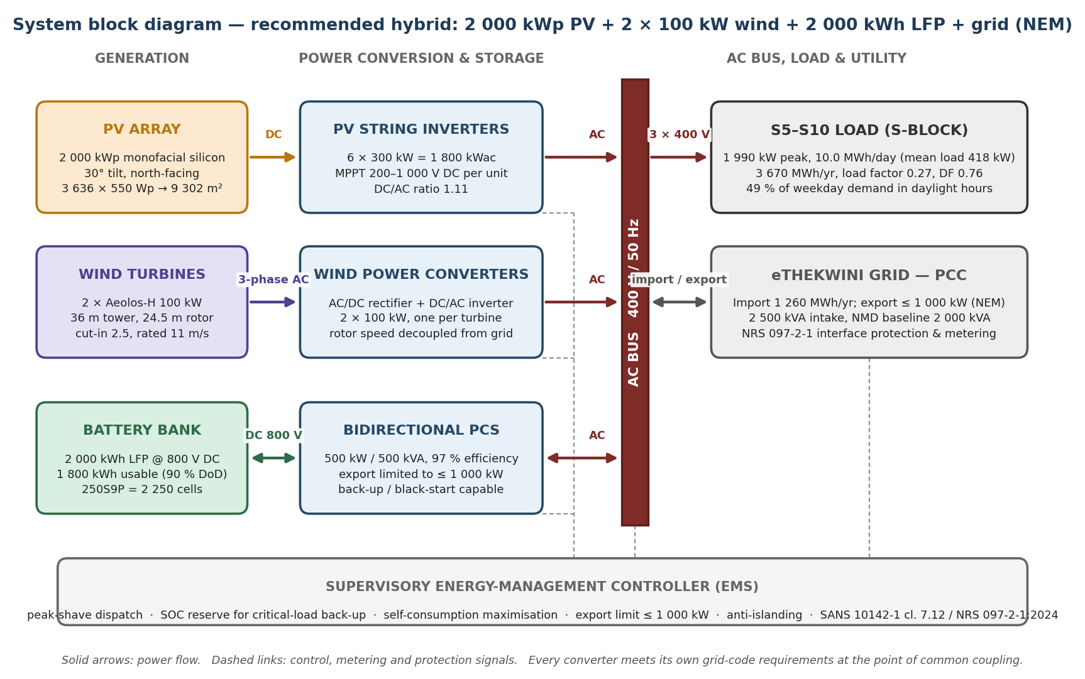
Fig. 1. System block diagram of the recommended 2 000 kWp PV + 2 × 100 kW wind + 2 000 kWh LFP + grid hybrid system. Solid arrows carry power; dashed links carry control signals and metering data.
Generation and conversion. The PV array (2 000 kWp at 30°, north-facing) feeds six 300 kW string inverters whose combined AC rating of 1 800 kWac gives a DC/AC ratio of 1.11; each string inverter performs its own maximum-power-point tracking over a 200–1 000 V DC window, so shading or soiling on one roof section cannot derate the others. Each Aeolos-H turbine has an integrated full converter (AC/DC rectifier followed by a DC/AC inverter) which decouples the permanent-magnet generator frequency from the grid, allowing the rotor to run at the aerodynamically optimal speed at any wind speed — material at a low-wind site where the turbine spends most of its hours between cut-in and rated speed. The battery connects to the AC bus through the 500 kW bidirectional power conversion system (PCS); between the battery rack and the PCS runs an 800 V DC circuit sized in Section 3.11.
Storage and dispatch. The 2 000 kWh LFP bank stores midday PV surplus and discharges into the 17:00–22:00 winter peak, so that a single unit serves both the demand-charge business case and the critical-load backup case. The supervisory energy-management controller sets the hourly dispatch priority (load → battery → export), holds a 10 % SOC floor and a load-shedding reserve above it, and clamps export at the assumed 1 000 kW NEM limit.
Grid interface and compliance. All sources export at the S-Block LV switchboard; the existing 2 500 kVA intake supplies any residual deficit and accepts surplus at the point of common coupling through the net-energy-metering meter. Because the utility network is stiff at this point, the system is dispatchable by construction and no subsystem has to be sized to carry the whole load. Interface protection, anti-islanding and power-quality limits are set by SANS 10142-1 Clause 7.12, NRS 097-2-1:2024 and SANS/IEC 62116, and are carried into the compliance assessment of Section 4.10.

3.2 Load analysis methodology

3.2.1 Data source and extraction
The primary data source is the DUT S-Block electrical appliance audit: a room-by-room inventory covering 77 rooms across the six blocks, recording for each appliance type its quantity, nameplate power (kW), daily operating hours and resulting daily energy (kWh). The audit document was parsed programmatically into 381 structured records covering 71 distinct appliance types, totalling 2 618.3 kW connected load and 15 230.8 kWh/day of audited energy. Room, block and appliance totals were regenerated from the parsed records (not transcribed), eliminating manual transfer error; the full parsed dataset underlies every downstream number.

3.2.2 From appliance energy to demand profiles
The audit records nameplate power, operating hours and daily energy, but not the time at which each appliance runs. A time-resolved profile is required for PV matching, battery dispatch and tariff analysis. Each appliance was therefore assigned to one of six load classes, each with an explicit operating window, a within-window shape, a utilisation factor (diversity) and a weekend multiplier (Table 1). Utilisation factors encode the probability that a given appliance is switched on at a given moment within its window (e.g. teaching laboratories are booked: 80 % of audited hours occur on a typical weekday); the weekend multipliers encode reduced holiday/vacation occupancy. Shapes are trapezoidal (1 h morning/evening ramps) for office, laboratory and workshop classes, a diurnal cooling curve for air-conditioning, and flat for continuous services.
Class | Description | Window | Shape | Utilisation factor | Weekend multiplier
CONT | Continuous services (ICT, refrigeration, growth chambers) | 00:00-24:00 | flat | 1.0 | 1.0
OFF | Office & ICT equipment | 07:00-17:00 | trap | 0.95 | 0.25
AC | Air-conditioning | 09:00-17:00 | ac | 0.95 | 0.25
LAB6 | Lab equipment (6 h sessions) | 08:00-14:00 | trap | 0.8 | 0.15
LAB8 | Lab services (8 h) | 08:00-16:00 | trap | 0.8 | 0.2
SHOP | Workshops / heavy plant | 07:00-13:00 | trap | 0.7 | 0.05
Table 1: Load classes, operating windows and diversity factors used to convert the appliance audit into hourly demand profiles.
Two further layers convert the class-modelled weekday profile into a realistic annual profile. First, an academic-calendar factor scales the whole profile by month (January 0.55 and December 0.45 for vacation; July 0.60 for mid-year recess; November 0.90 as assessments wind down; 1.00 during teaching semesters), reflecting that laboratory and teaching loads follow the DUT academic year while continuous services do not. Second, an explicit +15 % allowance is applied to represent services absent from the audit — general lighting, lifts, small power sockets and server rooms not itemised room-by-room — so that modelled consumption is conservative relative to the audited floor. The resulting profiles are: typical weekday 12 853.2 kWh/day, peak 1 989.5 kW at 11:00, load factor 0.27, night base load 57.2 kW; typical weekend 3 384.0 kWh/day, peak 371.5 kW. Annualised (audit-scope only) the profile totals 3.25 GWh; with the unaudited-services allowance the simulated annual load is 3 670 MWh.
The weekday profile is deliberately not a flat average: the 11:00 peak of nearly 2 MW against a 0.27 load factor is the direct consequence of laboratories, workshops and air-conditioning coinciding in the late morning — precisely the hours of maximum solar availability. This coincidence, quantified in Section 4, is what makes PV effective at this load despite its low load factor.

3.2.3 Assumptions and their traceability
Every assumption entering the load model — load class of each appliance type, utilisation factors, weekend multipliers, academic-calendar factors and the 15 % unaudited-services allowance — is listed in Appendix A with its rationale, and the class-level parameters are given in Table 1. The thought process is deliberately traceable: audited kWh (hard data) → class assignment (engineering judgement, Table 1) → time shape (occupancy logic) → calendar scaling (DUT academic year) → +15 % allowance (completeness margin). A reviewer can substitute measured interval data at the final step and re-run the model without repeating the audit.

3.3 Buildings and loads considered
All six audited blocks — S5, S6, S7, S8, S9 and S10 — are INCLUDED in the study boundary. No block was excluded: each contributes materially to demand (12–20 % share, Table 2) and each contains auditable, modelled loads. Per-block demand estimates derived from the audit are given in Table 2.
Block | Connected load (kW) | Audited energy (kWh/day) | Modelled weekday energy (kWh/day) | Share of complex (%)
S5 | 585.7 | 3 226.1 | 2 623.5 | 20.4
S6 | 515.5 | 2 986.7 | 2 544.4 | 19.8
S7 | 500.9 | 2 550.6 | 2 103.1 | 16.4
S8 | 364.6 | 1 931.1 | 1 552.1 | 12.1
S9 | 315.0 | 2 008.5 | 1 782.6 | 13.9
S10 | 336.6 | 2 527.9 | 2 247.4 | 17.5
TOTAL | 2 618.3 | 15 230.8 | 12 853.2 | 100.0
Table 2: Per-block demand estimates from the parsed appliance audit (all blocks included in the study).
Loads EXCLUDED from the audit boundary — and therefore represented only by the +15 % allowance rather than by explicit modelling — are: general (non-room) lighting, passenger lifts, small power in un-audited circulation and storage areas, and server/network rooms not itemised in the audit. These are excluded as discrete modelled entities because the audit does not inventory them; they are NOT excluded from the energy balance, since the +15 % allowance carries them. Also outside the boundary are campus buildings other than S5–S10 (out of audit scope) and the campus MV distribution network. The per-room breakdown of all 77 audited rooms is given in Appendix B.

3.4 Solar resource assessment
Hourly solar resource for 2020 (8 784 values) and a typical meteorological year (TMY) were obtained from the PVGIS v5.2 service (ERA5 meteorology, SARAH satellite irradiance) at the site coordinates (29.8587° S, 31.0218° E). A tilt-orientation optimisation (10°/20°/30°/40°, aspect 180° = north-facing) identified 30° as the optimum fixed tilt, yielding 1 431 kWh/kWp·yr — chosen for the design. PVGIS applies a default system loss of 14 % (equivalent to the PVWatts derate stack); the annual GHI of 1 632 kWh/m² and the tilted-plane irradiation components were extracted for the resource figures. All PVGIS timestamps (UTC) were converted to South African Standard Time (UTC+2) once, at the data-loading step, so that generation, load and tariff hours are aligned throughout the model — a two-hour misalignment would otherwise bias every dispatch result.

3.5 Wind resource assessment
The same PVGIS hourly series provides 10 m wind speed (ERA5 reanalysis). The 2020 hourly record has an annual mean of 3.56 m/s at 10 m (TMY: 3.74 m/s), consistent with the 4.14 m/s 20-year station mean of Rehman et al. given the ERA5 grid-cell averaging. Speeds were extrapolated to hub height with the power law
v(h) = v₁₀ · (h/10)^α , α = 0.14 (open coastal terrain) (3.1)
giving 4.26 m/s at the 36 m hub of the selected turbine and 4.76 m/s at 80 m. A two-parameter Weibull distribution was fitted to the 8 784 hourly 80 m speeds by the method of moments, yielding k = 1.99 and c = 5.37 m/s — the shape parameter independently validating the assumed Rayleigh (k = 2.0) default discussed in Section 2.3. The Aeolos-H 100 kW power curve was then applied hour by hour:
P(v) = 0 , v < v_cut-in (3.2)
P(v) = P_rated · (v³ − v_ci³)/(v_r³ − v_ci³), v_cut-in ≤ v < v_rated (3.3)
P(v) = P_rated , v_rated ≤ v < v_cut-out (3.4)
P(v) = 0 , v ≥ v_cut-out (3.5)
with v_cut-in = 2.5 m/s, v_rated = 11 m/s (conservative brochure value), v_cut-out = 25 m/s, a 96 % availability factor and 3 % array-wake losses. Note that the 36 m hub height is the tallest monopole option offered by the manufacturer; taller towers are not proposed because they would require a guyed or lattice structure beyond the published product range.

3.6 Component selection
PV: a 30°-tilted rooftop array of monofacial silicon modules with string inverters, sized in Section 4 from the sweep. Wind: Aeolos-H 100 kW turbines on 36 m monopole towers (Section 2.4). Battery: lithium iron phosphate, 90 % depth of discharge, 95 % cell round-trip efficiency, 97 % bidirectional inverter efficiency, 10 % SOC floor, 500 kW power conversion system — LFP selected on the cycle-life evidence of Preger et al. and Krieger (Section 2.5), with replacement provisioned in year 12 at 70 % of initial cost. Grid: existing connection (assumed 2 500 kVA substation capacity, above the modelled 2 MW peak), export limited to 1 000 kW to align with a conservative NEM agreement.
The selected items are consolidated below with the decision rule used in each case. Where a specific commercial product is named it is the reference product for the sizing calculation and the economic model — equivalent products are expected to be priced at tender, and Appendix A flags every parameter that a tender response must confirm.
Subsystem | Selected item | Decision rule / justification
PV module | Monofacial silicon, 550 Wp class, module efficiency 21.5 %; 3 636 modules for 2 000 kWp | Maximises energy per m² of scarce roof area (9 302 m² of module area versus 12 000–14 000 m² of roof footprint at 6–7 m²/kWp). Bifacial modules rejected: the gain depends on ground/roof albedo that a cluttered, light-coloured rooftop does not guarantee, so no bifacial gain is credited in the model.
PV inverter | 6 × 300 kW string inverters = 1 800 kWac (MPPT 200–1 000 V DC) | DC/AC ratio 1.11 over-provisions the DC array to capture clipping-free harvest in the high-irradiance shoulder hours — standard practice and already inside the PVGIS loss stack. String architecture: independent MPPT per roof section, no single point of failure, and 6 units keep one inverter outage to 5.6 % of capacity.
Wind turbine | 2 × Aeolos-H 100 kW, 24.5 m rotor, 36 m monopole | The 50–100 kW class machine with complete published data (power curve, noise, tower options, 20-year design life). 36 m is the tallest published monopole option and is selected from the power-law profile of Section 3.5; taller towers would need guyed or lattice structures outside the published product range.
Wind converter | Integrated AC/DC rectifier + DC/AC inverter per turbine | Decouples PMSG frequency from the 50 Hz grid so rotor speed follows the wind, which is worth most at a low-wind site; also provides the reactive-power and power-quality behaviour required by NRS 097-2-1:2024.
Battery | LFP (LiFePO₄), 2 000 kWh nominal / 1 800 kWh usable, 90 % DoD, 10 % SOC floor, 250S9P at 800 V | Cycle-life evidence (Section 2.5): LFP sustains 2 500–9 000 EFC against 200–2 500 for NMC/NCA under identical test conditions; cobalt-free chemistry removes the supply-chain and thermal-propagation concerns relevant to an occupied teaching building. Capacity is set by the 24 h critical-load autonomy calculation of Section 3.11.
PCS | 500 kW / 500 kVA bidirectional converter, 97 % efficiency | Set by the peak-shave and critical-load calculations of Section 3.11 (required 497 kW), not by nominal battery energy; 500 kW is the next standard rating.
Grid interface | Existing 2 500 kVA intake; NEM export capped at 1 000 kW | Avoids new substation capital; the export cap is the conservative NEM assumption (Appendix A) and is enforced by the controller, not by agreement alone.
Protection & control | Interface protection, anti-islanding, EMS/export limiter | Mandatory for an SSEG of this size under SANS 10142-1:2021 cl. 7.12, NRS 097-2-1:2024 and SANS/IEC 62116; the export limiter is the compliance mechanism for the 1 000 kW cap.
Table 3: Component selection and justification for the recommended hybrid system.

3.7 Hourly system simulation
An 8 784-hour chronological dispatch model (one leap year, 2020 weather) was written in Python. For each hour the model computes PV output (specific power × array size), wind output (power curve × hub-height speed), and demand (profile × calendar factor × allowance), then dispatches in load-following order: surplus generation charges the battery first (subject to power and energy limits and conversion losses); any remaining surplus is exported up to the 1 000 kW cap and curtailed beyond it; deficits are met by battery discharge first, then by grid import. The model reports, for any configuration, the annual energy balance, renewable fraction, self-consumption, grid exchange, curtailment, battery throughput and losses. Because the grid is present in every hour, the system is dispatchable by construction; reliability analysis (Section 4.7) addresses grid-absent intervals (load shedding) separately.
Storage conversion losses are treated conservatively and explicitly. The cell round-trip efficiency (95 %) and the PCS efficiency (97 %) are applied independently on charge and again on discharge, so the effective battery round-trip efficiency used by the model is (0.95 × 0.97)² = 84.9 %. This is verified in the simulation output: the recommended system charges 363.9 MWh and discharges 309.0 MWh over the year (309.0/363.9 = 84.9 %), giving 54.9 MWh of storage loss. A commercial LFP installation would typically achieve 90–92 %, so the bias in this model is against the battery, not for it — the reported renewable fraction, savings and NPV are therefore conservative with respect to this parameter.

3.8 Sizing methodology
Sizing proceeded in two stages over the configuration space. Stage 1: PV from 0 to 4 000 kWp in 250 kWp steps × 0 to 15 turbines, with the battery held at the recommended 2 000 kWh so that the PV/wind trade-off is evaluated at the storage size actually proposed — 272 configurations in total — to map the renewable-fraction and self-consumption surfaces and locate the region where self-consumption remains high (>85 %) — the region of maximum economic value given TOU tariffs. Stage 2: battery capacity over 0, 500, 1 000, 1 500, 2 000, 3 000 and 4 000 kWh at the economically promising PV/wind combinations. Each candidate was then evaluated economically (3.9); the recommended design is the configuration that satisfies the hybrid-system brief while remaining on the efficient frontier of NPV, with its premium over the PV-only optimum quantified explicitly rather than hidden.

3.9 Economic model
Capital and operating costs (2026 values, excluding VAT unless stated) are built bottom-up from South African market sources with international proxies flagged (Appendix A): PV at R7 500/kWp for a 1–2 MWp rooftop; small wind at R121 040/kW (NREL USD 6 800/kW × R17.80/USD); battery at R5 500/usable kWh (mid of the SA C&I range R4 500–7 000); power conversion at R7 000/kW. O&M: PV 1.0 % of capex p.a.; wind R730/kW·yr (NREL USD 41/kW·yr); battery 0.7 % of capex p.a. plus replacement in year 12 at 70 % cost.
Revenue is modelled against the eThekwini ITO schedule applied hour by hour: winter-peak (Jun–Aug, weekday 07:00–10:00 and 17:00–22:00) R7.0941/kWh; winter standard (10:00–17:00) R1.9881/kWh; summer peak (Sep–Apr, weekday 08:00–20:00) R3.1114/kWh; off-peak and all weekends R1.4207/kWh; surplus exported at the off-peak rate. Demand-charge saving is taken at 10 % of the assumed R238.45/kVA·month charge on a 2 000 kVA notified maximum demand (PV coincidence plus battery peak-shaving), a conservative share of the theoretically achievable reduction. Cash flows are evaluated over 25 years with 7 % nominal tariff escalation (below the ~10 %/yr of the past decade, deliberately conservative) and a 9 % nominal discount rate; NPV, IRR, simple payback and LCOE are computed as
NPV = −CAPEX + Σₜ₌₁²⁵ (Savingsₜ − OPEXₜ)/(1+r)ᵗ (3.6)
LCOE = (CAPEX·CRF + OPEX) / E_renewable,consumed , CRF = r(1+r)ⁿ/((1+r)ⁿ−1) (3.7)
with battery replacement subtracted in year 12. A sensitivity analysis varies each major assumption (±30 % capex, escalation 5–9 %, discount 7–12 %, export price ±50 %, demand-charge saving 0–20 %) to test the robustness of the investment decision.

3.10 Environmental and compliance assessment method
Avoided emissions are computed against the officially gazetted DFFE 2023 domestic generation grid emission factor of 0.942 tCO₂e/MWh, applied only to renewable energy actually self-consumed (exported energy does not avoid emissions under an average-factor accounting boundary; the alternative avoided-margin view is noted in Section 4.9). Noise, visual, structural, end-of-life and grid-compliance impacts are assessed qualitatively against SANS 10103, SANS 10328 and the equipment acoustic data, and the NERSA/NRS/SANS compliance chain.

3.11 Worked design calculations
Every design quantity quoted in this report is derived here from the audited data, the measured resource and the registered assumptions, with the numerical substitution shown so that each result can be reproduced independently. Equations are numbered sequentially within Section 3. Displayed values are rounded for legibility; every computation is carried at full precision in the scripts listed in Appendix D.

3.11.1 Demand, diversity and load factor
Step 1 — audited daily energy. Each of the 381 audit records contributes q·P·h (quantity × rated power × rated hours) and these are summed over all six blocks; the per-room result is tabulated in Appendix B so the total can be re-added by hand.
E_aud = Σᵢ (qᵢ · Pᵢ · hᵢ) = 15 230.8 kWh/day (3.8)
Step 2 — utilisation (diversity) adjustment. Each appliance class is multiplied by its utilisation factor (Table 1), giving an overall average of 0.844 for the complex:
E_eff = Σ_c (E_c · UF_c) = 15 230.8 × 0.844 = 12 853.2 kWh/day (typical weekday) (3.9)
Step 3 — unaudited-services allowance. Lighting, lifts, small power and network rooms absent from the audit are carried as a 15 % completeness margin:
E_wd = E_eff · (1 + a) = 12 853.2 × 1.15 = 14 781.2 kWh/day (3.10)
Step 4 — annual energy. The weekday and weekend profiles are scaled by the DUT academic-calendar factor of each month (Appendix C) and summed over all 8 784 hours of the weather year:
E_ann = Σ_d [P(dow_d) · f_month(d) · 1.15] = 3 669 746 kWh = 3 669.7 MWh/yr (3.11)
i.e. a mean daily demand of 10 027 kWh/day and a mean load of 418 kW against a typical-weekday peak of 1 989.5 kW at 11:00 and a connected load of 2 618.3 kW. Two dimensionless ratios follow, both used later:
LF = E_wd /(P_pk · 24) = 12 853.2 / (1 989.5 × 24) = 0.269 (3.12)
DF = P_pk / P_connected = 1 989.5 / 2 618.3 = 0.76 (3.13)
The diversity factor of 0.76 is what allows the LV switchboard and the demand-charge baseline to be set on peak rather than connected load, and the load factor of 0.27 confirms a strongly day-peaked teaching demand — the shape PV supplies best.

3.11.2 PV array sizing, module count and area
The array size is set by the Stage-1 sweep at the economic boundary where self-consumption is still ≈80 % (Section 4.4, Fig. 7): beyond that point incremental kWh are exported at R1.42 while carrying full capital cost. Energy, module count and area then follow:
E_pv = P_pv · Y = 2 000 kWp × 1 461 kWh/kWp·yr = 2 922 MWh/yr (simulated 2 921.6 MWh) (3.14)
The independent check uses the PVGIS typical meteorological year rather than the 2020 weather year: 2 000 kWp × 1 431 kWh/kWp·yr = 2 862 MWh, so the simulated year runs +2.1 % against the typical year — inside normal inter-annual variability, and not a bias in the design.
N_modules = P_pv / P_module = 2 000 000 W / 550 W = 3 636 modules (2 000.0 kWp) (3.15)
A_modules = P_pv /(G_STC · η_mod) = 2 000 kWp /(1 kW/m² × 0.215) = 9 302 m² (3.16)
Each module therefore presents 2.56 m², and at a 30° tilt with a 2.6 m row pitch the ground-coverage ratio is about 0.76, so the roof footprint required is:
A_roof = A_modules / GCR = 9 302 / 0.76 = 12 240 m² = 6.1 m²/kWp (3.17)
This is the 6.1–7 m²/kWp allowance quoted for the S5–S10 roofs in Section 4.9.1 and is the quantity a structural survey must confirm.

3.11.3 Battery bank sizing, autonomy and cell configuration
The storage requirement is driven by the critical-load backup duty rather than by energy arbitrage: carry the 57.2 kW overnight critical base (ICT, refrigeration, growth chambers, security and fire systems) for 24 h through a load-shedding event.
E_usable,req = P_crit · t_req = 57.2 kW × 24 h = 1 373 kWh (3.18)
E_nom,req = E_usable,req / DoD = 1 373 / 0.90 = 1 525 kWh → next standard modular size 2 000 kWh (3.19)
E_usable,prov = E_nom · DoD = 2 000 × 0.90 = 1 800 kWh , t_backup = 1 800 / 57.2 kW = 31.5 h (3.20)
The delivered duration after PCS losses is 30.5 h, still well beyond the 24 h criterion; 31 h is quoted throughout as the conservative energy-only figure. Nominal capacity equals 20 % of a mean day's demand (10 027 kWh) — enough for peak-shifting and backup without paying for cycling energy the load never needs.
N_series = V_DC / V_cell = 800 / 3.2 = 250 cells ; N_parallel = E_nom /(N_series · V_cell · Q_cell) = 2 000 000 / 224 000 = 9 (3.21)
E_bank = 800 V × (9 × 280 Ah) = 2 016 kWh (250S9P = 2 250 cells) (3.22)

3.11.4 Inverter, PCS and distribution ratings
I_PCS,max = P_PCS / V_DC = 500 000 W / 800 V = 625 A (3.23)
P_PV,ac = P_PV,dc / (DC:AC) = 2 000 / 1.11 = 1 802 kWac → 6 × 300 kW string inverters (3.24)
The battery PCS rating is the larger of the backup duty (with a factor of safety on the critical load) and the peak-shave duty, which must be able to offset a meaningful share of the coincident peak:
P_PCS ≥ max(5 · P_crit, 0.25 · P_pk) = max(286, 497) = 497 kW → 500 kW (next standard rating) (3.25)
P_ac,rated ≥ P_connected · DF = 2 618.3 × 0.76 = 1 990 kW = P_pk (consistency check on the switchboard rating) (3.26)

3.11.5 Wind energy, capacity factor and the PV/wind split
The rotor sweeps A = πD²/4 = π(24.5)²/4 = 471.4 m², and the annual energy is obtained by integrating the cubic power law over the fitted Weibull distribution of Section 3.5 (k = 1.99, c = 5.37 m/s):
P_av = ½ · ρ · A · v³ · C_p , ⟨v³⟩ = c³ · Γ(1 + 3/k) = 5.37³ · Γ(2.508) = 207.0 m³/s³ (3.27)
E_wind = N · ½ρA⟨v³⟩C_p,eff · 8760 · f_av · f_wake = 2 × 59.76 kW × 0.173 × 8760 × 0.96 × 0.97 = 168.7 MWh (simulated 168.7 MWh) (3.28)
Back-calculating the effective power coefficient from the simulated energy gives C_p,eff = 0.173, i.e. 29 % of the Betz limit of 0.593 — a physically plausible annual average for a machine that spends most of its hours at part load (mean speed 4.26 m/s against 11 m/s rated) and confirms the power-curve simulation is not over-predicting wind energy.
CF = E_wind /(N · P_rated · 8760) = 168 716 / (2 × 100 × 8760) = 9.6 % (3.29)
s_wind = E_wind /(E_pv + E_wind) = 168.7 / 3 090.3 = 5.5 % of generation from 9.1 % of capacity (3.30)

3.11.6 Energy-balance, financial and emissions metrics
RF = (E_pv + E_wind − E_curt − E_export) / E_load = (2 921.6 + 168.7 − 15.0 − 610.4) / 3 669.7 = 67.2 % (3.31)
SC = (E_pv + E_wind − E_curt − E_export) /(E_pv + E_wind) = 2 464.9 / 3 090.3 = 79.8 % (3.32)
CRF = r(1+r)ⁿ /[(1+r)ⁿ − 1] = 0.09(1.09)²⁵ /[(1.09)²⁵ − 1] = 0.10181 (3.33)
LCOE = (CAPEX · CRF + OPEX) / E_renew,delivered = (52 608 000 × 0.10181 + 365 300) / 2 464 908 = R2.32/kWh (3.34)
The same capital recovery factor values the project over its 25-year life; because savings grow with the 7 % tariff escalation while the discount rate is 9 %, the growing-annuity form gives an exact closed-form check on the discounted cash-flow model:
NPV = −CAPEX + (S₁ − OPEX₁)/(r − g) · [1 − ((1+g)/(1+r))ⁿ] − C_rep/(1+r)¹² = R95.8 m (3.35)
with S₁ − OPEX₁ = R8.14 m/yr, C_rep = 70 % of the battery cost = R6.93 m in year 12, and IRR 21.7 %. Payback is reported as simple payback — the first year in which the cumulative *undiscounted* cash flow (savings escalating at 7%) recovers the 52 608 000 capital cost — which is 6 years; on a discounted basis the project is already NPV-positive at a 9 % hurdle rate.
CO₂ avoided = (E_load − E_grid) · EF = (3 669.7 − 1 260.4) × 1 000 × 0.942 = 2 270 t/yr (3.36)
The displacement basis is grid imports avoided (E_load − E_grid = 2 409.3 MWh), not total renewable generation, because exported and curtailed energy does not displace grid emissions under an average-factor accounting boundary (Section 4.9). Battery losses of 54.9 MWh/yr are likewise excluded — they are consumed, not delivered.

4. Results and Analysis

4.1 Demand analysis
Fig. 2 shows the resulting hourly demand for a typical teaching weekday, resolved by load class (a) and by building block (b). The profile is strongly day-peaked: demand rises from the 57.2 kW overnight base (continuous ICT, refrigeration and growth chambers) from about 06:00, reaches 1 989.5 kW at 11:00 as laboratories, workshops and air-conditioning coincide, and decays after 16:00. Weekends drop to roughly a quarter of weekday energy. The weekday load factor of 0.27 reflects a teaching load dominated by scheduled daytime activity — a profile that is, by good fortune, close to the shape of solar generation.
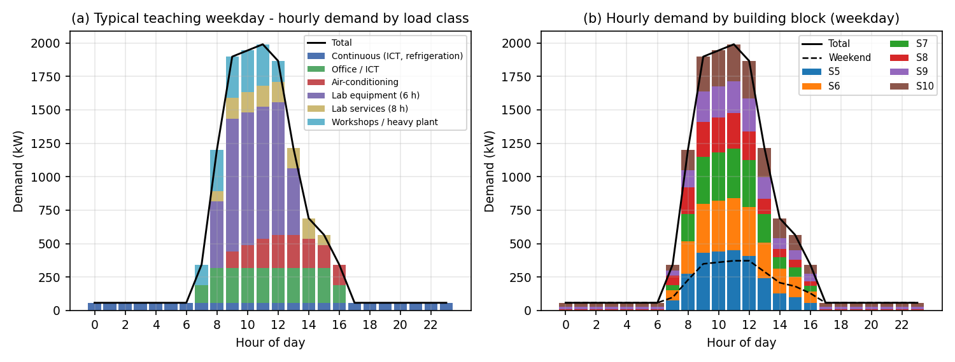
Fig. 2. Modelled typical weekday demand by load class (a) and by building block (b); dashed line: typical weekend demand.
Fig. 3 summarises audited energy, modelled weekday energy and connected load per block (Table 2). S5 (585.7 kW connected, 20.4 % of energy) and S6 (515.5 kW, 19.8 %) are the largest consumers; S8, the Electronic & Computer Engineering block, has the lowest daily energy despite substantial connected load, reflecting short laboratory sessions. The spread of modelled weekday energy across blocks (1 552–2 624 kWh/day) confirms that no single block dominates and that the complex-wide boundary chosen in Section 3.3 is appropriate.
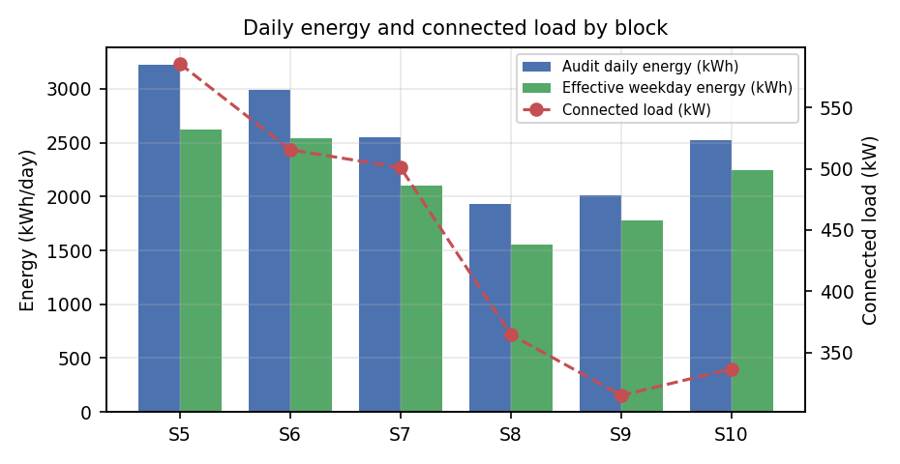
Fig. 3. Audited daily energy, modelled weekday energy and connected load by building block.

4.2 Solar resource results
Fig. 4 (a required graph of the brief) shows the average daily GHI profile at the site together with the average plane-of-array irradiance on the 30° north-facing array. Mean daily GHI totals 4.46 kWh/m² (1 632 kWh/m²·yr); POA on the optimally tilted array is higher than GHI in the winter half-year (when the sun is low) and lower in summer — the tilt flattens the seasonal swing, which is exactly the property needed to match a load with winter-peak tariffs.
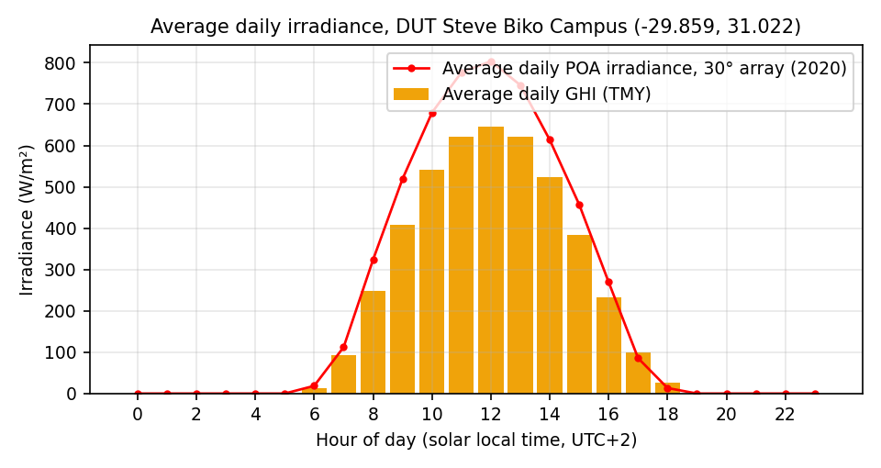
Fig. 4. Average daily GHI and plane-of-array irradiance (30° array), site -29.859, 31.022. Required graph.
Fig. 5(a) resolves the resource by month: tilted irradiation varies from ~5.6 kWh/m²/day in December to ~3.9 kWh/m²/day in June — only a ±20 % seasonal swing, versus ±60 % or more at high-latitude European sites. Monthly PV yield per kWp tracks this pattern, and the annual specific yield at 30° is 1 431 kWh/kWp·yr (PVGIS), or 1 461 kWh/kWp·yr from the 2020 hourly series used in the simulation — a 2 % difference between the typical-year and actual-year datasets, which bounds the inter-annual uncertainty of the PV yield estimate.
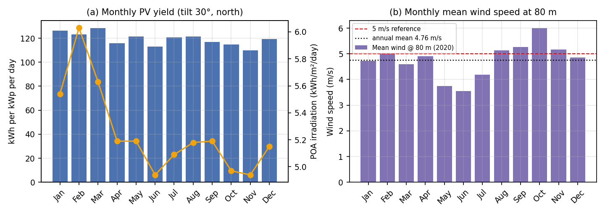
Fig. 5. (a) Monthly tilted irradiation and PV yield; (b) monthly mean wind speed at 80 m against the 5 m/s reference.

4.3 Wind resource results
Fig. 5(b) shows the monthly mean wind speed at 80 m: the annual mean is 4.76 m/s with a modest summer/autumn maximum — the seasonal pattern is roughly anti-phase to the winter tariff peak, which is unfavourable for the business case. Fig. 6 fits the Weibull distribution to the 8 784 hourly speeds: k = 1.99, c = 5.37 m/s. The independently fitted shape parameter of 1.99 confirms the assumed Rayleigh (k = 2.0) default (Section 2.3), closing that assumption with evidence.
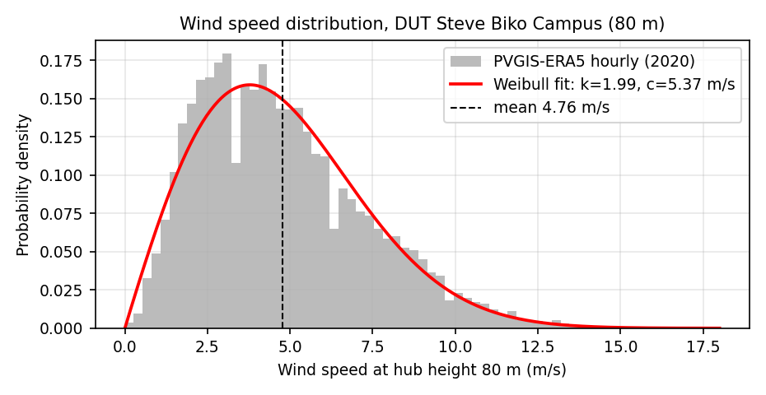
Fig. 6. Weibull fit to the 2020 hourly wind-speed record at 80 m (k = 1.99, c = 5.37 m/s; mean 4.76 m/s).
Applying the Aeolos-H power curve at the 36 m hub height (mean 4.26 m/s) yields a capacity factor of 9.6 % for the recommended two turbines — at the low end even for Durban, because the 36 m hub sits in the weaker part of the wind shear profile. At 80 m the same fleet would achieve roughly 13–15 % (engineering estimate from the v³ region of the power curve), still far below the ~30 %+ of SA utility wind and below the ~25 % threshold generally needed for small-wind economics. The wind resource at this site is therefore, quantitatively, marginal.

4.4 Sizing trade-offs
Fig. 7 maps the two sizing metrics against PV array size for several turbine counts, evaluated at the 2 000 kWh battery of the recommended design. Renewable fraction rises roughly linearly with PV (as expected for a sun-matched load), reaching 64 % at 2 000 kWp with no wind and 67 % with the recommended two turbines; self-consumption falls as the array outgrows the load — 88 % at 1 500 kWp, 80.7 % at 2 000 kWp with no wind (79.8 % with two turbines) — dropping below 70 % beyond about 2 750 kWp. The economically valuable region — high self-consumption under TOU tariffs, where every generated kWh displaces R1.99–7.09 of grid energy — lies around 1 500–2 250 kWp. Beyond that, incremental energy is exported at the R1.42/kWh off-peak rate while carrying full capital cost: technically feasible, economically dilutive.
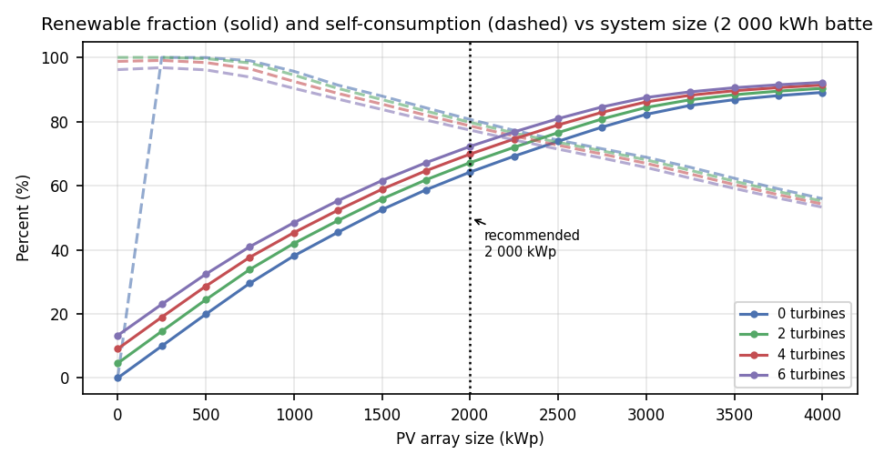
Fig. 7. Renewable fraction (solid) and self-consumption (dashed) versus PV array size for 0, 2, 4 and 6 turbines at the fixed 2 000 kWh battery of the recommended design. Dotted line: recommended 2 000 kWp.
Of the 160 configurations evaluated economically, the NPV-maximising configuration without constraints is larger PV with no wind and no battery (3 000 kWp; NPV R162 million, LCOE R0.99/kWh). This is the honest economic optimum for a purely commercial investor. The brief, however, calls for a hybrid PV–wind–battery system, and the marginal analysis quantifies exactly what that costs: adding two turbines to the PV-only design buys 168.7 MWh/yr of wind energy for R24.2 million of additional capex — a marginal capital cost of R143 per annual kWh delivered, against R5.13 per annual kWh for PV (R7 500/kWp ÷ 1 461 kWh/kWp·yr), i.e. small-wind energy is about 28× more capital-expensive than PV at this site. The recommended design therefore takes the smallest defensible wind contribution (two turbines) rather than sizing wind on symmetry or aesthetics, and the battery is sized on resilience and demand-charge value, not arbitrage.

4.5 Recommended system and performance
The recommended system is specified in Table 4. Fig. 8 (the 24-hour generation-versus-load graph required by the brief) shows the winter and annual typical weekdays: PV alone covers the entire daytime load from roughly 08:30 to 15:30 in winter, with the battery shifting midday surplus into the 17:00–22:00 winter-peak window; wind contributes a small but visible shoulder in the evening hours. Grid import is confined to mornings, evenings and the vacation season.
Subsystem | Specification | Basis
PV array | 2 000 kWp, 30° tilt, north-facing, rooftop | Tilt optimisation (PVGIS); sizing sweep (Fig. 7); self-consumption region
Wind | 2 × Aeolos-H 100 kW, 36 m monopole | Smallest defensible wind contribution; marginal economics (Section 4.4)
Battery | 2 000 kWh LFP (1 800 kWh usable @ 90 % DoD), 500 kW PCS | Peak-shaving, winter-peak load-shifting, backup (Section 4.7)
Grid connection | Existing; import unlimited (2 500 kVA), export capped at 1 000 kW | NEM agreement; NRS 097-2-1:2024 compliance
Annual renewable generation | PV 2 922 MWh + wind 169 MWh = 3 090 MWh | 8 784-h simulation, 2020 weather
Renewable fraction / self-consumption | 67.2 % / 79.8 % | Grid import 1 260 MWh (34.3 % of load); export 610 MWh
Capital cost | R52.6 million (PV R15.0m + wind R24.2m + battery R9.9m + PCS R3.5m) | Bottom-up capex, Appendix A
LCOE (25 y, 9 %, 7 % escalation) | R2.32/kWh vs grid blended R2.93/kWh | Section 3.9 model
NPV / IRR / payback | R95.8 m / 21.7 % / 6 yr | 25-year cash flow incl. battery replacement yr 12
Table 4: Recommended hybrid system specification and headline results.
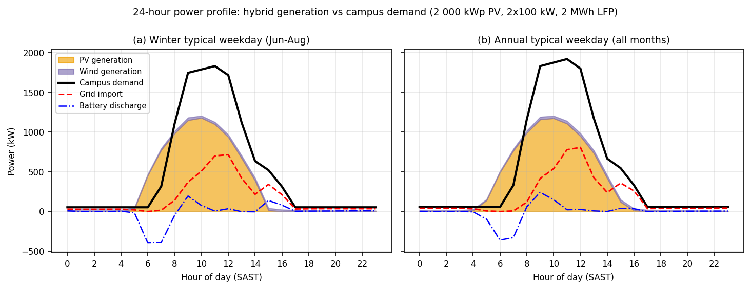
Fig. 8. 24-hour power profile: hybrid generation versus campus demand, winter typical weekday (left) and annual typical weekday (right). Required graph.
Fig. 9 shows the monthly energy balance. In vacation months (January, December, July) the system is nearly autonomous — renewable fractions of 96–99 % — with substantial export; in full-teaching months the renewable fraction settles around 55–67 %, with the grid covering mornings, evenings and laboratory overtime. Annual wind generation peaks in October–January (24.8 MWh in October versus 3.9 MWh in June), partially anti-phased to the winter tariff peak — a genuine but small complementarity benefit of the hybrid architecture.
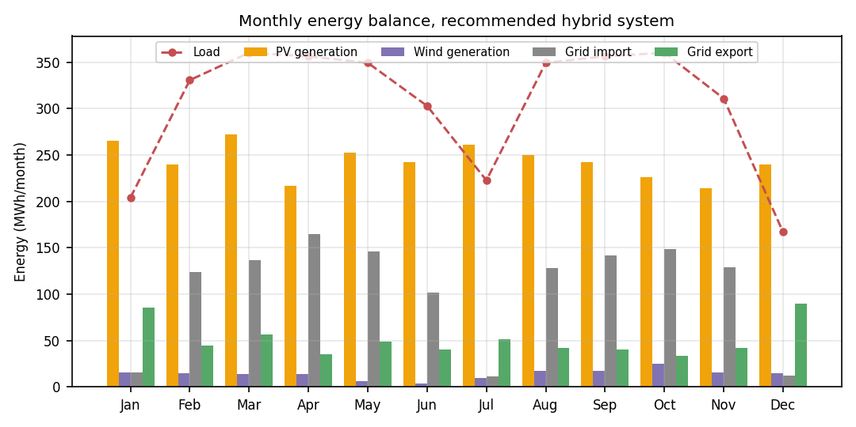
Fig. 9. Monthly energy balance: generation, grid import, export and load.

4.6 PV versus wind: basis of the split
The recommended system derives 94.5 % of its renewable energy from PV and 5.5 % from wind, against a capacity split of 90.9 % PV / 9.1 % wind. The basis for this deliberately skewed split is quantitative, not aesthetic:
- Resource: the site's tilted irradiation supports 1 461 kWh/kWp·yr, while hub-height wind supports only 9.6 % capacity factor — a ~14:1 ratio in energy per unit of rated capacity.
- Capital cost per delivered kWh: PV R5.13/annual-kWh versus wind R143/annual-kWh (Section 4.4) — small-wind energy is ~28× more expensive per unit of annual delivery.
- LCOE: PV-only R0.84/kWh and hybrid R2.32/kWh sit below the R2.93/kWh blended grid cost — the designs that are economically viable — while wind-only energy costs R16.57/kWh, roughly six times the grid tariff. The hybrid therefore remains viable, but the premium of wind over PV is explicit.
- Time-of-use mismatch: wind is strongest in October–January and weakest in June — anti-phased to the winter-peak tariff that dominates the revenue stream; PV generation coincides with the summer-peak window (08:00–20:00) and with the campus load peak.
Two turbines were nonetheless retained, for three documented reasons: (i) the project brief requires a hybrid PV–wind–battery architecture, and the study reports the cost of that requirement rather than quietly dropping wind (NPV premium: R95.8 m with wind versus R115.3 m for the otherwise identical PV-plus-battery system — an R19.5 m lifetime cost for 168.7 MWh/yr of additional renewable energy and the research/teaching value of a working wind plant on an engineering campus); (ii) wind output is statistically independent of irradiance, so it diversifies renewable supply within each day and year; and (iii) a 100 kW turbine at a University of Technology is a curriculum asset — resource assessment, power electronics and grid integration can be studied on live plant. Scaling wind beyond two turbines is not supported by the evidence: four turbines would cut NPV to R75.8 m and raise LCOE to R3.25/kWh, approaching the current grid tariff.

4.7 Reliability and backup
In normal operation the system is dispatchable by construction: the grid covers any deficit, and over the simulated year it supplies 34.3 % of demand. The resilience case rests on the battery. With 1 800 kWh of usable energy above the 10 % SOC floor and an overnight critical base load of 57.2 kW (ICT services, refrigeration, growth chambers, security and fire systems), the battery can carry the critical load for approximately 31 hours from full charge — covering the longest recorded load-shedding blocks in the South African context with margin. Fig. 10 shows the battery cycling normally through a winter fortnight: charged from midday PV surplus, discharged into the evening peak, and standing reserve available for grid interruption. The battery lifts the renewable fraction from 57.2 % (no battery) to 67.2 % and cuts grid import from 1 569 MWh to 1 260 MWh, while reducing peak demand on the substation — the demand-charge saving monetised in Section 4.8. Extended grid outages beyond the battery duration are covered by existing DUT generator provision; this study does not propose replacing standby generation.
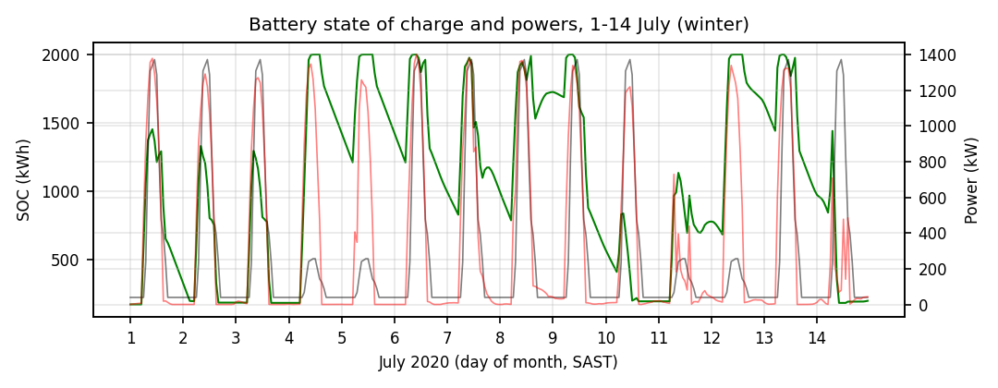
Fig. 10. Battery state of charge (green) with load (grey) and generation (red), 1–14 July 2020.

4.8 Economic analysis
Subsystem | Specification | Capital cost | Share of capex | Unit capital cost | Energy share
PV array | 2 000 kWp: 3 636 × 550 Wp, 30° north | R15.0 m | 28.5 % | R7 500/kWp | 94.5 %
Wind | 2 × Aeolos-H 100 kW, 36 m tower | R24.2 m | 46.0 % | R121 040/kW | 5.5 %
Battery | 2 000 kWh LFP (1 800 kWh usable, 90 % DoD) | R9.9 m | 18.8 % | R5 500/kWh | —
Conversion | 500 kW bidirectional PCS + 1 800 kW PV inverters | R3.5 m | 6.7 % | R7 000/kW (PCS) | —
Total | 2 200 kW installed | R52.6 m | 100.0 % | — | 100.0 %
Table 5: Capital cost breakdown of the recommended system (2026 ZAR, excl. VAT), showing why the PV/wind split is 94.5/5.5 rather than symmetric.
The allocation of capital is itself the quantitative answer to the PV-versus-wind question posed in Section 3.1: wind absorbs 46.0 % of the capital for 5.5 % of the delivered energy, whereas PV delivers 94.5 % of the energy for 28.5 % of the capital. Sizing wind on visual symmetry — the intuitive 50/50 split — would have multiplied the capital requirement while barely changing renewable fraction, and is therefore rejected on evidence rather than preference.
The economics are driven by the tariff, not by subsidies. Against a current annual electricity cost of R10.76 million for energy plus R5.72 million in demand charges (assumed 2 000 kVA NMD at R238.45/kVA·month), the recommended system delivers first-year net savings of approximately R8.2 million (self-consumption at TOU rates, export revenue at R1.42/kWh, and a conservative 10 % demand-charge saving), rising with 7 % tariff escalation. Table 4 summarises the investment metrics: NPV R95.8 million at a 9 % discount rate, IRR 21.7 %, simple payback 6 years and LCOE R2.32/kWh — a 21 % discount to the current blended grid tariff that widens every year tariffs escalate at ~9–10 %. Fig. 11 shows the cumulative cash flow; Fig. 12 compares the LCOE of each architecture against the grid.
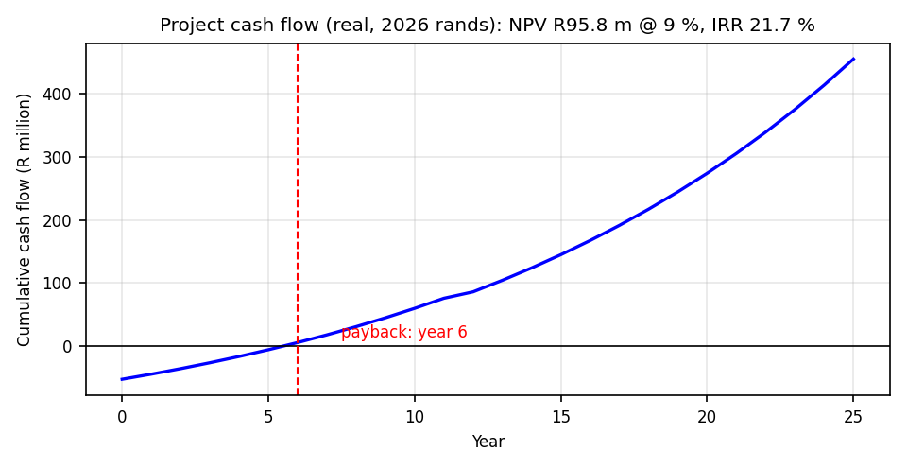
Fig. 11. Cumulative project cash flow including battery replacement in year 12.
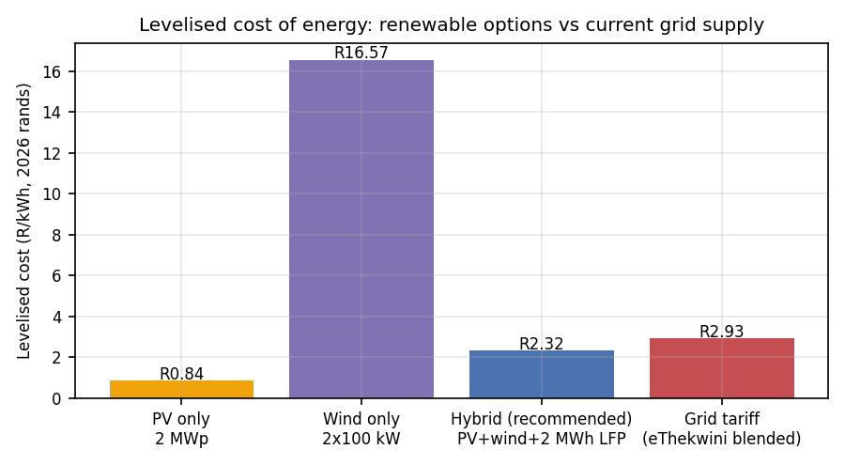
Fig. 12. Levelised cost of energy: PV-only, wind-only, hybrid (recommended) and the current blended grid tariff.
Fig. 13 tests the robustness of the decision. NPV remains strongly positive under every single-parameter excursion tested: ±30 % on PV, wind or battery capex; tariff escalation anywhere in 5–9 %; discount rate 7–12 %; export price halved; demand-charge saving removed entirely. The decision is most sensitive to PV capex and tariff escalation, as expected for a self-consumption business case; even the combined pessimistic case (30 % capex overrun, 5 % escalation, 12 % discount rate) retains a positive NPV. The investment conclusion is therefore robust within the tested ranges, with the caveat that the demand-charge baseline and the 2026/27 ITOU component rates are assumed values (Appendix A) that should be confirmed with eThekwini Electricity Services before commitment.
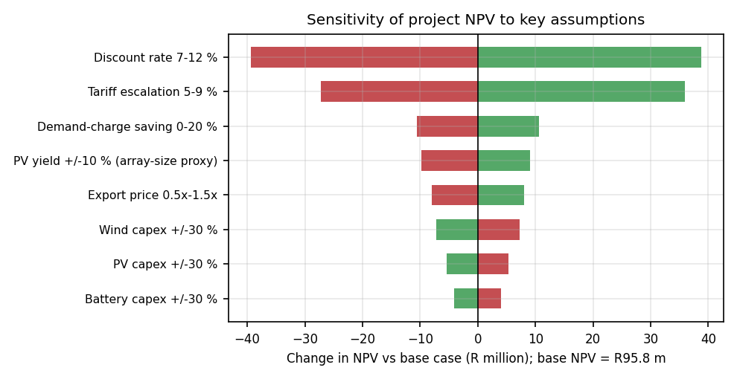
Fig. 13. Sensitivity of project NPV to key assumptions (base case R95.8 million).

4.9 Environmental and sustainability considerations

4.9.1 Site conditions and design constraints
The site is urban and rooftop-based: the PV array occupies no additional land, requiring approximately 12 000–14 000 m² of structurally assessed roof area at 6–7 m²/kWp including maintenance access — a structural survey of S5–S10 roofs is a recommended pre-investment step. Durban's coastal environment (salt aerosol, ~1 009 mm annual rainfall, humidity) drives two design constraints carried in the model: soiling at the upper end of the PVWatts range (3–4 %, conservatively inside the PVGIS 14 % loss stack) and corrosion-rated mounting, cabling and enclosure specification (marine-grade). Tropical-storm wind loading on the 36 m towers must be checked against SANS 10294/manufacturer design loads during detailed design. The turbines are sited at least 150 m from occupied facades where roofscape allows, on acoustic grounds (55 dBA at 40 m, assessed against SANS 10103 community-response criteria and SANS 10328).

4.9.2 Emissions and sustainability benefits
Avoided emissions total 2.27 ktCO₂e per year, based on grid imports avoided (E_load − E_grid = 2 409 MWh/yr × 0.942 tCO₂e/MWh) — approximately 57 kt over the 25-year study life, equivalent to the annual electricity consumption of roughly 670 South African households (at ~3.6 MWh per household). No emissions credit is claimed for exported energy under this average-factor boundary; had the export been valued at the marginal (coal) displacement rate, the figure would be some 20 % higher — the conservative treatment is retained. Beyond carbon, the system reduces campus exposure to load-shedding (a distinctly South African resilience benefit), reduces peak demand stress on the municipal network during summer cooling peaks, and demonstrates technology appropriate to the KwaZulu-Natal climate for DUT's ~34 000 students.

4.9.3 Lifecycle and end-of-life
The PV array (25-year design life) requires panel cleaning with harvested rainwater where practicable, and module recycling pathways exist in South Africa via PV GreenCard/SAPVIA industry stewardship. The LFP battery is replaced once in year 12; LFP's absence of cobalt and its thermal stability reduce both supply-chain and fire risk, and Sandia's second-life analysis indicates useful residual capacity for stationary applications after automotive service — though a campus battery at end-of-life would more likely be recycled directly. The turbines (20-year design life) have fully recyclable steel towers and reusable generator assemblies. Net environmental balance is strongly positive: energy-payback time for the PV components is ~1.5–2 years at Durban irradiance against a 25-year life, and the system displaces the most carbon-intensive major grid in the world.

4.10 Regulatory compliance pathway
At 2 200 kW of registered capacity the installation exceeds the 100 kW SSEG threshold and registers directly with NERSA, under the licence-exemption framework of the 2022 ERA amendment. Design and commissioning must satisfy: SANS 10142-1:2021 Clause 7.12 (alternative supplies, earthing, overcurrent and changeover protection); NRS 097-2-1:2024 grid-connection requirements including protection settings, power-quality and interface protection; the NERSA Renewable Power Plants grid connection code; SANS/IEC 62109-1/-2 converter safety and SANS/IEC 62116 anti-islanding verification; and — for the turbines — SANS 10103 noise assessment, SANS 10328 and SANS/IEC 61400-11 acoustic measurement. A NERSA registration application, a noise assessment and a structural certification of roof and tower foundations constitute the three parallel pre-construction work streams.

5. Conclusions and Recommendations

5.1 Conclusions
- The S-Block complex demand has been reconstructed from a 77-room, 381-record appliance audit into hourly profiles with fully documented assumptions: typical weekday peak 1 989.5 kW at 11:00, weekday load factor 0.27, and an annual simulated load of 3 670 MWh including a 15 % allowance for unaudited services. All six blocks S5–S10 are included; per-block estimates are given in Table 2.
- Durban's solar resource is good (GHI 1 632 kWh/m²·yr; 1 431 kWh/kWp·yr at the 30° optimum tilt) and its wind resource is weak (4.76 m/s at 80 m; Weibull k = 1.99, c = 5.37 m/s; small-wind capacity factor ~10 % at a 36 m hub) — independently confirming the published measurements of Rehman et al. and the WASA resource map.
- A grid-connected hybrid of 2 000 kWp PV, 2 × 100 kW wind and 2 000 kWh LFP storage is technically feasible and reliable: renewable fraction 67.2 %, self-consumption 79.8 %, with the grid covering the residual 34.3 % and the battery providing 31 h of backup for the 57.2 kW critical base load.
- The PV/wind energy split (94.5 / 5.5 %) is dictated by measured evidence: per delivered kWh, small-wind capital cost is ~28× PV capital cost at this site (R143 versus R5.13 per annual kWh), and wind's seasonal maximum coincides with the off-peak tariff window. Two turbines are retained as the smallest defensible hybrid contribution, at a quantified lifetime premium of R19.5 million over the PV-plus-battery twin.
- The investment is economically sound: capital cost R52.6 million, LCOE R2.32/kWh against a blended grid tariff of R2.93/kWh, NPV R95.8 million, IRR 21.7 % and 6-year payback, robust to ±30 % capex and 5–9 % tariff escalation. The system avoids 2.27 ktCO₂e/yr.

5.2 Recommendations
- Obtain 12 months of eThekwini interval data for the S-Block feeder and reconcile it against the modelled profile before final investment decision; the model accepts measured data as a drop-in replacement at the profile step (Section 3.2).
- Commission structural surveys of the S5–S10 roofs and a geotechnical/foundation assessment for the turbine towers; confirm the substation capacity and NMD history with eThekwini Electricity Services, and confirm the 2026/27 ITOU component rates.
- Obtain a South African supplier quotation for the Aeolos-H (or equivalent) 100 kW turbine to replace the NREL international capex proxy (Appendix A); the wind business case is most sensitive to this value.
- Proceed with NERSA SSEG registration (>100 kW), and parallel NRS 097-2-1:2024 protection design, SANS 10142-1 Clause 7.12 compliance certification and a SANS 10103 noise assessment.
- Consider phased implementation: PV and battery first (the economically dominant core, NPV R115.3 m as a PV-plus-battery twin), with the two turbines added in a second phase once structural and acoustic clearances are confirmed — the phasing costs nothing in modelled performance because wind and PV are independently dispatchable.
- Use the installed plant as a DUT teaching and research facility (resource monitoring, dispatch control and grid-integration laboratory), and evaluate an expansion beyond 2 000 kWp only if roof surveys confirm surplus area AND a future NEM agreement improves the export terms.

6. The Engineer and the World (ECSA GA7)

6.1 Societal and economic impact
A university campus is a public asset: the S-Block complex supports teaching, research and administration for DUT's ~34 000 students. The recommended system supplies 3 670 MWh/yr of campus demand at an LCOE of R2.32/kWh against a blended grid tariff of about R2.93/kWh. The campus's current electricity bill of roughly R16.5 million (R10.76 million of energy plus R5.72 million of demand charges) is reduced by approximately R8.2 million in the first year — including the demand-charge saving — and the saving grows thereafter as tariffs escalate (Section 4.8). Released operating expenditure can be redirected to laboratories, student support and maintenance — a direct, auditable societal dividend rather than an abstract benefit. Because the design is grid-connected rather than off-grid, it also strengthens the local distribution network instead of retreating from it: peak import falls by roughly one third, easing substation stress in a municipality that has struggled with capacity. The investment is aligned with South Africa's Just Energy Transition Investment Plan and with SDG 7 (affordable and clean energy) and SDG 13 (climate action) as applied to institutional infrastructure.

6.2 Environmental responsibility
The system avoids approximately 2.27 ktCO₂e per year on a grid-import-displacement boundary (Section 4.9.2), or some 57 kt over the 25-year study life, with no fuel combustion, no local air pollutants and no water consumption in operation — material considerations in a coastal industrial city. LFP chemistry was specified over nickel-manganese-cobalt precisely on grounds of thermal stability, absence of cobalt and a documented recycling pathway (Sections 3.6 and 4.9.3), so that the environmental burden is not merely transferred from the atmosphere to the mine. Two design choices are honest acknowledgements of environmental limits rather than greenwashing: the array uses existing roof area with a ground-coverage ratio of 0.76 (no land-take, no greenfield habitat loss), and the wind contribution was deliberately capped at two turbines after a SANS 10103 noise screen and a visual/structural constraint review (Sections 4.4 and 4.9.1). Where the study could not substantiate a claim with local evidence — for example the absence of a published Durban Weibull shape parameter — the uncertainty is disclosed rather than smoothed over, because selective environmental reporting is itself an ethical failure.

6.3 Ethical and professional responsibility
Every design decision in this report was made against the ECSA code of conduct's duties of honesty, competence and accountability. Safety is treated as a constraint, not an objective: SANS 10142-1 cl. 7.12 arc-flash and earthing provisions, NRS 097-2-1:2024 interface protection, NERSA registration for an SSEG above 100 kW, anti-islanding and a certified SANS 10103 noise assessment are all listed as conditions precedent in Section 5, not as optional refinements. The economic case deliberately charges the battery with a full replacement in year 12, applies cell and power-conversion losses in both directions (84.9 % effective round trip) and prices wind capital at an international proxy that is flagged PROXY in Appendix A — the assumptions are biased conservative on purpose, because an optimistic feasibility study that survives into procurement would be the more serious breach of professional duty. Risk allocation follows the same principle: the recommendation can be implemented in phases (PV and battery first, turbines on confirmation), so that no party is committed on the strength of the least certain input. Finally, the reproducibility appendix and the assumption register exist so that a reviewer, a future facilities engineer or a funding body can audit or refute any figure quoted here.

6.4 Global and technological awareness
Hybrid PV–storage–grid architecture with smart export limitation is the direction in which distribution systems worldwide are moving, from European self-consumption rules to utility-scale solar-plus-storage in India and Brazil. Designing for a common 400 V AC-coupled bus with independent converters per source (Section 3.1.1) keeps the plant open to later additions — additional PV strings, a larger battery, hydrogen or fuel-cell range extenders, and IoT-based monitoring — without redesigning the core. The control logic implemented here (self-consumption maximisation with a 1 000 kW export cap, demand-charge shaving and a reserved state of charge for resilience) is the same dispatch hierarchy used in commercial microgrid controllers, so the study engages global best practice with locally available tools rather than importing a black box. Knowledge of these trends, and of the South African grid-code environment in which they must be implemented, is the technological awareness GA7 expects of a graduating engineer.

6.5 Contribution to sustainable development
Sustainability in this project means the triple bottom line made quantitative. People: a load-shedding-resilient campus (31.5 h of critical-load backup at 57.2 kW) that keeps ICT, refrigeration, growth chambers, security and fire systems alive; Planet: 2.27 ktCO₂e avoided each year and no combustion on site; Prosperity: a positive NPV of R95.8 million at a 9 % discount rate and a 21.7 % IRR, so the project is not a charitable cost but a financially rational one that releases public funds for academic purposes. The plant doubles as a teaching and research asset — resource monitoring, dispatch control and grid-integration laboratory work (Section 5) — which multiplies the developmental return on the same capital and builds local skills in a field where South Africa needs them. Continuous learning is built into the recommendation itself: re-survey the roofs, re-tender the turbine, confirm the tariff, and revisit the design if those facts change.

6.6 Concluding reflection
The feasibility study demonstrates that engineering judgment, exercised transparently, can reconcile technical, economic, environmental and social objectives on a single campus. The recommended 2 000 kWp PV / 2 × 100 kW wind / 2 000 kWh battery system is not the largest system that could be built, nor the one that flatters the hybrid concept most; it is the smallest design that satisfies the load, the grid code, the roof area, the noise limit and the financial hurdle simultaneously — which is exactly what professional responsibility requires an engineer to deliver. The report as a whole stands as evidence of GA7: technical work conducted with awareness of its societal, environmental and ethical consequences, and with all of its uncertainty left visible for the reader to judge.

7. References
[Reference list to be inserted by the author.]

Appendix A — Assumption Register
Every assumption used in this study, with its value, rationale and evidence basis. Items marked PROXY or ESTIMATE are not supported by a South African primary source and are flagged for verification before investment decision.
Parameter | Value used | Rationale / basis | Evidence status
LOAD
Load classes & schedules | 6 classes; windows/shapes/Table 1 | Engineering judgement from audit metadata | Documented rationale per class
Utilisation factors | 0.70–1.00 by class (Table 1) | Booking/occupancy logic for teaching labs & offices | Table 1
Weekend multipliers | 0.05–0.25 by class (Table 1) | Reduced weekend occupancy; continuous services unaffected | Table 1
Academic-calendar factors | 0.45–1.00 by month | DUT academic year (semesters, July recess, Dec/Jan vacation) | Section 3.2
Unaudited-services allowance | +15 % on all energy | Lighting/lifts/small power/server rooms not itemised in audit | Conservative completeness margin
Night base load | 57.2 kW | Audited CONT class (ICT, refrigeration, growth chambers) | Derived from profile
RESOURCE
Site coordinates | 29.8587° S, 31.0218° E | DUT Steve Biko Campus | PVGIS input
PVGIS dataset | v5.2, ERA5 + SARAH, hourly 2020 + TMY | Standard validated European reanalysis for Africa | Section 3.4
PV tilt / aspect | 30° / 180° (north) | PVGIS tilt-optimisation sweep (10/20/30/40°) | Section 3.4
PV system losses | 14 % (PVGIS default) | Equivalent to PVWatts default derate stack | Section 3.4
Soiling (Durban) | 3–4 % within 14 % stack | Coastal salt aerosol; upper-end PVWatts guidance | PROXY — engineering judgement
Wind shear exponent α | 0.14 | Open coastal terrain (WMO/IEC power law) | Section 3.5
Weibull k (assumed) | 2.0 (Rayleigh) | Standard coastal default; no published Durban k found | ESTIMATE — verified: fitted k = 1.99
Hub height | 36 m | Tallest published Aeolos-H monopole option | Section 3.6
Turbine rated speed | 11 m/s (brochure) | Conservative vs website 10 m/s; discrepancy flagged | Section 2.4
Turbine IEC class | Class II assumed | Not published by manufacturer | ESTIMATE — flagged
Wind availability / wake | 96 % / 3 % | Standard small-wind practice | Section 3.5
SYSTEM
Battery chemistry | LFP | Cycle-life evidence: 2 500–9 000 cycles | Section 2.5
Battery DoD / SOC floor | 90 % / 10 % | LFP manufacturer-consistent operating window | Section 3.6
Battery round-trip efficiency | 95 % (cell) × 97 % (PCS) | LFP + bidirectional inverter datasheets | Section 3.6
Battery replacement | Year 12 at 70 % of initial cost | ~4 100 EFC at ~1 cycle/day; learning-curve cost reduction | Section 3.9
Export cap | 1 000 kW | Conservative NEM agreement assumption | ASSUMPTION — confirm with eThekwini
Substation capacity | 2 500 kVA | Assumed above modelled 2 MW peak | ESTIMATE — confirm with DUT
ECONOMIC
PV capex | R7 500/kWp excl. VAT | SA 2026 market, 1–2 MWp rooftop | Section 3.9
Wind capex | R121 040/kW (USD 6 800/kW × R17.80) | NREL 2024 <100 kW class; no SA source exists | PROXY — flagged; verify with supplier quote
Battery capex | R5 500/usable kWh | Mid of SA C&I range R4 500–7 000 | Section 3.9
PCS capex | R7 000/kW | USD ~350–400/kW × R17.80 | Section 3.9
PV O&M | 1.0 % of capex p.a. | Industry norm; cleaning + inverter service | Section 3.9
Wind O&M | R730/kW·yr (USD 41/kW·yr) | NREL 2024 | Section 3.9
ITOU tariff rates | 709.41 / 198.81 / 142.07 / 311.14 c/kWh | eThekwini 2025/26 incl. VAT | Section 3.9
2026/27 ITOU rates | 2025/26 rates (escalation in cash flow) | Per-component 2026/27 rates not extracted; ~9 % avg | ASSUMPTION — verify
Demand charge | R238.45/kVA·month (R177.50 + R60.95) | eThekwini ITO schedule | Section 3.9
NMD baseline | 2 000 kVA | Modelled peak 1 990 kW / pf 0.9 at ~90th percentile | ESTIMATE — verify with eThekwini
Demand-charge saving | 10 % of baseline | PV coincidence + battery peak-shave (conservative share) | Section 3.9
Export price | R1.4207/kWh (off-peak incl. VAT) | Conservative NEM credit assumption | ASSUMPTION — confirm
Tariff escalation | 7 %/yr nominal | Below historical ~10 %/yr; conservative | Section 3.9
Discount rate | 9 % nominal | Institutional cost of capital proxy | ESTIMATE
Study life | 25 years | PV design life; turbine 20 y (residual value ignored) | Section 3.9
Grid emission factor | 0.942 tCO₂e/MWh | DFFE 2023 DGGEF, gazetted Jul. 2025 | Section 3.10
Exchange rate | R17.80/USD (2025/26 avg) | Used for all USD-sourced values | Section 3.9
Table A1: Consolidated assumption register.

Appendix B — Per-Room Audit Summary (77 rooms)
Block | Room | Connected (kW) | Audit (kWh/day) | Modelled weekday (kWh/day)
S10 | Level 2: Wet Chemistry Labs 1, 2 & 3 (405, 406, 407 BS0) | 54.8 | 427.0 | 353.1
S10 | Level 4: Senior Chem, Spectrometry Prep & AAS Labs (605, 607, 608 BS0) | 54.8 | 427.0 | 353.1
S10 | Level 1: Fermentation Lab (305 BS0) | 25.8 | 286.8 | 275.8
S10 | Level 0: Food Science | 42.0 | 210.0 | 168.0
S10 | Level 0: Food Science Research Lab (207 BS0) | 31.8 | 194.4 | 172.8
S10 | Level 1: IWWT Research Offices (309 BS0) | 24.1 | 166.6 | 158.8
S10 | Level 3: Chemistry Offices (507 BS0) | 24.1 | 166.6 | 158.8
S10 | Level 01: Biotechnology UG Micro Labs | 10.0 | 160.0 | 160.0
S10 | Level 0: Post Graduate Computer Lab (210 BS0) | 18.0 | 141.4 | 134.9
S10 | Level 01: Biotechnology UG Micro Labs 1 & 2 (108 & 109 BS0) | 15.8 | 126.8 | 115.8
S10 | Level 02: Examination & Test Venue (003 BS9) | 12.8 | 100.3 | 95.4
S10 | Level 0: Instrumentation Lab (206 BS0) | 13.8 | 67.4 | 53.9
S10 | Level 0: Surveying Storeroom (208 BS0) | 8.6 | 53.6 | 47.0
S5 | Level 0: Chemical Engineering Water Lab (205 BS5) | 70.7 | 424.2 | 339.4
S5 | Level 0: Pulp and Paper Lab (203F BS5) | 70.7 | 424.2 | 339.4
S5 | Level 1: Mechanical Material Science Lab (305 BS5) | 65.9 | 290.3 | 206.4
S5 | Level 1: Mechanical Strengths Lab (304 BS5) | 65.9 | 290.3 | 206.4
S5 | Level 4: Textile Dry & Wet Labs (602 & 604 BS5) | 47.1 | 226.8 | 181.4
S5 | Level 4: Textile Technology Lab (606 BS5) | 47.1 | 226.8 | 181.4
S5 | Level 2: Civil BTech Lab (403 BS5) | 43.1 | 215.8 | 162.9
S5 | Level 2: Civil Drawing Lab (405 BS5) | 43.1 | 215.8 | 162.9
S5 | Level 0: Chemical Engineering Lab (204 BS5) | 26.5 | 168.5 | 147.8
S5 | Level 1: BE PG Lab (303 BS5) | 26.5 | 168.5 | 147.8
S5 | Level 2: Civil Annex (402 BS5) | 24.1 | 166.6 | 158.8
S5 | Level 3: Mechanical Engineering Offices (503W BS5) | 24.1 | 166.6 | 158.8
S5 | Level 4: Textile Computer Lab (603 BS5) | 18.0 | 141.4 | 134.9
S5 | Level 4: Team Teaching Room (605 BS5) | 12.8 | 100.3 | 95.4
S6 | Level 01: Structures Lab (108D BS6) | 65.9 | 290.3 | 206.4
S6 | Level 4: Clothing Patterns Lab (609 BS6) | 47.1 | 226.8 | 181.4
S6 | Level 4: Clothing Sewing Lab (611 BS6) | 47.1 | 226.8 | 181.4
S6 | Level 4: Textile Science & Apparel Tech (604 BS6) | 47.1 | 226.8 | 181.4
S6 | Level 01: Civil Geology Lab (105B BS6) | 43.1 | 215.8 | 162.9
S6 | Level 01: Civil Transport Lab (106 BS6) | 43.1 | 215.8 | 162.9
S6 | Level 0: Architecture Gallery & Virtual Studio (205 BS6) | 26.5 | 168.5 | 147.8
S6 | Level 4: Mini Lab (608 BS6) | 26.5 | 168.5 | 147.8
S6 | Level 3: Civil Engineering & Surveying Offices (504 BS6) | 24.1 | 166.6 | 158.8
S6 | Level 1: Civil S1 & S2 Computer Lab (304 & 305 BS6) | 18.0 | 141.4 | 134.9
S6 | Level 1: Civil S3 Computer Lab (306 BS6) | 18.0 | 141.4 | 134.9
S6 | Level 1: Civil S4 Computer Lab (308 BS6) | 18.0 | 141.4 | 134.9
S6 | Level 1: Surveying Computer Lab (307 BS6) | 18.0 | 141.4 | 134.9
S6 | Level 0: Lecture Rooms (204A, 204B, 204C BS6) | 12.8 | 100.3 | 95.4
S6 | Level 5: Lecture Venues 513 & 512/514 (705N & 705OP BS6) | 12.8 | 100.3 | 95.4
S6 | Level 5: Maritime GMDSS Training Venue (705K BS6) | 12.8 | 100.3 | 95.4
S6 | Level 01: Surveying Storeroom (107 BS6) | 8.6 | 53.6 | 47.0
S6 | Level 2: Photogrammetry Lab (405 BS6) | 8.6 | 53.6 | 47.0
S6 | Level 2: Surveying Lab (404 BS6) | 8.6 | 53.6 | 47.0
S6 | Level 5: Maritime Simulator Room (705M BS6) | 8.6 | 53.6 | 47.0
S7 | Level 01: Electrical Machines Lab (105B BS7) | 65.4 | 303.0 | 242.4
S7 | Level 0: Electrical Projects Lab (205 BS7) | 65.4 | 303.0 | 242.4
S7 | Level 1: Electrical Engineering Lab (307 BS7) | 65.4 | 303.0 | 242.4
S7 | Level 1: Power Electronics Lab (306 BS7) | 65.4 | 303.0 | 242.4
S7 | Level 5: Digital Systems Labs 1, 2 & 3 (704, 706, 707 BS7) | 65.4 | 303.0 | 242.4
S7 | Level 1: Mechanical PG Lab (304 BS7) | 65.9 | 290.3 | 206.4
S7 | Level 0 & 01: Construction Technology Labs (207 & 106 BS7) | 26.5 | 168.5 | 147.8
S7 | Level 4: Mechanics Lab 2 (605 BS7) | 26.5 | 168.5 | 147.8
S7 | Level 3: Electrical Power Engineering Offices (505 BS7) | 24.1 | 166.6 | 158.8
S7 | Level 1: Electrical CAD Lab (305 BS7) | 18.0 | 141.4 | 134.9
S7 | Level 4: Mechanical Venues (606, 607, 609 BS7) | 12.8 | 100.3 | 95.4
S8 | Level 4: Industrial Process Lab (602 BS8) | 70.7 | 424.2 | 339.4
S8 | Level 0: Projects Workshops 1 & 2 (204 & 207 BS8) | 86.0 | 356.0 | 249.2
S8 | Level 02: Tech Station Mfg & Composites Units (005 & 006 BS8) | 56.0 | 206.0 | 144.2
S8 | Level 1: Postgrad Research Lab & Unit (302 & 303 BS8) | 26.5 | 168.5 | 147.8
S8 | Level 02: Tech Station Mfg & | 30.0 | 150.0 | 105.0
S8 | Level 0: Projects CAD Lab (203 BS8) | 18.0 | 141.4 | 134.9
S8 | Level 2: Computer Systems Labs 1, 2 & 3 (402, 405, 406 BS8) | 18.0 | 141.4 | 134.9
S8 | Level 4: Instrumentation Computer Lab (604 BS8) | 18.0 | 141.4 | 134.9
S8 | Level 1: Electronics Labs 1 & 2 (306 & 307 BS8) | 13.8 | 67.4 | 53.9
S8 | Level 4: Process Control Lab (605 BS8) | 13.8 | 67.4 | 53.9
S8 | Level 4: Process Instrumentation Lab (603 BS8) | 13.8 | 67.4 | 53.9
S9 | Level 01: Food Tech Undergraduate Lab & Plant (104A & 107 BS9) | 73.8 | 404.4 | 340.8
S9 | Level 2: Food & Pre-Prep Labs (403 & 406 BS9) | 73.8 | 404.4 | 340.8
S9 | Level 4: Food Stores, Kitchen & Restaurant (603, 606, 607A BS9) | 73.8 | 404.4 | 340.8
S9 | Level 0: Biotech Enzyme & Plant Research Labs (203 & 204 BS9) | 25.8 | 286.8 | 275.8
S9 | Level 1: Biotech & Food Tech Offices & Boardroom (304 & 305 BS9) | 24.1 | 166.6 | 158.8
S9 | Level 3: Consumer Sciences Offices & Applied Sciences Comp Lab (503 & 506 BS9) | 18.0 | 141.4 | 134.9
S9 | Level 2: Lecture Venue (405 BS9) | 12.8 | 100.3 | 95.4
S9 | Level 4: Lecture Venue (608 BS9) | 12.8 | 100.3 | 95.4
Table B1: All 77 audited rooms, parsed from the DUT S-Block appliance audit.

Appendix C — Monthly Academic Factors
Month | Jan | Feb | Mar | Apr | May | Jun | Jul | Aug | Sep | Oct | Nov | Dec
Factor | 0.55 | 1.00 | 1.00 | 1.00 | 1.00 | 0.85 | 0.60 | 1.00 | 1.00 | 1.00 | 0.90 | 0.45
Table C1: Monthly academic-calendar scaling factors (Section 3.2).
Month | Load (MWh) | PV (MWh) | Wind (MWh) | Grid import (MWh) | Export (MWh) | RF (%)
Jan | 204.1 | 265.2 | 15.5 | 16.1 | 85.2 | 95.8
Feb | 330.6 | 239.5 | 15.2 | 124.0 | 44.3 | 63.6
Mar | 360.2 | 271.7 | 13.7 | 137.1 | 56.3 | 63.6
Apr | 356.3 | 216.9 | 14.0 | 165.0 | 35.5 | 54.8
May | 349.3 | 252.6 | 6.2 | 145.9 | 49.3 | 60.0
Jun | 302.9 | 242.0 | 3.9 | 101.3 | 40.6 | 67.8
Jul | 222.7 | 260.9 | 9.5 | 11.2 | 51.5 | 98.3
Aug | 349.3 | 250.2 | 17.7 | 128.1 | 42.1 | 64.6
Sep | 356.3 | 242.5 | 17.7 | 141.9 | 40.3 | 61.7
Oct | 360.2 | 226.0 | 24.8 | 148.5 | 33.5 | 60.3
Nov | 310.9 | 213.9 | 15.8 | 128.7 | 41.8 | 60.5
Dec | 167.0 | 240.1 | 14.8 | 12.6 | 90.1 | 98.6
Table C2: Simulated monthly energy balance of the recommended system.

Appendix D — Reproducibility
Every number in this report is generated by the following scripts from the raw data, and is reproducible by re-running them in order:
File | Content
data/audit_parsed.csv | 381 parsed audit records (block, room, appliance, qty, kW, h, kWh)
data/series_pv_2020.json | PVGIS hourly 2020: P per kWp, WS10m, T2m, POA components (8 784 rows)
data/tmy.json | PVGIS typical meteorological year (GHI/DNI/DHI/wind)
data/pvcalc_tilt{10..40}.json | PVGIS monthly PV yield, tilt-optimisation sweep
scripts/01_load_profile.py | Audit → hourly load model; class assumptions; block/room summaries
scripts/02_hybrid_sim.py | 8 784-hour dispatch engine (PV, wind power curve, battery, grid, TOU)
scripts/03_sizing_sweep.py | Two-stage sizing sweep (RF/self-consumption surfaces)
scripts/04_figures_load_resource.py | Figs. 2–6 (load, blocks, GHI, monthly resource, Weibull)
scripts/05_economics.py | Financial model (NPV/IRR/LCOE), 160-configuration economic sweep
scripts/06_final_design.py | Recommended design: hourly table, Figs. 7–13, sensitivity, summary JSON
scripts/07_report.py | This report (.docx)
scripts/08_block_diagram.py | System architecture block diagram (Fig. 1)
figures/fig00_block_diagram.png | Block diagram of the recommended AC-coupled hybrid system (Fig. 1)
results/final_design_summary.json | All headline numbers quoted in the text
results/final_hourly.csv | Full 8 784-hour simulation output of the recommended system
Table D1: Project data and script inventory.
Environment: Python 3.14 with numpy, pandas, matplotlib and python-docx. PVGIS data were retrieved from the JRC PVGIS v5.2 service (public API). All monetary values are 2026 South African Rand excluding VAT unless a source states otherwise.

