WEEK 3 TASK
Implementing and Evaluating Text Classification Models
Sentiment Classification of Tamil-English Code-Mixed Text

Field | Details
Prepared by | Shyma A
Programme | Yuva Intern - NLP Internship
Institution | Jeppiaar University, Chennai (B.Sc. Computer Science)
Document type | Methodology, findings, and analysis report (Week 3)
Builds on | Week 1 proposal and Week 2 preprocessing methodology
Dataset | Dravidian-CodeMix Tamil-English sentiment corpus (public)
Estimated effort | 30-35 hours

All numbers in this report come from experiments actually run for this task (Python 3, scikit-learn). The complete script is provided alongside this document.

1. Introduction and Objectives
Weeks 1 and 2 proposed a Tamil-English code-mixed sentiment system and designed its data pipeline. This report moves from planning to implementation: it trains several text classification models in a controlled setting, evaluates them with standard NLP metrics, and critically analyses where and why they succeed or fail.
- Implement classical (Naive Bayes, Logistic Regression, SVM) and neural (multi-layer perceptron) text classifiers.
- Apply the preprocessing and feature-engineering strategy from Week 2.
- Evaluate with accuracy, precision, recall, F1 (macro and weighted), confusion matrices, and per-class analysis.
- Run ablation studies to test which design decisions actually matter.
- Document challenges, insights, limitations, and improvements for future iterations.

2. Problem Simulation Strategy and Dataset

2.1 Task Definition
The simulated problem is multi-class sentiment classification of short Tamil-English code-mixed comments into five categories: Positive, Negative, Mixed_feelings, unknown_state (neutral or unclear), and not-Tamil. The strategy was to use a publicly available benchmark, hold out a separate evaluation set, and compare several models under identical conditions.

2.2 Dataset
The data come from the publicly released Dravidian-CodeMix Tamil sentiment corpus (Chakravarthi et al.), obtained from a public GitHub repository containing the shared-task train and dev files. The comments are YouTube comments, mostly on film trailers, written in Roman script, Tamil script, or a mix of both.
Property | Value
Raw training / dev rows | 35,656 / 3,962
Duplicates removed from training | 275
Dev rows also present in training (removed to prevent leakage) | 53
Final training / evaluation rows | 35,381 / 3,906
Average comment length | 10.4 words
Comments containing Tamil-script characters | 18.9%
Number of TF-IDF features (word + character) | 137,521

Class | Train count | Train share | Eval count
Positive | 19,892 | 56.2% | 2,219
unknown_state | 5,589 | 15.8% | 604
Negative | 4,256 | 12.0% | 476
Mixed_feelings | 3,986 | 11.3% | 435
not-Tamil | 1,658 | 4.7% | 172
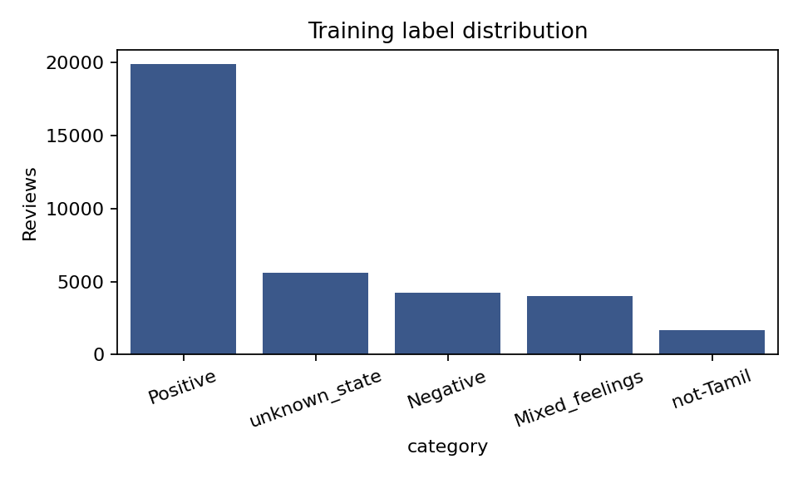
Figure 1: Training label distribution (strongly imbalanced toward Positive)
Important note on domain: this corpus consists of movie-trailer comments, not product reviews as described in the Week 1 proposal. It was chosen because it is the openly available benchmark for exactly the language setting (Tamil-English code-mixing) that the project targets. The methods transfer directly to product reviews, but the absolute scores should not be assumed to carry over.

2.3 Evaluation Protocol
- Models are trained on the training split only. The official test labels are not public in the copy of the data used, so the provided dev split serves as the held-out evaluation set.
- Vectorisers are fitted on training data only and then applied to the evaluation data.
- A fixed random seed (42) is used wherever randomness is involved.

3. Preprocessing and Feature Engineering
The steps follow the Week 2 methodology, applied in this order before model training:
- Remove exact duplicates from training; remove evaluation rows that also appear in training.
- Unicode NFC normalisation, so identical Tamil characters share one encoding.
- Remove URLs and @handles.
- Lower-case Roman text.
- Limit repeated characters to two ('Maassssss' becomes 'maass').
- Collapse extra whitespace. Emojis and punctuation are kept as they carry sentiment.
Stop-word removal, stemming, and lemmatisation were deliberately not applied in the main pipeline. Negation and intensity words in Tamil-English (for example 'illa', 'romba', 'but') flip or amplify sentiment, a reliable Tamil lemmatiser for Roman script is not available, and character n-gram features already absorb much of the morphological variation. This decision was a design choice from Week 2 and is partly tested in the ablation (Section 6.3).

Feature representation
- Word-level: Word TF-IDF with unigrams and bigrams (minimum document frequency 2, sublinear term frequency).
- Character-level: Character n-gram TF-IDF (2 to 5 characters, within word boundaries, minimum document frequency 3).
- Combined: The two matrices are concatenated, giving about 137,500 features. Character n-grams are intended to make the model robust to inconsistent transliteration such as 'nalla', 'nala', and 'nallaa'.

4. Classification Methods and Justification
Model | How it works | Why it was chosen
Majority-class baseline | Always predicts the most common class | Sanity floor: any useful model must beat it
Complement Naive Bayes | Probabilistic model using word statistics from the complement of each class | Very fast; designed for imbalanced text; classic reference point
Logistic Regression | Linear model producing class probabilities | Strong, interpretable baseline for sparse text
Linear SVM | Finds the maximum-margin linear boundary | Typically the best classical model for high-dimensional TF-IDF
Class-balanced variants (LR, SVM) | Errors on rare classes are penalised more | Tests whether handling class imbalance helps minority classes
MLP neural network | One hidden layer of 128 ReLU units, early stopping | Representative neural approach; can learn feature interactions

Transformer models (XLM-RoBERTa, MuRIL) proposed in Week 1 were not trained here. The environment used for this task has no GPU and no deep learning framework installed, so the neural component is a feed-forward network on TF-IDF features. Fine-tuning transformers is the main item of future work (Section 9).

5. Evaluation Metrics
Metric | Definition | Role in this task
Accuracy | Correct predictions / all predictions | Easy to read, but misleading under imbalance: predicting 'Positive' always already scores 56.8%
Precision | Of items predicted as class C, the share that truly are C | Shows how trustworthy a predicted label is
Recall | Of items truly in class C, the share found | Shows how many true cases are missed
F1-score | Harmonic mean of precision and recall | Single balanced score per class
Macro average | Unweighted mean over classes | Primary metric: treats rare classes equally
Weighted average | Mean weighted by class size | Reflects overall dataset composition
Confusion matrix | Counts of actual vs predicted classes | Reveals which classes are confused with which

Because 56.8% of evaluation comments are Positive, accuracy alone is a weak criterion. Macro-F1 is therefore used as the main comparison metric, with accuracy and weighted-F1 reported for completeness.

6. Results

6.1 Model Comparison
Model | Acc. | Macro P | Macro R | Macro F1 | Wtd F1 | Train time (s)
Majority class | 0.568 | 0.114 | 0.200 | 0.145 | 0.412 | 0
Complement Naive Bayes | 0.591 | 0.464 | 0.519 | 0.481 | 0.598 | 0.1
Logistic Regression | 0.627 | 0.524 | 0.470 | 0.491 | 0.608 | 29
Logistic Regression (balanced) | 0.573 | 0.468 | 0.514 | 0.486 | 0.587 | 25.9
Linear SVM | 0.642 | 0.549 | 0.478 | 0.503 | 0.618 | 2.2
Linear SVM (balanced) | 0.603 | 0.486 | 0.518 | 0.500 | 0.609 | 2.8
MLP neural network | 0.640 | 0.538 | 0.452 | 0.474 | 0.603 | 72.8
Highlighted row: Linear SVM, selected as the primary model. Evaluation on 3,906 held-out comments; single run.
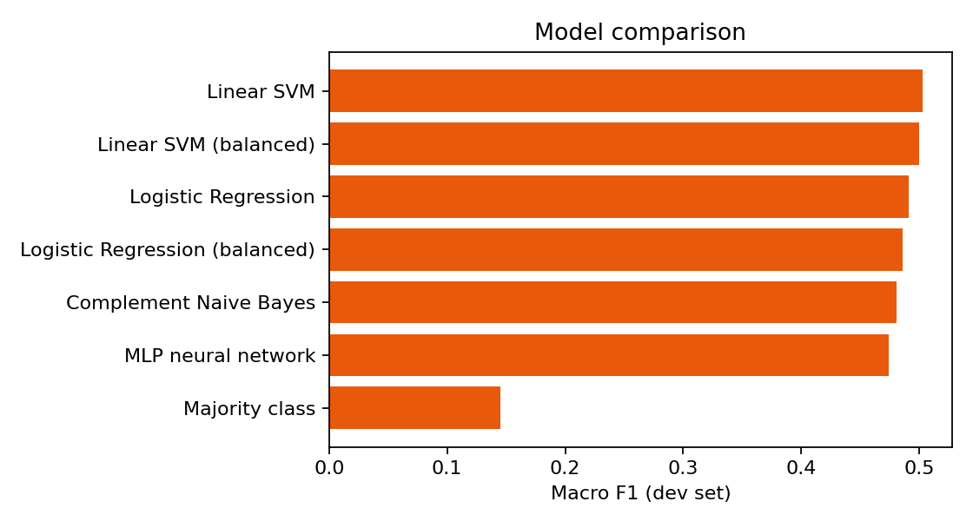
Figure 2: Macro-F1 of each model on the held-out evaluation set
Key observations:
- Every trained model clearly beats the majority baseline (macro-F1 0.145), so the features carry real signal.
- The linear models are the strongest. The plain Linear SVM has the best accuracy (0.642) and macro-F1 (0.503), but its lead over the class-balanced SVM (0.500), Logistic Regression (0.491), and Naive Bayes (0.481) is only 0.3 to 2.2 points. With one run and one split, differences this small should not be treated as a confirmed ranking.
- The MLP (accuracy 0.640, macro-F1 0.474) did not outperform the linear SVM and took about 73 seconds versus about 2 seconds. On sparse TF-IDF features, the extra capacity of a small neural network did not help.
- Class balancing shifts the trade-off rather than improving everything. For the SVM, balancing raised macro-recall from 0.478 to 0.518 but lowered accuracy from 0.642 to 0.603. It finds more minority-class comments at the cost of more false alarms.

6.2 Per-class Performance (Linear SVM, balanced)
The class-balanced SVM is analysed in detail because it has the most even recall across classes, which makes the confusion pattern easier to interpret. Its macro-F1 (0.500) is essentially tied with the plain SVM.
Class | Precision | Recall | F1-score | Support
Positive | 0.784 | 0.726 | 0.754 | 2219
Negative | 0.437 | 0.456 | 0.446 | 476
Mixed_feelings | 0.273 | 0.278 | 0.275 | 435
unknown_state | 0.426 | 0.492 | 0.457 | 604
not-Tamil | 0.512 | 0.640 | 0.568 | 172
Macro average | 0.486 | 0.518 | 0.500 | 3906
Weighted average | 0.617 | 0.603 | 0.609 | 3906
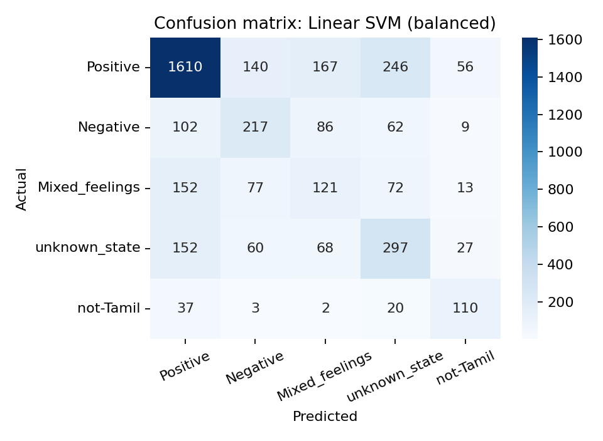
Figure 3: Confusion matrix of the balanced Linear SVM
- Positive. Positive is learned best (F1 0.754), as expected for the majority class with abundant examples. Of 2,219 Positive comments, 1,610 were found; most errors went to unknown_state (246) and Mixed_feelings (167).
- Mixed_feelings. Mixed_feelings is by far the hardest class (F1 0.275). Only 121 of 435 were found, and 152 were labelled Positive. A comment mixing praise and criticism shares most of its vocabulary with plainly positive or negative comments, so a bag-of-n-grams model has little to separate them.
- Negative and unknown_state. Negative (F1 0.446) and unknown_state (F1 0.457) are moderate. unknown_state is a catch-all for neutral, off-topic, or unclear comments (for example requests for likes), which gives it no consistent vocabulary.
- not-Tamil. not-Tamil (F1 0.568) is better than its small size suggests, because character n-grams easily detect English-only or other-language text.

6.3 Ablation Study
To test which pipeline decisions matter, the balanced Linear SVM was retrained with different inputs and feature sets:
Configuration | Macro-F1 | Accuracy | Change in macro-F1 vs cleaned word+char
Raw text, word+char | 0.502 | 0.603 | +0.002
Cleaned, word only | 0.476 | 0.582 | -0.024
Cleaned, char only | 0.505 | 0.605 | +0.005
Cleaned, word+char | 0.500 | 0.603 | +0.000

- Finding 1. Character n-grams matter. Word-only features score 0.476, while character-only (0.505) and word+character (0.500) are clearly better. This supports the Week 2 argument that transliteration variation hurts word-level features.
- Finding 2. Cleaning made no measurable difference (raw 0.502 vs cleaned 0.500). A likely reason is that the TF-IDF vectoriser already lower-cases text by default and character n-grams tolerate repeated letters, leaving little for the extra steps to fix. This is a useful negative result: preprocessing should be justified by evidence, and for this model family the cleaning steps used here are not essential. They may matter more for other models, such as transformer embeddings or word-level models.
- Finding 3. Character-only is as good as the combined features while being simpler, so the word-level matrix adds little here.

6.4 Sensitivity to Regularisation
SVM C value | Macro-F1
0.05 | 0.499
0.1 | 0.502
0.3 | 0.500
1 | 0.485
3 | 0.470
Macro-F1 is stable (0.499 to 0.502) for C between 0.05 and 0.3 and falls as C grows (0.485 at C=1, 0.470 at C=3), indicating that stronger regularisation suits this noisy, high-dimensional data. The value C=0.3 was set before this sweep; the sweep was run on the same evaluation split, so it is a sensitivity check rather than a source of an unbiased estimate.

7. Error Analysis
A random sample of misclassified comments from the balanced SVM illustrates the typical failure patterns:
Comment (truncated) | True | Predicted | Likely cause
Surya , rahul preetsigh, sai pallavi sema | Positive | not-Tamil | Names only, no sentiment words
Same raana same kekka bekka same veerabathran | Positive | unknown_state | Sentiment implied by context
நீண்ட நாள் கழித்து 100 நாள் தாண்டி ஓடும் படம். | Positive | unknown_state | Tamil script; sparser training coverage
Extrdinary illayaraja sir and marvelous maker miskin | Positive | Mixed_feelings | Praise for two different people
13M Hits For Bairavaa Teaser Eppa Varum nu Sollanama | Mixed_feelings | unknown_state | Implicit meaning; no polarity words
NERKONDA PAARVAI Fan Made Anthem | Positive | Negative | Title-like text labelled Positive
Siva kita inime padam koodukathinga.... | Mixed_feelings | Negative | Mixed message with negation
Kosu adikara machine... padam pathavangaluku mattun than puriyum | unknown_state | Negative | Slang with sarcasm-like tone

- Implicit sentiment: many comments express opinion through context, film references, or slang rather than polarity words, which n-gram features cannot capture.
- Label ambiguity: several errors are arguably reasonable predictions (for example fan-anthem titles or name lists), suggesting annotation noise puts a ceiling on achievable scores.
- Script mismatch: Tamil-script comments are only about 19% of the data, so the model sees fewer examples of them than of Roman-script text.
- Sarcasm and negation: statements such as 'only those who laughed at the trailer, press like' carry a negative judgement through irony.

8. Challenges Faced and Insights Gained

Challenges
- Class imbalance: 56% of comments are Positive and 4.7% are not-Tamil, which makes accuracy misleading and minority classes hard to learn.
- Data leakage risk: 275 duplicate training rows and 53 evaluation rows that also appeared in training had to be found and removed; otherwise scores would have been inflated.
- Noisy language: inconsistent transliteration, slang, emojis, and mixing of scripts.
- Subjective labels: the boundaries between Mixed_feelings, unknown_state, and the polarity classes are fuzzy.
- Compute: no GPU or deep learning framework was available, so transformer fine-tuning was not feasible in this task.

Insights
- A well-regularised linear SVM on character and word TF-IDF is a strong, fast baseline that a small neural network did not beat.
- Evaluation design matters as much as the model: macro-F1, per-class results, and leakage checks changed the conclusions compared with accuracy alone.
- Character-level features, not cleaning steps, produced the clearest gain, which suggests spending effort on representation rather than more rules.
- The hard problem is not polarity but nuance: mixed and implicit sentiment need contextual understanding.

9. Limitations and Future Improvements

Limitations
- Single train/evaluation split and a single run; no confidence intervals or significance tests, so small differences between models are inconclusive.
- The dev split served as the held-out set. Hyper-parameters were not tuned extensively, but the regularisation sweep reused the same split.
- Domain mismatch: the data are movie-trailer comments, not product reviews.
- No contextual (transformer) models, and no aspect-level analysis, which were part of the original proposal.

Planned Improvements
Improvement | Expected benefit
Fine-tune XLM-RoBERTa / MuRIL (GPU, e.g. Google Colab) | Context-aware representations to handle negation, implicit sentiment, and code-mixing
Stratified k-fold cross-validation with confidence intervals | Reliable comparison of models whose scores differ by only a few points
Transliteration normalisation and Roman-to-Tamil conversion | Reduce spelling-variant noise; unify the two scripts
Focal loss, threshold tuning, or targeted augmentation for Mixed_feelings | Improve the weakest class
fastText embeddings with a BiLSTM / CNN | Subword-aware neural alternative to TF-IDF
Ensembling of SVM and transformer outputs | Combine complementary strengths
Annotation review of ambiguous samples | Lower the label-noise ceiling
Evaluate on real product reviews | Confirm transfer to the Week 1 target domain

10. Conclusion
This task implemented and critically evaluated several text classifiers for Tamil-English code-mixed sentiment on a public benchmark. A Linear SVM on word and character TF-IDF features performed best (accuracy 0.642, macro-F1 0.503), clearly beating the majority baseline (macro-F1 0.145), while a neural MLP and Logistic Regression were close but not better. Ablations showed that character n-grams were the most useful design choice and that the additional cleaning steps made no measurable difference for this model. Error analysis showed that Mixed_feelings and implicit sentiment remain the main weaknesses, pointing to contextual transformer models as the logical next step. Results are indicative rather than definitive because of the single-split design and the domain difference noted above.

Appendix A: Core Implementation
The full script (exp.py) is provided with this report. Core steps:
tr = pd.read_csv('tamil_sentiment_full_train.tsv', sep='\t', quoting=3)
dv = pd.read_csv('tamil_sentiment_full_dev.tsv', sep='\t', quoting=3)
tr = tr.drop_duplicates('text')
dv = dv[~dv.text.isin(set(tr.text))] # remove train/eval leakage

def clean(t):
t = unicodedata.normalize('NFC', t); t = URL.sub(' ', t); t = HND.sub(' ', t)
return re.sub(r'\s+', ' ', REP.sub(r'\1\1', t.lower())).strip()

word = TfidfVectorizer(ngram_range=(1,2), min_df=2, sublinear_tf=True)
char = TfidfVectorizer(analyzer='char_wb', ngram_range=(2,5), min_df=3,
sublinear_tf=True)
X_tr = hstack([word.fit_transform(tr.c), char.fit_transform(tr.c)]) # fit on train
X_dv = hstack([word.transform(dv.c), char.transform(dv.c)])

svm = LinearSVC(C=0.3, class_weight='balanced').fit(X_tr, tr.category)
pred = svm.predict(X_dv)
print(classification_report(dv.category, pred))
print(confusion_matrix(dv.category, pred))

References
- Chakravarthi, B. R., et al. (2020). Corpus creation for sentiment analysis in code-mixed Tamil-English text. SLTU/CCURL Workshop, LREC.
- Cortes, C., & Vapnik, V. (1995). Support-vector networks. Machine Learning, 20(3), 273-297.
- Pedregosa, F., et al. (2011). Scikit-learn: Machine learning in Python. JMLR, 12, 2825-2830.
- Rennie, J., Shih, L., Teevan, J., & Karger, D. (2003). Tackling the poor assumptions of Naive Bayes text classifiers. ICML.
- Conneau, A., et al. (2020). Unsupervised cross-lingual representation learning at scale. ACL.
- Khanuja, S., et al. (2021). MuRIL: Multilingual representations for Indian languages. arXiv:2103.10730.
- Manning, C., Raghavan, P., & Schutze, H. (2008). Introduction to Information Retrieval. Cambridge University Press.

