WEEK 4 TASK
Designing an NLP Pipeline for Named Entity Recognition (NER)
Pipeline Design and Implementation Strategy for Product Reviews, including Tamil-English Code-Mixed Text

Field | Details
Prepared by | Shyma A
Programme | Yuva Intern - NLP Internship
Institution | Jeppiaar University, Chennai (B.Sc. Computer Science)
Document type | Pipeline design and implementation strategy (Week 4)
Builds on | Weeks 1-3: proposal, preprocessing, and text classification
Estimated effort | 30-35 hours

This is a design document. It specifies the architecture, choices, and evaluation plan. No NER model was trained for it, so no performance figures are reported; the targets listed are planning goals, not results.

1. Introduction and Objectives
Named Entity Recognition (NER) locates spans of text that refer to real-world things and assigns each a category, for example identifying 'Samsung' as a brand or 'Chennai' as a location. In the Week 1 proposal, NER supports aspect-aware analysis of Tamil-English product reviews: before a system can say that a customer is unhappy with the battery of a particular phone, it must first recognise the phone, the brand, and the feature being discussed.
This document designs an end-to-end NER pipeline that takes raw text and returns structured entities. It covers the system architecture, preprocessing, model selection, post-processing, validation, use of public datasets and pre-trained models, the main challenges (especially contextual ambiguity and polysemy), and strategies to reduce errors.

Goals
- Design a clear, modular architecture from raw text to validated entities.
- Justify every component and explain how it contributes to overall accuracy.
- Handle noisy, informal, code-mixed text rather than only clean English news text.
- Define how the pipeline will be evaluated and improved over time.

2. Problem Definition and Entity Schema

2.1 Task
Given a sentence as a sequence of tokens, assign each token a label that marks whether it begins an entity (B-), continues an entity (I-), or is outside any entity (O). This is the standard BIO tagging scheme, which turns NER into token-level sequence labelling.

2.2 Proposed Entity Types
Standard NER corpora cover mainly person, organisation, and location. A product-review system needs additional, domain-specific types, so a custom schema is proposed:
Entity type | Definition | Examples
PRODUCT | A specific product or model | Galaxy M34, Redmi Note 12, Instant Pot
BRAND | Manufacturer or brand name | Samsung, Boat, Realme
ASPECT | A product feature or service attribute under discussion | battery, camera, delivery, packing, display
ORG | Seller, store, platform, or service provider | Amazon, Flipkart, local dealer, courier firm
LOC | City, region, or place | Chennai, Coimbatore, T. Nagar
PRICE | Monetary amount | Rs. 12,999, 15k, 500 rupees
DATE | Date or time expression | last Diwali, 3 days, in January
PER (optional) | Person name | Mentioned reviewer, celebrity endorser

The schema is intentionally small. Fewer, well-defined types are easier to annotate consistently and easier for a model to learn. Further types can be added later.

2.3 Worked Example
Input review (Roman Tamil and English mixed): "Samsung M34 battery romba nalla, but Amazon delivery 5 days aachu Chennai la. Rs.15000 worth."
Token | Samsung | M34 | battery | romba | nalla | but | Amazon
Tag | B-BRAND | B-PRODUCT | B-ASPECT | O | O | O | B-ORG
Token | delivery | 5 | days | aachu | Chennai | la | Rs.15000
Tag | B-ASPECT | B-DATE | I-DATE | O | B-LOC | O | B-PRICE

Post-processing would additionally group 'Samsung M34' into a single PRODUCT with BRAND attribute through a normalisation rule (Section 6).

3. System Architecture
The pipeline is organised as eight stages. Each stage has one responsibility, and its output is the next stage's input, so any component can be improved or replaced independently.
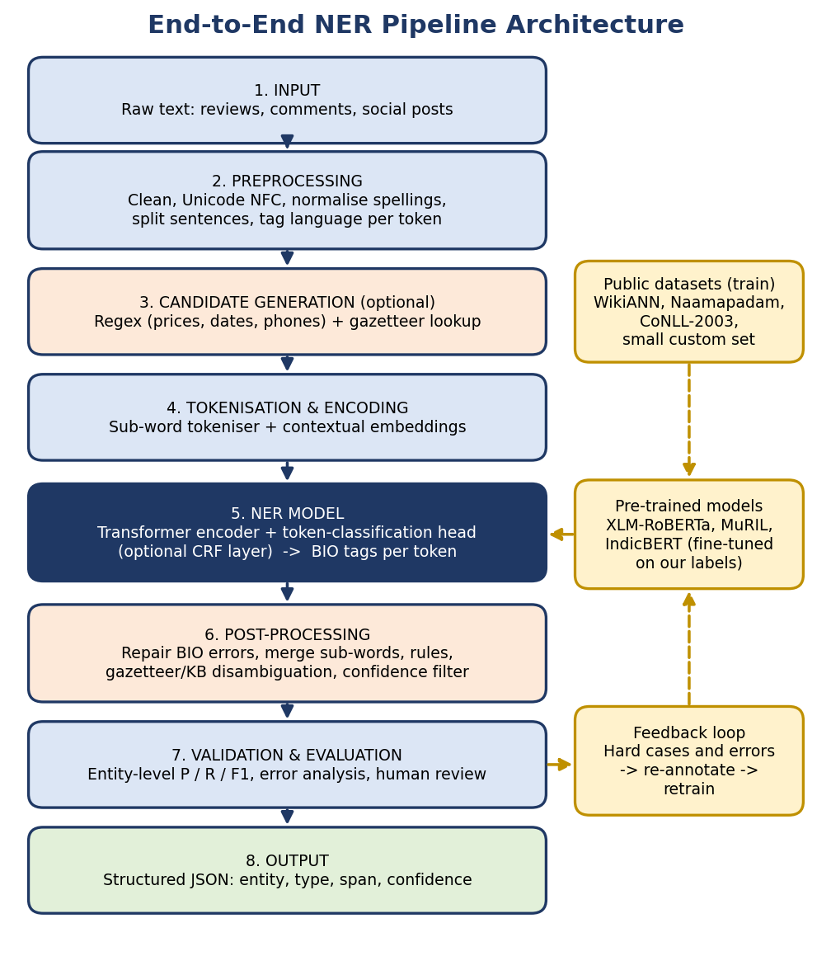
Figure 1: End-to-end NER pipeline (solid arrows: data flow; dashed arrows: training data, models, and feedback)

3.1 Step-by-step Description
# | Stage | What happens | Output
1 | Input | Raw text arrives from reviews, comments, or social posts, in one or several scripts | Unprocessed strings
2 | Preprocessing | Cleaning, Unicode normalisation, spelling normalisation, sentence splitting, language tagging | Clean sentences with token-level language tags
3 | Candidate generation | Regex and gazetteers (lists of known names) mark obvious entities such as prices, dates, and brands | Weak labels / hints
4 | Tokenisation and encoding | Sub-word tokeniser converts text to IDs; transformer produces contextual vectors | Vector per sub-word token
5 | NER model | Token-classification head predicts BIO tags; optional CRF layer enforces valid tag sequences | Tag and probability per token
6 | Post-processing | Repair invalid tags, merge sub-words into words, apply rules, disambiguate, filter low confidence | Clean entity spans with types
7 | Validation and evaluation | Entity-level metrics, error analysis, human spot-check | Quality report, error cases
8 | Output | Entities exported with type, character offsets, and confidence | Structured JSON

3.2 Output Format
{ "text": "Samsung M34 battery romba nalla, but Amazon delivery...",
"entities": [
{"text": "Samsung", "type": "BRAND", "start": 0, "end": 7, "conf": 0.97},
{"text": "M34", "type": "PRODUCT", "start": 8, "end": 11, "conf": 0.93},
{"text": "battery", "type": "ASPECT", "start": 12, "end": 19, "conf": 0.95},
{"text": "Amazon", "type": "ORG", "start": 36, "end": 42, "conf": 0.91} ] }

4. Data Preprocessing
Preprocessing for NER differs from preprocessing for text classification. NER depends on exact word boundaries and on features such as capitalisation, so aggressive cleaning can destroy information. The guiding rule is: normalise noise, but never delete or alter text in ways that shift entity boundaries.
Technique | What it does | Why it matters for NER
Unicode normalisation (NFC) | Makes identical Tamil characters share one encoding | Prevents the same word appearing as different tokens
Noise removal | Strips URLs, HTML, handles; keeps a mapping to original character offsets | Offsets let entities be mapped back to the original text
Case handling | Keep original case for the model; add a case feature or use a cased model | Capital letters strongly signal brands and places in Roman script (note that Tamil script has no capitalisation)
Repeated-character limit | 'Samsuuung' -> 'Samsuung' | Reduces spelling variation without erasing the word
Transliteration / spelling normalisation | Variant dictionary and fuzzy matching ('Chennai', 'Chenai', 'Madras') | Lets one entity be recognised in many spellings
Sentence splitting | Break long reviews into sentences | Keeps inputs within the model's length limit and improves context
Language identification (token level) | Tag tokens as Tamil-Roman, Tamil-script, or English | Gives the model a hint and routes to suitable gazetteers
Tokenisation | Whitespace/punctuation split for word labels, then the model's sub-word tokeniser | Word-level labels are aligned to sub-words (first sub-word carries the label, others are ignored in the loss)
Emoji and punctuation | Kept, not removed | Boundaries such as commas and brackets help delimit entities

Stop-word removal, stemming, and lemmatisation are not used in the NER pipeline. Removing function words changes sentence structure that the model uses as context, and stemming changes entity strings (for example 'Chennai' to 'chenna'), which would corrupt the output spans.

5. NER Model Selection

5.1 Approaches Compared
Approach | Description | Strengths | Weaknesses
Rule-based / gazetteer | Hand-written patterns and name lists | Precise for fixed formats (prices, dates); no training data | Cannot generalise; heavy maintenance
CRF (Conditional Random Field) | Statistical sequence model using hand-built features | Good with small data; fast; interpretable | Needs feature engineering; no deep context
BiLSTM-CRF | Neural network reading text in both directions, with a CRF output layer | Strong classic neural NER (Lample et al., 2016) | Needs substantial data; static embeddings
Transformer fine-tuning (BERT-family) | Pre-trained contextual encoder plus a token-classification layer | State-of-the-art; works with modest labelled data; handles context | Needs GPU; harder to interpret
Large language model prompting | Instruct a generative model to extract entities | No training; flexible schema | Cost, latency, inconsistent output format, hard to evaluate at scale

5.2 Selected Design: Hybrid Transformer-based NER
The proposed core is a pre-trained multilingual transformer encoder fine-tuned for token classification, supported by rule-based components. Candidate encoders:
Model | Why it is a candidate | Consideration
XLM-RoBERTa (base) | Multilingual, covers Tamil and English; strong cross-lingual transfer (Conneau et al., 2020) | Strong default; large vocabulary
MuRIL | Trained on Indian languages including transliterated text (Khanuja et al., 2021) | Likely best fit for Roman-script Tamil
IndicBERT | Compact model for Indian languages (Kakwani et al., 2020) | Lightweight option if resources are limited
Baseline: CRF or spaCy NER | Fast reference model | Shows how much the transformer adds

Justification: (1) contextual embeddings let the same word receive different labels in different sentences, which is essential for ambiguity; (2) pre-training on large multilingual corpora compensates for a small annotated dataset; (3) sub-word tokenisation copes with unseen and misspelt words; and (4) the architecture is simple (an encoder plus one classification layer), so it is easy to train, evaluate, and maintain. An optional CRF layer on top prevents invalid tag sequences such as an I-PRODUCT tag directly after O.
The final choice among the candidates should be made empirically, by fine-tuning each on the same data and comparing entity-level F1 on a held-out set.

5.3 Training Configuration (Planned)
Setting | Planned value / approach
Framework | Hugging Face Transformers (token classification), PyTorch
Labels | BIO tags over the schema in Section 2.2
Learning rate / epochs | About 2e-5 to 5e-5, 3 to 10 epochs, with warm-up and weight decay; tuned on the validation set
Batch size / max length | 16-32 sequences; 128 sub-word tokens
Regularisation | Dropout, early stopping on validation F1
Imbalance (O dominates) | Optional class weights; evaluate on entity-level F1, not token accuracy
Reproducibility | Fixed seeds, logged configuration, versioned data and code

6. Post-processing and Correction
Raw model output often contains small structural or contextual errors. Post-processing corrects these systematically and is usually the cheapest way to raise precision.
Technique | Description | Example
BIO repair | Convert an I- tag that has no preceding B- of the same type into B- | O, I-PRODUCT -> O, B-PRODUCT
Sub-word merging | Combine pieces back into whole words using the first-sub-word rule and offsets | 'Sam', '##sung' -> 'Samsung'
Span consistency | If a string is tagged in one place and an identical string is missed elsewhere in the same review, tag it consistently | Second 'Amazon' left as O gets ORG
Normalisation / entity linking | Map variants to a canonical entry in a product/brand list | 'Chenai', 'Madras' -> Chennai
Gazetteer validation | Check candidates against known brands/products; boost or downgrade confidence | 'Boat' near 'earphones' confirmed as BRAND
Type-compatibility rules | Reject impossible combinations | PRICE must contain a number or currency word
Regex-based extraction | Deterministic patterns for prices, dates, phone numbers | 'Rs.15000', 'Rs 15,000', '15k'
Confidence thresholding | Drop or flag entities below a threshold (e.g. 0.5) for review | Low-confidence spans routed to humans
Overlap resolution | Keep the higher-confidence or longer span when entities overlap | Prefer 'Galaxy M34' over 'Galaxy'

7. Challenges and Mitigation Strategies

7.1 Contextual Ambiguity and Polysemy
A word or name can refer to different entity types depending on context. This is the main conceptual challenge in NER.
Challenge | Example | Mitigation
Brand vs. common noun | 'Apple' (company or fruit); 'Orange' (telecom brand, fruit, or colour) | Contextual transformer embeddings; surrounding words ('iPhone', 'juice'); gazetteer cues
Product vs. aspect | 'Prime' (membership or product feature); 'Camera' (product or feature of a phone) | Context patterns; schema rules: 'camera' after a product name is ASPECT
Organisation vs. location | 'Amazon' (platform vs. river); 'Madras' (place or old city name) | Domain context (reviews) and entity linking
Generic words that are also names | 'Mi', 'One', 'Fire', 'Boat' | Capitalisation, nearby product words, minimum confidence
Nested or overlapping entities | 'Samsung Galaxy M34' (BRAND inside PRODUCT) | Use product-level span, store the brand as an attribute in post-processing
Boundary errors | Is 'M34 5G' one product or two? | Annotation guidelines with examples; CRF layer; span rules

7.2 Challenges Specific to Informal and Code-Mixed Text
Challenge | Why it is hard | Mitigation
Inconsistent transliteration | The same name is spelt many ways in Roman script | Spelling normalisation, character-aware or transliteration-aware models (MuRIL), augmentation with spelling variants
Code-mixing within a sentence | Grammar switches between Tamil and English mid-sentence | Multilingual encoders; language tags as hints
Missing capitalisation | Users type 'samsung' or 'SAMSUNG' | Train on mixed-case data, apply random lower-/upper-casing augmentation
Tamil morphology | Suffixes attach to names ('Chennai-la', 'Samsung-oda') | Sub-word tokenisation; suffix-splitting rules; character n-gram features in a CRF baseline
Slang, abbreviations, emojis | 'bt', 'prdct', 'M34..' | Normalisation dictionary; include informal text in training data
Limited labelled data | Few public datasets for this domain and language mix | Transfer learning, weak supervision from gazetteers, targeted manual annotation, active learning
Class imbalance | Most tokens are O | Entity-level metrics, class weights, oversampling of sentences with rare entities
Unseen / new entities | New phone models appear constantly | Contextual features rather than memorised lists; regular gazetteer updates
Annotation inconsistency | Annotators disagree on boundaries | Written guidelines, pilot round, inter-annotator agreement (e.g. Cohen's kappa)

8. Use of Public Datasets and Pre-trained Models

8.1 Datasets
Resource | Content | Planned use
CoNLL-2003 | English news NER (person, organisation, location, misc.) | Benchmark and sanity check for the training code
WikiANN (Pan et al., 2017) | Automatically annotated multilingual NER including Tamil | Multilingual pre-fine-tuning; Tamil-script coverage
Naamapadam (AI4Bharat, 2023) | NER data for several Indian languages | Indian-language fine-tuning
MultiCoNER-style resources | Complex, fine-grained and low-context entities | Practice with ambiguous entities
Custom annotated reviews | About 1,000-2,000 Tamil-English review sentences labelled with the Section 2.2 schema | In-domain fine-tuning and evaluation (main test set)
Availability, licences, and exact label sets of each resource must be verified on the dataset pages before use. Public corpora use their own entity types and mostly contain formal text, so they are used for general-purpose pre-fine-tuning, while the small custom set teaches the review-specific types (PRODUCT, ASPECT, PRICE) and informal style.

8.2 Annotation Plan for the Custom Set
- Sample sentences from public review/comment sources (respecting licences; remove personal data).
- Pre-label with the gazetteer and regex rules, then correct manually using an annotation tool such as Label Studio or Doccano.
- Write guidelines with examples for each entity type and edge case; double-annotate a subset (for example 10%) and measure agreement.
- Use active learning: train, find the sentences where the model is least confident, annotate those next.

8.3 Pre-trained Models and Transfer Learning
- Start from a pre-trained multilingual encoder (XLM-RoBERTa, MuRIL, or IndicBERT) rather than training from scratch.
- Stage 1: fine-tune on a large public NER corpus. Stage 2: continue fine-tuning on the custom review data. Compare against fine-tuning on the custom data alone.
- Optionally continue masked-language-model pre-training on unlabelled Tamil-English reviews to adapt the encoder to the domain.

9. Validation and Evaluation Framework

9.1 Metrics
NER is evaluated at the entity level: an entity counts as correct only if both its span boundaries and its type match exactly. This is stricter and more meaningful than token-level accuracy, which is inflated by the many O tokens.
Metric | Definition | Use
Precision | Correct predicted entities / all predicted entities | How many predicted entities can be trusted
Recall | Correct predicted entities / all true entities | How many true entities are found
F1-score | Harmonic mean of precision and recall | Main summary metric; reported per type and as micro/macro average
Partial-match score | Credit for overlapping but not identical spans | Diagnoses boundary errors specifically
Confusion between types | Which entity types are mistaken for each other | Shows polysemy problems (e.g. BRAND vs. PRODUCT)
Tool: the seqeval library computes entity-level precision, recall, and F1 for BIO-tagged sequences.

9.2 Experimental Design
- Split the custom data into train / validation / test (for example 80/10/10), keeping all sentences of one review in the same split to avoid leakage.
- Compare: rule-based only, CRF, fine-tuned transformer (each candidate), and transformer plus post-processing.
- Ablation: effect of each preprocessing step, the CRF layer, gazetteer features, and the two-stage fine-tuning.
- Repeat with several random seeds and report the mean and spread, because NER scores on small test sets can vary noticeably.

9.3 Error Analysis and Human Review
- Categorise errors: boundary errors, wrong type, missed entity, spurious entity, and polysemy-related errors.
- Review a random sample and all low-confidence predictions manually.
- Feed hard examples back into annotation and retraining (the feedback loop in Figure 1).

9.4 Planning Targets
As planning goals only (not results): transformer-based NER should clearly outperform the rule-based and CRF baselines on entity-level F1, with the largest gains expected on ambiguous entities; precision of high-confidence outputs should be high enough to use without review, while low-confidence cases are routed to a human.

10. Strategies for Error Handling and Boosting Accuracy
Strategy | How it improves recognition
Transfer learning from public data | Gives the model general knowledge of names and sentence structure before it sees scarce in-domain data
Data augmentation | Replace entities with others of the same type, add spelling variants, randomly change case, mix Tamil and English phrases
Weak supervision | Use gazetteers and regex to generate extra training labels, then correct a sample manually
Active learning | Annotate the examples the model is least sure about for the best accuracy gain per label
Hybrid rules + model | Rules provide high-precision fixes for formats such as prices; the model handles context
Ensembling / voting | Combine several models (for example XLM-R and MuRIL) and keep entities with agreement
Confidence calibration and thresholds | Reduces false positives; sends uncertain cases to review
Domain-adaptive pre-training | Adapts the encoder to the vocabulary and style of reviews
Regular gazetteer updates | Keeps pace with new products and brands
Monitoring in use | Track entity distributions and low-confidence rates over time to detect drift
Graceful failure | If the model fails or text is unsupported (other language, empty input), return an empty list with a flag instead of wrong entities

11. Implementation Strategy

11.1 Technology Stack
- Core: Python 3.10+, Hugging Face Transformers and Datasets, PyTorch, spaCy (rules and baseline), scikit-learn / sklearn-crfsuite (CRF), seqeval (metrics).
- Annotation: Label Studio or Doccano.
- Compute and versioning: Google Colab or a similar free GPU for fine-tuning; Git/GitHub for versioning.
- Serving: FastAPI or Streamlit demo that accepts text and highlights entities.

11.2 Conceptual Pseudo-code
FUNCTION extract_entities(raw_text):
text, offset_map = preprocess(raw_text) # clean, keep offsets
sentences = split_sentences(text)
results = []
FOR s IN sentences:
hints = regex_and_gazetteer_candidates(s) # prices, dates, known brands
enc = tokenizer(s, return_offsets=True)
probs = model(enc) # per sub-word label probs
tags = decode(probs, use_crf=TRUE) # BIO sequence
spans = merge_subwords(tags, enc.offsets)
spans = repair_bio(spans)
spans = apply_rules_and_linking(spans, hints, gazetteer)
spans = resolve_overlaps(spans)
spans = [e FOR e IN spans IF e.confidence >= THRESHOLD]
results.extend(map_to_original_offsets(spans, offset_map))
RETURN results

Fine-tuning sketch with Hugging Face (conceptual):
from transformers import AutoTokenizer, AutoModelForTokenClassification
from transformers import TrainingArguments, Trainer, DataCollatorForTokenClassification

labels = ['O','B-BRAND','I-BRAND','B-PRODUCT','I-PRODUCT','B-ASPECT','I-ASPECT',
'B-ORG','I-ORG','B-LOC','I-LOC','B-PRICE','I-PRICE','B-DATE','I-DATE']
tok = AutoTokenizer.from_pretrained('xlm-roberta-base')
model = AutoModelForTokenClassification.from_pretrained(
'xlm-roberta-base', num_labels=len(labels))
# align word-level labels to sub-words: first piece gets the label, others -100
args = TrainingArguments('ner-out', learning_rate=3e-5, num_train_epochs=5,
per_device_train_batch_size=16, eval_strategy='epoch')
Trainer(model, args, train_dataset=train, eval_dataset=val,
data_collator=DataCollatorForTokenClassification(tok)).train()

11.3 Project Plan
Phase | Activities | Output
1 | Finalise schema and annotation guidelines; collect sample text | Guidelines, raw sample
2 | Annotate pilot set; measure agreement; build gazetteers and regex | Pilot data, rule module
3 | Preprocessing module with offset tracking | Tested pipeline stage
4 | Baselines: rule-based and CRF | Baseline scores
5 | Fine-tune public-data model, then in-domain model; compare encoders | Trained models, comparison
6 | Post-processing, error analysis, active-learning round | Improved model
7 | Demo, documentation, final evaluation | Working prototype and report

12. Risks, Limitations, and Ethics
- Limited annotated data may restrict accuracy on rare entity types; mitigated by transfer learning and active learning.
- Public datasets differ in schema and style from product reviews, so gains from them need to be verified, not assumed.
- Models can reflect biases in training data (for example performing better on frequent brands); evaluate per entity and per brand group.
- Reviews may contain personal data. Anonymise usernames and contact details, and respect dataset licences and platform terms.
- This document is a design: all choices are proposals to be validated through experiments.

13. Conclusion
The proposed pipeline combines careful, offset-preserving preprocessing, a fine-tuned multilingual transformer as the core recogniser, and rule-based and knowledge-based post-processing to repair structural errors and resolve ambiguity. Public datasets and pre-trained models provide a strong starting point, a small in-domain annotated set adapts the system to Tamil-English product reviews, and entity-level evaluation with error analysis and a feedback loop provides a path for steady improvement. Each component has a clear purpose and can be tested separately, which makes the design practical to implement in the coming weeks and directly supports the aspect-aware sentiment system proposed in Week 1.

References
- Chakravarthi, B. R., et al. (2020). Corpus creation for sentiment analysis in code-mixed Tamil-English text. SLTU/CCURL Workshop, LREC.
- Conneau, A., et al. (2020). Unsupervised cross-lingual representation learning at scale. ACL.
- Devlin, J., Chang, M., Lee, K., & Toutanova, K. (2019). BERT: Pre-training of deep bidirectional transformers for language understanding. NAACL-HLT.
- Kakwani, D., et al. (2020). IndicNLPSuite: Monolingual corpora, evaluation benchmarks and pre-trained multilingual language models for Indian languages. Findings of EMNLP.
- Khanuja, S., et al. (2021). MuRIL: Multilingual representations for Indian languages. arXiv:2103.10730.
- Lafferty, J., McCallum, A., & Pereira, F. (2001). Conditional random fields: Probabilistic models for segmenting and labeling sequence data. ICML.
- Lample, G., Ballesteros, M., Subramanian, S., Kawakami, K., & Dyer, C. (2016). Neural architectures for named entity recognition. NAACL-HLT.
- Pan, X., et al. (2017). Cross-lingual name tagging and linking for 282 languages. ACL.
- Ramshaw, L., & Marcus, M. (1995). Text chunking using transformation-based learning. Third Workshop on Very Large Corpora.
- Tjong Kim Sang, E., & De Meulder, F. (2003). Introduction to the CoNLL-2003 shared task: Language-independent named entity recognition. CoNLL.

