WEEK 5 TASK
Advanced NLP Techniques: Topic Modeling and Text Summarization
Methodology, Demonstration, and Analytical Insights on Tamil-English Code-Mixed Text

Field | Details
Prepared by | Shyma A
Programme | Yuva Intern - NLP Internship
Institution | Jeppiaar University, Chennai (B.Sc. Computer Science)
Document type | Methodology and analytical insights report (Week 5)
Builds on | Weeks 1-4 (proposal, preprocessing, classification, NER pipeline)
Corpus used for demonstration | Dravidian-CodeMix Tamil-English comments (public)
Estimated effort | 30-35 hours

How to read this report: the methodology sections (steps, algorithms, comparisons, evaluation strategy) are a plan. Section 7 is a small demonstration that was actually run, and every number there comes from that run. Abstractive summarisation is designed but was not run, and no summary-quality scores (such as ROUGE) are claimed.

1. Introduction and Objectives
Organisations hold far more text than anyone can read: thousands of reviews, comments, survey answers, and reports. Two advanced NLP techniques help turn such corpora into usable knowledge. Topic modeling discovers the themes that run through a collection without labelled data. Text summarisation condenses long documents, or groups of documents, into short versions that keep the key information.
This report presents an analytical approach that combines both: topic modeling to organise a large corpus into themes, followed by summarisation to produce a short, readable description of each theme. It explains how to implement each technique step by step, compares the main algorithms, discusses their evaluation, and critically analyses how the outputs can support decisions, within the context of the Tamil-English code-mixed project from Weeks 1-4.

Objectives
- Research current methods for topic modeling and summarisation.
- Provide a step-by-step implementation guide for LDA and for extractive and abstractive summarisation.
- Compare techniques with their advantages and drawbacks.
- Define evaluation metrics and strategies for topics and summaries.
- Demonstrate the approach on a real public corpus and report honest findings, including limitations.
- Discuss applicability and decision-making value.

2. Overview of the Analytical Framework
Step | Stage | Description | Output
1 | Corpus preparation | Collect, deduplicate, and clean text; remove personal data | Clean corpus
2 | Preprocessing for topics | Tokenise, remove stop-words and rare/common terms, build dictionary | Bag-of-words matrix
3 | Topic modeling | Fit LDA (and NMF as comparison); choose the number of topics | Topics and per-document topic mix
4 | Topic interpretation | Read top words and representative documents; label topics; link to metadata (e.g. sentiment) | Topic report
5 | Summarisation | Extractive or abstractive summary of each topic's documents, or of single long documents | Short summaries
6 | Evaluation | Coherence and human judgement for topics; ROUGE, BERTScore, and human review for summaries | Quality assessment
7 | Decision support | Turn topic sizes, trends, and summaries into dashboards and actions | Insights

3. Topic Modeling

3.1 Concept
A topic model treats each document as a mixture of hidden topics, and each topic as a distribution over words. Words that often appear together form a topic. No labels are needed; the model infers structure from word co-occurrence.

3.2 Latent Dirichlet Allocation (LDA)
LDA (Blei, Ng, & Jordan, 2003) is the standard probabilistic topic model. Its generative story is: for each document, draw a topic mixture; for each word, draw a topic from that mixture, then draw the word from that topic's word distribution. Training reverses this process to find the topics that best explain the corpus.
Element | Meaning
K (number of topics) | Chosen by the analyst; the most influential setting
alpha | Prior on document-topic mixtures. Small values mean each document has few topics; asymmetric values let some topics be more common
eta (beta) | Prior on topic-word distributions. Small values mean each topic uses a few distinctive words
Inference | Variational Bayes (online, as in gensim) or collapsed Gibbs sampling
Input | Bag-of-words counts (word order is ignored)

Assumptions: documents are mixtures of a fixed number of topics; word order does not matter (bag-of-words); topics are independent apart from the prior; and the vocabulary is shared. These assumptions are the source of several limitations discussed later.

3.3 Alternatives
Method | Idea | Strengths | Drawbacks
LDA | Probabilistic mixture model | Interpretable, soft assignments, well studied | Sensitive to K and seeds; poor on very short text
NMF (non-negative matrix factorisation) | Factorise a TF-IDF matrix into topic-word and document-topic parts | Fast, deterministic with fixed initialisation, often crisp topics | No probabilistic model; hard assumption of non-negativity
LSA / LSI | SVD of the term-document matrix | Simple, fast | Topics can have negative weights and are hard to read
BERTopic (Grootendorst, 2022) | Embed documents, cluster, then describe clusters with class-based TF-IDF | Uses meaning rather than word counts; good for short text | Needs embeddings and more compute; one topic per document by default
Top2Vec | Joint document and word embeddings, then clustering | Finds the number of topics automatically | Embedding-quality dependent

3.4 Step-by-Step Implementation Guide (LDA)
- Collect and deduplicate the corpus; remove personal information and obvious spam.
- Clean text: Unicode normalisation (NFC), remove URLs and @handles, lower-case Roman text, limit repeated characters.
- Tokenise. For code-mixed text, keep both Roman-script and Tamil-script tokens (regex over Latin letters and the Tamil Unicode block).
- Remove stop-words using a custom list (English stop-words plus frequent Tamil function words in Roman script) and drop very short tokens.
- Optionally add bigrams (for example with gensim Phrases) and lemmatise English tokens.
- Build a dictionary and filter extreme terms: remove words appearing in fewer than about 15 documents and in more than about 30% of documents.
- Convert documents to bag-of-words vectors; drop documents that are too short to carry topic information.
- Train LDA for several values of K with fixed random seeds.
- Select K using topic coherence and human review, not perplexity alone.
- Inspect the top 10 words and several representative documents per topic; label topics and mark junk topics.
- Compute each document's dominant topic and join it with metadata such as sentiment, date, or product category.
- Iterate: adjust the stop-word list and filtering, and retrain.
dic = Dictionary(tokens); dic.filter_extremes(no_below=15, no_above=0.3)
corpus = [dic.doc2bow(t) for t in tokens]
for K in [3, 5, 8, 10, 12, 15]:
lda = LdaModel(corpus, id2word=dic, num_topics=K, passes=6,
alpha='asymmetric', eta='auto', random_state=42)
topics = [[w for w, _ in lda.show_topic(i, 10)] for i in range(K)]
cv = CoherenceModel(topics=topics, texts=tokens, dictionary=dic,
coherence='c_v').get_coherence()

4. Text Summarisation

4.1 Types
Type | How it works | Advantages | Drawbacks
Extractive | Selects the most important existing sentences | Faithful to source text; simple; no hallucination; works on any language with sentence splitting | Can be redundant and disjointed; cannot rephrase or compress within sentences
Abstractive | Generates new sentences with a sequence-to-sequence model | Fluent, concise, can merge information | Can state things the source does not say (hallucination); needs training data and compute; weaker for low-resource languages
Hybrid | Extract key sentences first, then rewrite them | Balances both; handles long input | More complex pipeline

4.2 Extractive Methods
Method | Algorithm | Assumption
Centroid-based | Represent sentences with TF-IDF, compute the document centroid, rank sentences by cosine similarity to it | Important sentences resemble the overall content
TextRank (Mihalcea & Tarau, 2004) | Build a graph of sentences linked by similarity; run PageRank; pick the top-ranked sentences | Sentences similar to many others are central
Lead / position baseline | Take the first n sentences | Important content comes first (true for news)
MMR (Maximal Marginal Relevance) | Pick sentences that are relevant but dissimilar to those already chosen | Removes redundancy
Supervised / BERT-based extractors (e.g. BERTSum) | Classify each sentence as in or out of the summary | Needs labelled summaries

4.3 Abstractive Methods (design)
- Models: Pre-trained encoder-decoder models fine-tuned for summarisation: mT5 (multilingual, includes Tamil), mBART, and IndicBART for Indian languages; BART and PEGASUS for English.
- Plan: Use a multilingual model (mT5-small or base, or IndicBART). Fine-tune on a public summarisation dataset if one is available for the language, otherwise on a small manually written set; start with the zero-shot output to establish a baseline.
- Long documents: Long inputs exceed the model's length limit (often 512 to 1,024 tokens). Use hierarchical summarisation: summarise chunks, then summarise the summaries.
- Risks: Hallucination and factual errors; weaker quality for Roman-script Tamil, which models saw little of in pre-training; need for human verification of important summaries.
- Alternative: Large language models can also summarise via prompting. They are flexible, but outputs vary between runs, cost more, and must be checked for faithfulness.

4.4 Step-by-Step Guide (Extractive Summarisation)
- Split the text into sentences (punctuation-based rules; for comments, treat each comment as a sentence).
- Clean sentences and remove very short or duplicate ones.
- Vectorise with TF-IDF (or sentence embeddings for better meaning matching).
- Score sentences (centroid similarity or TextRank).
- Select the top n sentences, optionally with MMR to remove redundancy.
- Order the selected sentences as in the original, or by score, and join them.
- Review the result and compare methods.

5. Comparison of Techniques
Technique | Best for | Data needed | Compute | Main risk
LDA | Discovering themes in medium-long documents | Unlabelled text | Low | Unstable, K-sensitive topics
NMF | Fast, crisp topics on TF-IDF | Unlabelled text | Low | Less principled; still needs K
BERTopic | Short, informal, multilingual text | Unlabelled text, embeddings | Medium to high | Embedding bias; many small topics
Centroid / TextRank | Quick, faithful summaries | None | Low | Redundant, disconnected output
BERT-based extractive | Higher-quality sentence selection | Labelled summaries | Medium | Needs training data
Abstractive (mT5 etc.) | Fluent concise summaries | Parallel text-summary pairs | High | Hallucination, poor Roman-script Tamil

Recommendation for this project: use LDA (with NMF as a cross-check) for exploring themes, extractive summarisation (TextRank or centroid plus MMR) as a faithful, low-cost default, and treat abstractive summarisation as an enhancement that requires evaluation against human judgement before use.

6. Evaluation Strategy

6.1 Evaluating Topics
Metric / method | Meaning | Caveat
Topic coherence c_v | Measures how often the top words of a topic co-occur in the corpus, using a sliding window and normalised mutual information (Roder et al., 2015). Higher is better | Single scores are noisy; depends on tokenisation
Coherence u_mass | Co-occurrence based on document counts; values are negative, closer to zero is better | Often favours smaller K
Perplexity | How well the model predicts held-out documents | Correlates poorly with human judgement (Chang et al., 2009); must use held-out data
Stability | Retrain with different seeds; compare coherence and topic words | Low stability signals weak or over-split topics
Topic diversity | Share of unique words across topics' top words | Detects redundant topics
Human judgement | Word intrusion, topic labelling, representative-document reading | Gold standard, but slower
Downstream usefulness | Do topics help a real task (e.g. explain sentiment, route comments)? | Task-specific

6.2 Evaluating Summaries
Metric / method | Meaning | Caveat
ROUGE-1 / 2 / L (Lin, 2004) | Overlap of words, bigrams, and longest common subsequence between a candidate and reference summaries | Needs reference summaries; rewards wording overlap, not meaning; poorly suited to rich morphology and spelling variation
BERTScore (Zhang et al., 2020) | Semantic similarity using contextual embeddings | Needs a model that handles the language
Compression ratio | Summary length divided by source length | Controls length
Redundancy | Average similarity between summary sentences | Detects repetition
Faithfulness / factual consistency | Does the summary assert only what the source says? | Critical for abstractive output; mostly human-judged
Human ratings | Rate coverage, coherence, fluency, and usefulness (for example on a 1-5 scale), with several raters | Costly but most reliable

For Tamil-English code-mixed text, reference summaries are rarely available and surface-overlap metrics are unreliable because the same word is spelled many ways. The evaluation plan therefore relies on a small set of human-written reference summaries, human ratings on a sample, and redundancy and coverage checks.

7. Demonstration on a Real Corpus
To test the approach, the topic modeling and extractive summarisation pipeline was run on the public Dravidian-CodeMix Tamil comment data used in Week 3 (YouTube comments on film trailers). The corpus is informal, short, and multi-script, which makes it a demanding test. It is not product-review data, so the themes below are film-related; the method itself is domain independent.

7.1 Setup
Item | Value
Documents after deduplication and filtering | 27,714 comments (from about 39,300 unique)
Vocabulary after filtering | 2,675 terms
Tokens | Roman-script and Tamil-script words of 3+ characters, custom stop-word list
LDA settings | gensim LdaModel, 6 passes, asymmetric alpha, learned eta, seed 42
Comparison model | NMF on TF-IDF with the same K
Selection criterion | Topic coherence (c_v) over K = 3, 5, 8, 10, 12, 15

7.2 Choosing the Number of Topics
K | Coherence c_v | Coherence u_mass | Note
3 | 0.434 | -4.73
5 | 0.561 | -3.81 | Nearly as high
8 | 0.568 | -4.95 | Highest c_v
10 | 0.525 | -5.67
12 | 0.506 | -6.95
15 | 0.486 | -7.77
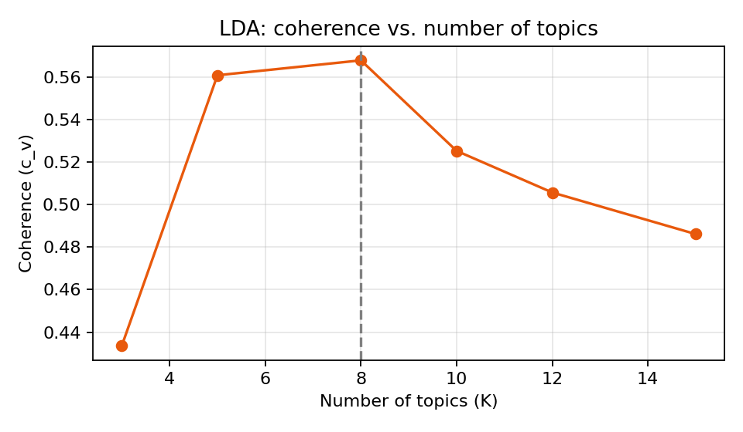
Figure 1: c_v coherence for different numbers of topics
c_v peaks at K = 8 (0.568), but K = 5 is almost as coherent (0.561), and u_mass prefers fewer topics (its best value is at K = 5). The two measures do not agree, which is a reminder that K is a judgement call. K = 8 was used because it gives more interpretable, distinct themes.

7.3 Stability Check
Retraining the same K = 8 model with three different random seeds gave c_v values of 0.517 (seed 1), 0.410 (seed 7), and 0.568 (seed 42). The wide spread (about 0.16) is an important finding: LDA topic quality on short, noisy text varies noticeably between runs, so a single run should not be trusted. The seed-42 model, which had the highest score, was used below; a stricter analysis would report the average over many seeds or use the most stable topics only.

7.4 Discovered Topics
# | Interpretive label (my judgement) | Top words (abridged) | Size | % positive
1 | Fan hype and engagement (likes, views, star names) | vijay, likes, fans, views, ajith, rajini | 8,174 | 53%
2 | Star-fan praise and release anticipation | padam, thalaivaa, pakka, indha, vaa, thalaiva | 5,968 | 57%
3 | Fans of one actor and the film's music/background score | surya, fans, waiting, hit, bgm, suriya | 4,645 | 62%
4 | Critique and dislike; originality (short-film) comparisons | nalla, film, padam, dislike, irukum, short | 2,819 | 37%
5 | Tamil-script good-wishes messages sent on behalf of community groups | வாழ்த்துக்கள், சார்பாக, படம், வெற்றி, பெற, வாழ்த்துகள் | 2,489 | 89%
6 | Tamil-script social and political commentary | நாடக, காதல், தான், என்ன, இது, ஒரு | 1,079 | 37%
7 | Praise with repeated filler words (likely spam / noise) | neraya, போல, நான், என், என்ற, lalettan | 373 | 57%
8 | Tamil-script debate on caste and social equality | இந்த, படம், ஒரு, சாதி, தான், ஜாதி | 2,167 | 46%
Note: labels are my interpretation of the top words and sample comments; the model itself only outputs word lists. Sizes are numbers of comments whose dominant topic this is. '% positive' is the share of comments in that topic carrying the dataset's Positive sentiment label.
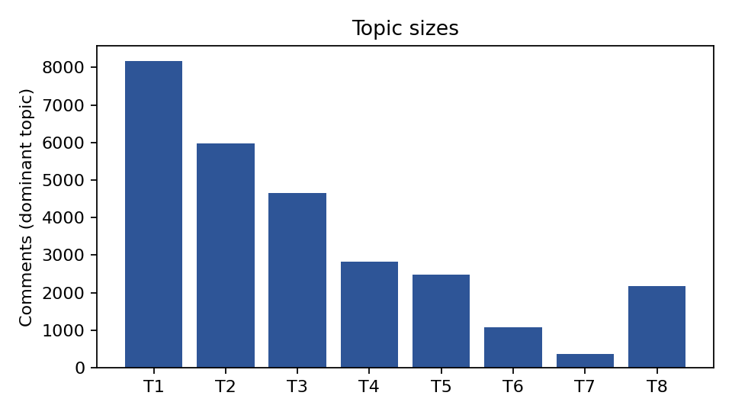
Figure 2: Number of comments per dominant topic

7.5 LDA versus NMF
NMF with the same number of topics scored c_v = 0.534, compared with 0.568 for the best LDA run and the lower values seen for other LDA seeds (down to 0.410). NMF therefore matched LDA within the run-to-run variation of LDA itself, and it is deterministic. It recovered much the same themes: Tamil-script good-wishes messages, fan and star mentions, music and background score, and likes/views engagement. For this kind of corpus, NMF is a strong, cheaper, and more stable cross-check, and it is sensible to run both.

7.6 Topics and Sentiment
Joining topics with the sentiment labels shows how topic modeling supports decisions. The good-wishes topic (5) is 89% Positive and only 1% Negative, while the critique topic (4) is only 37% Positive and 25% Negative, the highest negative share. Topics around fan hype are mostly positive (53-62%). A decision-maker would want to read the critique topic first, since that is where the problems are concentrated.

7.7 Extractive Summaries of Topics
For each topic, the 150 comments most associated with it were taken and two extractive methods (centroid and TextRank) selected three representative comments each. Examples for three topics:
Topic | Centroid summary (3 comments) | TextRank summary (3 comments)
T2 Star-fan praise | "Semma mass... Thalapathy Vera level.. #Varlam_Varlam_Vaa_Varlam_Vaa_Bhairavaaa""..." | Varlam Varlam Vaa Varlam Vaa Thalaivaa BAIRAVAA Thalapathy massssssss | varlam vaa varlam vaa vaa vaa bairavaaaaaaaaaaa | "Semma mass... Thalapathy Vera level.. #Varlam_Varlam_Vaa_Varlam_Vaa_Bhairavaaa""..." | Varlam Varlam Vaa Varlam Vaa Thalaivaa BAIRAVAA Thalapathy massssssss | Dharmapuri district,, Veera vanniyar sarbaga padam vetri Pera valthukkal
T3 Actor and music | Marana waiting Surya Anna mass Yuvan Shankar Raja BGM Vera level...masss | Yuvan fans hit like, Vera level BGM from king of BGM | Marana mass NGK trailer Surya Anna Vara level Yuvan music masss | Marana waiting Surya Anna mass Yuvan Shankar Raja BGM Vera level...masss | Yuvan fans hit like, Vera level BGM from king of BGM | Marana mass NGK trailer Surya Anna Vara level Yuvan music masss
T4 Critique | Kekka bekka kekka bekka short film.... | Keka beka keka beka short film copy DA ithu | Keka beka keka beka short film | Kekka bekka kekka bekka short film.... | Ithu kekka bekka kekka bekka short film. | Keka beka keka beka short film copy DA ithu

- The summaries capture each topic's character: the actor and music-focused topic yields comments about the actor and background score; the critique topic yields the short-film comparison.
- Redundancy is a clear weakness. In T4, all three selected comments are near-copies of one another, and in T3 centroid and TextRank chose almost the same set. Plain top-n ranking rewards the most common phrasing, so repeated comments crowd out other viewpoints. MMR or clustering before selection would fix this.
- Because no reference summaries exist for this data, no ROUGE score is reported. The assessment above is qualitative, from reading the outputs.
- Abstractive summarisation was not run. It would require a multilingual model and, ideally, human-written references for evaluation.

8. Critical Analysis

8.1 Applicability
- Customer feedback: group thousands of reviews into themes (delivery, battery, price) and summarise each theme for product teams.
- Social media and community monitoring: track which themes and which communities are most active, and how sentiment differs across them.
- Document-heavy work: policy, legal, research, and news collections where reading everything is impractical.
- Triage: route comments in negative-heavy topics to human reviewers first.

8.2 Benefits
- Needs no labelled data, so it works quickly on new corpora and new languages.
- Scales to far more text than manual reading.
- Provides structure that can be combined with sentiment, time, or product metadata.
- Extractive summaries remain traceable to real comments, so every claim can be checked.

8.3 Limitations Observed and Expected
Limitation | Evidence or explanation
Instability | Coherence varied from 0.41 to 0.57 across seeds on the same K (Section 7.3)
Subjective number of topics | c_v and u_mass disagreed on the best K
Noise topics | One topic (T7, 373 comments) was largely repeated filler words, and several topics were driven by spam-like repetition
Bag-of-words ignores meaning and order | Sarcasm, negation, and context are invisible to LDA; short comments give few word co-occurrences
Script and spelling fragmentation | Tamil-script and Roman-script text formed separate topics instead of one theme per idea, and spelling variants split counts
Topic labels are human interpretation | Different analysts could label the same word list differently
Redundant extractive summaries | Top-ranked sentences were near-duplicates (Section 7.7)
Abstractive hallucination risk | Not tested here, but well documented in the literature
Sensitive content | Some topics concern caste and community identity; such content needs careful handling, and topic outputs should not be used to profile groups or individuals

8.4 How Outputs Can Drive Decisions
Output | Decision it can support | Condition for trust
Topic sizes over time | Spot rising complaint themes and respond early | Stable topics; consistent preprocessing between periods
Topic + sentiment share | Prioritise which theme to fix first (the most negative) | Reliable sentiment labels (see Week 3 limits)
Representative comments per topic | Give managers concrete evidence, not just word lists | Check for duplicates and spam
Topic summaries in reports | Brief stakeholders quickly | Verified by humans before external use
Low-confidence / noise topics | Improve data cleaning and filtering | Noise topics reviewed, not acted on

The outputs should inform human decisions, not replace them: topics are exploratory hypotheses about the data, and summaries are a reading aid. Both should be validated by sampling the underlying text before any consequential action.

8.5 Ethical Considerations
- Anonymise usernames and personal details before analysis.
- Respect dataset licences and platform terms.
- Avoid inferring sensitive attributes (such as caste, religion, or political views) about individuals from topics; report group-level themes only and with care.
- State uncertainty and limitations whenever results are shared.

9. Recommendations and Future Work
Improvement | Expected benefit
Run many seeds and report mean and spread; keep only stable topics | More trustworthy topics
Try BERTopic with a multilingual encoder such as MuRIL or XLM-R | Meaning-based clustering; less script fragmentation
Add transliteration normalisation and Roman-to-Tamil conversion | Merge spelling and script variants into single themes
Remove near-duplicate and spam comments before modeling | Fewer noise topics
MMR or cluster-then-select for summaries | Less redundant, more diverse summaries
Evaluate abstractive models (mT5, IndicBART) against human-written references | Fluent summaries with measured faithfulness
Human evaluation protocol (word intrusion, 1-5 ratings) | Reliable quality evidence
Apply to real product reviews and add aspect and time breakdowns | Direct link to the Week 1 project goals

10. Conclusion
Topic modeling and text summarisation complement each other: the first organises a large corpus into themes, the second makes each theme quickly readable. The demonstration on a real Tamil-English corpus showed that the approach recovers meaningful, interpretable themes (fan engagement, music, critique, good-wishes messages) and that linking topics to sentiment points a reader to the most negative theme. It also showed the main weaknesses honestly: LDA results varied substantially between random seeds, the best number of topics depended on the metric, noise topics appeared, and plain extractive summaries were repetitive. A sound strategy therefore combines several methods (LDA with NMF, and later embedding-based topics), adds redundancy control to summarisation, and keeps human review in the loop. With these safeguards the pipeline is a practical foundation for turning large volumes of informal text into decisions.

Appendix A: Core Code for the Demonstration
The complete script (topic_modeling_demo.py) accompanies this report. Extractive summarisation core:
def centroid(cands, k=3):
v = TfidfVectorizer(sublinear_tf=True, token_pattern=r'[A-Za-z\u0B80-\u0BFF]{3,}')
M = v.fit_transform(cands); c = np.asarray(M.mean(axis=0))
score = cosine_similarity(M, c).ravel()
return [cands[i] for i in np.argsort(-score)[:k]]

def textrank(cands, k=3):
M = TfidfVectorizer(sublinear_tf=True).fit_transform(cands)
S = cosine_similarity(M); np.fill_diagonal(S, 0)
pr = nx.pagerank(nx.from_numpy_array(S), max_iter=200)
return [cands[i] for i in sorted(pr, key=pr.get, reverse=True)[:k]]

References
- Blei, D. M., Ng, A. Y., & Jordan, M. I. (2003). Latent Dirichlet allocation. Journal of Machine Learning Research, 3, 993-1022.
- Chang, J., Boyd-Graber, J., Gerrish, S., Wang, C., & Blei, D. (2009). Reading tea leaves: How humans interpret topic models. NeurIPS.
- Grootendorst, M. (2022). BERTopic: Neural topic modeling with a class-based TF-IDF procedure. arXiv:2203.05794.
- Lin, C.-Y. (2004). ROUGE: A package for automatic evaluation of summaries. ACL Workshop on Text Summarization Branches Out.
- Mihalcea, R., & Tarau, P. (2004). TextRank: Bringing order into texts. EMNLP.
- Roder, M., Both, A., & Hinneburg, A. (2015). Exploring the space of topic coherence measures. WSDM.
- Xue, L., et al. (2021). mT5: A massively multilingual pre-trained text-to-text transformer. NAACL.
- Zhang, T., Kishore, V., Wu, F., Weinberger, K., & Artzi, Y. (2020). BERTScore: Evaluating text generation with BERT. ICLR.
- Chakravarthi, B. R., et al. (2020). Corpus creation for sentiment analysis in code-mixed Tamil-English text. SLTU/CCURL Workshop, LREC.
- Rehurek, R., & Sojka, P. (2010). Software framework for topic modelling with large corpora. LREC Workshop on New Challenges for NLP Frameworks.

