WEEK 6 TASK | FINAL REPORT
End-to-End Integration and Reporting of NLP-based Data Analytics
Understanding Tamil-English Code-Mixed Text: Sentiment, Themes, Entities, and Summaries

Field | Details
Prepared by | Shyma A
Programme | Yuva Intern - NLP Internship
Institution | Jeppiaar University, Chennai (B.Sc. Computer Science)
Document type | Final integrated project report (Week 6)
Covers | Weeks 1-5 consolidated, plus an integrated end-to-end analysis
Primary data | Dravidian-CodeMix Tamil-English comments (public benchmark)
Estimated effort | 30-35 hours

Evidence note: every number in this report comes from experiments that were actually run (Weeks 3 and 5, and the integrated analysis in Section 6). Week 4 (NER) was a design task and was not trained, so no NER performance is claimed. Items that are plans or proposals are labelled as such.

1. Executive Summary
This project asked how an organisation could automatically understand large volumes of informal Tamil-English text, such as the reviews and comments written every day by Indian users who mix languages and scripts. Over six weeks the work moved from a proposal (Week 1), through data preparation (Week 2), model implementation and evaluation (Week 3), an entity-recognition design (Week 4), and topic modeling with summarisation (Week 5), to the integrated analysis in this report.

Key results
- Sentiment: A Linear SVM on word and character TF-IDF features classified five-way sentiment with accuracy 0.642 and macro-F1 0.503, against a majority-class baseline of 0.145 macro-F1. Mixed-feeling comments were the hardest class.
- Themes: LDA recovered interpretable themes (fan engagement, music, critique, Tamil-script good-wishes messages), but quality varied between random seeds (c_v 0.410 to 0.568), and NMF matched LDA within that variation.
- Integration: Combining the two, the classifier ranked the eight topics by negative-comment share in exactly the same order as the human labels (Spearman correlation 1.00 over 8 topics; a small sample, see Section 6), though it under-predicted the negative share on average.
- Summaries: Extractive summaries captured each theme's character but were repetitive, so redundancy control is needed.

Main recommendation
Use the pipeline to prioritise human attention (which themes to read first), not to replace reading. Next steps are fine-tuning multilingual transformers, adding transliteration normalisation, training the NER design on a small annotated set, and testing on real product reviews.

2. Project Background and Objectives
Many Indian users write online in Tamil and English together, often typing Tamil in Roman script with inconsistent spelling. Tools built for clean, single-language English handle this poorly. Businesses and researchers therefore miss what a large group of users is saying.

Objectives
- Define a real-world NLP problem and justify an NLP-based solution (Week 1).
- Design data collection, preprocessing, and feature engineering for noisy code-mixed text (Week 2).
- Implement and critically evaluate text classifiers (Week 3).
- Design an entity-recognition pipeline (Week 4).
- Apply topic modeling and summarisation to discover and describe themes (Week 5).
- Integrate everything into one workflow, evaluate it end to end, and derive insights, limitations, and recommendations (Week 6).

A note on domain
The Week 1 proposal targeted product reviews. The openly available benchmark for Tamil-English code-mixing is a corpus of YouTube comments on film trailers, so all experiments use that corpus. The methods transfer to product reviews, but absolute scores and the themes found (film, actors, music) should not be assumed to carry over.

3. Integrated Project Workflow
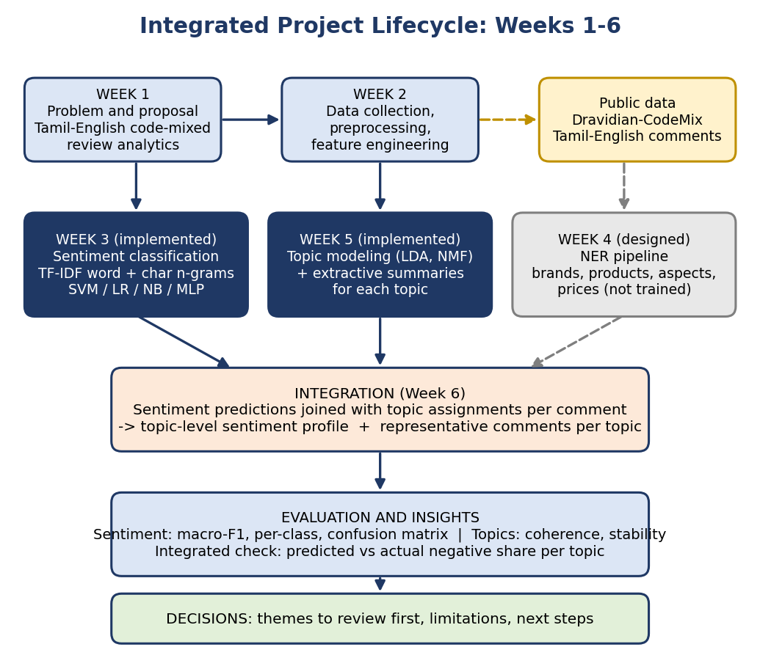
Figure 1: How the six weeks fit together into one workflow (dark boxes were implemented and evaluated; the grey box was designed only)
Phase | Purpose | Main deliverable | Status
Week 1 | Define problem, scope, methods, timeline, and risks | Project proposal | Plan
Week 2 | Collect data; clean, tokenise, and represent text | Preprocessing and feature methodology | Plan with worked examples
Week 3 | Train and evaluate classifiers | Evaluation report and script | Implemented, results reported
Week 4 | Design the entity-recognition pipeline | Pipeline design and flowchart | Design only
Week 5 | Discover themes and summarise them | Methodology and demonstration | Implemented demo, results reported
Week 6 | Integrate, evaluate end to end, and conclude | This report and integrated analysis | Implemented, results reported

3.1 End-to-End Process in Steps
- Collect the public corpus and remove duplicates (including test comments that also occur in training data).
- Clean text: Unicode normalisation, remove URLs and handles, lower-case, limit repeated characters. Keep emojis and punctuation.
- Sentiment stage: build word and character n-gram TF-IDF features and train the classifier on the training split.
- Topic stage: tokenise with a custom stop-word list, filter rare and over-common words, and fit LDA on the training split.
- For each held-out comment, predict sentiment and infer its dominant topic.
- Join the two outputs to build a sentiment profile per topic, and select representative comments per topic (extractive summary).
- Evaluate each stage on its own and the combination end to end against human labels.
- Interpret results, state limitations, and recommend actions.

4. Summary of Each Phase

4.1 Week 1: Planning and Proposal
The proposal framed the problem (code-mixed text defeats standard sentiment tools), reviewed key literature (BERT, XLM-RoBERTa, MuRIL, IndicBERT, and the Dravidian-CodeMix benchmark), and identified gaps: little aspect-level analysis for Tamil-English, noisy transliteration, small and off-domain datasets, and few reproducible tools. It set objectives, scope, an 8-week plan, and a risk table (scarce labelled data, class imbalance, limited GPU, noisy transliteration, annotation inconsistency).

4.2 Week 2: Data Collection, Preprocessing, and Feature Engineering
This phase documented a pipeline: audit the data, clean it in an order-aware way, protect sentiment-bearing tokens (negations, intensifiers, emojis), and choose features in layers (word TF-IDF, character n-gram TF-IDF, fastText embeddings, transformer encodings). It also listed pitfalls: data leakage, discarding negations as stop-words, over-stemming Tamil, inconsistent transliteration, and class imbalance.

4.3 Week 3: Implementation and Evaluation of Classifiers
Models were trained on 35,381 training comments and evaluated on 3,906 held-out comments (after removing 275 duplicates and 53 evaluation rows that also appeared in training).
Model | Accuracy | Macro-F1 | Weighted F1 | Note
Majority class | 0.568 | 0.145 | 0.412
Complement Naive Bayes | 0.591 | 0.481 | 0.598
Logistic Regression | 0.627 | 0.491 | 0.608
Logistic Regression (balanced) | 0.573 | 0.486 | 0.587
Linear SVM | 0.642 | 0.503 | 0.618 | Selected
Linear SVM (balanced) | 0.603 | 0.500 | 0.609
MLP neural network | 0.640 | 0.474 | 0.603

- Every model beat the majority baseline, but the best classical models were within about 2 points of each other, which a single split cannot resolve.
- A neural MLP did not beat the linear SVM and was far slower to train.
- Character n-grams helped (word-only macro-F1 0.476 vs 0.500 with characters); the extra cleaning steps made no measurable difference for this model.
- By class, Positive was strongest and Mixed_feelings weakest (F1 0.754 vs 0.275 for the balanced SVM).

4.4 Week 4: Design of an NER Pipeline
An eight-stage pipeline was designed to extract entities from reviews: preprocessing with offset tracking, optional regex and gazetteer candidates, sub-word encoding, a fine-tuned multilingual transformer with BIO tagging, post-processing (BIO repair, normalisation, overlap resolution, confidence filtering), and entity-level evaluation. A custom schema (BRAND, PRODUCT, ASPECT, ORG, LOC, PRICE, DATE) was proposed because standard corpora lack review-specific types. The design addressed polysemy (for example 'Apple' or 'Prime') through context, gazetteers, and rules. No model was trained, so this component remains a plan.

4.5 Week 5: Topic Modeling and Summarisation
On 27,714 filtered comments, LDA with K = 8 was chosen by coherence (c_v 0.568; K = 5 was nearly as good at 0.561 and u_mass preferred fewer topics). Retraining with other seeds gave c_v from 0.410 to 0.568, showing instability. NMF reached 0.534 and recovered similar themes. Extractive summaries (centroid and TextRank) described each topic but selected near-duplicate comments.

5. Integrated Methodology

5.1 Design Principles
- One shared preprocessing path. Every stage uses the same cleaned text, so results are comparable.
- No leakage. Models and vectorisers are fitted on the training split only, and all integrated results use held-out comments.
- Metrics that expose imbalance. Macro-F1 and per-class results, not accuracy alone, because 57% of comments are Positive.
- Layered evaluation. Each stage is evaluated alone and then in combination.
- Honest reporting. Weak results (Mixed_feelings, topic instability, redundant summaries) are reported rather than hidden.

5.2 Stage Specifications
Stage | Configuration | Why this choice
Preprocessing | NFC normalisation, remove URLs and handles, lower-case, repeated-character limit; duplicates removed | Reduces noise without deleting sentiment cues
Sentiment model | Word (1-2 gram) plus character (2-5 gram) TF-IDF, Linear SVM, C = 0.3 | Best accuracy and macro-F1 among tested models, fast, robust to spelling variation
Topic model | LDA, K = 8, asymmetric alpha, 6 passes, seed 42; tokens of 3+ characters with custom stop-words; words in under 15 or over 30% of documents removed | Coherence-selected K; interpretable themes
Topic assignment | Dominant topic from LDA inference (needs at least 3 vocabulary tokens) | Simple and explainable
Summaries | Centroid and TextRank over each topic's top comments | Faithful, no hallucination, language-agnostic
Entities (design) | Fine-tuned transformer with BIO tags plus rules | Planned extension

6. Integrated Case Study: Sentiment by Theme
The integrated analysis tests whether the two implemented components work together and produce useful, trustworthy insight. Unlike Week 5 (where topics were fitted on all comments and joined with human labels), this analysis is strictly out-of-sample: the sentiment classifier and the topic model were both trained on the training split only, then applied to the held-out comments.

6.1 Setup
Item | Value
Training comments for topic model | 24,618 (with at least 3 vocabulary tokens)
Held-out comments | 3,906
Held-out comments assigned a topic | 2,695 (69%); the rest have too few usable words
Sentiment model | Linear SVM from Week 3 (accuracy 0.642, macro-F1 0.503 on all held-out comments)
Comparison | Per topic: share of comments labelled Positive or Negative by humans vs predicted by the classifier

6.2 Results by Topic
# | Topic (my label) | n | Actual neg. | Pred. neg. | Actual pos. | Pred. pos. | Accuracy
1 | Star-fan praise and dialogue comments | 741 | 16% | 13% | 54% | 67% | 62%
2 | Fan engagement (Vijay / Ajith fans) | 655 | 14% | 10% | 53% | 63% | 63%
3 | Tamil-script good-wishes messages | 261 | 1% | 1% | 82% | 85% | 88%
4 | Actor fans and film anticipation | 348 | 6% | 3% | 66% | 82% | 72%
5 | Tamil-script social debate | 343 | 12% | 6% | 45% | 60% | 51%
6 | Song-lyric quotes, short Tamil replies | 48 | 0% | 0% | 83% | 75% | 79%
7 | Music and engagement metrics | 130 | 18% | 14% | 48% | 55% | 58%
8 | Colloquial critique and praise | 169 | 22% | 19% | 44% | 57% | 51%
Topic labels are my interpretation of the top words; the model outputs only word lists. 'n' is the number of held-out comments whose dominant topic this is, so small topics (for example T6, n = 48) give noisy percentages.
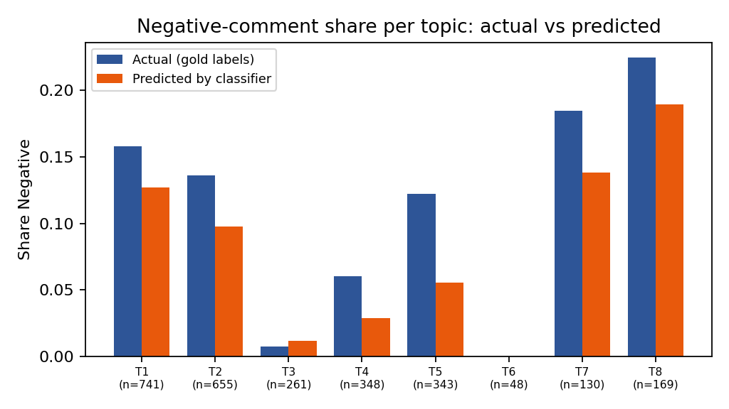
Figure 2: Share of Negative comments per topic, actual vs predicted by the classifier

6.3 Findings
- Prioritisation works. Ranking agreement: ordering the 8 topics by predicted negative share gives exactly the same order as the human labels (Spearman 1.00); for positive share the correlation is 0.86. With only 8 topics and some small ones, this supports the usefulness of the combined pipeline for prioritising themes but does not prove it.
- Where to look first. The most negative theme by human labels is T8 (Colloquial critique and praise, 22% Negative) and the least negative is T6 (Song-lyric quotes, short Tamil replies, 0%; this is a small topic with only 48 comments, and the larger good-wishes theme T3 is similarly low). The classifier agrees on both.
- Systematic bias. On average the classifier under-predicts negative share by about 3 percentage points per topic and over-predicts positive share by about 8 points. This follows from class imbalance: the plain SVM leans toward the majority Positive class. Absolute percentages should be treated as underestimates for negative content; relative rankings are more reliable.
- Uneven reliability. Classification accuracy varies by theme, from 51% to 88%. It is highest for the Tamil-script good-wishes theme (clear, formulaic language) and lowest for the social-debate and colloquial-critique themes, where meaning is implicit.
- Coverage. About 31% of held-out comments are too short to receive a topic, so topic-based insight covers only part of the data.

6.4 Representative Comments (Extractive Summaries)
Theme | Representative comments selected by the centroid method (Week 5 topics)
Actor fans and music | Marana waiting Surya Anna mass Yuvan Shankar Raja BGM Vera level...masss | Yuvan fans hit like, Vera level BGM from king of BGM | Marana mass NGK trailer Surya Anna Vara level Yuvan music masss
Critique and originality | Kekka bekka kekka bekka short film.... | Keka beka keka beka short film copy DA ithu | Keka beka keka beka short film
Star-fan praise | "Semma mass... Thalapathy Vera level.. #Varlam_Varlam_Vaa_Varlam_Vaa_Bhairavaaa""..." | Varlam Varlam Vaa Varlam Vaa Thalaivaa BAIRAVAA Thalapathy massssssss | varlam vaa varlam vaa vaa vaa bairavaaaaaaaaaaa

These show how a theme can be summarised for a reader, and also the repetition problem: in the critique theme all three comments are near-copies. Pairing each theme's sentiment profile with a short, de-duplicated set of representative comments would give a decision-maker both the how much and the what.

7. Overall Insights
- 1. Code-mixed text can be analysed with simple, fast methods. A well-regularised linear model on character n-grams is a strong baseline that a small neural network did not beat.
- 2. Representation mattered more than rules. Character n-grams produced the clearest gain, while extra cleaning steps made no measurable difference for the linear model.
- 3. Evaluation design changed conclusions. Macro-F1, per-class analysis, and removal of duplicate and overlapping rows revealed the weakness on minority classes and prevented inflated scores.
- 4. The hard part is nuance, not polarity. Mixed feelings, implicit opinion, sarcasm, and context-dependent meaning limit bag-of-words models.
- 5. Unsupervised themes are useful but unstable. They should be checked across seeds and methods, and noise topics (repeated filler words) removed.
- 6. The combination adds value beyond either part: sentiment alone says how people feel; topics say what they are talking about; together they show where the problems are.
- 7. Human review remains essential, especially for sensitive themes.

8. Limitations
Limitation | Detail
Domain mismatch | Film-trailer comments, not product reviews; themes and scores may not transfer
Single split, single run | No confidence intervals; small differences between classical models are inconclusive
Evaluation set reuse | The dev split served as the held-out set, and the SVM regularisation sweep reused it
Weak minority classes | Mixed_feelings F1 about 0.28; classifier under-predicts negative share
No transformers trained | No GPU or deep-learning framework available; XLM-R, MuRIL, IndicBERT remain future work
NER not implemented | Design only; no entity-level results
Topic instability | c_v 0.410 to 0.568 across seeds; K choice disagreed between metrics
Topic coverage | About 31% of held-out comments had too few words to be assigned a topic
Redundant summaries | Extractive selection returned near-duplicates; abstractive methods untested
Label noise | Subjective sentiment labels cap achievable accuracy
Small integrated sample | Eight topics, some with few comments, so the rank correlation is indicative only

9. Recommendations and Future Work

9.1 Technical Improvements
Improvement | Expected benefit
Fine-tune XLM-RoBERTa / MuRIL for sentiment | Contextual understanding of negation, implicit and mixed sentiment
Stratified k-fold cross-validation with confidence intervals | Reliable model comparison
Transliteration normalisation and Roman-to-Tamil conversion | Merge spelling and script variants; fewer fragmented topics
Class-balancing, calibrated thresholds, or focal loss | Reduce the under-prediction of Negative and Mixed
Run LDA over many seeds, or use NMF / BERTopic with multilingual embeddings | Stable, meaning-based themes
Remove duplicates and spam before topic modeling; use MMR in summaries | Fewer noise topics, more diverse summaries
Train the Week 4 NER design on 1,000-2,000 annotated sentences | Extract brands, products, aspects, and prices; enable aspect-level sentiment
Evaluate abstractive summaries (mT5, IndicBART) with human ratings | Fluent summaries with measured faithfulness
Test on real product reviews | Confirm transfer to the intended domain

9.2 Potential Applications
- Product teams: topic-level sentiment dashboards from regional-language reviews, showing which features need attention.
- Customer support: route negative-heavy themes to human agents first.
- Brand and campaign monitoring: track how reaction to a launch or trailer varies across themes.
- Research and public-interest analysis: organise large collections of community feedback, with careful, group-level reporting.

9.3 Proposed Roadmap
Stage | Activities | Outcome
Next 1-2 months | Transformer fine-tuning on Colab; cross-validation; transliteration normalisation | Stronger sentiment model with confidence intervals
Months 2-3 | Annotate NER sample; train NER; add aspect extraction | Entity and aspect-level insights
Months 3-4 | Stable topics (NMF / BERTopic); redundancy-aware summaries; human evaluation | Reliable theme reports
Months 4-5 | Switch to real product reviews; build dashboard demo | Deployable prototype

9.4 Ethical Considerations
- Use only publicly available or licensed data and anonymise usernames and personal details.
- Some themes concern caste, community, or politics. Report group-level themes carefully and never use outputs to profile individuals or groups.
- Disclose model weaknesses (for example under-detection of negative comments) when sharing results.
- Keep humans in the loop for consequential decisions.

10. Reflection and Conclusion
Across the six weeks the work followed the full project lifecycle: defining a problem, preparing data, building and evaluating models, designing an extension, discovering structure in unlabelled text, and integrating the pieces. The main lesson is that the value of an NLP system lies as much in careful evaluation and honest limitations as in the model itself. The simple models performed respectably but showed clear weaknesses on mixed and implicit sentiment, the unsupervised topics were useful but unstable, and the summaries were faithful but repetitive.
The integrated analysis showed that these imperfect parts can still work together: the pipeline ranked themes by negativity in the same order as human labels, on comments it had never seen. That makes it a practical way to decide where human attention should go first, provided results are read with their limitations in mind. The roadmap above (multilingual transformers, transliteration handling, trained NER, stable topics, and testing on real product reviews) outlines how the project can grow from a benchmark study into a tool that helps organisations listen to what regional-language users are actually saying.

Appendix A: Repository and Reproducibility
File | Purpose
exp.py (Week 3) | Sentiment models, ablations, confusion matrix, figures
topic_modeling_demo.py (Week 5) | LDA and NMF, coherence sweep, stability check, extractive summaries
integrated_pipeline.py (Week 6) | Out-of-sample sentiment and topic integration, per-topic comparison
Data | Dravidian-CodeMix Tamil sentiment train and dev files (public GitHub copy)
Software | Python, pandas, scikit-learn, gensim, networkx, matplotlib
All scripts use fixed random seeds. Suggested repository layout: /data (not committed if licensing requires), /src (scripts), /reports (the six Word documents), README.md with run instructions.

References
- Blei, D. M., Ng, A. Y., & Jordan, M. I. (2003). Latent Dirichlet allocation. Journal of Machine Learning Research, 3, 993-1022.
- Chakravarthi, B. R., et al. (2020). Corpus creation for sentiment analysis in code-mixed Tamil-English text. SLTU/CCURL Workshop, LREC.
- Conneau, A., et al. (2020). Unsupervised cross-lingual representation learning at scale. ACL.
- Cortes, C., & Vapnik, V. (1995). Support-vector networks. Machine Learning, 20(3), 273-297.
- Devlin, J., Chang, M., Lee, K., & Toutanova, K. (2019). BERT: Pre-training of deep bidirectional transformers for language understanding. NAACL-HLT.
- Kakwani, D., et al. (2020). IndicNLPSuite: Monolingual corpora, evaluation benchmarks and pre-trained multilingual language models for Indian languages. Findings of EMNLP.
- Khanuja, S., et al. (2021). MuRIL: Multilingual representations for Indian languages. arXiv:2103.10730.
- Mihalcea, R., & Tarau, P. (2004). TextRank: Bringing order into texts. EMNLP.
- Pedregosa, F., et al. (2011). Scikit-learn: Machine learning in Python. JMLR, 12, 2825-2830.
- Rehurek, R., & Sojka, P. (2010). Software framework for topic modelling with large corpora. LREC Workshop on New Challenges for NLP Frameworks.
- Roder, M., Both, A., & Hinneburg, A. (2015). Exploring the space of topic coherence measures. WSDM.

