

Basics of MySQL & Databases

[Document subtitle]

July 29, 2024

shyma asghar

shymaasghar@hotmail.com

Contents

Task1 – MySQL Part 1 screenshots & script: 2-5

Task 2 – My SQL Part 2: 6-18

Task 2 Script 19-23

Task 3 – Interview Part 1: 24

Task 4 – Interview questions Part 2: 24-25

# **Task1 – MySQL Part 1:**

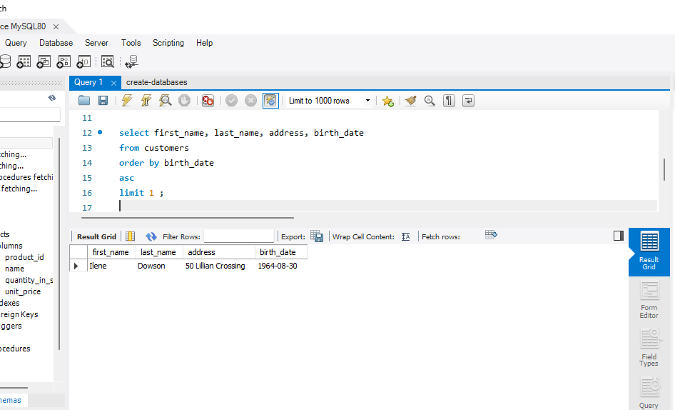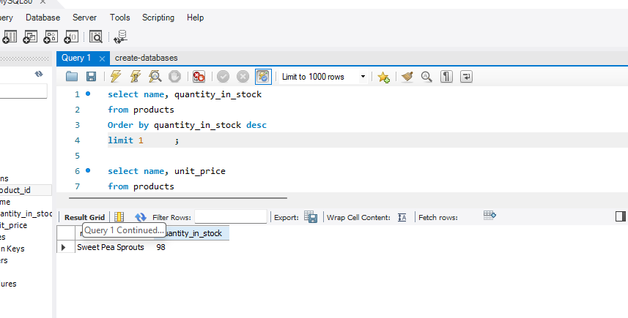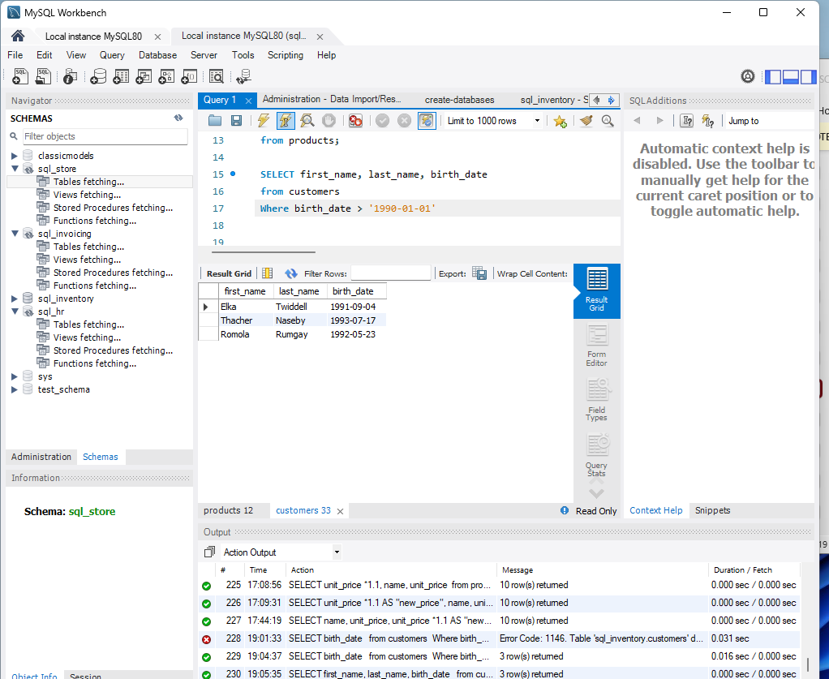

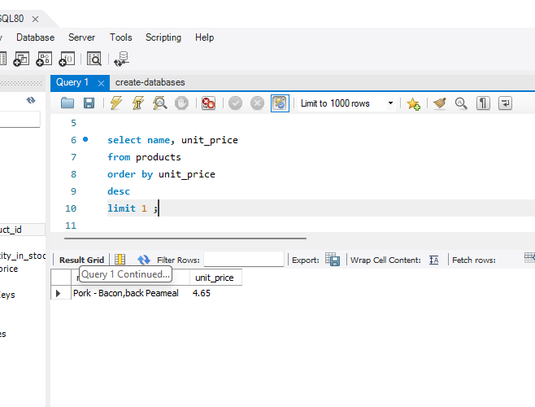

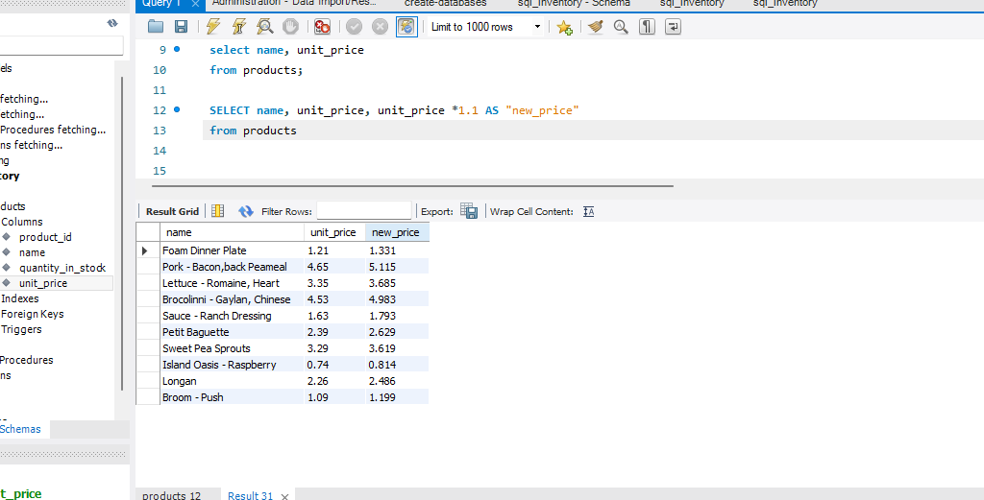

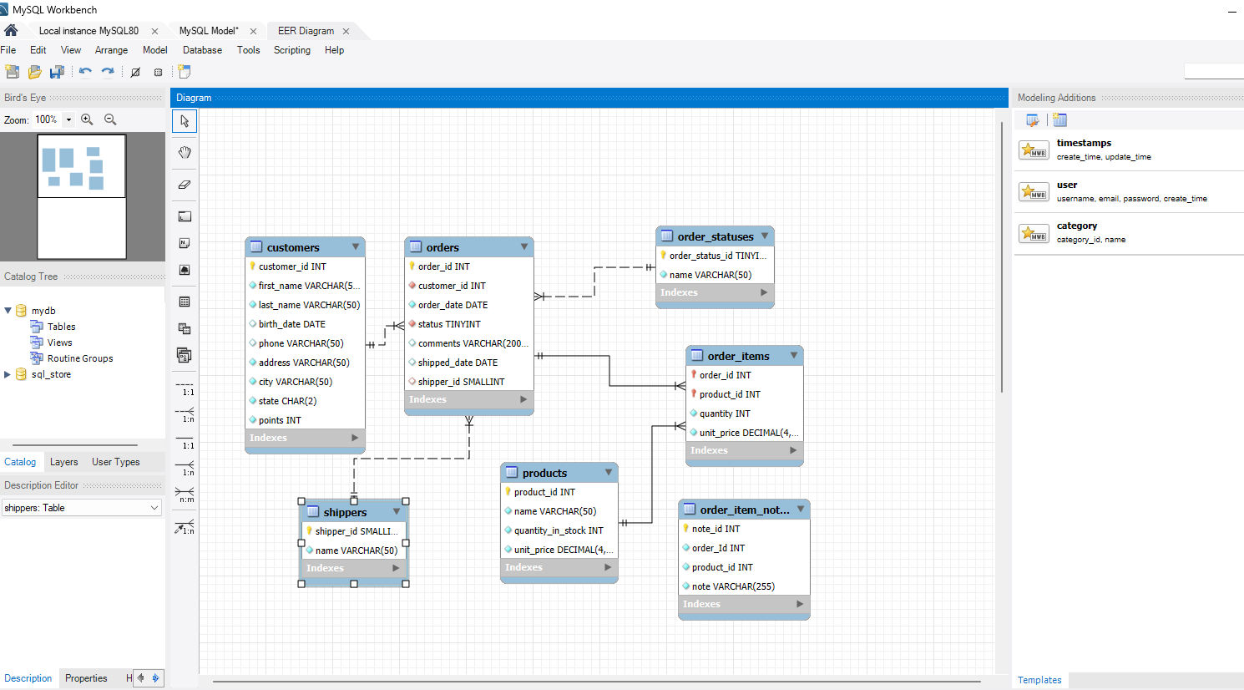

**SCRIPT:**

USE sql_store;

SELECT *

FROM customers

-- WHERE CUSTOMER_ID=1

ORDER BY first_name;

SELECT last_name, first_name, points, (points + 10) * 100 AS discount_factor

FROM customers;

select name, unit_price

from products;

SELECT name, unit_price, unit_price *1.1 AS "new_price"

from products;

SELECT first_name, last_name, birth_date

from customers

Where birth_date > '1990-01-01';

# **Task 2 – My SQL Part 2:**

## Tasks

1. **Count Cities in USA:** *Scenario:* You've been tasked with conducting a demographic analysis of cities in the United States. Your first step is to determine the total number of cities within the country to provide a baseline for further analysis.

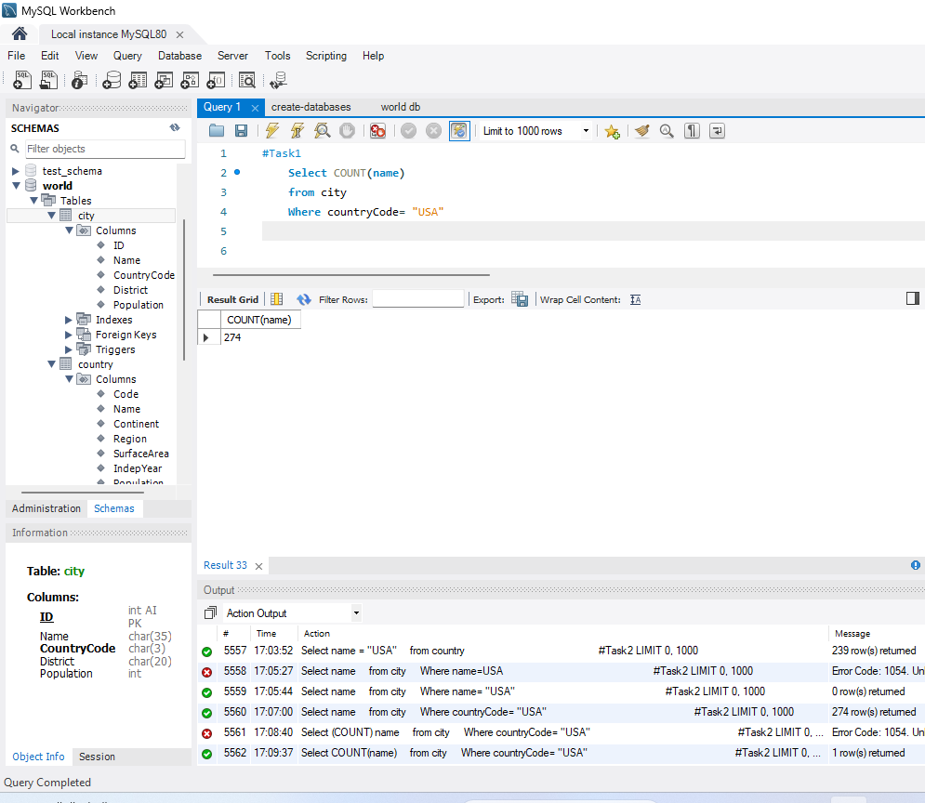

1. **Country with Highest Life Expectancy:** *Scenario:* As part of a global health initiative, you've been assigned to identify the country with the highest life expectancy. This information will be crucial for prioritizing healthcare resources and interventions.

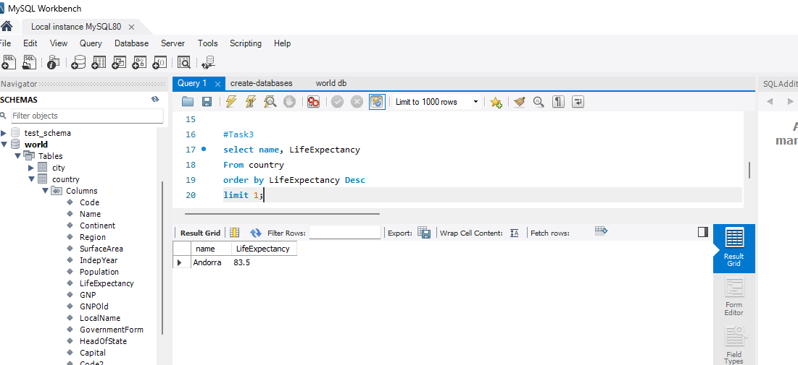

1. **"New Year Promotion: Featuring Cities with 'New :** *Scenario:* In anticipation of the upcoming New Year, your travel agency is gearing up for a special promotion featuring cities with names including the word 'New'. You're tasked with swiftly compiling a list of all cities from around the world. This curated selection will be essential in creating promotional materials and enticing travellers with exciting destinations to kick off the New Year in style.

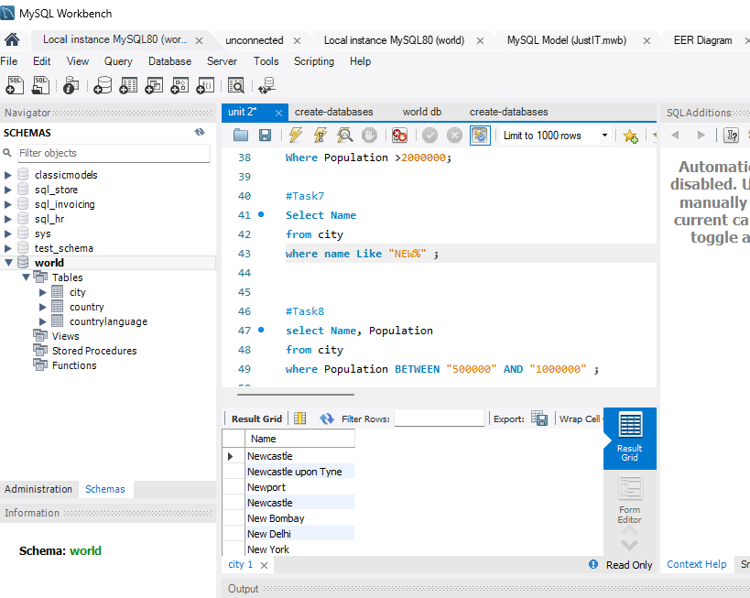

1. **Display Columns with Limit (First 10 Rows):** *Scenario:* You're tasked with providing a brief overview of the most populous cities in the world. To keep the report concise, you're instructed to list only the first 10 cities by population from the database.

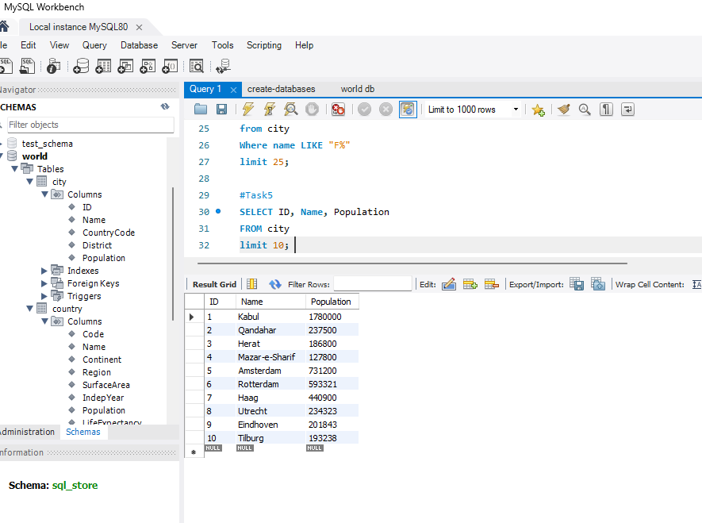

1. **Cities with Population Larger than 2,000,000:** *Scenario:* A real estate developer is interested in cities with substantial population sizes for potential investment opportunities. You're tasked with identifying cities from the database with populations exceeding 2 million to focus their research efforts.

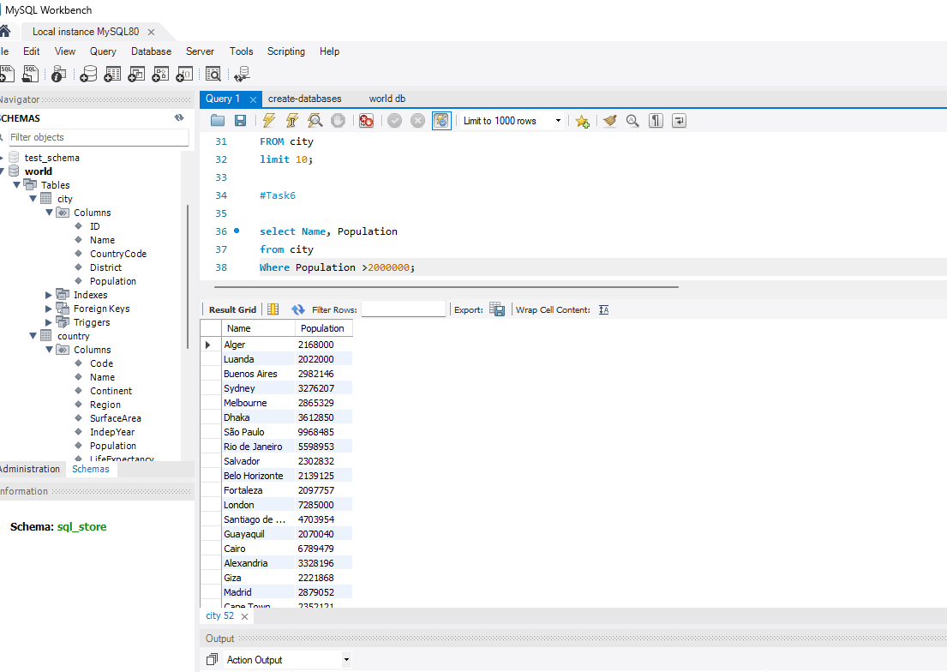

1. **Cities Beginning with 'Be' Prefix:** *Scenario:* A travel blogger is planning a series of articles featuring cities with unique names. You're tasked with compiling a list of cities from the database that start with the prefix 'Be' to assist in the blogger's content creation process.

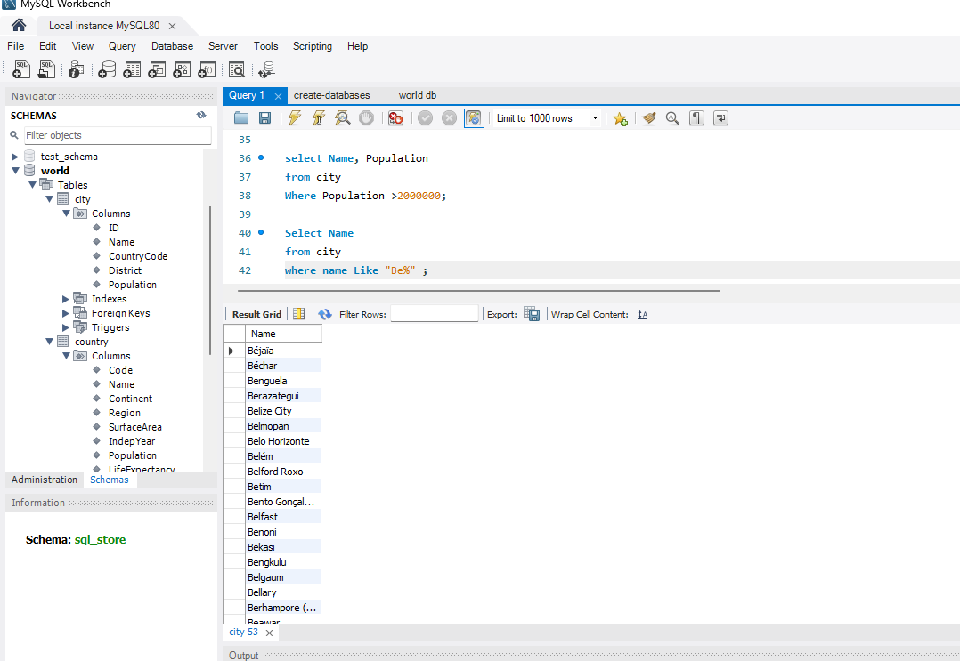

1. **Cities with Population Between 500,000-1,000,000:** *Scenario:* An urban planning committee needs to identify mid-sized cities suitable for infrastructure development projects. You're tasked with identifying cities with populations ranging between 500,000 and 1 million to inform their decision-making process.

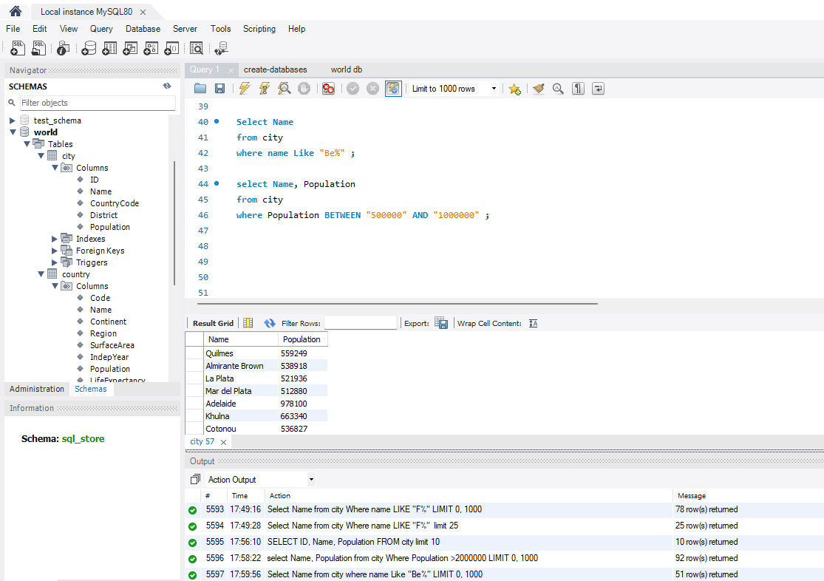

1. **Display Cities Sorted by Name in Ascending Order:** *Scenario:* A geography teacher is preparing a lesson on alphabetical order using city names. You're tasked with providing a sorted list of cities from the database in ascending order by name to support the lesson plan.

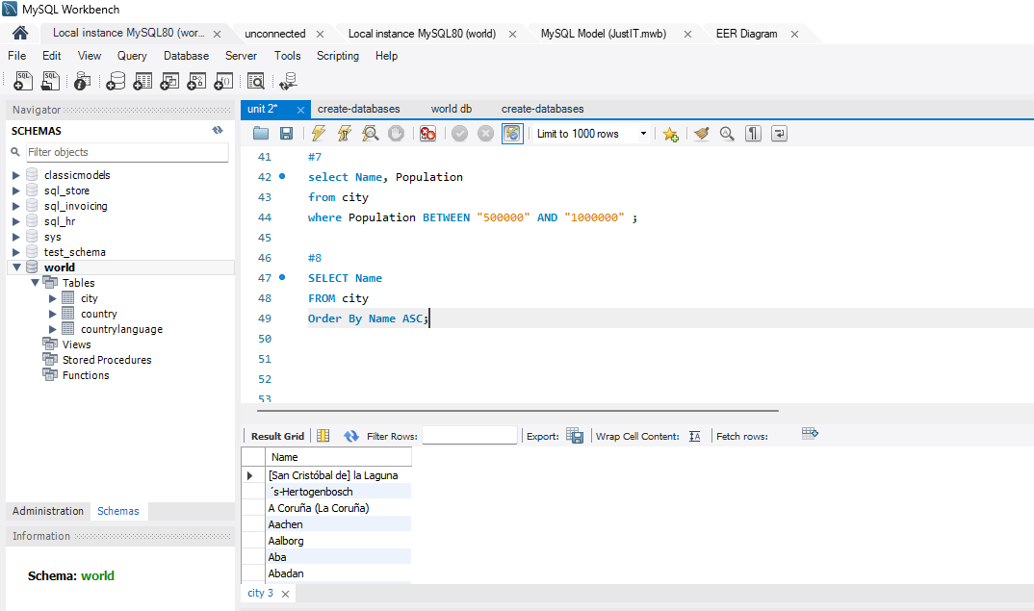

1. **Most Populated City:** *Scenario:* A real estate investment firm is interested in cities with significant population densities for potential development projects. You're tasked with identifying the most populated city from the database to guide their investment decisions and strategic planning.

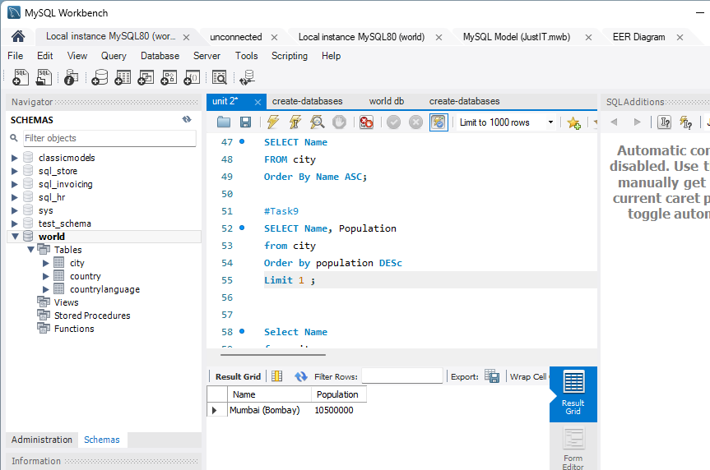

1. **City Name Frequency Analysis: Supporting Geography Education** *Scenario*: In a geography class, students are learning about the distribution of city names around the world. The teacher, in preparation for a lesson on city name frequencies, wants to provide students with a list of unique city names sorted alphabetically, along with their respective counts of occurrences in the database. You're tasked with this sorted list to support the geography teacher's l

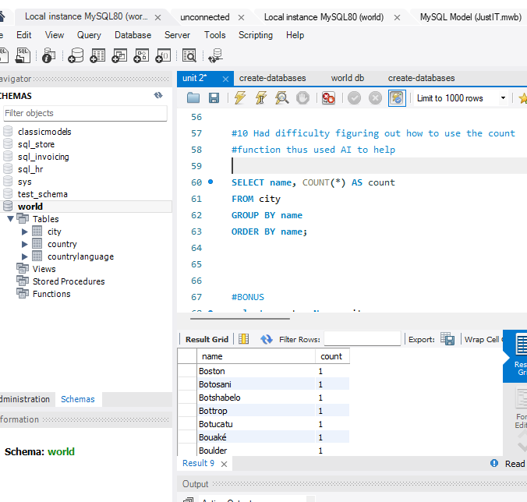

1. **City with the Lowest Population:** *Scenario:* A census bureau is conducting an analysis of urban population distribution. You're tasked with identifying the city with the lowest population from the database to provide a comprehensive overview of demographic trends.

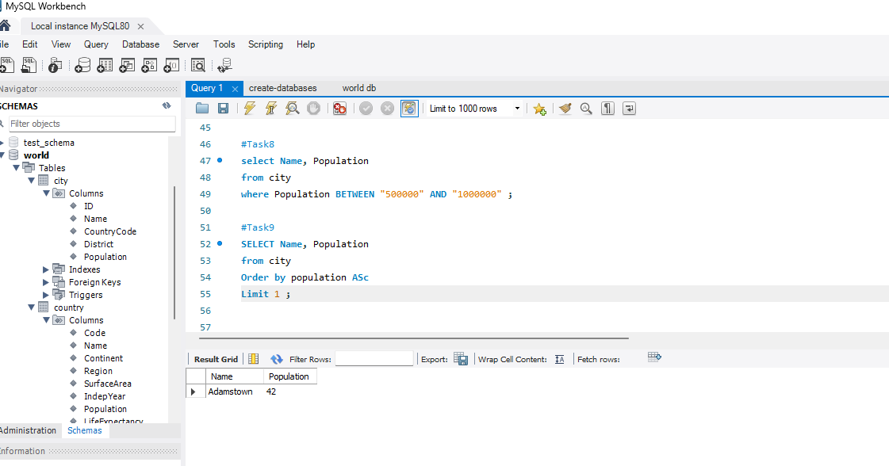

1. **Country with Largest Population:** *Scenario:* A global economic research institute requires data on countries with the largest populations for a comprehensive analysis. You're tasked with identifying the country with the highest population from the database to provide valuable insights into demographic trends.

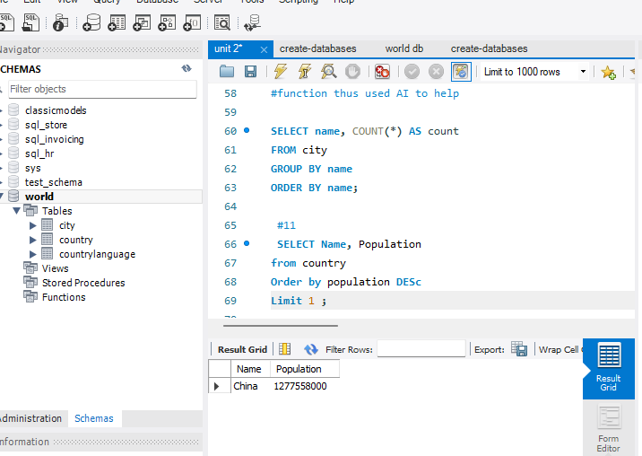

1. **Capital of Spain:** *Scenario:* A travel agency is organizing tours across Europe and needs accurate information on capital cities. You're tasked with identifying the capital of Spain from the database to ensure itinerary accuracy and provide travellers with essential destination information.

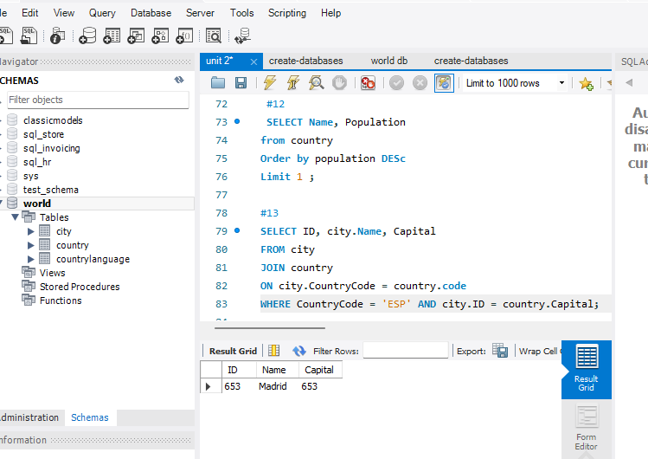

1. **Country with Highest Life Expectancy:** *Scenario:* A healthcare foundation is conducting research on global health indicators. You're tasked with identifying the country with the highest life expectancy from the database to inform their efforts in improving healthcare systems and policies.

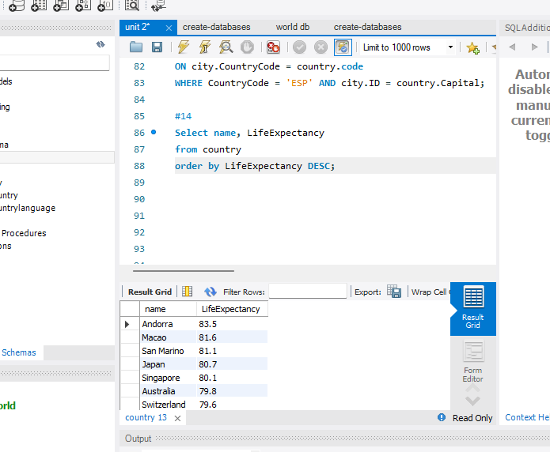

1. **Cities in Europe:** *Scenario:* A European cultural exchange program is seeking to connect students with cities across the continent. You're tasked with compiling a list of cities located in Europe from the database to facilitate program planning and student engagement.

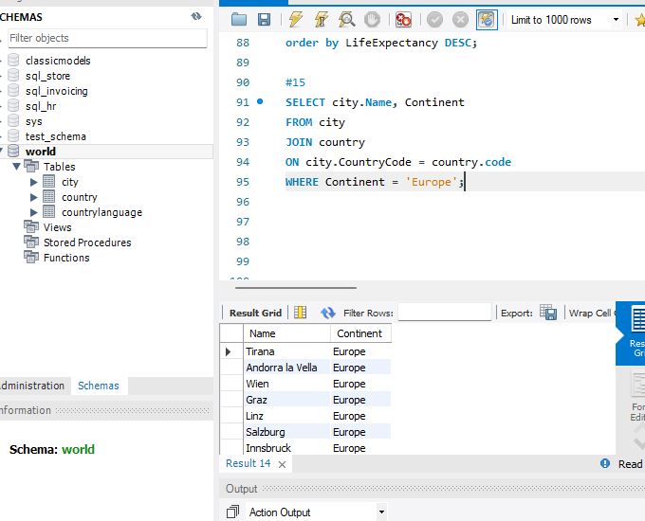

1. **Average Population by Country:** *Scenario:* A demographic research team is conducting a comparative analysis of population distributions across countries. You're tasked with calculating the average population for each country from the database to provide valuable insights into global population trends.

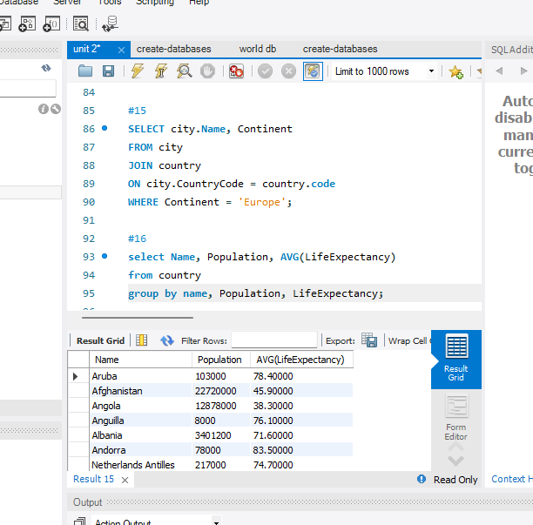

1. **Capital Cities Population Comparison:** *Scenario:* A statistical analysis firm is examining population distributions between capital cities worldwide. You're tasked with comparing the populations of capital cities from different countries to identify trends and patterns in urban demographics.

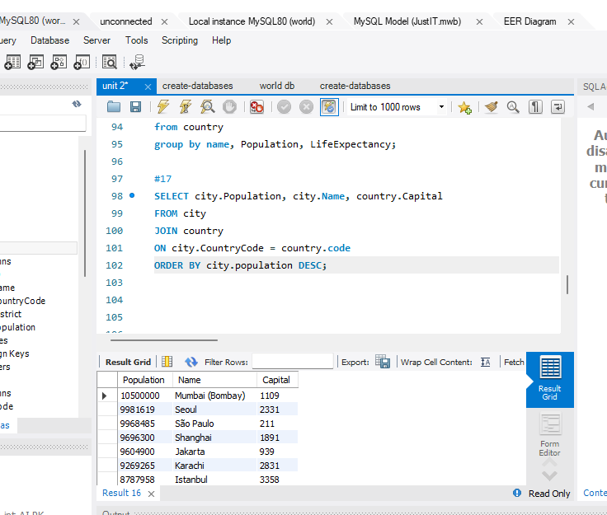

1. **Countries with Low Population Density:** *Scenario:* An agricultural research institute is studying countries with low population densities for potential agricultural development projects. You're tasked with identifying countries with sparse populations from the database to support the institute's research efforts.

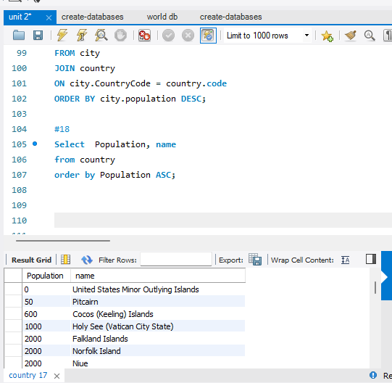

**SCRIPT:**

**#1**

**Select COUNT(name)**

**from city**

**Where countryCode= "USA";**

**#Figuring out what tables to use helped me solve this one.I first narrowed down the by cities in the usa then added count ()**

**#2**

**#population, expectency ARG**

**select name, LifeExpectancy**

**From country**

**order by LifeExpectancy Desc**

**limit 1;**

**#3**

**Select Name**

**from city**

**where name Like "NEW%" ;**

**#4**

**SELECT ID, Name, Population**

**FROM city**

**limit 10;**

**#5**

**select Name, Population**

**from city**

**Where Population >2000000;**

**#6**

**Select Name**

**from city**

**where name Like "BE%" ;**

**#7**

**select Name, Population**

**from city**

**where Population BETWEEN "500000" AND "1000000" ;**

**#8**

**SELECT Name**

**FROM city**

**Order By Name ASC;**

**#9**

**SELECT Name, Population**

**from city**

**Order by population DESc**

**Limit 1 ;**

**#10 Had difficulty figuring out how to use the count**

**#function thus used AI to help**

**SELECT name, COUNT(*) AS count**

**FROM city**

**GROUP BY name**

**ORDER BY name;**

**#11**

**SELECT Name, Population**

**from city**

**Order by population ASC**

**Limit 1 ;**

**#12**

**SELECT Name, Population**

**from country**

**Order by population DESc**

**Limit 1 ;**

**#13**

**SELECT ID, city.Name, Capital**

**FROM city**

**JOIN country**

**ON city.CountryCode = country.code**

**WHERE CountryCode = 'ESP' AND city.ID = country.Capital;**

**#14**

**Select name, LifeExpectancy**

**from country**

**order by LifeExpectancy DESC;**

**#15**

**SELECT city.Name, Continent**

**FROM city**

**JOIN country**

**ON city.CountryCode = country.code**

**WHERE Continent = 'Europe';**

**#16**

**select Name, Population, AVG(LifeExpectancy)**

**from country**

**group by name, Population, LifeExpectancy;**

**#17**

**SELECT city.Population, city.Name, country.Capital**

**FROM city**

**JOIN country**

**ON city.CountryCode = country.code**

**ORDER BY city.population DESC;**

**#18**

**Select Population, name**

**from country**

**order by Population ASC;**

# **Task 3 – Interview Part 1:**

**What is a Query?** A query is a detailed question that is used for searching between one or more tables.

**What is the SELECT statement?** The SELECT statement is used to query data

**What is the WHERE clause?** The WHERE clause allows to specify a search condition for the rows returned by a query.

**What is the Primary key?** The primary key uniquely identifies each record in a table

**What is a Database?** A database is a collection of data designed to efficiently manage, store, retrieve, and manipulate large volumes of data. Data is arranged as tables consisting of fields (columns) and records (rows) in relational databases using SQL and other times as unstructured or semi structured databases known as NoSQL (not only SQL).

# **Task 4 – Interview questions Part 2:**

***List the different types of relationships in SQL and give examples.***

1. One-to one : A customer only has one email and each email address is associated with one customer.
2. One to many: One customer may place several orders, so there is a one to many relationship.
3. Many to many: Products and suppliers- each supplier has many products and each product may have many different suppliers.

***What is Normalization?***

It is the process of reducing duplicate data (redundancies) so each column is unique and identifiable, which allows data to be stored logically as well as ensuring the data is complete and correct. First normal form is where every row and column exist only as a single value, not a list of values. Second normal form is where each non primary column must be fully dependant on the entire primary key and thirdly, a non-key column must be dependant only on the primary key and nothing else.

***Modify query to show the population of Germany.***

SELECT population FROM world

WHERE name = 'Germany'

***Select the query which gives the name of countries beginning with U.***

SELECT name FROM world WHERE name LIKE 'U%'

***Select the answer which shows the problem with this SQL code - the intended result should be the continent of France:***

SELECT continent FROM world WHERE 'name' = 'France'

1. 'name' should be name

***Select the code which shows the countries that end in A or L.***

SELECT name FROM world WHERE name LIKE 'a%' OR name LIKE 'l%'

***Given the table on the left, select the query which produces this table below.***

SELECT name, population FROM world WHERE population BETWEEN 1000000 AND 1250000