SoK : Can NFTs Solve The Economic Problems of Countries with Ancient Heritage? Egypt as a Case Study

Shymaa Arafat

Retired Associate Professor in Computer Science & Engineering

shymaa.arafat@gmail.com, shar.academic@gmail.com

**Abstract.** A lot of research has been done on the debatable role cryptocurrencies can play in developing countries; in this paper we look from a different angle at NFTs. We believe that NFTs, especially with MetaVerses, came as a bless to nations with ancient heritage that attract tourists. Online tourism existed from the year 2000, and nowadays with COVID-19 travelling restrictions along with the advance of VR/AR/XR museum tours many projects are there and gained satisfaction. In this paper we propose and analyze the merit of adding the NFT component to this recipe; NFTs of museum pieces can be sold for money , and NFT games can be made based on historical stories or famous characters. There is also the use of NFTs inside Metaverses whether by selling country original NFTs on existing ones like brands do, or by building special Metaverses of ancient civilizations and places like the Red Sea with its rare coral reefs; we trace similar starting projects around the world. Then we discuss the challenges and design decisions involved in the development cycle of such projects, including Blockchain choice, auction & pricing mechanisms, economical analysis; also NFT copyrights problems and Metaverses security risks along with the newest available and under research solutions. We end the journey with the conclusion that NFTs & Metaverses can monetize the country's heritage without selling the physical assets, and will promote research and education of human resources as a bonus advantage.

**Keywords:** NFT, Metaverse, Blockchains, tourism economics, cryptocurrency, security & privacy, developing countries.

1. Countries & Cryptocurrencies

With the emergence of cryptocurrencies, especially at the prices rise up time of Bitcoin and Ethereum, a lot of developing countries thought that mining crypto can provide them with an economic boost like it enriched some people [1]; many voices inside developing countries see crypto as a gate to escape poverty and connect equally with the developed world [2] and thus encourage governments to do so [3,4,5][1]. As for developed countries the USA, which was the origin of Bitcoin & Ethereum, there are more than 8000 Bitcoin ATM by the end of 2020 [6]; the government of Fort Worth in Texas did started mining recently [7]. Other countries created their own digital currency [8]; from the middle east Tunisia created eDinar[2], according to [9], Egypt, UAE, and Israel had some thoughts. Then with the popularity of individuals usage of cryptocurrencies, where there are no law regulations along with the anonymity nature of blockchains could hide a lot of money laundering, criminal, or against-government activities, a lot of governments became repulsive and took an offensive position against cryptocurrencies [10[3],11,12]. Other countries took a conceptual risk by adopting Bitcoin as their main currency which led to dramatic losses [13,14]. In fact, most of the described experiment failure reasons contradicts with the *Financial Inclusion* incentives described in[2]; dealing with digital wallets is not easier than holding bank accounts, and doesn't necessarily measured by possessing smart phones. All those economic factors on developing countries have been studied extensively in the literature [2,6,15,16]; a side note in [17] about "*currency inconvertibility problems*" between African countries that plagued trading for long times and could be solved by using a cryptocurrency, is worth mentioning. We here clarify that all the above is not the scope of this paper, we avoid those controversy risk vs return crypto usages, and concentrate on different cultural and entertainment uses of ***NFTs*** [18] that will be detailed in what follows.

1. Countries & NFTs

In November 2021, a European Parliament report about NFTs [19] stated that "*NFTs might act as a boost to support the creator economy. NFTs are highly innovative technologies, with a clear market value proposition, which might nurture a new techno-cultural movement. It is recommended that the EU supports NFTs through European projects aimed to promote culture, arts, and youth creativity. Generally, a clear European policy regarding NFTs will support entrepreneurs to choose EU member states as their base, while supporting the creation of new jobs in the EU".* In this section we will explore different countries and institutional uses of NFTs.

Existing governmental and institutional uses of NFTs include holding health or educational records. Ethiopia 5 million child educational NFT records on the Cardano Blockchain is an example [17], [20,21] list different universities and professors in USA, China, and South Korea that use NFTs to hold students results; the first DeFi MOOC course offered by Berkeley University in Aug 2021 has just offered students success NFT badges [22].

The use of NFTs to collect donations money has been widely adopted by NGOs and universities [23,24,25], and even countries recently [26]. There were some rejecting voices from environmental activists earlier [27] due to the carbon inflation environmental harm from the very high energy consumption in ***Proof of Work (POW)*** blockchains, however this has not become a problem anymore. Lately, a Crypto Climate Accord has been signed which seeks to decarbonizing the cryptocurrency and blockchain industry and achieve net-zero greenhouse gas emissions by 2040 through different solutions [28]. ***Proof of Stake (POS)*** blockchains with their low energy consumption is the current dominant solution; in 2021 [29] conducted a comperative study of energy consumption between POW blockchains, different POS systems and more. As for now in 3rd quarter of 2022, Cardano [30] and Solana[31] are well known of their low energy consumption, also Ethereum, the first Blockchain to deploy NFTs, will soon (6th Sep) perform Ethereum L2, POS, merge phase that is said to consume 99% less energy [32]; a longer list of the 10 most Eco-Friendly blockchains can be found in [33]. So we go forward on our proposed variety of applications, with a clear conscious towards environment and climate change.

1. NFTs Profitable Uses

Now let us span the NFT well known commercial uses, as the main purpose of this paper is to propose money rewarding solutions especially for Egypt. The ***PWC*** *global entertainment and media outlook* 2022-2026 [34] reports a 10.4% increase in 2021 revenue, and expects it to reach US$3tn in 2026; a section was dedicated to NFTs $55bn[4] exchange in 2021 featuring it to put more power in creators hands (what most youth love about the crypto world in general). From Blockchain specific analytical sites, glassnode [35] reported a $100m NFT trading in *OpenSea* in just the early days of Aug2021, also the *Axie Infinity* NFT game market cap have risen in July 2021 from $200m to $2bn. Examples for celebrity NFTs the Johnny Depp NFT collection "*Never Fear Truth"* selling has made about $300-400K (an average price of 0.8 ETH each) after his famous trial [36], and Nelson Mandela "*My Robben Island".*

Musicians, and similarly football celebrities [37], use NFTs as a form of trading digital copies, posters, or what could be similar to baseball cards; where people, specially youth, naturally buy excessive amounts from those things in cheap to moderate prices. The business nourished at first by those who looks for everything new, for those who are nostalgic about rare old records [38]; and finally as cases mentioned in the same reference because public figures are used to internet copyrights concept to prevent impersonating them or stealing their material. In addition, NFTs have evolved to add more features to attract target customers like adding some bonuses or special rights to their buyers, to benefit their issuers like ***royalty*** that gives the the celebrity a ratio of each resell value,.....etc. The tactics of sometimes selling and sometimes giving free air drops of such NFTs, the feel of fairness, the proof of identity techniques (***proof of personhood***) to prevent monopoly possession of free drops, and more issues are summarized in Vitalik Buterin blog [39].

The popularity and profits from such uses encouraged educational (Yale University in June 2021 [40]) and cultural ( Russian museum in July 2021 [41])[5] institutions to gain money through NFTs as a mean of digital copyrights. An NFT of a rare first-edition printed copy of the US Constitution was sold in November 2021 at $43.2m [42]; recently the *White House Historical Association* is also minting NFTs through *Iconic Moments* [43]. [44,45,46] consolidate and discuss around the globe museums NFT selling experience, while [47] is a webinar debating the subject; [48] is an interview discussion by Los Angeles museum with a computer scientist from *UNCOPIED;* the article is interestingly featuring an NFT of an Egyptian piece in the museum. Although halted at the moment[6], in 2018 some Italian museums and galleries signed a 5 year deal with ***Cinello****.com* company to create ***DAWs*** (***Digital Art Work***) which are much more expensive 3D encrypted digital objects, and usually accompanied with a minted NFT on the Blockchain [49] that could be viewed as a new piece of art itself; in 2019 DAWs were used instead of real pieces in Leonardo da Vinci's exhibition in Saudi Arabia [50]. To our knowledge, UAE is the pioneer Arab country in the field of NFTs; since the beginning of 2022 museum NFTs have been launched tioned [51], and governmental[7] NFTs had been minted by Dubai police department twice; their enthusiasm to Metaverse is no less with $54m investment aiming to $4bn gains by 2030[52]. The producers of *the Squid* *Game,* South Korea, has dedicated $200m for Metaverses projects [53] including culture and tourism. In fact, several projects have already started to build museums Metaverse that combine NFTs, and games in ***learn & earn*** schemes to serve educational and commercial purposes. The ***Morpheus*** project [54] is one of the earliest (starting 2019) and the largest with the collaboration of many international entities, Vastari Labs is running another [55]; [56,57] covers those and more different projects that follow the same approach.

1. The Egyptian Case

In light of the above, we propose in this paper different NFT lines of use for Egypt, mainly in heritage-based projects, that we believe may have a considerable impact on its economy. In fact, if the government didn't do it someone else will; there exists already Egyptian heritage inspired NFT games [58] done by non-Egyptians, even the egyptian women in debt donation NFTs was originally created by Horizon FCB Dubai [25].

In fact Egypt was one of the countries poineering online tourism; an international golden medal in 2000 prove it [59] as documented by a remote tourism USA located ***EgyptTours*** company founded 1996; a joint project was launched in 2007-2013 to archive the Mediterranean Heritage [60], and gained a lot of satisfaction. As for the NFT market taste, a PhD study named ***crypto connections*** project let users freely mint an NFT from whatever they felt spiritual connection with in Liverpool museum [61]; the fact that one of the users chose the Egyptian ***Book of the dead*** from all existing pieces, reveals that there is a market for Egyptian NFTs. So, we believe it is time due for Egypt to step in this full of magic varieties empowering creators NFT world and start its own large scale projects; there are eneromus number of ancient pieces, sights, rare coral reefs that can be sold as NFTs with different prices according to value. There are also scientifically valuable Egyptology digital images (like mummies CAT scans, and Pyramids inside angles,..) which can be made as *DAWs* and rented to scientific gatherings or sent in abroad exhibitions. Historical legends and stories from different eras can be used to create tons of games; joining NFTs with Metaverse can reach even more higher domains. If recent research-based virtual museum tours has gained such satisfaction [62,63], especially with recent pandemics and other factors that promote remote tourism activities, then different ancient eras and temple Metaverses, red sea navigation between colored fishes and rare coral reefs are expected to gain more for having more user interactivity and role varieties. Hence, such Metaverses can be designed on commercial basis, not just for educational purposes as mentioned in the first few lines in [64]. In addition, based on the popularity of Egyptology fans real life activities [65], virtual historical clothes and jewelries from different eras can be traded as NFTs inside different existing Metaverses in a similar way to fashion brands NFTs [66,67,68]. A team of 42 authors surveyed the Metaverse possible research areas in [69], while the Current economy volume and Future estimates were discussed thoroughly in the World Economic Forum 2022 [70,71], along the debatable need[8] [64,72] and different uses of NFTs and Blockchain technology inside it [72,73]. On 28 June, the ***European Parliament research service (EPRS)*** organized a round table discussing “The Metaverse: a unique opportunity for innovation and growth – or a dangerous ‘parallel reality’?”, a note was released followed by a more recent paper [74].

1. Issues, Challenges, and Design Decisions

Naturally, these fancy financially promising projects comes with some design and implementation issues and problematic areas that remains a subject of research; things that must be studied and design decesions, the network and infrastructure needed to implement them should also be studied. Fig.1 is an example roadmap from the Morpheus project [54].

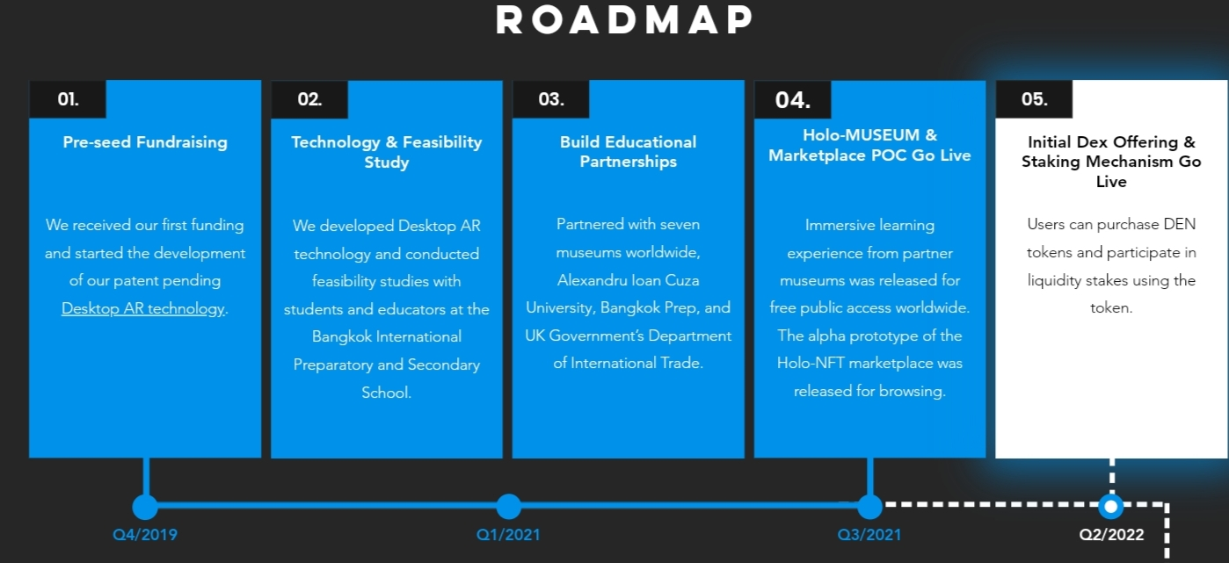

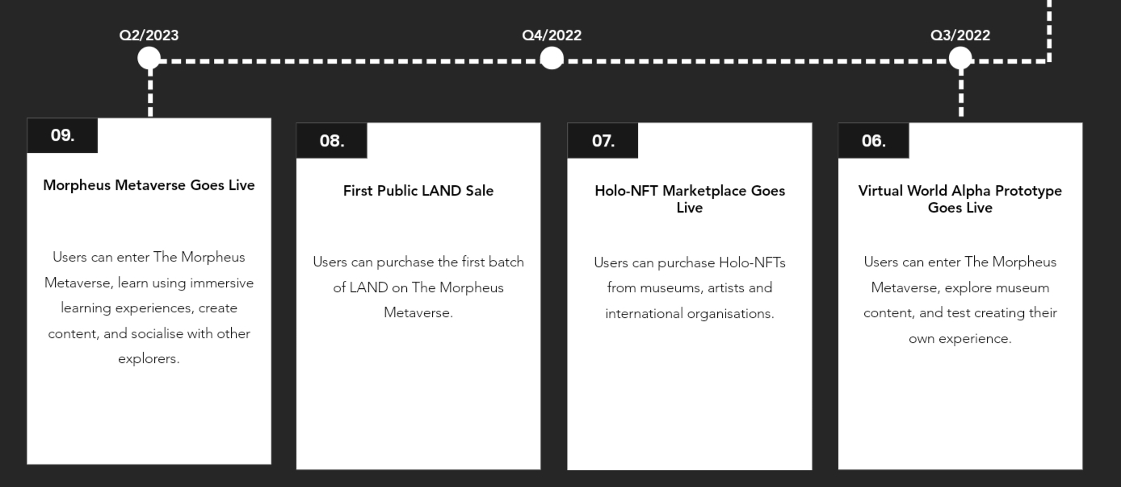

Fig.1: Morpheus project time phases

* ***Network Readiness:***

For a start let us agree that any investment in enhancing the network and internet infrastructure in Egypt, or any country, will be beneficial for many sectors in the country not just what we propose in this paper; ie, it's always worth it. Articles in [13,14] concludes that network readiness problems was the main failure element for El Salvador Bitcoin adaption, going back to table3 in [15] network readiness in Egypt was scaled to be **38.58%,** while El Salvador's was 37.27%. However, network facilities required in cryptocurrency adoption is not necessarily the same as for minting NFTs or implementing games and Metaverses; the target customer here is abroad tourists and thus what we care most about is to cope with the most advanced network speeds and capacities of people with high tech capabilities to spend hours in Metaverse worlds without being bored of low download or having fears of trojan horses attached to the software. Finally like El Salvador minister said in [14], adding a crypto payment option increased their USA tourists by 30% from youth generations who only use crypto money, thus we expect that adding NFTs and Blockchain technology to whatever remote tourism activity the government plans to do, will add a ratio from people who pay online only through crypto wallets.

* ***Developers and team qualifications:***

There are many sites that facilitate minting NFTs without much coding experience, still Egyptology experts and tourism economics experts need to be there to decide what to mint and in what floor price. However, designing NFT games or Metaverses that use NFTs and Blockchain technology does need programming experience; see [75] for an example of developing an NFT game, while [76] is a post graduate students experience in learning the technicalities of minting an NFT. We believe this is not much of a problem, Egyptian universities graduate no less than 4000 qualified students every year[9]; regarding virtual tours, the samples in [60,63,77] are done by Egyptians, with the first project starting as early as 2007 and keeping an open source framework available for interested developers [78]. In any case, training generations to code smart contracts and design games or Metaverses increases the country human resources. Artistic and creativity drawing will be needed to inspire from the history, and Egypt do not lack cartoon designers or applied arts faculties. Also, lawyers with enough information technology skills, and DeFi knowledge will be needed at some stage to review the terms in the contract deals (recall the Italian case), and formulate the necessary usage regulations. The study in [15], as a peer reviewed study, has scaled ***Egypt Human Development Index (HDI)*** as **0.707** and ***Education*** to be **0.618**, both in a 0 to1 scale.

* ***Blockchain Choice & Design decisions***

There are a lot of existing Blockchains each with certain features and characteristics; countries do thorough studies and examine different aspects and deal proposals before choosing to mint their NFTs on a certain Blockchain. Examples from the above are El Salvador choice of Bitcoin, Ethiopia choice of Cardano, and Dubai choice of Ethereum; Appendix A is a table consolidating different choices of museums and cultural entities. Factors that affect such choice include transaction fees [76], popularity of the network, being *un-forkable*[10], energy consumption and eco-friendly (Tezos were chosen by WitWorth art Gallery for that [79], Palm, and Algorand by others). Other design decisions include off-chain NFT data storage [80], available auction mechanisms and whether it would be possible to divide the NFT ownership into stakes that could be traded separately[11] to sell the NFTs, security guarantees; *interoperability* between different Metaverses, liabilities and defining responsibilities in an interactive user empowering environment as Metaverse, were some of the issues pointed out by the EPRS paper [74].

* ***NFT Copyrights and IP rights***

As the NFT community which was initiated mainly by enthusiased youth gradually matures, it started to recognize and define different copyrights for different NFT types; there are edit rights, intellectual rights, resell rights, royalty rights for original owner resell profit ratio, buyers group membership rights, and IP copyrights [81]. Buyers also sometimes are confused and sometimes get, or feel, decieved about they actually bought [82,83]. [84] is a starting project offering '***Can't Be Evil***'[12] alpha version NFT licences smart contract (*CantBeEvil.sol*)[13]; the team contains legal consultants too. In general, governmental scale projects should make carefully thought choices about each NFT kind they sell and be clear to their customers. For example, one may expect rare heritage NFT photos should have the same rights as physical pieces sold in international auctions with additional country's royalty ratio from any resell, while memorial moderate to cheap NFTs may be user editable, maybe royalty rights from using the NFT in media clips or shows, and maybe buyers benefits like bonuses or discounts on tours, also Metaverse NFTs could be rentable (not just sellable) to be worn in a certain Metaverse world gathering.

* ***Security & Privacy, Data Protection***

It's expected that any virtual or augmented reality application will get some information about its users that will increase with like the dimensions of the room they're in, their figure shape, arm length or strength,...etc all these information are used by the application [85]; naturally a complete Metaverse world with clothes and accessories to be worn will know more about its users [86,87]. For those threats and more many voices claim blockchains are essential to Metaverses; blockchains provide cryptographically secure transactions and authentication. ***Meta Guard*** is a recently proposed solution [88], where techniques we could relate to differential privacy that protects people privacy when gathering statistics, or to obfuscation that is sometimes used in web browsers [89] or blockchains to hide transactions details or smart contract codes [90], by mangling different users data so none is revealed, or injecting random data is in each user data; see the original paper [91] for the details and the trade offs. We have to know also that NFT different attacks are still there and have to be dealt with [92]. In general, users should feel more confident to buy or get into authorities backed NFTs and Metaverses, and thus states are expected to design more robust and cryptographically secure applications. A merit or advantage which could be promoted is that parents should feel more safe for their children to spend time playing and learning history at the same time (***learn & earn*** concept) in governmental backed games and metaverses, with the all going talks about a massive number of risky games and expectedly future metaverses around.

* ***Regulations & Liabilities***

In any case, countries ought to decide on larger scope regulations for NFTs and cryptocurrency trading. In addition the EPRS paper [74] pointed out in its paper to the necessity of defining responsibilities in data sharing between different Metaverses and the challenge of allocating liabilities in an often overlapping roles environment as Metaverses; what the PWC [34] described as *"empowering users"* feature. Meaning that this users attracting feature that gives them the power to be creative and make their own rules, will make it harder for regulators to separate such overlapping roles and define responsibilities when something wrong happens. So, if governments will design their state backed Metaverses, they have to be more cautious in defining user capabilities and constrains inside the Metaverse without being so repulsively constraining them. Also governments will have to make their own regulations that NFT buyers should obey, because users are expected to be from different countries and there's no unique international law till now.

* ***Economical Decisions & Analysis***

Many studies and discussions are there in the literature about NFTs risk & return analysis [93,94], and more is expected to evolve about Metaverses. However, we believe this can't be considered enough to judge the proposed tourism applications; the analysis should be done in a case by case basis, where the people passion about the NFT or Metaverse subject is a correlated variable. The target customers willing to pay amount should be studied with the project cost to determine fees and prices. We have virtual museum tours prices as a starting guide [95], then [96] is an example of a recent (April 2022) marketing study on metaverse's potential audience focusing on the specific case of museums Metaverses. Decisions may include what to sell and what to use as an advertising promo or free NFT drops, the geo distribution of free drops in correlation to tourists ratios, how to assess customers satisfaction (performance metrics) and use it as a feedback to enhance the Metaverse or game. DAWs as being more expensive to create should be done according to prior selling or renting demands, along with a comparative study of using them in abroad exhibitions instead of real pieces (less transformation cost, needed guards,...etc). Existing literature examples for analyzing the economic potential of virtual tours and other factors during COVID-19 are [97,98], with [97] focusing on Egypt although done in Oman; while [99] is a forecasting study using neural networks. Note that NFT royalties profit can help in measuring Market preferences as will be explained shortly.

1. NFTs .. The Concept, and Technical Details

This section gives the necessary scientific background to understand NFTs from the developers view.

**6.1 The Conceptual Meaning of an NFT**

The term NFT stands for ***Non Fungible Token***, and was first introduced then standardized by the Ethereum foundation in Jan 2018, to represent, and hence trade, uniquely identified items through transactions in the Blockchain [18,100]. The term ***Token*** is adopted from Systems Programming where it refers to the item currently processed by the parser of a programming language compiler; tokenizing an item in Blockchain terminology means allocating a storage type to it and define the necessary interface functions to be processed in smart contracts code and thus transactions. In Ethereum, NFTs are represented by the ERC-721 token type as opposed to the original ERC-20 token type representing fungible tradable money[14]. ERC-721 evolved in the year 2017 through Cryptopunks then the famous Cryptokitties game [18] till it was standardized by EIP-721, because those items needed more data attributes to be attached to them, like Metadata, and different interface functions to handle them [101].

The ***fungiblility*** of currency in general, whether fiat or crypto, means money is only identified by its value; even in fiat currency, people normally do not care about its serial number unless there's an authority tracing investigation. On the other hand, your ticket seat for example is unique and have a unique time date & seat position, even though there could be many tickets with the same price. See [102] for a law suit example illustrating fiat currency fungiblility, and to understand that even UTXO-based blockchains treats cryptocurrency as fungible.

**6.2 Implementing NFTs in Different Smart Contract Blockchains**

Ethereum was the poineer Blockchain in introducing and massive usage of NFTs through two standard token types ERC-721 and ERC-1155 , however most current blockchains like Solana, Flow, Cardano, Algorand,... offer standard handling of NFTs. In fact they had a chance to be explored and nourish when Ethereum transaction gas fees became too high[15] for gamers and artists at the early days of EIP-1559 . It's merely like handling different abstract data structures, Fig.2 [81,103], in different programming languages, where each blockchain has a different smart contracts coding language; examples are Solidity in Ethereum, Rust in Solana, Cadence in Flow. [76] is post graduate students report describing Ethereum's Solidity to be as abstract as Python, while developing on Solana's Rust to be similar to programming in C. A detailed thorough comparison of different NFTs standards may extend to a complete technical report, graduation project, or thesis, and we believe it is recommended to be done if Egypt is to go forward in implementing the proposed ideas; see sec.2.2 in [19] for a condensed survey. Other than coding methodology, implementations differ on how Metadata is handled and stored, what do they contain [104], where the original NFT image itself is stored [80], how batch minting is handled in one transaction to save gas fees, what cryptographic functions and techniques are used, how royalties are handled to trace original owner with a certain ratio with each resell. We will suffice here with a brief few remarks and terminologies to make things clear; we also selected an NFT learning example diagram from *OpenSea.com* inFig.3, more with different implementations are included in the Mandiant report [80].

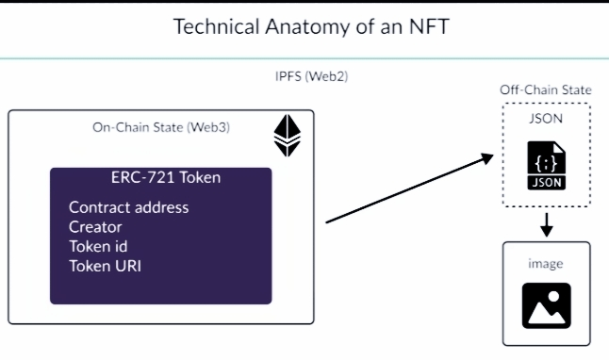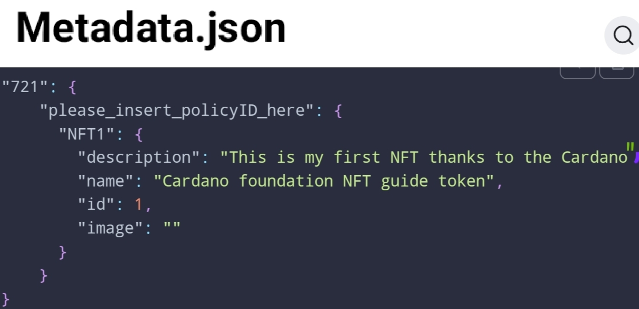

Fig.(2-a) abstract anatomy of NFT [81]. Fig.(2-b) example NFT JSON [103]

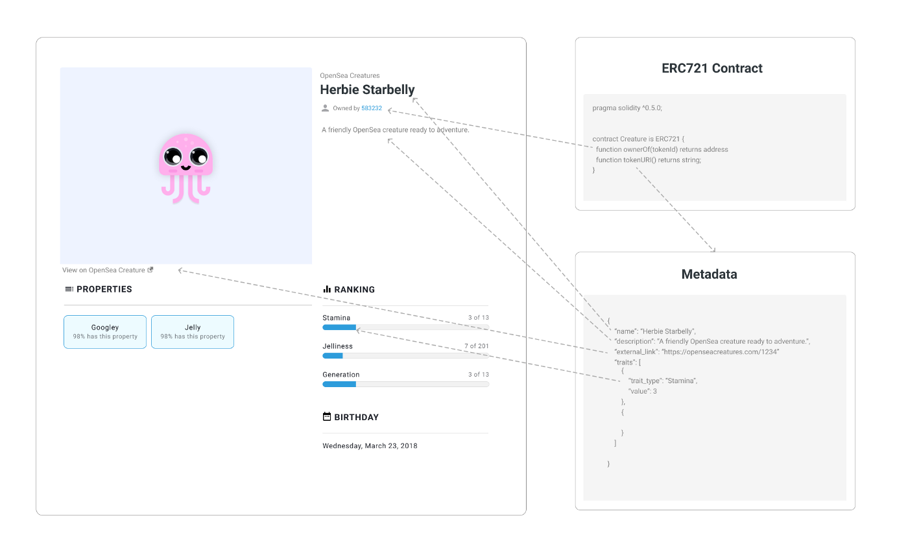

Fig.3: an NFT with it's ERC-721 and metadata (OpenSea)

***Metadata***

The term means in general *data about data*; ie, data needed to identify or classify the stored data. This is an optional extension in Ethereum ERC-721, and a must in Cardano; usually contains name, symbol, URL, description of the NFT, could contain thumbnail image, ... . Blockchains may differ in the way Metadata is stored, because it would be expensive to store all the metadata about every NFT on the Blockchain. Such details should be part of the Blockchain choice decision depending on the usage purpose; for example the cryptographic hash in Cardano metadata make it more suitable for identity and traceability management [103,105], the flexibility and continuous evolve of Ethereum make it more popular in Game NFTs.

***Where's the NFT Physically Stored?*** In addition to the Blockchain token, and the metadata, the digital image representing the NFT has to be stored somewhere. NFTs could be stored in a centralized server like the *Amazon* ***CloudFront***, or in a distributed peer-to-peer networks like the *InterPlanetary* *File System (****IPFS***) and more recently ***arweave****.org* which is a permissioned Blockchain[16]; [80] goes through all such methods and the data availability risks and loss incidents in each, while [106] proposes a similar side Blockchain solution named ***StateSnap***, [104] also suggests data blockchains proliferation. We in this paper think this decision should be carefully studied, since the incidents in [80] include a penetration to a US state government server.

The ***Enumeration Extension*** in Ethereum allows an NFT issuer contract to publish its full list of NFTs and make them discoverable. Solana [76, 107] has the ***candy machine*** to mint multiple NFTs, and the ***Gumdrop*** to give NFTs to a large number of users through the use of Merkle trees [108]. Cardano also allows the mint of multiple NFTs in one transaction.

***Royalty***

Used to retain a profit ratio to the original creator from every resell, a property that is considered useful for art creators; could be used similarly by countries or museums for their NFTs. The Whitworth for example has decided to retain 20% royalties from its minted NFTs; this means that the gallery will earn an extra revenue from every resell along with the statistical benefit of reading the market preferences and resulted variation in price of its NFTs [109].

**6.3 Implementing NFTs in Bitcoin**

Although NFTs got their popularity through Ethereum, historical surveys relate NFTs to as early as 2012 ***colored coins*** in Bitcoin [19]. The problem with implementing NFTs in Bitcoin does not support smart contracts; however more functionality is possible through lightning networks and side chains. Typically a transaction with minimum possible BTC value, dust UTXO, moves the action to another side chain (Bitcoin pegged blockchain) where the NFT is minted or processed in any way [110]. A lot of Bitcoin NFTs providers are given in [111]; in fact this could be one of the reasons behind the increase of dust UTXOs in Bitcoin lately[17]. It's also worth mentioning that Cardano too as a UTXO-based blockchain, and in spite of providing coding capabilities, needs a 1.4 ADA minimum value UTXO in each transaction minting one or possibly multiple NFTs [103]. Supporters of Bitcoin NFTs say that it is more robust and safe for users to mint their NFTs on a Bitcoin empowered Blockchain than on a newer one that may disappear or fork after sometime; however, we point out that Bitcoin remains a *POW* Blockchain for massive NFT minting plans. It's also worth mentioning that buying other blockchains NFTs with Bitcoin money is possible through tokenizing BTC into Wrapped token WBTC offered by most DEXs which can be then traded or used as a collateral [110].

1. Conclusions & Prospectives

We aimed at this paper to study the potential of all NFTs uses as collectables, in games, and in Metaverses uses to monetize heritage, ancient civilizations, and all tourism resources for a country like Egypt. We wrote a Systemization of knowledge paper trying to consolidate all what is there in the literature and in the internet as well. The hardest part was sifting through a tremendous amount of information, deciding what was more important to document in the big picture, and also doing it in a way that the deeper details are accessible to the reader through the provided links and references. We conclude our paper with recommending that Egypt, which started thinking of virtual online tourism as early as 1996, should catch-up with the developed world and launch its NFT collections, a number of learn, play, and earn history games and Metaverses as well; we proposed a number of choices in this paper. We also touched on the security problems and different design decisions involved in the development cycle of such series of projects. At the end, we don't say it is an easy task, we showed example similar project that planned a 3 years roadmap, however we believe it is worth it. In addition to the impact of direct revenue for a country in debt, there's the advantage of digitaly archiving all the existing heritage and whatever is under the threat of destruction or elimination; in fact the government usually pay for that while here it will be a source of income. Also, we emphasize on the beneficial impact of increasing the number of qualified Human resources; in 2022 Egypt Central Bank statistics Egyptians working abroad remittances added $31.9bn to the country's foreign currency balance which is much more than tourism revenue [112]. We believe such up-to-date Blockchain and Metaverse projects will promote research and experience in all Blockchain, web3, and multimedia related fields; in a way it will be a learn & earn process like that in existing museums projects. Every participant will have to learn about Blockchains, DeFi systems, smart contracts coding; each implementation problem or debatable design decision can start a scientific research thread, maybe a thesis or a graduation projecy. At the end, this will provide them with distinguished work chances in a variety of applications, and will raise Egypt HDI & Education in studies like [15].

Acknowledgements

I'm grateful to everyone participated in making me acquire this level of knowledge & research skills: from my graduation faculty Alexandria Computer Engineering department (the encouragement of Prof. Nagwa Elmekky, and the guiding soul of Prof. Ahmed Belal), to everyone who has put their work free online (MIT, Prof. Roughgarden, Berkeley MOOC, arXiv). I also thank EAI for the given discount to an independent researcher from a developing country.

References

1. Toronto Universit, https://citizenlab.ca/2018/03/bad-traffic-sandvines-packetlogic-devices-deploy-government-spyware-turkey-syria/, Cited by Bitcoin News and market watch, accessed 10/8/2022.
2. https://guardian.ng/opinion/outlook/bitcoin-adoption-and-its-impacts-on-the-developing-world, accessed 7/8/2022.
3. https://allaboutethio.com/blockchain-cryptocurrencty-bitcoin-in-ethiopia.html, written 2017, accessed 7/8/2022
4. “How Ethiopia Could Monetize Bitcoin & Escape The Industrial Phase”, https://projectmano.com/plan, last accessed 7/8/2022.
5. https://twitter.com/betelhem_dessie/status/1369390186115833857, accessed 8/8/2022.
6. https://www.pelicoin.com/blog/what-is-the-economic-impact-cryptocurrency, accessed 7/8/2022.
7. https://www.cnbc.com/2022/04/26/fort-worth-tx-the-first-city-in-the-us-to-mine-bitcoin.html, accessed 10/8/2022
8. Ian Smith, https://www.euronews.com/next/2022/03/09/cbdcs-these-are-the-countries-are-using-launching-or-piloting-their-own-digital-currencies, accessed 11/8/2022.
9. https://nilefm.com/geekdom/article/4750/betting-on-bitvoin-egypt-to-release-a-digital-currency-framework-soon, accessed 10/8/2022.
10. MacKenzie Sigalos, https://www.cnbc.com/2021/07/19/malaysian-police-steamroll-1point25-million-worth-of-bitcoin-mining-rigs.html, accessed 12/8/2022.
11. Chloe Orji, https://www.euronews.com/next/2022/04/27/bitcoin-ban-these-are-the-countries-where-crypto-is-restricted-or-illegal2, accessed 12/8/2022.
12. David Thomas, https://beincrypto.com/national-bank-of-ethiopia-warns-of-illegal-crypto-use/, accessed 7/8/2022.
13. Bloomberg, “El Salvador.s Big Bitcoin Gamble Backfires to Deepen Debt Woes”, https://www.bloomberg,com/, accessed 7/8/2022.
14. Mackenzie Sigalos, https://www.cnbc.com/2022/06/25/el-salvador-bitcoin-experiment-not-saving-countrys-finances.html, accessed 7/8/2022.
15. Alnoor Bhimani and Sameen Arif, “Do National Development Factors Affect Cryptocurrency Adaption”, Science direct Technological Forcasting and Social Change, Vol 181. Aug 2022, 121739. https://doi.org/10.1016/j.techfore.2022.121739
16. Kelsie Nabben, RMIT University, https://theconversation.com/cryptocurrency-has-an-impact-on-economies-thats-why-some-are-afraid-of-it-and-some-welcome-it-175911, accessed 7/8/2022.
17. Iwa Salami, University of East London, https://theconversation.com/amp/ethiopias-blockchain-deal-is-a-watershed-moment-for-the-technology-and-for-africa-160719, accessed 26/7/2022
18. Ethereum use cases, "Non-fungible Tokens (NFT)", https://ethereum.org/en/nft/, accessed 28/8/2022.
19. "Demystifying Non-Fungible Tokens", A Thematic Report Prepared ByThe European Union Blockchain Observatory & Forum, https://www.eublockchainforum.eu/files/reports/DemystifyingNFTs_November%202021_2.pdf
20. https://www.terminalfour.com/blog/posts/fad-or-future-can-nfts-transform-higher-education.html, accessed 11/8/2022.
21. Knack, https://nonfungible.com/news/opinions/nfts-and-higher-education-part-1, accessed 11/8/2022.
22. DeFi MOOC, https://medium.com/@defi.mooc/announcing-the-defi-mooc-2021-nft-and-badge-collection-c8a42fbdc998, last accessed 23/7/2022; the minted NFTs https://gallery.metamirror.space/collection/?name=defimooc2021nft, accessed 15/8/2022.
23. https://news.bitcoin.com/ngo-announces-plan-to-use-nfts-for-famine-victims-of-ethiopia-tigray-war/, accessed 2/2022.
24. https://www.insidehighered.com/news/2022/01/20/colleges-cash-nfts-new-fundraising-mechanism, accessed 11/8/2022.
25. Amy Corr, https://musebycl.io/digital-data/nft-sales-free-egyptian-women-jailed-defaulting-loans, accessed 10/8/2022.
26. https://www.outlookindia.com/business/ukraine-raises-600-000-through-nfts-to-rebuild-museums-destroyed-in-russian-invasion-news-189742, accessed 18/8/2022.
27. Mona Abdou, https://egyptianstreets.com/2021/08/21/why-charity-nfts-wont-save-palestine/, accessed 16/2/2022.
28. Crypto Climate Accord, "Powering Crypto with 100% Renewable", https://cryptoclimate.org/solutions/, accessed 16/8/2022.
29. M. Platt, J. Sedlmeir, D. Platt, J. Xu, P. Tasca, N. Vadgama, and J. I. Ibañez, "The Energy Footprint of Blockchain Consensus Mechanisms Beyond Proof-of-Work", IEEE 1st International Conference on Software Quality, Reliability and Security Companion (QRS-C), Dec 2021, https://ieeexplore.ieee.org/document/9741872.
30. Francis Bignell, https://thefintechtimes.com/traders-of-crypto-finds-cardano-to-be-the-least-energy-intensive-crypto-coin-in-2021/, accessed 16/8/2022.
31. https://solana.com/news/solanas-energy-use-report-march-2022, accessed 10/8/2022
32. Liam Frost, https://decrypt.co/71353/ethereum-foundation-eth-2-0-will-use-99-95-less-energy, accessed 16/8/2022.
33. https://www.thetimes.co.uk/money-mentor/article/eco-friendly-cryptocurrencies/, accessed 10/8/2022.
34. PWC, "Perspectives from the Global Entertainment & Media Outlook 2022–2026", https://www.pwc.com/gx/en/industries/tmt/media/outlook/outlook-perspectives.html, accessed 14/8/2022.
35. https://insights.glassnode.com/nfts-and-gaming-lead-the-eth-rally/amp/#click=https://t.co/2Hx3hOJdkk, accessed 12/2021.
36. Jason Nelson, ,https://decrypt.co/101922/johnny-depp-ethereum-nfts-surge-after-actor-wins-suit-against-amber-heard, accessed 12/8/2022.
37. Ashish Priyadarshi, https://thesportsrush.com/nfl-news-patrick-mahomes-joined-rob-gronkowski-after-selling-3-4-million-worth-nft-art-pieces-in-just-20-minutes/, accessed 11/8/2022.
38. Jon Rice, https://cointelegraph.com/news/thanks-to-bauhaus-i-totally-get-nfts-now, accessed 4/8/2021.
39. Vitalik Buterin, "Alternatives to selling at below-market-clearing prices for achieving fairness (or community sentiment, or fun)", https://vitalik.ca/general/2021/08/22/prices.html, accessed 23/1/2022.
40. https://statistics.yale.edu/news/yale-statistics-and-data-science-auctions-nft; the NFT: https://foundation.app/@YaleDataScience/foundation/41810, accessed 11/8/2022.
41. Helen Partz, https://cointelegraph.com/news/russian-state-hermitage-raises-440k-via-binance-nft-auction, accessed 12/8/2022.
42. Megan C. Hills, CNN, "First-edition copy of US Constitution sells for record $43.2 million", http://edition.cnn.com/style/article/us-constitution-sothebys-sale/index.html, accessed 18/8/2022.
43. https://www.iconicmoments.co/proof-collective-partners-with-iconic-moments-for-grails-ii, accessed 31/8/2022.
44. F. Valoneti et al, “Crypto Collectibles, Museum Funding and OpenGLAM: Challenges, Opportunities and the Potential of Non-Fungible Tokens (NFTs)”, Appl. Sci. 2021, 11(21), 9931, a special issue on Advanced Technologies in Digitizing Cultural Heritage; https://doi.org/10.3390/app11219931.
45. https://cuseum.com/blog/2021/11/16/how-21-museums-amp-cultural-organizations-engaged-with-nfts-in-2021, accessed 31/8/2022
46. Scott Reyburn, https://www.nytimes.com/2022/03/25/arts/design/museums-nfts.html, accessed 7/8/2022.
47. https://cuseum.com/webinars/discussing-and-debating-the-potentials-of-nfts-in-the-museum-sector-overview, accessed 19/8/2022.
48. Elian Carsenat, Joey Heinen, Joel Ferree, Los Angeles museum, https://unframed.lacma.org/2021/12/03/nfts-and-museum-part-5-art-collections-blockchain, accessed 31/8/2022.
49. https://greg.org/archive/2022/07/19/objet-daw.html, accessed 14/9/2022.
50. https://consgedda.esteri.it/consolato_gedda/en/la_comunicazione/dal_consolato/2019/10/inaugurazione-mostra-leonardo-da.html, accessed 14/9/2022.
51. Ian Oxborrow, https://www.thenationalnews.com/business/2022/05/18/dubais-museum-of-the-future-to-launch-its-first-nft-collection/, accessed 18/8/2022.
52. Paulina Okunytė, https://dailycoin.com/dubai-aims-to-become-metaverse-capital-of-the-world/, accessed 10/9/2022.
53. Ch. Ligon, https://www.coindesk.com/layer2/metaverseweek/2022/05/25/why-is-south-korea-throwing-money-at-the-metaverse/, accessed 10/9/2022.
54. The Morpheus project, https://www.morpheus.art/, accessed 31/8/2022.
55. Vastari Labs, https://labs.vastari.com/about-us, accessed 31/8/2022.
56. Tim Deakin, https://www.museumnext.com/article/iconic-moments-developing-an-nft-marketplace-for-museums-around-the-world/, accessed 31/8/2022.
57. Yizan He, https://fortune.com/2022/04/28/museums-history-gamification-nfts-metaverse-tech-art-yizan-he/, accessed 31/8/2022
58. Egyptian GODs NFT game, https://linktr.ee/egyptiangods, https://twitter.com/Egyptiangodsnft., accessed 11/8/2022.
59. Egypt Tours 2000 about file, http://www.touregypt.net/egypt-info/magazine-mag03012001-mag6.htm, accessed 31/8/2022
60. Bibliotheca Alexandrina and The Alexandria & Mediterranean Research Center, "Heritage Preservation: Tangible Heritage: International Augmented Med (I AM)", https://www.bibalex.org/alexmed/Projects/Details.aspx?ID=98f32266-8aff-4060-a07a-e7d84383293c, accessed 29/8/2022.
61. Min Chen, https://jingculturecommerce.com/national-museums-liverpool-crypto-connections/, accessed 14/9/2022.
62. Lizzie Glithero-West, “Performing Tut”, Tutankhamun Exhibition, @UoBEgyptology, https://twitter.com/heritage_lizzie/status/1542850475548098560, accessed 3/7/2022
63. R. Hammady, M. Ma, Z. Alkahla, and C. Strathearn, “A Framework for Constructing and Evaluating the Role of MR as a Holographic Virtual Guide in Museums”, Museum Eye project, Springer, Virtual reality, Dec2021, DOI: 10.1007/s10055-020-00497-9.
64. Andrew Singer, https://cointelegraph.com/news/does-the-metaverse-need-blockchain-to-ensure-widespread-adoption, accessed 4/8/2022.
65. https://trc-leiden.nl/trc/index.php/nl/textiel-momenten/1410-tutankhamun-s-wardrobe, accessed 26/7/2022.
66. https://www.prnewswire.com/news-releases/truesy-a-curated-nft-gallery-and-marketplace-for-culture-and-fashion-301277983.html, accessed 3/5/2022.
67. https://www.cnbc.com/2021/12/22/here-are-the-companies-building-the-metaverse-meta-roblox-epic.html, accessed 3/5/2022.
68. Maghan Macdowell, https://www.voguebusiness.com/technology/the-baby-birkin-nft-and-the-legal-scrutiny-on-digital-fashion, accessed 3/5/2022.
69. "Metaverse beyond the hype: Multidisciplinary perspectives on emerging challenges, opportunities, and agenda for research, practice and policy", July 2022, International Journal of Information Management.
70. Stefan B. Hall and Cathi Li, World Economic Forum, https://www.weforum.org/agenda/2022/02/metaverse-monetization-business-guide/, accessed 12/8/2022.
71. Cathi Li, World Economic Forum, https://www.weforum.org/agenda/2022/05/how-to-build-an-economically-viable-inclusive-and-safe-metaverse/, accessed 12/8/2022.
72. https://www.xrtoday.com/virtual-reality/what-is-blockchain-and-what-does-it-have-to-do-with-the-metaverse/, accessed 4/8/2022.
73. Elena Canorea,, https://www.plainconcepts.com/nft-blockchain-metaverse/, accessed 4/8/2022.
74. Osborne Clarke,https://kqeducationgroup.com/european-institutions-contemplate-the-metaverse-and-its-policy-challenges-osborne-clarke/, accessed 24/8/2022.
75. Xuannu, ”Inking a Smart Contract”, Crypto Coven NFT game, https://cryptocoven.mirror.xyz/A622VSRm8-9oLzc8l3oFGmfnFUZQmDQ3Wx3ObhSlhsc, Cited in Women in Blockchains WIB, accessed 15/3/2022.
76. Julia Martin, Carrie Hay Kellar, "A Technical Deep Dive Into and Implementation of Non-Fungible Tokens in a Practical Setting", COMS 6998-006: Foundations of Blockchains, 2021, https://timroughgarden.github.io/fob21/reports/r8.pdf.
77. https://worldvirtualtours.online/the-extraordinary-life-of-hatshepsut-daughter-sister-wife-of-pharaoh-and-pharaoh-herself, accessed 13/8/2022.
78. https://vi-seem.eu/2018/07/19/virmuf-virtual-museum-framework-for-exhibiting-digitized-collections/, accessed 6/9/2022.
79. Eruc James Beyer, https://nftnow.com/features/hit-hard-by-the-pandemic-museums-turn-to-nfts-to-survive/, accessed 31/8/2022.
80. Randi Eitzman, https://www.mandiant.com/resources/blog/nft-storage-and-availability-risk-worth-considering, accessed 17/9/2022.
81. https://www.galaxy.com/research/insights/a-survey-of-nft-licenses-facts-and-fictions/, accessed 24/8/2022.
82. Andrew Hayward, https://decrypt.co/107827/bored-apes-moonbirds-misled-buyers-nft-ip-rights-galaxy-digita, accessed 20/8/2022.
83. https://twitter.com/Lakoz_/status/1555570398267412480, accessed 1/9/2022.
84. Miles Jennings and Chris Dixon, "The Can’t Be Evil NFT Licenses", a16x crypto, https://a16zcrypto.com/introducing-nft-licenses/, accessed 1/9/2022.
85. Junsu Lim, Hyeonggeun Yun, Auejin Ham, and Sunjun Kim, "Mine yourself!: A role-playing privacy tutorial in virtual reality environment", In CHI Conference on Human Factors in Computing Systems Extended Abstracts, CHI EA ’22, New York, NY, USA, 2022. Association for Computing Machinery.
86. Philipp Sykownik, Divine Maloney, Guo Freeman, and Maic Masuch.,"Something personal from the metaverse: Goals, topics, and contextual factors of self-disclosure in commercial social vr.", In CHI Conference on Human Factors in Computing Systems, CHI’22, NY, USA. Association for Computing Machinery.
87. https://www.securitymagazine.com/articles/98142-9-security-threats-in-the-metaverse, accessed 23/8/2022; the original report: https://www.trendmicro.com/vinfo/us/security/news/cybercrime-and-digital-threats/metaworse-the-trouble-with-the-metaverse#newnavmenu-mobile, accessed 26/8/2022.
88. T.Claburn,https://www.theregister.com/2022/08/18/metaguard_promises_protection_from_metaverse/, accessed 23/8/2022.
89. AdNauseam, a tool to confuse Google's ad network, https://adnauseam.io/, accessed 26/8/2022.
90. Vitalik Buterin, https://ethresear.ch/t/how-obfuscation-can-help-ethereum/7380, last accessed 26/8/2022.
91. V. Nair, G. M. Garrido, and D. Song, “Exploring the Unprecedented Privacy Risks of the Metavers”, arXiv:2207.13176v1 [cs.CR], 26/7/2022; the product: https://rdi.berkeley.edu/metaguard/, accessed 25/8/2022.
92. Will Gottsegen, https://www.coindesk.com/layer2/2021/12/20/nft-forgeries-arent-going-away/, accessed 19/8/2022.
93. Mieszko Mazur, "Non-Fungible Tokens (NFT). The Analysis of Risk and Return", Elsevier Science, SSRN, https://papers.ssrn.com/sol3/papers.cfm?abstract_id=3953535, 32/10,2021
94. WIB, "NFT Trading and Risk Management", https://twitter.com/i/spaces/1MnGnkwWrgYJO, accessed 26/8/2022.
95. https://360virtualbusinesstours.com/360-virtual-business-tour-faqs/how-much-does-it-cost-to-make-a-virtual-tour/, accessed 6/9/2022.
96. Hyun-Kyung Lee, S. Park, Y. Lee, "A proposal of virtual museum metaverse content for the MZ generation", Digital Creativity, vol.33- Issue 2, pp. 79-95, (2022), https://www.tandfonline.com/doi/abs/10.1080/14626268.2022.2063903.
97. Giuseppe Resta, Fabiana Dicuonzo, Evrim Karacan, Domenico Pastore, "The impact of virtual tours on museum exhibitions after the onset of covid-19 restrictions: visitor engagement and long-term perspectives", July 2021.
98. O. ElSayed & H. Aziz, "Virtual Tours a Means to an End: An Analysis of Virtual Tours’ Role in Tourism Recovery Post COVID-19", Journal of Travel Research, March 2021, https://journals.sagepub.com/doi/full/10.1177/0047287521997567
99. Anestis Fotiadis, Stathis Polyzos, Tzung-Cheng T.C. Huan, "The good, the bad and the ugly on COVID-19 tourism recovery", Annals of Tourism Research, Elsevier, 2020, https://www.ncbi.nlm.nih.gov/pmc/articles/PMC7832145/
100. William Entriken, Dieter Shirley, Jacob Evans, Nastassia Sachs, https://eips.ethereum.org/EIPS/eip-721, accessed in 28/8/2022.
101. https://ethereum.org/en/developers/docs/standards/tokens/erc-721/, accessed 28/8/2022.
102. MAS.S62, lec.17, Tadge Dryja, "Coinjoin, Signature Aggregation", pdf: https://ocw.mit.edu/courses/mas-s62-cryptocurrency-engineering-and-design-spring-2018/c879ebcc61792c1df2a0f0a610350c24_MAS-S62S18-lec17.pdf, slides 5-7, video: https://youtu.be/BFwc2XA8rSk, mins .
103. https://developers.cardano.org/docs/native-tokens/minting-nfts/, accessed 29/8/2022.
104. Anastasiya Lavrova and Oleg Iakushkin, "NFT Performance and Security Review", Computational Science and Its Applications – ICCSA 2022 Workshops: Malaga, Spain, July 4–7, 2022, Proceedings, Part I, https://dl.acm.org/doi/abs/10.1007/978-3-031-10536-4_15
105. https://github.com/cardano-foundation/CIPs/blob/8b1f2f0900d81d6233e9805442c2b42aa1779d2d/CIP-NFTMetadataStandard.md, accessed 30/8/2022.
106. Siqi Feng et al, "StateSnap: A State-Aware P2P Storage Network for Blockchain NFT Content Data", Algorithms and Architectures for Parallel Processing: 21st International Conference, ICA3PP 2021, Virtual Event, December 3–5, 2021, Proceedings, Part III, pp. 3-18, https://doi.org/10.1007/978-3-030-95391-1_1
107. https://solana.com/developers/nfts, accessed 29/8/2022.
108. https://gist.github.com/jcnelson/8c5f89c29192166a4a37f2b807ed1431, accessed 9/9/2022.
109. Frances V Liddell, "The Crypto-Museum: Investigating the impact of blockchain and NFTs on digital ownership, authority, and authenticity in museums", A thesis submitted to the University of Manchester for the degree of Doctor of Philosophy in the Faculty of Humanities, 2022.
110. Alex Lielacher, https://cryptonews.com/exclusives/nfts-on-bitcoin-yes-thats-a-thing.htm, accessed 29/8/2022.
111. Juhi Mirza, https://www.gfinityesports.com/cryptocurrency/bitcoin-nft/, accessed 30/8/2022.
112. Mena, https://www.egyptindependent.com/cbe-remittances-of-egyptians-abroad-hit-dlrs-31-9-bln-in-fy-2021-22/, accessed 31/8/2022.

**Appendix A**

We tried to consolidate all musuems NFT experiments around the world with their Blockchain choices and any necessary remarks

|  |  |  |  |
| --- | --- | --- | --- |
| **Museum/Gallery** | **Country** | **Blockchain** | **Remarks** |
| Liverpool | England |  | Crypto Connections, free, PhD study, "Book of the Dead" NFT  https://jingculturecommerce.com/national-museums-liverpool-crypto-connections/ |
| British Museum | England | planning to switch to Ethereum 2.0 POS | have been fiercely criticized for corporate and private philanthropy linked to fossil fuels, planning to switch to the Ethereum 2.0 blockchain  https://rga.com/futurevision/articles/new-nft-service-industry-courts-culture-amid-controversy |
| State Hermitage | Russia | Binance | https://cointelegraph.com/news/russian-state-hermitage-raises-440k-via-binance-nft-auction |
| Uffizi Galleries & 8 more | Italy | Ethereum | DAWs, Cinello  https://news.artnet.com/art-world/unit-london-digital-artwork-2074552 |
| the Belvedere | Vienna, Austria | planning to switch to Ethereum 2.0 | did receive some negative comments around sustainability issues.  https://rga.com/futurevision/articles/new-nft-service-industry-courts-culture-amid-controversy |
| WitWorth & Manchester Srt Galleries | England | Tezos  https://tezos.com/ | Vastari Labs  https://blooloop.com/sustainability/news/green-nfts-sustainable-museum-technology-greenloop/ |
| Aspen Museum | USA | Palm  https://palm.io/ | https://www.ft.com/content/76cacb9e-ba20-44e7-9ced-f570553af5e1 |
| Data History Artifacts Museum | NY-USA | Algorand | https://www.binance.com/en/news/top/7038222  https://museum.datahistory.org/about |
| Moco Museum | USA | Algorand | https://mocomuseum.com/mocoverse/ |
| Himalayas Museum | India | Re-NFT Shards Protocol | https://renft-shards-protocol.medium.com/himalayas-museum-created-the-first-global-nft-artverse-by-cooperating-with-renft-shard-protocol-c3d04c4b5430 |
| Museum of The Future | Dubai, UAE | Ethereum | https://jingculturecommerce.com/museum-of-the-future-dubai-immersive-superflux-marshmallow-laser-feast/ |
| Universal Hip Hop Museum | Bronx-NY-USA | Near Protocol | https://afrotech.com/universal-hip-hop-museum-nft-series |
| National Art Museum of Ukraine | Ukraine |  | In partnership with Estonia-based startup, STAMPSDAQ  https://www.ukrinform.net/rubric-society/3339822-works-of-ukrainian-artists-could-be-purchased-in-nft-version.html |
| St. Petersburg institution | Russia | Binance | https://news.artnet.com/art-world/guernica-tapestry-un-returned-2069976 |
| Shanghai Museum | China | Shangbo Chain | Made their own special purpose Blockchain  https://jingculturecommerce.com/shanghai-museum-museum-of-the-sea-shangbo-nfts-blockchain/ |
|  | England | DEN tokens  (a special purpose Blockchain) | The Morpheus  A joint learn to earn project  Metaverse+ HOLO-NFTs  https://www.morpheus.art/  https://whitepaper.morpheus.art/ |
| IWM  Imperial War Museums | England |
| EPIC  The Irish Imigration Museum | Ireland |
| The Hunt Museum | Ireland |
| MM  The Museum of Menerology | Romania |
| Anglo-Boer War Museum | South Africa |
| UNHCR  The UN Refugee Agency | UN |

1. We even believe the electricity needed for crypto mining in Ethiopia may have changed the valuation of different cards in the Game Theory model of the Nile Basin conflict of interests towards GERD at some moments; agriculture water was the most important in the introduction of (https://www.academia.edu/15471274/A_Game_Theory_Approach_to_Understanding_the_Nile_River_Basin_Conflict), while electricity is the dominant factor in recent statements (https://twitter.com/FdreService/status/1557674864454078464)
2. We found conflicting news about Tunisia: a negating fact checking site (https://misbar.com/en/factcheck/2022/05/25/tunisia-did-not-pioneer-the-use-of-cryptocurrency-and-blockchain), the early launching of eDinar (https://cointelegraph.com/news/tunisia-to-launch-e-dinar-national-currency-using-blockchain), the Finance minister statement: (https://www.coindesk.com/policy/2021/06/14/tunisian-finance-minister-says-bitcoin-ownership-should-be-decriminalized/). However, this is beyond the scope of this paper focusing on Egypt
3. Malaysia didn't prevent trading, only mining & what they described as illicit activities (https://www.malaymail.com/news/malaysia/2022/02/21/malaysias-illegal-crypto-mining-reaches-an-all-time-high-in-2021/2042862)
4. [18] says that NFTs trading volume in 2021 is only $17 bn, but maybe this because PWC number may include repeated selling as they stated in in their report, also "Non Fungible" recorded a potential decrease in the 2022 NFT quarterly report (https://nonfungible.com/reports/2022/en/q2-quarterly-nft-market-report) mainly due to the noticable fall of crypto prices, we believe this will not destroy our case since we are targeting tourists and Egyptology fans not for FOMO (https://www.spiceworks.com/tech/innovation/guest-article/the-future-of-nfts-is-fomo-the-best-business-model/ ) ; will be explained in more detail later in the paper
5. The Russian Central Bank consultation paper Aug2022 is described as a *blanket ban* (https://www.cbr.ru/Content/Document/File/132241/Consultation_Paper_20012022.pdf) and this doesn't prevent or contradict with the NFTs selling, the same stands for China banning mining & trading while supporting crypto research, Blockchain conferences, and Museum NFTs. In addition Russia has another problem with most of the crypto community taking the Ukrainian side (https://cointelegraph.com/news/crypto-community-reacts-to-russia-s-war-in-ukraine), collecting donations for them [26], and calling to ban Russian TXs (https://blog.chainalysis.com/reports/cryptocurrency-liquidity-russia-sanctions/), this naturally is expected to affect the Russian government strategy towards crypto.
6. The Italian government found out that Uffizi Gallery got only 70,000€, about 30% of the selling price, because the DAW creation costed 100,000€, see (https://www.museumnext.com/article/italian-government-halts-museum-nft-sales/). However, we don't know about the 2019 Saudi Arabia and 2022 exhibitions profits.
7. In fact UAE government has a stated policy about it in their official website https://u.ae/en/about-the-uae/strategies-initiatives-and-awards/local-governments-strategies-and-plans/dubai-metaverse-strategy.
8. In [64] Stanford University professor Jeremy Bailenson explains why he thinks Metaverses can exit without Blockchains using a 2003 project called "Second Life" with 70m registered accounts till now; this 2016(before NFTs) paper (https://www.sciencedirect.com/science/article/abs/pii/S026840121630175X) supports his point proposing a Metaverse deployment plan with no Blockchains.
9. In2011 Computer&Information Sciences graduated 2643+1383 Computer Engineering (https://censusinfo.capmas.gov.eg/Metadata-ar-v4.2/index.php/catalog/447/download/2411), more faculties opened since then; there's also governmental training (https://www.iti.gov.eg/iti/home) & presedential initiative (http://www.epmp.gov.eg/Default.aspx)
10. Blockchains fork (the append-only ledger splits into separe two ledgers with one parent block, the last one before the fork) when the decentralized community majorly disagrees, like Bitcoin cash and Ethereum classic. After forks the data state on-chain and off-chain would may be inconsistent (https://dl.acm.org/doi/10.1007/978-3-030-95391-1_1)
11. See (https://youtu.be/8WpIGsmyF2A) for a securitization and repurchase scheme for shared NFTs based on Stakelberg game model, (https://timroughgarden.github.io/fob21/reports/r2.pdf)for constraints/goals and impossibility results in designing an optimal NFT auction, and (https://a16zcrypto.com/nft-sales-market-clearing-gas-wars-auction-mechanism-design-for-builders/) for a very recent follow up on [39].
12. As cited in [84], the name is a guiding principle in web3 (https://twitter.com/OnChainBuilders/status/1554591962182946816) as a follow up on the 'don't be Evil' Google popularized slogan ( we are not asking you not to be Evil, we will prevent you, https://twitter.com/milesjennings/status/1564991866340184065?s=20&t=40UgFzrjtdJ5D9K6KkW_LA) .
13. The smart contract is written in Solidity; ie, for Ethereum NFTs but they will extend the project later to include other blockchains.
14. Another token type is ERC-1155, which is used to represent a collection of mixed tokens to simplify batch processing in one smart contract (https://eips.ethereum.org/EIPS/eip-1155). There are more improvement proposals to be discussed in (https://eips.ethereum.org/EIPS/); examples in pp.30-31 of [19].
15. Reached a max of 196$ in May 2022, but back to 1.57$ average (https://cointelegraph.com/news/ethereum-average-gas-fee-falls-down-to-1-57-the-lowest-since-2020), and still (https://news.bitcoin.com/ethereums-post-merge-transfer-fees-remain-low-since-mid-may-high-priority-eth-fees-are-93-cheaper/), although an extreme was reported for an NFT recording the merge (https://www.theblock.co/post/170278/an-nft-minted-after-the-merge-cost-60000-in-transaction-fees)
16. named *Block-weave* as stated in their light-paper, arweave is said to be deployed by Solana, and *Valuables* which is a market place for NFTs of tweets screenshots.
17. Observing the most richest Bitcoin addresses daily (https://bitinfocharts.com/top-100-richest-bitcoin-addresses.html), one can always find more than 10m addresses holding less than 2$. Tracing UTXOs in the dustiest addresses (https://bitinfocharts.com/top-100-dustiest-bitcoin-addresses.html) reveals another 10m; ie., ~ 20m dust UTXOs probably attaching side projects to Bitcoin Blockchain.