**ICT374 – Lab1**

1. We know that an operating system is a program. Explain the main difference between an operating system and other non-operating system programs.

Answer:

An operating system (OS) is one of the most important part of a computer, it is the system software that manages computer hardware to communicate and operate with software resources and supply common services for computer programs. Also OS allow users to interact with the hardware and the user application (e.g Google Chrome).

A non-operating system programs are the common programs that run in the foreground of a computer, for example application software is. It can perform useful tasks which are not related with what have done by OS, such as hardware communication. Non-operating system programs are directly relying on the OS to communicate with computer hardware and it cannot operate without OS.

**Difference between Operating System and Non-Operating System:**

|  |  |
| --- | --- |
| Operating System Program | Non-Operating System Program |
| Manage communication of both hardware and software part of a computer, medium where every application software runs on | Software that install onto OS, consist programs that is designed to perform a group of organized functions, activities or tasks that enable users to complete tasks |
| Perform hardware device controlling, process management, memory management, task scheduling, etc. | Perform a single specific task |
| Boots up when user switches on the computer and runs until the computer is being switched off | Runs only when user requests |
| Essential to function correctly of a computer, does not rely on non-operating system program | Always rely on OS, cannot work or cannot be installed without an OS |
| Pre-installed on the computer when purchased | Installed after the computer purchased |
| Only one OS for each computer | Without any limit on the same computer |
| E.g. Windows, macOS, Unix | E.g. RealPlayer, Outlook, Word, Spreadsheet |

1. The operating system on your computer system shares the processor (assuming there is only one processor) with many other programs. However we understand that at any given moment, the processor can only execute the instructions from one program. Explain how could the operating system and several other programs could run on the same processor interleavely with each others.

Answer:

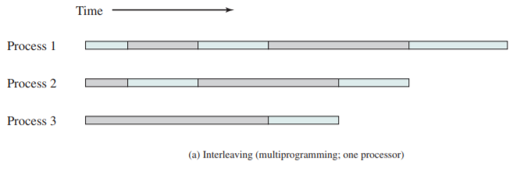

*Figure 1*

Refer to Figure 1, operating system and several other programs could run on the same processor interleaving with each other by multiprogramming. Multiprogramming allows the processor to handle multiple batch jobs at a time so the jobs can run concurrently. When one job needs to wait for I/O, the processor can switch to the other job, for example multiprogramming with two programs (see figure 2)

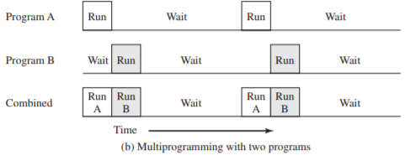

*Figure 2*

For example, the current running process is performing an I/O task, then the OS may interrupt that process and give control to another programs that are ready execute. With interrupts, the processor can be engaged in executing other instructions while an I/O operation is in progress.