**ICT374 – Lab 10**

1. Complete Unix Programming Exercise 6.

**Example 6 - stream read and write**



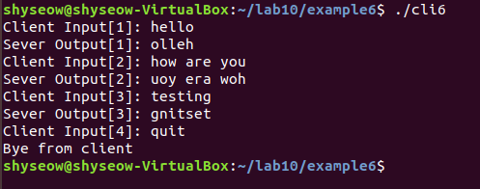

1. Complete Unix Programming Exercise 7.

**Example 8 - UDP protocol**

