**ICT374 – Lab2**

1. Explain what the *current directory* is and what the *home directory* is. Demonstrate how to set your current directory to a particular directory and how to find out your current directory and how to set your current directory to your home directory.

Answer:

**Current Directory:**

Current directory is the current working directory which user is working, is where the user is right now. All relative pathnames are interpreted in this directory. We can go to current working directory directly with “pwd” command.

**Home Directory:**

Home directory is the terminal when we start to open a shell, the working directory is set to home directory when we log in. The directory that serves as the repository for a user's directories, personal files and programs. symbol "~" stands for the home directory of the current user.

Current working directory is displayed when run pwd

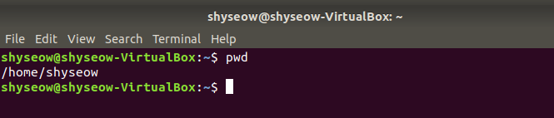

Current directory changed from one directory to another directory using cd command.



To set current directory to home directory.

The command cd sets current directory to home directory.

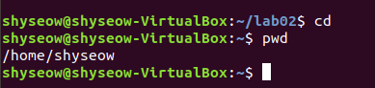

1. Demonstrate that you can create a simple C program (eg hello.c) with a text editor from command line (not with a GUI tool) and compile it with gcc and generate executable with appropriate name (eg hello).

Answer:

hello program (hello.c)

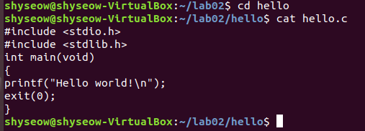

Compile program with command gcc hello.c.



Run program

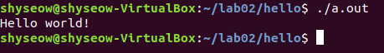

1. Complete Exercise 4 in C Programming Exercises.

Answer:

Source code in **lab2 folder > filename c_ex4**

Compile program with command gcc reverse.c



Run program

