**ICT374 – Lab3**

1. Demonstrate that you can archive all files in a directory and compress the archive file.

To create an archive file:

tar -cvf ~/lab03.tar ~/lab02

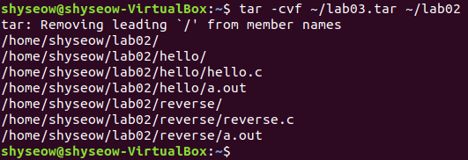

lab03.tar file

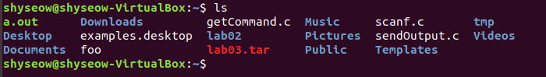

To compress a file



This will create a compressed file named lab03.tar.gz

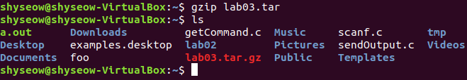

1. Demonstrate the program from C Program Exercise 2.

**Sending Output to a File with fprintf**

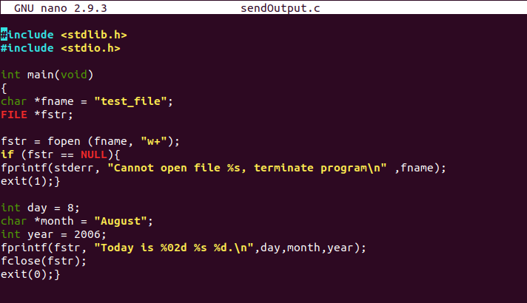

* Compile and run

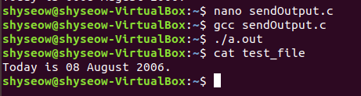

1. Demonstrate the program from C Program Exercise 5.

**Get Input From Standard Input with scanf**

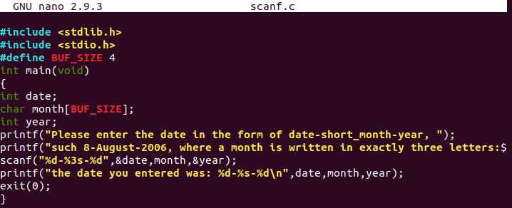

* Compile and run
* Enter date

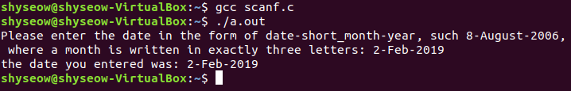

1. Demonstrate the program from C Program Exercise 8.

**Get Command Line Arguments**

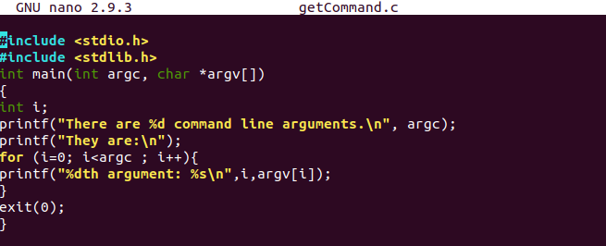

* Compile and run

