**ICT374 – Lab4**

1. Demonstrate Unix Exercise 2 (chmod).

* Files and directories ownded by user shyseow and group shyseow

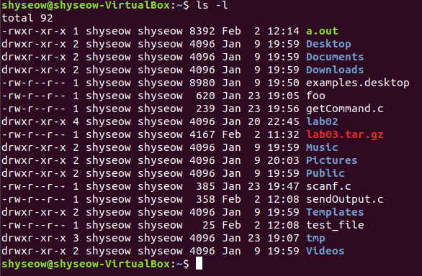

* Adding execute permission to file scanf.c to the user shyseow
* **chmod u+x scanf.c**
* The command added execute (x) to the user(u) shyseow

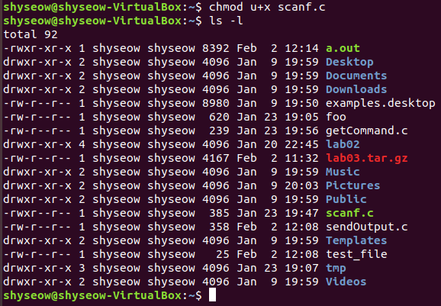

* Removing execute permission to the user shyseow for the same file using
* **chmod u-x scanf.c**

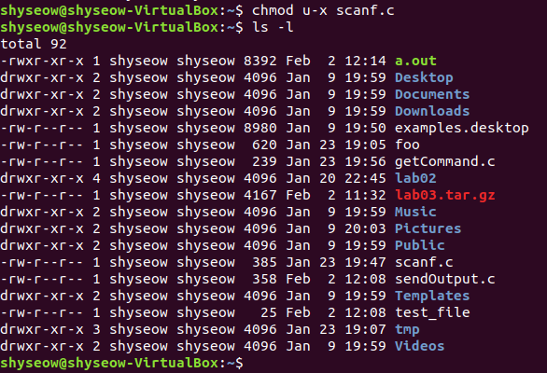

* Changing permission to add execute to the group using command **chmod 676 scanf.c**
* The number 6 stands for read+right while 7 stands for read+write+execute

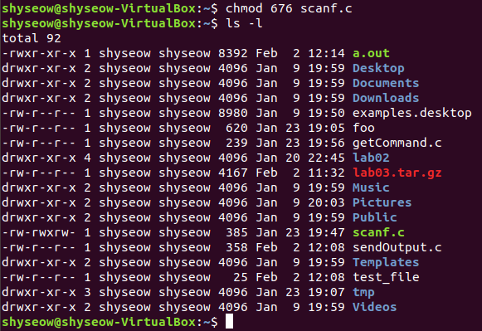

1. Demonstrate Unix Exercise 6 (ps).

* Display the list of processes running under the current shell

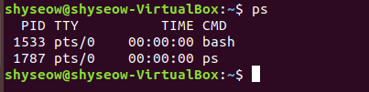

* Display the name of terminal

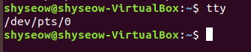

* Display more information with ps -f

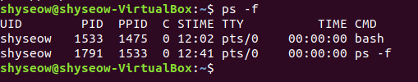

* Display more information with ps -l

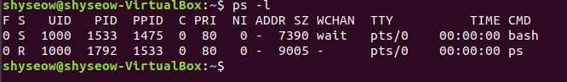

* Using -e to combine different options together
* To display all processes with ps -el

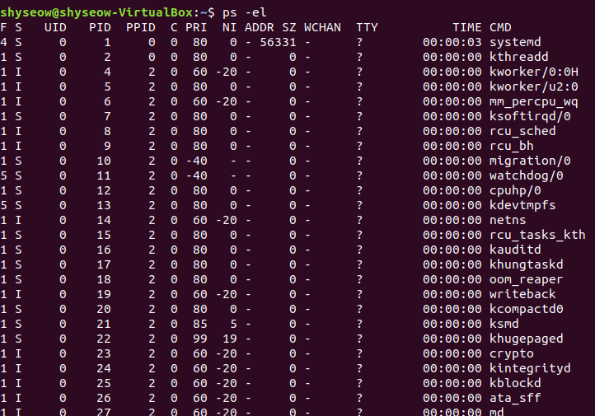

* Using -e to combine different options together
* To display all processes with ps -ef

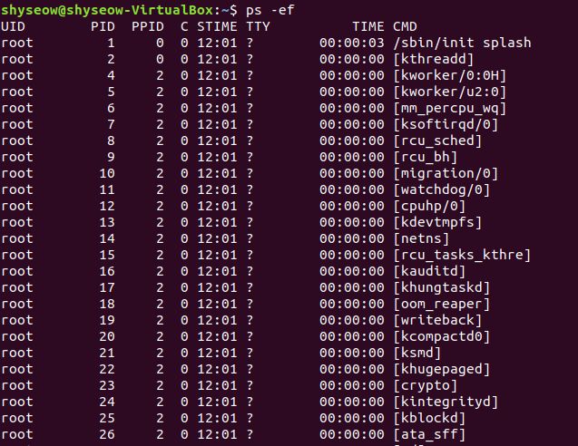

1. Demonstrate the program from C Program Exercise 2.

* Compile and Run

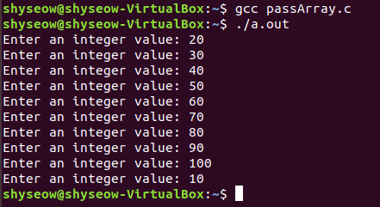

1. Demonstrate the program from C Program Exercise 4.

* Compile and Run

