**ICT374 – Lab 5**

1. Demonstrate Unix Exercises 2 and 4.

Exercise 2: **Execute process in the background**

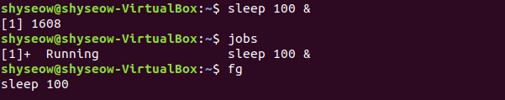

Exercise 4: **Display the information about filesystems**

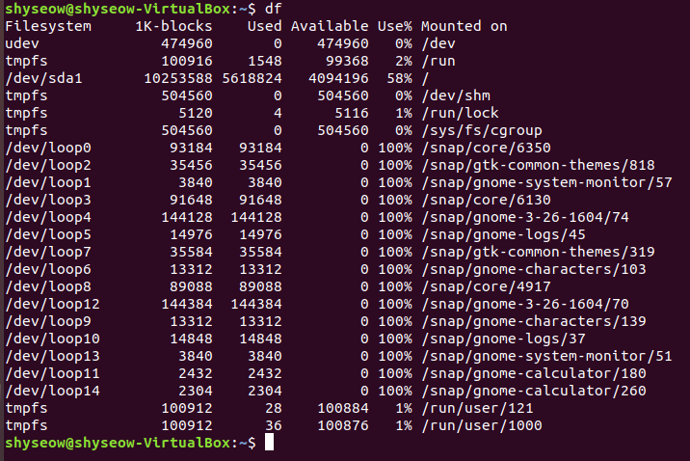df

1. Complete C Programming Exercise 3.

**Change a structure from inside of a function**

* **Compile and run**

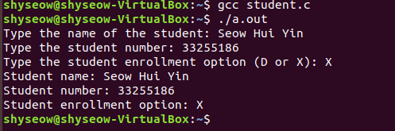

1. Complete Unix Programming Exercise 5.

**Get the exit status of child process**

* **Compile and run**

