**ICT374 – Lab 6**

1. Demonstrate C Programming Exercise 4.

* **Using Makefile to Build a Project**

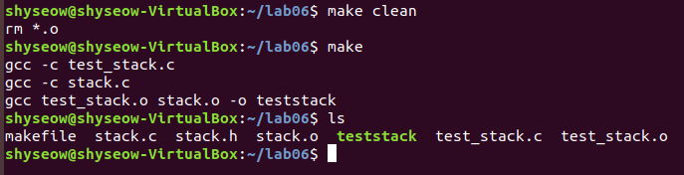

1. Complete Unix Programming Exercise 2.

* **Creating multiple direct child processes**

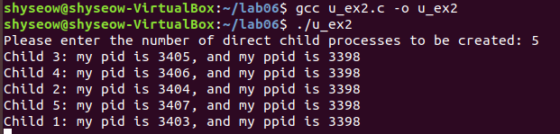

1. Complete Unix Programming Exercise 6.

* **Creating child process to execute a command**

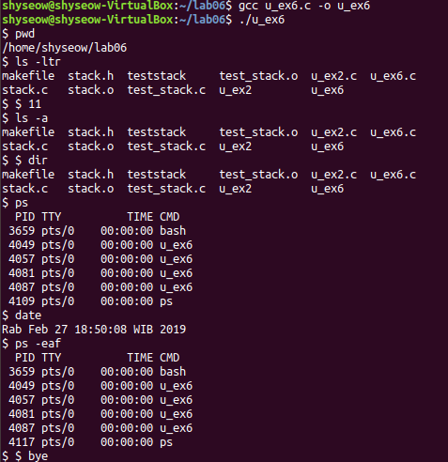

1. Complete Unix Programming Exercise 7.

* **Creating a daemon process**

