**ICT374 – Lab 7**

1. Complete C Programming Exercise 3.

* **Breaking a command line into a sequence of tokens**

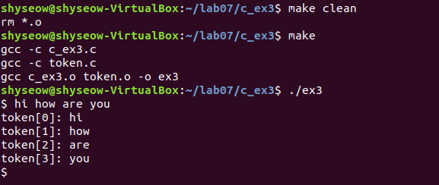

1. Complete Unix Programming Exercise 2.

* **Copying files**

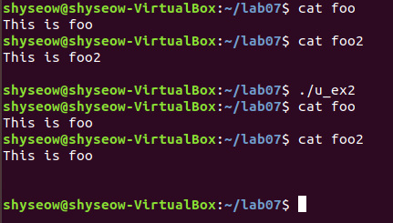

1. Complete Unix Programming Exercise 6.

* **File descriptors 1 & 2 - what's the difference?**

**>> There’s no difference**

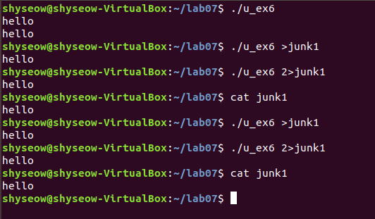

1. Complete Unix Programming Exercise 12.

* **Listing directory entries**

