**ICT374 – Lab 8**

1. Complete C Programming Exercise 2.

* **Separating a command line into a sequence of commands**

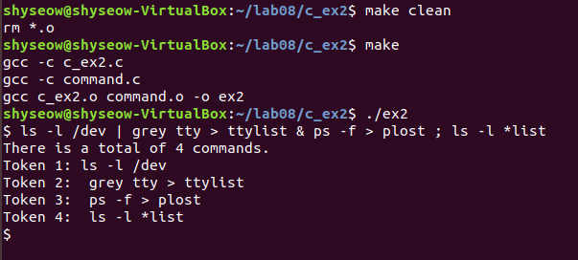

1. Complete Unix Programming Exercise 7.

* **Use sigaction**

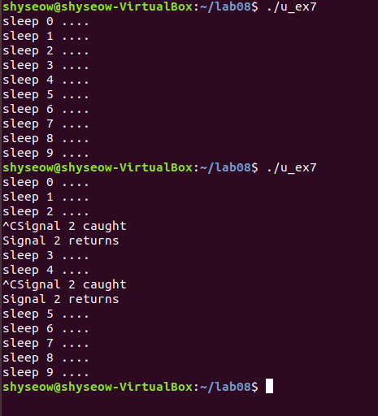

1. Complete Unix Programming Exercise 8.

* **Catching different signals**

