**ICT374 – Lab 9**

1. Complete C Programming Exercise 2.

**Separating a command line into a sequence of commands - building command line argument array argv**

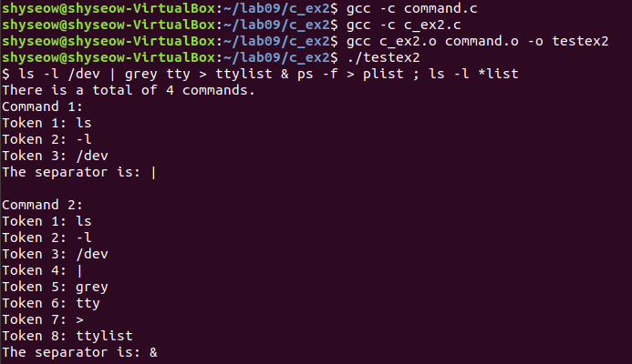

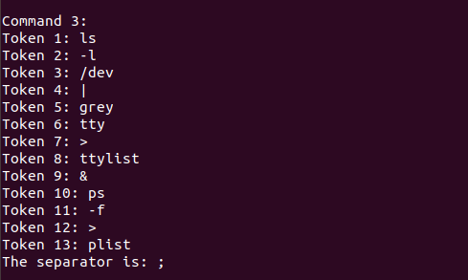

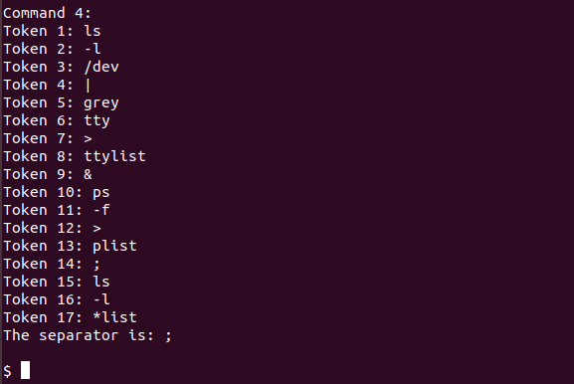

1. Complete Unix Programming Exercise 2.

**Blocking read from a unnamed pipe**

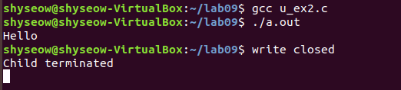

1. Complete Unix Programming Exercise 3.

**Finding deadlocks due to pipe connections**

* close(BA[1]) at line L1;



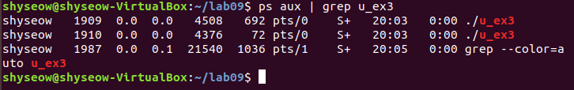

* close(AB[1]) at line L2;



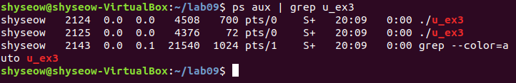

* close(AB[1]) at line L3.



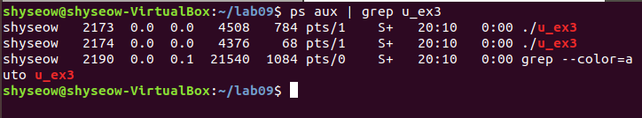

1. Complete Unix Programming Exercise 6.

**Using FIFO for communications on the shell**

