**ACROPOLIS INSTITUTE OF TECHNOLOGY AND RESEARCH**



**Seminar Document**

**Topic*:*** Shading: Gouraud shading and Phong shading

Submitted to: Submitted by :

Mr. Anil patidar Siddharth Deulkar(221)

Sagar Suryawanshi(195)

# SHADING

In [computer graphics](https://en.wikipedia.org/wiki/Computer_graphics), shading refers to the process of altering the color of an object/surface/polygon in the 3D scene, based on things like the surface's angle to lights, its distance from lights, its angle to the camera and material properties to create a [photorealistic](https://en.wikipedia.org/wiki/Photorealistic) effect. Shading is performed during the [rendering](https://en.wikipedia.org/wiki/Rendering_(computer_graphics)) process by a program called a [shader](https://en.wikipedia.org/wiki/Shader).

Examples of shading:

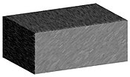

TYPES OF SAHDING

1. Flat Shading

2. Gouraud Shading

3. Phong Shading

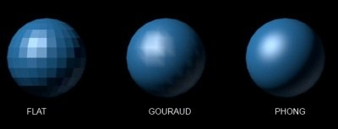

We can shade any surface by calculating the surface normal at each visible point and applying the desired illumination model at that point

**FLAT SHADING**

The fast and simplest method for shading polygon is constant shading. In this method, illumination model is applied only once for each polygon to determine single intensity value. The entire polygon is displayed with single intensity value.

ASSUMPTIONS for this method

1. Light source is at infinity.
2. Viewer is at infinity.
3. The polygon represents actual surface being modelled, not an approximation to a curved surface.

**Advantages**:

1. It is fast.

**Disadvantages**:

1. Inaccurate.
2. Discontinuities at polygon boundaries.

**Gouraud Shading**

In this method, the intensity interpolation technique developed by Gouraud is used, hence the name. The polygon surface is displayed by linearly interpolating intensity values across the surface. Here, intensity values for each polygon are matched with the values of adjacent polygons along the common edges.

This eliminates the intensity discontinuities that can occur in flat shading.

By performing following calculations we can display polygon surface with Gouraud shading.

1. Determine the average unit normal vector at each polygon vertex.
2. Apply an illumination model to each polygon vertex to determine the vertex intensity.
3. Linearly interpolate the vertex intensities over the surface of the polygon.

We can obtain a normal vector at each polygon vertex by averaging the surface normal of all polygons sharing that vertex.

Nv = N1+N2+N3+N4

| N1+N2+N3+N4|

Once we have vertex normals, their vertex intensities can be calculated by applying illumination model to each polygon vertex.

Finally, each polygon is shaded by linear interpolation of vertex intensities along each edge and then between edges along each scan line.

Illumination values are linearly interpolated across each scan-line as shown in figure

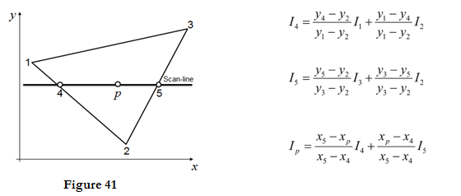

1. The intensities at point 4 can be interpolated from intensities 1 and 2.
2. Similarly, the intensities at point 5 can be interpolated from intensities 2 and 3.
3. Therefore the intensities of interaction points 4 and 5 are calculated from scan line.

**Advantages:**

1. It removes the intensity discontinuity which exists in constant shading model.

2. It can be combined with hidden surface algorithm to fill in the visible polygons along each scan line.

**Disadvantages:**

1. **Highlights on the surface are sometimes displayed with anomalous shapes.**
2. **The linear intensity interpolation can result bright or dark intensity streaks to appear on the surface. These streaks are called Mach bands. The mach band effect can be reduced by breaking the surface into a greater number of smaller polygons.**
3. **Sharp drop of intensity values on the polygon surface can not be displayed.**

**PHONG SHADING**

Phong Shading is more accurate interpolation based approach for rendering a polygon. It was developed by Phong Bui Tuong.

Basically the Phong surface rendering model is also called as normal-vector interpolation rendering.

It interpolates normal vectors instead of intensity values.

To render a polygon, Phong surface rendering proceeds as follows:

1. Determine the average unit normal vector at each vertex of the polygon.
2. Linearly interpolate the vertex normal over the projected area of the polygon.

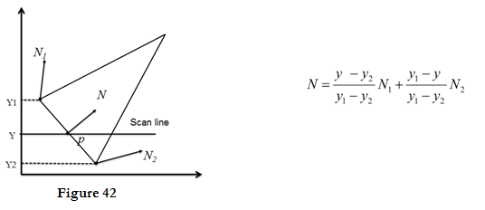

1. Apply an illumination model at positions along scan lines to calculate pixel intensities using the interpolated normal vectors as shown in figure.

**Advantages:**

i. It displays more realistic highlights on a surface.

ii. It greatly reduces the Mach band effect.

iii. It gives more accurate results.

**Disadvantages:**

It requires more calculations and greatly increases the cost of shading steeply.