OVERVIEW
Siddharth Gopal Dubey

F.CS
Foundation of Cybersecurity

Foundation of Cybersecurity
Google Cybersecurity Professional Certificate
Prepared by: Siddharth | B.Tech CSE
- Module 1: Introduction
Cybersecurity is the practice of protecting systems, networks, applications, and data from unauthorized access, misuse, or disruption.
## What you learn in this Introduction
- Why cybersecurity is essential in today’s digital world.
- The CIA Triad: Confidentiality, Integrity, and Availability.
- The difference between threats, vulnerabilities, and risks.
- Common cybersecurity career paths and tools.

## The CIA Triad
- Confidentiality: Only authorized users can access information.
- Integrity: Data remains accurate and unaltered.
- Availability: Systems and data are accessible when needed.

## Threat vs Vulnerability vs Risk
A threat is a potential danger, a vulnerability is a weakness, and risk is the likelihood and impact of a threat exploiting that weakness.
## Why Organizations Invest in Cybersecurity
- Protects against internal and external attacks.
- Helps meet compliance requirements.
- Reduces financial and reputational damage.
- Builds customer trust.
## Entry-Level Roles
- Security Analyst
- SOC Analyst
- Information Security Analyst
- Cybersecurity Specialist
## Key Takeaway
Cybersecurity is a continuous learning journey. Most practical skills are developed through hands-on labs, real-world environments, and consistent practice.

## Challenge :

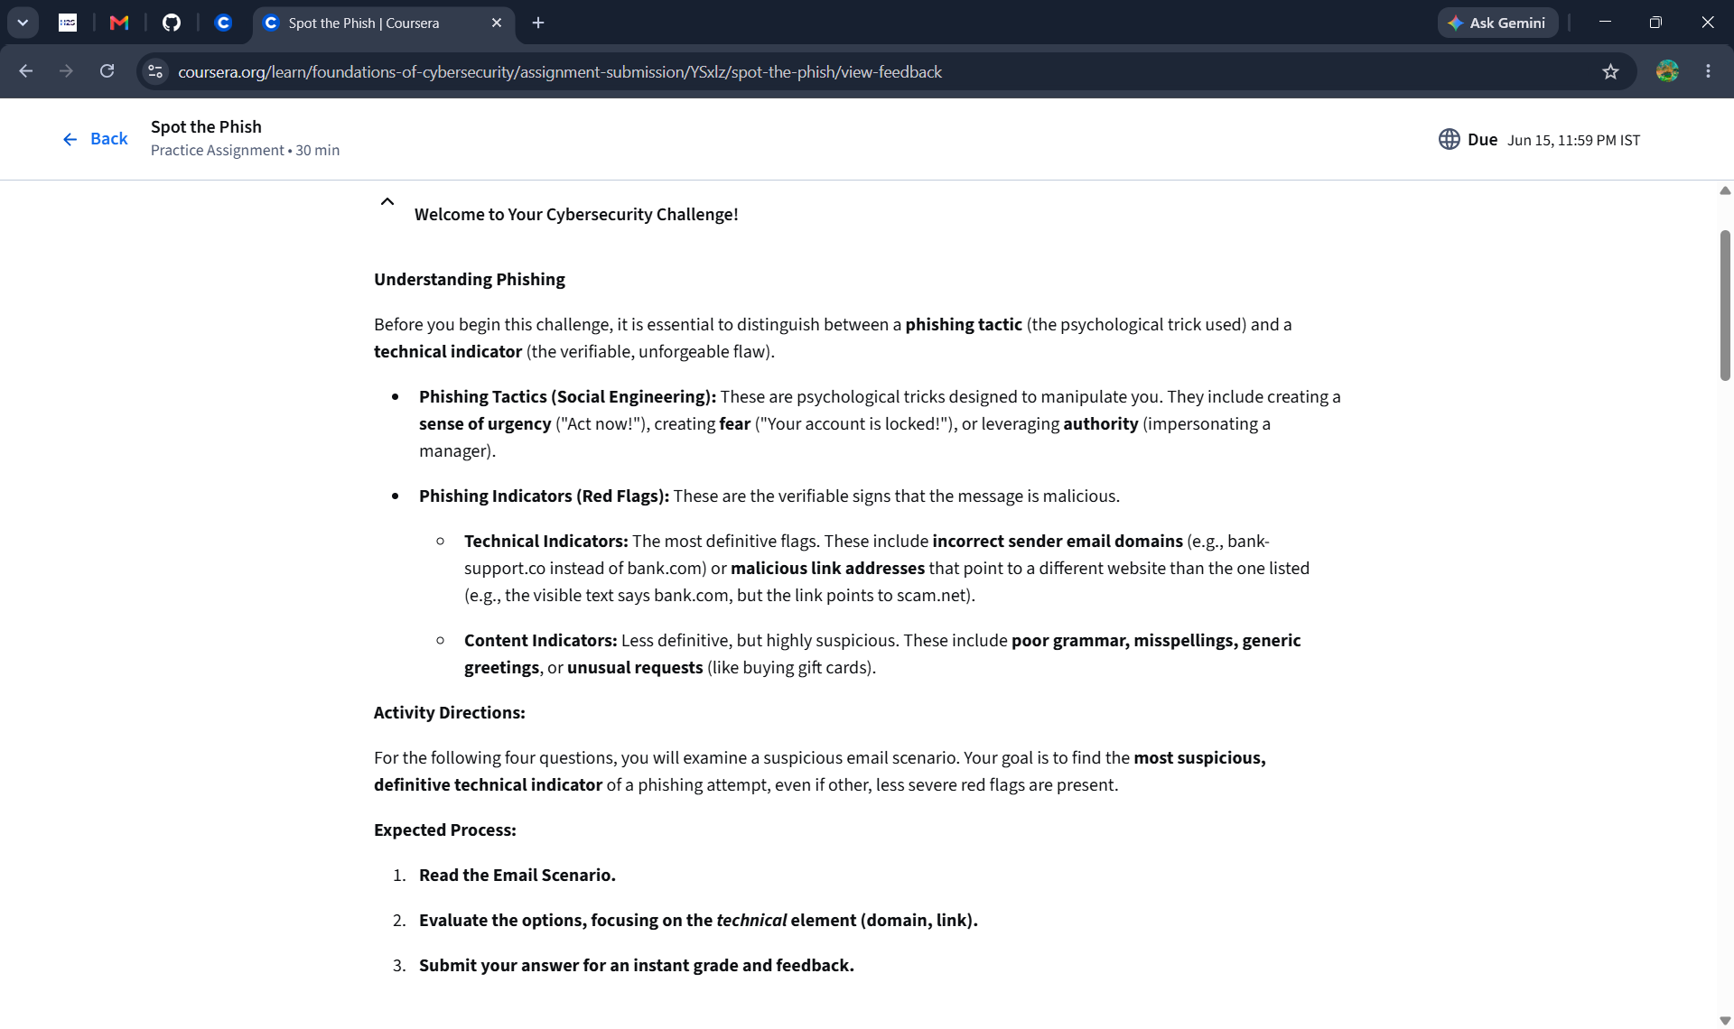
It’s the Rough Idea of what challenge was about…..
Most of Cybersecurity work is going to be learned on the job in the specific environment that you’re protecting.

