INARA

OpenCV features an implementation for a very fast human detection method, called HOG (Histograms of Oriented Gradients).

the detector works better if the person is not too close to the camera.

evaluated really fast on a CPU.

#ignore learning cv

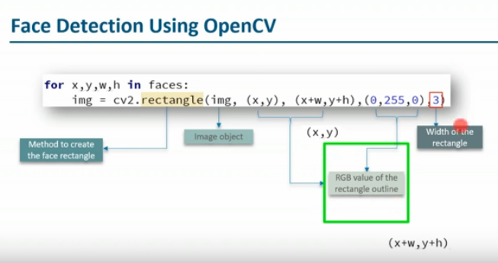

**Functionalities :**

* While drones do their work from high above, other robots are operating on the ground in battlefields worldwide.
* American forces relied on bomb-squad robots to inspect and defuse possible explosive devices during military operations in Iraq and Afghanistan.

 The remote-controlled machines moved via tank tread and featured

1. infrared vision,
2. multiple cameras,
3. floodlights and
4. mechanical arms in order to spot bombs and dispose of them,

all while human operators stayed a safe distance away

* keep them in fixed locations where they were used to defend perimeters rather than actively chase after bad guys
* respond to gestures and voice commands (telepresence gloves that let the user move the machine's arms and hands by simply moving his or her own arms and hands,

 as well as a motion tracking headset that allows the user to see what the robot sees)

* capable of carrying – and using – lethal weapons like grenade launchers and machine guns on command
* Also in development is a pack animal-esque robot prototype designed to make human soldiers better fighters by lightening their loads    (The goal is for each semiautonomous machine to be able to "carry 400 pounds [181 kilograms] of a squad's load, follow squad members through rugged terrain, and interact with troops in a natural way, similar to a trained animal and its handler.)

Screenshots

Detection of motion in real time.



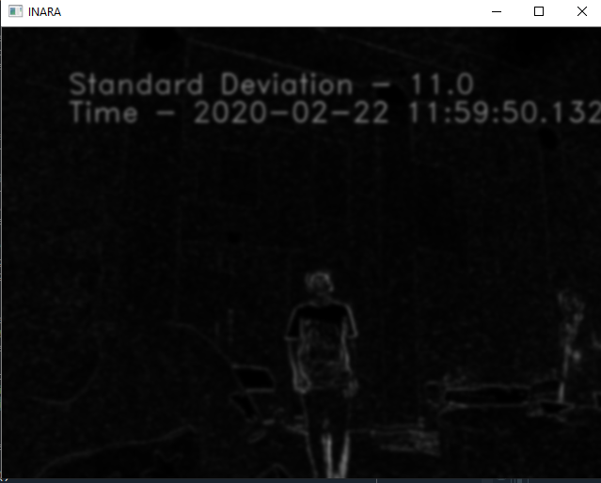



Terminal in device os

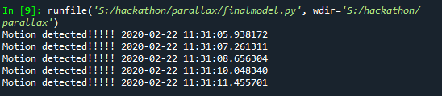

Headquarters

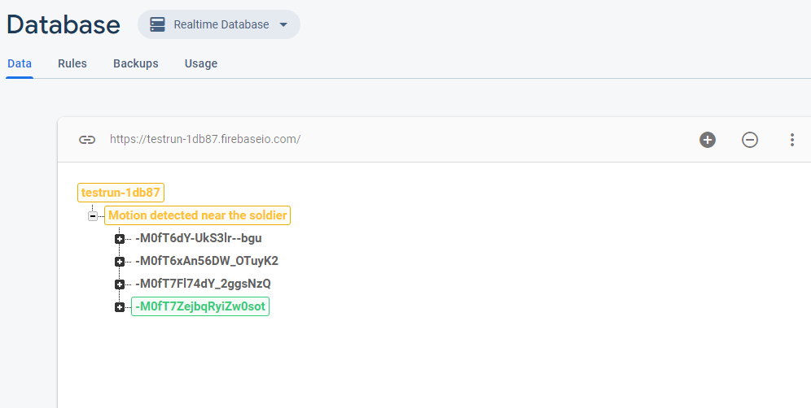

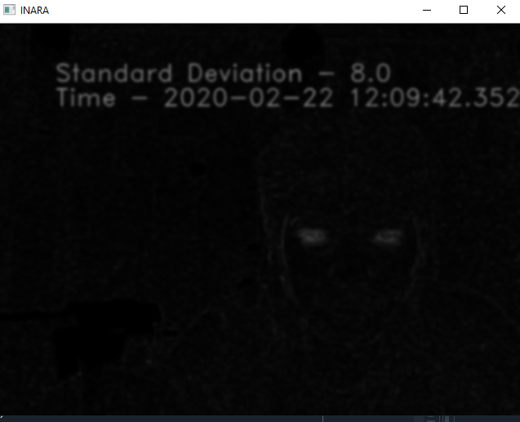

The eyes

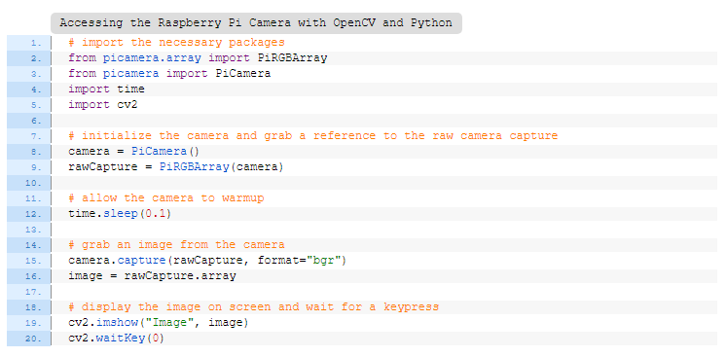

<https://www.pyimagesearch.com/2015/03/30/accessing-the-raspberry-pi-camera-with-opencv-and-python/>

Functionalities of the product

1. Keeping the injured soldier hidden by distracting enemies.
2. Sending information to the battalion about the injured soldier.
3. Sending all the medical readings of the injured soldier to the headquarters so that they can send a rescue team for the soldier.
4. Keeping the soldier alive until the rescue team arrives.
5. Identifying potential threats to the soldier and informing the battalion.