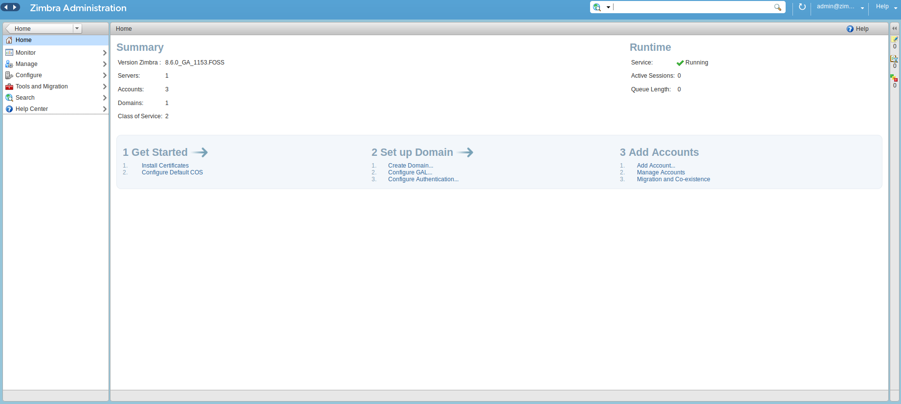
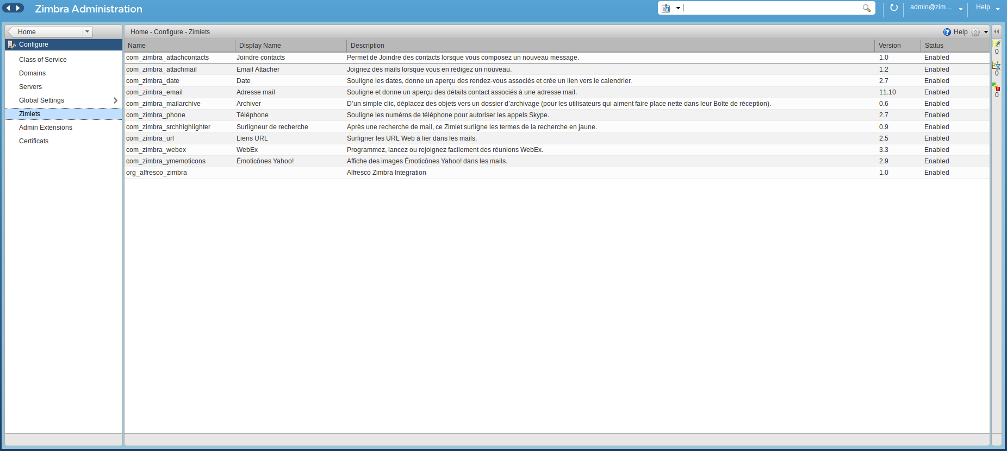
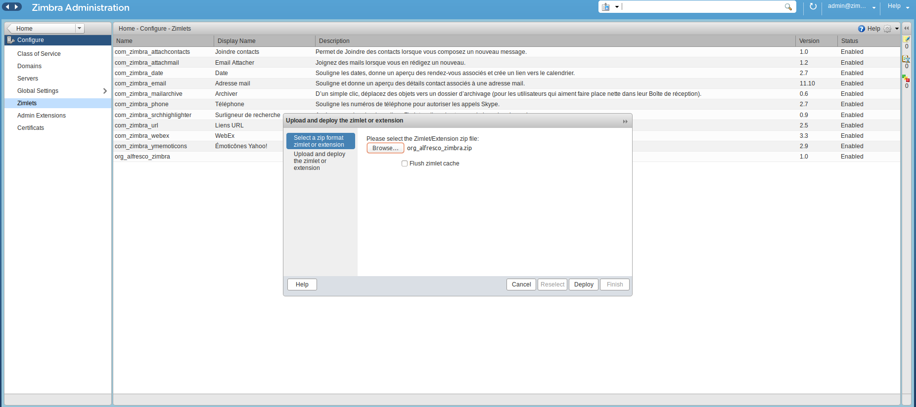
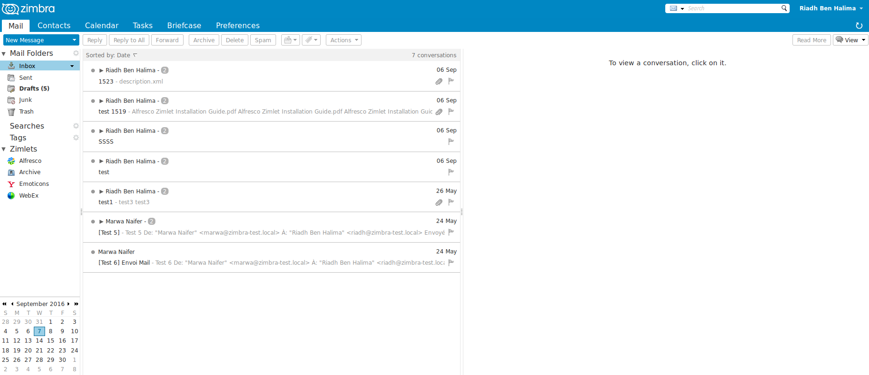
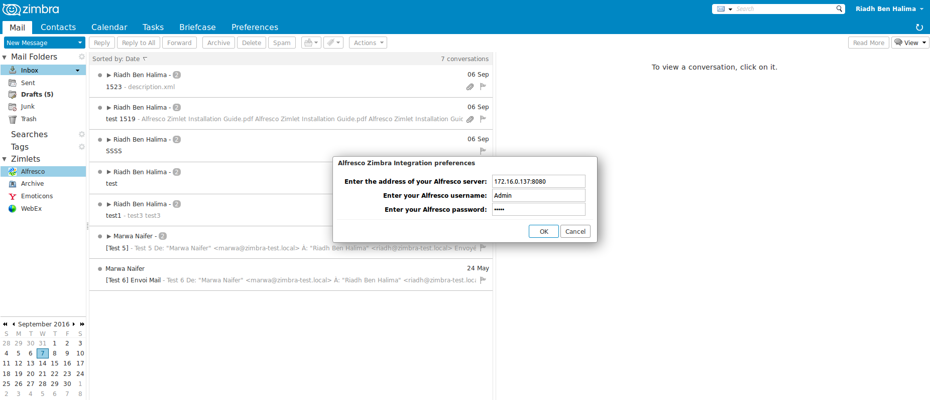
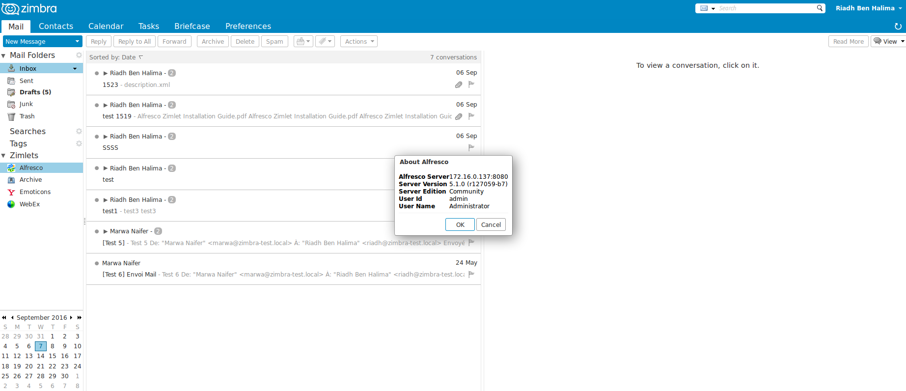
Installation Guide
Overview:
Alfresco Zimlet Package provides integration between Zimbra Collaboration Suite and Alfresco Enterprise Content Management (ECM) using Zimbra Zimlet technology, Alfresco Webscript technology and Yahoo YUI Javascript library.
It consists following two components
- Zimlet – Zimbra extension that provides user interface for end users to save email attachments to Alfresco server or select documents from Alfresco server and then attach them to emails.
- Alfresco Webscripts – Set of web scripts that provides necessary services on Alfresco side for zimlet to interact with.
Installation Requirements:
This integration package requires pre-installation of
- Zimbra Collaboration Suite (Version 8.x) and
- Alfresco Enterprise Content Management (Version 5.x).
Installation Steps:
Step One: Install Zimlet on Zimbra Collaboration Suite
Using Zimbra Administration Console:

- Open your browser and log on to Zimbra Administration Console, e.g. https://your.zimbra.server:7071

- Locate and click on “Zimlets” button on the left navigation bar. And then use the “Deploy” button on the right panel to upload the zimlet zip file.

- Connect as zimbra user by taping sudo su zimbra

- To enable Zimbra proxy for the domain where Alfresco server is installed, log on to Zimbra Server as zimbra and run following command:
zmprov mc default zimbraProxyAllowedDomains "*"

- To avoid Mixed content error, log on to Zimbra Server as zimbra and run following command:
zmtlsctl both ;
Then you should connect as http protocol.

- To support JSP Servlet, log on to Zimbra Server as zimbra and run following command:
zmprov ms mail.zimbra-test.local zimbraZimletJspEnabled TRUE
- Restart Zimbra Server : zmcontrol restart
Step Two: Add Webscripts to Alfresco Enterprise Content Management
Locate the folder alfresco_zimlet_webScript, from the installation bundle.
Open your browser and log on Alfresco web client.
Browse to :
Space Company Home -> Data Dictionary -> Web Scripts Extensions (English version).
Espace racine -> Dictinnaire de données -> Extensions Web Scripts (French version).
Make the same tree folders and then copy all files starting from org folder.
Browse to http://your.address:8080/alfresco/service/index and click Refresh Web Scripts.
A message indicates there is additional Web Scripts.
Step Three: Configure and Validate Installation
Once both components are installed. Log on to Zimbra web client and expand Zimlets link on the left navigation panel. You should now find the Alfresco zimlet.

Right click on the Alfresco zimlet and select “Pereferences” menu item. Enter the location of Alfresco ECM server ( with both host name and port number. e.g. labs.alfresco.com:8080 ) as well the user name and password for the Alfresco ECM server. Click OK button once all details have been provided.

Right click on the Alfresco zimlet and select “About” menu item. If it shows a popup window with details configuration information about Alfresco ECM server, the installation is successful.

