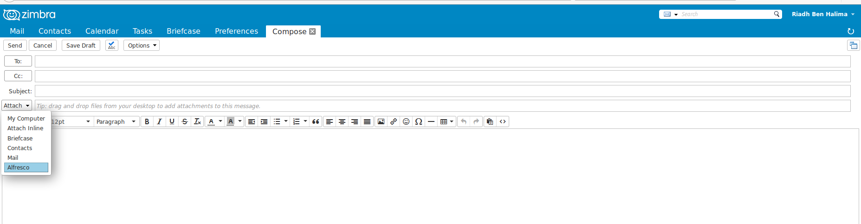
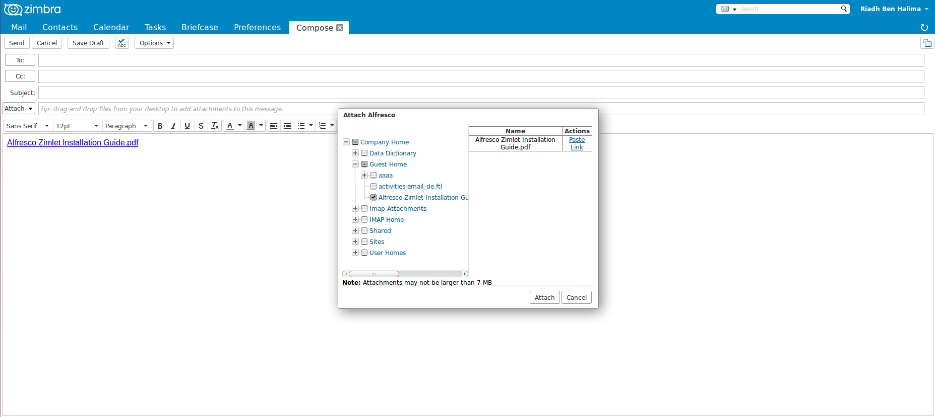
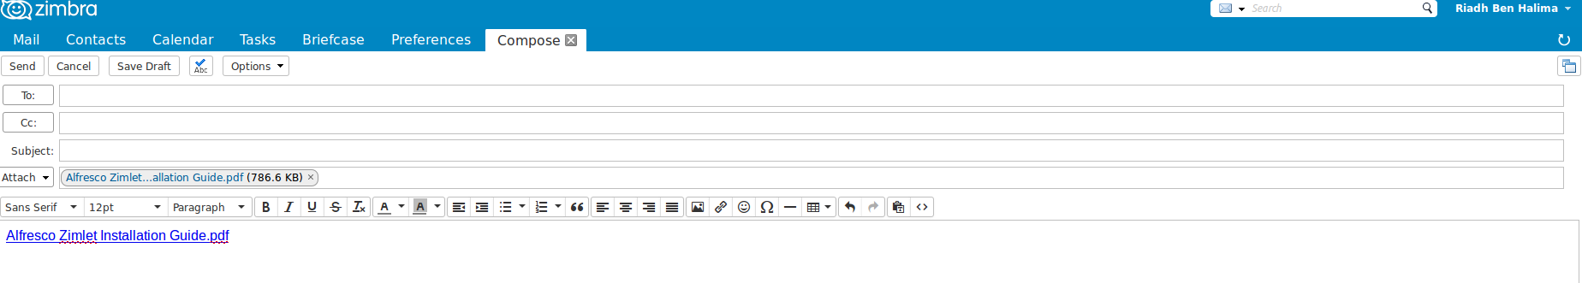
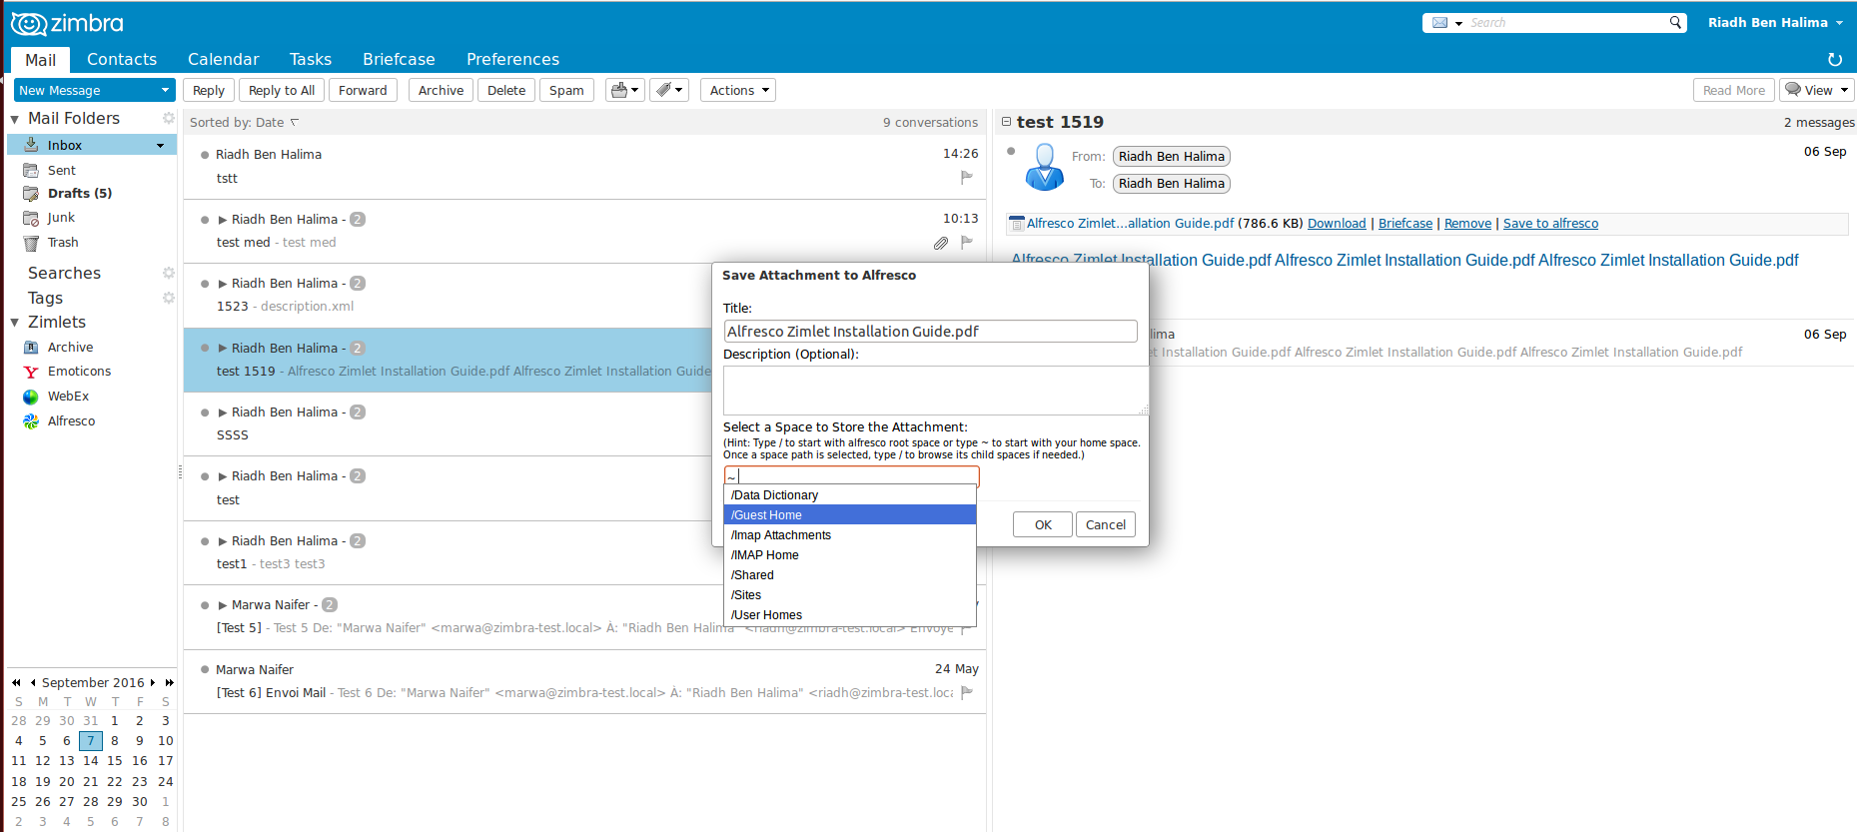
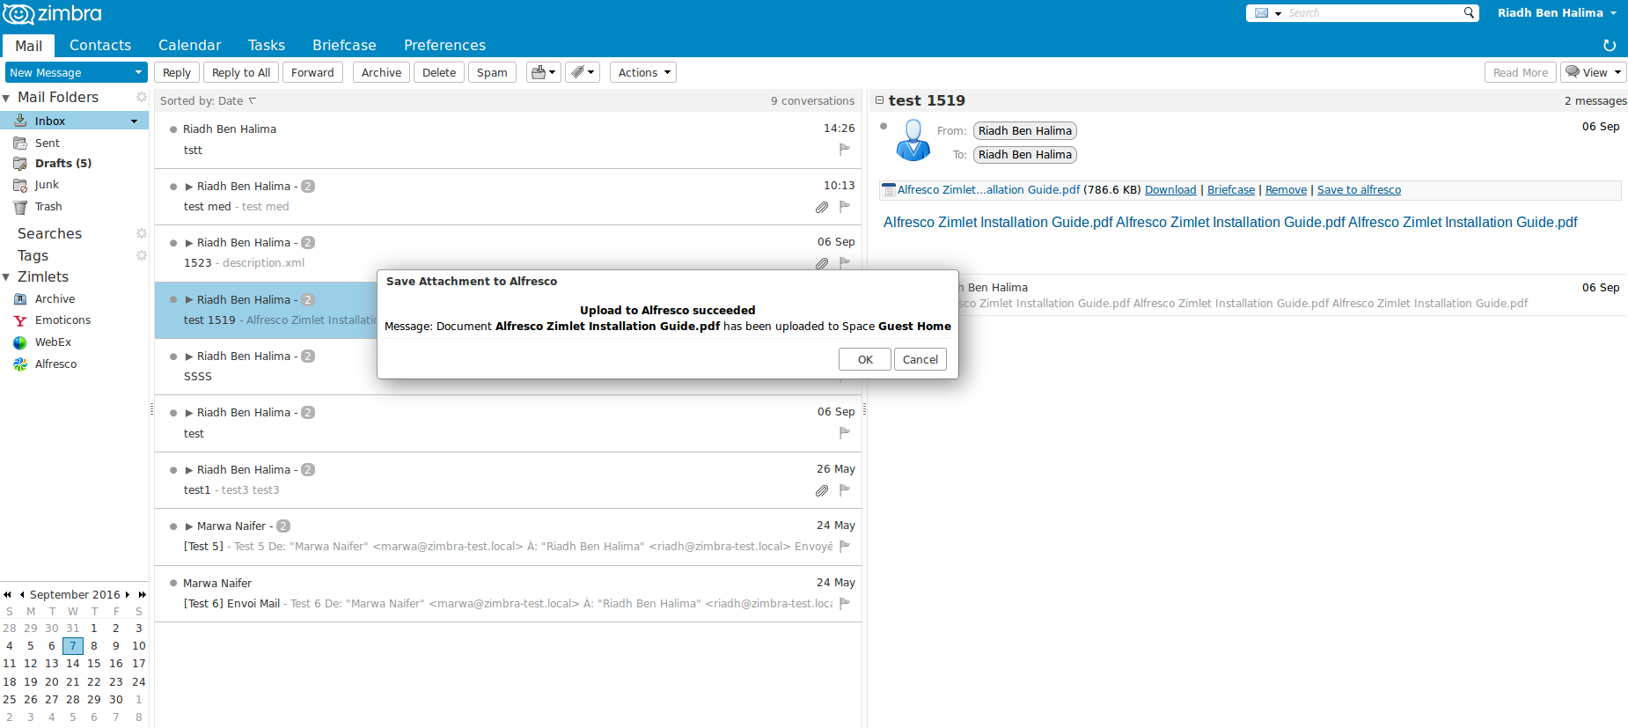
Alfresco Zimlet Utilisation Guide
Attach Alfresco file(s) to mail compose
- Click on Alfresco item in Attach button.
- Choose to attach or/and paste short link.

- Attachment and paste link done.

Save to Alfresco example
- Click on the Save to Alfresco link.
- Choose the right folder.

- Save to Alfresco done.

