CORDIA project
ADCs test and characterization
verification of the stability and reliability of the Test-setup (Hardware, firmware and Software)
Lamine Hafiane / 15.02.2022

I. Loop-Test: the same measurement, with the same set-up, is repeated several times.
I.1 Noise evaluation
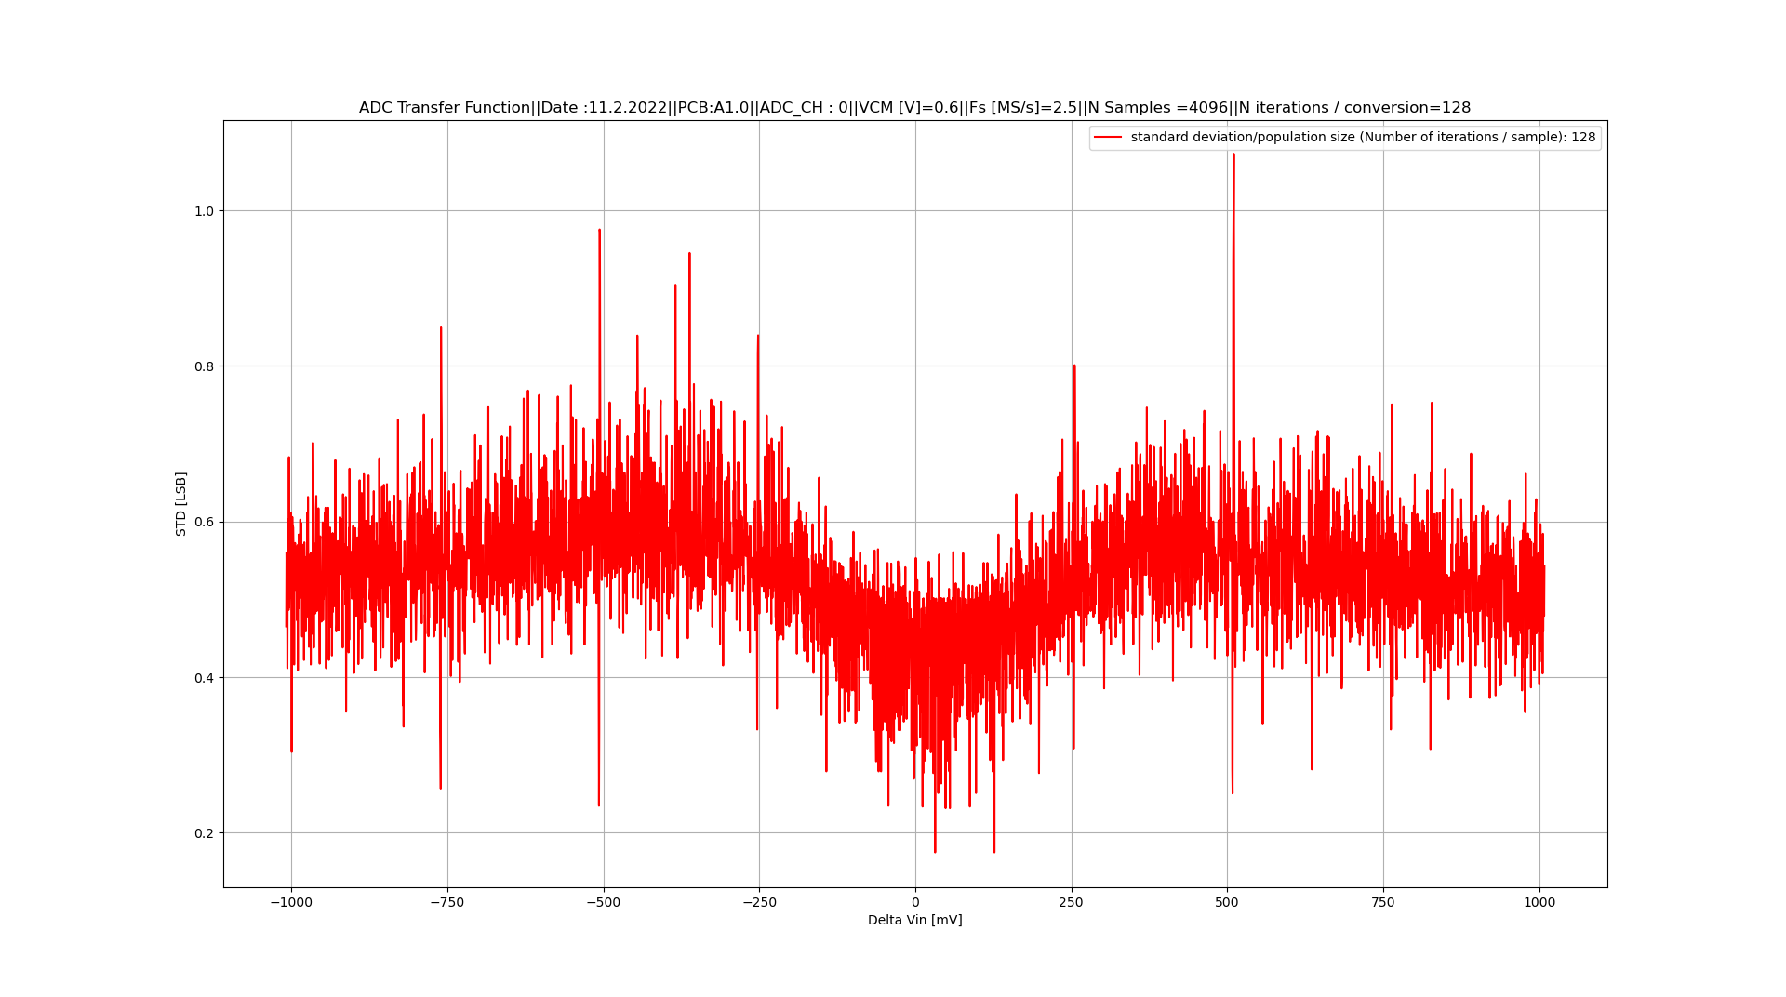
Test 1
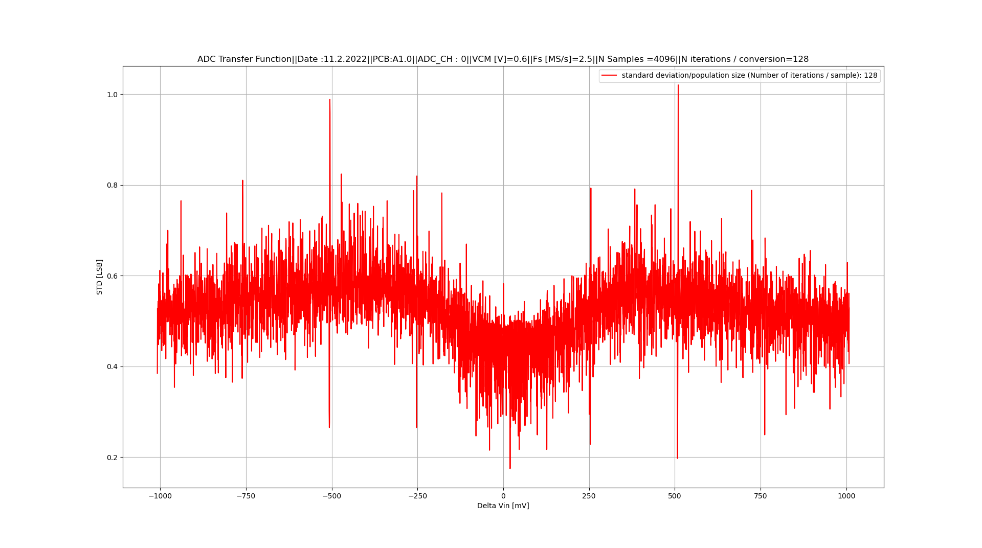
Test 2
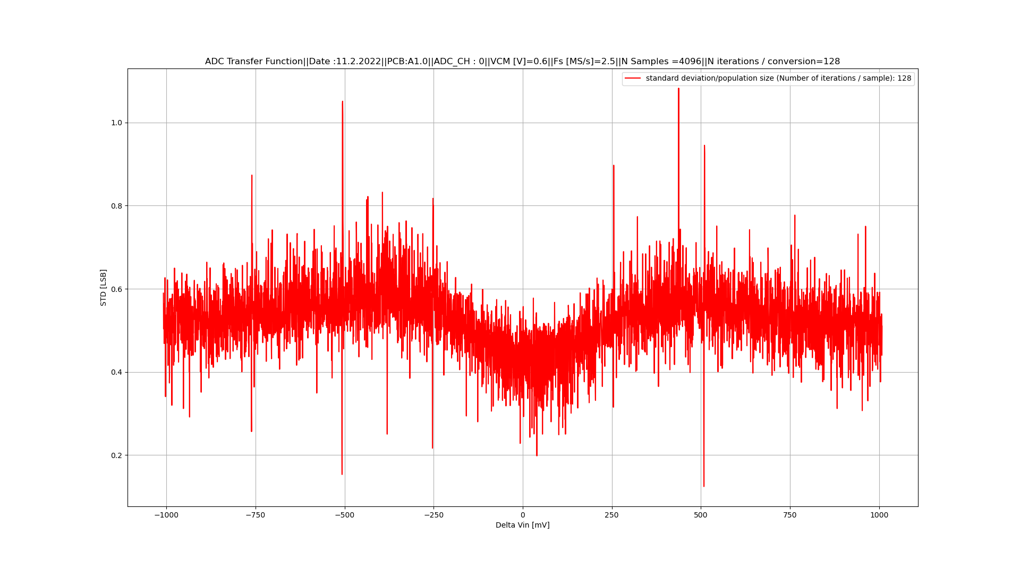
Test 3
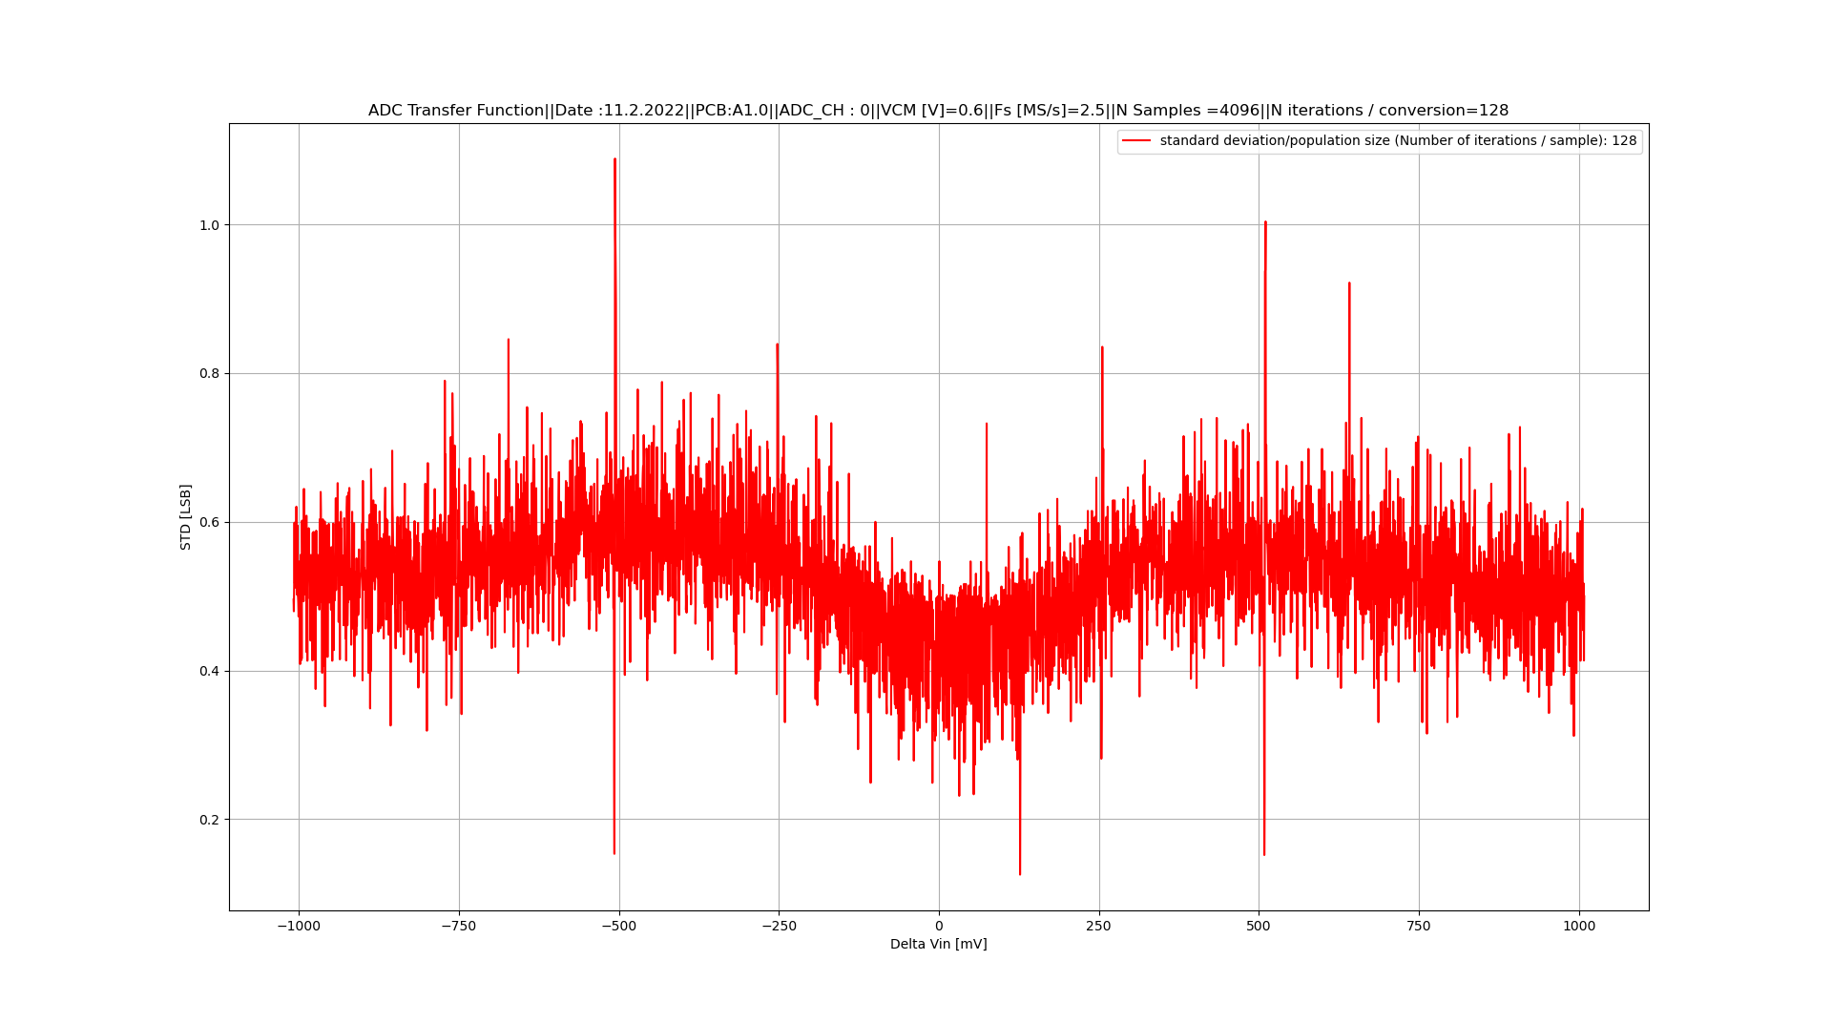
Test 4

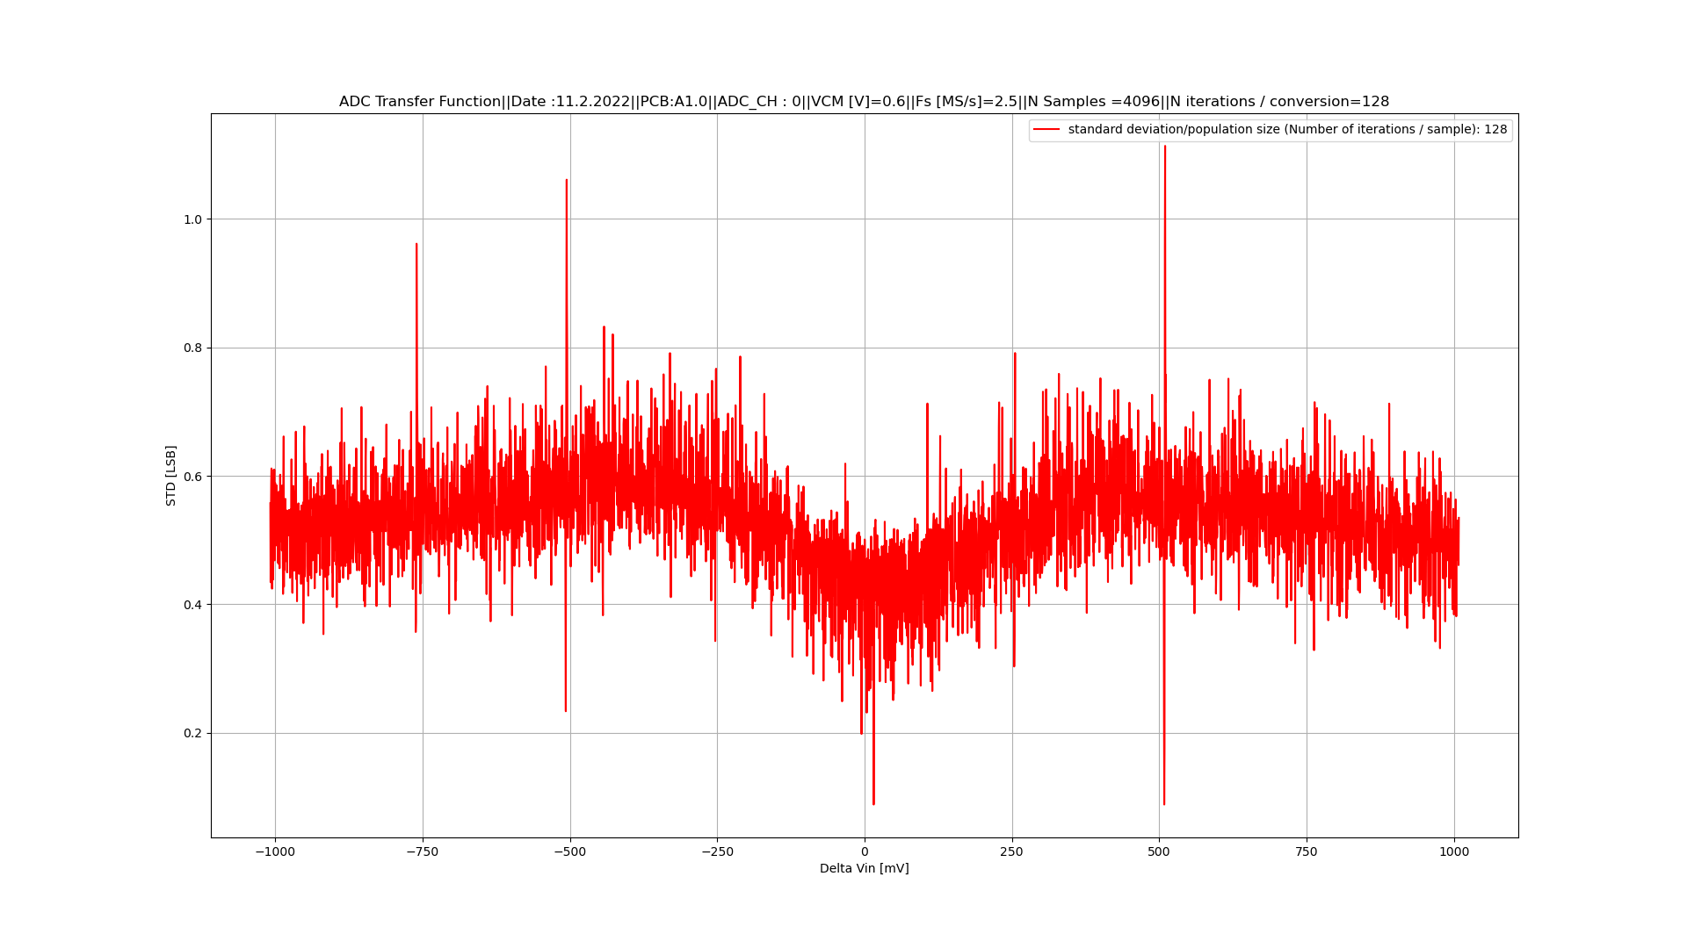
Test 5
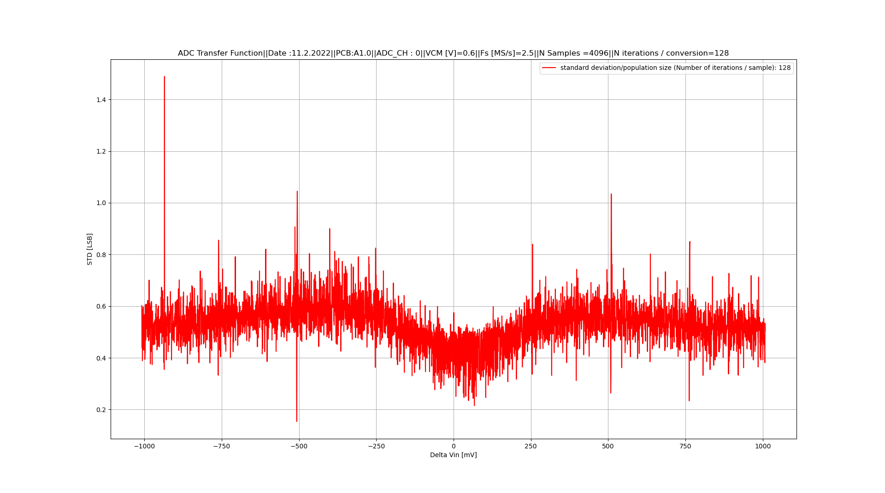
Test 6

1.II INL
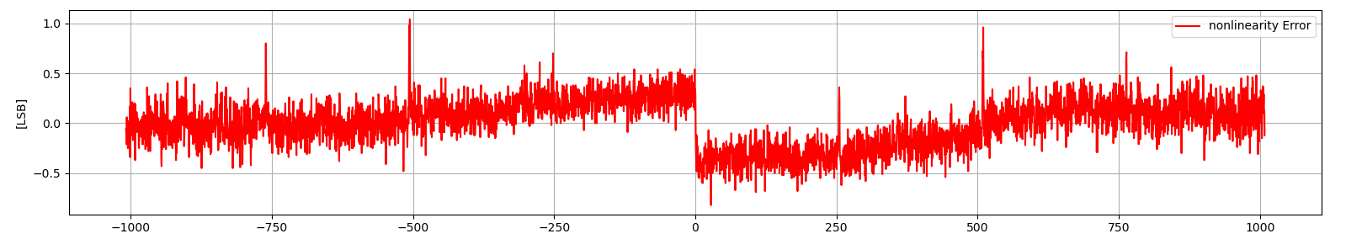
Test 1
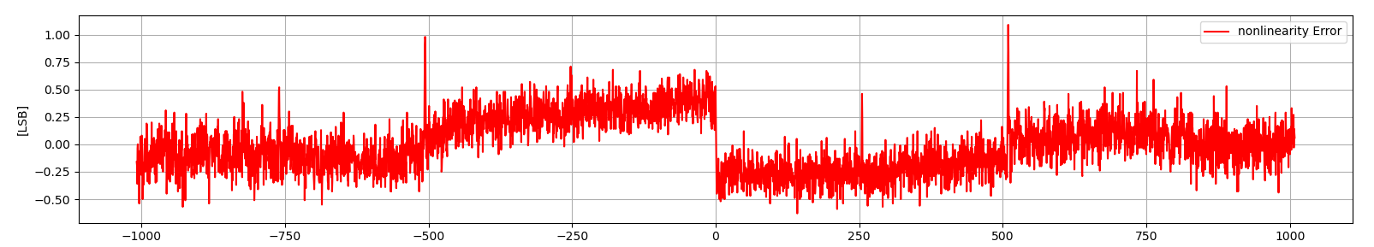
Test 2
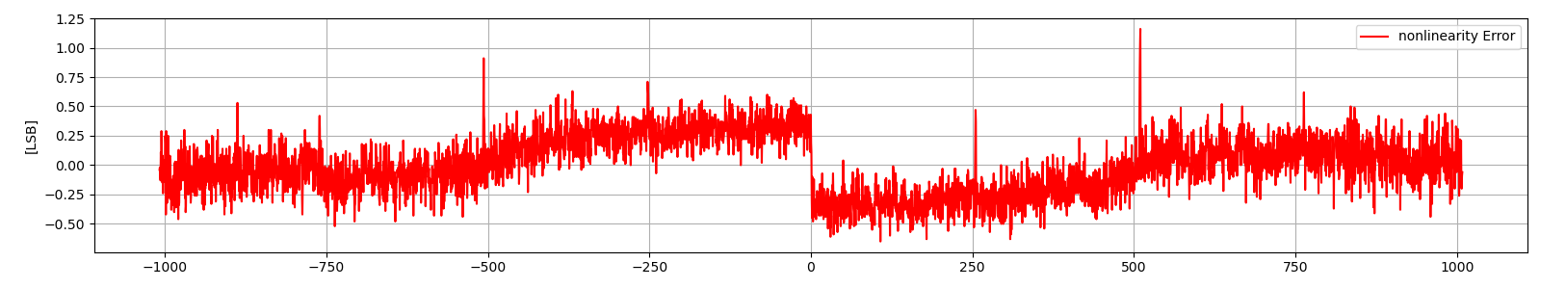
Test 3
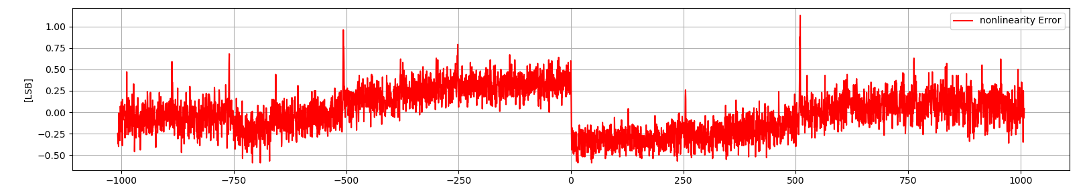
Test 4
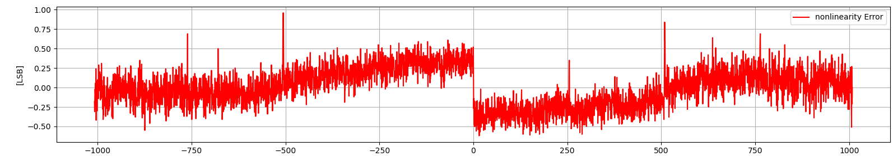
Test 5

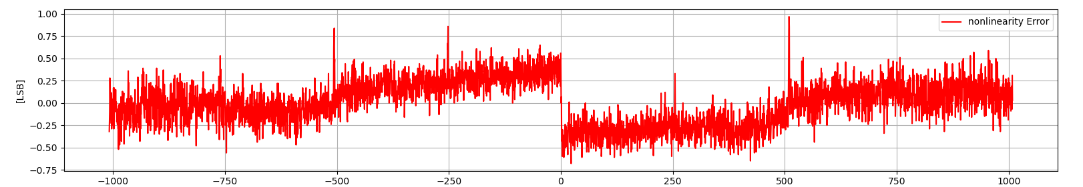
Test 6

II. Checking the computing methods (ODS vs Python) / evaluation based-on the same measurement set
II.I. Noise
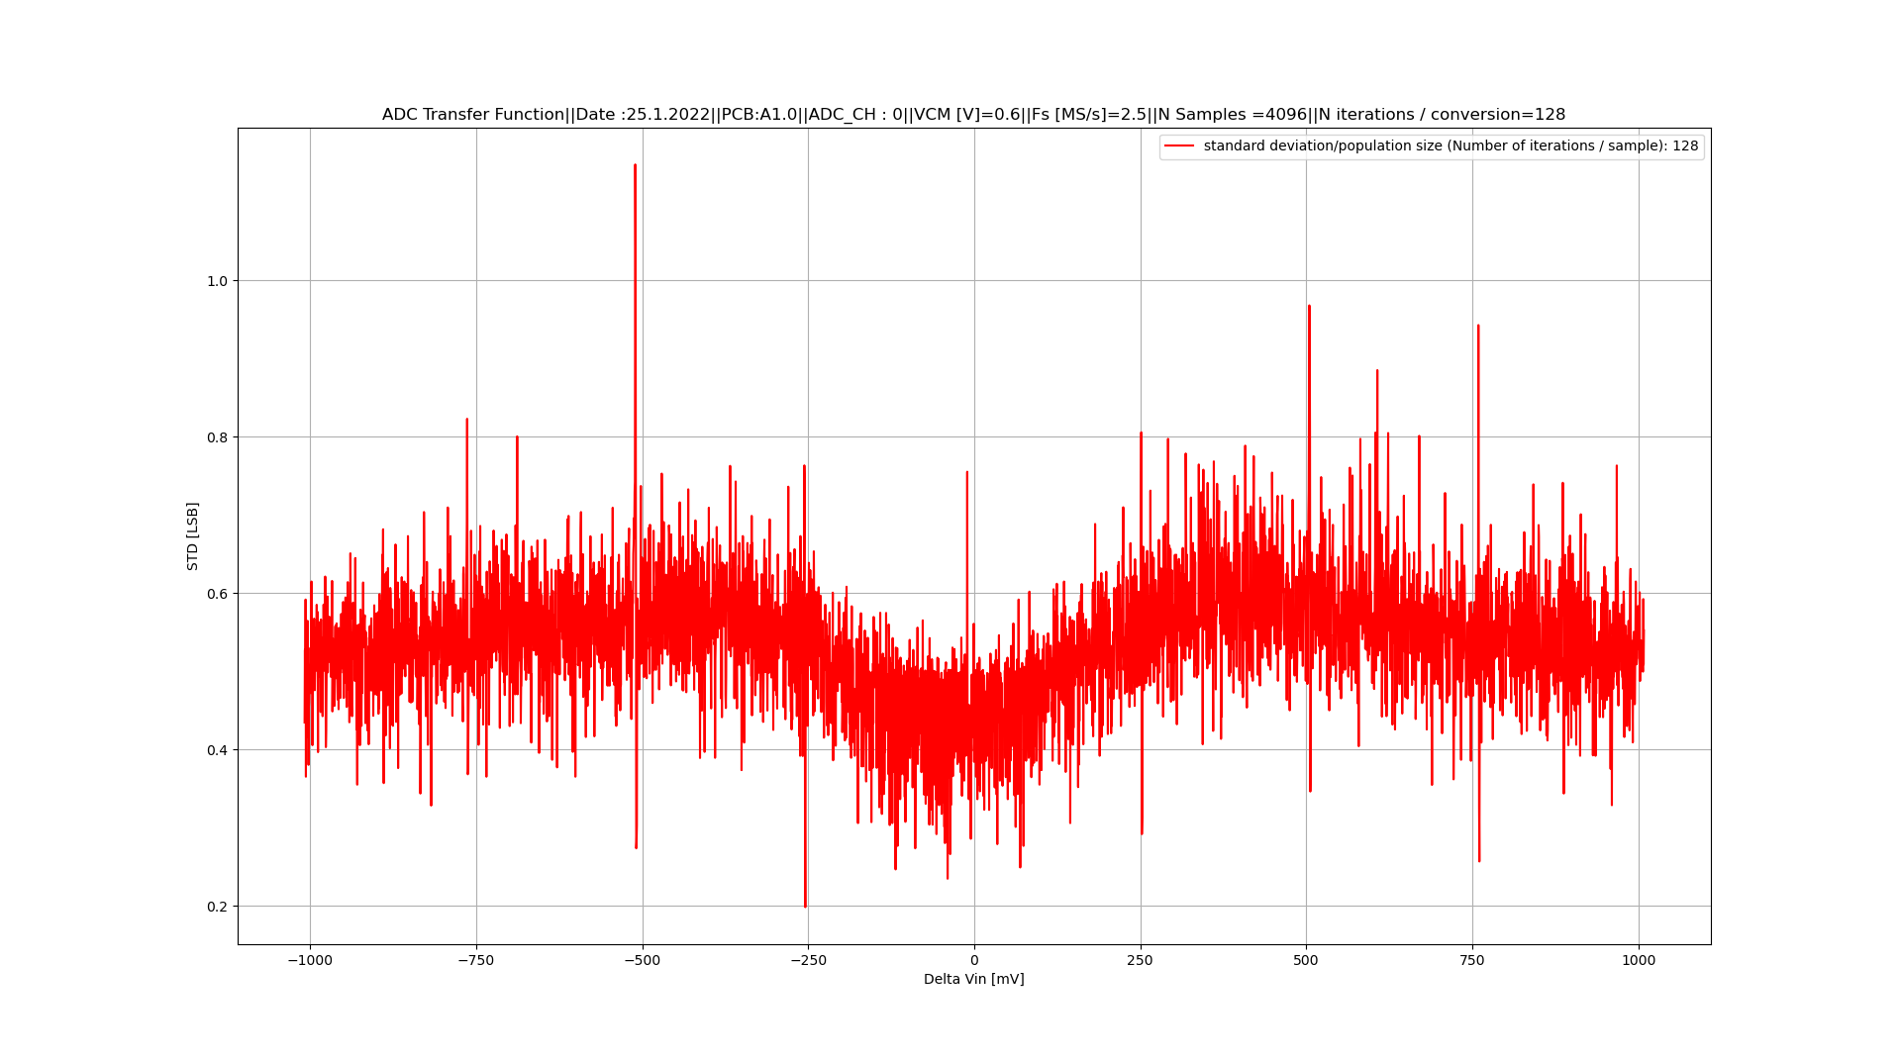

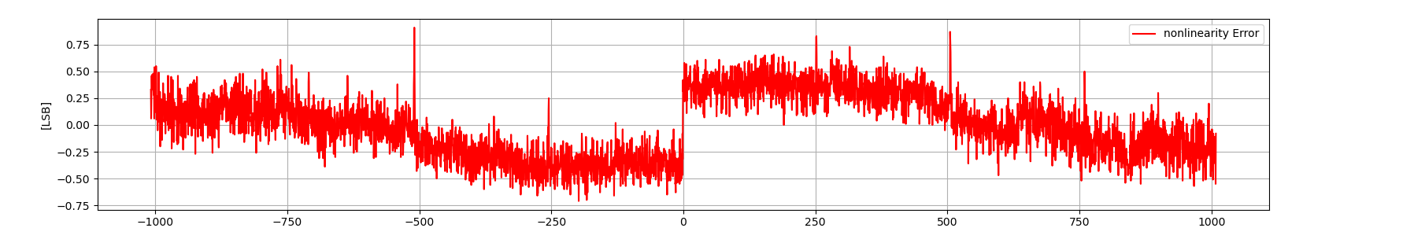
I.2 INL
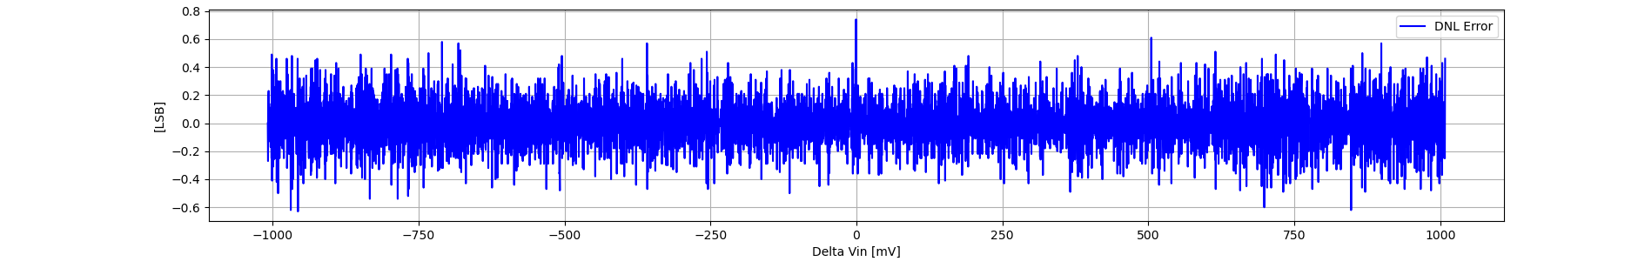
1.3 DNL

