Lamine Hafiane / 16.05.22
effect of the low-VCM (common mode voltage) on the ADC performances

→ the lower VCM is the slower the comparator. This is due to the NMOS input transistors. With VCM < 500mV and VIN_N ~ VIN_P, the delay may be even larger than the half of the CLK-periode !!

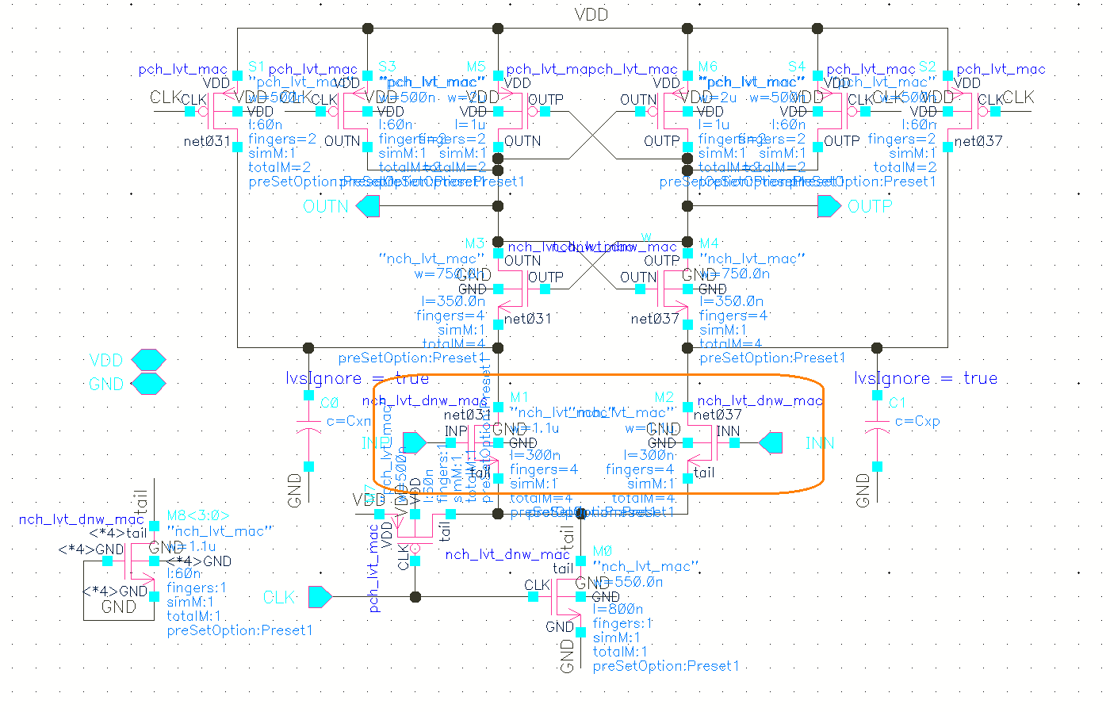
comparator schematic

→ by design ! A half clock period is allocated to the comparator and the other half is reserved for the DAC settling. So, cmp-delay vs settling time of the DAC !

