FFT
M : is the size of the FFT—> number of samples stored in the buffer memory
The spectral output of the FFT is a series of M/2 points in the frequency domain
bin size (the resolution of the FFT/The spacing between the points) is fs/M
FFT process gain = 10×log(M/2) → FFT acts as a narrowband spectrum analyzer with a bandwidth of fs/M that sweeps over the spectrum. This has the effect of pushing the noise down by an amount equal to the process gain—the same effect as narrowing the bandwidth of an analog spectrum analyzer.

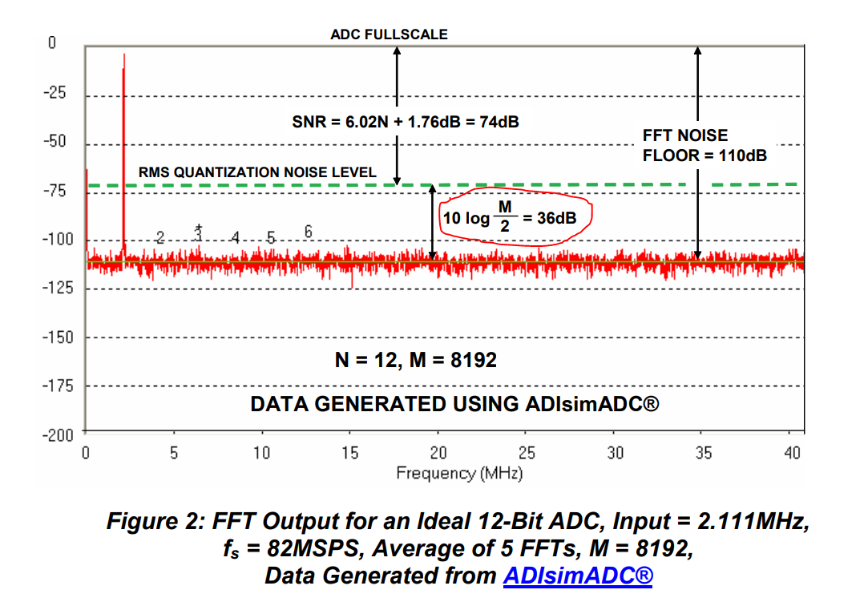
From the doc of Analog Devices
The FFT data shown in Figure 2 represents the average of 5 individual FFTs. Note that averaging a number of FFTs does not affect the average noise floor, it only acts to "smooth" the random variations in the amplitudes contained in each frequency bin.

Signal-to-Noise-and-Distortion SINAD is equal to THD + N

case the signal level is reduced t is necessary to add a correction factor
SINAD + 20log(FS/Amp)

as the spectrum of FFT is mirrored, the first half of M/2 bins contains all necessary information ! the remaining bins are scaled by a factor of 2, except the (first) DC bin !

The magnitude are scaled by 1/M
summary:
M : time domain samples (Sn , n=1 .. M)
2 sided FFT → FFT_mag_2=(1/M) * ABS (FFT(Sn)) ; 1 .. M points
DC component → FFT_mag_2(1)
1 sided FFT → FFT_mag =2 * FFT_mag_2(2:M/2) ; 1 .. M/2 points
copy the DC component FFT_mag(1)=FFT_mag_2(1)
power spectrum → (FFT_mag)^2
introduced errors

1. Leakage
Spectral leakage is the eect, that the energy of the signal is distributed (smeared) among many frequency bins. This effects occurs due to the fact that the FFT analyzes only a finite slice of a signal (N samples). Usually, the the signal discontinuities at the borders of the slices. Provided a set of samples represents a multiple of a period the leakage effects doesn't occurs, in theory.
→ to suppress the leakage : windowing the time-domain signal
Coherent power gain : windowing the signal reduces the amplitude in frequency domain. Accordingly to the used window (Hann, Flattop …. etc) a correction factor should be considered
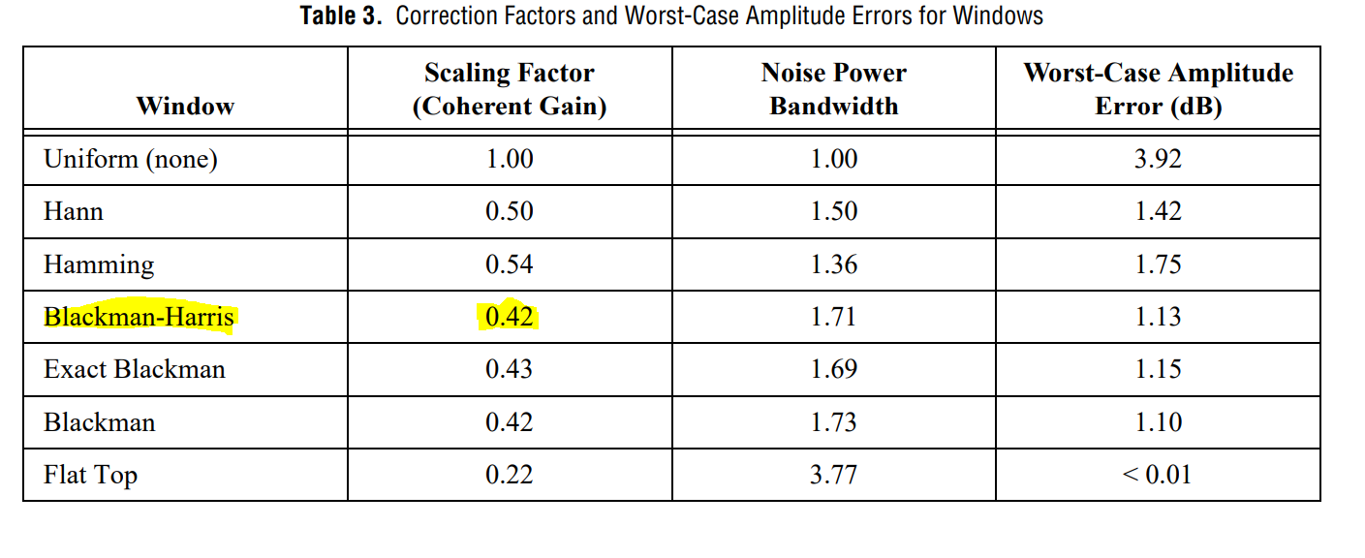
2. Scalloping loss
Due to frequency discretization the frequency of a signal may fall in between two bins!.
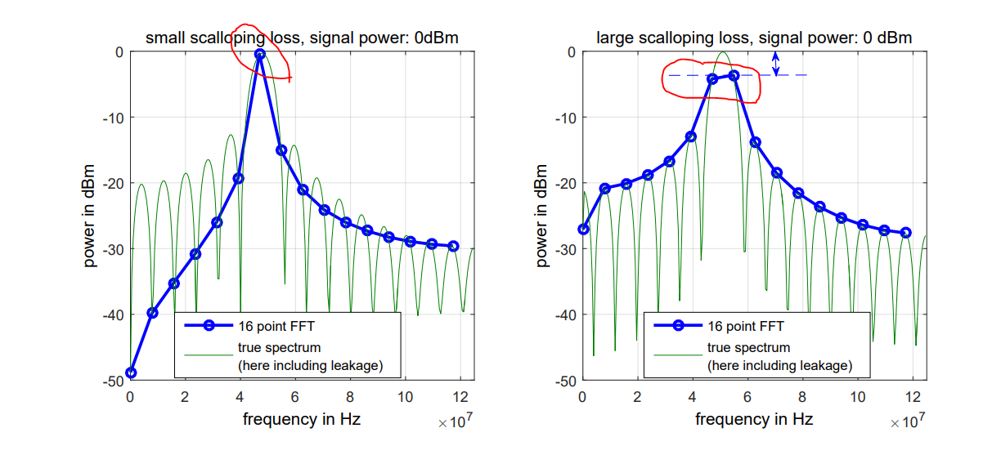

→ use flatttop window
→ couple the signal frequency properly with the sample rate

3. FFT processing gain

→ to measure the noise floor “accurately” :
1 . Average FFTs (not time domain signal!!)
2 . add 10log(N/2) → processing gain compensation

4. Equivalent noise bandwidth

depends on the applied window. The displayed noise floor is higher than the actual level ! A correction factor is required ENBW !
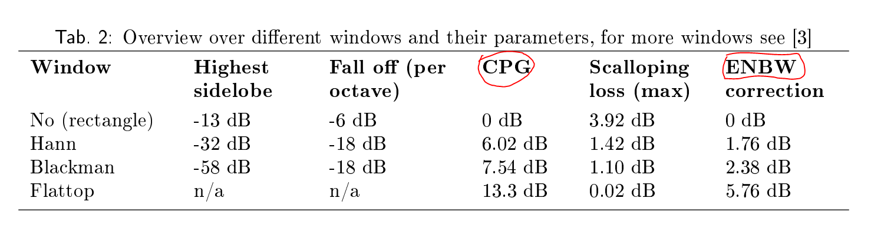
Summing of FFT bins
no correction of processing gain is required, since it is inherently considered by the summation process
Window Characteristics :

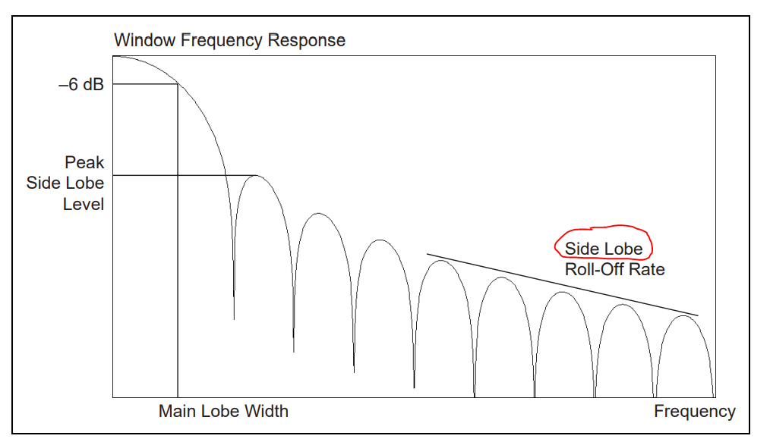
main lobe : -3 db or -6 db → the width of the main lobe @ 0.707 (–3 dB) and 0.5 (–6 dB), respectively.
side lobes : the maximum side lobe level
side lobe roll-off rate : decay rate [db/decade]

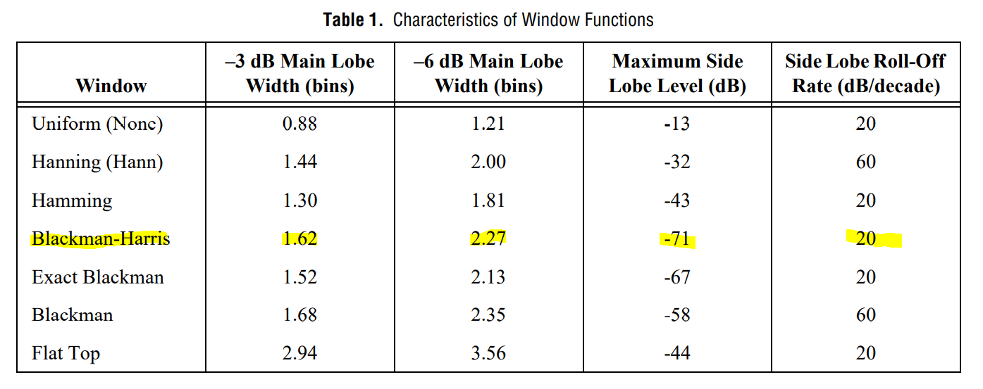

Choosing Windows

“The Hann and Hamming windows do not offer enough side lobe attenuation to be used to test high-resolution ADCs. The four-term Blackman-Harris function has a side lobe rejection level that allows us to accurately test a 12-bit ADC converter.”

Window Correction Factors !!
noted that since a window is applied in time domain, which corresponds a convolution in the linear spectrum, we cannot have both a valid amplitude and correct energy correction at the same time. Use Figure 3to select appropriate spectrum types

while a window helps reduce leakage, the window itself distorts the data in two different ways:
- Amplitude – The amplitude of the signal is reduced
- Energy – The area under the curve, or energy of the signal, is reduced
Window correction factors are used to try and compensate for the effects of applying a window to data. There are both amplitude and energy correction factors.

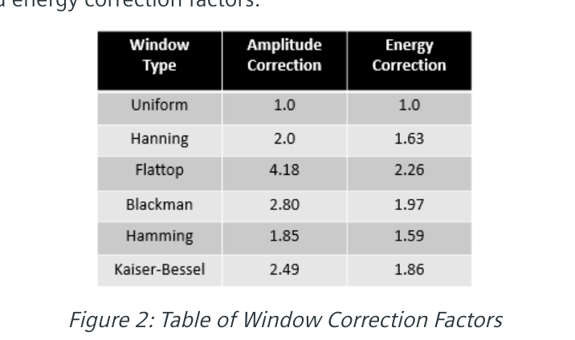
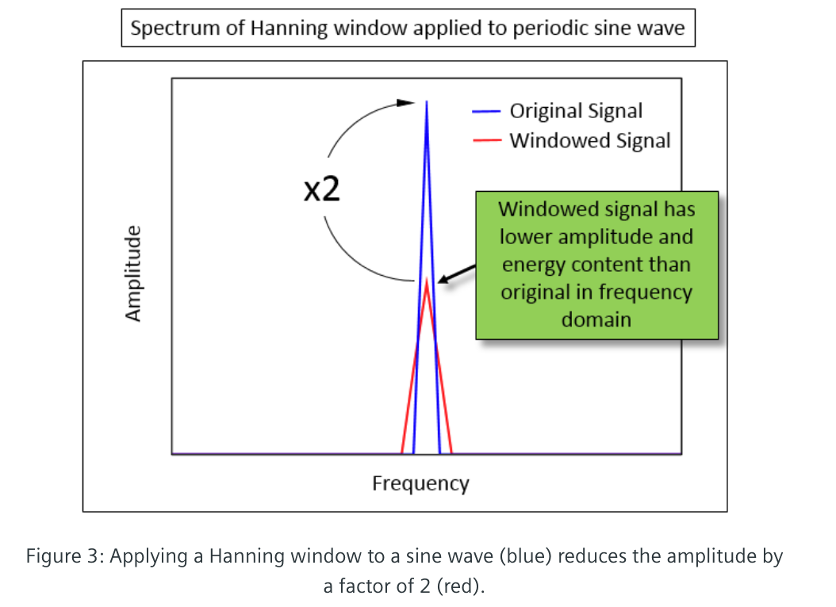
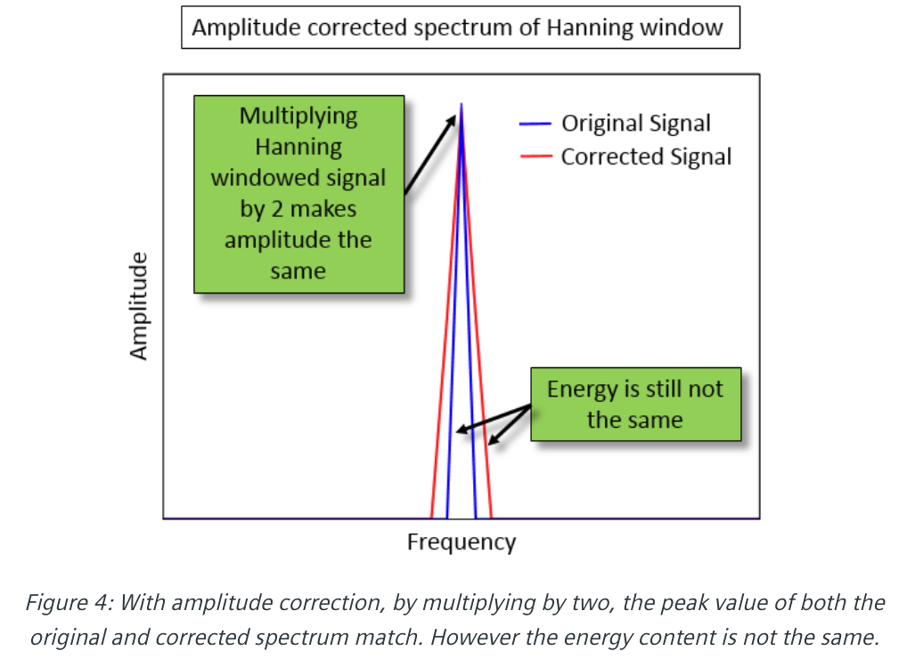

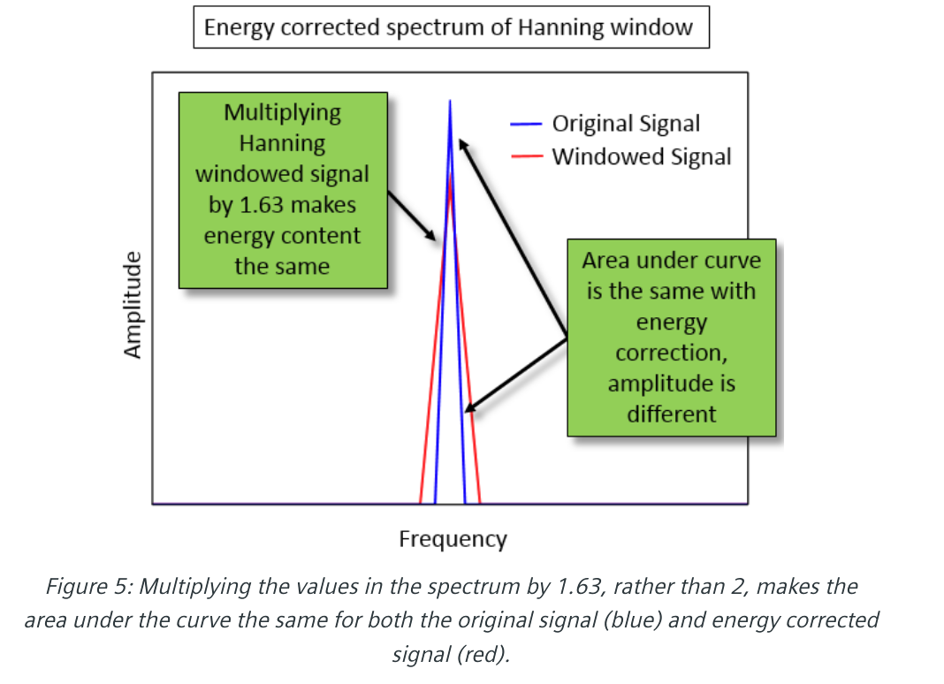
Exactely calculating the factor
