Problem with diff. driver

1. there is no input protection @ ADC level ! VCC = 4.5V (OPAMP) / ADC =1.2V
2. PD_NOT does”t work because of the supply level !
→ acceding to the data sheet it has a pull-up resistor

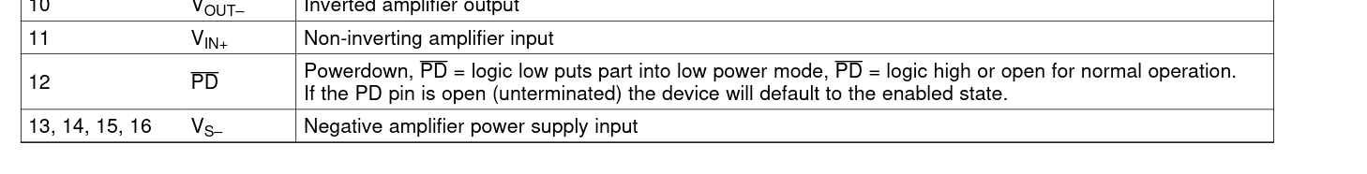
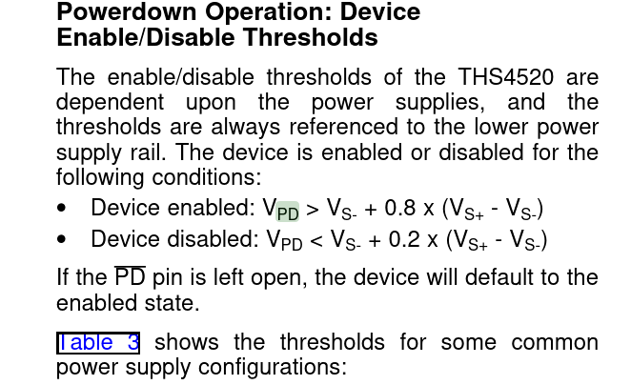

Vth=0 + 0.8 *(4.5V) = 3.6 V
Vth=0+ 0.2*(4.5V) = 0.9 V

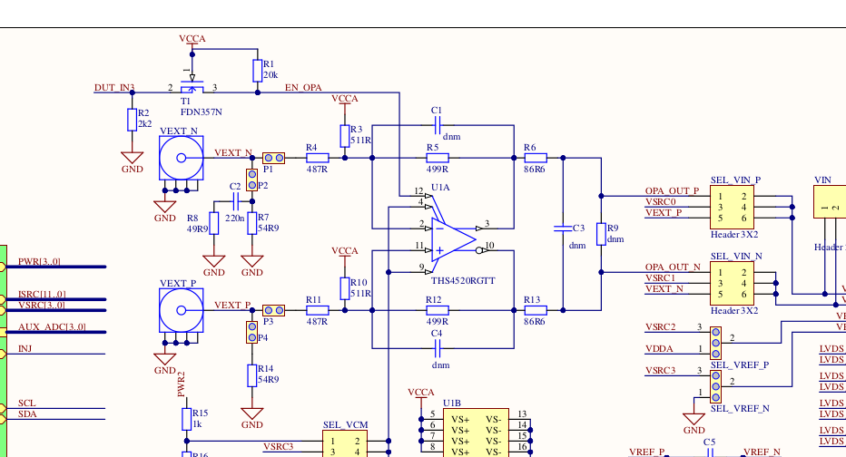
3. small problem in the HDL ! Wrong LOC

