Measurement report of the ADC-TEST-IC

Hans Krueger, Tomasz Hemperek and Lamine Hafiane

Physikalisches Institut, Universität Bonn



!! work in progress !!
This version is submitted only for reviewing !! the content may be subject to changes !!

This report summaries the measurement-results and characterization of the ADC-TEST-IC (called : ADC_CORDIA_1). This IC consists of 4 variants of the SAR-ADC architecture (briefly described below). The design was successfully carried out by Tianyang Wang a former Postdoc-employee at the SILAB of the physical institute (university of Bonn). Please note, the document is not intended to describe the design of the ADCs; it focus, mainly, on the measurement results.

1. Cordia project

The ADC-TEST-IC was developed in cooperation with DESY (Deutsches Elektronen-Synchrotron) as part of a comment research project called : CORDIA : COntinuous Readout Digitising Imager Array. For extended information please refer to [1].

2. ADC- Design

The Design aims an ADC with an effective resolution of 10 bits and a sampling rate of 2.5MS/sec. It is based-on the well-known SAR architecture (Successive Approximation Register) with 4 different variants, which are summarized in table 1. As depicted in figure 1, an integrated 2-bits decoder and 4X1 multiplexer allow the selection of the desired ADC. Note that all ADC's implementations are similar (Figure 2), they differs, however, in the scheme of the capacitive DAC (BSS vs. CRS) as well as the use of the redundancy technique (ADC0 and ADC1 vs. ADC2 and ADC3). For more theoretical background please refers to [2-4].

ADC | SEL | Symbol | Description | Bit stream size
ADC0 | 00 | BSS | Bidirectional Single-Sided switching | 11
ADC1 | 01 | CRS | Correlated reverse switching | 11
ADC2 | 10 | BSS_RE | BSS with redundancy | 13
ADC3 | 11 | BSS_AW_RE | BSS attenuated weighting and with redundancy | 13
Table 1: designed SAR-ADC variants

Fig. 1: abstracted diagram of ADC-TEST-IC
ADC 0
Bit stream
Differential ANALOG input
EN
ADC 1
ADC 2
ADC 3
4
sel_1
CLK_SAR
CLK_CMP
SAMPLE
2 bits Decoder
sel_0
4
X
1
M
U
X
1
EN
EN
EN
CMP_P
CMP_N
S
R
capacitive
DAC

VREF_N
VIN_N
VIN_P
SAMPLE
(LVDS)
CLK_CMP
(LVDS)
SAR
register
CLK_SAR
(LVDS)
VREF_P
RSTB
(LVDS)
OUT_N
OUT_P
Fig. 2: simplified diagram of SAR-ADC

3. Key requirements of the ADC

- Bitstream size : 11 to 13 bits (13 bits when redundancy is used)
- Digital output resolution : 11 Bits
- Aimed effective resolution : 10 Bits
- Maximum Sampling Frequency 2.5MS/sec
- Typical DNL less than 1 LSB (evaluated based on 11 Bits / aimed 10 Bits resolutions)
- Typical DNL less than 1 LSB (evaluated based on 11 Bits / aimed 10 Bits resolutions)
- Noise (1 Sigma) ~ 0.6 LSB (evaluated based on 11 Bits)
- ENOB 9.5 Bits (Typical operation condition) / not completely tested yet !!
- Operating ambient temperature : -20 to 85 °C (validated with a measurement-test)
- Typical power consumption (per ADC/rough estimation): 25uA*1.2V = 30uW
- For the electrical parameters see table 2

Param. | Description | MIN | TYP | MAX | unit | condition
VIN_P | Positive input voltage | 0 |  | 1.3 | V | VDDD=VDDA=1.2V
VIN_N | Negative input voltage | 0 |  | 1.3 | V | VDDD=VDDA=1.2V
VCM | Common mode voltage | 500 | 600 | 700 | mV
VDIFF | Differential input voltage (VIN_P-VIN_N) | -0.80 |  | 0.80 | % VREF
VDDA | Analog supply (+/- 10%) | 1.08 | 1.2 | 1.32 | V
VDDD | Digital supply (+/- 10%) | 1.08 | 1.2 | 1.32 | V
VDDIO | Input/output supply (+/- 10%) | 1.08 | 1.2 | 1.32 | V
VREF_P | Positive analog reference | n. a. | 1.2 | 1.3 | V | VDDD=VDDA=1.2V
VREF_N | Negative analog reference | -100 | 0 | n. a. | mV | VDDD=VDDA=1.2V
VREF | ADC reference  (VREF_P-VREF_N) | 1.08 | 1.2 | 1.32 | V | VDDD=VDDA=1.2V
Table 2: electrical parameters

4. description and configuration of the PINOUT (ADC-TEST-IC )

Figure 3 depicts the configuration of the chip PINOUT. The chip has, in total, 28 PADs with 7 each side. The digital IO-PADs are supplied with VDD_IO /GND_IO, while the chip core contains 2 power domains: Digital and Analog supplied via VDDD/GNDD and VDDA/GNDA respectively. The LVDS (Low-Voltage Differential Signaling) configuration is used for the main digital control signals (SAMPLE, RESB, CLK_SAR and CLK_CMP) as well as the bit-stream output. However, since the ADCs selection bits (SEL0, SEL1, and SEL2) are static-signals, they are connected to a simple CMOS input-PAD. The ADC differential analog input is connected to the PADs : VIN_P and VIN_N while the PADs: VREF_P and VREF_N connects the differential input reference.
Fig. 3: PINOUT
VREF_N
VIN_N
VIN_P
CLK_CMP_P
CLK_SAR_P
VREF_P
CLK_CMP_N
CLK_SAR_N
OUT_N
OUT_P
SAMPLE_P
SAMPLE_N
RST_B_P
RST_B_N
SEL0
SEL1
SEL2
VSUB
GND_IO
GND_IO
GNDA
VDDD
VDD_IO
GNDD
1
GNDD
GNDA
VDDA
VDD_IO

N | PIN | Description | note
1 | GND_IO | Ground of PAD-RING domain | Input/Output PADs
2 | SEL0 | Select (LSB) | CMOS input
3 | SEL1 | Select | CMOS input
4 | SEL2 | Select (MSB) | CMOS input
5 | OUT_P | Output bitstream | LVDS output
6 | OUT_N | Output bitstream | LVDS output
7 | VDD_IO | Supply of PAD-RING domain | Input/Output PADs
8 | CLK_CMP_N | comparator clock | LVDS input
9 | CLK_CMP_P | comparator clock | LVDS input
10 | SAMPLE_N | Sample signal | LVDS input
11 | SAMPLE_P | Sample signal | LVDS input
12 | GND_IO | Ground of PAD-RING domain
13 | VDDD | Digital supply
14 | GNDD | Digital ground
15 | GNDD | Digital ground
16 | VSUB | Subtract connection (ground)
17 | VREF_N | Positive reference voltage
18 | VREF_P | Negative reference voltage
19 | VIN_N | Positive input voltage
20 | VIN_P | Negative input voltage
21 | GNDA | Analog ground
22 | GNDA | Analog ground
23 | VDDA | Analog supply
24 | VDD_IO | Supply of PAD-RING domain
25 | RST_B_P | Reset signal | LVDS input
26 | RST_B_N | Reset signal | LVDS input
27 | CLK_SAR_N | SAR clock (shift register) | LVDS input
28 | CLK_SAR_N | SAR clock (shift register) | LVDS input
Table 3: PINs description

5. Measurement setup (soft- and hardware)
as depicted in figure 4 the test setup consists of an FPGA- and GPAC-board (general purpose analog card) and the DUT-PCB. The system is controlled based on BASIL-system : a data acquisition framework in Python and Verilog (for more information : https://github.com/SiLab-Bonn/basil). The FPGA configuration (firmware) generates the ADC control signals (Figure 5 and figure 7) and allows, simultaneously, the data acquisition (ADC's bitstream). This is further illustrated in figure 6. The signals timing is stored in a configurable sequencer (SEQ) allowing the control and the synchronization of A/D conversion cycles. So, the sampling rate and the number of iteration (conversion) can be set to a given values. A measurement frame starts always with the trigger signal: EN_SEQ. The acquired data (16 bits per conversion) through the SPI (Serial Peripheral Interface) are transferred to an external RAM and read out via USB interface.
Fig. 4: diagram of the measurement setup
DUT
FPGA
USB controller
SRAM
…...

DACs
ADCs
Power supplies
LVDS digital Ios
--------

USB
BASIL
environment
MIO
GPAC

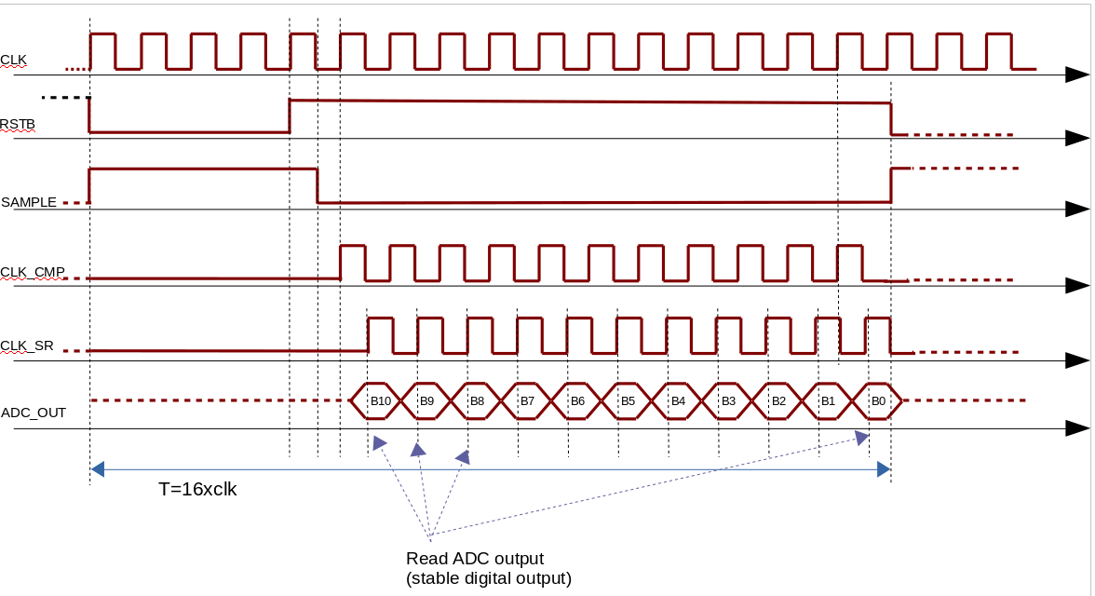
Fig. 5: typical timing diagram (without redundancy)

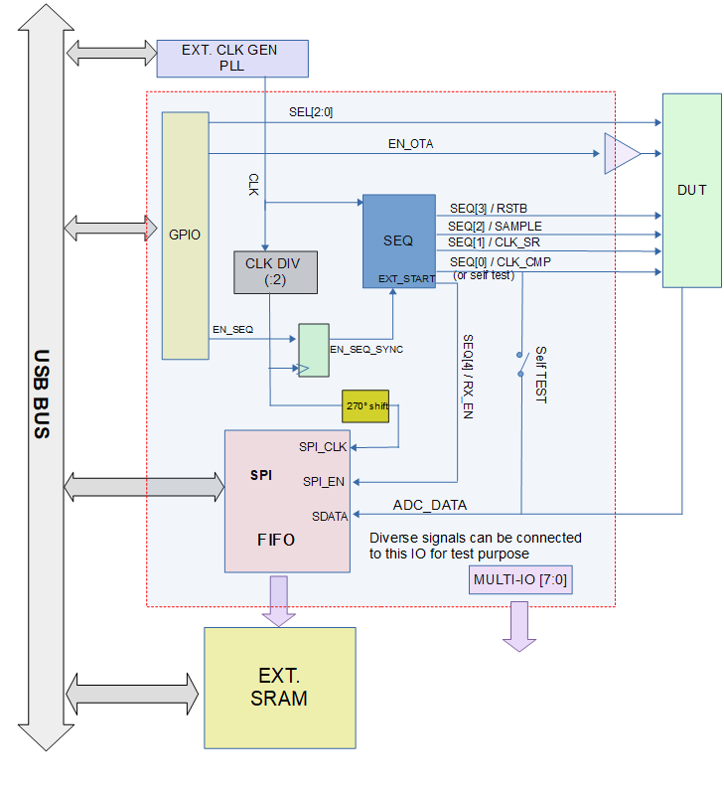

Fig. 6: diagram of the FPGA configuration

6. Weights vector (with redundancy)

when redundancy is used (ADC02 and ADC03) , specific weights must be used instead of the usual one : Wi=2^{i} with i=0 to 10 (11 bits). This is owing to the non-binary steps used in the capacitive DAC with redundancy configuration. Table 4 reports the weights vector relative to ADC02 and ADC03. Note that the bit-stream size is 16 bits; 3 out of that are not used (0,1 and 2). The decimal value of the ADC output is computed based on eq. (1).
Table 4: redundancy weights vector
(1)

7. measurement and characterization
At this stage, the measurement and characterization are performed using only 4 DUTs (bonded die on PCB). Hence, the results reflect only typical performances and no statistical data are available, at this point. All measurement are performed under typical operation conditions (see section 3); unless otherwise indicated. In additional, the ADC performances are tested against the variations of supplies and temperature (see table 2). This section is organized in two main parts : DC and AC (or dynamic) characterization. In both tests we use the well known standard methods for testing and computing the key parameters, e. g. INL, DNL and ENOB.
Figure 7 shows an oscilloscope-capture of the timing of the control signals (for reference see also figure 6). This configuration is standard for our application and used for all measurements. Further
details including timing, FPGA configuration (firmware), entire measurement database can be found under SVN.
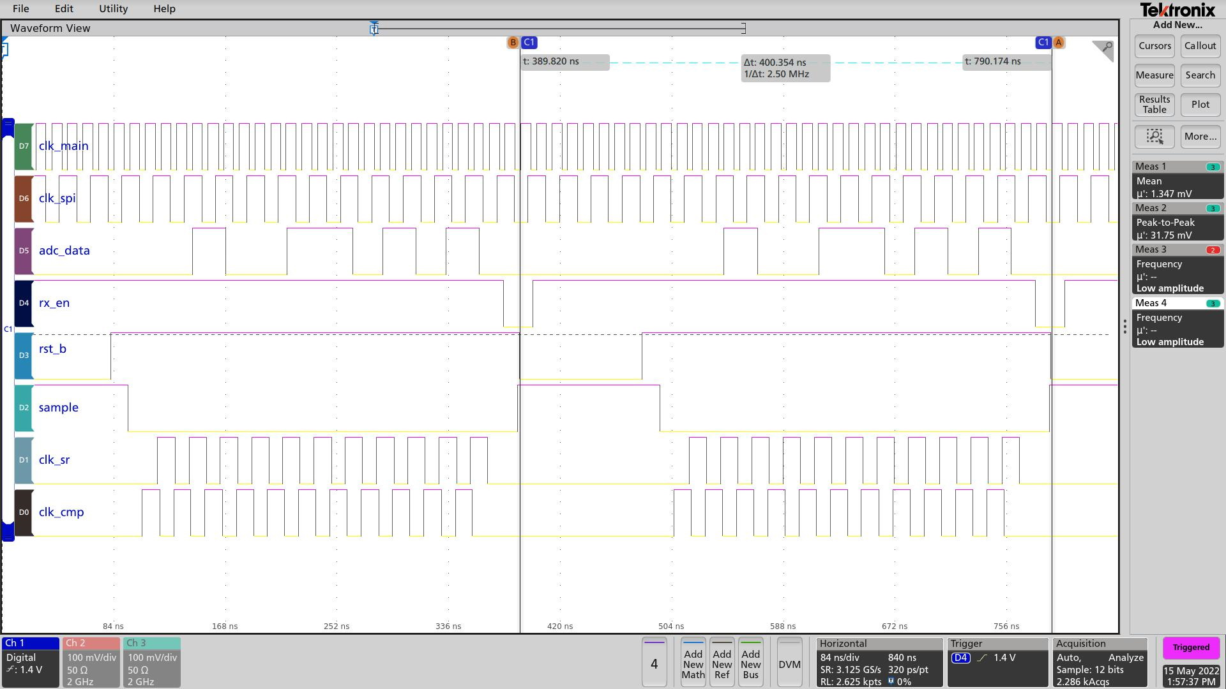
Fig 7: control digital signals

7.1 DC transfer function
A higher resolution digital ramp, compared to 11 bits, is applied to the ADCs input. The DC-ramp is generated using high precision SMU device (Source Measure Unit). For a typical measurement, the input voltage covers the range from nearly -1V to + 1V (~ 85% of the full range : 1.2V) with 4096 steps (∆V= 2V/4096 ≈ 488uV); which means twice resolution of the ADC under test. In order to reduce the impact of the noise on the INL/DNL computing, each point is averaged based on 128 iterations. The INL is computed, for each single point, as the difference between the linear regression (using least square method) and the actual data. The DNL, in the other hand, is computed as the difference between 2 successive points compared to the expected ideal step. A typical results are shown in figure 8. Further detailed results of all tested devices (4 DUTs times 4 ADCs) are reported in the section detailed results.

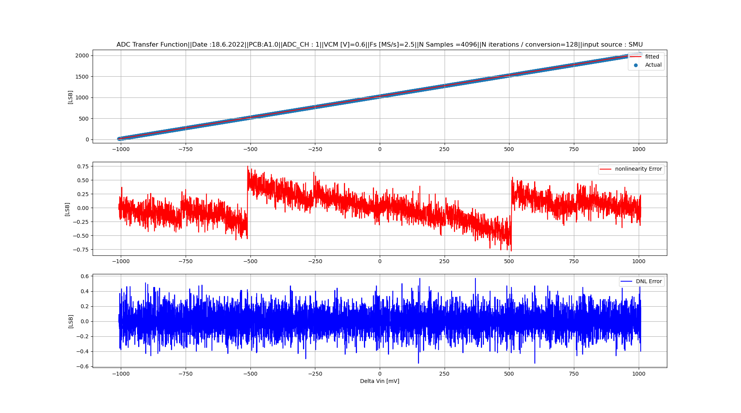
Fig. 8: typical DC transfer characterization (ADC01/CRS)

7.2 Noise
using the same test-setup, described in the latter section, the noise is evaluated as the standard deviation for each single input voltage (4096 step/ 128 iteration per step). A typical noise behavior is plotted in figure 9. Note that, all ADCs show, nearly, the same behavior (see section detailed results). This is owing, probably, to the CMOS input switches (sampling phase), in which the ON-resistance varies as a function of the input voltage. In additional, the noise behavior is further investigated using the histogram method. This consists of computing the PDF (probability distribution function) of the ADC output @ a given constant input. The aim is to determine the distribution function (Gaussian is expected). Using 12000 successful iterations (conversions), a typical histogram of the ADC output is depicted in figure figure 10 (more results are reported in the section detailed results). From this results it can be inferred that the span of the ADC output lays in the range of 2 LSB (MAX-MIN) with a sigma of 0.35 LSB.

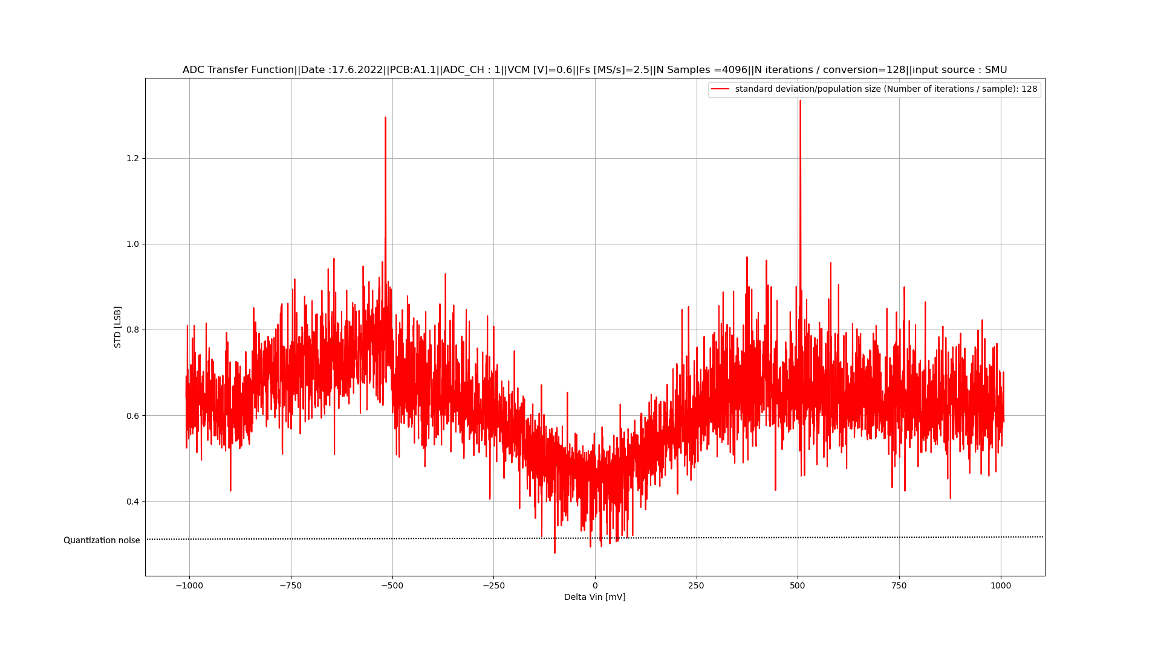
Fig. 9: typical standard deviation (ADC01/CRS)
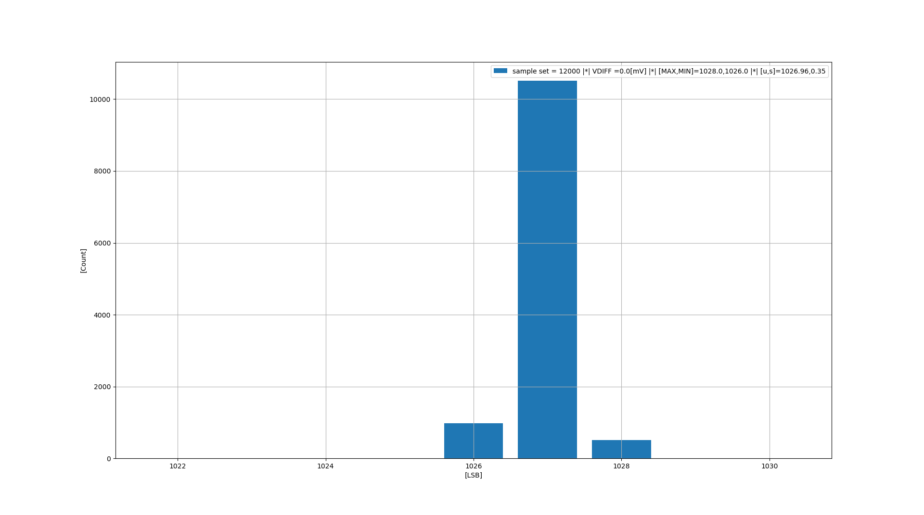
Fig. 10: typical histogram of the ADC output (ADC01/CRS)

7.3 Temperature and supplies variation
The limits of the electrical parameters reported in table 2, as well as the operating temperature range (-20 to 85 °C) are tested and validated based on the DC-test-setup described above (see section 7). All ADCs exhibits a good robustness against temperature and supplies variations. Detailed results are reported in the section: “detailed results”.
7.4 Higher sampling rate
Similar to the test of temperature and supplies variation, the ADCs are tested with higher sampling rate (up to 3MS/sec). Note that the design is optimized for 2.5MS/s ! and so the aim of this test is only to investigate the robustness of the system.
8. AC (dynamic) characterization
ENOB measures the combined effects of all sources of noise and distortion. This parameter provides a figure-of-merit for a given ADC. Most common ENOB test procedure is based on acquiring and analyzing the digital data of a pure sinus analog input. The FFT of the digitized signal is used as an analog spectrum analyzer to measure the magnitude of the various harmonics and noise components.
“!! Work on progress !! at this point ! We were not able to set up a sinus wave with required spectral purity. We have only used an arbitrary function generator (Agilent) with THD in the range of 60dBc. We are working on a solution with 4th order bandpass filter! unfortunate the delivery is delayed due to the chips shortage!
This section will be updated ”
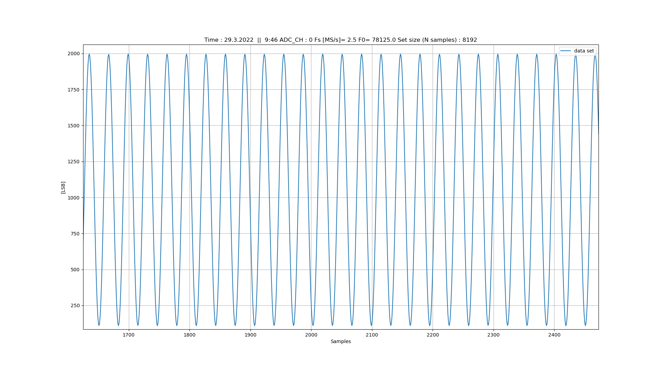
Fig. 11: digitized sinus waveform (input frequency F0=78.125 kHz)

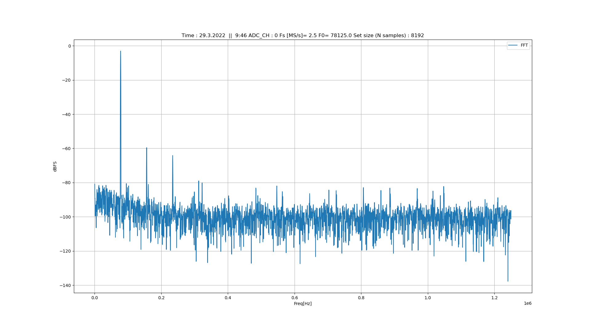
Fig. 12: FFT (input frequency F0=78.125 kHz)
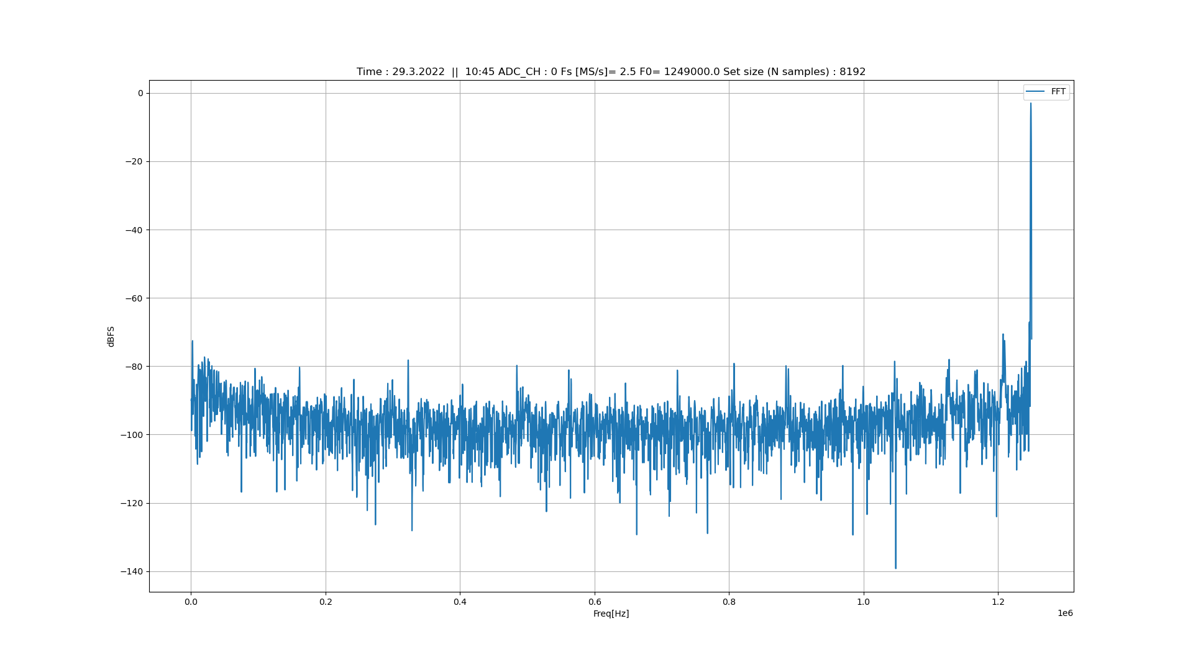
Fig. 13: FFT (input frequency F0=1.249 MHz)

Fig. 14: ENOB vs. input frequency
comparison and assessment

As mentioned before only 4 DUTs, at this point, are characterized and hence no statistical data are available. Since, both INL and DNL depends on the mismatch between devices (e. g. DAC-Capacitors) as well as the process variation (die -to-die and/or wafer-to-wafer), the current results reflect only a typical performances. Nonetheless, considering the ENOB, noise evaluation and INL/DNL of all tested DUTs, it can be concluded that the 4 ADCs (table 1) exhibit a 10 bits resolution. However, ADC01 (CRS) shows relatively stable behavior with respect to INL/DNL. It is worth mentioning that ADC02/03 (with redundancy) can be further improved with calibrate (by adjusting the weight matrix). All 4 ADCs exhibits the same noise level, which is expected, as the ADC's variants have the same input capacitance, sampling switches and comparator. The latter is the main contributor to the total noise.

ADC01 (CRS) |  | Description | Condition | MIN | TYP | MAX
DC characteristics | INL [LSB] |  |  | n. a. | < 1 | No data available
DC characteristics | DNL [LSB] |  |  | n. a. | < 1 | No data available
DC characteristics | Typical offset [LSB] | Rough estimation |  | -10 |  | +10
DC characteristics | Typical gain [LSB/1V] | Rough estimation |  | 990 | 1000 | 1010
AC (dynamic)  characteristics | ENOB |  | @ Finput = Fs/2 |  | !!!! Bits
Table 5: characteristics of ADC01

Nomenclature

ENOB : effective number of bits
THD : total harmonic distortion
INL : integral non-linearity
DNL : differential non-linearity
FFT : fast fourier transformation
DUT : device under test

Reference
[1] A. Marras a,b , A. Klyuev a,b , T. Laurus a,b , D. Pennicard a,b , U. Trunk a,b , C.B Wunderer a,b ,
[1] T. Hemperek c , T. Kamilaris c , H. Krueger c , T. Wang c and H. Graafsma a,b,d“Development of CoRDIA: a High-Speed Imaging Detector, for Diffraction-Limited Synchrotron Rings and Continuous-Wave Free Electron Lasers“, 2021 IEEE NSS MIC.
[2] Jen-Huan Tsai, Hui-Huan Wang, Yang-Chi Yen, Chang-Ming Lai, Yen-Ju Chen, Po-Chuin Huang, Ping-Hsuan Hsieh, Hsin Chen, and Chao-Cheng Lee, “A 0.003 mm 10 b 240 MS/s 0.7 mW SAR ADC
in 28 nm CMOS With Digital Error Correction and Correlated-Reversed Switching”, EEE JOURNAL OF SOLID-STATE CIRCUITS, VOL. 50, NO. 6, JUNE 2015
[3] Wan Kim, Student Member, IEEE, Hyeok-Ki Hong, Student Member, IEEE, Yi-Ju Roh, Student Member, IEEE, Hyun-Wook Kang, Student Member, IEEE, Sun-Il Hwang, Dong-Shin Jo, Dong-Jin Chang, Min-Jae Seo, and Seung-Tak Ryu, Senior Member, IEEE, “A 0.6 V 12 b 10 MS/s Low-Noise Asynchronous SAR-Assisted Time-Interleaved SAR (SATI-SAR) ADC”, IEEE JOURNAL OF SOLID-STATE CIRCUITS, VOL. 51, NO. 8, AUGUST 2016.
[4] Chun-Cheng Liu, Member, IEEE, Che-Hsun Kuo, and Ying-Zu Lin, Member, IEEE, “A 10 bit 320 MS/s Low-Cost SAR ADC for IEEE 802.11ac Applications in 20 nm CMOS”, IEEE JOURNAL OF SOLID-STATE CIRCUITS, VOL. 50, NO. 11, NOVEMBER 2015

detailed measurement results:
INL/DNL (4 DUTs X 4 ADCs / Typical)

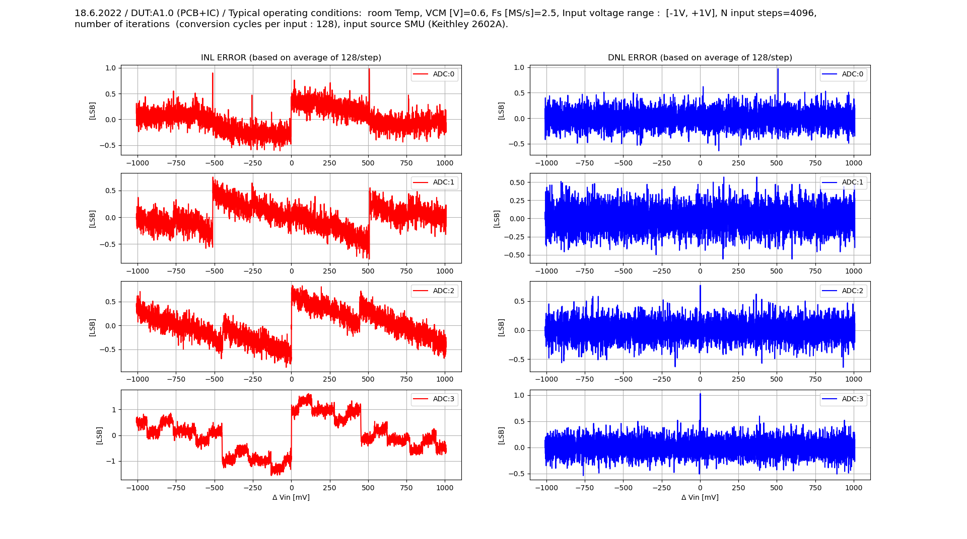
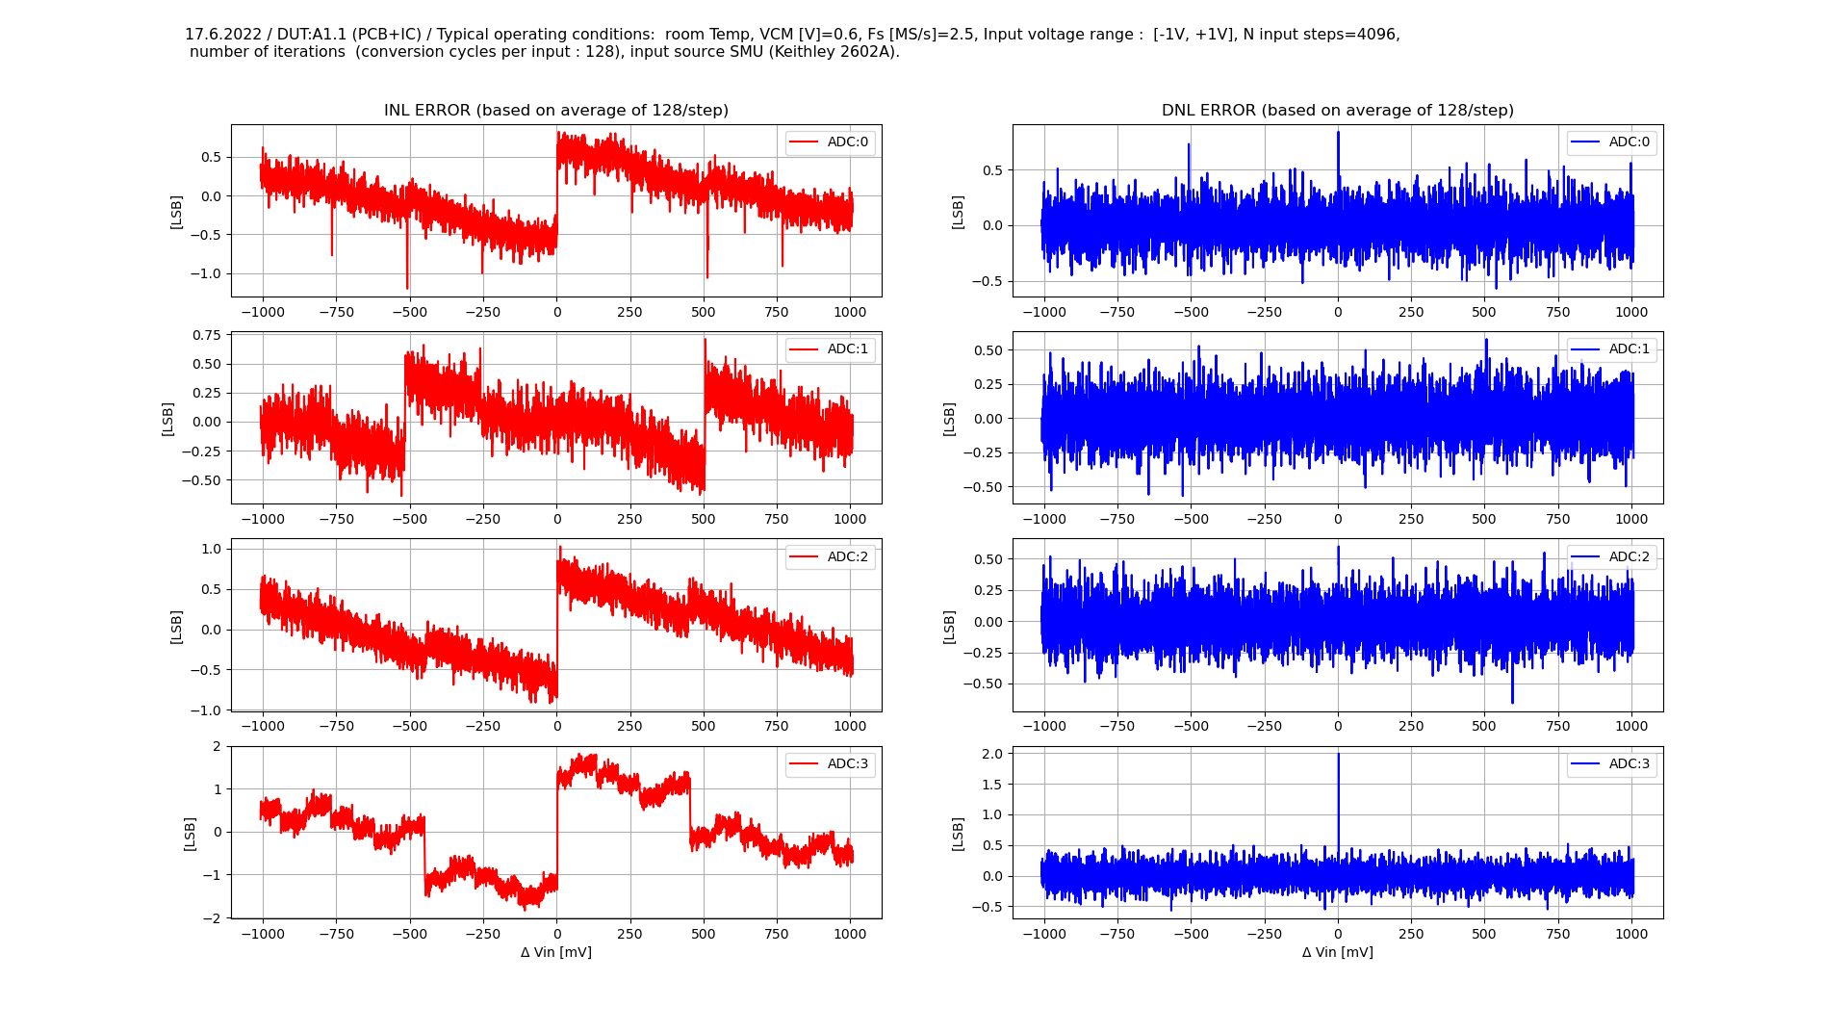
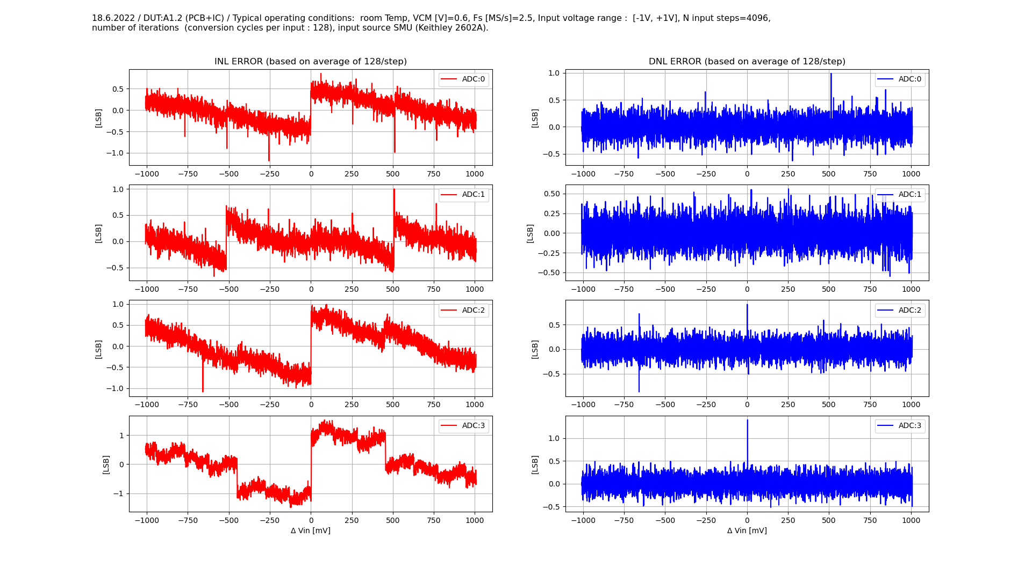
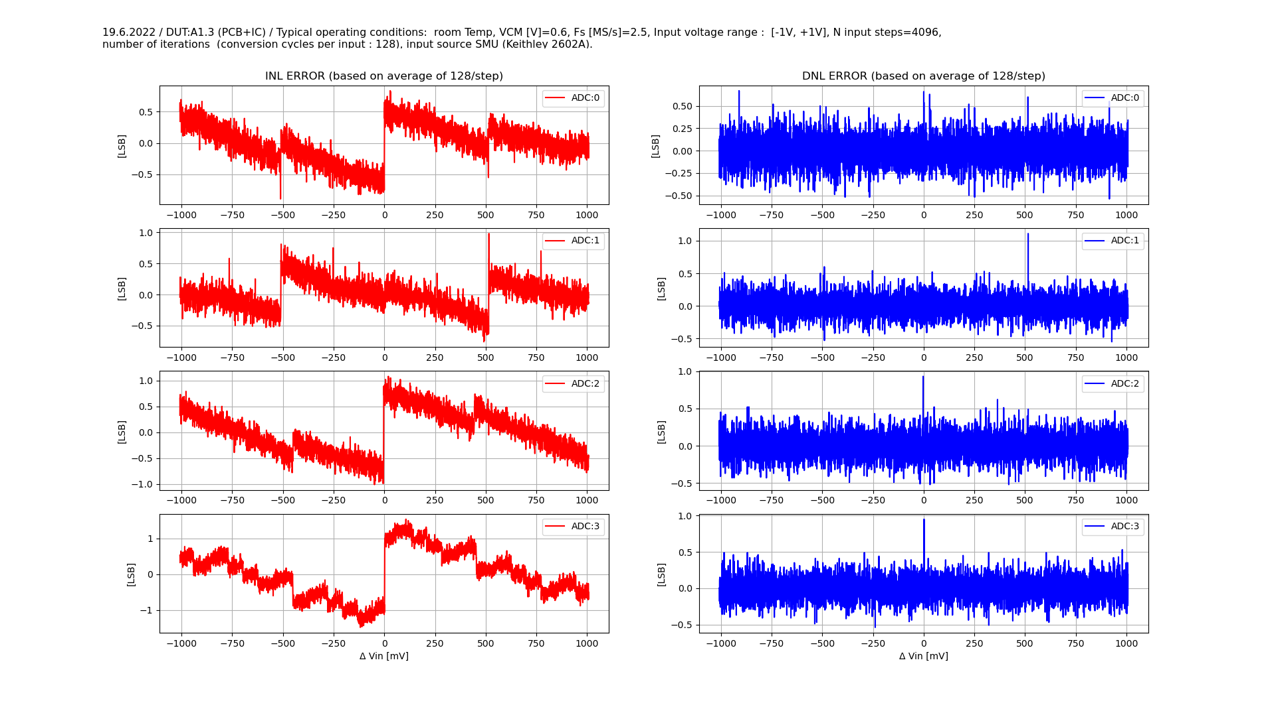

Noise (4 X ADCs / Typical)

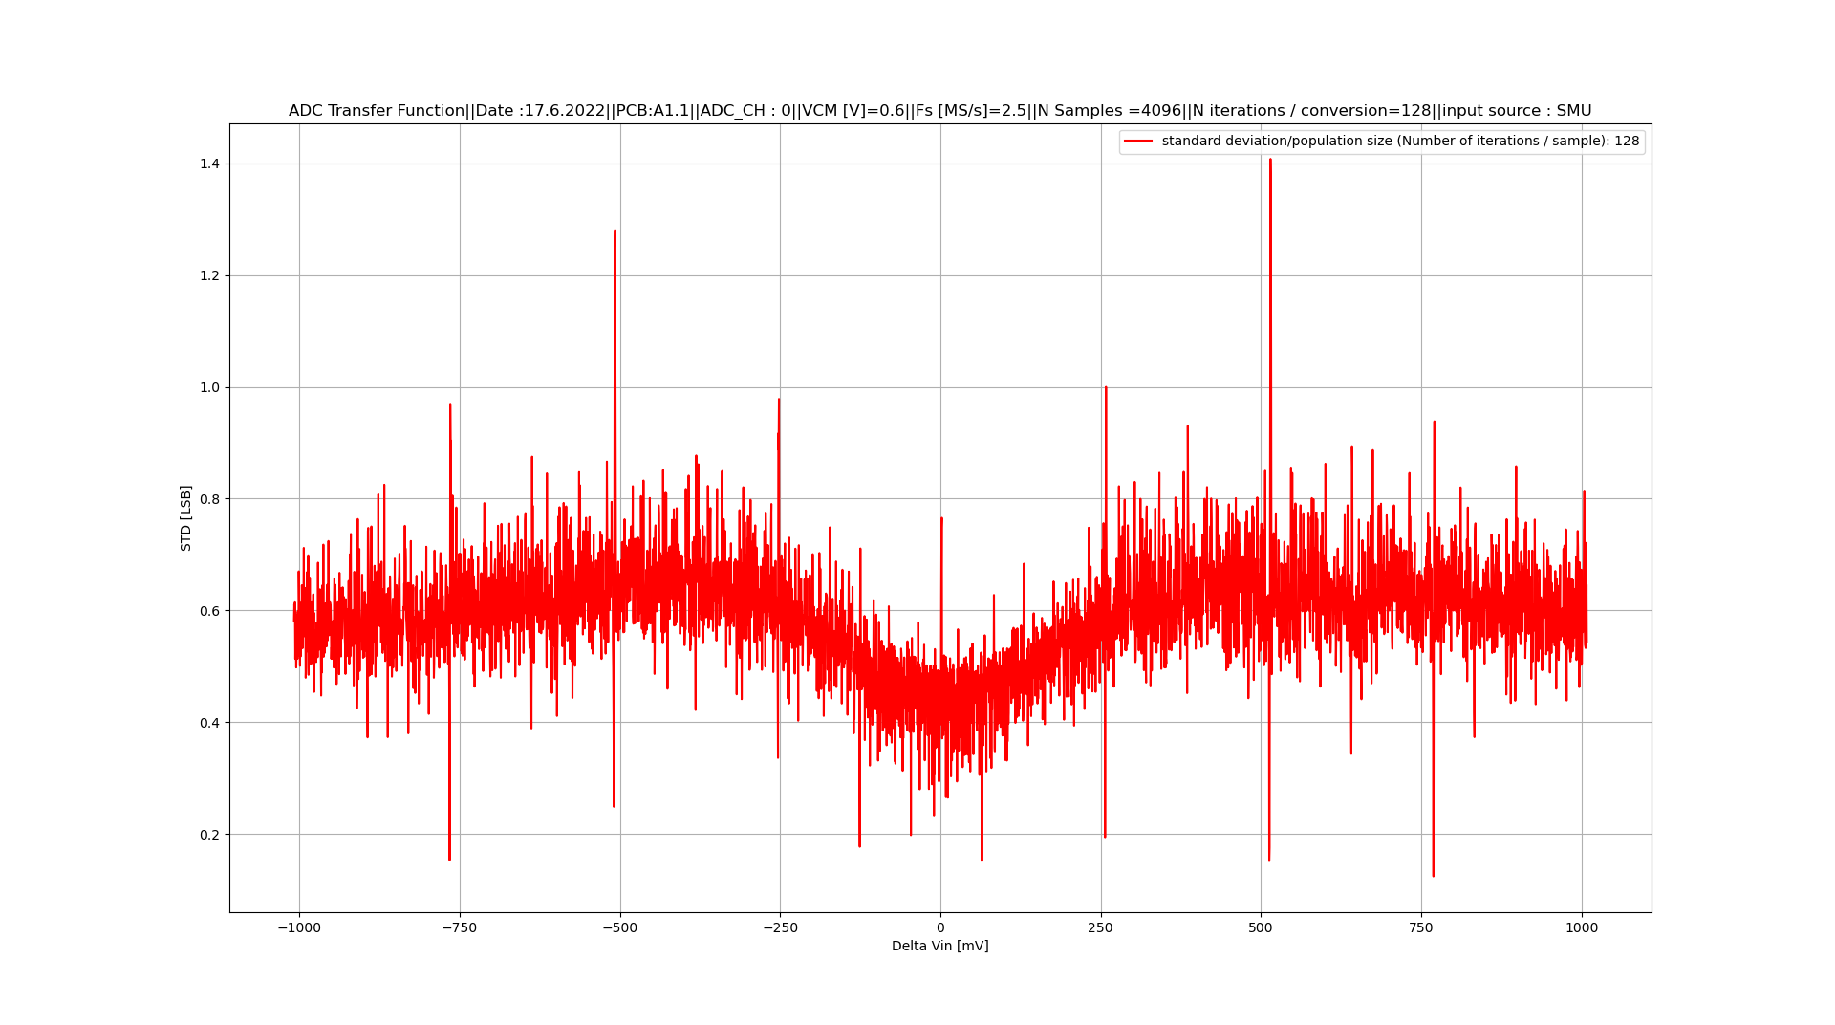
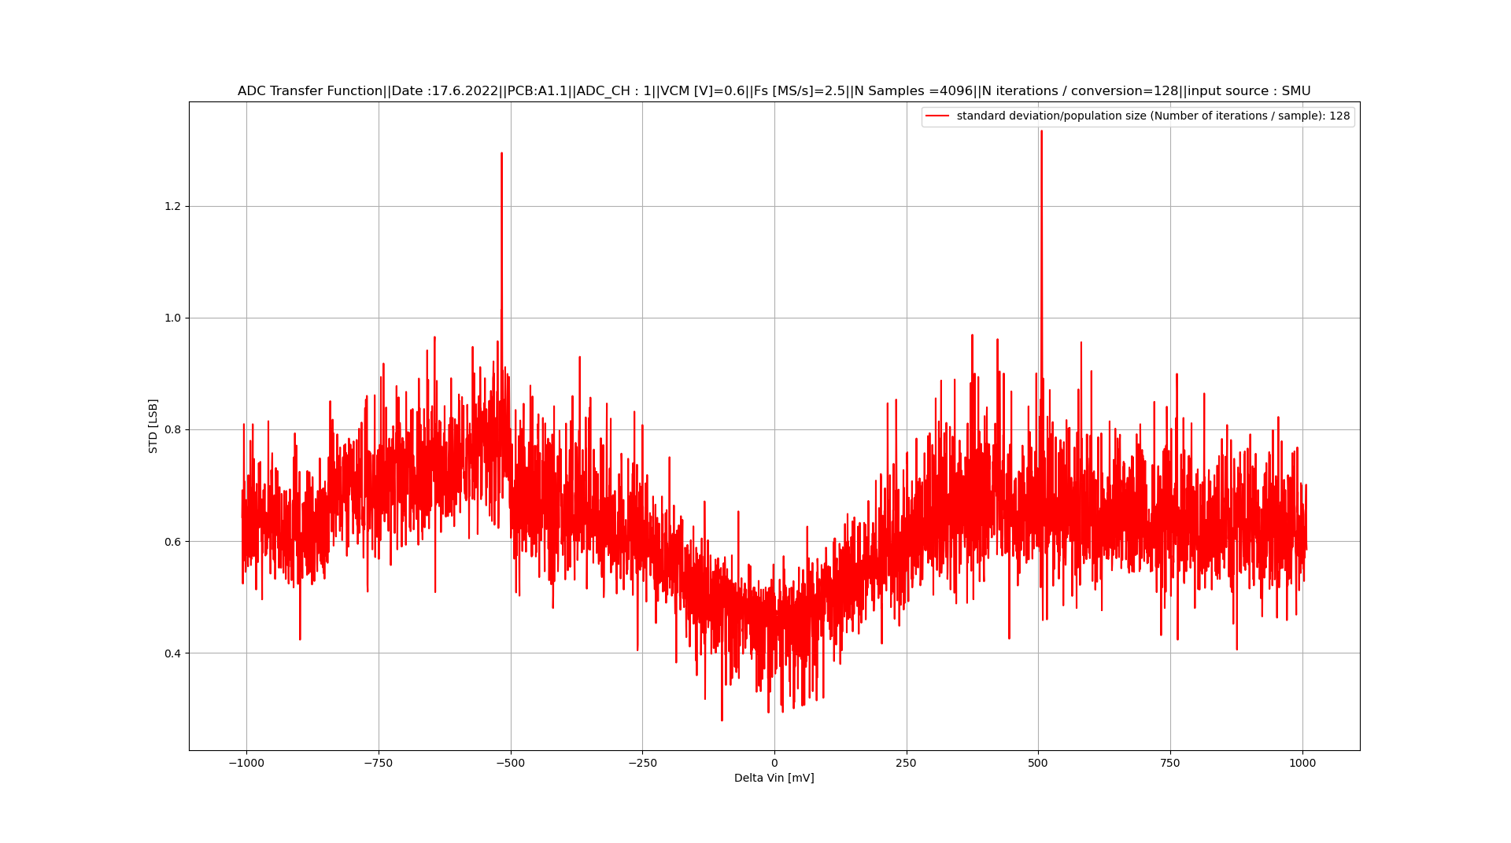

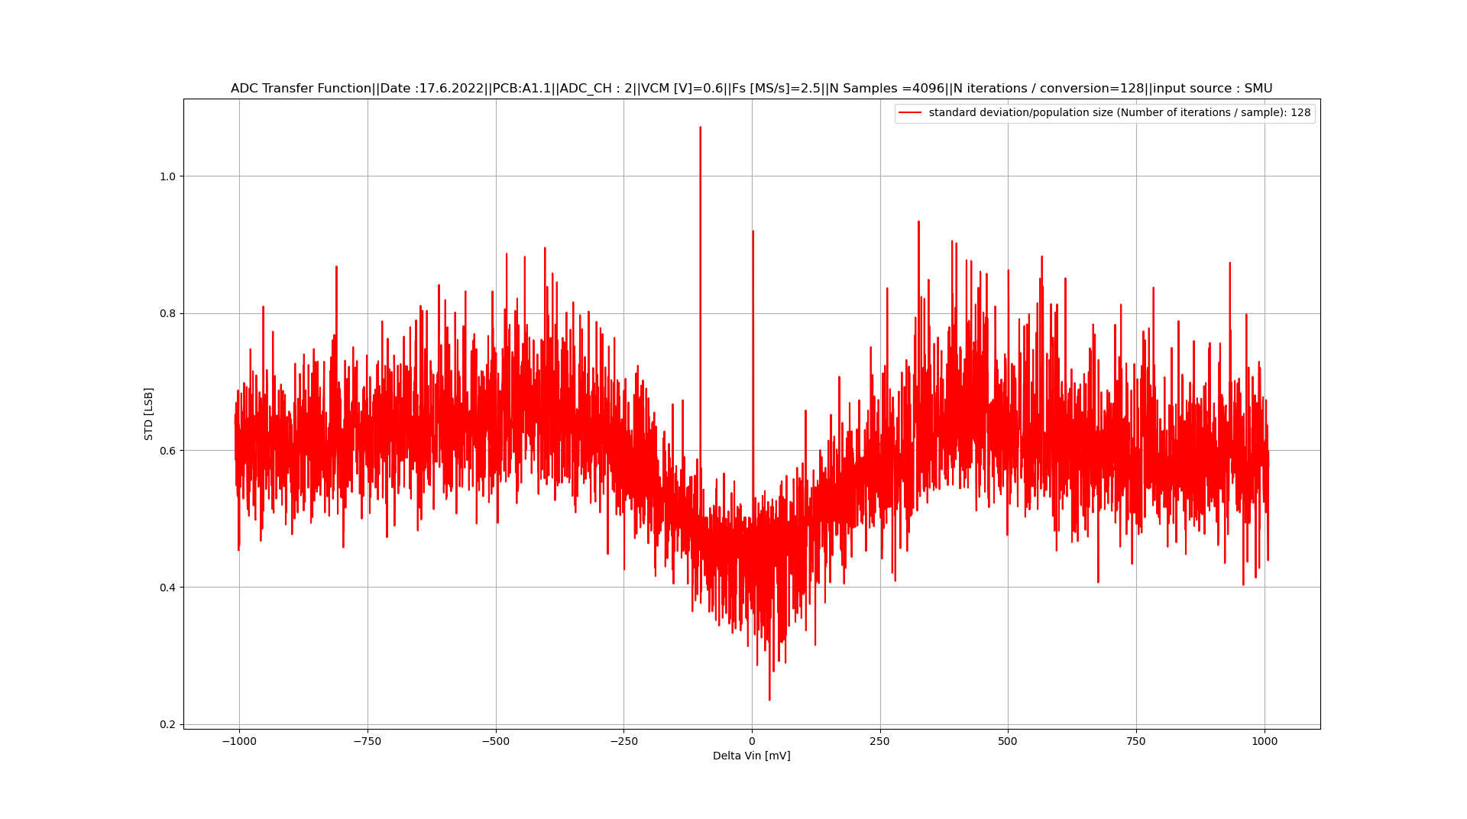
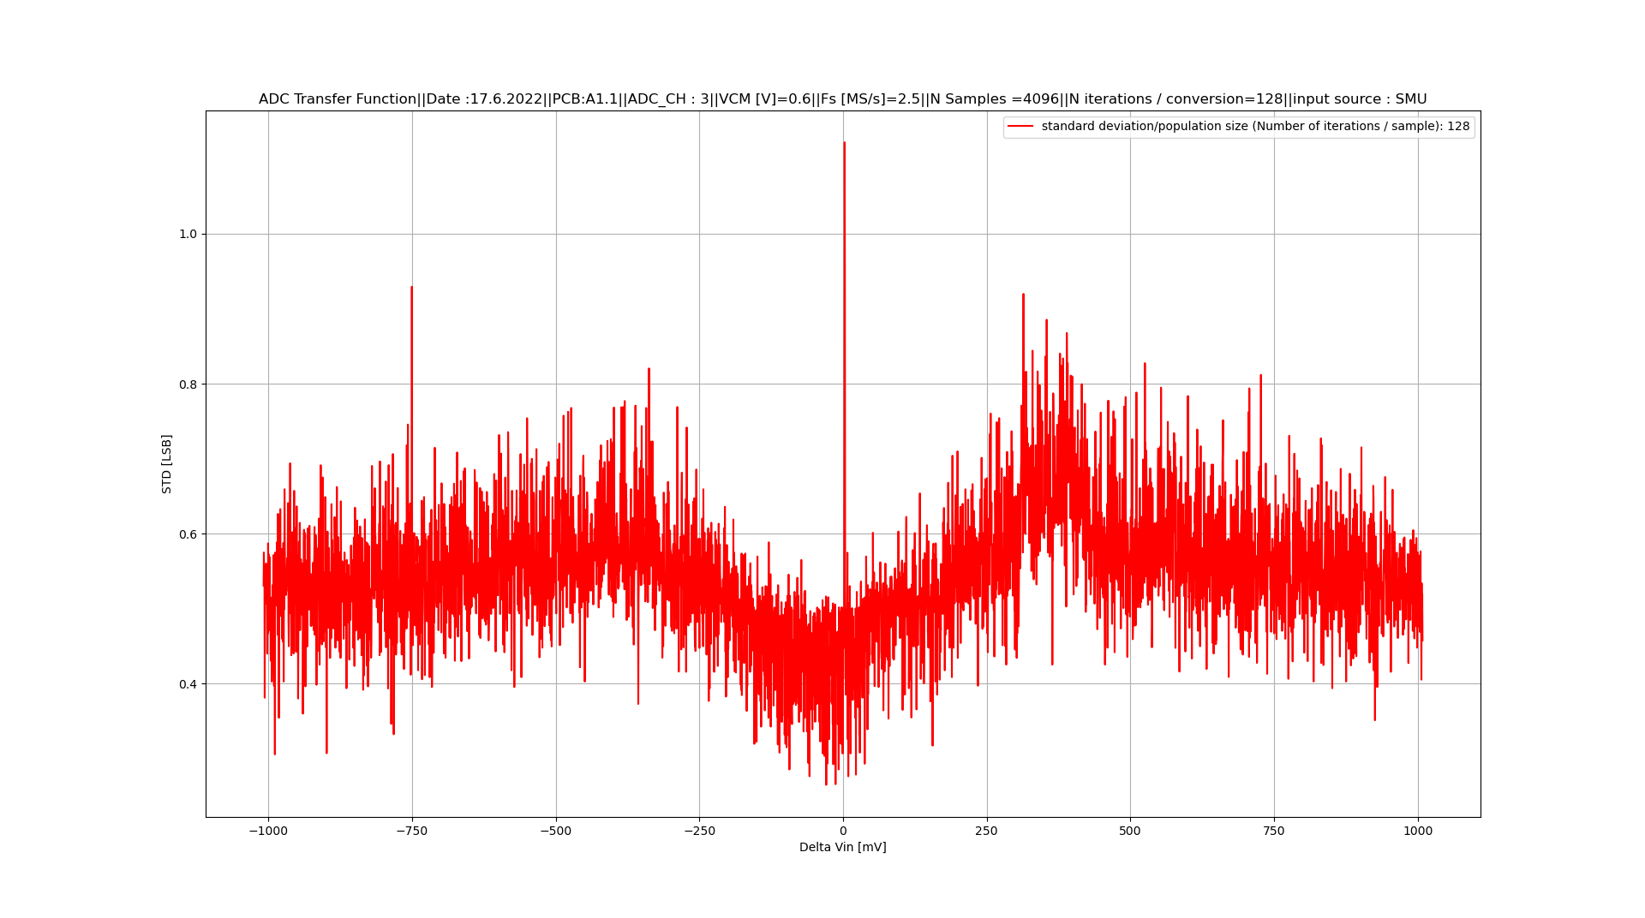

Noise (Histogram / ADC01 / Typical)

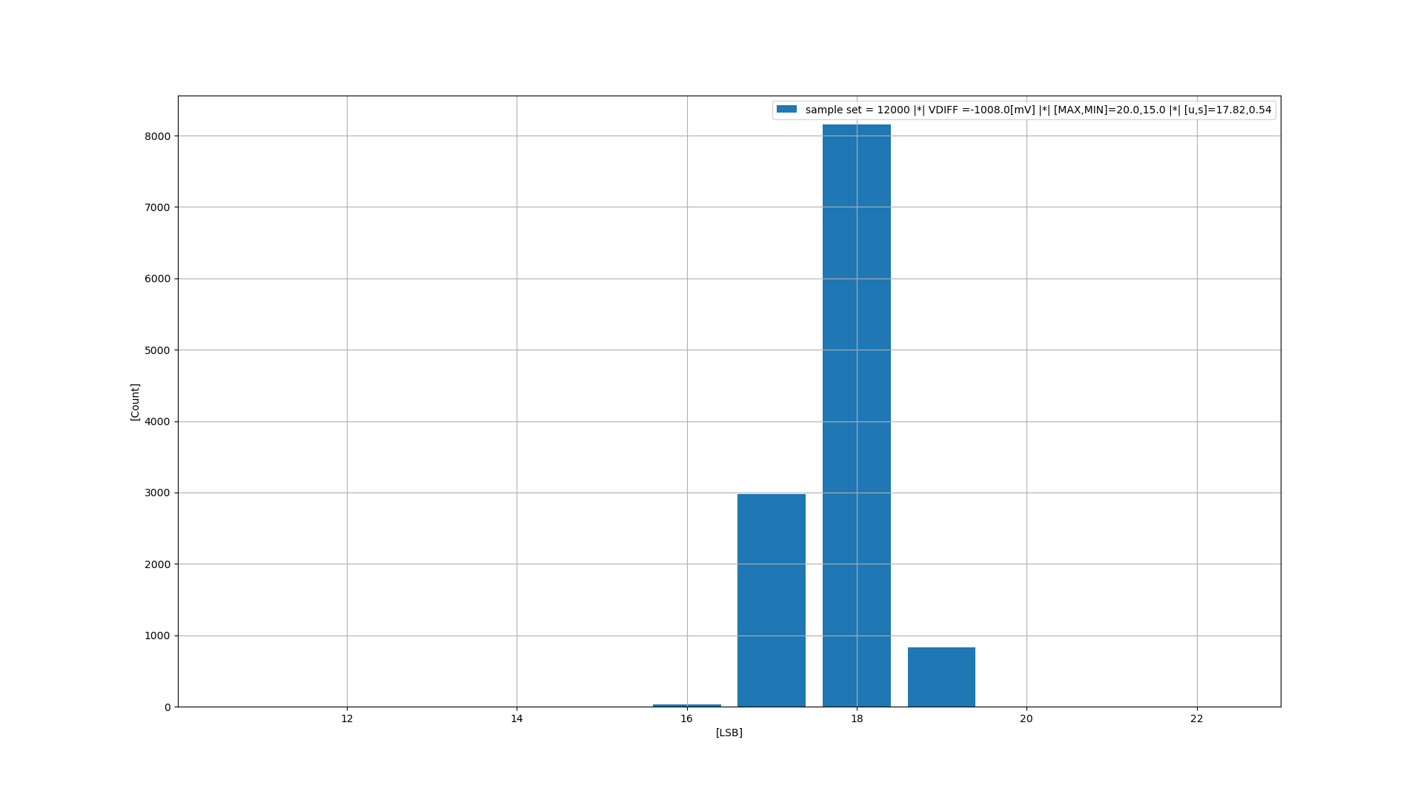
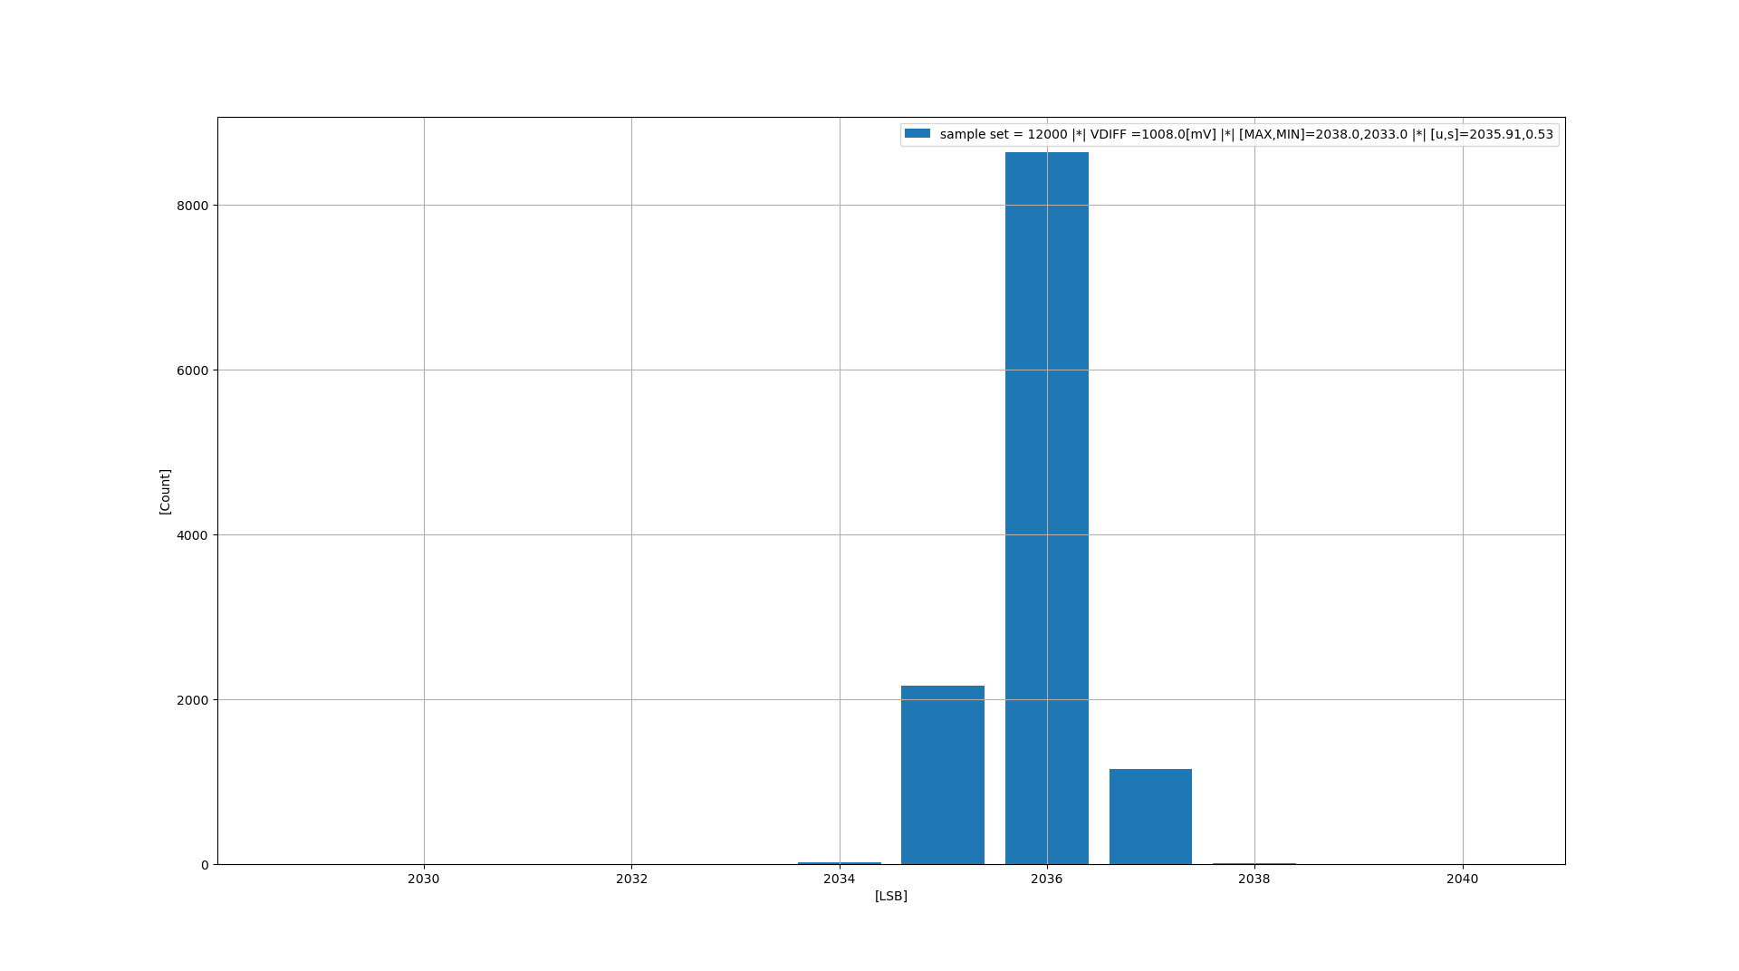
Temperature test (INL/DNL / 4 X ADCs)

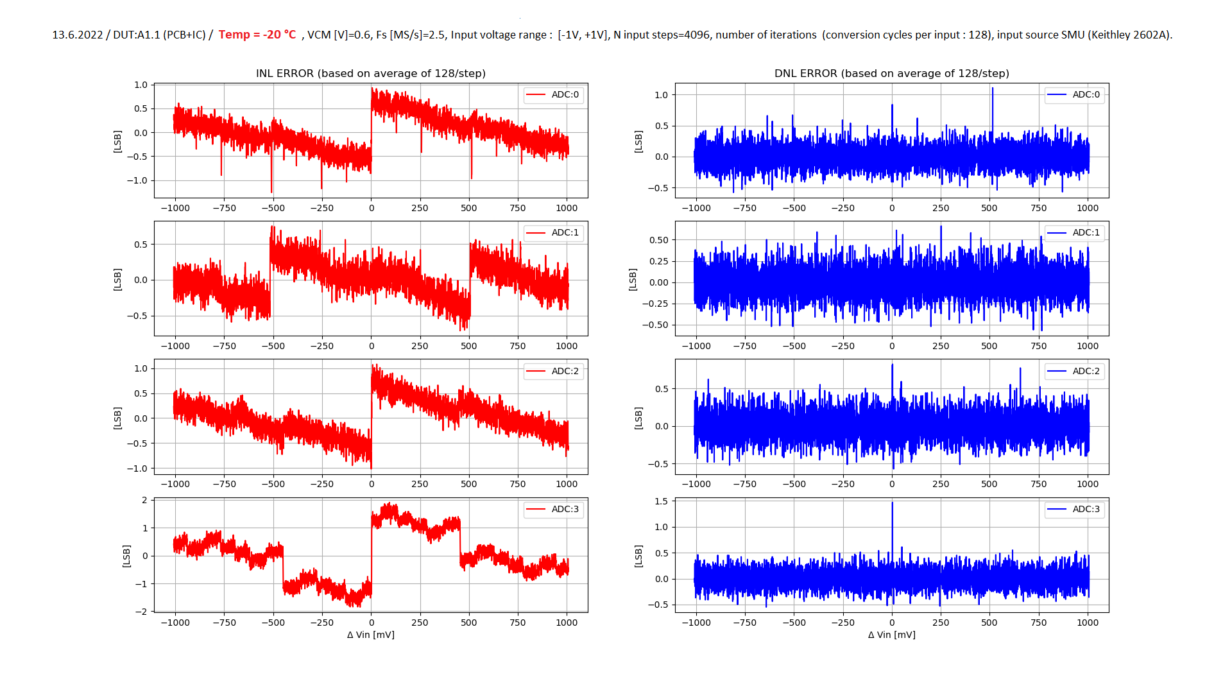
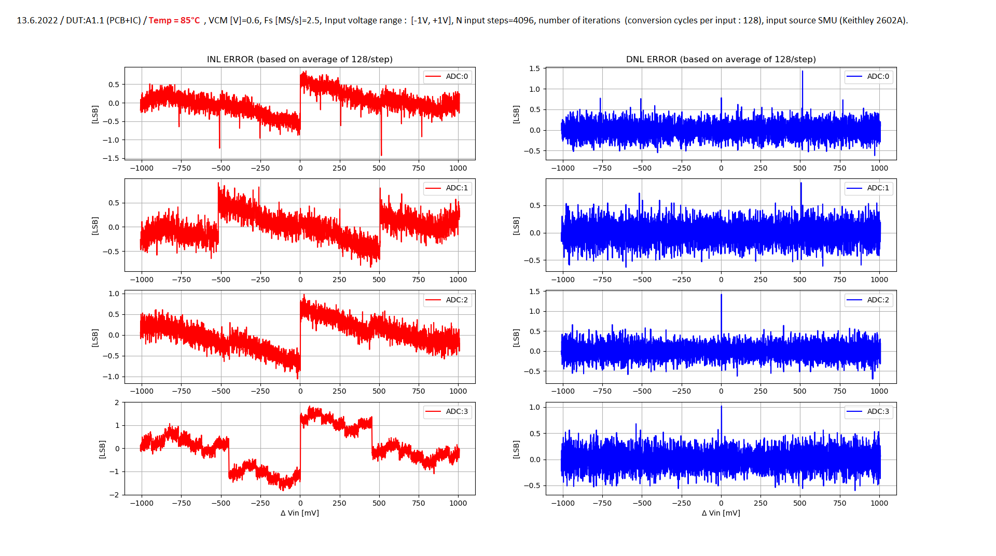

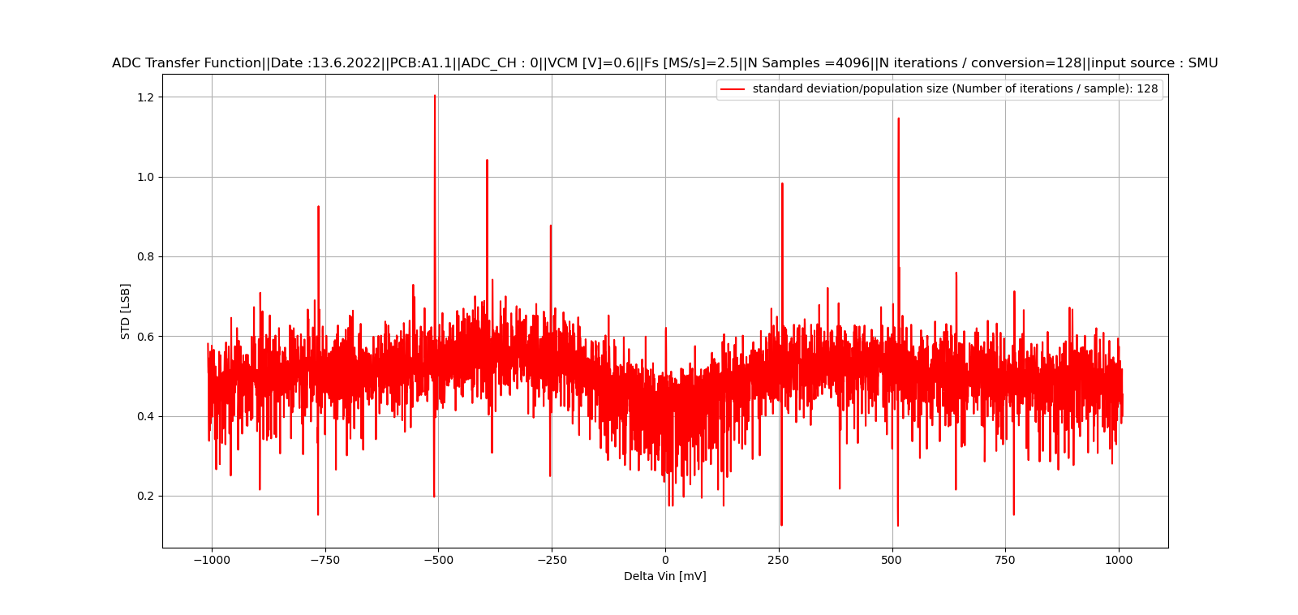
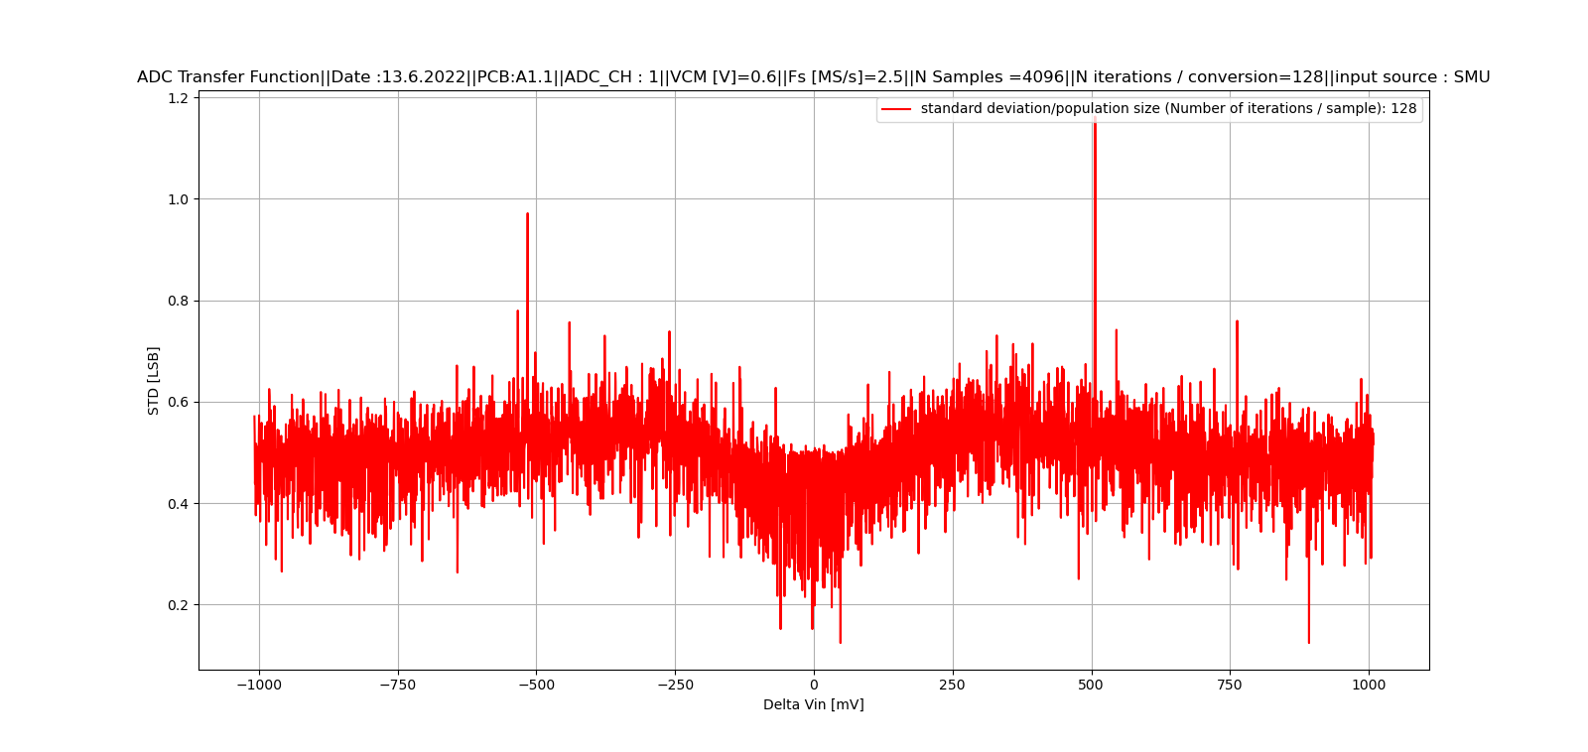
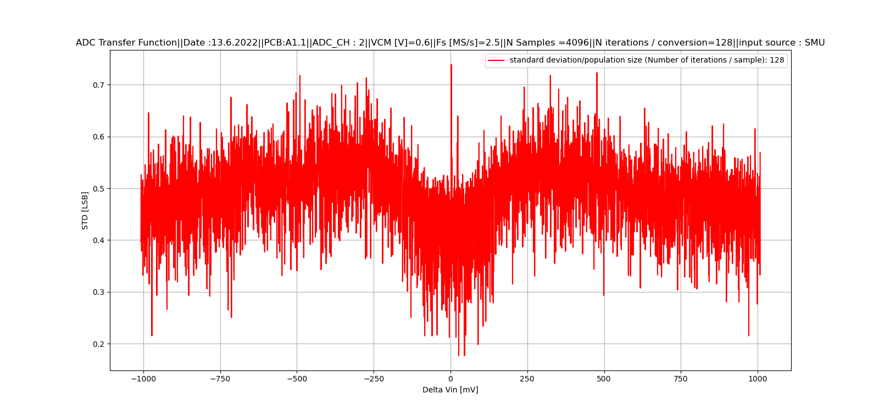
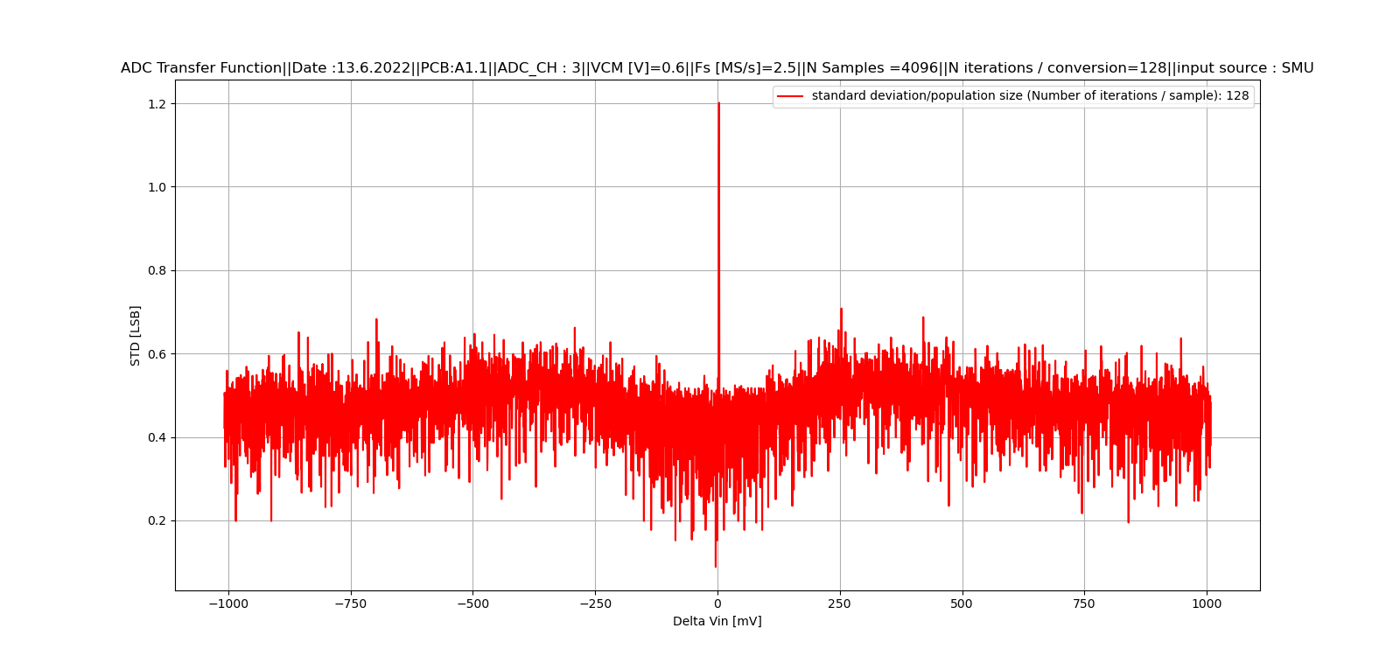
Temperature test (Noise @ -20 °C / 4 X ADCs)
T=-20°C
T=-20°C
T=-20°C
T=-20°C
Temperature test (Noise @ 85 °C / 4 X ADCs)
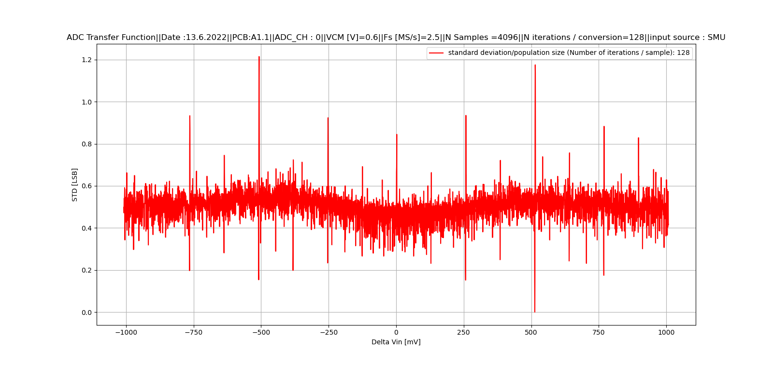
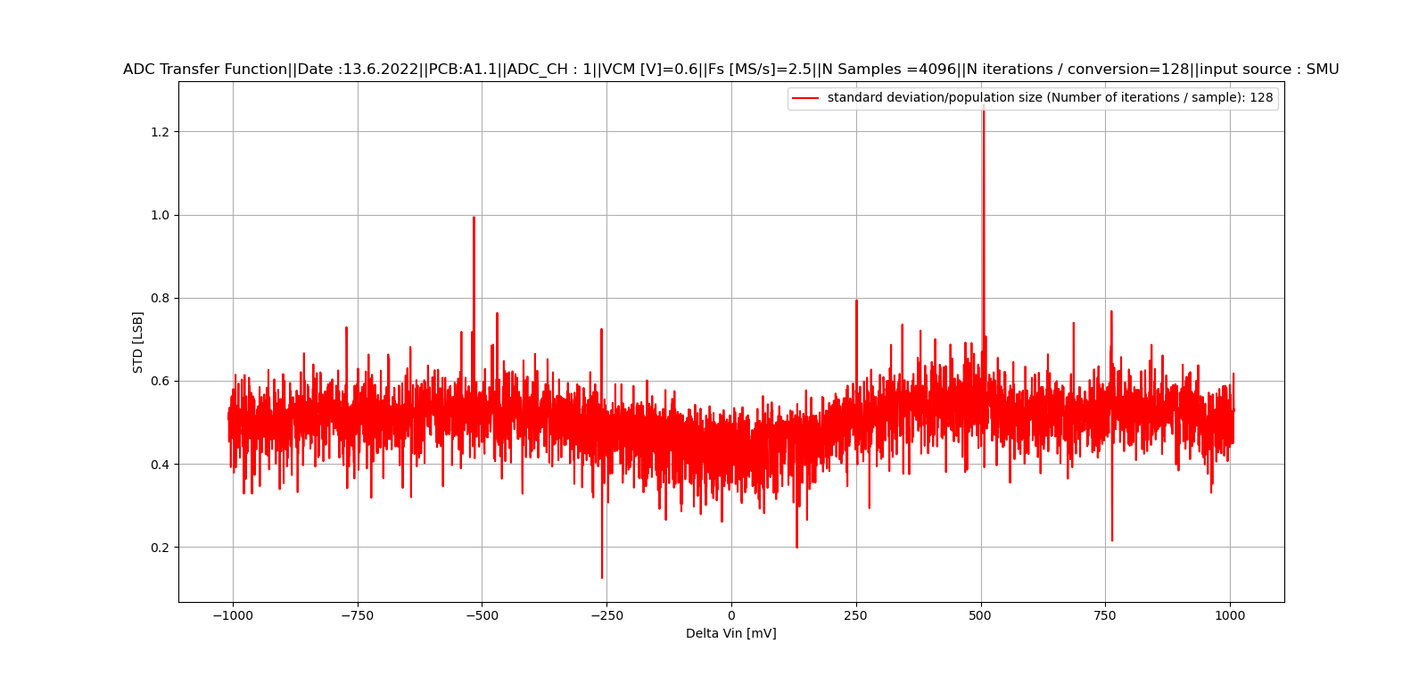
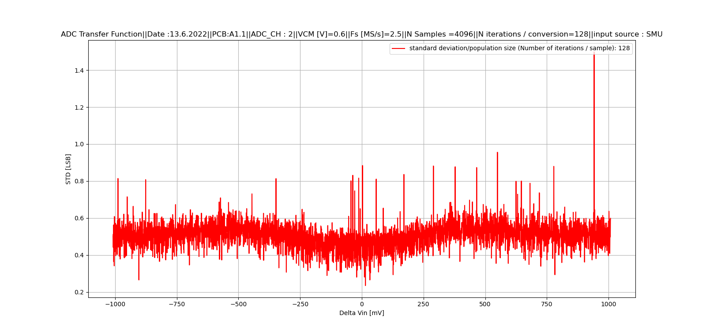
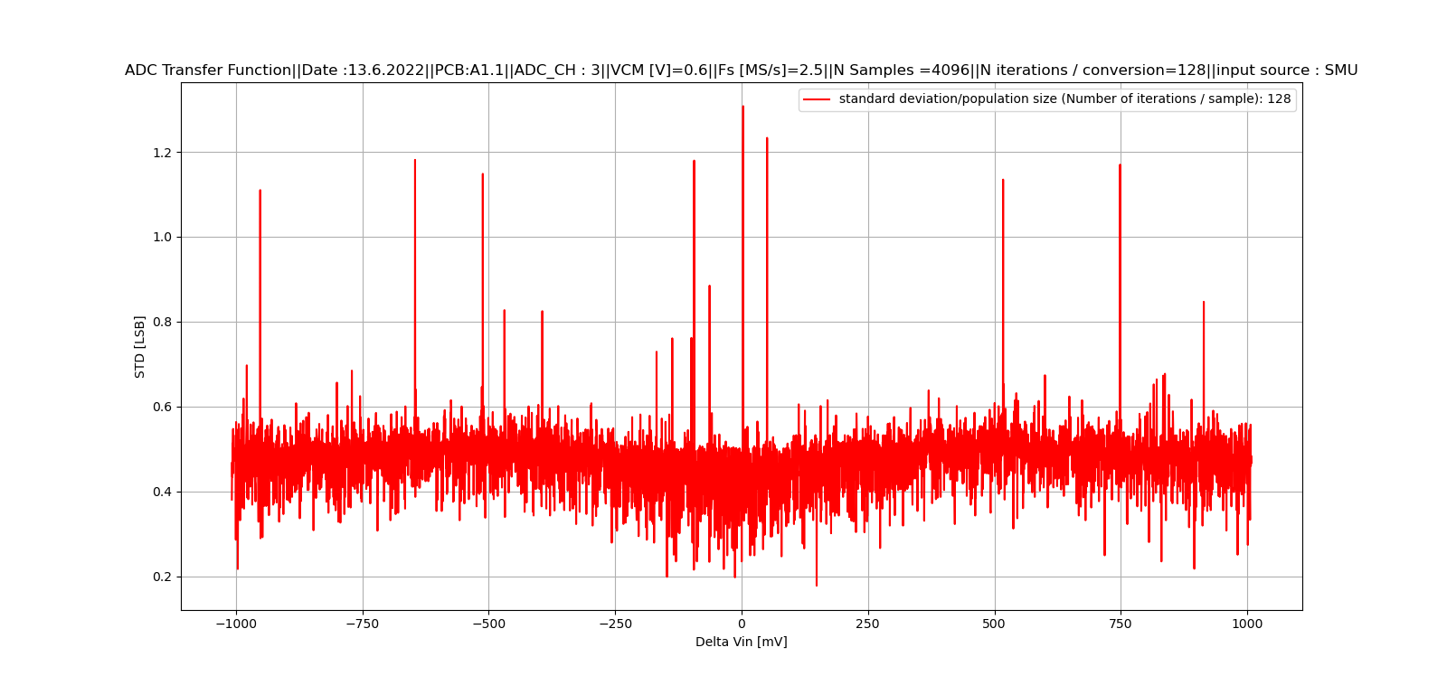
T= 85°C
T= 85°C
T= 85°C
T= 85°C

Higher sampling rate (INL/DNL / 4 X ADCs)
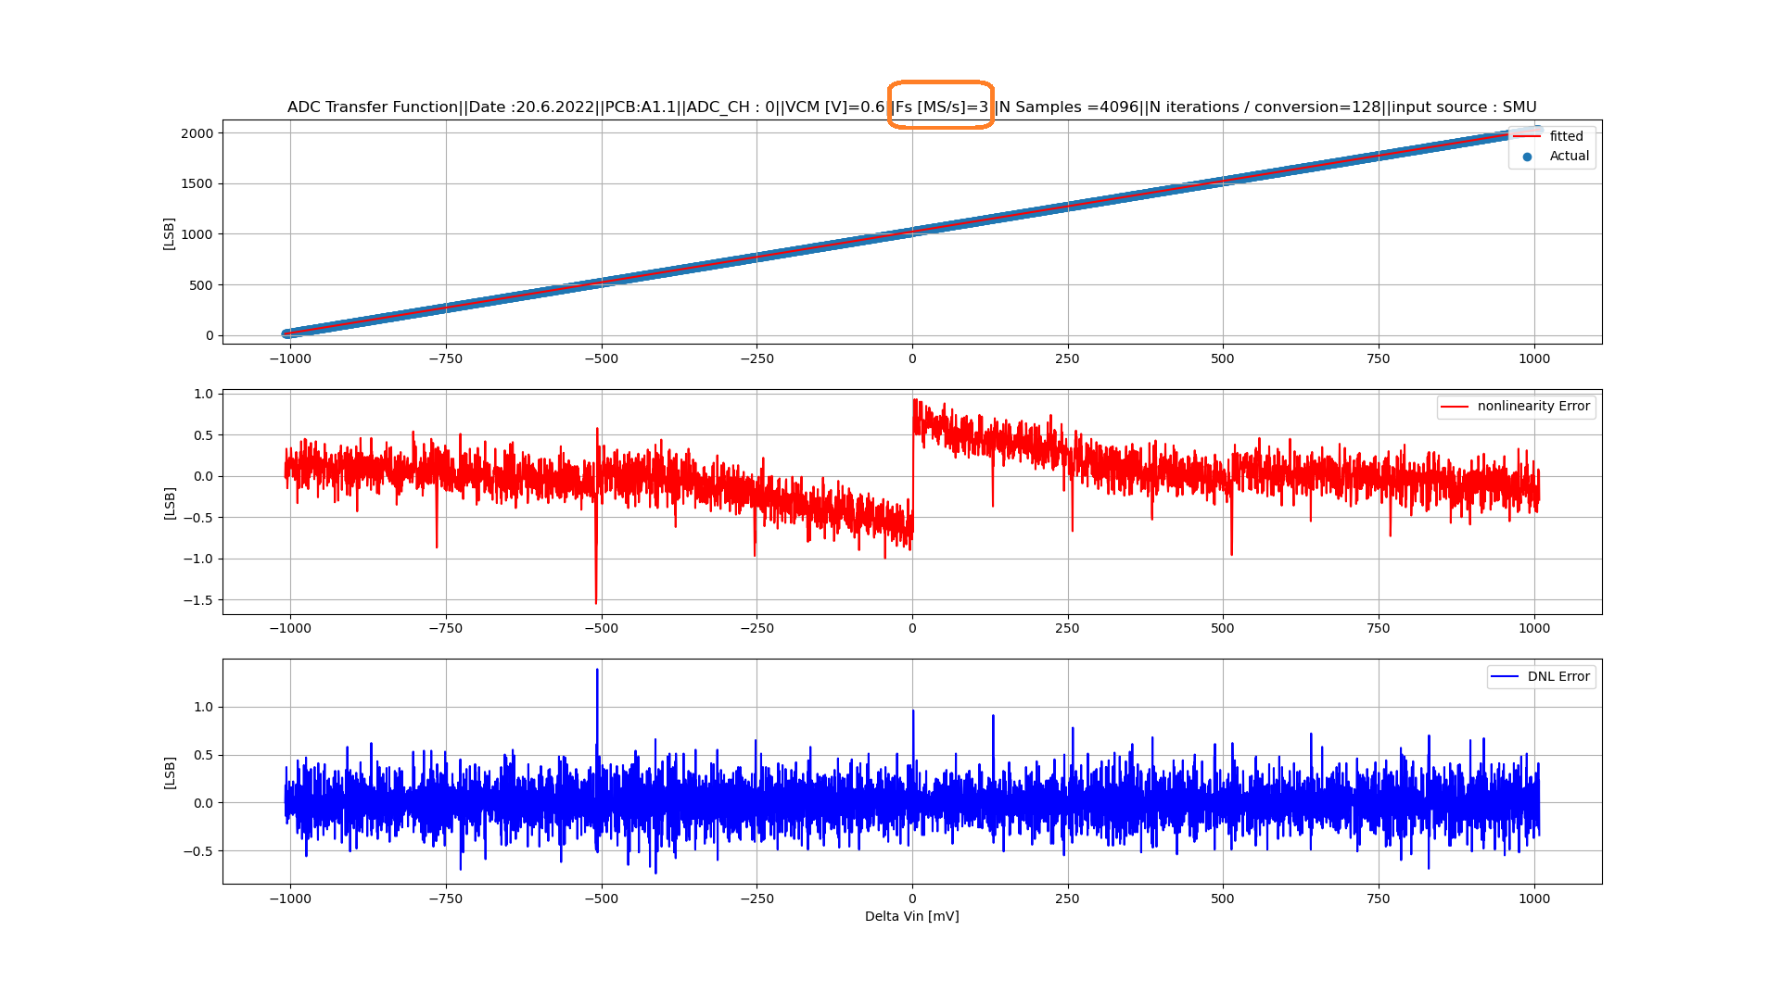
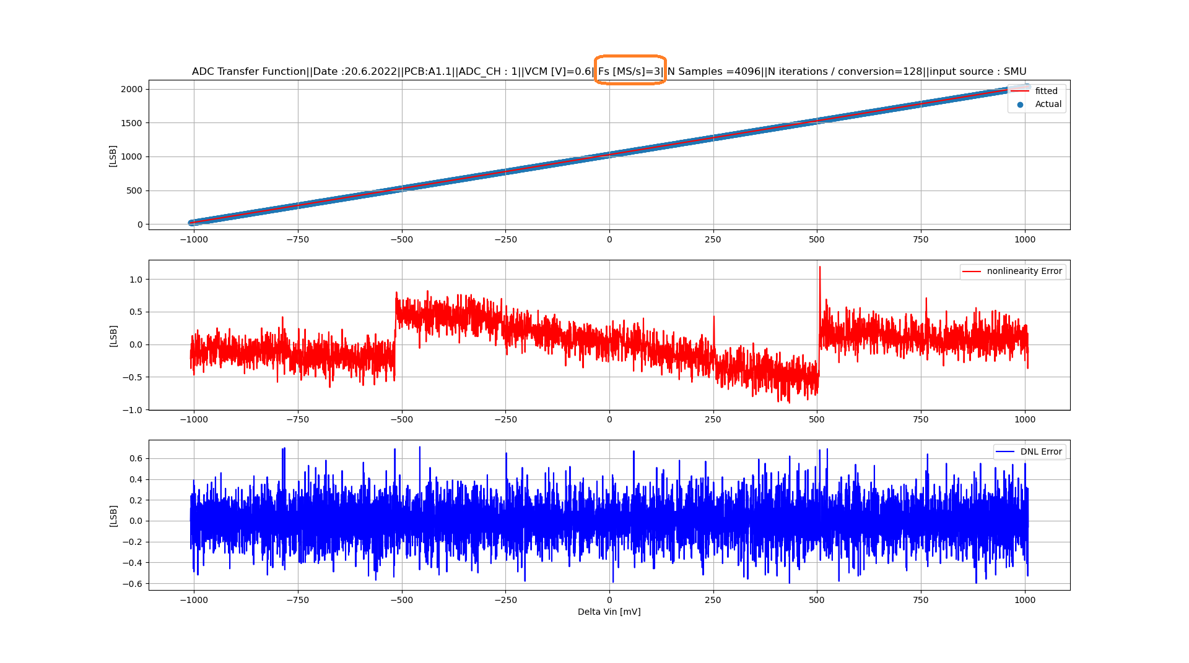

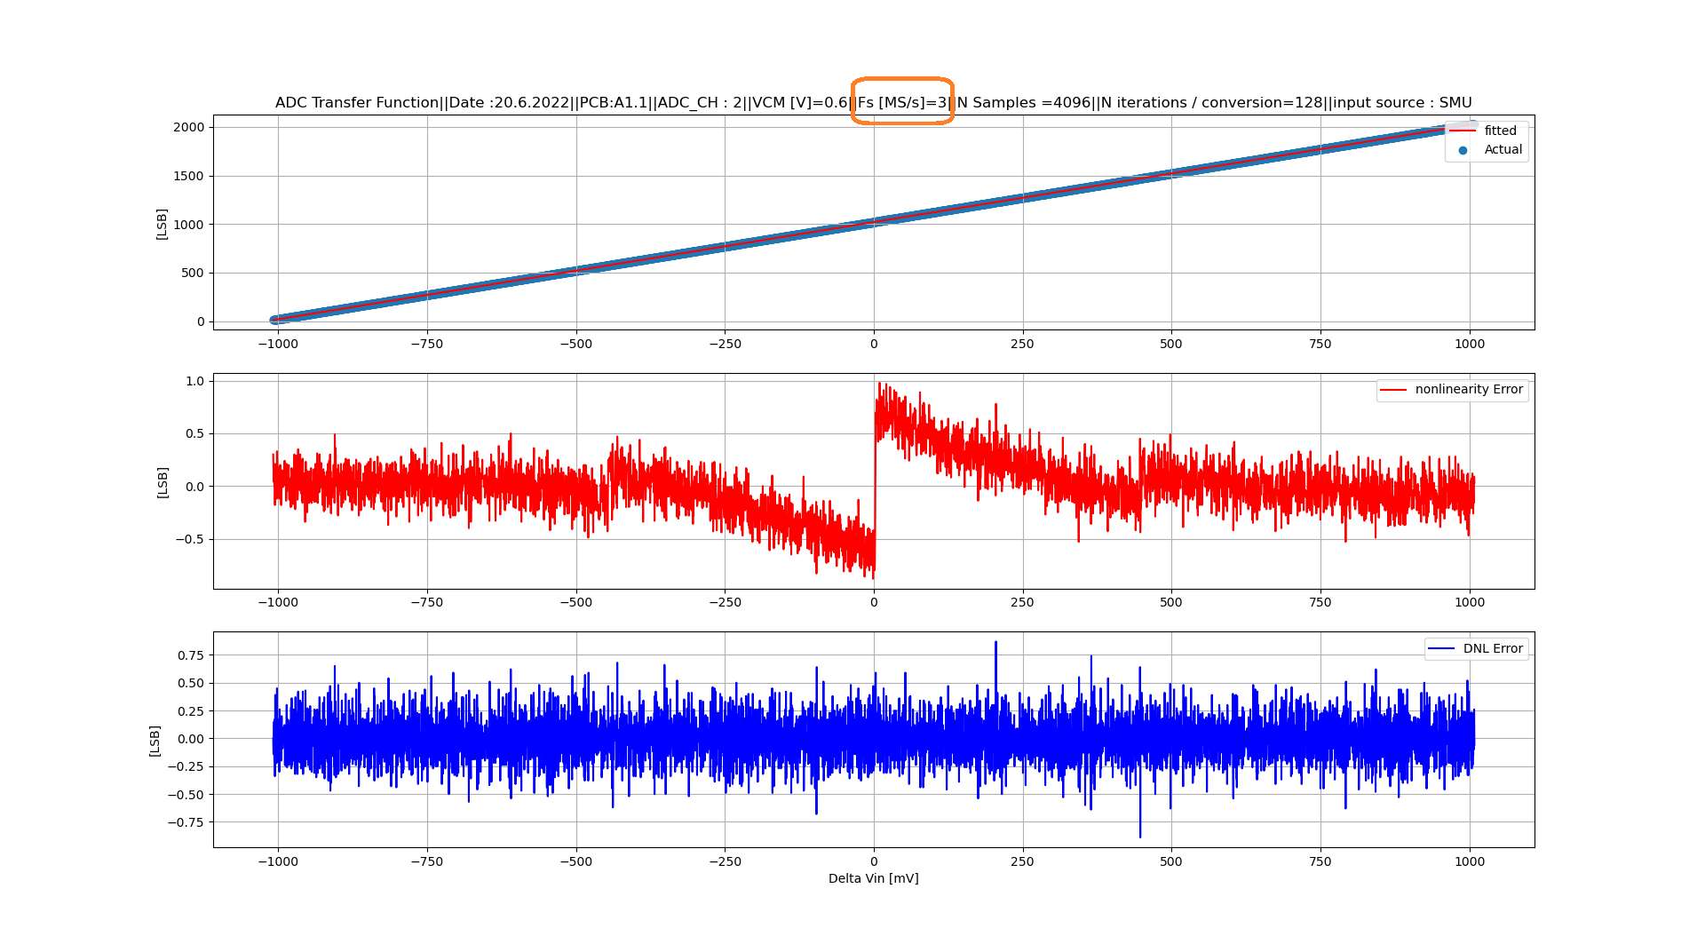
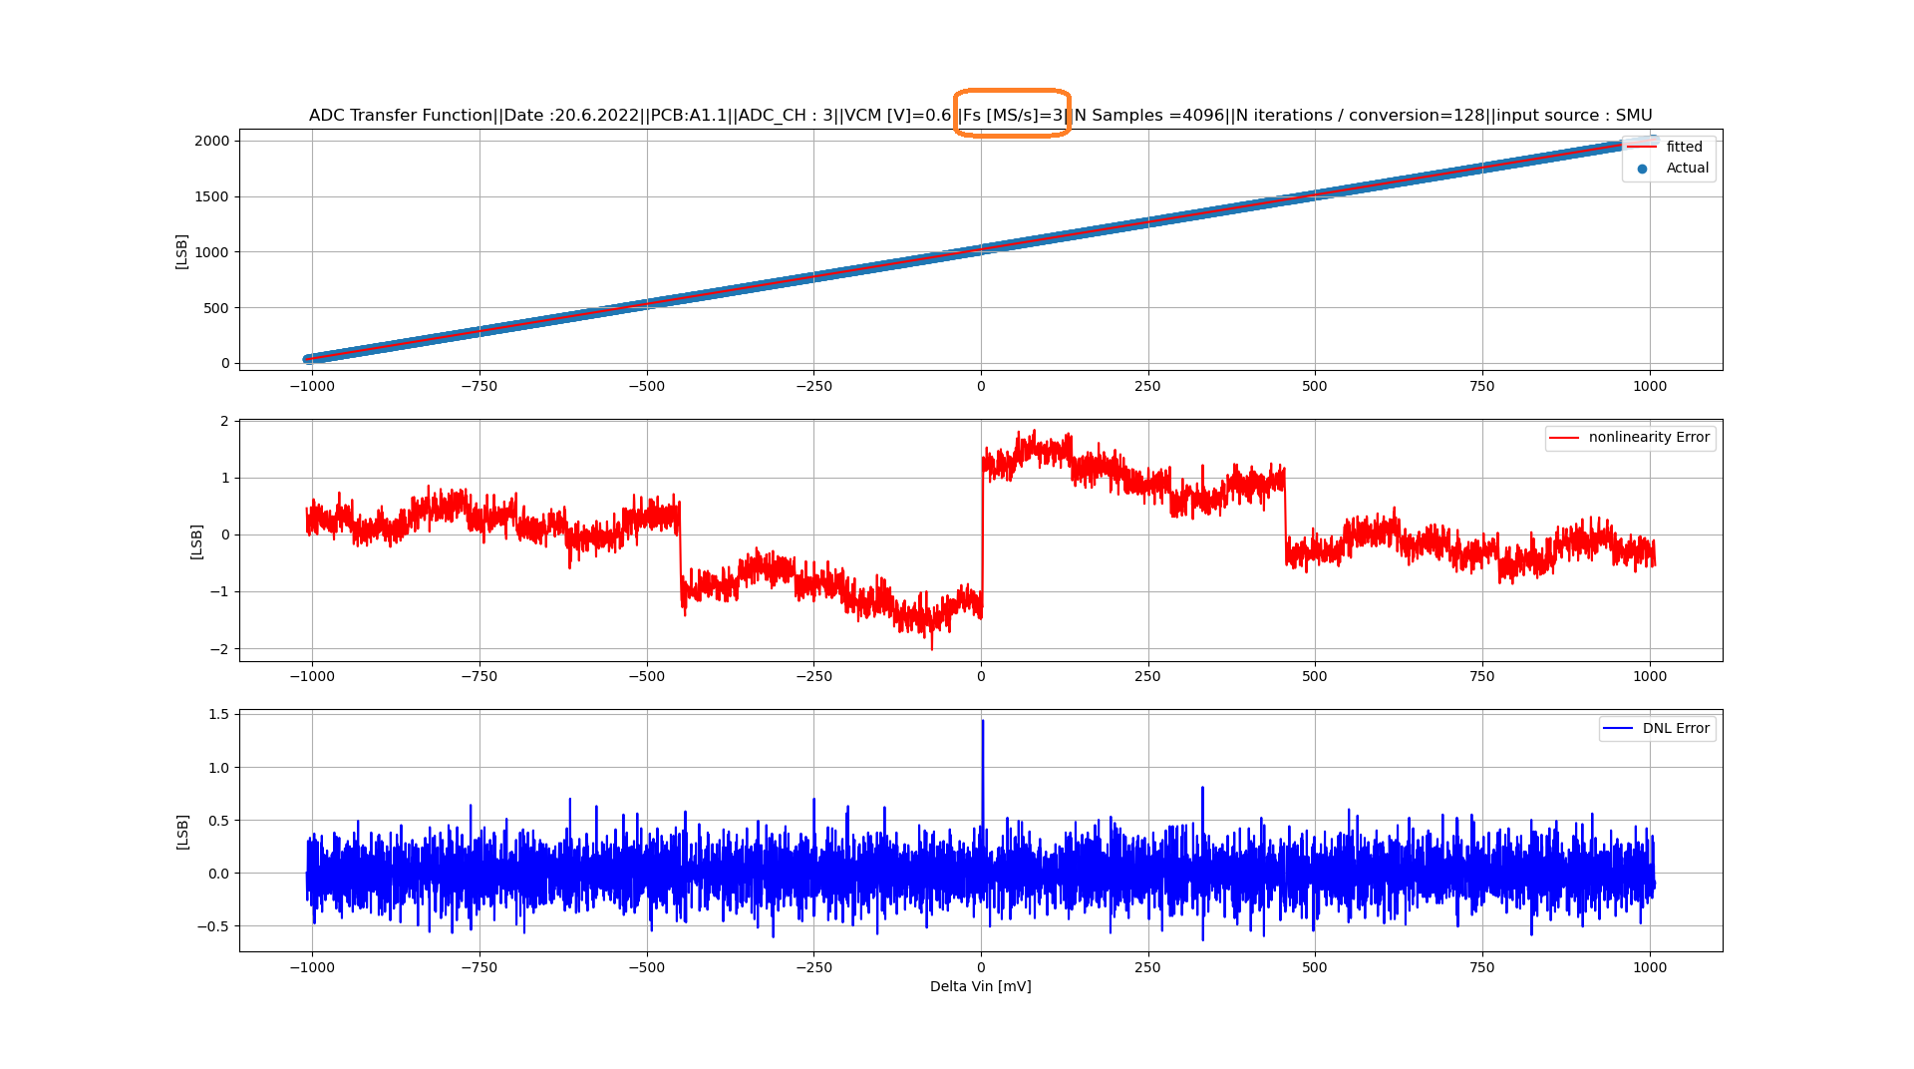

High sampling rate (Noise / 4 X ADCs)
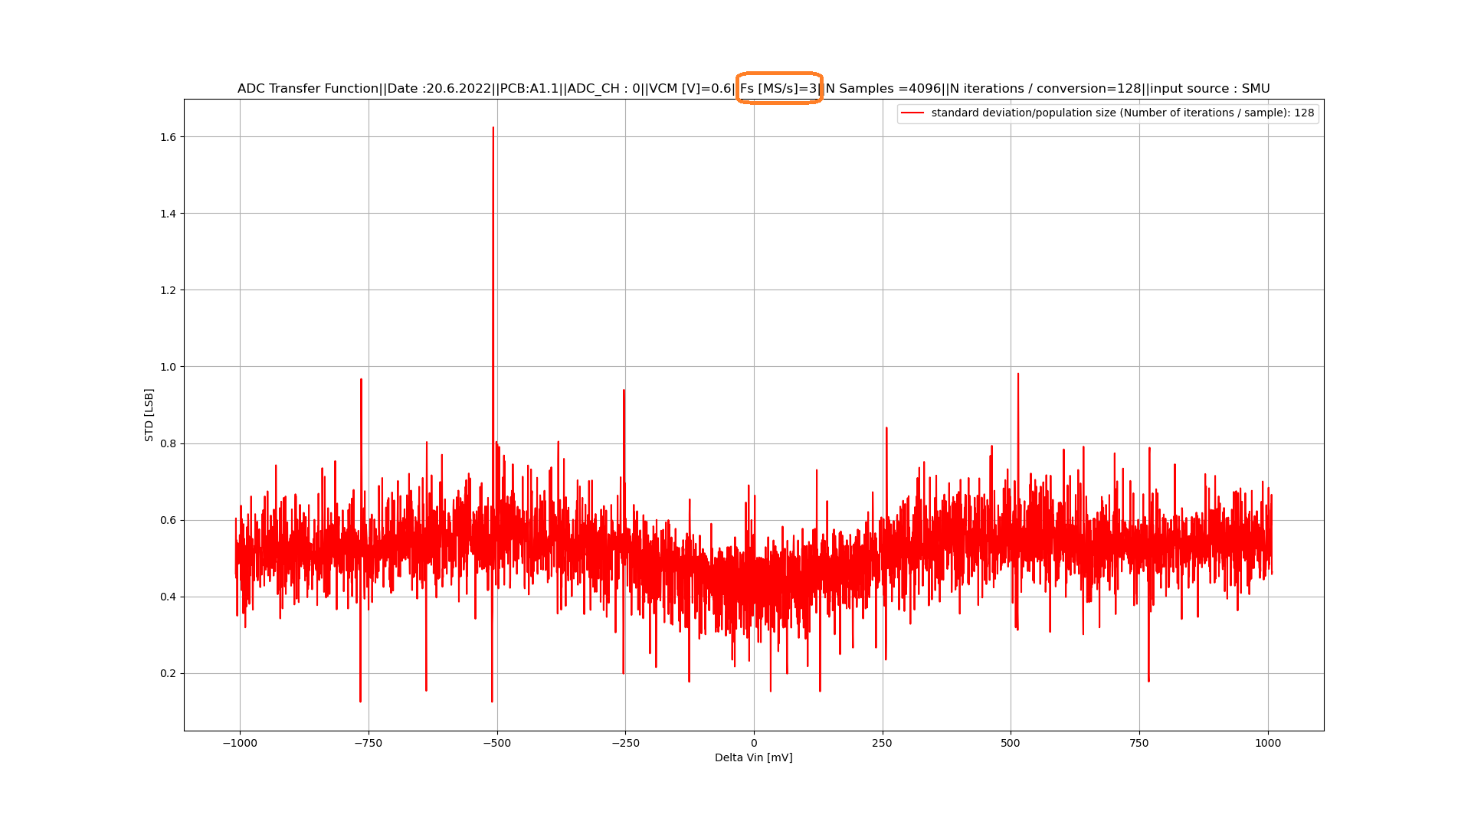
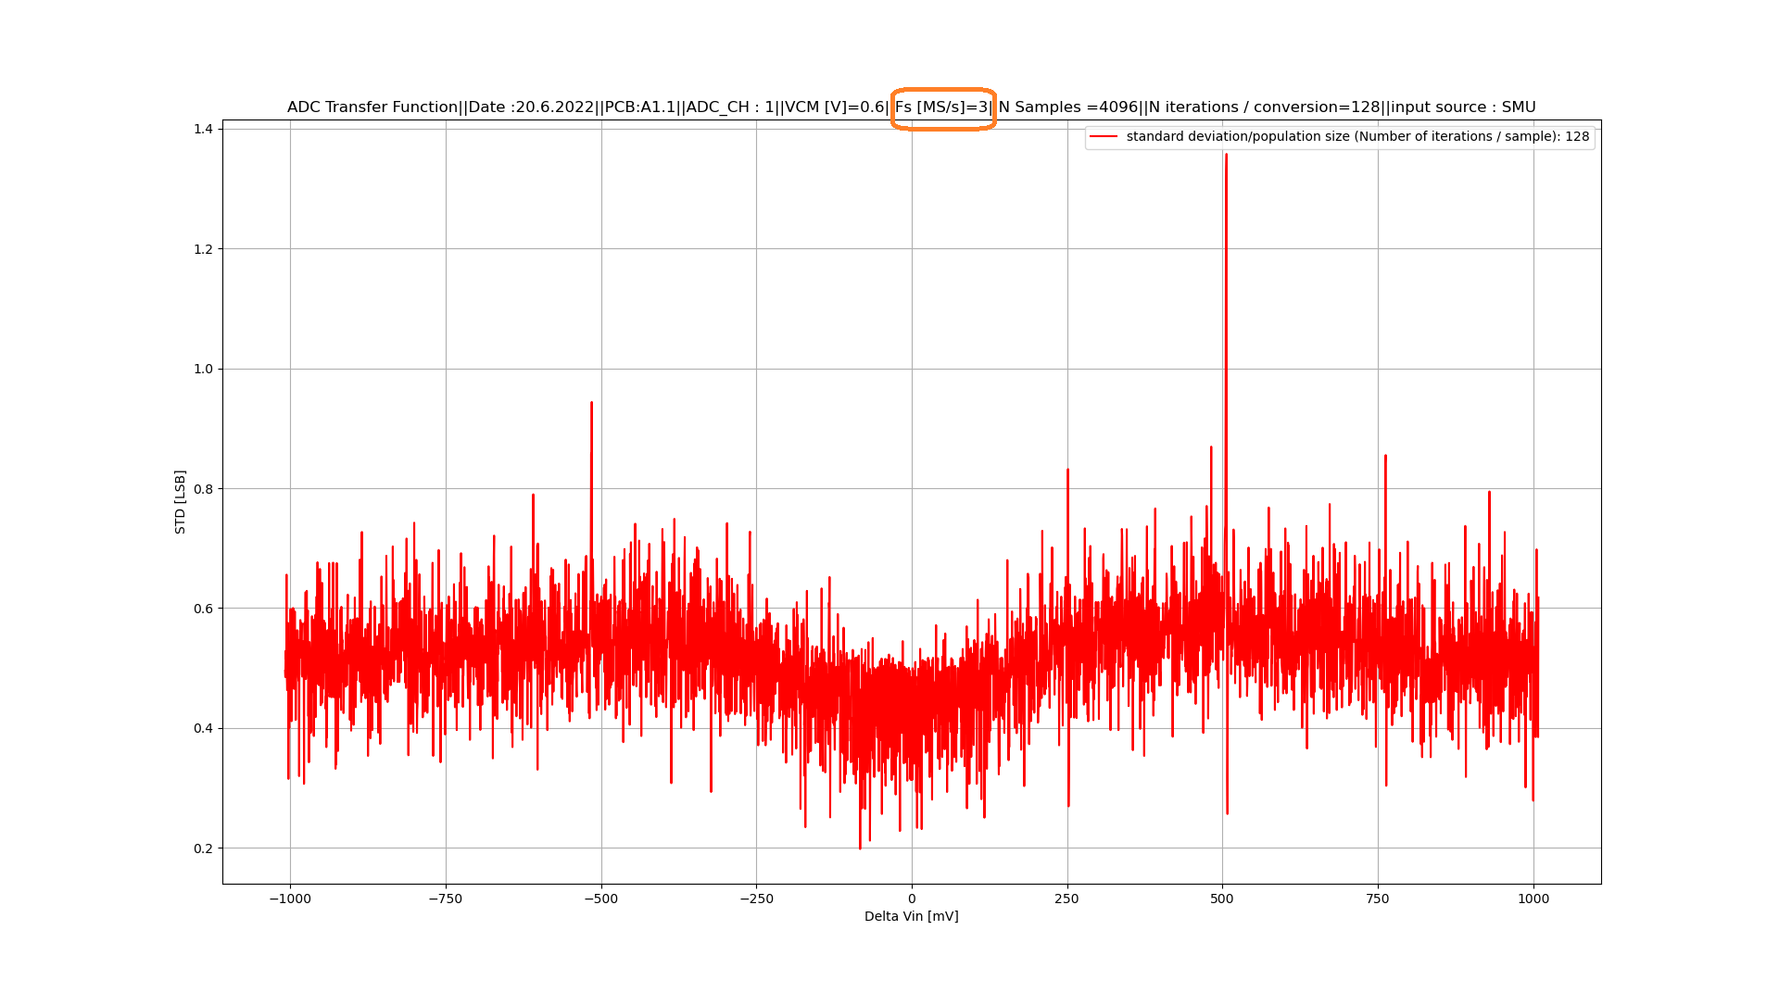

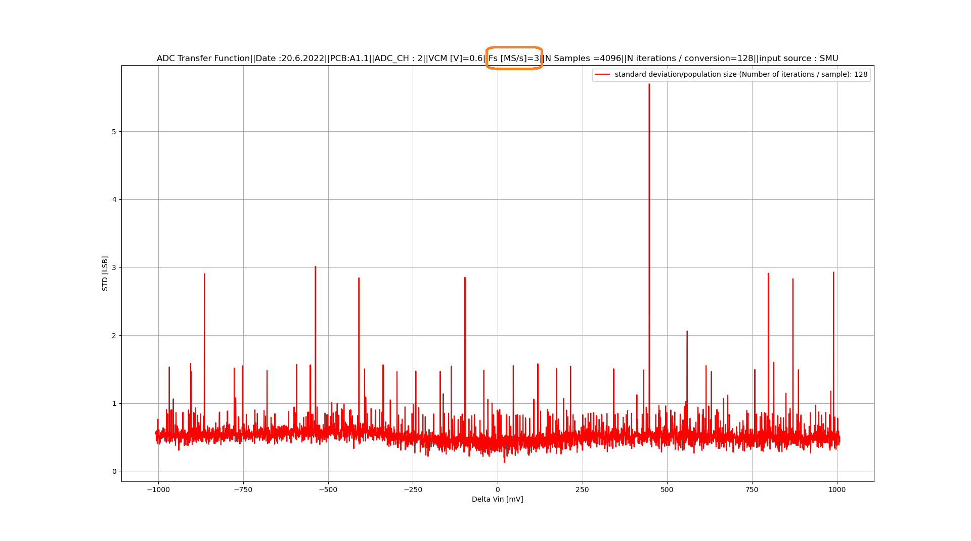
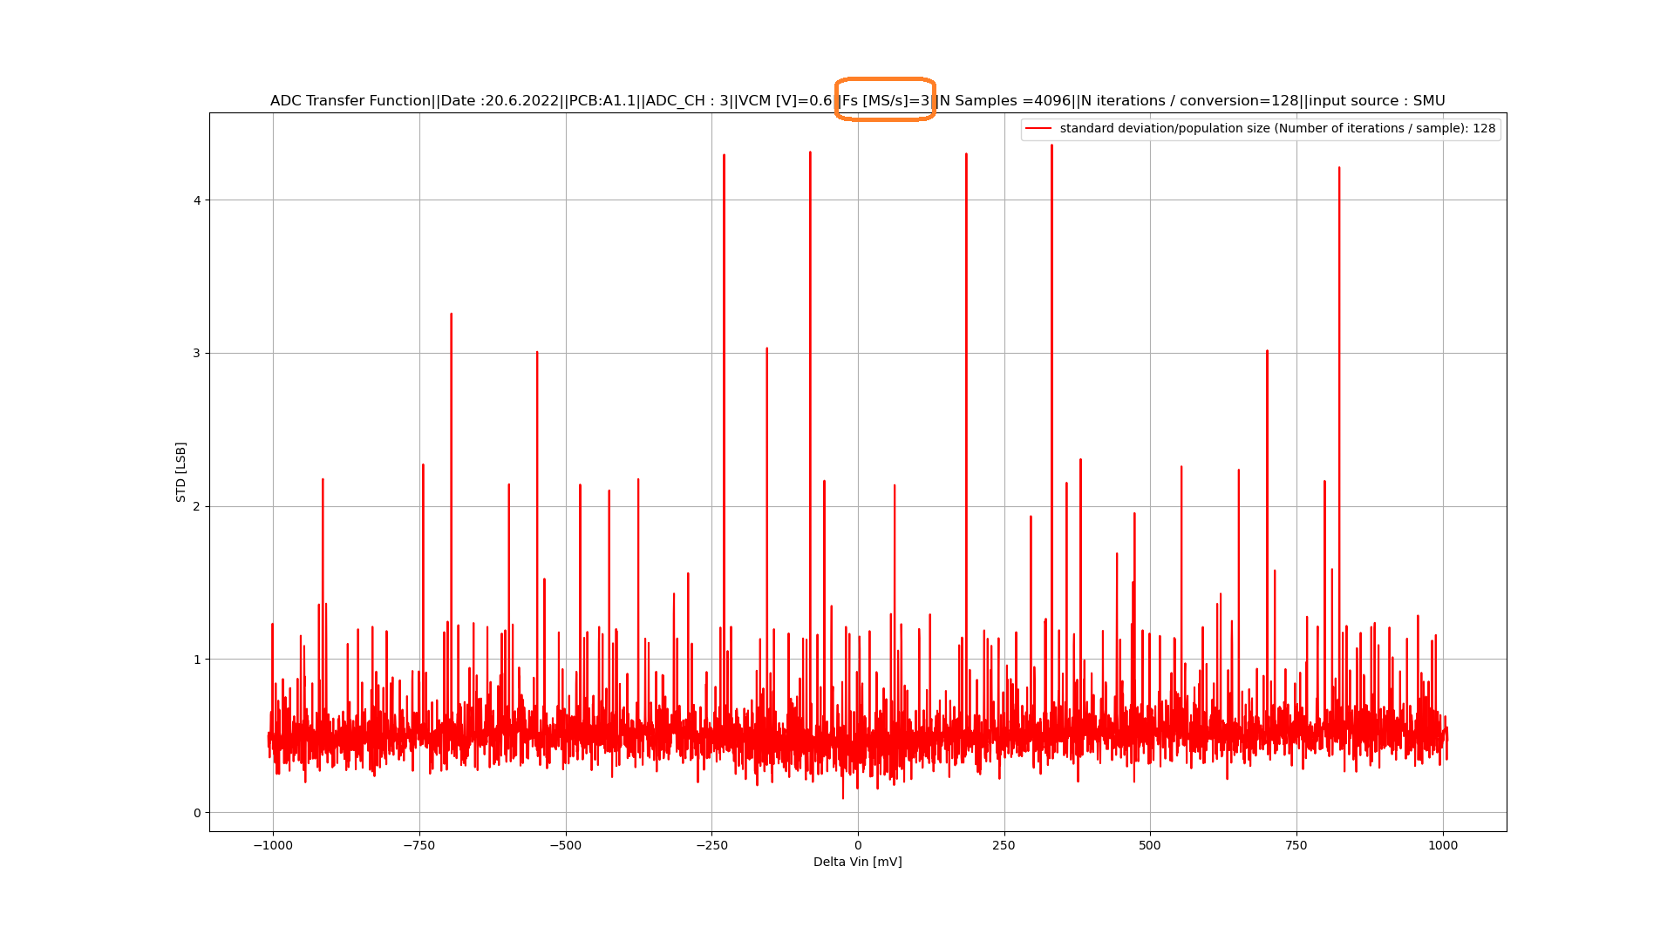

the theoretical limits of the quantization noise of 10 Bits
functional up to 0.84% (validated with test) / 0.8% with reserve (owing to the expected process corners and mismatch)
for this TEST-ASIC the redundancy is designed for calibration purpose. In general, it is used also to reduce the output uncertainty when wrong decisions occurs during the SAR iterations (e. g. due to comparator settling time).
https://silab-redmine.physik.uni-bonn.de/repos/cordia/ADC_01
Keithley 2602a
To be further investigated (simulation!)
this refers to the spectral purity of sinus signal (THD); for 10 Bit resolution at least 62 dBc is needed
evaluated based on 11 Bits / aimed 10 Bits resolutions
based on the evaluation of only 4 devices ! No statistical data are available
guess based on former experience

