Essential PMM-Lab and KNIME nodes

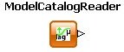
ModelCatalogReader
Reads in growth/inactivation models.

A model is represented by its formula and some additional information. The ModelCatalogReader reads all available models from the PMM-Lab database and locates them in a table.


CombaseReader
Reads in empirical data.

Combase data is usually stored in a semi-structured spreadsheet file. The CombaseReader reads in that file and stores its content in a structured table. Each entry in a Combase file describes a single growth/inactivation experiment. An experiment is characterized by time series data, information about the environmental conditions and physical parameters such as temperature, pH value or water activity.

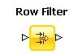
Row Filter
Keeps only the rows that fulfill some inclusion criteria.

The row filter tests each row in a table for a certain acceptance condition. If the row fulfills that condition, it is stored in the output table. The row is disposed otherwise. One might for example desire to collect all data rows for experiments at exactly 20°C.

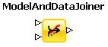
ModelAndDataJoiner
Adjoins models and data to a common table.

Models and experimental data may exist independently from each other. However, in order to perform a model estimation, one needs both, the empirical data and the model that is to be fitted to that data. The

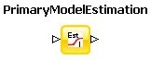
PrimaryModelEstimation
Performs model estimation on model and data.

A Least Squares approach is applied to optimally estimate the model parameters in a growth/ inactivation model. The quality of a fit is expressed in its associated Root Mean Square (RMS) value. Alternatively the R² value serve as a measure for fitting success.

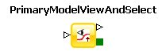
PrimaryModelViewAndSelect
Visualizes the a combination of model and data.

Models and their underlying data can be inspected and compared. The node can also be used as a filter that disposes all models that were not selected in the execution dialog.

