
University Of Science And Technology Houari Boumediene
Faculté d’informatique
Module : TIC

Information and Communication Technologies
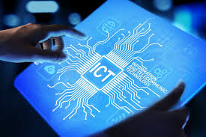

Student: Si Lounis Anis
Group: 3

Academic Year: 2025/2026
Contents

Table des matières
1. Introduction 3
2. Chapter 1: Overview of Information and Communication Technologies 4
2.1. Definition of TIC 4
2.2. Components of TIC 4
3. Chapter 2: Google Services on TIC 5
3.1. Google Workspace: 5
3.2. Google Drive: 5
4. Chapter 3: Microsoft Tools in TIC 6
4.1. Microsoft Office: 6
4.2. Microsoft Teams: 6
5. Chapter 4: Version Control Systems: Git and GitHub 7
5.1. Git: 7
5.2. GitHub: 7
6. Chapter 5: LaTex 8
6.1. Definition of LaTex : 8
6.2. Overleaf: 8
7. Advantages and Disadvantages of TIC: 9
7.1. Advantages: 9
7.2. Disadvantages: 9
8. Conclusion 10

Introduction

Information and Communication Technologies (TIC or ICT) play a fundamental role in modern society. They enable the creation, processing, storage, and exchange of information using digital systems. TIC is widely used in education, businesses, and communication.

The objective of this report is to present the main concepts of TIC and introduce some modern digital tools such as Google services, Microsoft tools, Git, and GitHub.

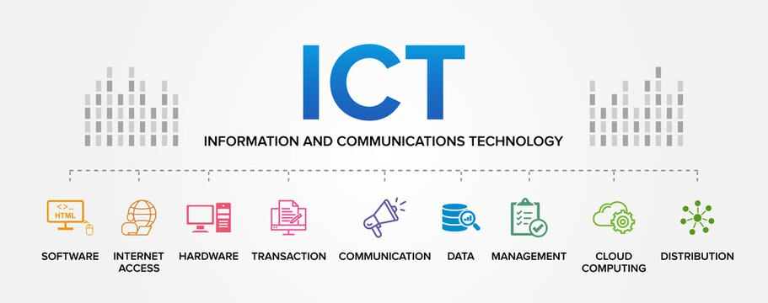

Chapter 1: Overview of Information and Communication Technologies

Definition of TIC

Technologies of Information and Communication (TIC) refer to the set of technological tools and resources used to collect, process, store, transmit, and share information. TIC plays a fundamental role in modern society by facilitating communication, improving access to information, and increasing efficiency in many fields such as education, business, healthcare, and government.

Components of TIC

Component | Description
Hardware | Computers, servers, smartphones, and networking devices
Software | Operating systems and applications
Networks | Internet, intranet, and communication protocols
Tableau 1 Main components of TIC

Chapter 2: Google Services on TIC

Google Workspace:

Google Workspace includes tools such as:


- Gmail: it is an email service used worldwide.
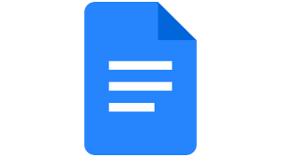
- Google Drive: it is a cloud storage for files and documents.
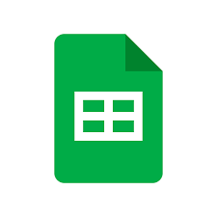
- Google docs
- Google sheets

These services enable collaboration and real-time communication between the users, making work easier and more flexible.

Google Drive:

Google Drive is a cloud storage service that lets users store, access, and share files from anywhere. It supports real-time collaboration on documents, spreadsheets, and presentations, making teamwork easier and more efficient


Chapter 3: Microsoft Tools in TIC

Microsoft Office:

Microsoft Office includes:

- Word for document creation.

- Excel for data analysis and calculations.

- PowerPoint for presentations.

These tools are widely used in education and companies for document creation, data analysis, and professional presentations. Microsoft Office improves productivity and supports collaboration through file sharing and cloud integration.

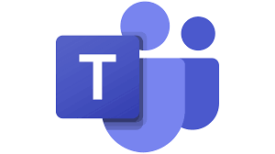
Microsoft Teams:

Microsoft Teams is a collaboration platform that allows users to communicate through chat, voice calls, and video meetings. It also supports file sharing and integration with other Microsoft Office tools, making teamwork more organized and efficient.
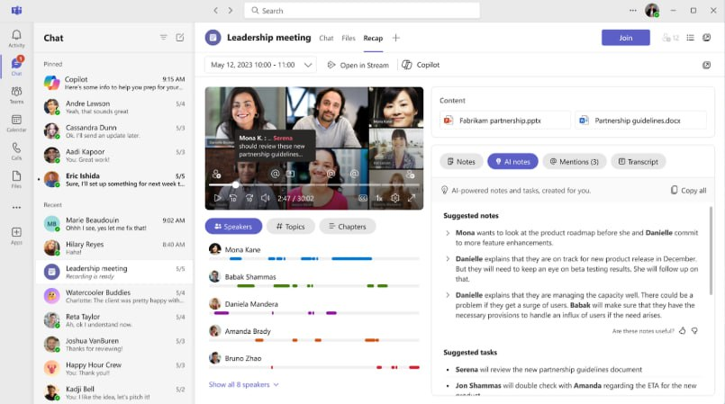
Figure 1 Microsoft Teams interface

Chapter 4: Version Control Systems: Git and GitHub

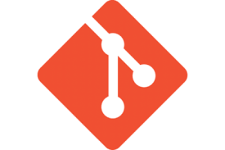
Git:

Git is a version control system that aids programmers in monitoring code modification over time. Git keeps track of each modification and stores it as a version rather than storing multiple copies of the same project. This makes it simple to revert to a previous version in the event of an error. Because each team member can work on the project independently of the others, Git is also very helpful when working in a group.


GitHub:

GitHub is a web-based service that enables programmers to keep and disseminate their work via Git. It offers a unified location where the code can be reached and well controlled. With GitHub, co-working won’t be an issue anymore; it lets several people work simultaneously on one project, check the modification, and give their opinions on good practices. It also aids in the regular and availability, mainly when you are in a group or dealing with open-source projects.
Tool | Purpose
Git | version control system
Github | Code hosting and collaboration platform

Chapter 5 : LaTex

Definition of LaTex :

LaTeX is an extremely popular document preparation system for academic and scientific documents. Especially for writing research papers, reports, theses, and books with excellent formatting.
You write text-based code that describes the contents of your document (titles, sections, images, tables) and their spatial layout. The data is then organized to generate a polished PDF.


Overleaf:

Overleaf is an online LaTeX editor enabling users to generate and modifiy LaTeX documents collaboratively without using any software. Students frequently use it to write LaTeX projects and share them online.

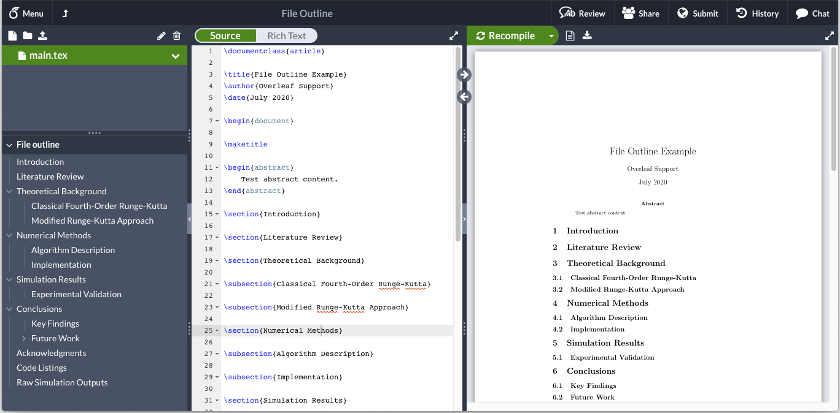
Figure 2 Overleaf interface

Advantages and Disadvantages of TIC:

Advantages:

- Fast and efficient communication across the world
- Easy access to information and knowledge
- Improvement of education through e-learning platforms
- Better collaboration and teamwork using digital tools
- Increased productivity in academic and professional fields
- Easy storage, sharing, and backup of data
- Encouragement of innovation and creativity

Disadvantages:

- Privacy issues and misuse of personal data
- High cost of some technologies and equipment
- Technical problems and system failures
- Reduced physical activity and health problems
- Need for continuous learning to keep up with technology
- Cybersecurity threats such as hacking and data theft
- Dependence on technology and reduced human interaction

Figure 3 advantages and disadvantages of TIC
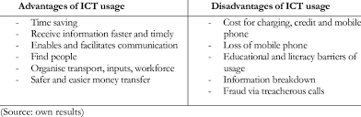

Conclusion

It’s hard to imagine our daily lives now without the influence of Information and Communication Technologies (TIC). They’ve completely reshaped the way we learn and get things done, making it easier than ever to collaborate through platforms like Google, Microsoft, and even more technical tools like GitHub and LaTeX. These aren't just applications; they are the gears that keep modern education and professional workflows running smoothly.

​ That said, this level of connectivity isn't without its headaches. We’re constantly balancing the perks of efficiency against real-world issues like security risks and our growing habit of relying too much on screens. In the end, TIC is an incredible tool for progress, but its real value depends on us—how we choose to use it wisely and keep our digital ethics in check.

