Software Requirements Specification (SRS)
Project: Smart Parking Management System (SPMS)
Version: 1.1
Authors: Satyanarayana Kallakuri, Shubham D Bhat, Sujan S M, Siddanth Anil
Date: 10-10-2026
Status: Draft

Team member | SRN | Module owned | Features
Satyanarayana Kallakuri | PES1UG24AM257 | Allocation (allocation.py) | SPMS-F-002 to F-005
Shubham D Bhat | PES1UG24AM273 | Entry / Exit (entry_exit.py) | SPMS-F-006 to F-009
Sujan S M | PES1UG24AM292 | Reservations (reservations.py) | SPMS-F-010 to F-013
Siddanth Anil | PES1UG24AM274 | Billing & Reports (billing.py, reports.py) | SPMS-F-014 to F-017

Revision history
Version | Date | Author | Change summary | Approval
1.0 | 10-10-2026 | Team (all members) | Initial SRS with use-case diagrams and RTM
1.1 | 11-10-2026 | Team (all members) | RTM status updated after implementation (103 tests passing)

Approvals
Role | Name | Signature / Email | Date
Course Coordinator

Table of Contents
1. Introduction
2. Overall description
3. External interfaces
4. System features (detailed)
5. Non-functional requirements (detailed)
6. Quality attributes & Acceptance tests
7. UML Use-Case Diagrams
8. Requirements Traceability Matrix (RTM)

1. Introduction

1.1 Purpose
This document specifies the software requirements for the Smart Parking Management System (SPMS). It defines the functional and non-functional requirements, external interfaces, security requirements and verification criteria that the team will implement and test during the SE mini project.

1.2 Scope
SPMS tracks parking availability, vehicle entry and exit, reservations and payments for a multi-level parking lot. It automatically allocates the most suitable free slot to each arriving vehicle and provides real-time occupancy information to operators and drivers. In scope: slot allocation, entry/exit ticketing, reservations, fee calculation, payment through a gateway interface, receipts and occupancy reports. Out of scope: physical gate/barrier hardware, number-plate recognition cameras, a production payment gateway (a mock adapter is used), and a mobile app.

1.3 Audience
Developers and testers on the project team, the course instructor and evaluators, and future maintainers of the codebase.

1.4 Definitions
Term | Meaning
SPMS | Smart Parking Management System
Slot | A single parking space with a type (two-wheeler, compact, large), a level and an optional EV charger
Ticket | Record of one parking session: plate, slot, entry/exit time, amount due, paid flag
Reservation | A slot held for a vehicle from a start time; expires 15 minutes after start if unused
Grace period | First 15 minutes of parking, charged at ₹0
EV | Electric vehicle
CI | Continuous Integration (GitHub Actions running pytest on every pull request)
RTM | Requirements Traceability Matrix
UUID | Universally Unique Identifier (version 4, random)

2. Overall description

2.1 Product perspective
SPMS is a standalone software system for one parking facility. In version 1.0 it is a Python package with an operator console; it is designed in layers so that a web UI, a database and a real payment gateway can be attached later without changing the core logic. It interacts with drivers (through the operator console or a future web/kiosk UI), parking operators, administrators and an external payment gateway.

2.2 Major product functions
- Real-time occupancy tracking for every slot and for the lot as a whole
- Automatic allocation of the most suitable free slot (type compatibility, best fit, lowest level, EV priority)
- Vehicle entry with number-plate validation and ticket issue; duplicate-entry prevention
- Vehicle exit with fee settlement and slot release
- Advance reservations with cancellation, check-in and automatic no-show expiry
- Fee calculation by vehicle type with grace period and daily cap
- Payment through a gateway interface and receipt generation
- Occupancy reports by level and slot type

2.3 User roles and characteristics
- Driver: wants to find a slot quickly, reserve in advance and pay without confusion. No technical knowledge assumed.
- Parking Operator: works at the gate; registers entries and exits and watches live occupancy. Needs fast, simple screens and clear error messages.
- Admin: manages slot layout and tariffs, views reports and the audit log. An Admin can do everything an Operator can.
- Payment Gateway (external system): authorises payments and returns a reference.

2.4 Operating environment
Python 3.12 on Windows 10/11 or Linux; runs offline on a laptop or kiosk PC. The test suite runs on GitHub Actions (ubuntu-latest). A future web layer would run on any WSGI host.

2.5 Constraints
- Implementation in Python 3.12 using only the standard library at runtime; pytest for testing
- All changes go through feature branches and pull requests into a protected main branch, with CI and one teammate's approval
- No real card data may be stored (payment handled through a gateway adapter)
- Fee rules and slot layout must be configurable by an Admin, not hard-coded per lot

2.6 Assumptions and dependencies
- Each vehicle is identified by its number plate; plate entry is manual in v1.0
- The system clock is correct; all times are local time (IST)
- A mock payment gateway is acceptable for the project; a real provider would implement the same adapter interface

3. External interface requirements

3.1 User interfaces
Operator console (command line in v1.0): menu for Entry, Exit, Reserve, Cancel, Check-in, Pay, Occupancy and Report. Each screen shows the result in one line (e.g. 'Ticket 3f2a… → slot L0-C2, level 0') and every error as a plain-language message. A future web dashboard will show a colour-coded availability board per level.

3.2 Hardware interfaces
None required in v1.0. The design leaves adapter points for a barrier gate controller, a ticket printer and a number-plate recognition camera.

3.3 Software interfaces
- Payment Gateway adapter: charge(amount, method) → approved (gateway reference) or declined. v1.0 uses a mock implementation.
- Data store: in-memory objects in v1.0, behind a repository interface so SQLite can be added later.
- Audit logger: append-only log of entry, exit, payment and admin actions.

3.4 Communications
- All network traffic (future web UI, payment gateway) uses HTTPS with TLS 1.2 or later.
- Payment calls time out after 10 seconds and are reported as declined; the operator may retry.
Requirement count: 17 functional requirements, 6 non-functional requirements, 3 security objectives and 6 security requirements.

4. System features (detailed)
Each requirement below has acceptance criteria and a reference test case from the Test Plan. IDs follow SPMS-F-###.

4.1 Occupancy & Slot Allocation
Description: Track the state of every slot and automatically allocate the most suitable free slot to an arriving vehicle.
Req ID | Requirement (shall…) | Type | Priority | Source / Stakeholder | Acceptance criteria / Test case ref | Comments / Deps
SPMS-F-001 | The system shall report, at any moment, the total, occupied, reserved and available slot counts for the lot. | Functional | High | Operator / Driver | Empty lot reports all slots available; occupying one slot and reserving another reduces available by 2. Test: TC-OCC-01 | Baseline (on main)
SPMS-F-002 | The system shall find a free slot whose type can hold the vehicle (bike → two-wheeler; car → compact or large; SUV → large). | Functional | High | Operations | A car is never given a two-wheeler slot; an SUV is only given a large slot. Test: TC-ALC-01 | Owner: Satyanarayana
SPMS-F-003 | The system shall prefer the smallest suitable slot type and, among equals, the lowest level. | Functional | Medium | Operations | With a compact and a large slot free, a car receives the compact slot; level 0 is chosen before level 1. Test: TC-ALC-02 | Depends on F-002
SPMS-F-004 | The system shall allocate EV-charging slots to non-EV vehicles only when no other suitable slot is free. | Functional | Medium | Business | A non-EV car gets a normal compact slot when one is free, and the EV slot only when it is the last option. Test: TC-ALC-03 | Depends on F-002
SPMS-F-005 | The system shall return a clear 'lot full' result when no suitable slot is free for the vehicle type. | Functional | High | Driver | With all large slots occupied, an arriving SUV receives a lot-full result and no slot changes state. Test: TC-ALC-04 | Depends on F-002

4.2 Vehicle Entry & Exit
Description: Register vehicles at the gate, issue tickets, prevent duplicate entries and release slots on exit.
Req ID | Requirement (shall…) | Type | Priority | Source / Stakeholder | Acceptance criteria / Test case ref | Comments / Deps
SPMS-F-006 | The system shall validate Indian number-plate format (e.g. KA01AB1234) before accepting an entry. | Functional | High | Security / Operations | 'KA01AB1234' is accepted; '', '1234', 'KA-01' and plates containing symbols are rejected. Test: TC-ENT-01 | Owner: Shubham
SPMS-F-007 | The system shall, on entry, allocate a slot, mark it occupied and issue a ticket with a unique id and the entry time. | Functional | High | Driver / Operator | After entry the ticket holds plate, slot id and entry time, and occupancy shows one more occupied slot. Test: TC-ENT-02 | Depends on F-002, F-006
SPMS-F-008 | The system shall reject entry of a plate that is already parked in the lot. | Functional | High | Security | A second entry of the same plate raises DuplicateEntryError and no second slot is occupied. Test: TC-ENT-03 | Depends on F-007
SPMS-F-009 | The system shall, on exit, record the exit time, close the ticket and release the slot; exit is refused if an amount due is unpaid. | Functional | High | Driver / Operator | Paid (or zero-fee) ticket: slot becomes free and exit time is set. Unpaid ticket with amount due > 0: UnpaidTicketError. Test: TC-EXT-01 | Depends on F-007, F-014

4.3 Reservations
Description: Let drivers reserve a slot ahead of arrival, cancel it, and check in against it; release slots held by no-shows.
Req ID | Requirement (shall…) | Type | Priority | Source / Stakeholder | Acceptance criteria / Test case ref | Comments / Deps
SPMS-F-010 | The system shall let a driver reserve a suitable slot for a vehicle type and start time, holding that slot. | Functional | High | Driver | The held slot has reserved_for set and occupancy shows one more reserved slot. Test: TC-RES-01 | Owner: Sujan; uses F-002
SPMS-F-011 | The system shall let a driver cancel an active reservation and release the held slot. | Functional | Medium | Driver | After cancellation the slot is free and status is CANCELLED; cancelling twice is rejected. Test: TC-RES-02 | Depends on F-010
SPMS-F-012 | The system shall expire reservations not checked in within 15 minutes of the start time and release their slots. | Functional | Medium | Business | At start + 16 min the reservation is EXPIRED and the slot free; at start + 14 min it is still ACTIVE. Test: TC-RES-03 | Depends on F-010
SPMS-F-013 | The system shall park a vehicle in its held slot when it checks in with a valid reservation id. | Functional | High | Driver | Check-in issues a ticket for the held slot and sets status USED; an unknown id is rejected. Test: TC-RES-04 | Depends on F-010

4.4 Billing & Payments
Description: Compute parking fees, accept payments through a gateway and produce receipts.
Req ID | Requirement (shall…) | Type | Priority | Source / Stakeholder | Acceptance criteria / Test case ref | Comments / Deps
SPMS-F-014 | The system shall compute the fee as: first 15 minutes free, then each started hour charged at the vehicle-type rate (bike ₹10, car ₹30, SUV ₹40), capped per 24 hours at 8× the hourly rate. | Functional | High | Business | Car 10 min → ₹0; car 61 min → ₹60; car 10 h → ₹240 (capped). Test: TC-BIL-01 | Owner: Siddanth
SPMS-F-015 | The system shall accept payment of the exact amount due through the payment-gateway interface and mark the ticket paid. | Functional | High | Business / Driver | Exact amount → ticket.paid = True; wrong amount → PaymentError; declined gateway → ticket stays unpaid. Test: TC-PAY-01 | Depends on F-014
SPMS-F-016 | The system shall generate a receipt showing ticket id, plate, entry/exit times, duration, amount and payment reference. | Functional | Low | Driver | Receipt text contains all six fields for a paid ticket; requesting a receipt for an unpaid ticket is rejected. Test: TC-PAY-02 | Depends on F-015

4.5 Reporting
Description: Give operators and admins a breakdown of occupancy across the lot.
Req ID | Requirement (shall…) | Type | Priority | Source / Stakeholder | Acceptance criteria / Test case ref | Comments / Deps
SPMS-F-017 | The system shall produce an occupancy report broken down by level and slot type (total, occupied, reserved, available). | Functional | Medium | Admin | For the demo lot, each level × slot-type entry is present and the counts sum to the lot totals. Test: TC-RPT-01 | Owner: Siddanth

5. Non-functional requirements (detailed)
NFRs are measurable and tied to test cases. IDs follow SPMS-NF-###.
Req ID | Requirement | Category | Priority | Acceptance criteria / Measurement
SPMS-NF-001 | Slot allocation shall complete in ≤ 200 ms for a lot of 1,000 slots on a standard laptop. | Performance | High | Timed pytest over 100 allocations; 95th percentile ≤ 200 ms. Test: TC-PERF-01
SPMS-NF-002 | Occupancy information shall reflect any entry, exit or reservation change within 1 second. | Performance / Real-time | High | Occupancy read immediately after each state change matches expected counts. Test: TC-PERF-02
SPMS-NF-003 | The system shall never allocate one slot to two vehicles (state consistency). | Reliability | High | 10,000 randomised entry/exit/reservation operations leave no slot double-occupied. Test: TC-REL-01
SPMS-NF-004 | Every feature shall have unit tests; line coverage of the smart_parking package shall be ≥ 80%, and CI shall run all tests on every pull request. | Maintainability | High | pytest-cov report in CI ≥ 80%; branch ruleset requires the 'test' check. Test: TC-MNT-01
SPMS-NF-005 | An operator shall complete a vehicle entry in at most 3 interactions, and every error shall be shown as a plain-language message. | Usability | Medium | Walkthrough of the operator console against a checklist. Test: TC-UX-01
SPMS-NF-006 | The system shall run on Python 3.12 on both Windows and Linux with no external services required. | Portability | Medium | Test suite passes on GitHub Actions (Ubuntu) and on team members' Windows machines. Test: TC-PORT-01

5.1 Security

5.1.1 Security Objectives
Objective | Description
SO-1 Integrity | Parking, ticket and payment records must not be forged or altered: a vehicle cannot leave without the correct fee, and a slot cannot be claimed twice.
SO-2 Confidentiality | Driver data (number plates, reservation details) and payment information must be visible only to authorised staff, and card data must never be stored.
SO-3 Accountability | Every entry, exit, payment and administrative change must be traceable to a time and an actor.

5.1.2 Security Requirements
Req ID | Requirement (shall…) | Type | Priority | Acceptance criteria / Test case ref
SPMS-SR-001 | TLS 1.2+ shall be mandatory for all network connections (web UI and payment gateway). | Security | High | Connections using TLS < 1.2 are refused (configuration review once the web layer is deployed). Test: TC-SEC-06
SPMS-SR-002 | Only users with the Admin role shall change tariffs, slot configuration or view the audit log. | Security | High | An Operator attempting to change a tariff receives PermissionError. Test: TC-SEC-01
SPMS-SR-003 | The system shall never store full card numbers; only the gateway reference and last 4 digits are kept. | Security | High | Payment records contain no field matching a 13–19 digit card number. Test: TC-SEC-02
SPMS-SR-004 | All external input (plate, reservation id, amount, times) shall be validated and malformed input rejected. | Security | High | Plates with symbols, negative or non-numeric amounts and unknown ids are rejected without changing state. Test: TC-SEC-03
SPMS-SR-005 | Entry, exit, payment and admin actions shall be written to an append-only audit log with timestamp and actor. | Security | Medium | Each action produces exactly one audit entry; existing entries cannot be modified through the API. Test: TC-SEC-04
SPMS-SR-006 | Ticket, reservation and payment ids shall be random UUIDv4 values, not sequential numbers. | Security | Medium | 1,000 generated ids are unique, valid UUIDv4 and non-sequential. Test: TC-SEC-05

6. Quality attributes & Acceptance tests
- Exit criteria for acceptance: all High-priority functional requirements implemented and verified, no failing NFR test, CI green on main, and the RTM shows every High-priority requirement with status P (passed).
- Acceptance test suites: Allocation, Entry/Exit, Reservations, Billing & Payments, Reporting, End-to-end integration, Performance, Reliability, Security and Usability.
- Process quality: every feature is delivered on its own branch with at least one test, reviewed by a teammate and merged only after CI passes.

7. System models and diagrams

7.1 UML Use-Case Diagram 1: Driver services
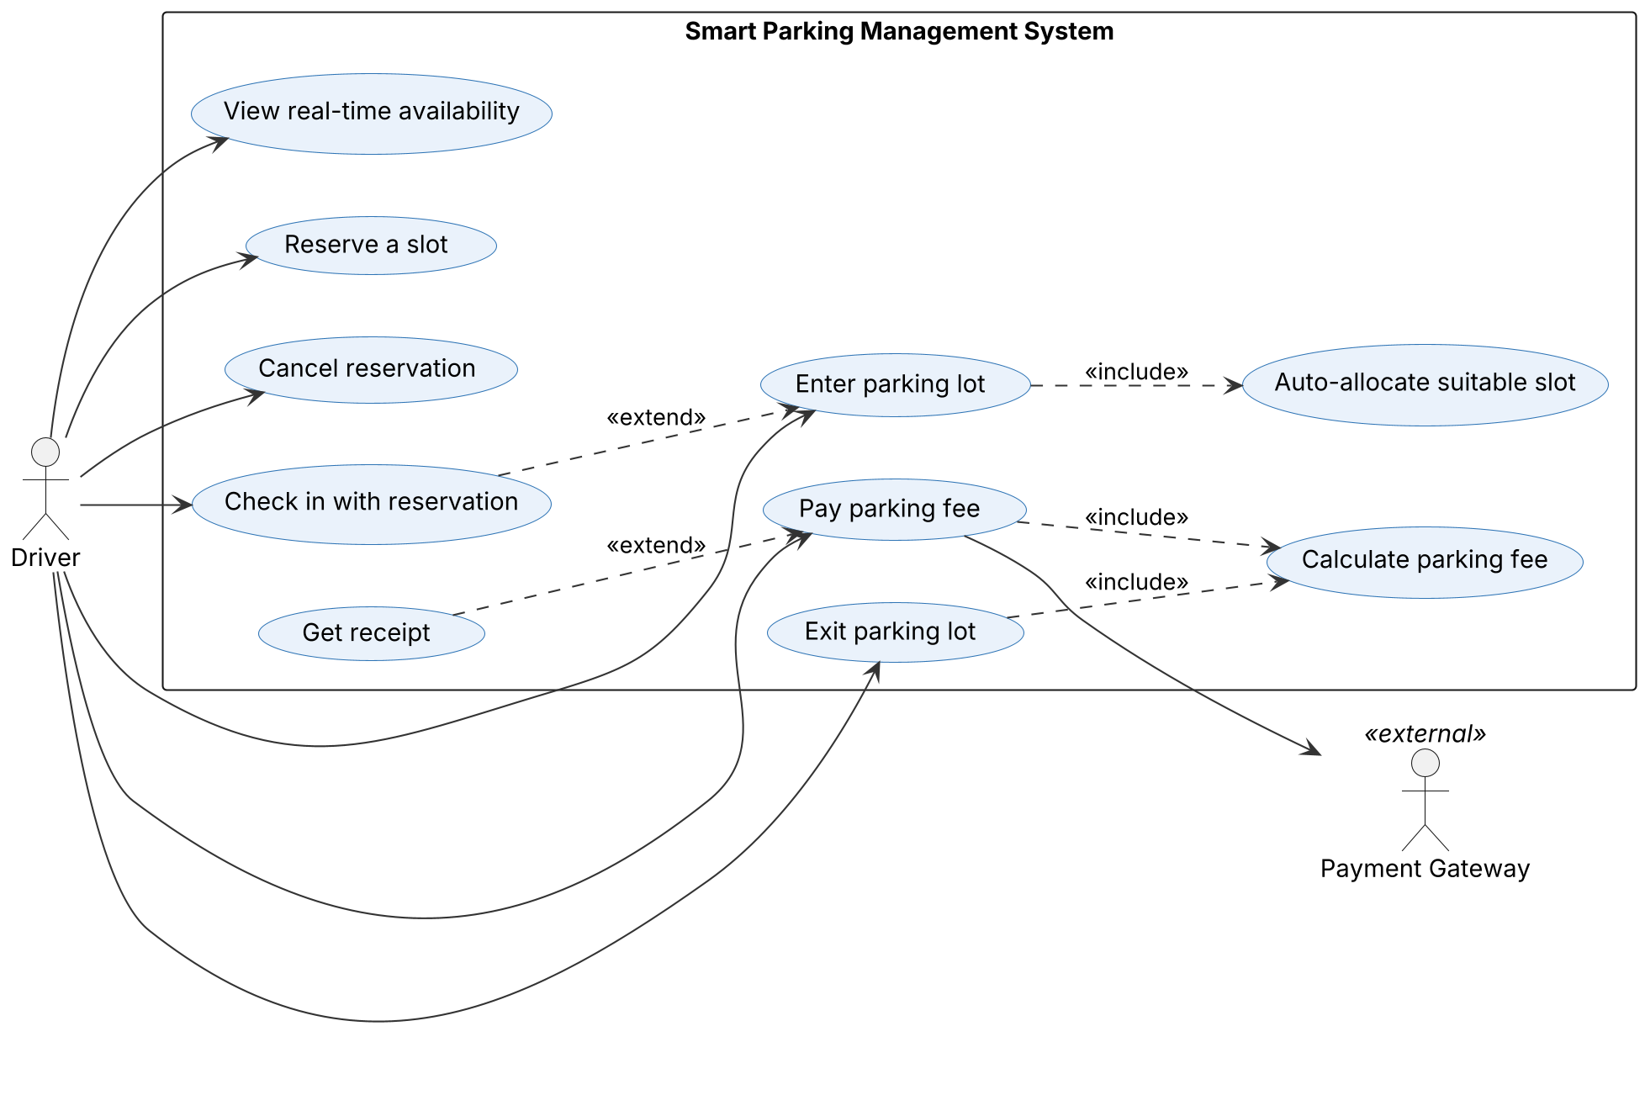
Figure 1. Driver use cases: availability, reservations, entry with automatic allocation, exit, payment and receipt

7.2 UML Use-Case Diagram 2: Operator and Admin services
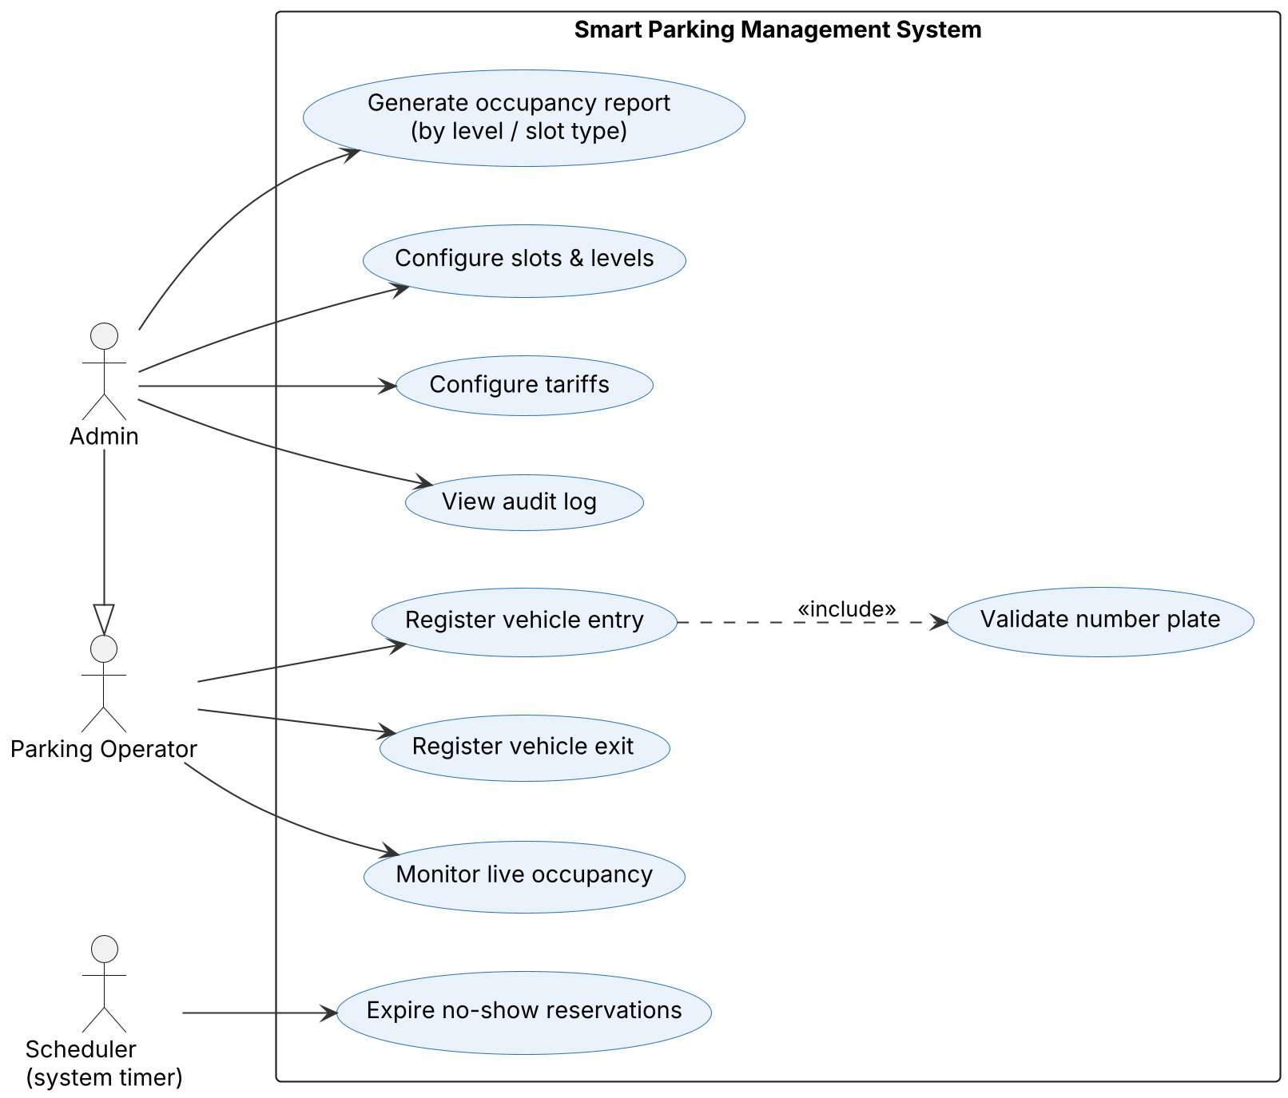
Figure 2. Operator, Admin and scheduler use cases (Admin inherits all Operator use cases)

8. Requirements Traceability Matrix (RTM)
Status: N = Not started, P = Passed, A = Accepted. Design references point to the SAD (DS-xx) sections.
Req ID | Requirement short | Section ref / Design Spec | Module | Test case(s) | Status (N/P/A) | Comments
SPMS-F-001 | Real-time occupancy summary | 4.1 / DS-Domain | models.py (ParkingLot) | TC-OCC-01 | P | Baseline (on main)
SPMS-F-002 | Find compatible slot | 4.1 / DS-Alloc | allocation.py | TC-ALC-01 | P | Owner: Satyanarayana
SPMS-F-003 | Best-fit allocation | 4.1 / DS-Alloc | allocation.py | TC-ALC-02 | P | Depends on F-002
SPMS-F-004 | EV slot priority | 4.1 / DS-Alloc | allocation.py | TC-ALC-03 | P | Depends on F-002
SPMS-F-005 | Lot-full handling | 4.1 / DS-Alloc | allocation.py | TC-ALC-04 | P | Depends on F-002
SPMS-F-006 | Plate validation | 4.2 / DS-EntryExit | entry_exit.py | TC-ENT-01 | P | Owner: Shubham
SPMS-F-007 | Vehicle entry | 4.2 / DS-EntryExit | entry_exit.py | TC-ENT-02 | P | Depends on F-002, F-006
SPMS-F-008 | Duplicate entry prevention | 4.2 / DS-EntryExit | entry_exit.py | TC-ENT-03 | P | Depends on F-007
SPMS-F-009 | Vehicle exit | 4.2 / DS-EntryExit | entry_exit.py | TC-EXT-01 | P | Depends on F-007, F-014
SPMS-F-010 | Create reservation | 4.3 / DS-Resv | reservations.py | TC-RES-01 | P | Owner: Sujan; uses F-002
SPMS-F-011 | Cancel reservation | 4.3 / DS-Resv | reservations.py | TC-RES-02 | P | Depends on F-010
SPMS-F-012 | No-show expiry | 4.3 / DS-Resv | reservations.py | TC-RES-03 | P | Depends on F-010
SPMS-F-013 | Reservation check-in | 4.3 / DS-Resv | reservations.py | TC-RES-04 | P | Depends on F-010
SPMS-F-014 | Fee calculation | 4.4 / DS-Billing | billing.py | TC-BIL-01 | P | Owner: Siddanth
SPMS-F-015 | Payment processing | 4.4 / DS-Billing | billing.py | TC-PAY-01 | P | Depends on F-014
SPMS-F-016 | Receipt | 4.4 / DS-Billing | billing.py | TC-PAY-02 | P | Depends on F-015
SPMS-F-017 | Occupancy report | 4.5 / DS-Report | reports.py | TC-RPT-01 | P | Owner: Siddanth
SPMS-NF-001 | Performance | 5 / DS-NFR | All modules | TC-PERF-01 | P
SPMS-NF-002 | Performance / Real-time | 5 / DS-NFR | All modules | TC-PERF-02 | P
SPMS-NF-003 | Reliability | 5 / DS-NFR | All modules | TC-REL-01 | P
SPMS-NF-004 | Maintainability | 5 / DS-NFR | All modules | TC-MNT-01 | P | CI gate --cov-fail-under=80; 98% coverage
SPMS-NF-005 | Usability | 5 / DS-NFR | All modules | TC-UX-01 | P | Scripted console tests; manual walkthrough pending
SPMS-NF-006 | Portability | 5 / DS-NFR | All modules | TC-PORT-01 | N | Passes on CI (Ubuntu); Windows run to confirm
SPMS-SR-001 | TLS 1.2+ everywhere | 5.1.2 / DS-Sec | Cross-cutting | TC-SEC-06 | N | Applies once web layer exists
SPMS-SR-002 | Admin-only configuration | 5.1.2 / DS-Sec | Cross-cutting | TC-SEC-01 | N | Planned (no login in v1.0)
SPMS-SR-003 | No card data stored | 5.1.2 / DS-Sec | Cross-cutting | TC-SEC-02 | N | Mock gateway stores no card data; formal test planned
SPMS-SR-004 | Input validation | 5.1.2 / DS-Sec | Cross-cutting | TC-SEC-03 | P
SPMS-SR-005 | Append-only audit log | 5.1.2 / DS-Sec | Cross-cutting | TC-SEC-04 | N | Planned
SPMS-SR-006 | Random UUID ids | 5.1.2 / DS-Sec | Cross-cutting | TC-SEC-05 | P

