Software Architecture and Design Specification
Project: Smart Parking Management System (SPMS)
Version: 1.0
Authors: Satyanarayana Kallakuri, Shubham D Bhat, Sujan S M, Siddanth Anil
Date: 10-10-2026
Status: Draft

Team member | SRN | Module owned | Features
Satyanarayana Kallakuri | PES1UG24AM257 | Allocation (allocation.py) | SPMS-F-002 to F-005
Shubham D Bhat | PES1UG24AM273 | Entry / Exit (entry_exit.py) | SPMS-F-006 to F-009
Sujan S M | PES1UG24AM292 | Reservations (reservations.py) | SPMS-F-010 to F-013
Siddanth Anil | PES1UG24AM274 | Billing & Reports (billing.py, reports.py) | SPMS-F-014 to F-017

Revision History
Version | Date | Author | Change Summary
1.0 | 10-10-2026 | Team (all members) | Initial architecture, UML diagrams, ADRs, threat model and API design

Approvals
Role | Name | Signature/Date
Course Coordinator
Team Lead / Repo Owner | Siddanth Anil

1. Introduction

1.1 Purpose
This document specifies the architecture and detailed design of the Smart Parking Management System (SPMS). It explains how the requirements in the SRS are realised as components, the decisions behind the structure, and the interfaces each team member implements.

1.2 Scope
Covers slot allocation, vehicle entry/exit, reservations, billing and payments, and occupancy reporting for SPMS v1.0 (Python package plus operator console), and the extension points for a future web UI, database and real payment gateway.

1.3 Audience
Team developers, testers/reviewers, the course instructor and evaluators, and future maintainers.

1.4 Definitions
SPMS, Slot, Ticket, Reservation, ADR (Architecture Decision Record), STRIDE (threat model categories), CI, UUID, TLS. See SRS §1.4 for full definitions.

2. Document Overview

2.1 How to use this document
Section 3 gives the architecture: goals, the component and class diagrams, the chosen pattern with ADRs, technology, risks, traceability and the threat model. Section 4 gives the detailed design: sequence diagrams for the two core flows, API definitions per component, error handling and UX. Each team member should implement their module against the interfaces in §4.3.

2.2 Related Documents
SPMS Software Requirements Specification (SRS) v1.0; SPMS Software Test Plan (STP) v1.0; RTM in SRS §8; repository README.md and FEATURES.md.

3. Architecture

3.1 Goals & Constraints
- Goals: correct, consistent slot state (no double allocation); fast allocation (≤ 200 ms for 1,000 slots); modules that four people can build in parallel with few merge conflicts; high testability (≥ 80% coverage); easy to extend with a web UI, database and real gateway.
- Constraints: Python 3.12 standard library at runtime; pytest; GitHub Actions CI with a protected main branch; no card data stored; project timeline of one semester.

3.2 Stakeholders & Concerns
Stakeholder | Concerns
Drivers | Finding a slot quickly, fair and transparent fees, reliable reservations
Parking Operators | Fast entry/exit, clear errors, live occupancy
Admin / Owner | Configurable tariffs and layout, reports, audit trail, revenue integrity
Developers (team) | Modularity, parallel work, clear interfaces, fast tests
Instructor / Evaluators | Traceability from requirements to design to tests, process discipline (branches, PRs, CI)

3.3 Component (UML) Diagram
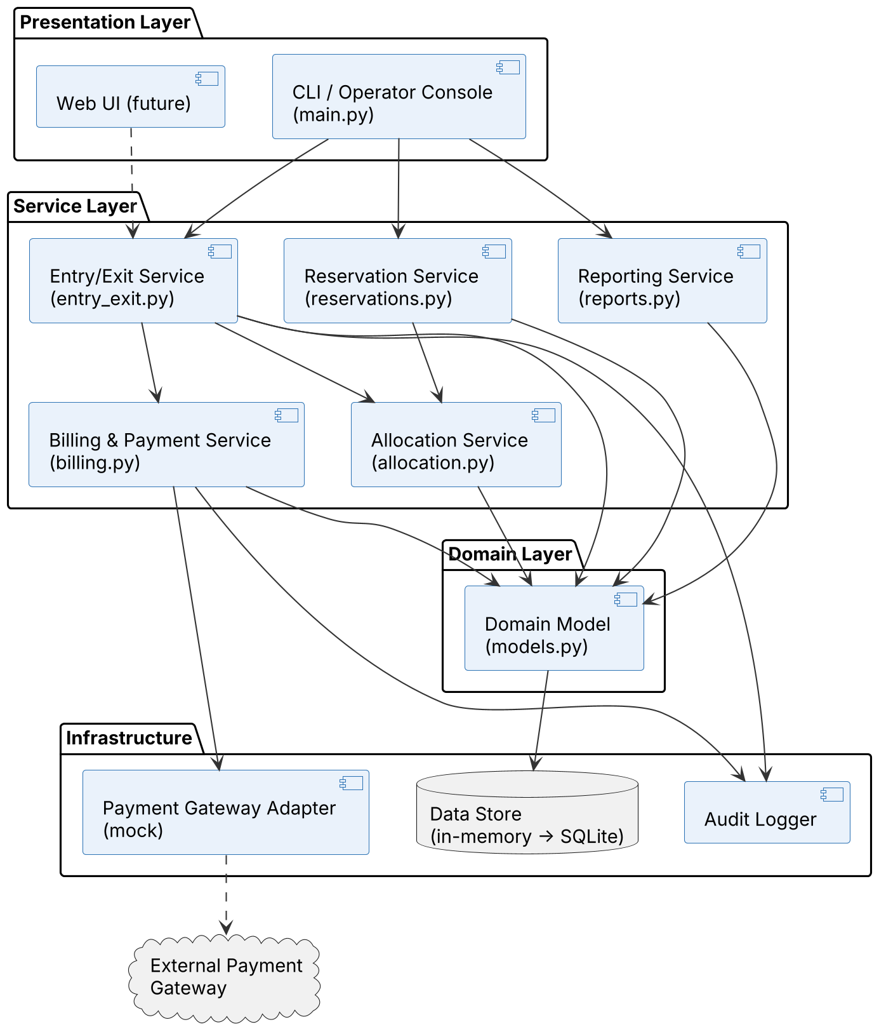
Figure 1. Layered component view. Arrows show allowed dependencies (top to bottom only).

UML Class Diagram
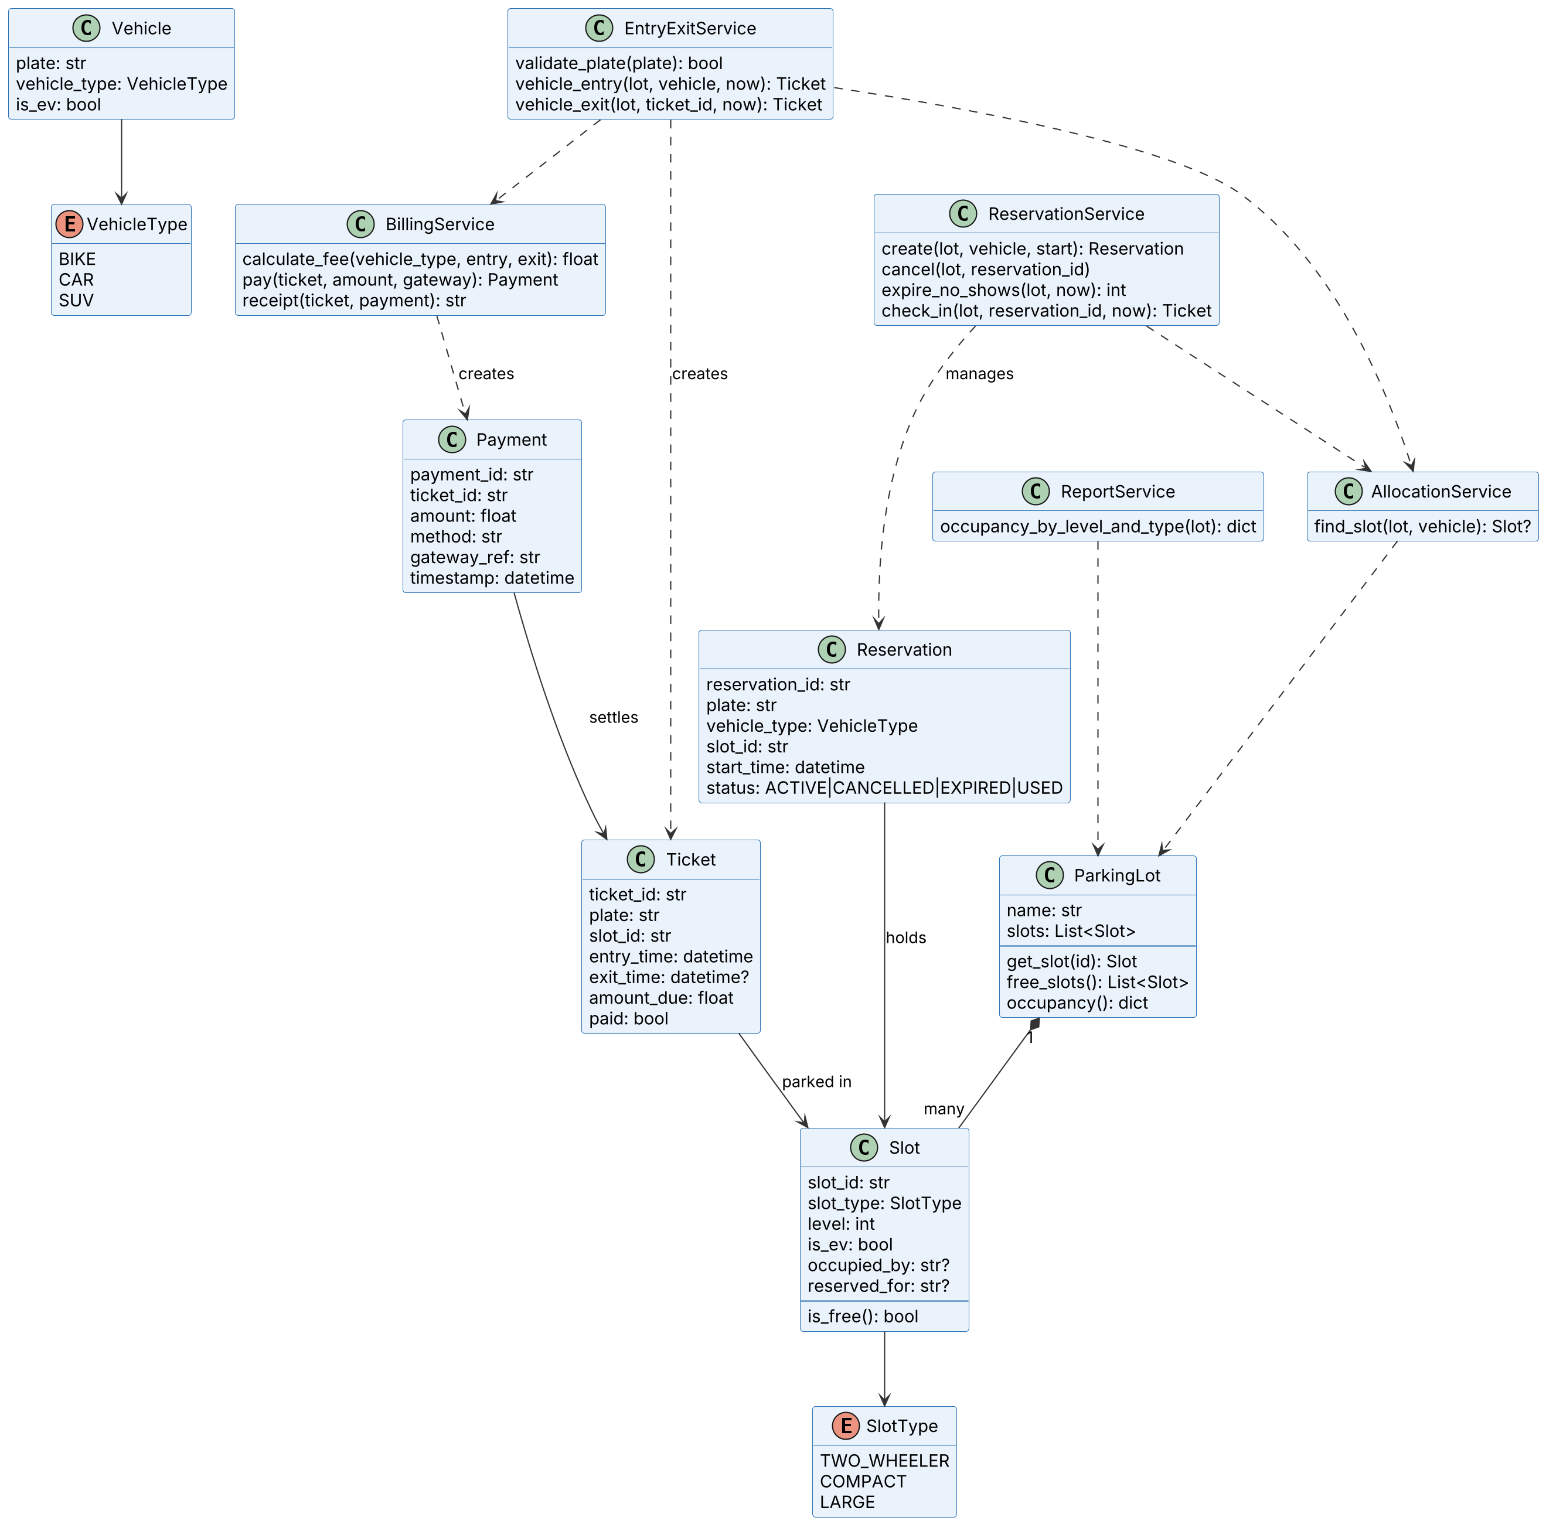
Figure 2. Domain classes (models.py) and service interfaces implemented by each module

3.4 Component Descriptions
Component | Responsibility | Owner
Operator Console (main.py) | Presentation: reads operator input, calls services, displays results and errors | All (each adds own menu item)
Domain Model (models.py) | Vehicle, Slot, Ticket, ParkingLot data classes; slot compatibility table; occupancy summary | Shared (baseline)
Allocation Service (allocation.py) | Selects the best free slot: compatibility, best fit, lowest level, EV priority | Satyanarayana Kallakuri
Entry/Exit Service (entry_exit.py) | Plate validation, ticket issue, duplicate prevention, exit and slot release | Shubham D Bhat
Reservation Service (reservations.py) | Create, cancel, expire and check in reservations; holds slots | Sujan S M
Billing & Payment Service (billing.py) | Fee calculation, payment through gateway adapter, receipts | Siddanth Anil
Reporting Service (reports.py) | Occupancy breakdown by level and slot type | Siddanth Anil
Payment Gateway Adapter | Interface charge(amount, method); mock implementation for tests | Siddanth Anil
Audit Logger | Append-only record of entry, exit, payment and admin actions | Shared
Data Store | In-memory in v1.0; repository interface allows SQLite later | Shared

3.5 Chosen Architecture Pattern and Rationale
A layered architecture (Presentation → Service → Domain → Infrastructure) with one service module per functional area. Layers only depend downwards, so services can be unit-tested without the console, and the console can later be replaced by a web UI. One module per team member keeps pull requests independent.

Architecture Decision Records
ADR | Decision | Alternatives considered | Rationale
ADR-001 | Layered architecture with service modules | Microservices; event-driven | Microservices add deployment and network overhead with no benefit at one-lot scale; event-driven is harder to test and reason about for a student team.
ADR-002 | Python 3.12 + dataclasses + pytest | Java/Spring Boot; Node.js | Fastest to write and test; matches the course CI demo; runs anywhere without a server.
ADR-003 | In-memory store behind a repository interface | SQLite or MySQL from day one | Keeps tests fast and setup-free; the interface lets SQLite be added without changing services.
ADR-004 | Payment gateway behind an adapter interface with a mock | Direct calls to a real provider | No real money or card data in a course project; the mock makes success, decline and timeout testable.
ADR-005 | Pass the current time (now) into services | Calling datetime.now() inside services | Makes time-based rules (grace period, expiry, fees) deterministic and testable.

3.6 Technology Stack & Data Stores
Concern | Choice
Language / runtime | Python 3.12 (standard library only at runtime)
Testing | pytest; pytest-cov for coverage
CI / CD | GitHub Actions (ubuntu-latest) on every pull request and push to main; protected main branch (1 approval + 'test' check)
Data store | In-memory objects (v1.0) → SQLite via repository interface (planned)
Web layer (future) | Flask REST API exposing the endpoints in §4.3, served over HTTPS (TLS 1.2+)
Tools | Git/GitHub, VS Code, PlantUML (diagrams), Jira or GitHub Issues (defects)

3.7 Risks & Mitigations
Risk | Impact | Mitigation
Two vehicles allocated the same slot | High | Single place that changes slot state per flow; randomised consistency test (TC-REL-01)
Merge conflicts between members | Medium | One module file per member; small PRs; pull main before each feature
Entry/Exit blocked waiting on Allocation | Medium | F-002 (find_slot) delivered first; interface fixed in this document
Time-dependent bugs in fees/expiry | Medium | ADR-005: inject now; boundary tests at 15 min, 60 min, 24 h
Payment gateway unavailable | Medium | Timeout → treated as declined; operator can retry; exit blocked until paid
Tests pass locally but fail in CI | Low | Same Python version locally and in CI; CI is the merge gate

3.8 Traceability to Requirements
Requirement | Short | Component | Design reference
SPMS-F-001 | Real-time occupancy summary | Domain Model | §4.3
SPMS-F-002 | Find compatible slot | Allocation Service | §4.2 Seq. 1, §4.3
SPMS-F-003 | Best-fit allocation | Allocation Service | §4.3
SPMS-F-004 | EV slot priority | Allocation Service | §4.3
SPMS-F-005 | Lot-full handling | Allocation Service | §4.3
SPMS-F-006 | Plate validation | Entry/Exit Service | §4.3
SPMS-F-007 | Vehicle entry | Entry/Exit Service | §4.2 Seq. 1, §4.3
SPMS-F-008 | Duplicate entry prevention | Entry/Exit Service | §4.3
SPMS-F-009 | Vehicle exit | Entry/Exit Service | §4.2 Seq. 2, §4.3
SPMS-F-010 | Create reservation | Reservation Service | §4.3
SPMS-F-011 | Cancel reservation | Reservation Service | §4.3
SPMS-F-012 | No-show expiry | Reservation Service | §4.3
SPMS-F-013 | Reservation check-in | Reservation Service | §4.3
SPMS-F-014 | Fee calculation | Billing & Payment Service | §4.3
SPMS-F-015 | Payment processing | Billing & Payment Service | §4.2 Seq. 2, §4.3
SPMS-F-016 | Receipt | Billing & Payment Service | §4.3
SPMS-F-017 | Occupancy report | Reporting Service | §4.3
SPMS-NF-001/003 | Performance, consistency | Allocation Service, Domain Model | §3.5, §3.7
SPMS-SR-002…006 | Security | All services, Audit Logger, Gateway Adapter | §3.9, §4.4

3.9 Security Architecture
Threat modelling with STRIDE on the entry/exit, reservation and payment flows:
STRIDE category | Threat in SPMS | Mitigation | Req
Spoofing | Someone checks in with another driver's reservation, or uses a stolen operator login | Random UUID reservation ids; role-based login for staff | SR-002, SR-006
Tampering | Altering a ticket's entry time or amount to pay less | Fees computed server-side from stored entry time; tickets only changed by services; audit log | SR-004, SR-005
Repudiation | Operator denies waiving a fee or changing a tariff | Append-only audit log with actor and timestamp | SR-005
Information disclosure | Leaking plates or card data from logs or storage | No card numbers stored; logs hold ids, not card data; TLS for network traffic | SR-001, SR-003
Denial of service | Fake reservations filling the lot | 15-minute no-show expiry; reservation limits per plate (future) | F-012
Elevation of privilege | Operator changes tariffs or slot layout | Role checks on admin-only operations | SR-002

4. Design

4.1 Design Overview
Each service is a module of plain functions that take the ParkingLot (and the current time where needed) and return domain objects or raise a typed exception. Services never print or read input; the console handles all I/O. Slot state changes happen in exactly one place per flow: allocation chooses, entry/check-in occupies, exit/cancel/expiry releases.

4.2 UML Sequence Diagrams

Sequence 1: Vehicle entry with automatic slot allocation (F-006, F-007, F-008, F-002, F-005)
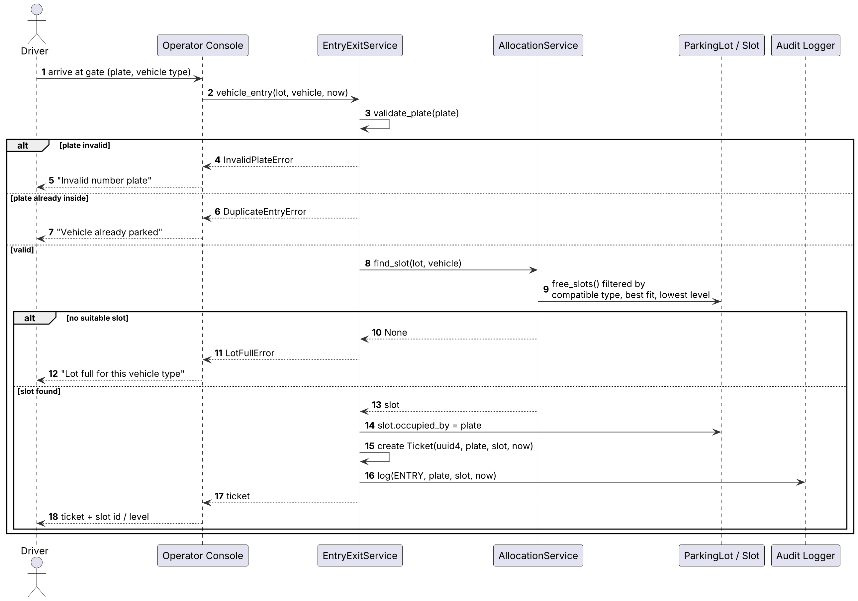
Figure 3. Entry flow: validate plate, prevent duplicates, allocate best slot or report lot full, issue ticket

Sequence 2: Fee payment and vehicle exit (F-014, F-015, F-016, F-009)
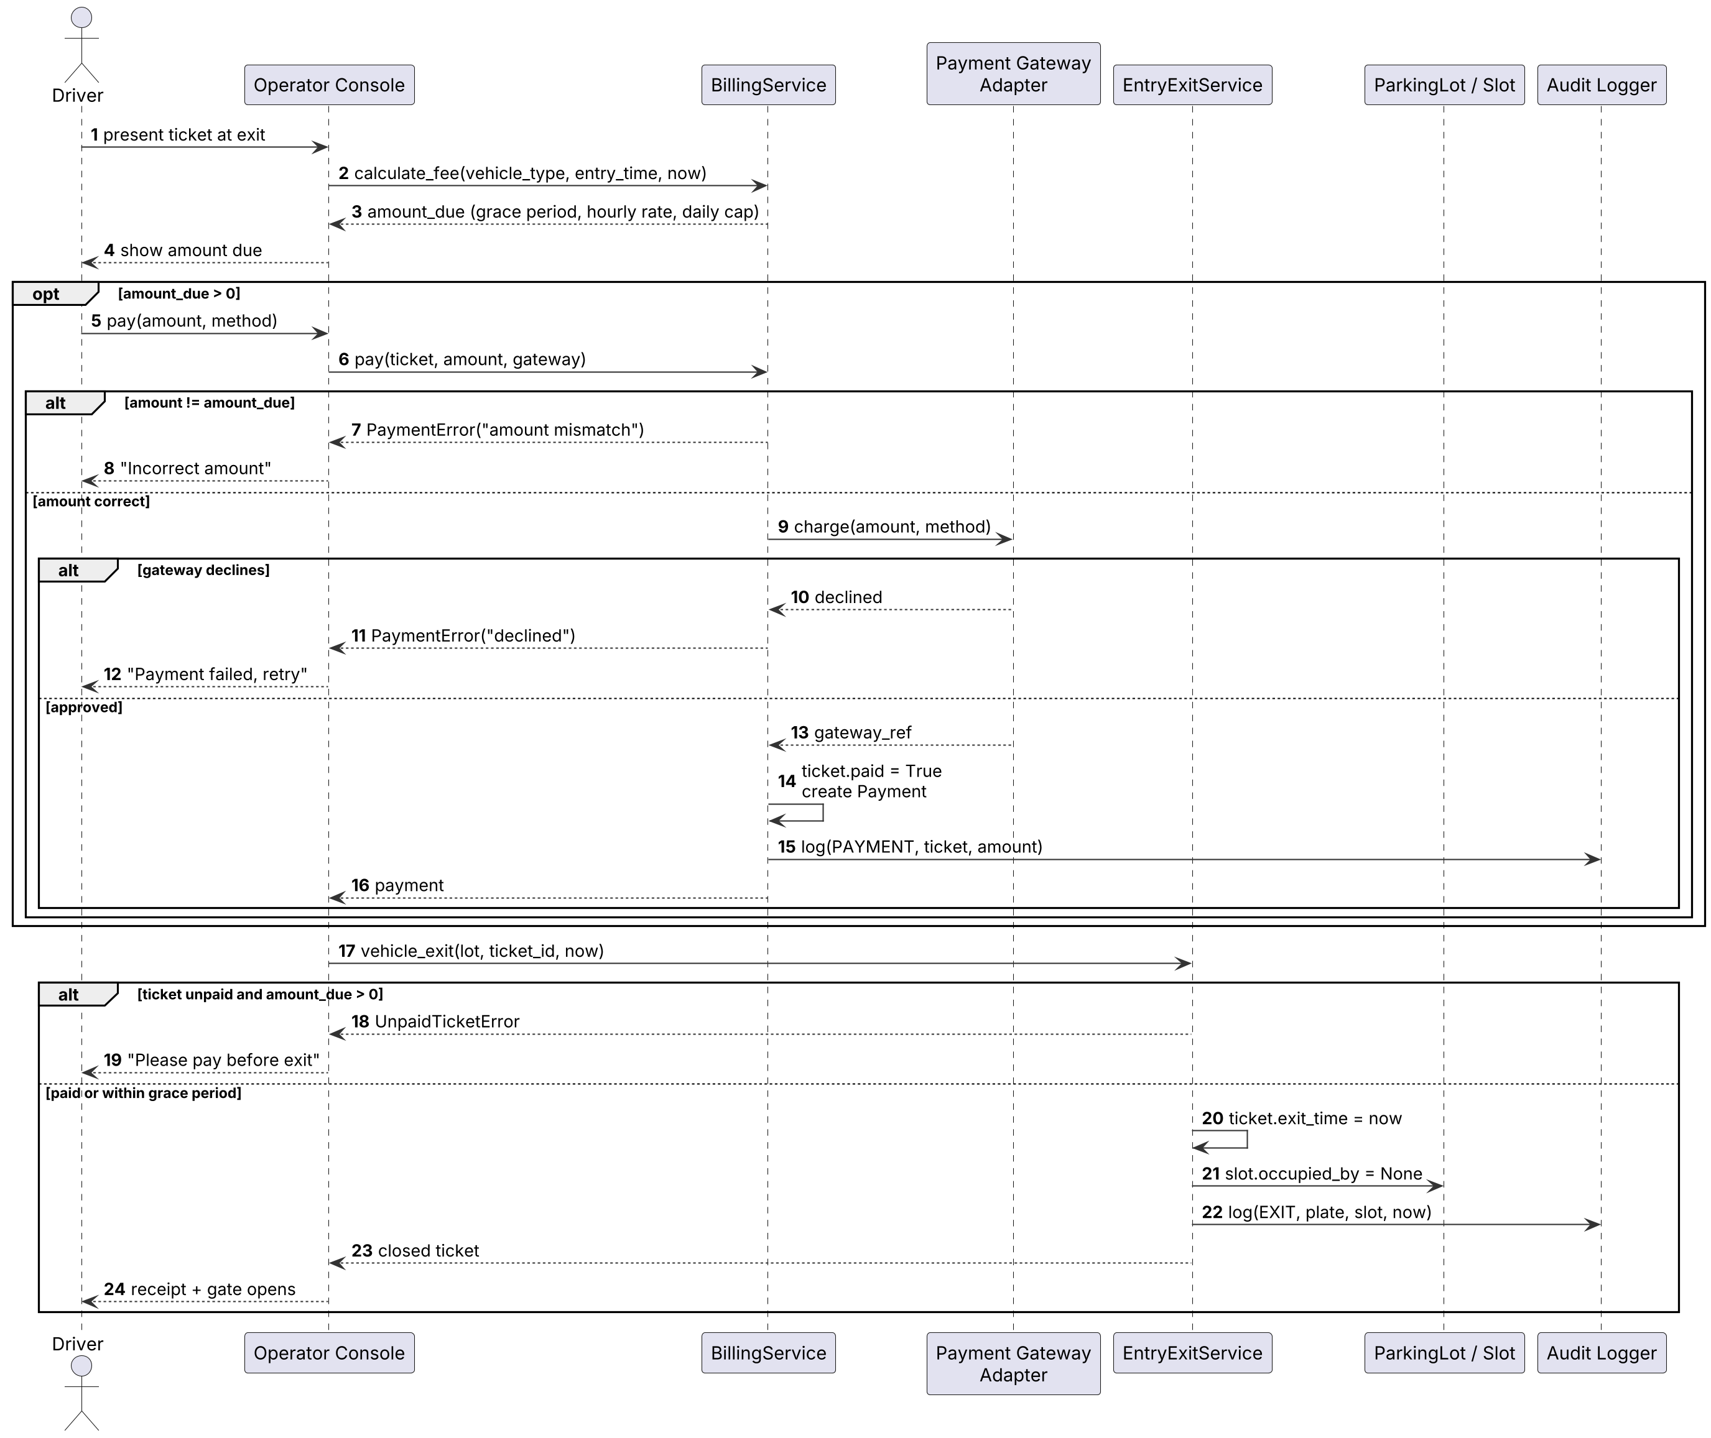
Figure 4. Exit flow: calculate fee, pay through gateway (mismatch/decline handled), release slot only when paid

4.3 API Design
Interfaces for the four service components. Each row gives the Python function implemented in v1.0 and the REST endpoint that the future web layer will expose for it.

Allocation Service (allocation.py)
Endpoint | Method | Python function | Request | Response | Errors
/slots/allocate | POST | find_slot(lot, vehicle) | {plate, vehicle_type, is_ev} | {slot_id, level, slot_type} | 409 LotFullError
/occupancy | GET | lot.occupancy() | — | {total, occupied, reserved, available} | —

Entry/Exit Service (entry_exit.py)
Endpoint | Method | Python function | Request | Response | Errors
/entries | POST | vehicle_entry(lot, vehicle, now) | {plate, vehicle_type, is_ev} | 201 {ticket_id, slot_id, level, entry_time} | 400 InvalidPlateError; 409 DuplicateEntryError; 409 LotFullError
/exits/{ticket_id} | POST | vehicle_exit(lot, ticket_id, now) | — | {ticket_id, exit_time, amount_due, paid} | 404 unknown ticket; 402 UnpaidTicketError

Reservation Service (reservations.py)
Endpoint | Method | Python function | Request | Response | Errors
/reservations | POST | create(lot, vehicle, start) | {plate, vehicle_type, start_time} | 201 {reservation_id, slot_id, status} | 400 invalid input; 409 LotFullError
/reservations/{id} | DELETE | cancel(lot, reservation_id) | — | {reservation_id, status: CANCELLED} | 404 unknown id; 409 not ACTIVE
/reservations/{id}/check-in | POST | check_in(lot, reservation_id, now) | — | {ticket_id, slot_id} | 404 unknown id; 409 expired/used

Billing & Payment Service (billing.py)
Endpoint | Method | Python function | Request | Response | Errors
/tickets/{id}/fee | GET | calculate_fee(vehicle_type, entry, exit) | ?at=<time> | {amount_due} | 404 unknown ticket
/payments | POST | pay(ticket, amount, gateway) | {ticket_id, amount, method} | 201 {payment_id, gateway_ref, paid: true} | 400 amount mismatch; 402 declined; 504 gateway timeout
/tickets/{id}/receipt | GET | receipt(ticket, payment) | — | text/plain receipt | 409 ticket unpaid

4.4 Error Handling, Logging & Monitoring
- Exceptions: all domain errors inherit from ParkingError: InvalidPlateError, DuplicateEntryError, LotFullError, UnpaidTicketError, ReservationError, PaymentError, PermissionError. Services raise; the console catches and shows a plain-language message. No error leaves the lot in a half-changed state.
- Logging: audit entries {timestamp, actor, action, ticket/reservation id, slot id, amount}. Never logged: card numbers, full payment payloads.
- Monitoring (future web layer): occupancy %, lot-full events per hour, payment decline rate, reservation no-show rate, CI pass rate on main.

4.5 UX Design
- Operator console: numbered menu; entry in three steps (choose Entry → type plate → choose vehicle type); result shows slot id and level in one line.
- Messages say what happened and what to do, e.g. 'Lot full for SUVs, try the overflow area' or 'Please pay ₹60 before exit'.
- Future web dashboard: per-level grid coloured green (free), amber (reserved), red (occupied), with EV slots marked; large fonts for the kiosk view.

4.6 Open Issues & Next Steps
- Persist state in SQLite via the repository interface
- Expose the §4.3 endpoints with Flask over HTTPS; add operator login
- Number-plate recognition camera and barrier-gate adapters
- Dynamic pricing at peak hours and per-plate reservation limits
- Integration with a real payment provider (UPI/cards) through the existing adapter

5. Appendices
5.1 Glossary: SPMS, Slot, Ticket, Reservation, EV, ADR, STRIDE, TLS, UUID, CI, RTM.
5.2 References: IEEE 42010 (architecture description), IEEE 829 (test documentation), OWASP Top 10, NIST SP 800-160, Python dataclasses documentation.
5.3 Tools: PlantUML, draw.io, GitHub Actions, pytest, VS Code.

