Backend Technical and Administration Guide
Reviewed: 2 October 2026, based on the current working tree including uncommitted development. This is implementation documentation and a source review, not a full penetration test, financial compliance review, or production verification. Only the four requested Markdown guides are edited.
Related: complete API reference, frontend architecture, user workflows. Status labels distinguish implemented, partial, experimental, deprecated/unused, and recommended/planned functionality.

Architecture and versions
Composer requires PHP ≥8.2 and Laravel ^12.0; installed framework is 12.13.0 and local CLI is PHP 8.2.12. composer.lock resolves actual versions. Sanctum ^4.0 provides tokens; Tinker supports development inspection. Pest 3/Pest Laravel, Mockery and Faker support tests; Pint provides formatting; Pail and Sail are development tools. No Stripe SDK, production PDF library, policy package, or custom queue-job/event layer is installed. Stripe uses Laravel's HTTP client, PDF uses a custom generator, and authorization lives in middleware/controllers/Form Requests.
Figure 1
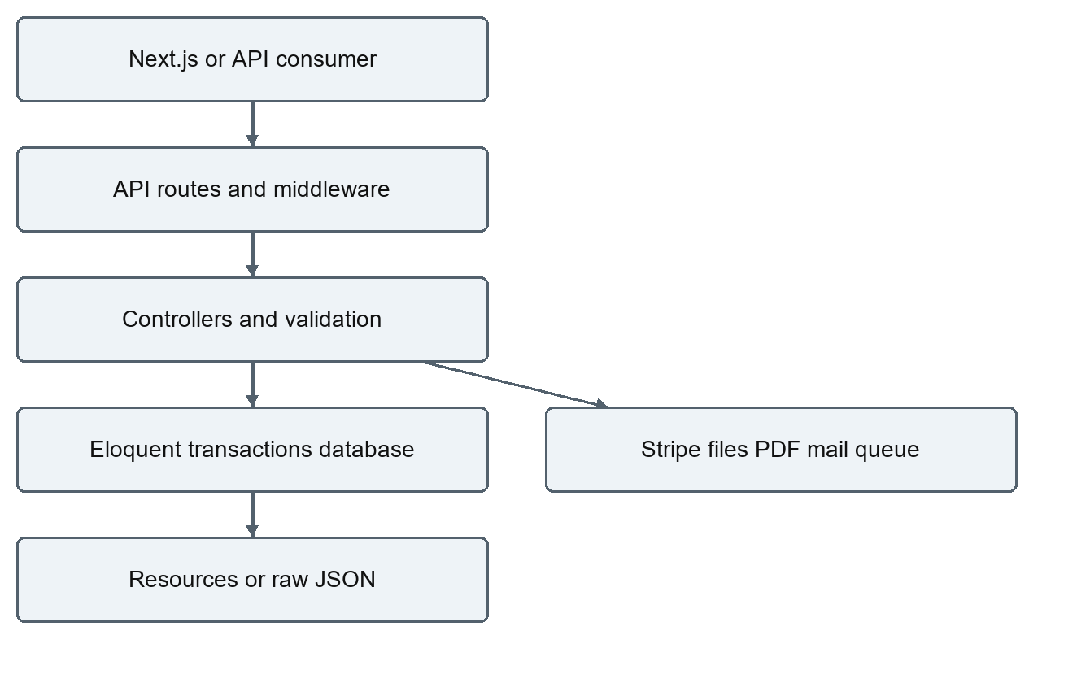

Directory structure and responsibilities
app/​
Filter/​ Whitelisted query comparisons, with V1 feature filters
Http/​Controllers/​ Auth and V1 feature controllers
Http/​Middleware/​ Role, explicit capability, selected-route audit
Http/​Requests/​V1/​ Create/​update/​checkout validation and input mapping
Http/​Resources/​V1/​JSON resources and paginated collections
Models/​ Eloquent data, casts and relationships
Mail/​ Queued order confirmation and fulfillment update
Services/​ Stripe hosted-session/​signature implementation
Support/​ Minimal PDF byte generator
Providers/​ Standard AppServiceProvider (no reset-link callback)
bootstrap/​ Routing/​middleware bootstrap and providers
config/​ Framework configuration plus commerce/​cors/​services
database/​ Factories, 18 migrations, development seeders
routes/​ api.php, web.php welcome page, console.php inspire command
resources/​ Welcome page, email Blade views, optional Vite CSS/​JS
public/​ PHP entrypoint and static assets; storage symlink at runtime
storage/​ Logs/​cache/​jobs-related artifacts, public/​private file disks
tests/​ Pest Unit/​Feature suites
docs/​ Existing OpenAPI/​workflow/​operations plus backend guides
.github/​workflows/​ Backend quality CI, including disposable MySQL service

Complete maintained file inventory
Paths are repository-relative. Dependencies, .git, private environment files, storage/cache contents, temporary diagnostics and generated reports are intentionally omitted; these are not maintained source. Runtime database.sqlite, uploaded files, and backups must not be treated as source-code assets.
.editorconfig
.env.example
.gitattributes
.github/​workflows/​quality.yml
.gitignore
LOCAL_DEVELOPMENT.md
README.md
app/​Filter/​ApiFilter.php
app/​Filter/​V1/​AddressFilter.php
app/​Filter/​V1/​CategoryFilter.php
app/​Filter/​V1/​ImageFilter.php
app/​Filter/​V1/​OrderFilter.php
app/​Filter/​V1/​ProductFilter.php
app/​Filter/​V1/​RoleFilter.php
app/​Filter/​V1/​UserFilter.php
app/​Http/​Controllers/​Api/​V1/​AccountController.php
app/​Http/​Controllers/​Api/​V1/​AddressController.php
app/​Http/​Controllers/​Api/​V1/​AdminController.php
app/​Http/​Controllers/​Api/​V1/​CatalogueController.php
app/​Http/​Controllers/​Api/​V1/​CategoryController.php
app/​Http/​Controllers/​Api/​V1/​CouponController.php
app/​Http/​Controllers/​Api/​V1/​ImageController.php
app/​Http/​Controllers/​Api/​V1/​OrderController.php
app/​Http/​Controllers/​Api/​V1/​PaymentController.php
app/​Http/​Controllers/​Api/​V1/​ProductController.php
app/​Http/​Controllers/​Api/​V1/​ReviewController.php
app/​Http/​Controllers/​Api/​V1/​RoleController.php
app/​Http/​Controllers/​Api/​V1/​ShoppingExperienceController.php
app/​Http/​Controllers/​Api/​V1/​SupportTicketController.php
app/​Http/​Controllers/​Api/​V1/​UserController.php
app/​Http/​Controllers/​Api/​V1/​WishlistController.php
app/​Http/​Controllers/​Auth/​AuthController.php
app/​Http/​Controllers/​Auth/​EmailVerificationController.php
app/​Http/​Controllers/​Auth/​PasswordRecoveryController.php
app/​Http/​Controllers/​Controller.php
app/​Http/​Middleware/​AuditAdministrativeChanges.php
app/​Http/​Middleware/​HandleRoleMiddleware.php
app/​Http/​Middleware/​RequirePermission.php
app/​Http/​Requests/​V1/​BulkStoreImageRequest.php
app/​Http/​Requests/​V1/​CheckoutOrderRequest.php
app/​Http/​Requests/​V1/​StoreAddressRequest.php
app/​Http/​Requests/​V1/​StoreCategoryRequest.php
app/​Http/​Requests/​V1/​StoreImageRequest.php
app/​Http/​Requests/​V1/​StoreProductRequest.php
app/​Http/​Requests/​V1/​StoreRoleRequest.php
app/​Http/​Requests/​V1/​StoreUserRequest.php
app/​Http/​Requests/​V1/​UpdateAddressRequest.php
app/​Http/​Requests/​V1/​UpdateCategoryRequest.php
app/​Http/​Requests/​V1/​UpdateImageRequest.php
app/​Http/​Requests/​V1/​UpdateOrderRequest.php
app/​Http/​Requests/​V1/​UpdateProductRequest.php
app/​Http/​Requests/​V1/​UpdateRoleRequest.php
app/​Http/​Requests/​V1/​UpdateUserRequest.php
app/​Http/​Resources/​V1/​AddressCollection.php
app/​Http/​Resources/​V1/​AddressResource.php
app/​Http/​Resources/​V1/​CategoryCollection.php
app/​Http/​Resources/​V1/​CategoryResource.php
app/​Http/​Resources/​V1/​ImageCollection.php
app/​Http/​Resources/​V1/​ImageResource.php
app/​Http/​Resources/​V1/​OrderCollection.php
app/​Http/​Resources/​V1/​OrderItemResource.php
app/​Http/​Resources/​V1/​OrderResource.php
app/​Http/​Resources/​V1/​ProductCollection.php
app/​Http/​Resources/​V1/​ProductResource.php
app/​Http/​Resources/​V1/​RoleCollection.php
app/​Http/​Resources/​V1/​RoleResource.php
app/​Http/​Resources/​V1/​UserCollection.php
app/​Http/​Resources/​V1/​UserResource.php
app/​Mail/​OrderConfirmation.php
app/​Mail/​OrderShippingUpdate.php
app/​Models/​Address.php
app/​Models/​AuditLog.php
app/​Models/​Brand.php
app/​Models/​Category.php
app/​Models/​Collection.php
app/​Models/​Coupon.php
app/​Models/​DigitalDownload.php
app/​Models/​Image.php
app/​Models/​LoginHistory.php
app/​Models/​Order.php
app/​Models/​OrderActivity.php
app/​Models/​OrderItem.php
app/​Models/​Product.php
app/​Models/​ProductAlert.php
app/​Models/​ProductVariant.php
app/​Models/​ReturnRequest.php
app/​Models/​Review.php
app/​Models/​Role.php
app/​Models/​SavedCart.php
app/​Models/​Shipment.php
app/​Models/​ShipmentEvent.php
app/​Models/​SupportTicket.php
app/​Models/​Tag.php
app/​Models/​User.php
app/​Models/​VariantImage.php
app/​Providers/​AppServiceProvider.php
app/​Services/​StripePaymentService.php
app/​Support/​SimplePdf.php
artisan
bootstrap/​app.php
bootstrap/​providers.php
composer.json
composer.lock
config/​app.php
config/​auth.php
config/​cache.php
config/​commerce.php
config/​cors.php
config/​database.php
config/​filesystems.php
config/​logging.php
config/​mail.php
config/​queue.php
config/​sanctum.php
config/​services.php
config/​session.php
database/​.gitignore
database/​factories/​AddressFactory.php
database/​factories/​CategoryFactory.php
database/​factories/​ImageFactory.php
database/​factories/​OrderFactory.php
database/​factories/​OrderItemFactory.php
database/​factories/​ProductFactory.php
database/​factories/​RoleFactory.php
database/​factories/​UserFactory.php
database/​migrations/​0001_01_01_000001_create_cache_table.php
database/​migrations/​0001_01_01_000002_create_jobs_table.php
database/​migrations/​2025_04_27_01_create_categories_table.php
database/​migrations/​2025_04_27_02_create_roles_table.php
database/​migrations/​2025_04_27_03_create_products_table.php
database/​migrations/​2025_04_27_04_create_images_table.php
database/​migrations/​2025_04_27_05_create_orders_table.php
database/​migrations/​2025_04_27_06_create_users_table.php
database/​migrations/​2025_04_27_07_create_addresses_table.php
database/​migrations/​2025_04_27_08_create_order_details_table.php
database/​migrations/​2025_05_10_065813_create_personal_access_tokens_table.php
database/​migrations/​2026_09_08_000000_redesign_orders_and_create_order_items_table.php
database/​migrations/​2026_09_09_000000_add_commerce_features.php
database/​migrations/​2026_09_10_000000_add_order_lifecycle_timestamps.php
database/​migrations/​2026_09_11_000000_add_customer_and_admin_features.php
database/​migrations/​2026_09_11_100000_add_shopping_shipping_and_returns.php
database/​migrations/​2026_09_11_200000_expand_product_catalogue.php
database/​migrations/​2026_09_28_000000_harden_checkout_and_payments.php
database/​seeders/​AddressSeeder.php
database/​seeders/​CategorySeeder.php
database/​seeders/​CouponSeeder.php
database/​seeders/​DatabaseSeeder.php
database/​seeders/​ImageSeeder.php
database/​seeders/​OrderSeeder.php
database/​seeders/​ProductSeeder.php
database/​seeders/​RoleSeeder.php
database/​seeders/​UserSeeder.php
docs/​OPERATIONS.md
docs/​WORKFLOWS.md
docs/​backend/​BACKEND_API_GUIDE.md
docs/​backend/​BACKEND_TECHNICAL_GUIDE.md
docs/​openapi.yaml
package.json
phpunit.xml
pint.json
public/​.htaccess
public/​favicon.ico
public/​index.php
public/​robots.txt
resources/​css/​app.css
resources/​js/​app.js
resources/​js/​bootstrap.js
resources/​views/​emails/​orders/​confirmation.blade.php
resources/​views/​emails/​orders/​shipping-update.blade.php
resources/​views/​welcome.blade.php
routes/​api.php
routes/​console.php
routes/​web.php
tests/​Feature/​AccountAndAdminFeaturesTest.php
tests/​Feature/​ApiSecurityTest.php
tests/​Feature/​AuthenticationTest.php
tests/​Feature/​CheckoutTest.php
tests/​Feature/​DocumentationContractTest.php
tests/​Feature/​ExampleTest.php
tests/​Feature/​ImageUploadTest.php
tests/​Feature/​PaymentAndIdempotencyTest.php
tests/​Feature/​ProductCatalogueTest.php
tests/​Feature/​ShoppingExperienceTest.php
tests/​Feature/​ValidationNormalizationTest.php
tests/​Pest.php
tests/​TestCase.php
tests/​Unit/​ExampleTest.php
vite.config.js

Route organization and module map
bootstrap/​app.php mounts routes/​api.php with the framework /​api prefix, web/console routes, and /​up health, and aliases role/audit.admin/permission. Its exception callback adds no custom normalization. Most application methods are synchronous; no separate repository/service pattern or policies directory is present.
Module | Responsibilities
AuthController | Customer-only registration, token login, user read, current-token logout, successful-login history/referral award
PasswordRecoveryController / EmailVerificationController | Password broker reset/revoke, signed verification/resend/redirect; reset URL generation incomplete
AccountController | Self profile/preferences/password/session/history/deletion
Product/Category/Image controllers | Catalogue reads/filtering, CRUD, public uploads/records; individual product update triggers alerts
CatalogueController | Draft-inclusive staff list, brands/collections/tags/publishing/relations, variants/media/digital purchase access, compare
AddressController | Customer ownership/staff access, CRUD and application-level default selection
OrderController | Locked checkout/prices/inventory/coupons/store credit, lists/show, status update/cancellation restoration, hard delete
PaymentController / StripePaymentService | Owner hosted Stripe session and signed/deduplicated completion webhook
ShoppingExperienceController | Shipping/format validation, carts/history/alerts, customer cancel/reorder, returns/refunds, shipment/item fulfillment, PDFs
Review/Wishlist controllers | Approved review reads/submission/delete and personal saved products
CouponController | Validated staff percent-discount CRUD
SupportTicketController | Owner/staff lists, customer create, staff status/response
AdminController | Sales/dashboard/tax estimate/low stock, CSV/bulk updates, moderation, audit read
User/Role controllers | Admin identity/role mutations; authenticated role reads

The API guide endpoint catalogue is the detailed route/access matrix. Avoid adding imagined endpoints from model names.

Form Requests Resources and filters
StoreAddress, StoreCategory, StoreImage, BulkStoreImage, StoreProduct, StoreRole, StoreUser requests validate creation; matching Update requests use PUT-required versus PATCH-present rules. CheckoutOrderRequest normalizes nested productId/variantId and checkout camelCase. UpdateOrderRequest restricts submitted status values. Most authorize methods rely on route middleware; address/order requests additionally check user/role. Other modules use inline $request->validate, not their own Form Requests.
Rules and public names are listed in API payload contracts. Important differences: product PUT requires stock/low-stock threshold; catalogue/variant/coupon PATCH require fields or reset omissions rather than true preserve-all PATCH; account new password policy is stricter than registration/reset; single/bulk-image APIs create records separately from file upload.
Address, Category, Image, Order, OrderItem, Product, Role and User Resources transform selected database names to camelCase. Collections retain Laravel paginator metadata. Relations use whenLoaded; query/controller eager loading determines whether data exists. Raw models are returned for many new endpoints, so response conventions are not globally standardized. OrderResource exposes employeeNote and activity metadata to owners as well as staff, contrary to a strictly internal-note expectation. UserResource excludes secrets but role includeUsers can expose other customer contact/account fields.
ApiFilter accepts only whitelisted operators but does not comprehensively validate query shapes. Address area/state and role name filters are stale/nonexistent columns. Product direct query options add searches/base-price CASE expressions/approved-rating average; minimum rating uses HAVING and needs testing on actual supported engines.

Authentication roles capabilities and auditing
Figure 2
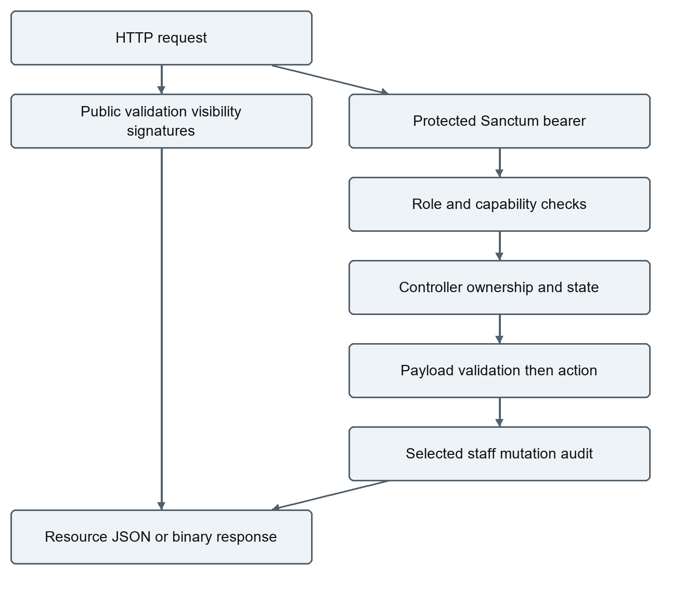
User uses HasApiTokens, HasFactory, Notifiable and MustVerifyEmail. Password is hashed by cast (registration also hashes explicitly); password/remember_token are hidden in model serialization and absent in UserResource. There is no MFA, granular object policy layer, token expiration schedule, or capability use of Sanctum token abilities; capabilities live on user.permissions JSON.
Capability/action | Customer | Employee | Admin
Own profile, cart, wishlist, owned order reads | Own | Own; staff order reads global | Own; staff order reads global
Address/order read | Own | All without manage_orders | All
Address mutation | Own | All without catalog/order capability | All
manage_catalog | No | Explicit permission | Allowed
manage_orders (updates, shipments, item fulfillment, returns, packing slips) | No | Explicit permission | Allowed
manage_coupons | No | Explicit permission | Allowed
moderate_reviews | No | Explicit permission | Allowed
view_reports (dashboard/report/low stock) | No | Explicit permission | Allowed
view_audit | No | Explicit permission | Allowed
manage_support | Own ticket create/read only | Required for non-null permissions; null incorrectly bypasses | Allowed
Users/roles mutation and core entity hard deletion | No | No | Allowed
Role read/includeUsers | Allowed; exposure risk | Allowed | Allowed
Review delete | Own | Own, not arbitrary moderation deletion | Any
Stripe session/download metadata | Own eligible order | Own eligible order | Own eligible order
Invoice | Own | Any without manage_orders | Any

RequirePermission is deny-by-default for Employee null permissions, but SupportTicketController is inconsistent. There is no role called Seller. Changing/adding role names through Admin API does not automatically extend middleware role allowlists.
AuditAdministrativeChanges wraps selected staff routes and support processing, records method/path/status/IP and filtered request input after $next. It skips GET/HEAD/OPTIONS and excludes password/image/file fields. It does not create reliable before/after snapshots, cover Admin users/roles/core deletes, or guarantee atomic mutation-plus-audit. Failed requests throwing before response can bypass audit; non-throwing non-2xx responses can be logged. It should not be described as a complete administrative audit ledger.

Database and models
Final schema below derives from all 18 migrations, not a live production introspection. id is the normal bigint primary key unless stated otherwise. ts means created_at/updated_at; nullable columns are noted with ?. Money is decimal with two fractional digits; orders/items use precision 12, base product prices precision 10. Most foreign keys create indexes and cascade unless otherwise described.

Identity catalogue and pricing tables
Table | Columns and constraints
roles | id, role_type unique; no timestamps
users | id, name, email unique, email_verified_at?, password, phone?, image_url?, role_id? (set null), remember_token?, ts, notification_preferences? JSON, permissions? JSON, loyalty_points unsigned default 0, store_credit default 0, referral_code? unique, referred_by? (user FK set null)
addresses | id, user_id (cascade), full_name, postal_code, street_name, suburb, city, country, is_default boolean default false; no timestamps/unique-default constraint
personal_access_tokens | id, tokenable_type/id morph index, name, token unique, abilities?, last_used_at?, expires_at?, ts
login_histories | id, user_id cascade, ip_address?, user_agent?, logged_in_at; no ts
categories | id, name unique; no ts
products | id, category_id cascade, name, description varchar, price, offer_price, date, stock_quantity unsigned default 100, sku? unique, low_stock_threshold default 5, popularity_count default 0, brand_id? set null, barcode? unique, publication_status default published, publish_at?, featured/trending/is_digital booleans default false; no ts
images | id, product_id cascade, url; no ts
brands | id, name unique, slug unique, description? text, ts
collections | id, name unique, slug unique, description? text, featured boolean, ts
collection_product | collection_id/product_id cascade; composite primary key
tags | id, name unique, slug unique; no ts
product_tag | product_id/tag_id cascade; composite primary key
related_products | product_id/related_product_id cascade to products; composite primary key, directional links
product_variants | id, product_id cascade, name, sku unique, barcode? unique, options JSON, price, offer_price default 0, stock_quantity unsigned default 0, active default true, ts
variant_images | id, product_variant_id cascade, url, position unsigned default 0, ts
coupons | id, code unique, percent_off unsigned tinyint, active true, expires_at?, ts
reviews | id, user_id/product_id cascade, rating, comment?, ts, status default pending, moderated_by? set null, moderated_at?; unique user/product
wishlists | id, user_id/product_id cascade, ts; unique user/product

User model deliberately disables timestamps despite users table having ts. Product, Address, Category, Image, Role, OrderItem and Tag also disable them. Brand/Collection/Variant/Shipment/new audit and support models use default timestamps. Do not assume created_at exists for every entity. SKU/barcode uniqueness is separate between product and variant tables, not a unified global namespace.

Commerce support and runtime tables
Table | Columns and constraints
orders | id, user_id cascade, address_id? set null, status default pending, subtotal, total, placed_at, ts, payment_status unpaid, payment_method manual, fulfillment_status unfulfilled, coupon_code?, discount_total 0, inventory_restored_at?, shipped_at?, delivered_at?, billing_address_id? set null, shipping_method standard, shipping_total 0, estimated_delivery_at?, click_and_collect false, gift_wrapping false, customer_note?/employee_note? text, refund_total 0, idempotency_key? ≤100, payment_provider_id? indexed; unique user/idempotency
order_items | id, order_id cascade, product_id? set null, product_name, unit_price, quantity unsigned, line_total, fulfilled_quantity 0, refunded_total 0, product_variant_id? set null, variant_name?, sku?; no ts
order_activities | id, order_id cascade, user_id? set null, type, description, metadata? JSON, ts
payment_events | id, provider, provider_event_id unique, type, payload JSON, processed_at?, ts; no order FK
saved_carts | id, user_id cascade, name default Saved cart, items JSON, ts; no unique user/name constraint
product_alerts | id, user_id/product_id cascade, type, price_at_creation?, active true, ts; unique user/product/type
browsing_histories | id, user_id/product_id cascade, viewed_at; unique user/product; no ts
shipments | id, order_id cascade, carrier?, tracking_number? unique, status processing, shipped_at?, delivered_at?, ts; no unique order_id constraint
shipment_events | id, shipment_id cascade, status, location?, description text, occurred_at; no ts
return_requests | id, order_id/order_item_id/user_id cascade, quantity unsigned, reason, details? text, evidence_path?, status requested, refund_amount 0, processed_by? user set null, ts
digital_downloads | id, product_id cascade, name, path, download_limit default 5, ts
digital_download_logs | id, digital_download_id/user_id/order_id cascade, downloaded_at; no ts or uniqueness/allowance constraint
support_tickets | id, user_id cascade, subject, message text, status open, priority normal, admin_response? text, assigned_to? user set null, ts
audit_logs | id, user_id? set null, method, path, status_code unsigned, ip_address?, changes? JSON, ts
password_reset_tokens | email primary key, token, created_at?
sessions | id string primary key, user_id? indexed (no constrained FK here), ip_address?, user_agent?, payload text, last_activity indexed
cache / cache_locks | key string PK, value/expiration; locks use owner/expiration
jobs | id, queue indexed, payload, attempts, reserved_at?, available_at, created_at integer
job_batches | id string PK, name, total/pending/failed_jobs, failed_job_ids, options?, cancelled_at?, created_at, finished_at?
failed_jobs | id, uuid unique, connection, queue, payload, exception, failed_at
migrations | Framework migration repository (migration, batch tracking); created by migration installation

No order currency, immutable billing/shipping-address text, gift-charge amount, tax breakdown, provider refund ledger, inventory movement ledger, or soft-delete/archive schema exists. The historical order_​details and legacy product-row orders are replaced, not current tables.
Figure 3
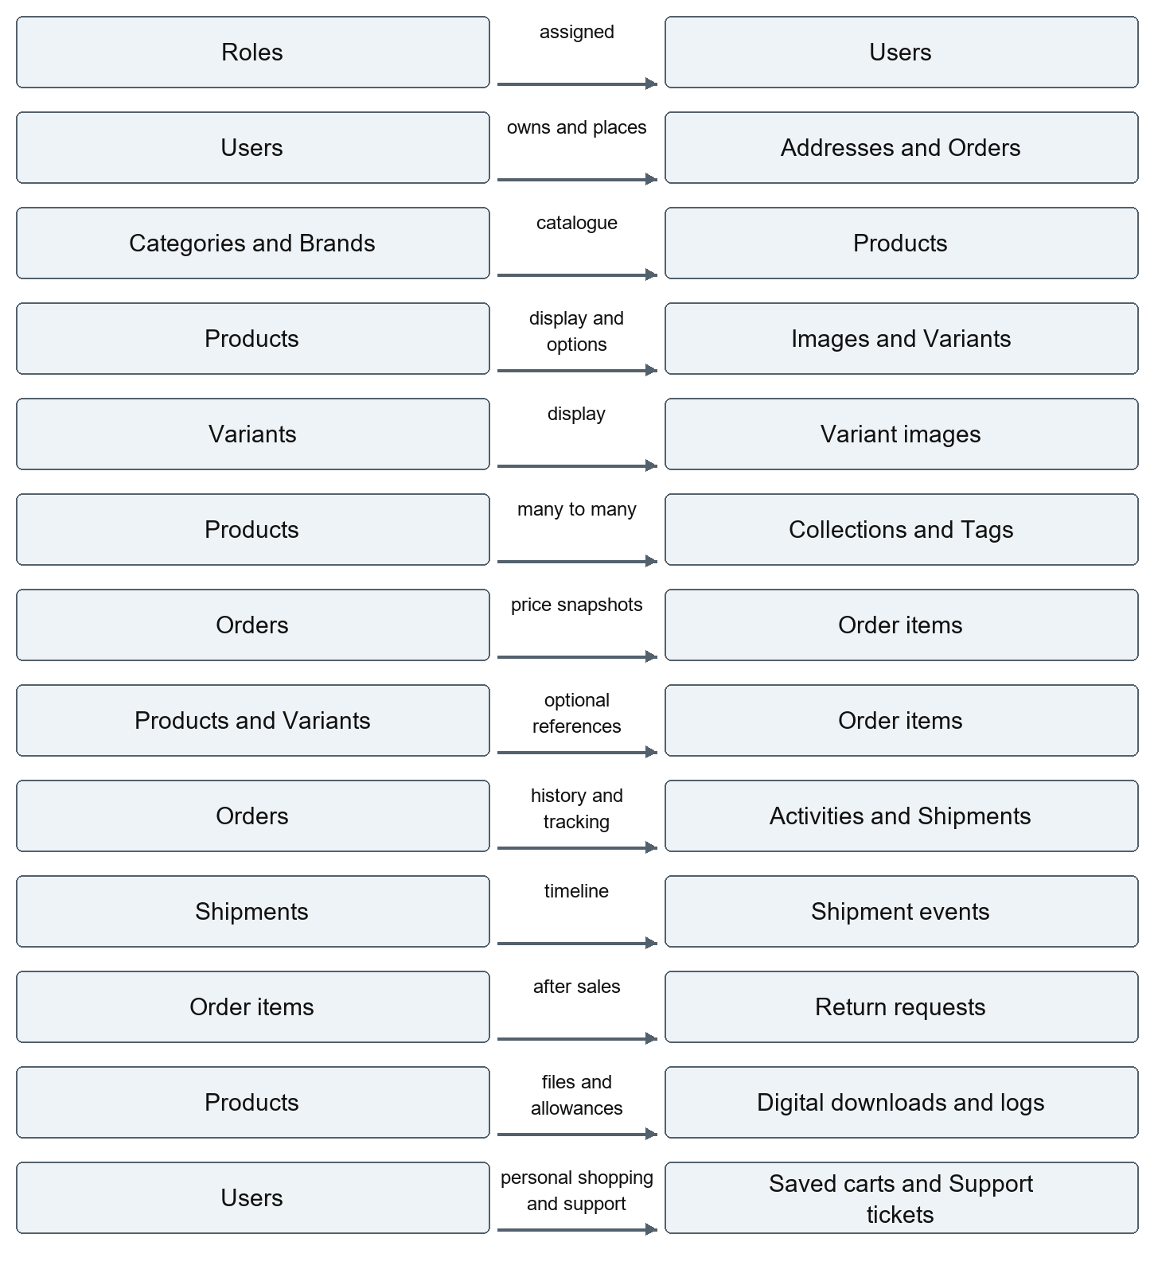
This is the core commerce relationship diagram; peripheral table FKs/indices are enumerated above. Shipment model permits many per order, but its current write endpoint updates one order match.

Casts relationships methods and seeding
User casts password hashed, verification datetime, preference/permission arrays, loyalty integer, credit decimal; belongs to Role and has addresses/orders. Product belongs to Category/Brand; has images/orderItems/reviews/variants/downloads; belongs-to-many collections/tags/related. Product and variant prices use decimal casts; stock is integer; publishAt datetime; flags boolean. Variant images are ordered by position. No reusable published-product scope is defined; repeated visibility predicates live in controllers.
Order has user/address/items/activities/shipments/returns; monetary/date/flag casts. No billingAddress relationship is defined despite billing FK. OrderItem belongs to Order/Product/Variant and casts price/line total/refunded total and fulfilled quantity. ReturnRequest has order/item and decimal refund. Shipment events are ordered by occurred_at; activity relationships have no explicit chronological sort. Remaining models are fillable record wrappers with selective JSON/boolean/date casts; not every SQL relationship is represented as an Eloquent method.
Factories exist for User, Role, Product, Order, OrderItem, Image, Category, Address; tests override relevant ownership/role IDs. UserFactory's random role IDs and seeded-model assumptions are unsuitable as standalone predictable onboarding. DatabaseSeeder calls Category, Role, Product, Image, User, Address, Coupon; OrderSeeder is not invoked. Category/product/image seed data includes random/sample records; UserSeeder provides deterministic development Admin/Employee/Customer emails and all explicit capabilities for the employee. AddressSeeder gives the customer a default Auckland address with country New Zealand; ProductSeeder creates DEV-SMOKE-001; CouponSeeder supplies WELCOME10.
Credential values are intentionally omitted. Never seed production: UserSeeder resets existing known-email credentials, product seeding appends random records and resets smoke stock, and category seeding can hit duplicate unique names. Use migrate --seed only for a disposable/new development database or knowingly reviewed seed runs.

Checkout inventory pricing and idempotency
Figure 4
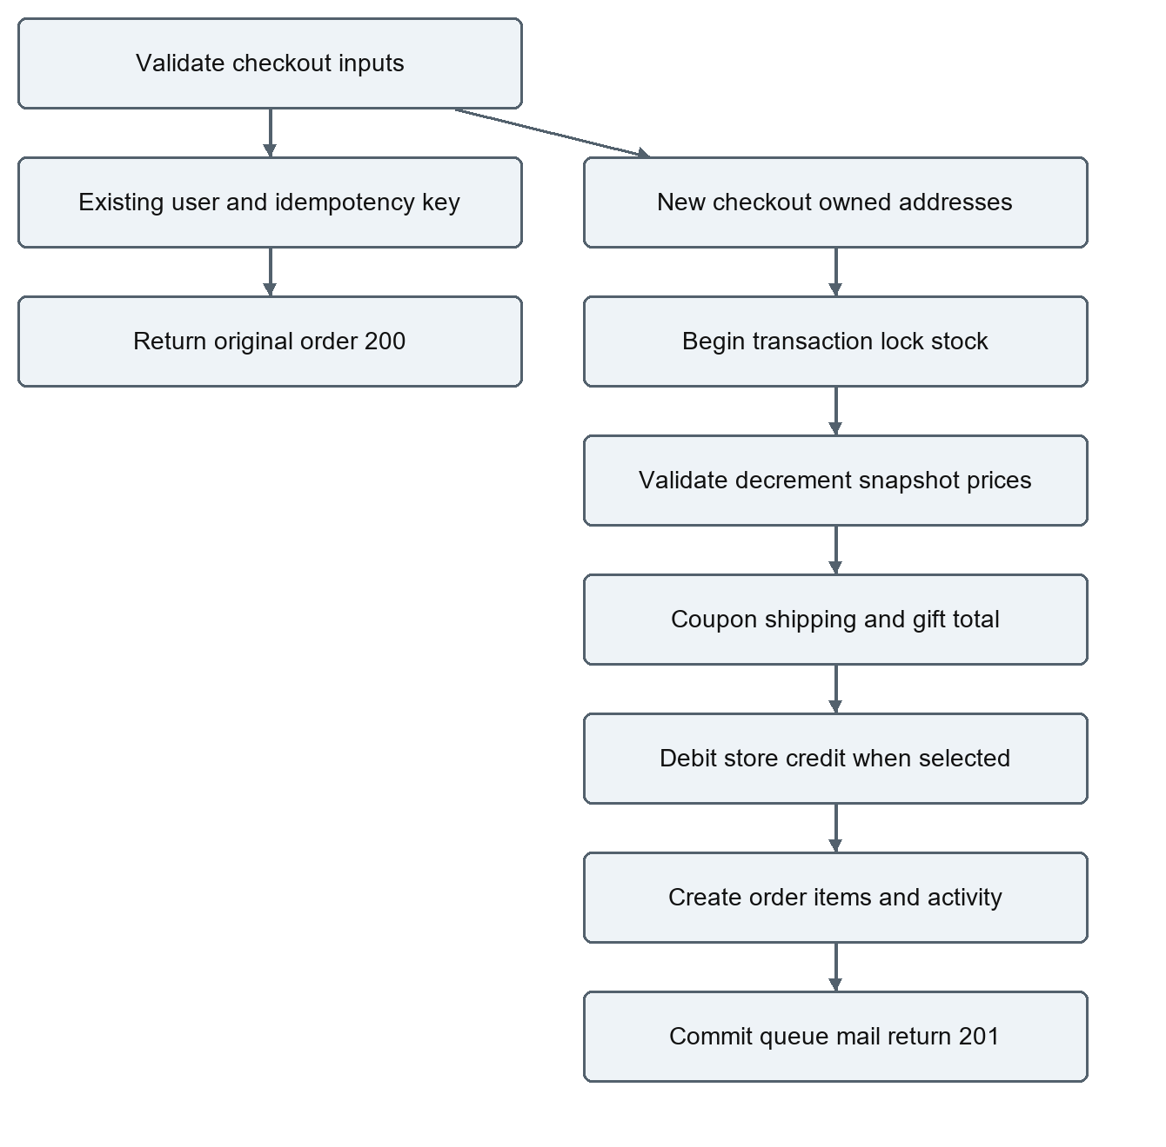
OrderController converts monetary values to cents, chooses positive offer below regular, sums line totals, rounds percent discount, and formats stored decimals. Charge formula: subtotal minus discount plus checkout shipping plus gift charge. Free shipping threshold uses discounted subtotal ≥100 or collect; otherwise standard 8/express 18, regardless of country. Gift wrap costs 5. No coupon allocation to item refunds or separate tax/gift/currency record exists. Shipping endpoint has different international/express/threshold/estimate behavior. The browser preview does not reconcile it. This is a Critical payable-total consistency risk.
Stock decrements at order creation, not payment completion. Variants decrement their own stock; base products decrement base stock. Locks prevent simple oversell on supported databases. SQLite test success is not evidence of MySQL lock/concurrency behavior. Checkout can purchase draft products by ID and can omit a variant even when variants exist; these rules need strengthening.
Cancellation locks order, checks inventory_restored_at and restores once. Customer requires unpaid/unfulfilled. Staff fulfillment cancellation permits unpaid/unfulfilled or processing. Hard delete does neither refund nor stock restoration. There is no automatic reservation expiration for abandoned unpaid/pending orders, inventory movement ledger, or restore-on-return handling.
Idempotency is partial: initial user/key lookup outside transaction, unique user/key constraint, no payload fingerprint, no duplicate-constraint catch/re-read for simultaneous requests, nullable key if omitted. Failed mail queuing after commit can cause a created order with an error response; retry finds the order but does not requeue missing mail. Product rows are locked together, but repeated variants/items are not required distinct. Concurrency deadlock/retry strategy and durable outbox are not implemented.

Stripe and store credit behavior
Figure 5
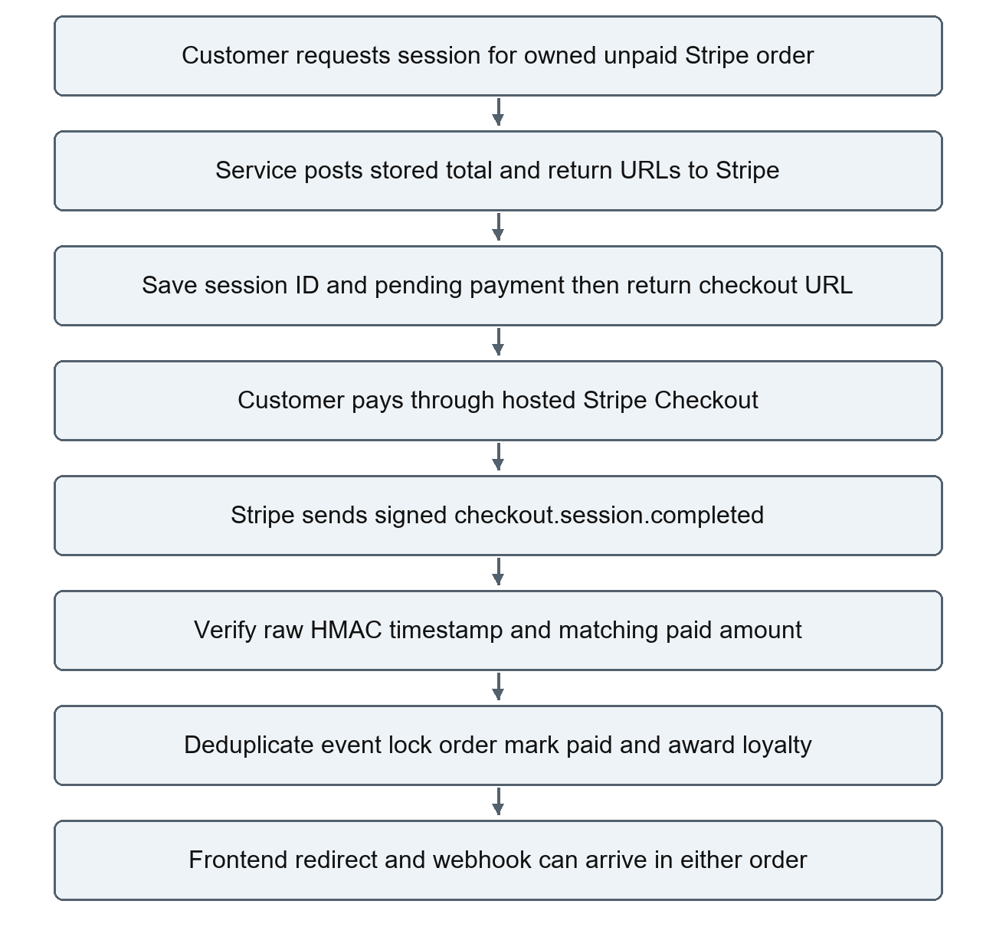
Service uses Laravel Http::asForm, secret bearer, one total line item, currency from STRIPE_CURRENCY (default nzd), metadata order_id, frontend success/cancel URLs. No Stripe PHP SDK is used. PaymentController checks owner/unpaid/stripe but not fulfillment cancellation before session creation; session creation/update is not a single locked operation. Signature verifier implements timestamp tolerance 300 seconds and HMAC SHA-256 with one parsed v1 signature; key absence/rotation/multiple signature hardening is limited.
Webhook deduplicates payment_events by event ID, then handles only paid checkout.session.completed with matching total and not already paid. It does not validate expected currency, original provider ID, payment method, or cancelled fulfillment. Mismatched/unsupported events are still marked processed; no reconciliation job exists. No expiry/failure/async success/refund/dispute events or corresponding stock restoration are implemented. Staff can set paid/failed/refunded directly for any payment method. Staff paid→unpaid→paid updates can award loyalty repeatedly.
Store-credit checkout locks/debits user and marks paid inside transaction but does not award loyalty in that branch. Referrals award referrer 100 points on registration, without anti-abuse verification. Credit is a mutable user balance, not a transaction ledger. Admin may replace balances through User update outside commerce ledger/locks/audit; refund adds credit. Loyalty display/redemption and invoice reporting are not a full accounting system.

Fulfillment shipments cancellation returns and downloads
Figure 6
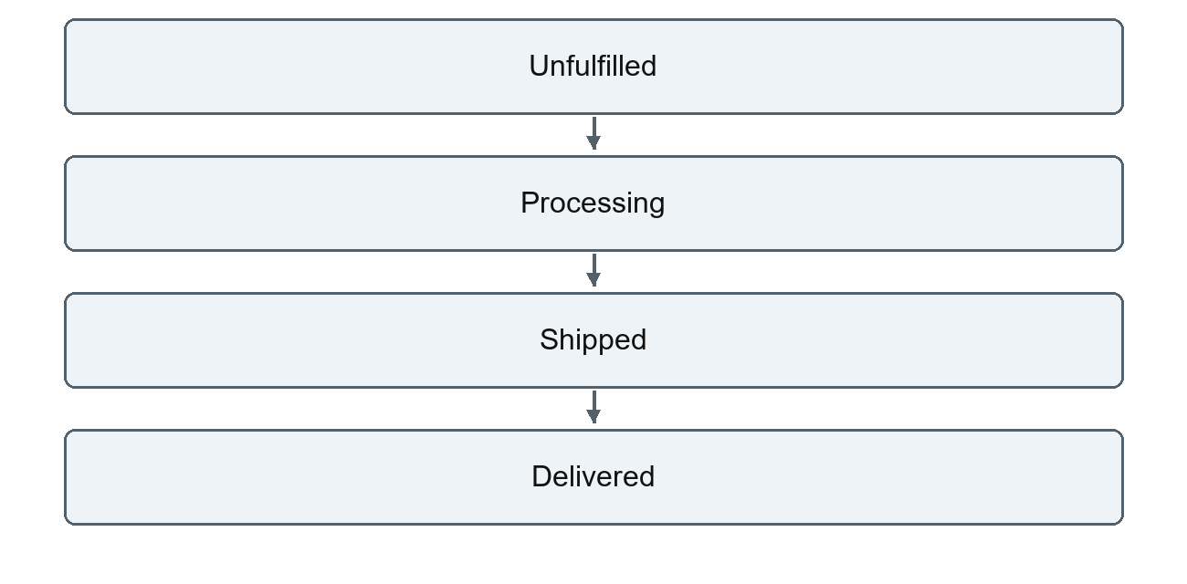
Unpaid orders may be cancelled from unfulfilled or processing by authorized staff. Customers may cancel only unpaid unfulfilled orders. Delivered and cancelled are terminal for the staged order update path.
Order update forbids fulfillment skips/backwards and stamps shipped/delivered dates. No general paid-before-processing/shipping rule is enforced. Payment status is a separate enum, not a fully enforced state machine; marking refunded does not pay money back. Legacy status generally remains pending except cancellation. Item partial fulfillment locks order/item, bounds cumulative quantity, saves employeeNote and activity, but does not advance order fulfillment or validate payment/terminal state. It returns raw snake_case, while frontend setOrder expects camelCase. Customers can read employeeNote through OrderResource.
Shipment POST updateOrCreate by order, append manually supplied status/location/description event and activity. It does not lock a unique-per-order shipment, constrain monotonic progression, preserve original shipped timestamp on every event, update fulfillment, or send the order shipping email. No carrier polling/webhook exists. Customer UI displays tracking only on fresh reads.
Figure 7
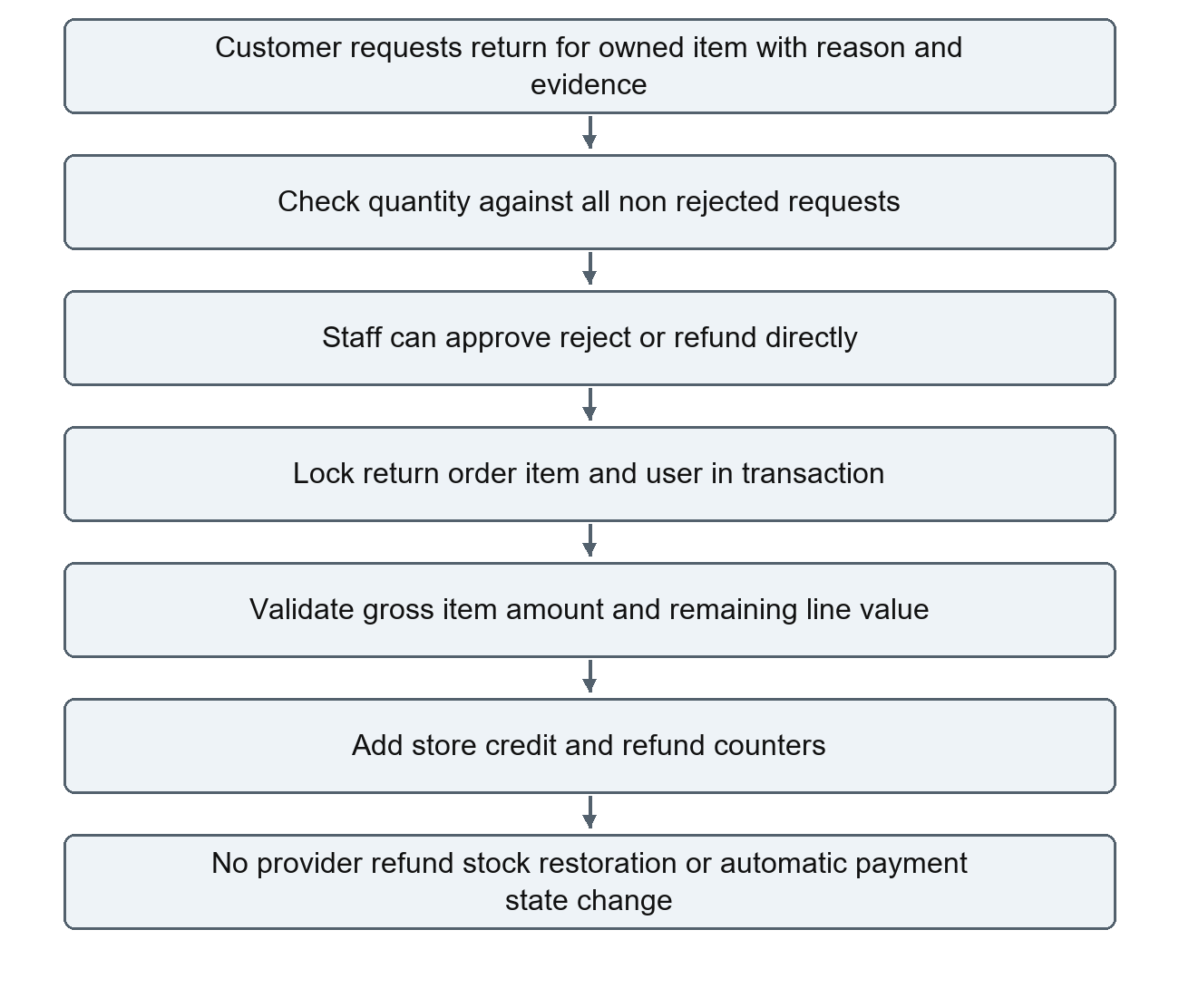
This diagram shows actual permissive transitions, not the stricter intended WORKFLOWS table. Return create verifies owner/item and requested quantity but not paid/delivered status; concurrent allowance checks can race. Processing forbids reprocessing a refunded return, but permits direct refunded and rejected→refunded. Amount defaults to zero if omitted, even if prior refund_amount was set on approval. Gross item caps ignore discounts and actual payment, so unpaid/coupon-discounted purchases can receive excessive credit. No automatic restock, payment reconciliation, loyalty reversal, or original-card refund exists. These are Critical financial risks.
Digital files live on local/private disk. Staff marks isDigital and uploads; listing requires owner/paid order; download finds newest paid owned order containing the product, checks count against download limit, logs attempt, serves attachment. Metadata does not expose path, but entitlement uses current product files rather than a purchased file/version snapshot. Count/log is not atomic; logging precedes successful file delivery; newest-order selection can disagree with order page's allowance; refunds/payment changes can leave access. No malware scanning, revocation ledger, or download concurrency test exists.

Email notifications support files and PDF
Figure 8
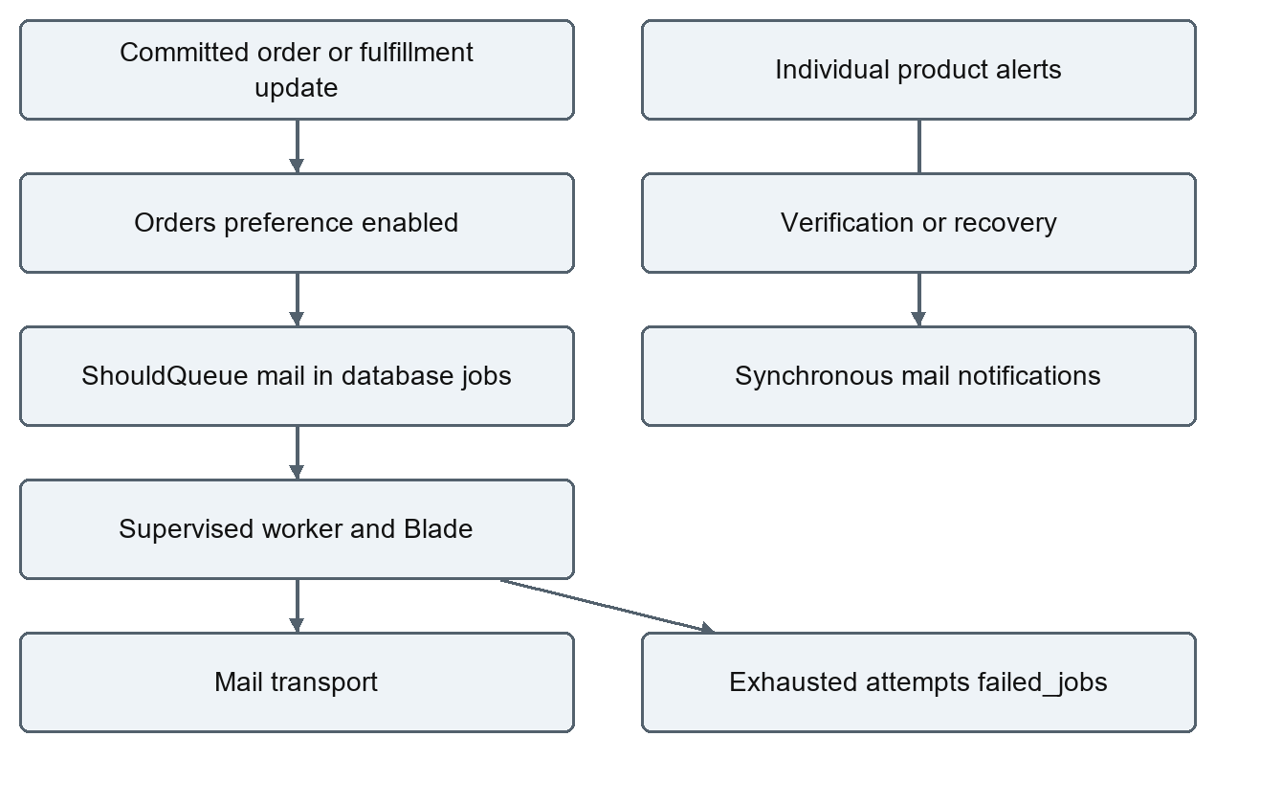
Only OrderConfirmation and OrderShippingUpdate implement ShouldQueue. They serialize order models and reference email views under resources/views/emails/orders. Enqueue happens after checkout/update transaction commit; database queue connection after_commit defaults false but the current callers enqueue outside transactions. Rehydrated models can show later state, not a fixed notification snapshot. Order preference gates these custom mails. Cancellation, shipment-event changes, return/refund and Stripe paid webhook do not each queue dedicated notifications. Support/promotions preference flags have no comprehensive send workflow; seeded preferences use marketing while UI uses promotions.
ProductController individual update detects base stock 0→positive and lower effective price, synchronously emails active alerts then deactivates. The price rule differs from checkout; bulk/import/variant updates do not trigger mail. Failure during mail can occur after product persistence and before deactivation. There is no queued alert worker, subscription management endpoint, or low-stock email alert; low stock is a report. Password/verification default notifications send synchronously. Recovery notification tries named password.reset route: it is absent and no createUrlUsing callback exists in AppServiceProvider. route:list --name=password.reset confirmed no matching route; known-account email recovery is broken by source inspection.
Support tickets have one original message and one admin_response, status/priority and assigned_to. Updates overwrite response; no conversation thread or automatic support notification is implemented. Customer lists own; staff list all, and manage_support null-permission bypass needs repair.

Storage and uploads
- Public disk: storage/​app/​public, URL derived from APP_URL + /​storage, symlink public/​storage; product/variant images and return evidence are stored there.
- Local disk: storage/​app/​private, explicitly used for digital downloads; do not expose it through a public symlink.
- File upload rules: product/variant JPG/JPEG/PNG/WebP ≤5 MB; return evidence image ≤5 MB; digital any file ≤50 MB; CSV ≤5 MB. PHP upload_max_filesize/post_max_size and proxy limits also apply.
- Record/file creation is not one cross-system transaction. Failed DB writes can orphan files; record deletion does not clean disk files. Evidence is publicly addressable, not authenticated private evidence. Changing FILESYSTEM_DISK alone does not move uploads because controllers explicitly select public/local disks. S3 configuration is present but driver/dependency/controller/storage migration work is still needed.
SimplePdf creates a single-page PDF with escaped text and Helvetica. Invoice lists snapshot items, shipping, total/refunds; packing slip lists address/items/fulfilled count. No tax registration/breakdown, robust line wrapping/pagination, Unicode font handling, or visual-regression tests. Treat output as experimental, not production accounting documents.

Configuration and local development
Never publish real .env, tokens, credentials, keys, reset-link values, payment event payloads or customer data. Only environment names and safe defaults are documented here.
Configuration | Relevant environment names and responsibilities
app.php | APP_ENV, APP_DEBUG, APP_KEY, APP_URL, FRONTEND_URL, locale/timezone; stable key privately managed
database.php | DB_CONNECTION/HOST/PORT/DATABASE/USERNAME/PASSWORD; config fallback SQLite, example chooses MySQL; MySQL strict mode
auth.php / sanctum.php | AUTH_GUARD, password broker/table; reset expiry 60 min/throttle 60 sec; Sanctum expiration null; stateful domains do not implement frontend cookie login
cors.php | FRONTEND_URL is one exact allowed origin; all methods/headers, credentials true, API and Sanctum CSRF paths; localhost ≠127.0.0.1
cache.php | CACHE_STORE default/database example; cache/cache_locks required; array in tests; Redis/memcached alternatives need extensions/services
session.php | SESSION_DRIVER database example, lifetime/domain/path/encryption; API token sessions are separate records
queue.php | QUEUE_CONNECTION database; DB_QUEUE/DB_QUEUE_RETRY_AFTER default 90 sec; after_commit false; failed database-uuids
mail.php | MAIL_MAILER log default; SMTP host/port/scheme/username/password/from privately configured; extra transports require appropriate dependencies
filesystems.php | FILESYSTEM_DISK; public/local explicit roots; APP_URL determines public URL; S3 environment exists but not active upload implementation
services.php | STRIPE_SECRET_KEY, STRIPE_WEBHOOK_SECRET, STRIPE_CURRENCY nzd, FRONTEND_URL; third-party scaffold is not proof integration enabled
commerce.php | COMMERCE_TAX_RATE default 15 for report estimate; LOW_STOCK_THRESHOLD default 5 exists but request/migration use hardcoded 5 and do not consume it
logging.php | LOG_CHANNEL/LOG_STACK/LOG_LEVEL, default local single/stack logs; protect/sanitize logs

PHP needs PDO with chosen database driver, fileinfo, mbstring/OpenSSL and framework-required extensions; image tests use small PNG content without requiring generated GD image helpers. Worker signal/time-limit support differs on Windows; deploy supervised workers on an appropriate host. Backend package.json contains optional Vite 6/Tailwind 4/Axios/concurrently tooling for Laravel's welcome assets, not Next's storefront.
Follow API local setup using migrate --seed only on a dedicated development database, storage:link, serve, and a separate queue worker. Configure Next's API origin and CORS exactly. Never regenerate APP_KEY against existing encrypted production data. Do not use LOCAL_DEVELOPMENT's migrate:fresh command on valuable data. Composer dev starts Laravel, queue:listen and Laravel Vite, not the sibling Next.js server.

Tests formatting and verification
composer test
composer format:check
composer validate --no-check-publish
php artisan route:list --path=api
composer format applies Pint, unlike format:check which is read-only for source. Pint uses Laravel preset plus statement/array indentation and no multiple statements per line. Composer test clears cached config and runs Artisan tests; runtime caches/logs can change, not application source. phpunit.xml defaults in-memory SQLite, array cache/session/mail, sync queue and low-cost hashing. RefreshDatabase recreates test schema; do not point it at real data. Existing external shell DB variables can override PHPUnit defaults, so confirm a disposable test target.
Feature suites cover account/admin/default-address/import/capabilities, auth/security/ownership, snapshot checkout/stock/coupon/store-credit/fulfillment mail, deterministic seeding/OpenAPI paths, product/image uploads/publishing/variants, cart merge/returns/tracking/PDF header, idempotency/Stripe fake completion and input mapping. Unit/Example tests are minimal scaffolding. Current verification: 33 tests, 166 assertions passed; Pint 159 files passed; Composer valid; API routes verified. No live MySQL migration, production queue, real SMTP/Stripe, concurrency/negative privacy regression, or rendered PDF quality test was run.
.github/​workflows/​quality.yml provisions MySQL 8.4 and PHP 8.3, installs Composer, runs migrate:fresh --seed against its disposable database, Composer tests and Pint. Environment overrides target MySQL rather than local SQLite defaults. This workflow's presence is not proof of a successful remote run. Frontend CI runs format/unit/lint/build/mocked browsers, not automatic cross-repository real smoke. Actual local browser verification: two mocked tests passed, opt-in real smoke skipped; no claim of a real payment journey.

Production administration
These are recommended operating procedures using existing framework commands, not a provisioned deployment system. Check the risks below before promotion. Commands for installation/migration/workers were inspected, but deployment-changing operations were not executed during review.

Release process
- Require passing CI, review migration/down() and compatibility, verify database/file backup and staging restore. Resolve Critical findings first.
- Provision HTTPS API host/PHP runtime/extensions and a web root of public/​, never repository root. Restrict secret/read permissions; allow service user write to storage/bootstrap/cache.
- Install locked production dependencies with composer install --no-dev --optimize-autoloader --no-interaction in the release environment. Do not run development seeders.
- Populate environment privately: production APP_ENV, false APP_DEBUG, stable APP_KEY, actual APP_URL/FRONTEND_URL, database, cache/session/queue/mail, Stripe test/live isolation and appropriate signing secret.
- Back up; enter php artisan down if incompatible schema changes require it; run php artisan migrate --force once per release against correct target. Do not use fresh/refresh/reset.
- Link persistent public storage using storage:link; preserve private files separately. Confirm explicit disks are persistent across releases.
- Run php artisan optimize after environment is ready. Restart PHP and queues with queue:restart; persistent cache must be shared for restart signals to reach workers. php artisan up exits maintenance.
- Probe /​up, public catalogue, authorized/unauthorized routes, image/download storage and a staged queued mail. Run real smoke only against disposable/staging data, not a customer database.
- Register Stripe webhook for checkout.session.completed at API HTTPS endpoint, independently verify event delivery/status and amount/currency/session association. Current handler's limitations must be fixed before relying on it financially.

Queue supervision and failure recovery
Use an actual managed worker, systemd, Supervisor or container service, not an interactive production terminal. Suggested invocation:
php /​srv/​store/​artisan queue:work --sleep=3 --tries=3 --timeout=60 --max-time=3600
/​srv/​store is an example deployment path, not this Windows checkout. Configure working directory/release path, non-root service user, private environment, automatic restart, centralized stdout/stderr, graceful stop timeout and shared persistent storage. Set job timeout below retry_after (database default 90 sec) to reduce duplicate execution. No service unit is committed. Long-lived workers need restart after release; monitor process uptime and queue age/backlog, not just API health.
Inspect php artisan queue:failed, investigate exception and transport/storage/database causes, then selectively php artisan queue:retry <job-id>. Do not flush/forget failures as a fix; it destroys diagnostic/retry data. Retry mail can duplicate deliveries; no durable notification idempotency key is implemented. Configure log retention and protect payment/user payloads. /​up indicates process health, not database, mail, inventory, or Stripe readiness. No custom readiness/business metrics/exporter exists; add monitoring for checkout errors, webhook mismatches, failed jobs, queue lag and storage growth.

Backups migrations and rollback
Back up database plus public/private files and securely preserve environment/key management. For MySQL, use an access-controlled logical/physical backup with transaction-consistency settings appropriate to the deployment; never embed credentials in command examples. For SQLite, use a consistent database backup operation or stop writers rather than copying during active writes. Encrypt backups, define retention, and test restore into a separate isolated system; verify row counts, order items, credits, private file access and migrations before recovery.
The 2026-09-08 redesign renames legacy tables, creates orders/order_items, converts complete joined records using then-current prices, drops originals, and loses unattached rows. New order IDs are assigned and historical old prices cannot be recovered from missing snapshots. Its down() drops current order data and recreates empty legacy tables. Later down() routines drop commerce fields/tables. Rollback is not a data backup. Prefer compatible application rollback/forward fix; any schema rollback requires a verified restoration plan and approved data-loss scope. migrate:status is diagnostic; migrate:rollback/fresh/refresh/reset are destructive and were not executed here.
Account and Admin order/user deletion physically cascade financial records. Category deletion cascades products/images/variants; order-item product references are nulled but text/price remain. Deleting address nulls linked order address rather than preserving immutable original address. Digital record deletion cascades logs but leaves files unless separately cleaned. Establish archive/retention/reconciliation policy and explicit admin safeguards before enabling destructive operations in production.

Performance security and troubleshooting
Catalogue/order relation loading can be large; order index includes items/product/images/users/activities/shipments/events/returns per page. Reports load paid orders/items into memory; CSV reads complete rows; low stock/history/wishlist/metadata are unbounded. Leading-wildcard search and expression sorting/HAVING need profiling/index strategy. No cache invalidation layer or background report/export exists. Multi-database support is partial: dashboard branches only MySQL versus SQLite-style SQL. Locks/deadlocks/concurrent allowance tests are missing. Add measured query plans and explicit list limits before scale.
Symptom | Diagnostic/action
Unknown placed_at column | Correct DB connection/cache; inspect migrate:status and apply reviewed pending migration after backup
MySQL refusal | Check service, configured host/port, permissions and network; do not print credentials or reset databases
Upload 422/413/500 | Check auth/capability, MIME/size, PHP/proxy limits, fileinfo, disk write/link/APP_URL; inspect sanitized logs
Broken public URL | APP_URL persisted in storage URL, public link/persistent files; default localhost may be wrong port
No inbox mail | Log mailer by default; configure transport and queued worker; synchronous recovery has missing route
Pending Stripe stock | Inspect provider events/session, signature/amount and worker-independent webhook logs; no expiry recovery implemented
Refund exceeds actual payment | Gross-item calculation ignores coupons/paid-state; disable unsafe business use until corrected
Customer sees private/staff data | Role includeUsers / OrderResource employeeNote / non-product publication surfaces need restrictions
Employee unexpectedly allowed support or blocked Manage Store | Controller null-permission exception / frontend Admin-only aggregate call
Incorrect low stock frontend | API raw stock_quantity versus expected stockQuantity; threshold config not wired
SQL filter errors | Stale address area/state and role name; invalid filter shapes; compare to actual schema

Security priorities include request throttles, centralized ownership/capability enforcement, removing excess resource fields, immutable financial audit/credit ledger, explicit payment state matching, secret/log protection, private return evidence, file scanning/cleanup, token/XSS strategy and strict input/schema bounds. Debug SQL exposure is an environment risk; tests passing does not remove these source-backed gaps.

Review report

Implemented functionality
Laravel/Sanctum models/routes/middleware, request validation/selective Resources, database migrations/factories/seeding, transaction locks and price snapshots, store-credit debit, staged fulfillment, queued order mail, direct Stripe HTTP/signature/dedup logic, file purchase gating, cart/return/report/admin APIs and CI definitions are implemented.

Partially implemented functionality
Financial state/retention model, concurrency-safe replay/returns/downloads/default addresses, shipping/currency/pricing consistency, audit coverage, support capabilities, privacy/publication policy, alert/preference workflows, recovery notifications, refund reconciliation, invoices and operator monitoring remain partial. SimplePdf is experimental. Scheduled publishing is implemented as query-time visibility, not a scheduled publishing job.

Missing or unfinished functionality
No provider refund/failure/expiry/dispute reconciliation, reservation expiry worker, credit/inventory ledger, net-price refund allocation, policy-based authorization, full request/response schema generation, readiness check, managed worker configuration, robust PDF renderer, original address/file-version snapshots, private evidence delivery or automatic restoration runbook test exists. Removed legacy order_details API is deprecated; scaffold services are not enabled integrations.

Outdated existing documentation
WORKFLOWS describes payment failure/refund and stricter return approval flows not implemented. README claims only webhook can mark Stripe paid, all paid orders award points, all administrative mutations are audited, and LOW_STOCK_THRESHOLD drives defaults; actual paths contradict those claims. OpenAPI's camelCase/verification queue/redirect claims and generic schemas are incomplete. Existing LOCAL_DEVELOPMENT omits destructive-seed warnings and origin/country spelling pitfalls. Existing OPERATIONS storage suggestion needs controller/disk/dependency work rather than simply setting the default disk.

Documentation gaps risks and recommended next steps
Priority | Action and evidence
Critical | Close Customer role includeUsers and employeeNote exposure; enforce publication across category/history/wishlist/images and checkout
Critical | Require paid/delivered/net-refundable amounts; integrate provider refunds or clearly bounded credit-only policy; validate provider session/method/currency/cancelled state
Critical | Prevent destructive account/order-history cascades; design retention/archive and tested database/file restoration
Critical | Unify shipping quote/payable total and resolve abandoned Stripe reservation/cancellation/expiry lifecycle
High | Add repeatable MySQL concurrency/replay/refund/download/default-address tests and real browser/provider test-mode smoke
High | Repair reset URL callback, null-support permissions, typed malformed-payload validation, DB varchar/request bounds
High | Build durable payment/email outbox, session recovery and original price/currency/address snapshots
Medium | Extract large controllers into transactional services; shared publication/price policy and resource schemas
Medium | Expand audit/ledger coverage, limit/paginate reports/history, queue alerts for every mutation path, wire thresholds/preferences
Medium | Add supervised worker/deployment/readiness examples and visual PDF QA; complete OpenAPI schema/status verification
Low | Add richer loyalty/saved-cart/coupon/provider integrations after core safety work

All recommendations are future work, not application changes delivered in this review.

