Myanmar Institute of Information Technology

I Semester 2026-2027
Natural Language Processing Project Report
Project Title | : | Context-Aware Myanmar Language Tutor for Computer Engineering
Project Members | :
Roll Number | Name | Role
2021-MIIT-CSE-064 | Si Thu Tun | System Developing, Dataset Preparation, Evaluation, Report Writing
2021-MIIT-CSE-085 | Wai Yan Win Kyaw | Dataset Preparation

Table of Contents
Chapter 1: Introduction 3
1.1 What is the Computer Engineering Tutor? 3
1.2 The Importance of a Burmese Computer Engineering Tutor 3
1.3 Project Overview 3
Chapter 2: Methodology 5
2.1 Knowledge Notes 5
2.2 Technologies Used 5
2.3 Routing 5
2.4 Retrieval 6
2.5 Generation 6
2.6 System Process Flow 6
2.7 Deployment 8
Chapter 3: Evaluation 10
3.1 Evaluation Metrics 10
3.2 Results 10
3.3 Comparison with Gemini Chat 11
Chapter 4: Conclusion 12
4.1 Result 12
4.2 Future Work 12
4.3 Conclusion 12
References 13

Chapter 1
Introduction

1.1 What is the Computer Engineering Tutor?
This project is a Burmese-language assistant for CSE and ECE students at Myanmar Institute of Information Technology. Gemini (gemini-3.1-flash-lite) tutors computer-engineering subjects: programming (algorithms, Python, web, pasted code) and CSE/ECE lecture content (for example Ohm’s law, circuits, digital electronics, OS, networks). Those turns use a spoken-tutor prompt and no retrieval. Questions about the CSE or ECE B.E. (Hons.) programme, bachelor admission, faculty, and campus retrieve local JSONL notes with gemini-embedding-001; the same chat model then answers only from those passages and lists source URLs. Chit-chat, biology, general physics, and other non-CE, non-MIIT questions receive a fixed Burmese refusal.
The system is not a locally fine-tuned language model. Ask-time routing uses keyword rules, follow-up inheritance over chat history, and an optional JSON classifier. The campus demo is Gradio, with Myanmar neural TTS (edge-tts).

1.2 The Importance of a Burmese Computer Engineering Tutor
CSE and ECE students at MIIT often need help in Myanmar while keeping English for people, brands, course codes, and technical terms. A general chat model can explain Ohm’s law or Python, but it invents staff biographies and elective codes. A hybrid tutor closes that gap: Gemini for computer-engineering subjects in Burmese, retrieval-augmented generation (RAG) for CSE/ECE curriculum and admission notes plus campus and faculty facts with source URLs, and a refusal for chit-chat and non-CE topics.

1.3 Project Overview
A classifier labels each turn as programming, MIIT, or out of scope. The programming label includes coding and CSE/ECE lecture questions; those turns use a tutor prompt with no retrieval. MIIT turns—CSE/ECE years, electives, capstone, admission, and faculty—retrieve JSONL passages with embeddings and constrain generation to those notes. Short follow-ups in Gradio inherit the prior MIIT or programming thread so a second ask stays on the same person, programme, or subject.
Gradio keeps multi-turn chats, Light/Dark theme, and Listen (edge-tts). An HTTP API and CLI share the same HybridEngine without conversation memory. After make miit-index, the demo runs with make app.

Chapter 2
Methodology

2.1 Knowledge Notes
Campus facts live in JSONL records {id, text, sources[]} under data/miit/. All *.jsonl files are loaded. Embeddings are stored in data/miit/index.json (rebuilt with make miit-index). There is no relational database.
File | Content
institute.jsonl | Campus, governance, programmes
bachelor_admission.jsonl | B.E. (Hons) CSE/ECE admission
cse_be_hons.jsonl | CSE years, electives, capstone
ece_be_hons.jsonl | ECE years, electives, capstone
Faculty JSONL files | Role, research, papers, work email
Table 2.1: Knowledge files under data/miit/

2.2 Technologies Used
- Python 3.12, uv, pytest
- google-genai SDK: gemini-3.1-flash-lite (chat) and gemini-embedding-001
- NumPy cosine similarity over the embedding index
- Gradio 6 Blocks UI; Litestar POST /v1/chat
- edge-tts: my-MM-NilarNeural and my-MM-ThihaNeural

2.3 Routing
classify_route labels each question. Rule hints fire first (MIIT names and campus terms, or programming terms and pasted code). If the ask is a short follow-up, inherit_thread_route keeps the last MIIT or programming topic. An optional Gemini JSON classifier with disk cache runs when rules miss. Out-of-scope questions that still sit on a prior thread are remapped. other with no thread returns a constant Burmese sentence and never calls generation.

2.4 Retrieval
MIIT turns call retrieve_miit. The query concatenates the last two history questions with the new question, embeds with gemini-embedding-001, and ranks index chunks by cosine similarity. Default top-k is 3 (higher for curriculum and paper questions). A token-overlap fallback runs if the index is missing or embed quota fails. Programming turns do not retrieve.

2.5 Generation
Gemini receives a flattened prompt. Programming sampling uses temperature 0.85; MIIT uses 0.7. Max tokens follow TUTOR_CLOUD_MAX_TOKENS (3072). The client retries network errors, 5xx, and 429. A primary 429 can switch GEMINI_API_KEY_FALLBACK for chat only. Prompts keep English for people and technical terms, and they forbid inventing electives or biographies.

2.6 System Process Flow
Figure 2.6 is the ISO 5807 flowchart of one Ask: capsule Start and End, parallelograms for input and output, rectangles for processes, diamonds with Yes or No on the arrows. Listen (edge-tts) is a later UI action and is not on this chart. Figure 2.7 is the offline index build.
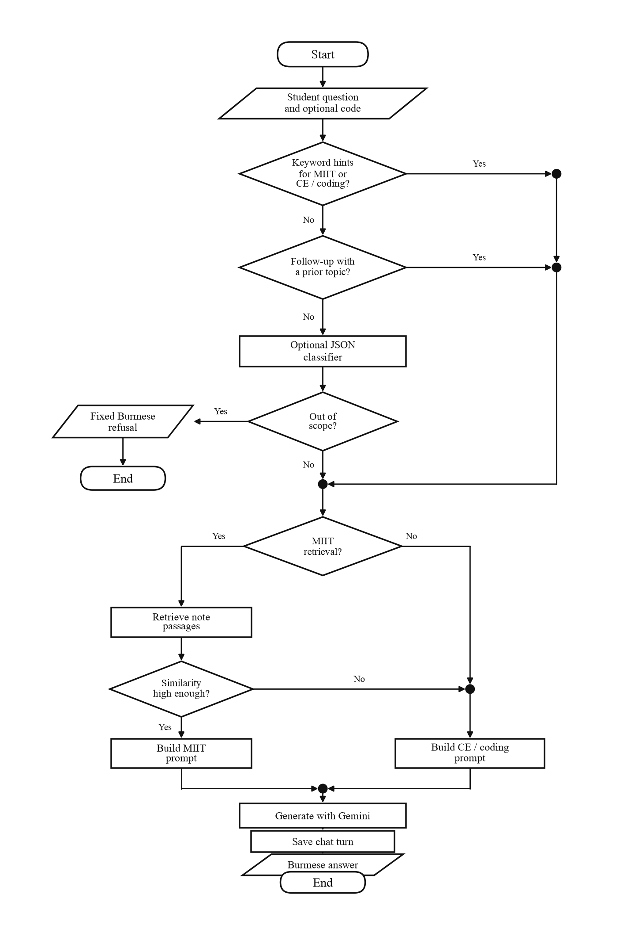
Figure 2.6: One Ask turn
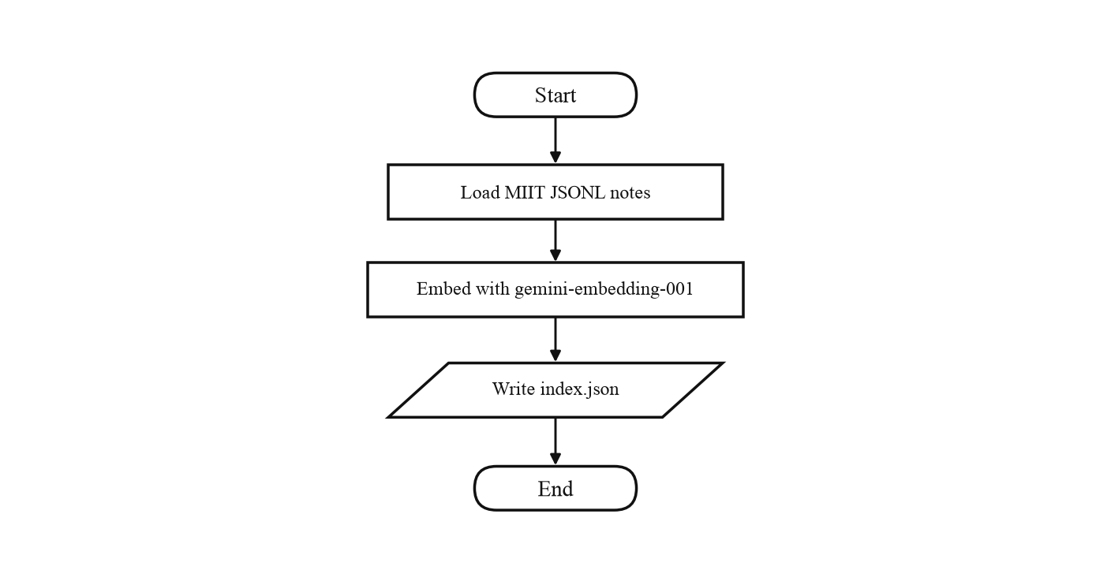
Figure 2.7: Offline knowledge index

2.7 Deployment
The examiner runs make preflight && make app and opens http://localhost:7860. The page title is Computer Engineering Tutor. Students type in the composer, click Ask, optionally Listen, switch Light/Dark, or start a New chat. Chats persist in results/chats.json (local, gitignored). POST /v1/chat and the CLI call the same engine without history. Network is required for Gemini, embeddings, and edge-tts. No GPU is required. Figures 2.8 and 2.9 show the campus demo answering an admission question and a faculty follow-up from notes.
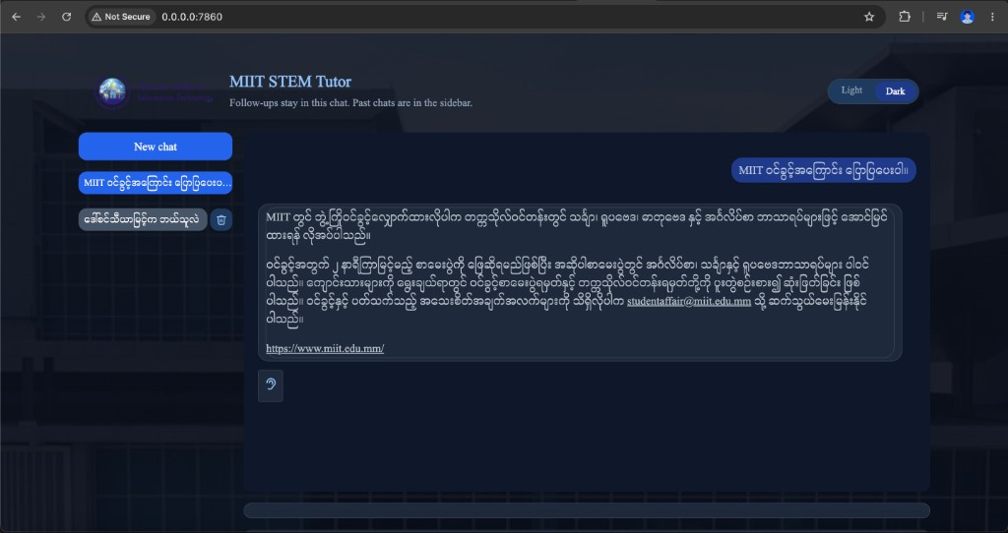
Figure 2.8: Gradio Ask for bachelor admission (notes and source URL)
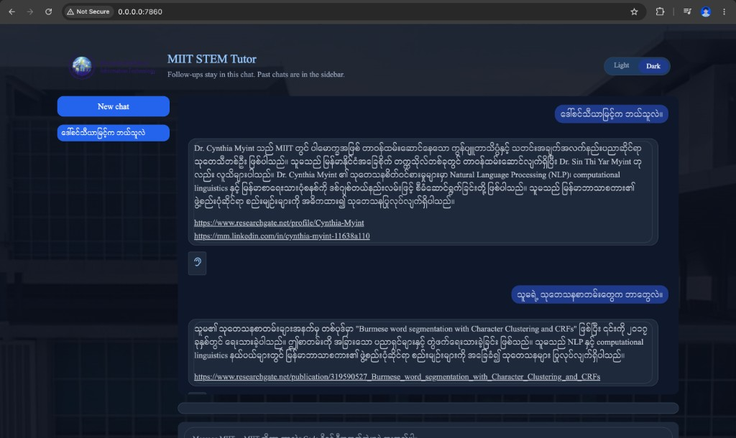
Figure 2.9: Gradio faculty thread with a research follow-up

Chapter 3
Evaluation

3.1 Evaluation Metrics
Official scores use a labelled file eval/items.jsonl and make eval. Gradio Myanmar-script ratio is a language-style log, not accuracy. Liu et al. (2016) show that surface overlap correlates poorly with dialogue quality (https://aclanthology.org/D16-1230/).
Routing is a three-way label (miit, programming, other). We report Accuracy and Macro-F1 as in Sokolova and Lapalme (2009), https://doi.org/10.1016/j.ipm.2009.03.002. Retrieval of MIIT notes is scored with Recall@3 and MRR as in Karpukhin et al. (2020) Dense Passage Retrieval, https://aclanthology.org/2020.emnlp-main.550/, with IR definitions from Manning, Raghavan and Schütze (2008), https://nlp.stanford.edu/IR-book/. Closed campus facts use Exact Match on gold spans, the protocol Lewis et al. (2020) used for RAG QA, https://arxiv.org/abs/2005.11401.

3.2 Results
Metric | n | Score
Accuracy | 58 | 1.000
Macro-F1 | 58 | 1.000
Table 3.1: Route classification (Sokolova & Lapalme, 2009)
Metric | n | Score
Recall@3 | 23 | 0.870
MRR | 23 | 0.775
Table 3.2: Dense retrieval (Karpukhin et al., 2020)
Metric | n | Score
Exact Match | 14 | 0.643
Token F1 | 14 | 0.084
Table 3.3: Closed-fact generation (Lewis et al., 2020)
On the labelled set (eval/items.jsonl, 58 items covering MIIT notes, computer-engineering subjects, out-of-scope, and follow-ups) the router reached Accuracy 1.000 and Macro-F1 1.000 (Sokolova and Lapalme, 2009). Dense retrieval of the correct note reached Recall@3 0.870 and MRR 0.775 (Karpukhin et al., 2020; Manning et al., 2008). Closed campus facts reached Exact Match 0.643 (Lewis et al., 2020): gold names and numbers appear in the Burmese answers. These are the same metric families used in published intent classification, passage retrieval, and RAG QA.
Exact Match is the primary generation number: each gold span (for example Win Aye) must appear in the Burmese answer. Token F1 is lower because the tutor writes a full paragraph while the gold is a short fact string.

3.3 Comparison with Gemini Chat
Programming answers use the same Gemini chat model as a public Gemini session. The project is stronger on grounded campus QA: local notes, source URLs, and routing. Table 3.4 records those system behaviours; it does not quote a live Gemini transcript.
Aspect | This project | Gemini online chat
MIIT facts | Answers only from retrieved JSONL notes and lists source URLs | No local note constraint; may mix or invent campus facts
Curriculum / electives | Must not invent course codes that are absent from the notes | Can invent elective names and codes
Faculty | Role, papers, and email only from faculty JSONL | Can invent titles and publications
Out of scope | Fixed Burmese refusal; generation is not called | Will answer weather, news, and chit-chat
Follow-up | Inherits the last MIIT or programming thread | A short follow-up may start a new topic
CE subjects / coding | Same Gemini model; gain is routing plus campus RAG | Same class of chat model without MIIT retrieval
Table 3.4: This project versus Gemini online chat

Chapter 4
Conclusion

4.1 Result
The tutor uses Gemini for computer-engineering subject tutoring in Burmese, and embedding RAG over public notes for programme, admission, faculty, and campus facts. On the labelled set the router Accuracy is 1.000, retrieval Recall@3 is 0.870, and closed-fact Exact Match is 0.643. The Gradio campus demo supports follow-up threads, Myanmar TTS, and the same HybridEngine as the API and CLI.

4.2 Future Work
- Persist API and CLI history so follow-up inherit works outside Gradio.
- Host a public demo on a free Spaces tier.
- Enlarge the public note set while keeping source URLs.
- Optional AIS-style attribution scoring of MIIT answers (Rashkin et al., 2021).

4.3 Conclusion
The project shows applied NLP on a real student task: intent routing, dense retrieval, constrained generation, and Myanmar speech, without claiming a new foundation model. Gemini answers coding and CSE/ECE lecture questions; local CSE and ECE notes ground programme and campus facts.

References
[1] Jurafsky, D. & Martin, J. H. Speech and Language Processing. https://web.stanford.edu/~jurafsky/slp3/
[2] Karpukhin, V. et al. (2020). Dense Passage Retrieval for Open-Domain Question Answering. EMNLP. https://aclanthology.org/2020.emnlp-main.550/
[3] Lewis, P. et al. (2020). Retrieval-Augmented Generation for Knowledge-Intensive NLP Tasks. NeurIPS. https://arxiv.org/abs/2005.11401
[4] Liu, C.-W. et al. (2016). How NOT to Evaluate Your Dialogue System. EMNLP. https://aclanthology.org/D16-1230/
[5] Manning, C. D., Raghavan, P. & Schütze, H. (2008). Introduction to Information Retrieval. https://nlp.stanford.edu/IR-book/
[6] Myanmar Institute of Information Technology. https://www.miit.edu.mm/
[7] Rashkin, H. et al. (2021). Measuring Attribution in Generated Text. https://arxiv.org/abs/2112.12870
[8] Sokolova, M. & Lapalme, G. (2009). A systematic analysis of performance measures for classification tasks. IP&M. https://doi.org/10.1016/j.ipm.2009.03.002
[9] van der Lee, C. et al. (2019). Best practices for the human evaluation of automatically generated text. INLG. https://aclanthology.org/W19-8643/

