3D Game Programming: Programming Assignment One
YOU WILL RECEIVE ZERO POINTS IF YOU COPY and PASTE THE MATERIALS OF OTHER! LATE SUBMISSION WILL BE DEDUCTED BY
30 points a day.
In this assignment, you must implement the program individually. You must use the template to do this assignment. Rename the folder name to hw01_student ID.
You can refer to the demo program. The demo content may not be consistent with the instruction. Thus, you always follow the instructions to do the assignment.
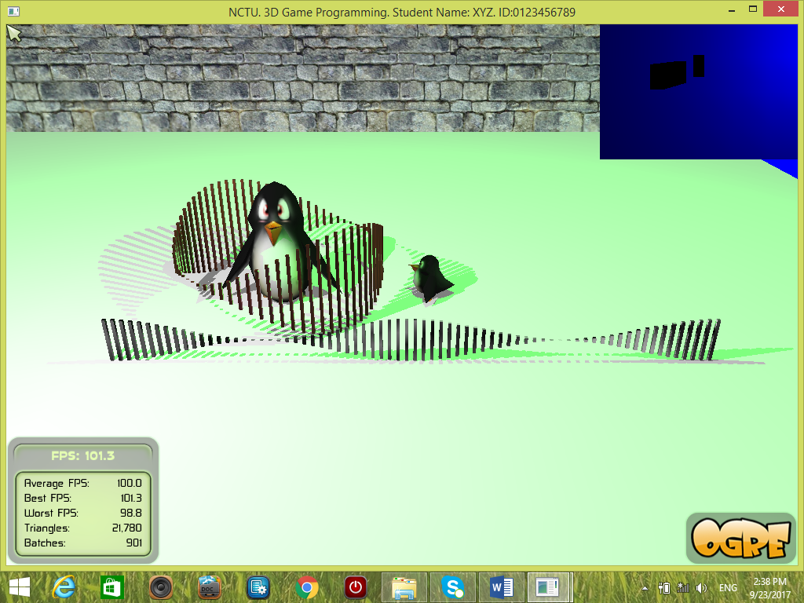
Penalties: File organization is wrong [-20%]; program crashes [-20%], No student ID [-30%]. The program cannot be compiled on .NET2010 [-30%]. And something that is not similar to the demo.
There are four tasks. You must finish all of them. You must show two viewports with different contents as follows:
Task One [40%]:
- [4%] Create a scene manager. Use it to create its own camera and the first viewport.
- [4%] The viewport occupies the entire screen space. Background color must be BLUE, e.g., color = (0, 0, 1).
- [2%] Enable ambient light and shadow.
- [4%] Create a plane and two penguins. Set the first penguin (large penguin) to look at the user. Set the second penguin (small penguin) to look at the first penguin. The first penguin should be larger than the second penguin.
- [10%] Create two set of objects by scaling cube objects. One set of objects form a circle around a large penguin. Another set of objects form a row and they are placed in front of both penguins.
- [4%] Create two lights.
- [2%] Enable shadows.
- [4%] Show the mouse cursor.
- [6%] Show your name and ID on the top bar of the window.
Task Two [20%]:
- [2%] Create a scene manager. Use it to create its own camera and the second viewport.
Set the camera position to (0,350,0.001). Set the camera to look at (0, 0, 0).
- [2%] The viewport occupies the upper left corner, for example, ¼ region of the entire screen.
- [2%] Create a plane.
- [2%] Ambient color.
- [2%] One light with blue color (diffuse and specular).
- [2%] Enable shadow.
- [2%] Create an object, such as a sphere or a cube. Scale it with different scaling factors in x-, y- and z-directions. Must place it above the plane. Set it’s x-coordinate to 50. Its shadow must be seen.
- [4%] Edit your own material (pure green color). Apply the green material to the object (created in Task 7).
- [2%] Disable overlays.

Task Three [20%]. If something is not clear, Check the demo for details.
- [5%] Press 1, 2, 3, 4, and 5 to set the camera at different positions and directions.
- [3%] Press ‘M’ to make the second viewport at the bottom level (z-order = 0) and the first viewport at the top level (z-order = 1). The first viewport is at the upper left corner. Disable the overlay in the second viewport. Set the background color of the first viewport to other color (not blue).
- [2%] Press ‘N’ to make the first viewport at the bottom level (z-order = 0) to cover the entire screen and the second viewport at the top level (z-order = 1). The second viewport is at the right middle portion of the screen. Disable the overlay in the second viewport. Set the background color of the first viewport to other color (not blue).
- [2+8%] Press ‘P’ to toggle the animation (i.e., turn on or off). First part: The large penguin stays at the same position but it looks at the small penguin. Second part: The small penguin moves around a circle around the large penguin in clockwise at the beginning. The angular speed of the small penguin is zero when a new cycle starts. The small penguin is accelerated to a maximum angular speed while it moves. Once it finishes a cycle, its motion path is reversed and it starts a new cycle. That is, if it rotates in clockwise in the previous cycle, then it rotates in counter-clockwise in the new cycle and vice versa. The process is repeated.

[20%] Task Four: Use doxygen to generate an on-line documentation browser for the program. You MUST document each function and each class that you implement. You MUST write down your name, student ID and email address in the TutorialApplication.h. and TutorialApplication.cpp. Your name, student ID and email address must be shown in the documentation. You should document at least FOUR functions. The htm files must be stored in ./docs/html. The entry htm file is index.html.
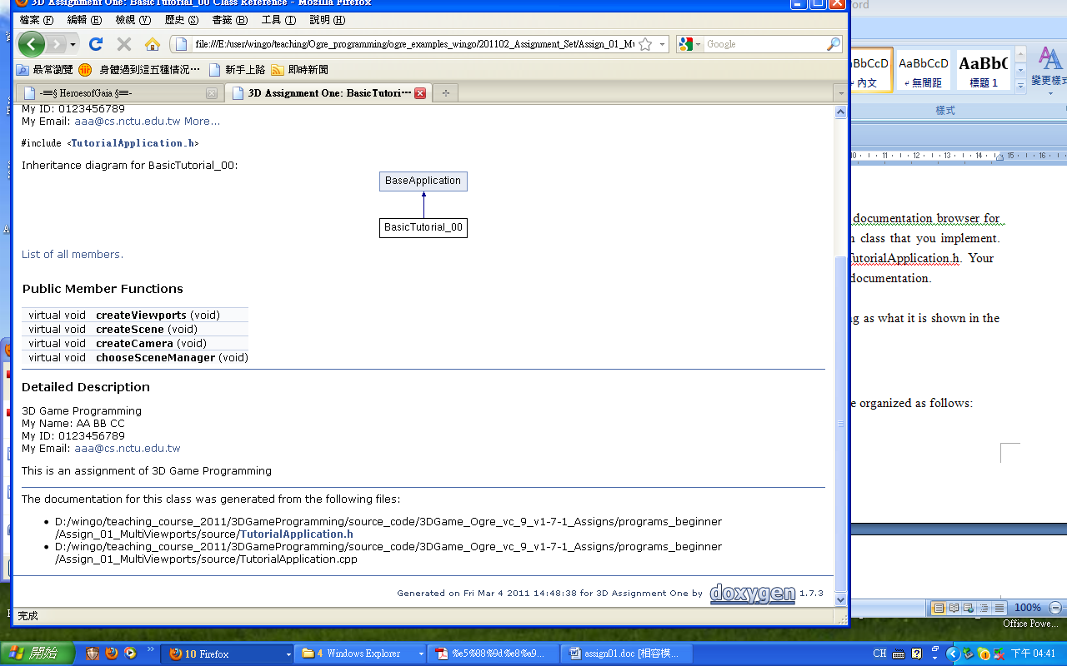
Please see the demo for your reference.

File organization:
The folder name must be hw01_STUDENT_ID. For example, if your ID is 123456789 and name is XYZ. The folder name must be hw01_123456789. Make sure that your folder hw01_STUDENT_ID must be organized as follows.
The root folder (hw01_123456789). Inside it, we have the followings:
\boost_1_42 : boost files
\include : header files
\lib : contains the precompiled libraries
\programs, inside \programs it contains \assign_01.
Inside assign_01, we have the following items:
\bin : contains the executable, materials, dll, etc.
\media :contain media files
\docs : documentation, such as \html generated by doxygen
\source : contains all the .cpp and .h
\release
.sln : the project file for .NET2010
Submission:
1. zip and upload your source code to the E3 platform.
2. Write a report and submit a hardcopy to describe the way how you finish the assignment. Submit the report in class. No plagiarism in your report. If you copy the instruction to your report, your report score is ZERO. Write the report in your own words.

//If you write down something that is irrelevant to the content of this assignment, your score will be deducted.

Report format
Name: __________________________ Student ID: __________Assignment:_____
Email:___________________________
THIS MUST BE YOUR OWN WORK! YES (Please Tick Yes)
***BONUS: The best report(s) has at most 13 bonus points.
[10%] Introduction (At least 100 words)
WORD COUNT: ___________ //must fill this blank.
// describe the purpose of this assignment
// describe the tasks that you have to finish

[10%] System architecture
-[5%] Draw a diagram of the system. At least FIVE components.
-[5%] Describe in words about the system. At least 50 words.
WORD COUNT: ___________ //must fill this blank.

[30%] Methods (At least 300 words)
WORD COUNT: ___________ //must fill this blank.
//describe how you finish the tasks one by one.
//You must state clearly how to implement each item!

[40%] Discussion (At least 400 words)
WORD COUNT: ___________ //must fill this blank.
You must include the following items!
//1. Describe what you see on the screen, e.g. shadows, etc.
//2. Explain why the object in the second task is black.
//3.In Task Two. What happen if you change the position of the camera to Vector3(0,350,0)? Why?
//4. Try other different parameters and describe what you see or the effects.
//Extra bonus points will be given here if you could raise up some interesting ideas.

[10%] Conclusion (At least 100 words)
WORD COUNT: ___________ //must fill this blank.
// what have you learnt? What are the problems that you encounter? How to solve the problems? What do you think about this assignment?

