**University of Balamand**

**Faculty of Sciences, Department of Computer Science**

**CSIS290 – Senior Project**

Fashion AI

Project Proposal

Prepared by:

**Sondos Halawani A2112613**

&

**David Kharrat A2110272**

Spring 2025

7/02/2025

Contents

**1. Project Group Member(s)** 3

**2. Project Abstract** 3

**3. Project Overview** 3

**4. Motivation and Scope** 4

**Motivation** 4

**Scope** 4

**5. Related Work** 4

**Similar Systems** 4

**6. System Architecture** 5

**7. Goals and Objectives** 5

**Final Outcomes** 5

**8. Individual Tasks** 6

**9. Gantt Chart** 6

**10. Future Work** 7

**Possible Extensions:** 7

**11. Tools and Technologies** 7

**12. Resources** 8

**Critical Resources** 8

**13. Conclusion** 8

**1. Project Group Members**

* **Names & IDs:** Sondos Halawani – A2112613, David Kharrat – A2110272

**2. Project Abstract**

**Brief Description**  
Fashion AI is a web and mobile application that helps users manage wardrobes and receive AI-generated outfit recommendations. The platform suggests outfits using existing clothing images, integrates social sharing, and includes e-commerce features for a seamless fashion experience. An admin dashboard ensures effective user and content management.

**3. Project Overview**

* Fashion AI is a web and mobile application designed to enhance wardrobe management and fashion selection through artificial intelligence. Users can upload images of their clothing items, categorize them, and receive AI-generated outfit recommendations based on personal preferences, current trends, and weather conditions.
* The system provides an image-based outfit recommendation engine, displaying pre-existing clothing images to suggest the best outfit combinations. Social-sharing features allow users to create profiles, follow others, engage with posts, and share outfit inspirations through a “stories feature”.
* E-commerce integration via Amazon API, Stripe, and PayPal enables users to shop for suggested items seamlessly. An admin dashboard, built with React.js and Firebase, allows efficient content moderation, AI model oversight, and user management.
* Fashion AI aims to simplify digital wardrobe management, provide fashion inspiration, and create a seamless online shopping and social experience.

**4. Motivation and Scope**

**Motivation**

With the growing influence of AI in fashion and wardrobe optimization, Fashion AI provides users with a convenient way to organize their clothing and receive personalized outfit suggestions. By relying on image-based recommendations, it ensures accurate and practical styling solutions while remaining efficient and easy to use.

**Scope**

* **Wardrobe Management:** Users upload and categorize clothing images.
* **AI-Powered Outfit Recommendations:** Image-based suggestions tailored to user preferences, trends, and weather.
* **Social Features:** Profile creation, outfit sharing, likes, comments, messaging, and stories.
* **E-commerce Integration:** Users can purchase suggested outfits via Amazon API, Stripe, and PayPal.
* **Admin Dashboard:** Built with React.js + Firebase to oversee users, AI suggestions, and content moderation.
* **Limitations:** Advanced VR-based try-ons and AI-powered styling will be considered for future enhancements.

**5. Related Work**

**Similar Systems**

Existing applications, such as Zalando and Amazon Virtual Try-On, offer outfit recommendations. However, Fashion AI stands out with its advanced wardrobe management system, allowing users to digitize their closets, categorize clothing, and receive personalized styling suggestions based on their existing wardrobe. The platform enhances user engagement through a social stories feature, enabling fashion inspiration and trend-sharing within the community.

**6. System Architecture**

The Fashion AI system consists of three primary layers: Frontend, Backend, and Database.

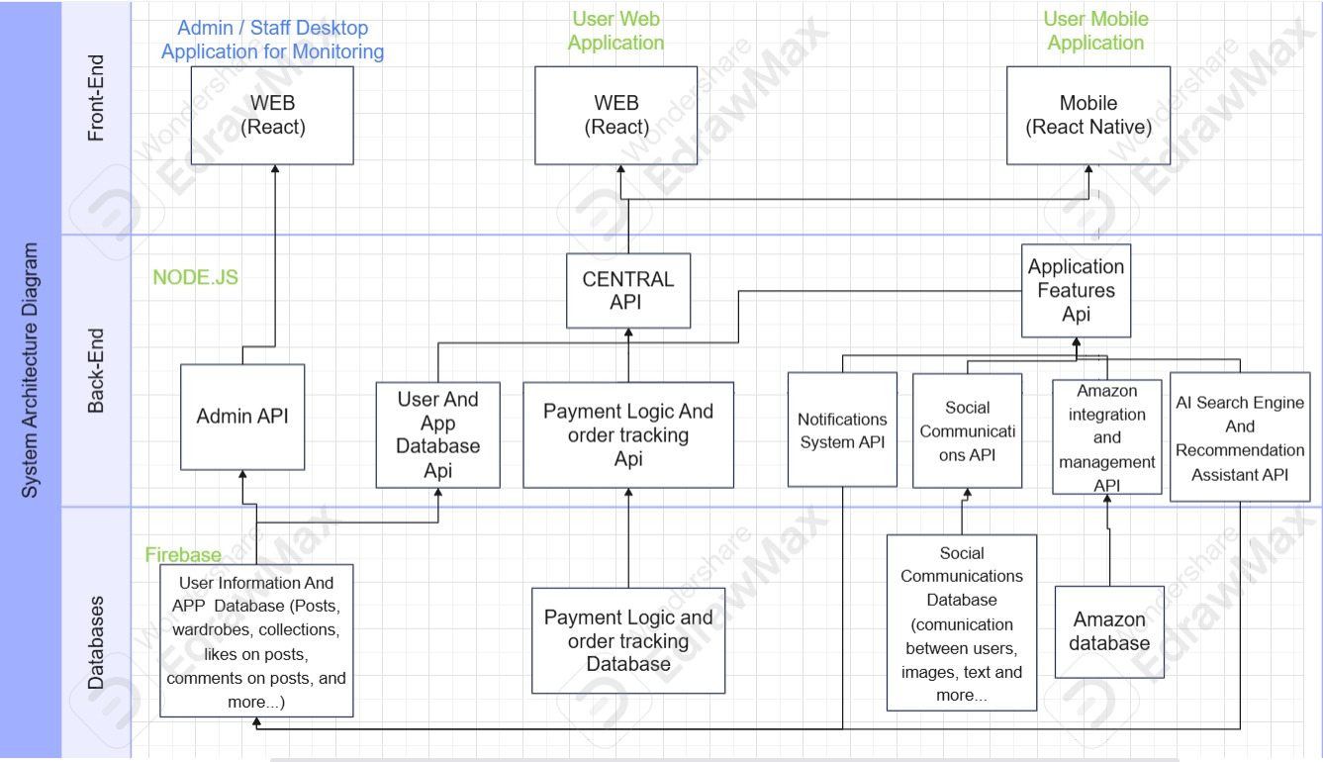

**7. Goals and Objectives**

**Final Outcomes**

1. **Wardrobe Management:** Users upload and organize clothing images.
2. **AI-Generated Recommendations:** Image-based outfit suggestions.
3. **Social Engagement:** Enable outfit sharing, community interaction, profile creation, and follower engagement.
4. **E-commerce Integration:** Allow users to purchase suggested items.
5. **Admin Panel:** Efficiently manage users, clothing data, and AI recommendations.

**8. Individual Tasks**

|  |  |
| --- | --- |
| Task | Assigned Member |
| Backend Development | Shared – Sondos Focused |
| AI Model Training | Shared – David Focused |
| Frontend Web Development | Shared |
| Frontend Mobile Development | Shared – David Focused |
| Image-Based Outfit Recommendation | Shared – David Focused |
| Social Features Development | Shared |
| Stories & Community Interaction | Shared |
| Database Integration | Shared – Sondos Focused |
| Admin Panel (React.js + Firebase) | Shared – Sondos Focused |
| Testing & Debugging | Shared |
| Documentation & Report | Shared – Sondos Focused |

**9. Gantt Chart**

The following Gantt chart outlines the project timeline, detailing the development phases, testing, and final deployment.

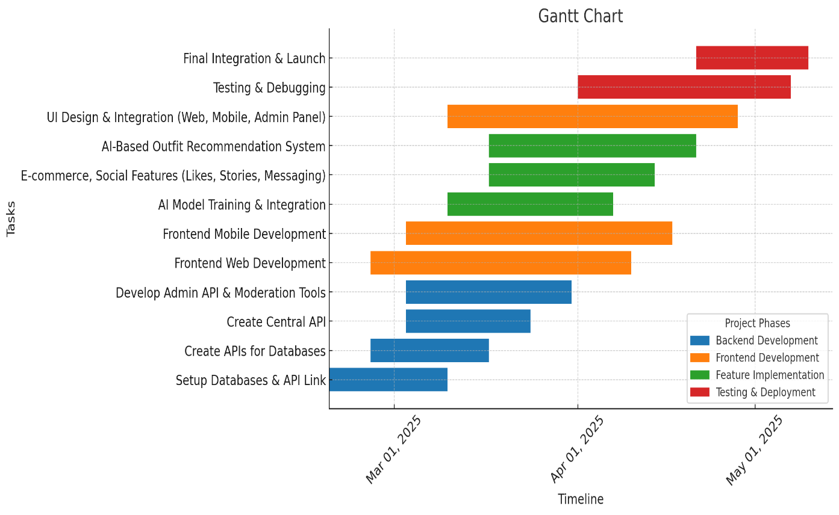

**10. Future Work**

**Possible Extensions:**

* **AI-Powered Color Coordination & Styling**: Enhance outfit suggestions based on complementary color theory and personal preferences.
* **Advanced Outfit Matching Algorithms**: Improve AI accuracy in coordinating outfits by analyzing fabric type, fit, and occasion-based recommendations.
* **Virtual Fitting Room (Image Overlay or Avatar-Based Try-On)**: Allow users to see outfit suggestions on a digital avatar or overlay outfits on their own photos.
* **E-Commerce Expansion with More Retailers**: Integrate with more fashion brands beyond Amazon, such as Zara, H&M, and ASOS, for a wider range of shopping options.
* **AI-Based Trend Prediction**: Use machine learning to analyze fashion trends and suggest relevant outfit recommendations based on real-time data.

**11. Tools and Technologies**

|  |  |
| --- | --- |
| Category | Technology |
| Frontend | React.js (Web), React Native (Mobile) |
| Backend | Firebase (Auth, Database, Storage, Push Notifications) |
| AI & ML | OpenCV, TensorFlow |
| Image Processing | OpenCV, Deep Learning Models (DeepSeek-VL, TryOnGAN) |
| Social Features API | Firebase Firestore, WebSockets |
| E-commerce | Amazon API, Stripe, PayPal |
| Admin Panel | React.js + Firebase, , Material UI / Tailwind CSS |

**12. Resources**

**Critical Resources**

* **Cloud Computing:** Firebase Hosting, Firestore, and Firebase Functions for real-time updates.
* **AI & Image Processing Tools:** OpenCV, TensorFlow, and DeepSeek-VL for styling simulations and outfit recommendations.
* **Fashion Datasets:** DeepFashion & OpenFashion for AI model training and outfit classification.
* **External APIs:** Amazon API, Stripe/PayPal for secure transactions and e-commerce integration.
* **Development Frameworks:** React.js (Web), React Native (Mobile), Firebase SDK for scalable and responsive applications.
* **CI/CD & Deployment Tools:** Firebase Hosting, GitHub Actions, Docker (if used) to streamline development and deployment processes.

**13. Conclusion**

Fashion AI is an AI-powered fashion assistant that streamlines wardrobe management, delivers image-based outfit recommendations, integrates e-commerce, and includes a React.js-based admin dashboard. By focusing on efficient AI-driven styling suggestions and a strong social engagement system, the platform ensures a seamless and scalable solution.

Future work will focus on enhancing AI-powered styling capabilities, expanding e-commerce integrations, and exploring new ways to improve the user experience. With further development, Fashion AI has the potential to evolve into a leading AI-driven fashion assistant.

*Thank you!*