Software Requirements Specification

for

PROJECT: Fashion AI

Version 1

Prepared by Sondos Halawani A2112613, David Kharrat A2110272

DATE 25/2/2025

Contents

[1. Introduction 3](#_Toc191844099)

[1.1 Purpose and Intended Audience 3](#_Toc191844100)

[1.2 Project Scope 3](#_Toc191844101)

[1.3 Terms, Definitions, and Acronyms 4](#_Toc191844102)

[1.4 References 6](#_Toc191844103)

[2. Overall Description 7](#_Toc191844104)

[2.1 Product Perspective 7](#_Toc191844105)

[a) Key Features & System Independence 8](#_Toc191844106)

[b) System Interactions & External Interfaces 8](#_Toc191844107)

[c) User Interaction & Access Points 8](#_Toc191844108)

[d) System Architecture & Data Flow 9](#_Toc191844109)

[i. Front-End (User Interface) 9](#_Toc191844110)

[ii. Back-End (APIs & Processing) 11](#_Toc191844111)

[iii. Databases & External Services 13](#_Toc191844112)

[2.2 Product Features 17](#_Toc191844113)

[2.3 User Classes and Characteristics 18](#_Toc191844114)

[2.4 Operating Environment 21](#_Toc191844115)

[2.5 Design and Implementation Constraints 22](#_Toc191844116)

[2.6 Assumptions and Dependencies 23](#_Toc191844117)

[3. System Features 24](#_Toc191844118)

[1. 👤 General Users (Casual Fashion Enthusiasts & Everyday Users) will be able to: 24](#_Toc191844119)

[2. 📢Fashion Influencers & Trendsetters 25](#_Toc191844120)

[3. 🛍️E-Commerce Shoppers 25](#_Toc191844121)

[4. 🛠️Administrators & Moderators 25](#_Toc191844122)

[5. 🤖 AI & Data Analysts (Internal Team) 26](#_Toc191844123)

[6. 💼IT Support & Maintenance Team 26](#_Toc191844124)

[Summary of Functionalities by User Group: 26](#_Toc191844125)

[4. Non-Functional Requirements 27](#_Toc191844126)

[📌 Functionality 27](#_Toc191844127)

[🎨 Usability 28](#_Toc191844128)

[⚙️ Reliability 28](#_Toc191844129)

[🚀 Performance 29](#_Toc191844130)

[🛠️ Supportability 29](#_Toc191844131)

[➕ Miscellaneous 29](#_Toc191844132)

[5. External Interface Requirements 30](#_Toc191844133)

[a) User Interfaces 30](#_Toc191844134)

[b) Hardware Interfaces 31](#_Toc191844135)

[c) Software Interfaces 31](#_Toc191844136)

[d) Communication Interfaces 32](#_Toc191844137)

[6. Detailed Use Cases 33](#_Toc191844138)

[6.1 Primary Use Cases & Actors 33](#_Toc191844139)

[6.2 Use Case Details 33](#_Toc191844140)

[a) UC-01: Upload Clothing Image 33](#_Toc191844141)

[b) UC-02: Generate AI Outfit Recommendation 34](#_Toc191844142)

[c) UC-03: Browse & Purchase Suggested Outfit 36](#_Toc191844143)

[d) UC-04: Engage in Social Features (Post, Like, Comment) 36](#_Toc191844144)

[e) UC-06: Moderate Content & Manage Users 37](#_Toc191844145)

[6.3 UML Diagrams 38](#_Toc191844146)

[7. Appendix 41](#_Toc191844147)

[Included Documents: 41](#_Toc191844148)

# ****Introduction****

## ****Purpose and Intended Audience****

Fashion AI is a web and mobile application designed to enhance wardrobe management and fashion selection through artificial intelligence. Many users, including **fashion enthusiasts, casual shoppers, and individuals looking for daily outfit inspiration**, struggle with organizing their clothing, deciding what to wear, and keeping up with fashion trends. Additionally, **e-commerce shoppers and influencers** often find it difficult to visualize how new items would fit into their existing wardrobe.

Fashion AI addresses these challenges by allowing users to upload images of their clothing, categorize them, and receive AI-generated outfit recommendations based on personal preferences, weather, and current trends. The platform also integrates social features, enabling users to engage with a **fashion-focused community**, and provides seamless **e-commerce integration** for purchasing recommended clothing items. An **admin panel** ensures effective content moderation, AI oversight, and user management, making Fashion AI a **comprehensive solution for both individual users and businesses in the fashion industry**.

## ****Project Scope****

Fashion AI is a **digital wardrobe assistant** that helps users **organize their clothing, receive AI-generated outfit recommendations, engage with a fashion-focused community, and purchase suggested items from online retailers**. Users can **upload images of their clothing, categorize them, and let the AI suggest stylish outfit combinations based on weather, trends, and personal preferences**. The platform also allows **social interaction**, where users can share looks, follow others, and engage with fashion content. Additionally, an **admin panel** ensures **content moderation and AI oversight** to maintain a safe and engaging environment.

**However, Fashion AI will not include** **real-time virtual try-on features, advanced 3D outfit visualization, or direct personal styling services.** It will not act as an **online store** selling its own fashion items, nor will it support **physical inventory tracking for retailers** or **second-hand clothing sales**.

## ****Terms, Definitions, and Acronyms****

Below is a list of key terms and acronyms used throughout this document to ensure clarity for both technical and non-technical readers.

* **AI (Artificial Intelligence):** The capability of a computer system to process data, recognize patterns, and generate intelligent suggestions, such as outfit recommendations based on user wardrobe and trends.
* **AI Model Training:** The process of refining Fashion AI's recommendation engine using machine learning algorithms and fashion datasets to improve accuracy.
* **Admin Panel:** A secure interface for administrators to manage users, moderate content, oversee AI functionality, and configure system settings.
* **Amazon API:** A system that allows Fashion AI to fetch and display clothing items from Amazon’s online store, enabling users to purchase recommended outfits.
* **API (Application Programming Interface):** A set of protocols that enables Fashion AI to communicate with external systems (e.g., Amazon API, Stripe, PayPal).
* **Authentication:** The process of verifying a user’s identity before granting access to the platform, typically through login credentials or multi-factor authentication.
* **Category Tagging:** Assigning classification labels to clothing items (e.g., "casual," "formal") to improve AI outfit suggestions.
* **Cloud Computing:** The use of remote servers hosted on the internet to store, manage, and process Fashion AI data instead of relying on local computers.
* **Cloud Storage:** A system (Firebase) that securely stores user-uploaded images, outfit data, and AI-generated recommendations online.
* **Content Moderation:** The process of reviewing and managing user-generated posts, images, and comments to ensure compliance with platform guidelines.
* **CSS (Cascading Style Sheets):** A technology used to style the web interface of Fashion AI, defining the visual layout, fonts, and colors.
* **Database:** A structured collection of data used to store user information, clothing images, shopping transactions, and AI-generated recommendations.
* **Data Encryption:** A security measure that converts sensitive information into a coded format to prevent unauthorized access (AES-256 encryption is used).
* **Data Privacy Compliance:** Ensuring Fashion AI adheres to regulations such as GDPR (General Data Protection Regulation) and CCPA (California Consumer Privacy Act) for handling personal data.
* **E-Commerce Integration:** The feature that enables Fashion AI to connect with online shopping platforms (Amazon) for purchasing recommended outfits.
* **Engagement Metrics:** Analytics that track user interactions on the platform, such as likes, comments, shares, and purchase conversions.
* **Encryption:** A security process that converts user data into a protected format to safeguard against unauthorized access and cyber threats.
* **Fashion Dataset:** A collection of labeled fashion-related images and metadata used to train the AI recommendation engine.
* **Firebase:** A cloud-based backend service used for storing user data, managing authentication, handling real-time updates, and sending push notifications.
* **Frontend:** The part of the application that users interact with, including the web and mobile interfaces (built using React.js and React Native).
* **Hosting Service:** A cloud infrastructure (Firebase) that enables the deployment and accessibility of the Fashion AI platform across devices.
* **Machine Learning:** A subset of AI that allows Fashion AI to improve outfit recommendations over time by analyzing user preferences, fashion trends, and feedback.
* **Moderation:** The process of administrators reviewing user-generated content to ensure compliance with community guidelines.
* **Multi-Factor Authentication (MFA):** A security feature that requires users to verify their identity using multiple authentication methods (e.g., password + phone verification).
* **Node.js:** A runtime environment that executes backend logic, handling API requests, user authentication, and database interactions in Fashion AI.
* **Outfit Recommendation Engine:** The AI-powered system that analyzes clothing images, user preferences, and trends to generate personalized outfit suggestions.
* **Payment Gateway:** A secure service (Stripe & PayPal) that processes online transactions when users purchase recommended clothing items.
* **Personalization:** The process of tailoring AI-generated outfit recommendations based on a user’s past interactions, style preferences, and seasonal trends.
* **React.js:** A JavaScript framework used to develop the web interface of Fashion AI, providing a responsive and interactive user experience.
* **React Native:** A cross-platform framework used to build the Fashion AI mobile application for both iOS and Android.
* **Scalability:** The ability of Fashion AI to support an increasing number of users and data without performance degradation.
* **Server:** A remote computer that processes Fashion AI requests, such as fetching wardrobe data, running AI algorithms, and handling payments.
* **Social Features:** Interactive elements that allow users to engage with fashion content, such as liking, commenting, following, and sharing outfits.
* **Stripe & PayPal:** Online payment processing services integrated into Fashion AI to facilitate secure purchases and transactions.
* **TensorFlow:** A machine learning framework used in Fashion AI to power AI-based outfit recommendations and image analysis.
* **UI (User Interface):** The visual layout and interactive components of the Fashion AI web and mobile applications.
* **User Authentication:** The process of verifying a user’s credentials to allow access to their account and stored wardrobe.
* **User Engagement:** The level of activity on the platform, including interactions with AI recommendations, social content, and purchases.
* **Virtual Try-On:** A planned future feature that would allow users to visualize outfits on a digital avatar before making a purchase.
* **WebSockets:** A communication protocol that enables real-time updates for features such as live chat, social notifications, and AI recommendations.

## ****References****

The following documents and sources were used in the preparation of this **Software Requirements Specification (SRS)** to ensure accuracy, alignment with academic guidelines, and completeness in defining system requirements:

1. **Fashion AI1 Project Proposal** (February 2025) – The original document outlining the objectives, features, and goals of the Fashion AI project, including system architecture and development plan. (Included in the Appendix)
2. **SRS Template v4** – The official SRS template provided by the **CSIS290 – Senior Project** course to ensure compliance with IEEE SRS standards and academic expectations. (Included in the Appendix)
3. **SRS Document (CSIS290 - Senior Project, Moodle Source)** – A reference document from the course materials on Moodle that serves as an example or guide for structuring software requirement specifications. (Included in the Appendix)
4. **Discussions with Course Instructor & Team Meetings** – Clarifications, guidelines, and feedback provided during senior project discussions to refine system requirements.
5. **Industry Reports on AI in Fashion** – Research and market studies on AI-powered outfit recommendation systems, social fashion platforms, and e-commerce integration trends.
6. **Technical Documentation for APIs and Tools**:
   * **Firebase Documentation** – Guidelines for authentication, database management, and cloud storage.
   * **Amazon API Documentation** – Reference for integrating fashion retail products.
   * **Stripe & PayPal API Documentation** – Payment processing guidelines.
   * **React.js & React Native Official Documentation** – Framework guidelines for frontend and mobile application development.
7. **ChatGPT (OpenAI)** – Used for structuring and refining the SRS document to meet professional and academic standards, ensuring clarity, consistency, and adherence to IEEE specifications.

# ****Overall Description****

## ****Product Perspective****

Fashion AI is a **standalone web and mobile application** that provides **AI-powered outfit recommendations, wardrobe management, social engagement features, and e-commerce integration**. While the system is self-contained, it interfaces with external services to enhance functionality.

# ****Key Features & System Independence****

✅ **Self-contained** – Users can manage their wardrobe, get AI-driven styling suggestions, and interact with a fashion community without external dependencies.  
✅ **External integrations** – The system connects with online shopping platforms and payment services to offer additional functionality.

# ****System Interactions & External Interfaces****

Fashion AI **interacts with multiple external systems**, including:

* **Amazon API** – Allows users to browse and purchase recommended clothing items.
* **Stripe & PayPal APIs** – Handles secure online transactions.
* **Firebase** – Manages user authentication, real-time data storage, and push notifications.
* **AI Processing System (OpenCV & TensorFlow)** – Analyzes clothing images and generates personalized outfit recommendations.

# ****User Interaction & Access Points****

Users can interact with Fashion AI through:

* **Web Application (React.js)** – Accessible from any modern browser for wardrobe management, AI recommendations, and social interactions.
* **Mobile Application (React Native)** – Optimized for **Android and iOS** to provide the same features on the go.
* **Admin Panel** – A dedicated interface for administrators to moderate content, manage AI-generated suggestions, and oversee user activity.

# ****System Architecture & Data Flow****

The **Fashion AI** system architecture is structured into three key layers, ensuring seamless communication between user interfaces, back-end processing, and databases or external services. Each component serves a distinct role in enabling AI-powered outfit recommendations, wardrobe management, social features, and e-commerce integrations.

## ****Front-End (User Interface)****

The **Front-End Layer** provides users with interactive interfaces to engage with Fashion AI's features. It comprises web and mobile applications for general users, along with an admin panel for platform moderation and oversight.

**Web Application (React.js)**

* **Connected to:** Central API
* **Receives Data From:**
  + Firebase Authentication (user login)
  + AI API (outfit recommendations)
  + Social API (user posts, comments, interactions)
  + E-Commerce API (shopping and transactions)
  + Notification API (alerts and updates)
* **Sends Data To:**
  + Central API (via HTTPS requests)
  + Firebase Authentication (user login/registration)
  + Social API (posting, liking, following users)
  + AI API (outfit request generation)
  + E-Commerce API (purchase processing)

**Mobile Application (React Native)**

* **Connected to:** Central API
* **Receives Data From:**
  + Firebase Authentication (user authentication)
  + AI API (outfit recommendations)
  + Social API (social media feed and user interactions)
  + E-Commerce API (shopping module)
  + Notification API (push alerts)
* **Sends Data To:**
  + Central API (via HTTPS requests)
  + Firebase Authentication (login/registration)
  + AI API (personalized styling requests)
  + Social API (posting, following users)
  + E-Commerce API (transaction handling)
  + Notification API (enabling push notifications)

**Admin Panel (React.js - Moderation Interface)**

* **Connected to:** Central API
* **Receives Data From:**
  + User Database (for account management)
  + Social API (for content moderation)
  + AI API (for managing AI-generated recommendations)
* **Sends Data To:**
  + User Database (updating user permissions and restrictions)
  + Social API (content moderation and flagging)
  + AI API (adjustments to AI model settings)

## ****Back-End (APIs & Processing)****

The **Back-End Layer** manages all core functionalities, data processing, and external service integrations. Built with **Node.js**, it acts as the communication hub between the front-end, databases, and third-party APIs.

**Central API (Core Processing Hub)**

* **Manages:** Routing user requests, AI computations, social interactions, and transactions.
* **Connected to:**
  + Web/Mobile Applications (receives user interactions)
  + Admin Panel (for content moderation)
  + AI API (for outfit recommendations)
  + Social API (for user interactions and engagement)
  + E-Commerce API (for purchase handling)
  + Notification API (for real-time updates)
* **Receives Data From:**
  + User Database (authentication and wardrobe data)
  + AI API (fashion suggestions)
  + Social API (user-generated content)
  + Amazon API (e-commerce product listings)
  + Stripe & PayPal (transaction status)
* **Sends Data To:**
  + Front-End Interfaces (web, mobile, admin panel)
  + AI API (processing wardrobe recommendations)
  + Social API (managing social interactions)
  + E-Commerce API (purchase and shopping data)
  + Notification API (triggering user alerts)

**AI Outfit Recommendation API (OpenCV & TensorFlow)**

* **Function:** Analyzes wardrobe images, generates outfit suggestions, and improves recommendations based on user behavior and trends.
* **Connected to:**
  + Central API (receives recommendation requests)
  + AI Model Database (fetches machine learning models)
  + Firebase Database (fetches user wardrobe data)
* **Receives Data From:**
  + User wardrobe data (via Firebase)
  + Machine Learning Models (via AI Model Database)
  + Trend data (previous interactions and global fashion trends)
* **Sends Data To:**
  + Central API (delivers personalized outfit recommendations)

**Social Features API**

* **Function:** Handles all user interactions, social posts, and community engagement.
* **Connected to:**
  + Central API (for managing user interactions)
  + Firebase Database (for storing social engagement data)
* **Receives Data From:**
  + Web & Mobile Applications (user-generated content, likes, comments, and follows)
* **Sends Data To:**
  + Firebase Database (storing social interactions)
  + Notification API (triggering alerts for social interactions)

**E-Commerce & Payment API**

* **Function:** Facilitates shopping features, handles transactions, and integrates with external e-commerce platforms.
* **Connected to:**
  + Central API (for processing shopping transactions)
  + Amazon API (for product data retrieval)
  + Stripe & PayPal (for payment processing)
* **Receives Data From:**
  + Amazon API (real-time product inventory)
  + User purchase history (stored in Shopping History Database)
* **Sends Data To:**
  + Central API (order tracking and confirmation)
  + Notification API (for purchase updates and order status)

**Notification System API**

* **Function:** Handles alerts and push notifications.
* **Connected to:**
  + Firebase Cloud Messaging (for mobile notifications)
  + Central API (triggering alerts)
* **Receives Data From:**
  + Social API (new follows, likes, and comments)
  + AI API (new outfit recommendations)
  + E-Commerce API (purchase confirmations)
* **Sends Data To:**
  + Web & Mobile Applications (real-time user notifications)
  + Firebase Cloud Messaging (message delivery)

## ****Databases & External Services****

The **Data Layer** ensures structured storage, retrieval, and processing of user and AI-generated data.

**Firebase Database**

* **Function:** Manages user profiles, wardrobe data, and social interactions.
* **Connected to:**
  + Central API (data storage and retrieval)
  + AI API (for user wardrobe recommendations)
  + Social API (for posts, comments, and engagement)
* **Stores:**
  + User profiles and authentication credentials
  + Wardrobe items and collections
  + Social media interactions (likes, comments, follows)
  + AI-generated outfit recommendation history

**AI Model Database**

* **Function:** Stores and updates machine learning models used for fashion recommendations.
* **Connected to:**
  + AI API (for fetching trained models)
* **Stores:**
  + AI-powered outfit generation models
  + Fashion trend datasets

**Shopping History Database**

* **Function:** Tracks user purchases and order history.
* **Connected to:**
  + E-Commerce API (for storing transactions)
* **Stores:**
  + Past purchase history
  + Shopping preferences

**Amazon API**

* **Function:** Provides real-time clothing inventory and handles purchases via Amazon’s marketplace.
* **Connected to:**
  + E-Commerce API (for retrieving product details)
* **Provides:**
  + Updated inventory listings
  + Affiliate product integration

**Stripe & PayPal APIs**

* **Function:** Securely processes online transactions.
* **Connected to:**
  + E-Commerce API (for payment handling)
* **Manages:**
  + Secure payment verification
  + Refund and transaction processing

**Firebase Cloud Messaging**

* **Function:** Sends notifications for AI suggestions, social activity, and purchase confirmations.
* **Connected to:**
  + Notification API (for message routing)
* **Handles:**
  + Real-time push alerts

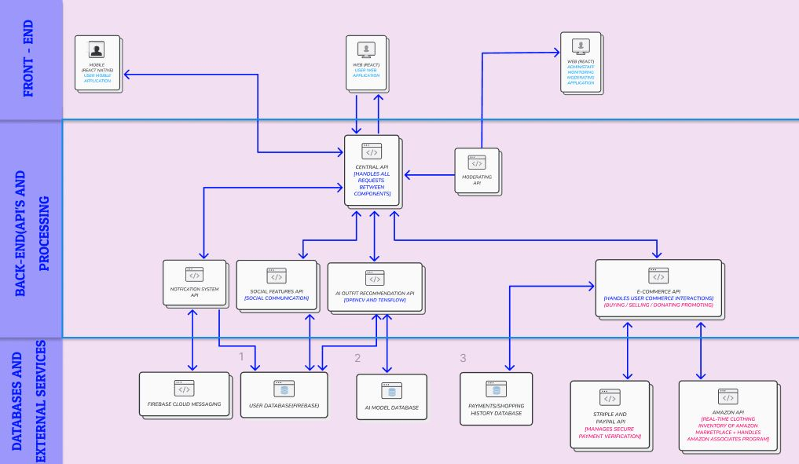

## ****Product Features****

Fashion AI is designed to provide a **seamless, AI-powered fashion experience** by combining wardrobe management, smart outfit recommendations, social engagement, and e-commerce integration. The following features highlight the core functionalities of the system:

**🛍️ Wardrobe Management**

* **Upload & Organize Clothing** – Users can upload images of their clothing, categorize them (e.g., casual, formal, seasonal), and manage their digital wardrobe.
* **Edit & Remove Items** – Modify or delete clothing items as needed.
* **Search & Filter** – Easily find specific clothing items using search or filters (e.g., color, type, occasion).

**🤖 AI-Powered Outfit Recommendations**

* **Smart Outfit Suggestions** – AI analyzes a user’s wardrobe and recommends stylish outfit combinations based on preferences, weather, and trends.
* **Event-Based Styling** – Users can request outfit ideas for specific occasions (e.g., date night, business meeting, casual outing).
* **Trend-Based Recommendations** – AI suggests trending styles based on global fashion trends.

**🌍 Social Features & Community Engagement**

* **Profile Creation & Customization** – Users can create and personalize their profiles.
* **Follow & Interact** – Follow other users, like posts, and comment on outfit inspirations.
* **Stories & Posts** – Share outfit ideas and fashion inspiration through posts and story features.
* **Direct Messaging** – Chat with friends and fashion enthusiasts within the platform.

**🛒 E-Commerce & Shopping Integration**

* **Shop Recommended Outfits** – Buy AI-recommended outfits directly via Amazon API integration.
* **Secure Transactions** – Make purchases using Stripe & PayPal for secure payments.
* **Affiliate Shopping Links** – Redirect users to external fashion retailers for additional shopping options.

**🛠️ Admin Panel & Moderation**

* **Content Moderation** – Admins can review and remove inappropriate or spam content.
* **AI Model Oversight** – Adjust AI recommendation algorithms and update trend-based suggestions.
* **User Management** – Admins can manage users, handle reports, and ensure a positive platform experience.

**📌 Future Enhancements:** While the current version does not support **real-time virtual try-ons** or **advanced AR outfit previews**, these features are planned for future releases.

## ****User Classes and Characteristics****

Fashion AI is designed for a diverse range of users with varying levels of technical expertise. Below are the six user groups, as described in the client document, along with their expected familiarity with technology.

#### ****👤 General Users****

**(Casual Fashion Enthusiasts & Everyday Users)**

* **Description:** Regular users who use the app for wardrobe management, outfit recommendations, and social engagement.
* **Technical Skill Level:**
  + Comfortable using mobile apps and web platforms.
  + Familiar with uploading photos and interacting with social media features.
  + May have limited knowledge of AI and recommendation algorithms.

#### ****📢 Fashion Influencers & Trendsetters****

* **Description:** social media-savvy users who create and share outfit inspiration, follow trends, and engage with the community.
* **Technical Skill Level:**
  + Highly proficient in using mobile and web-based applications.
  + Comfortable with social media platforms and content creation.
  + Likely to use advanced features like stories, posts, and direct messaging.

#### ****🛍️ E-Commerce Shoppers****

* **Description:** Users who rely on Fashion AI’s recommendations to purchase clothing via Amazon API integration.
* **Technical Skill Level:**
  + Comfortable navigating online shopping platforms.
  + Familiar with making online payments using Stripe or PayPal.
  + May not engage with the wardrobe management or social features extensively.

#### ****🛠️ Administrators & Moderators****

* **Description:** Responsible for managing user interactions, moderating content, and overseeing AI-generated recommendations.
* **Technical Skill Level:**
  + Familiar with **moderation tools, database management, and AI-driven systems**.
  + Comfortable using admin dashboards and content management systems.
  + Skilled in handling user reports and ensuring platform security.

#### ****🤖 AI & Data Analysts (Internal Team)****

* **Description:** Users responsible for monitoring and improving the AI recommendation system.
* **Technical Skill Level:**
  + **Highly skilled in AI, machine learning, and data analytics.**
  + Familiar with **OpenCV, TensorFlow, and Firebase backend management**.
  + Able to fine-tune recommendation algorithms based on trend analysis.

#### ****💼 IT Support & Maintenance Team****

* **Description:** Handles system updates, backend performance monitoring, and bug fixes.
* **Technical Skill Level:**
  + **Expertise in software development, server management, and cloud infrastructure.**
  + Proficient in **React.js, React Native, Node.js, Firebase, and API integrations**.
  + Capable of troubleshooting **security vulnerabilities, app crashes, and performance bottlenecks**.

***Key Considerations for Usability & Performance:***

* **General users, influencers, and shoppers** should experience a simple, intuitive UI.
* **Admins, AI analysts, and IT support teams** need access to **technical dashboards and control panels**.
* The system must accommodate users with **varying levels of expertise**, ensuring that **advanced features** do not overwhelm casual users.

## ****Operating Environment****

Fashion AI is a **cloud-based web and mobile application** designed for **global accessibility** across various environments. It operates on **desktop browsers (React.js) and mobile devices (React Native for Android & iOS)**, requiring a **stable internet connection** for AI recommendations, social features, and e-commerce transactions.

#### ****Common Usage Environments:****

* **Personal/Home Use:** Users manage wardrobes and receive outfit suggestions via mobile or desktop.
* **Retail & E-Commerce:** Shoppers explore AI-generated outfit recommendations linked to online stores.
* **Public & Social Spaces:** Influencers engage with the community in real time.
* **Administrative & AI Management:** Admins and AI analysts monitor content and optimize recommendations using secured desktops.

#### ****Hardware & Software Requirements:****

* **Supported Devices:**

**Mobile Phones & Tablets** (Android 8.0+ / iOS 14+)  
**Laptops & Desktops** (Windows, macOS, Linux)

* **Operating Conditions:**

Optimized for **indoor/outdoor use**, with a responsive UI.  
Requires **internet access** but supports limited offline functionality.

## ****Design and Implementation Constraints****

Fashion AI must adhere to several **technical, regulatory, and operational constraints** to ensure functionality, security, and scalability.

#### ****🖥️ Platform & Technology Constraints****

* The **web application** must be developed using **React.js**, while the **mobile application** must use **React Native** for cross-platform compatibility.
* The **backend** must be built using **Firebase** for authentication, data storage, and real-time synchronization.
* The system must support **Android (8.0+) and iOS (14+)** for mobile users.
* Internet connectivity is **required** for AI recommendations, social interactions, and e-commerce transactions.

#### ****🔐 Security & Compliance Constraints****

* Must follow **GDPR** (General Data Protection Regulation) and **CCPA** (California Consumer Privacy Act) for handling user data.
* User authentication must be secured using **OAuth 2.0** and **Multi-Factor Authentication (MFA)** for admins.
* All stored images and personal data must be **encrypted using AES-256**.

#### ****⚙️ Performance & Scalability Constraints****

* AI-generated outfit recommendations must be processed **within 2 seconds for 95% of requests**.
* The system must support **at least 10,000 concurrent users** without performance degradation.
* Cloud storage limitations apply: **each user is allocated 50MB for wardrobe images**.

#### ****💰 E-Commerce & API Constraints****

* Fashion AI does not handle **direct** transactions but relies on **Amazon API, Stripe, and PayPal** for purchases.
* AI recommendations are **limited to products available in integrated e-commerce platforms**.

## ****Assumptions and Dependencies****

The successful development and operation of **Fashion AI** depend on several external factors and underlying assumptions.

#### ****📌 Assumptions****

* Users will have **stable internet access** for real-time AI recommendations, social interactions, and e-commerce transactions.
* AI algorithms will continue to improve and adapt based on **user preferences, fashion trends, and seasonal changes**.
* **Amazon API, Stripe, and PayPal services** will remain operational and accessible for e-commerce transactions.
* **Cloud services (Firebase)** will provide reliable uptime, scalability, and security for storing user data and images.
* The application will primarily serve **English-speaking users**, but future versions may support additional languages.

#### ****⚙️ Dependencies****

* **AI Processing:** The accuracy of outfit recommendations depends on **OpenCV and TensorFlow**, requiring periodic updates and retraining with new datasets.
* **Third-Party APIs:** Functionality such as shopping integration and payment processing relies on external services (**Amazon API, Stripe, PayPal**). Any changes in their policies or availability could affect system operations.
* **Device Compatibility:** The mobile application depends on **Android (8.0+) and iOS (14+)** support, requiring updates to ensure compatibility with future OS versions.
* **Security & Compliance:** The system must comply with **GDPR and CCPA** regulations, requiring ongoing monitoring to meet evolving data protection laws.
* **User Adoption & Engagement:** The success of the social features depends on users actively engaging with the platform by sharing outfits and interacting with content.

# ****System Features****

The Fashion AI system provides various functionalities tailored to different user groups. Below is a breakdown of the **six user groups** and the features available to each.

### ****👤 General Users (Casual Fashion Enthusiasts & Everyday Users)**** will be able to:

* **Manage wardrobe items** (add, update, delete clothing images).
* **Receive AI-powered outfit recommendations** based on weather, trends, and personal preferences.
* **Manage profile** (create, update, delete personal details).
* **Engage with social features**, including:
  + Browse and follow other users.
  + Like, comment, and share outfit inspirations.
  + Post outfit images and styling ideas.
  + View and interact with user stories.
* **Search & filter wardrobe items** based on category, color, or occasion.
* **Shop for AI-recommended clothing** via Amazon API integration.
* **Save favorite outfits** for future reference.

### ****📢Fashion Influencers & Trendsetters****

In addition to general user features, influencers will be able to:

* **Manage (add, update, delete) fashion content** (e.g., outfits, stories, and styling tips).
* **Host fashion challenges and polls** for community engagement.
* **View engagement metrics** (likes, comments, shares) on their content.
* **Collaborate with brands** by promoting AI-recommended outfits through affiliate links.

### ****🛍️E-Commerce Shoppers****

Shoppers using Fashion AI will have access to:

* **AI-based outfit recommendations linked to purchasable items.**
* **Manage shopping preferences** (e.g., favorite brands, preferred price ranges).
* **Secure online transactions** using Stripe & PayPal.
* **Track orders** and receive updates on purchased items.

### ****🛠️Administrators & Moderators****

Admins and moderators will be responsible for maintaining a **safe and functional environment** by being able to:

* **Manage user accounts** (suspend, reactivate, or remove users violating guidelines).
* **Moderate (approve, delete, flag) user-generated content** (e.g., inappropriate posts, spam).
* **Oversee AI recommendation quality** and adjust filtering settings if necessary.
* **Generate analytics reports** on user engagement and system performance.
* **Manage platform settings** (update community guidelines, modify terms of use).

### ****🤖 AI & Data Analysts (Internal Team)****

The AI and data analysis team will have access to:

* **Manage AI model training2**(update, refine, and retrain AI-based outfit recommendations).
* **Analyze user interaction data** to improve AI accuracy.
* **Monitor performance metrics** (e.g., AI response time, recommendation success rates).
* **Adjust trend-based styling recommendations** based on fashion industry insights.

### ****💼IT Support & Maintenance Team****

IT personnel will be responsible for **technical stability and security** by being able to:

* **Manage system updates** (deploy new features, fix bugs, and enhance security).
* **Monitor server health** and ensure uptime reliability.
* **Manage API integrations** with external services (Amazon, Stripe, Firebase).
* **Troubleshoot performance issues** (slow AI processing, database errors).

### ****Summary of Functionalities by User Group:****

|  |  |
| --- | --- |
| **User Group** | **Key Functionalities** |
| **General Users** | Manage wardrobe, receive AI outfit suggestions, social interactions, shop recommended items. |
| **Fashion Influencers** | Create and manage content, interact with followers, track engagement metrics, collaborate with brands. |
| **E-Commerce Shoppers** | Browse AI-recommended clothing, purchase items securely, track orders. |
| **Administrators** | Moderate content, manage user accounts, oversee AI recommendations, generate reports. |
| **AI & Data Analysts** | Train AI models, analyze user interaction data, refine fashion recommendations. |
| **IT Support Team** | Maintain system security, deploy updates, monitor backend performance, troubleshoot issues. |

# ****Non-Functional Requirements****

The **non-functional requirements** for **Fashion AI** are categorized using the **FURPS+** model to ensure a high-quality user experience and maintainability.

### ****📌 Functionality****

* The system must provide **AI-powered outfit recommendations** with at least **85% accuracy** based on user preferences and trends.
* The platform must support **seamless integration** with external APIs, including **Amazon (shopping), Stripe & PayPal (transactions), and Firebase (authentication and data storage)**.
* **Content moderation** tools must be available for administrators to **review and remove inappropriate content**.
* The system must **log and track user activity** for analytics and AI model improvements.

### ****🎨 Usability****

* The **user interface (UI)** must be **intuitive and visually appealing**, following **modern UX/UI best practices**.
* The system should allow users to **complete a wardrobe upload in fewer than 5 clicks**.
* AI recommendations must be displayed in a **clear and easy-to-understand format** with outfit details.
* The system should support **multi-language capabilities in future versions** to expand global accessibility.
* The mobile application must be **fully responsive**, adjusting to different screen sizes and orientations.

### ****⚙️ Reliability****

* The system must maintain an **uptime of at least 99.9%**, ensuring minimal downtime for users.
* AI outfit recommendations must be **processed within 2 seconds for 95% of requests**.
* The system should be able to **recover from failures** within **30 seconds** using automated rollback mechanisms.
* User data must be **backed up daily** to prevent loss in case of system failure.

### ****🚀 Performance****

* The system must support **at least 10,000 concurrent users** without noticeable slowdowns.
* The mobile app must load within **3 seconds on a standard 4G connection**.
* Image uploads and processing should be completed within **5 seconds per item**.
* The search and filtering system must return results within **1 second**.

### ****🛠️ Supportability****

* The system must be built using **React.js (web), React Native (mobile), Firebase (backend), and OpenCV/TensorFlow (AI processing)** for maintainability.
* The AI recommendation engine must be **modular**, allowing for easy updates and improvements.
* **System updates and security patches** should be deployed at least **once per quarter**.
* The platform must be **compatible with future OS updates** (Android, iOS, and web browsers).
* Admin and IT teams should have **access to debugging and error-tracking tools** for quick issue resolution.

### ****➕ Miscellaneous****

* The system must comply with **GDPR and CCPA regulations** for user data privacy.
* Content moderation policies must align with **global community guidelines** to ensure a safe user experience.
* The application should be designed with **scalability in mind**, allowing for expansion of features such as **virtual try-ons and multi-language support** in future updates.

# ****External Interface Requirements****

### ****User Interfaces****

Fashion AI provides multiple user interfaces designed for seamless interaction across different devices:

* **Web Application (React.js):**
  + Accessible via modern web browsers (Chrome, Firefox, Edge, Safari).
  + Responsive and optimized for desktop and mobile web experiences.
  + Includes features for wardrobe management, AI outfit recommendations, social engagement, and shopping integration.
* **Mobile Application (React Native):**
  + Available on **Android (8.0+) and iOS (14+)**.
  + Offers a touch-optimized experience with the same core functionalities as the web version.
  + Supports push notifications for AI recommendations, shopping deals, and social interactions.
* **Admin Panel:**
  + Restricted to administrators and accessible through a secure web interface.
  + Includes user management, content moderation, and AI oversight features.

### ****Hardware Interfaces****

Fashion AI does not require specialized hardware but must support standard computing and mobile devices:

* **Supported Devices:**
  + Smartphones, tablets, and desktops/laptops.
  + Devices must support touchscreen interactions (for mobile).
* **Storage & Processing:**
  + The system relies on **cloud storage (Firebase)** instead of local device storage.
  + AI computations are processed on **cloud-based servers**, minimizing dependency on device processing power.
* **Camera Access (for Image Uploads):**
  + Mobile devices must allow camera access for **clothing image uploads**.
  + Browser-based users can upload images from local storage.

### ****Software Interfaces****

Fashion AI integrates with several external software systems for authentication, AI processing, payments, and e-commerce:

* **Authentication & Database:**
  + Firebase Authentication – Secure user login and session management.
  + Firebase Firestore – Cloud database for storing user wardrobes and AI-generated recommendations.
* **AI Processing & Image Analysis:**
  + OpenCV – Used for image processing and feature extraction.
  + TensorFlow – AI model for outfit recommendations and trend analysis.
* **E-Commerce & Payment Systems:**
  + Amazon API – Retrieves fashion items and facilitates purchases.
  + Stripe & PayPal – Handles online transactions securely.
* **Social & Communication Features:**
  + WebSockets – Enables real-time interactions for social engagement (likes, comments, chat).
  + Firebase Cloud Messaging (FCM) – Push notification service for mobile alerts.

### ****Communication Interfaces****

Fashion AI requires various communication protocols for **secure data exchange** between users, databases, and external services:

* **Web & Mobile Connectivity:**
  + HTTPS (SSL/TLS) – Encrypts all user interactions for secure data transmission.
  + RESTful APIs – Facilitates backend communication with AI services, databases, and third-party integrations.
* **Real-Time Communication:**
  + WebSockets – Enables real-time updates for notifications and social interactions.
  + Firebase Cloud Messaging – Sends push notifications for AI recommendations and shopping deals.
* **Payment Processing:**
  + Secure Payment Gateway APIs (Stripe & PayPal) – Ensures safe transactions using industry-standard encryption.

# ****Detailed Use Cases****

This section provides a **detailed breakdown of key system functionalities** using **Use Case Descriptions** and **UML Diagrams** to illustrate user interactions. Each use case outlines **actors, steps, conditions, and exceptions** to ensure clarity in system behavior.

## ****Primary Use Cases & Actors****

|  |  |  |
| --- | --- | --- |
| **Use Case ID** | **Use Case Name** | **Actors** |
| UC-01 | Upload Clothing Image | General User |
| UC-02 | Generate AI Outfit Recommendation | General User |
| UC-03 | Browse & Purchase Suggested Outfit | E-Commerce Shopper |
| UC-04 | Engage in Social Features (Post, Like, Comment) | General User, Fashion Influencer |
| UC-05 | Manage User Account & Profile | General User |
| UC-06 | Moderate Content & Manage Users | Administrator |
| UC-07 | Monitor & Improve AI Model | AI & Data Analyst |
| UC-08 | Perform System Maintenance & Updates | IT Support Team |

## ****Use Case Details****

### ****UC-01: Upload Clothing Image****

**Actors:** General User  
**Preconditions:**

* The user must be **logged in**.
* The device must have **camera access/storage permissions enabled**.

#### ****Steps****

1. The user navigates to the **Wardrobe Management** section.
2. Clicks on **“Upload New Clothing”**.
3. Selects an image **from device storage or takes a new photo**.
4. AI processes the image to detect **clothing type, color, and category**.
5. The user **confirms or modifies** AI-detected details (e.g., renaming the item, changing the category).
6. The system saves the clothing item to the **user’s digital wardrobe**.

**Postconditions:**

* The item is stored in the **wardrobe database** and is available for **AI outfit recommendations**.

**Exceptions:**

* If the **image format is unsupported**, the system displays an error.
* If the **internet connection is lost**, the system queues the image upload and retries when online.

### ****UC-02: Generate AI Outfit Recommendation****

**Actors:** General User  
**Preconditions:**

* The user must have **at least three clothing items uploaded** in their wardrobe.
* AI algorithms must be trained and available.

#### ****Steps****

1. The user selects **“Generate Outfit”** from the home screen.
2. The system retrieves **existing wardrobe items**.
3. AI processes data and **suggests multiple outfit combinations** based on:
   * User preferences (e.g., casual, formal).
   * Weather conditions (fetched via API).
   * Fashion trends (AI-based analysis).
4. The user **filters outfits** by occasion, color, or style.
5. The system displays **final AI-generated outfits**.
6. The user can:
   * **Save** the outfit.
   * **Request a new suggestion**.
   * **Share the outfit** with friends via social features.

**Postconditions:**

* The recommended outfit is saved for future reference.

**Exceptions:**

* If **AI fails to generate an outfit**, the system suggests a **manual outfit selection**.

### ****UC-03: Browse & Purchase Suggested Outfit****

**Actors:** E-Commerce Shopper  
**Preconditions:**

* The user must be **logged in** and have an **Amazon account linked**.

#### ****Steps****

1. The user navigates to the **"Shop AI Picks"** section.
2. The system displays a **personalized selection of clothing items** from Amazon API.
3. The user **selects an item** and clicks **“Buy Now”**.
4. The system redirects to **Amazon’s checkout page**.
5. The user **completes payment** using Stripe or PayPal.
6. The system **confirms order status** and updates the **purchase history**.

**Postconditions:**

* The purchase is **completed** and tracked in the user’s **shopping history**.

**Exceptions:**

* If an item is **out of stock**, the system suggests an **alternative product**.

### ****UC-04: Engage in Social Features (Post, Like, Comment)****

**Actors:** General User, Fashion Influencer  
**Preconditions:**

* The user must have a **public profile** to engage in social features.

#### ****Steps****

1. The user navigates to the **Social Feed**.
2. The user selects an **existing post** or creates a **new post**.
3. For **new posts**, the user:
   * Uploads an image.
   * Adds a description.
   * Tags items from their wardrobe.
4. The system **publishes the post** to the user’s profile.
5. Other users can:
   * **Like** the post.
   * **Comment** on the post.
   * **Share** the outfit on their own profile.
6. The system updates **engagement metrics** in real-time.

**Postconditions:**

* The post is publicly available for other users to interact with.

**Exceptions:**

* If the **internet connection is lost**, the post is **saved as a draft**.

### ****UC-06: Moderate Content & Manage Users****

**Actors:** Administrator  
**Preconditions:**

* The admin must have **moderation privileges**.

#### ****Steps****

1. The admin logs into the **Admin Panel**.
2. Views **reported content** or flagged user activity.
3. Selects an action:
   * **Approve** the content.
   * **Remove** the content (if violating guidelines).
   * **Suspend the user** (for repeated violations).
4. The system logs the admin’s action.

**Postconditions:**

* Content is either restored or removed from the platform.

**Exceptions:**

* If a **user appeals a suspension**, the admin must **review the case** manually.

## ****UML Diagrams****

1. Activity Diagram: User Flow in Fashion AI

The Activity Diagram outlines the main user interactions with Fashion AI, covering login, wardrobe management, social engagement, and purchases. It shows how users navigate different features and how AI enhances browsing recommendations. This helps in understanding the system’s workflow and user journey.

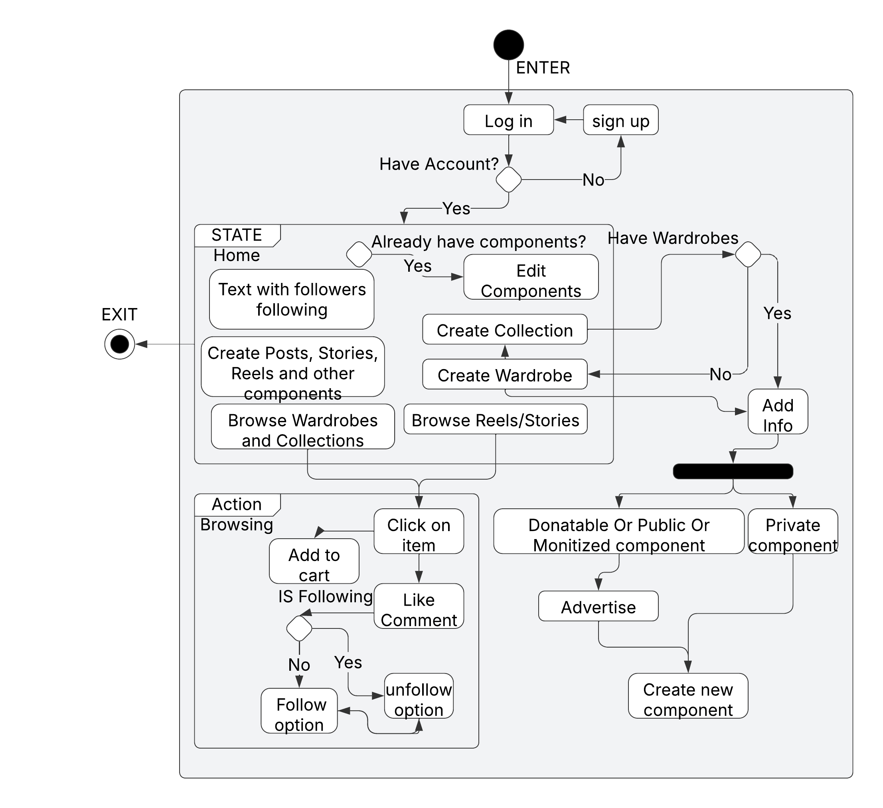

1. Use Case Diagram: User Interactions in Fashion AI

The Use Case Diagram presents the major user interactions, defining key system functionalities such as wardrobe management, social features, and e-commerce integration. It clarifies how users interact with different components and highlights AI’s role in generating recommendations.

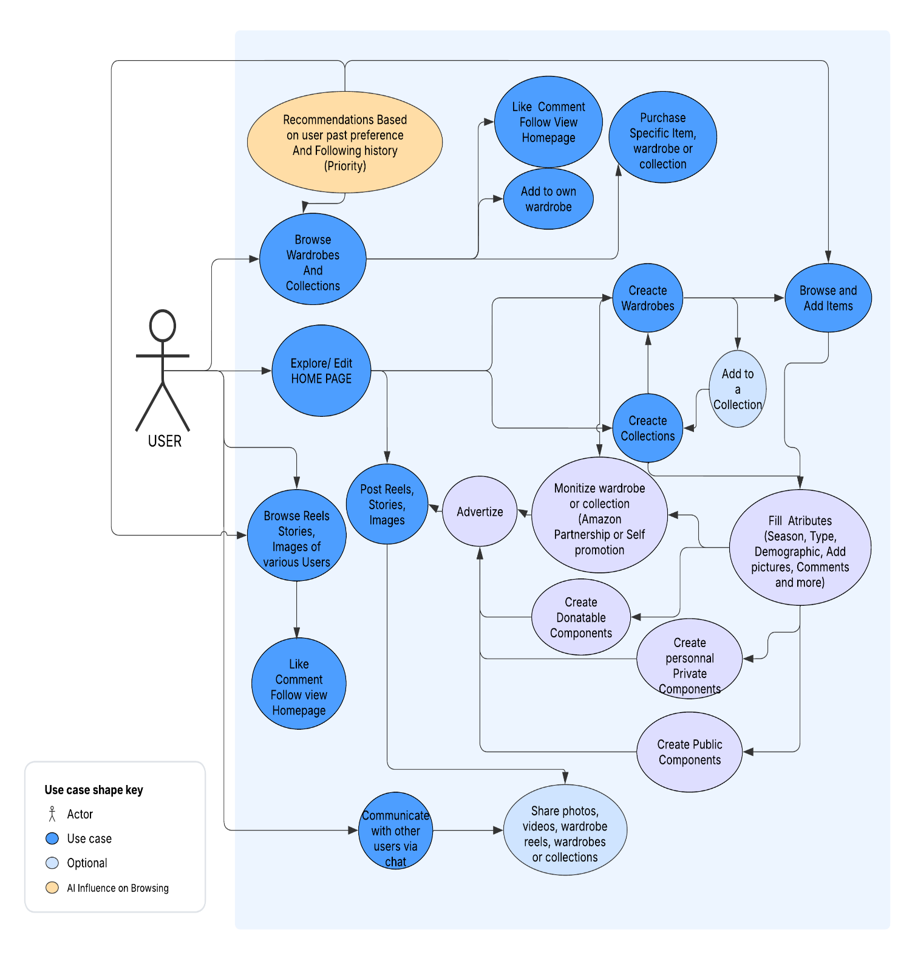

# ****Appendix****

The following supporting documents are included in the appendix to provide **additional reference material** relevant to the **Fashion AI** project. These documents were used during system development and are cited in the **References (Section 1.4)**.

### ****Included Documents:****

1. **Fashion AI Project Proposal**
   * A comprehensive document detailing the initial project concept, objectives, system architecture, and expected outcomes.

[](appendix/Proposal_SondosHalawani_DavidKharrat.docx)

1. **SRS Template v4 (CSIS290 – Senior Project)**
   * The official **Software Requirements Specification (SRS) template** provided by the **CSIS290 course** to ensure compliance with IEEE SRS standards.



1. **SRS Document (CSIS290 – Senior Project, Moodle Source)**
   * An example document from **Moodle**, used as a reference to format and structure this SRS.



1. **Client & User Research Notes**
   * Insights from **client discussions, fashion industry analysis, and user feedback** that shaped system requirements.



1. **ChatGPT (OpenAI) – Technical Reference**

Used for structuring and refining the SRS document, as well as gathering technical explanations on:

* [Firebase Documentation (User Authentication, Cloud Storage)](https://firebase.google.com/docs)
* [Amazon API Documentation (E-Commerce Integration)](https://developer.amazon.com/docs" \t "_new)
* [Stripe API Documentation (Payment Processing)](https://stripe.com/docs/api" \t "_new)
* [PayPal API Documentation (Payment Processing)](https://developer.paypal.com/docs/api/overview/)
* [OpenCV Documentation (AI Processing & Image Recognition)](https://docs.opencv.org/master/)
* [TensorFlow Documentation (AI Processing & Machine Learning)](https://www.tensorflow.org/guide)