

School of Computing
and
Digital Technologies

Software Projects
(SEM2 AF-2025/6)

Individual Project

Name: Sia A. Pugal
Student ID: c5058028
Degree Route: BSc CS

Table of Contents

1. Requirements Gathering Stage
1.1 Project Description and Users
1.2 User Stories and Acceptance Tests
2. Design Stage
2.1 Entity Relationship Diagram
2.2 Excalidraw Prototype
3. Development Stage
3.1 Transitioning a Prototype to Production-Quality Software
3.2 Test Description
4. Software and Its Presentation
4.2 The Production-Quality Software
4.3 Video Presentation
5. Evaluative Report on Legal, Social, Ethical and Professional Issues
5.1 Relevant Issues
5.2 Discussion
6. Incorporation of formative feedback
7. Use of AI declaration
8. References

1. Requirements Gathering Stage

1.1 Project Description and Users
Name | Description
Doctor User | A user that can register/authenticate into the system as a doctor. Able to see all patient history and access everything needed in their role.
Patient User | A user that can register/authenticate into the system as a patient. Able to see all their own information and have access to everything needed for their role.
Admin User | A user that can register/authenticate into the system as an admin. An admin can check in patients and access everything needed in their role.

1.2 User Stories and Acceptance Tests
ID | User Story | Notes | Acceptance Test
PU-US-1  (Patient User User Story 1) | As a patient  I want to request a repeat prescription  so that I can get the medication. | Assumes that the user is logged in. | - Given the patient is on the view my medication page, when they have a repeatable prescription, then the prescription should be repeated.  - Given the patient is on the view my medications page, when they don’t have any repeatable prescriptions, then they should not be able to repeat a prescription.
PU-US-2  (Patient User User Story 2) | As a patient  I want to view my appointments  so that I can check when I have appointments. | Assumes that the user is logged in. | - Given the patient is on the view appointments page when they go to view their appointment, then they should be able to see the date and time of the appointment.  - Given the patient is on the view appointments page when they go to view their appointment and they don’t have any, then they should not be able to view any appointments.
PU-US-3  (Patient User User Story 3) | As a patient  I want to view all information about my repeat prescribed medication  so that I can know the dosage etc. | Assumes that the user is logged in. | - Given the patient has a repeat prescription already, when they go on the view my medications page, then they should be able to view valid information about their repeat prescription.  - Given the patient does not have a repeat prescription, when go on the view my medications page then they should only be able to view information about normal prescriptions not repeat ones.
DU-US-1  (Doctor User, User Story 1) | As a doctor  I want to view and be able to search in my patient’s records  so that I can access the information I need to know about them. | This story assumes user has a patient with a record. | - Given the doctor is on the view patients record page, when they search valid information about the patient, then they should be able to access the patient’s record and information about them.  - Given the doctor is on the view patients page, when they search invalid credentials, then they should not be able to access the patient’s record and information about them.
DU-US-2  (Doctor User, User Story 2) | As a doctor  I want to prescribe my patients medication  so that they can receive their medicine. | Assumes the doctors logged in. | - Given the doctor is on the prescribe medication page, when they enter valid information about the patient and medication, then they should be able to prescribe medicine to the patient successfully.  - Given the doctor is on the prescribe medication page, when they don’t fill in all the fields, then they should not be able to prescribe medicine to the patient.
DU-US-3  (Doctor User, User Story 3) | As a doctor  I want to see my timetable  so that I can know what I’m doing throughout my workday. | Assumes the doctors logged in. | - Given the doctor is on the timetable page, when they view their appointments then they should be able to see everything scheduled that they have to do.  - Given the doctor is on the timetable page, when they try to add something to their timetable, then they should be able to.  - Given the doctor is on the timetable page, when they try to add something to their timetable for a day that already passed, then they should not be able to.
AU-US-1  (Admin User, User Story 1) | As an admin  I want to check in patients  so that they can be seen by a doctor. | Assumes the admins logged in. | - Given the admin is on the check-in page, when they enter valid information about the patient and appointment, then they should be able to check in the patient.  - Given the admin is on the check-in page, when they enter valid information about the patient but the patient doesn’t have an appointment, then they should not be able to check in the patient.
AU-US-2  (Admin User, User Story 2) | As an admin  I want to create new doctor specialities  so that doctors can select their correct speciality. | Assumes the admins logged in. | - Given the admin is on the create new doctor speciality page, when they enter valid information, then they should be able to create a new speciality.  - Given the admin is on the create new doctor speciality page, when they don’t fill in all the fields, then they shouldn’t be able to create a new speciality.
AU-US-3  (Admin User, User Story 3) | As an admin  I want to create a new admin  so that admins can be created only by other admins. | Assumes the admins logged in. | - Given the admin is on the create new admin page, when they enter valid information about an admin, then they should be able to create an admin account.  - Given the admin is on the create new admin page, when they don’t fill in all the fields, then they should not be able to create a new admin account.

2. Design Stage

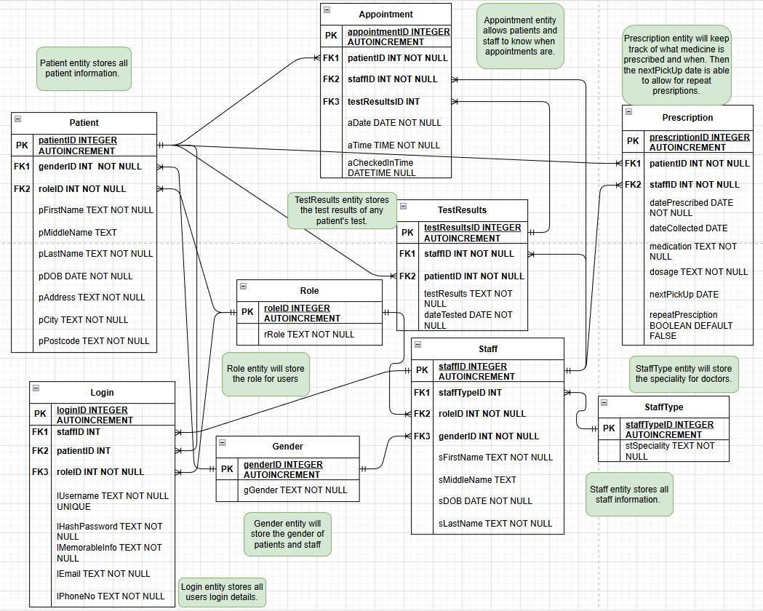
2.1 Entity Relationship Diagram

2.2 Excalidraw Prototype
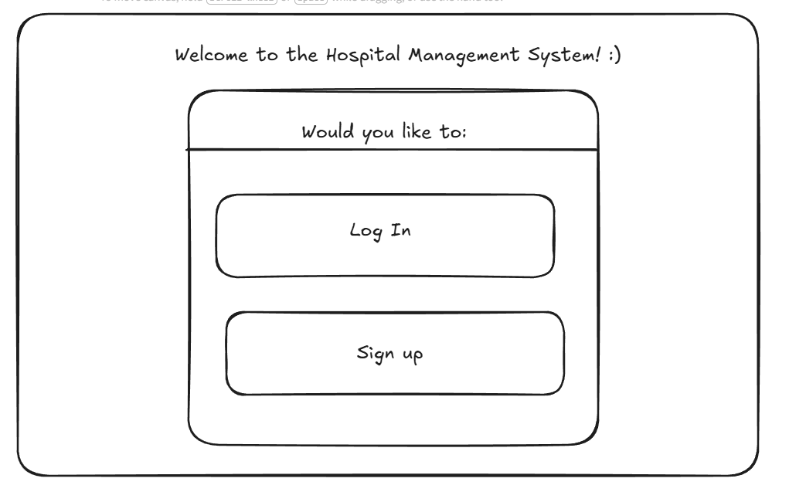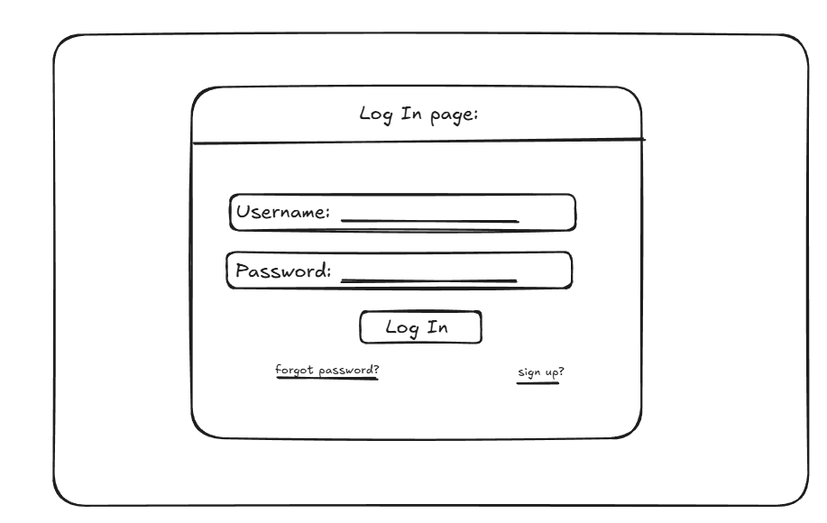
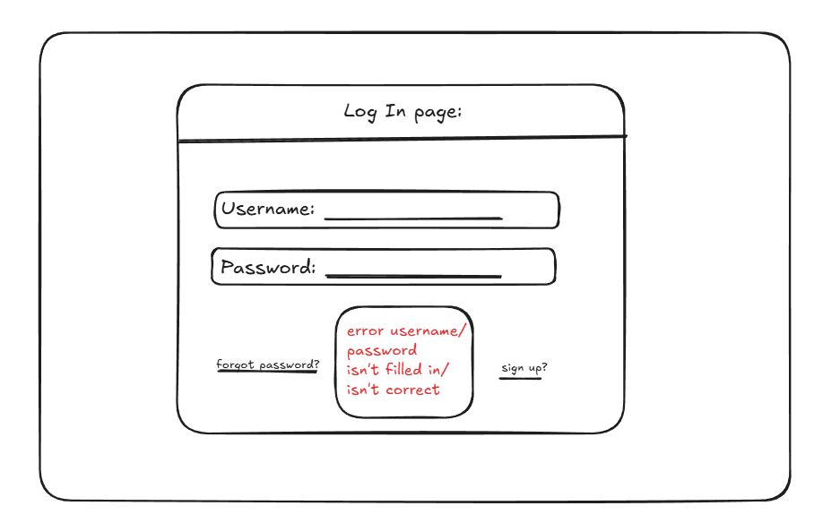

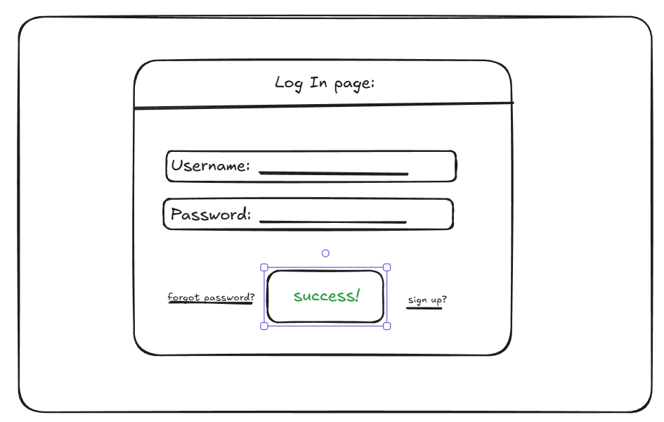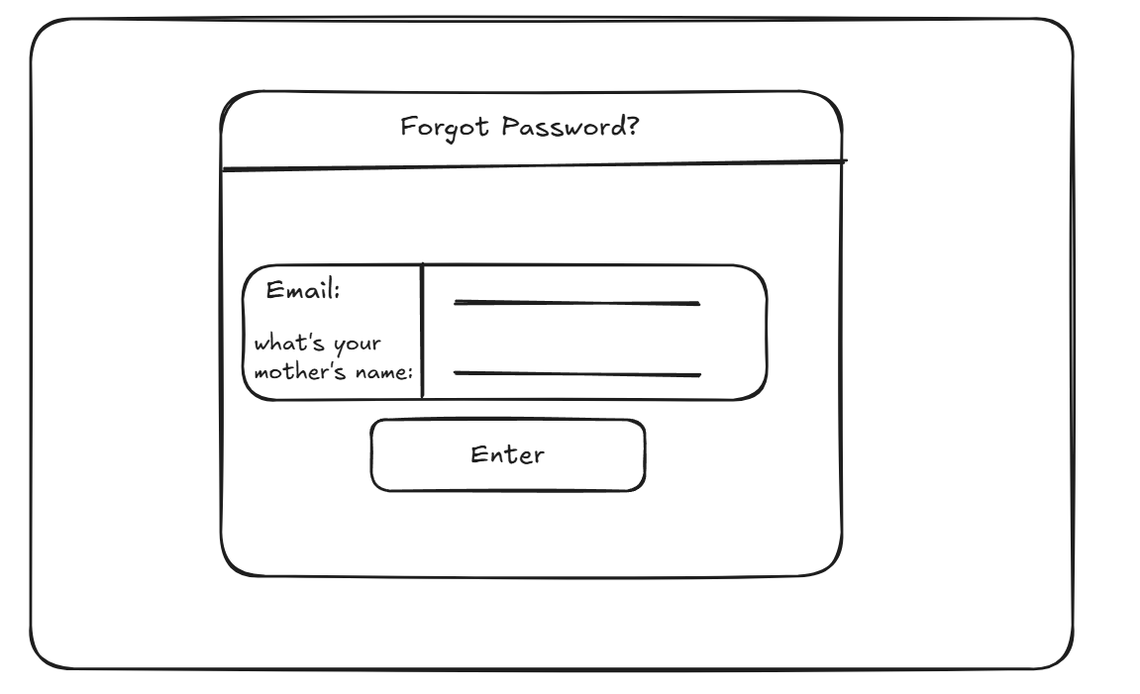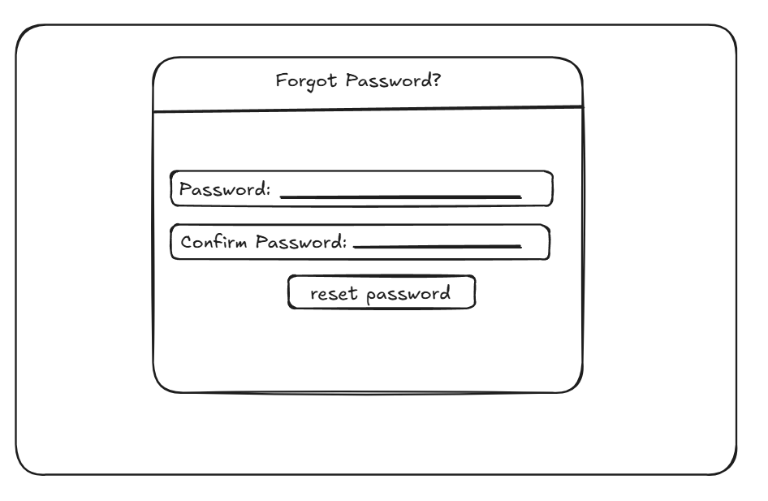
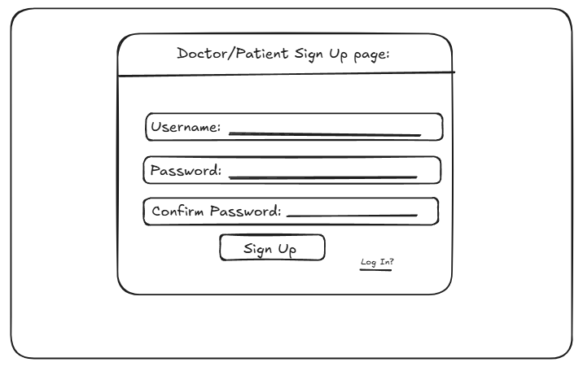

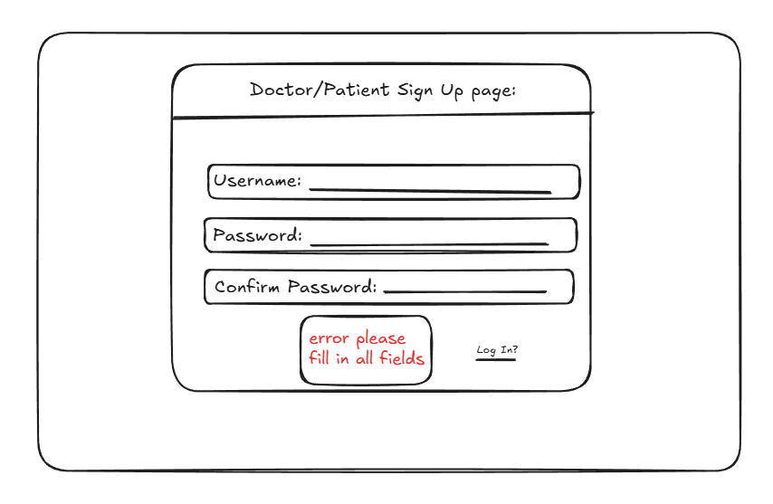
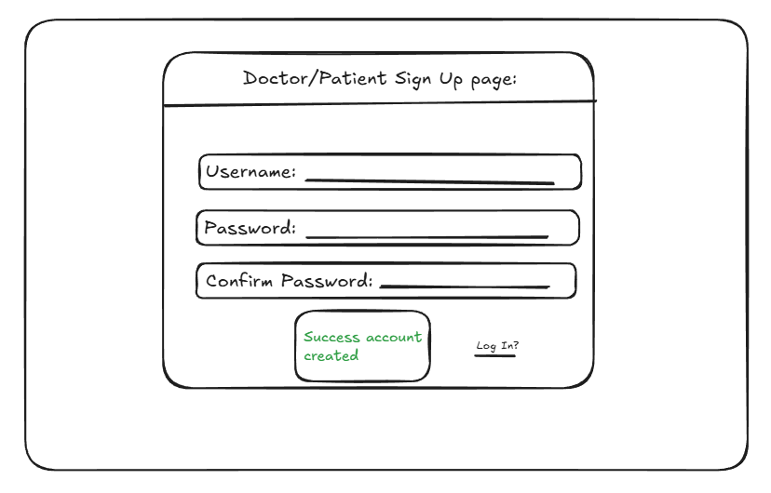
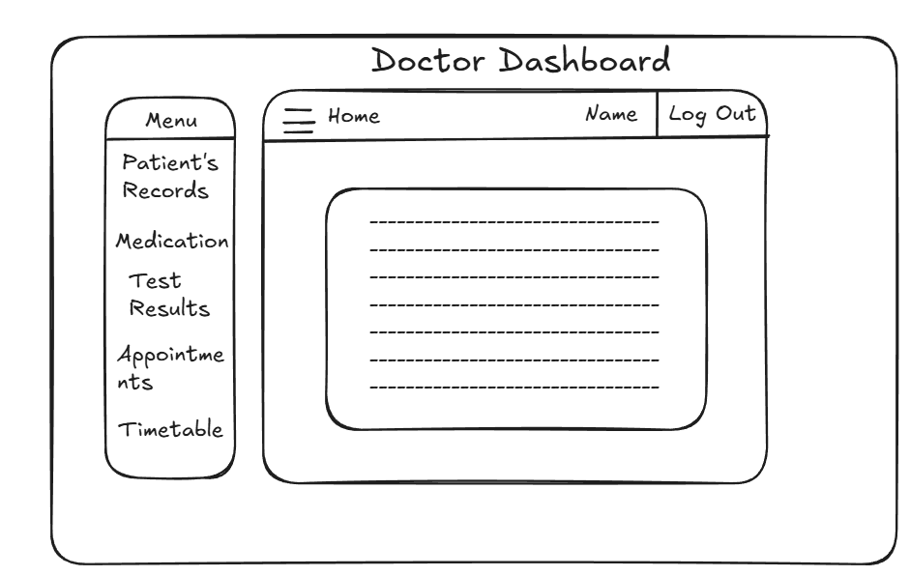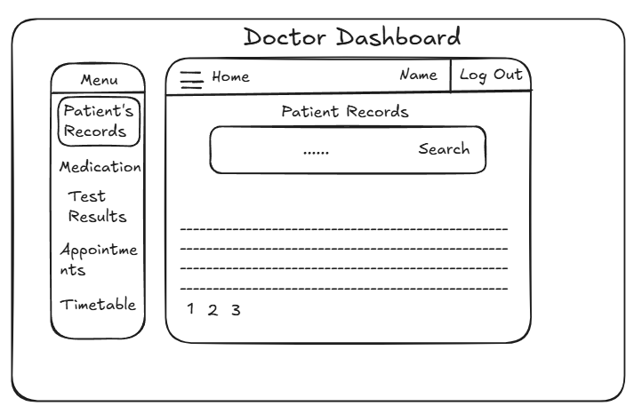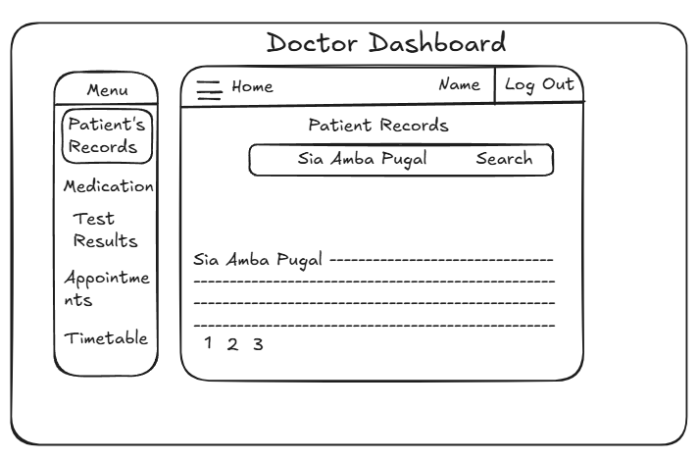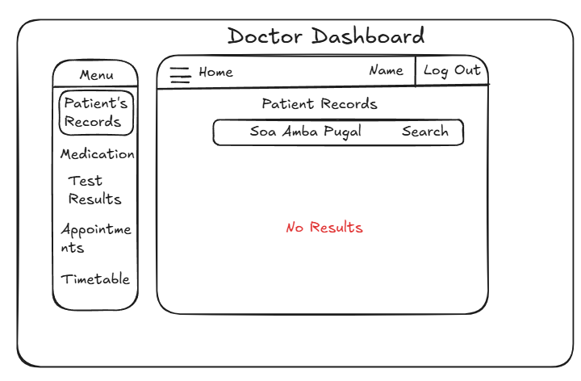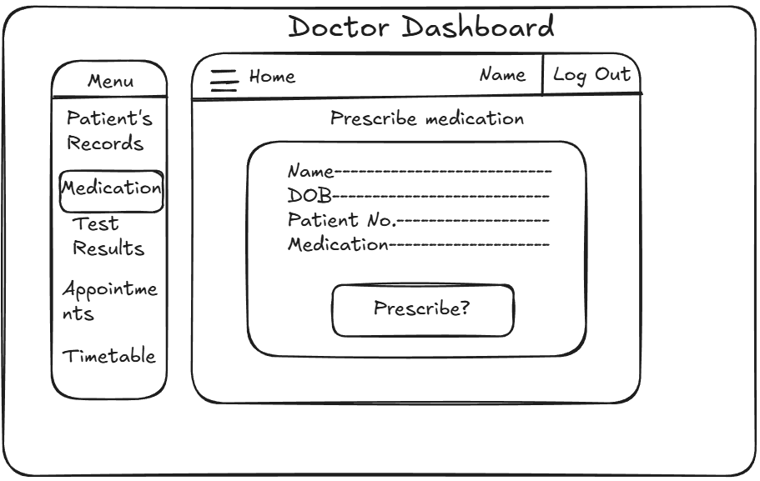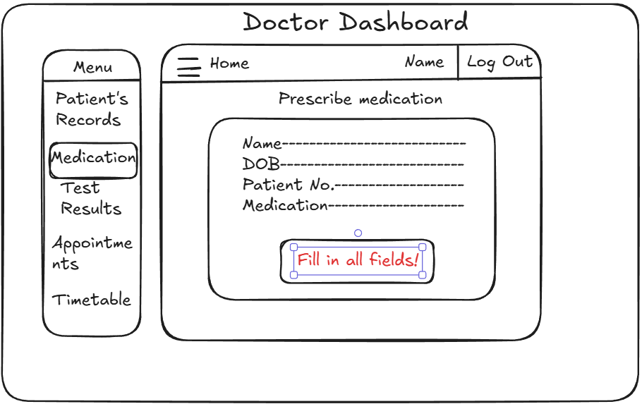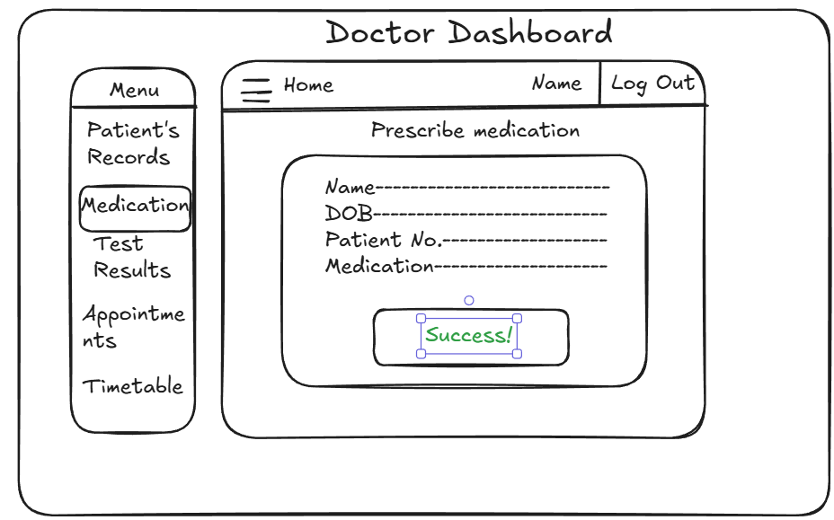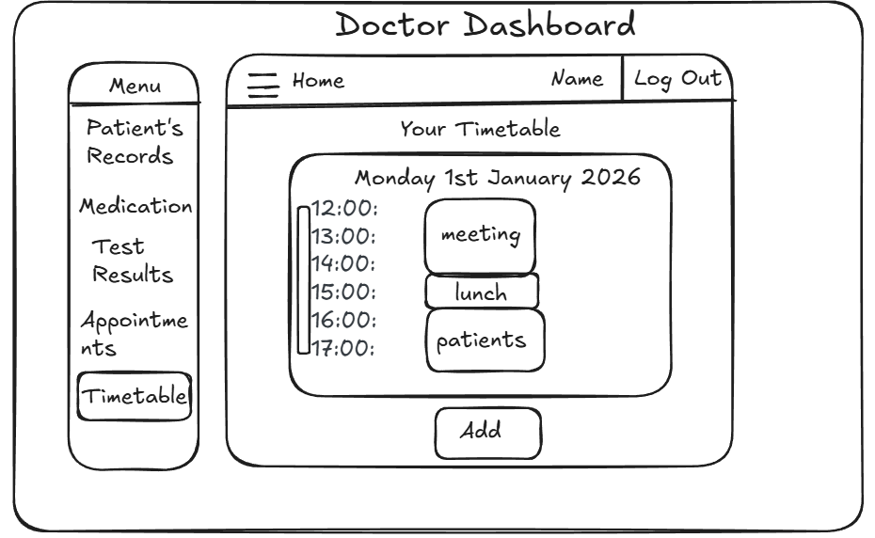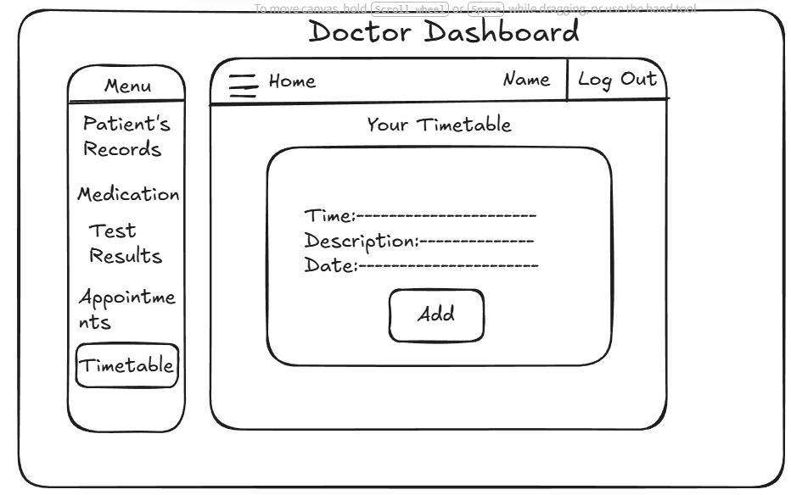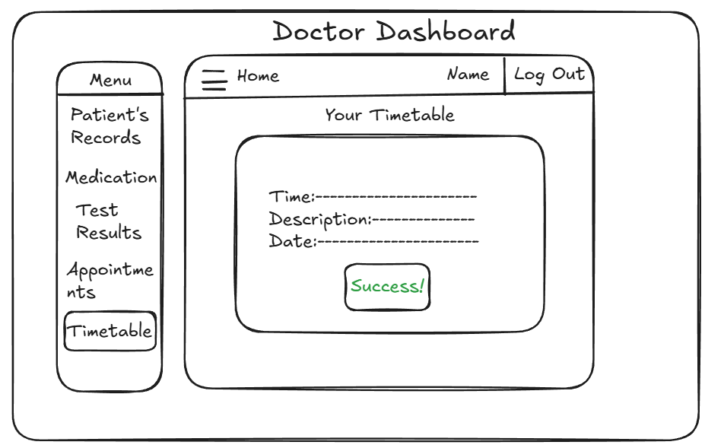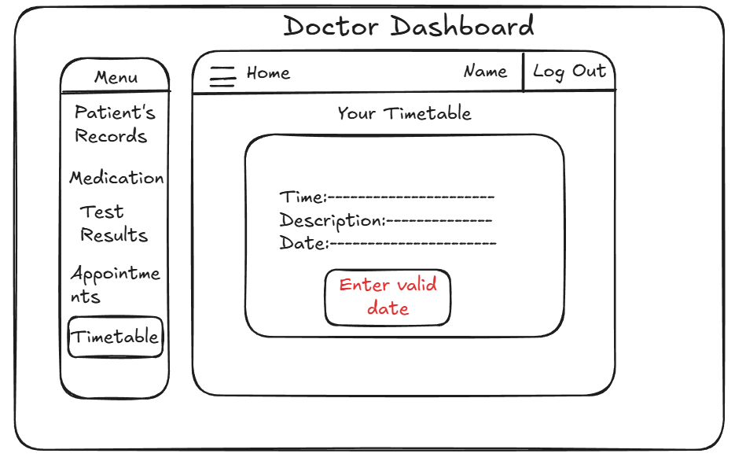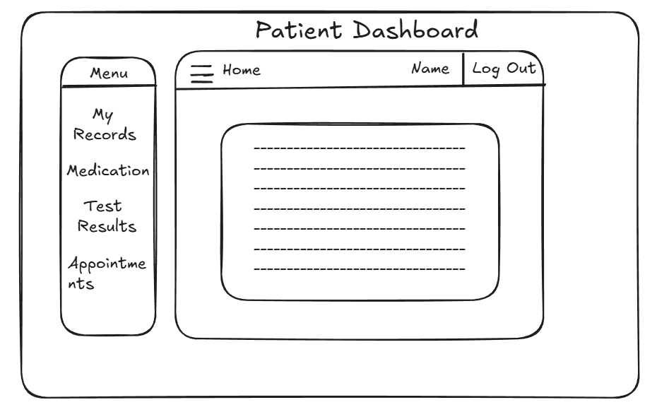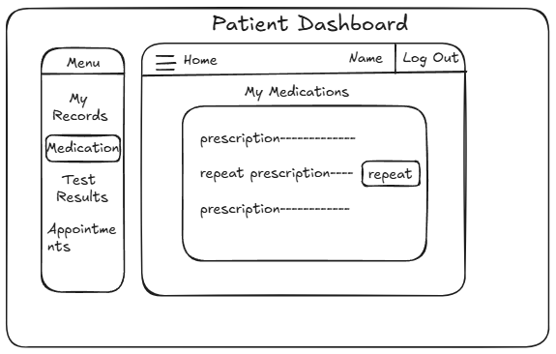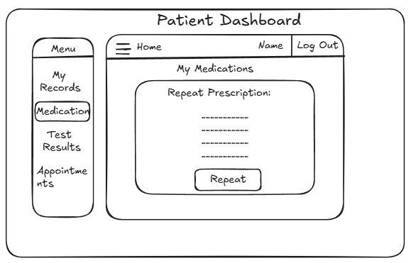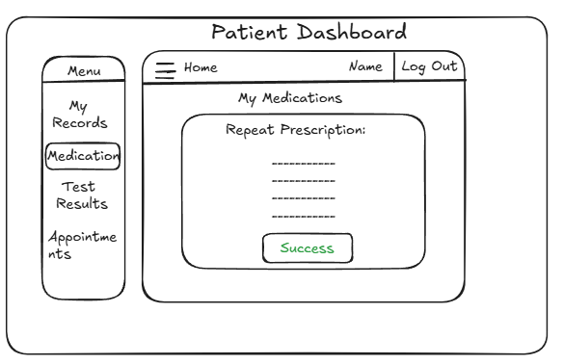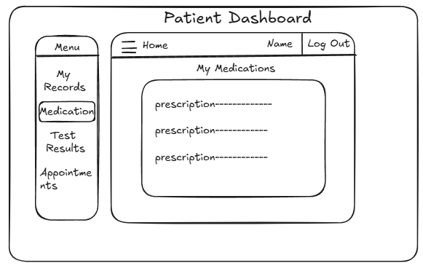
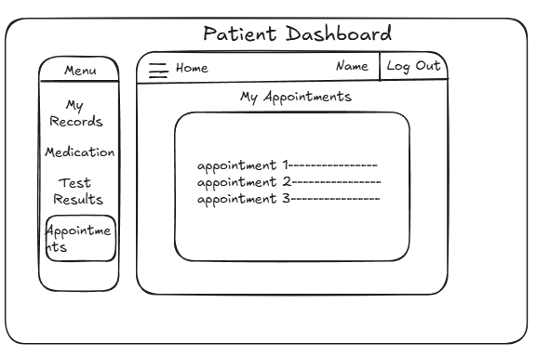
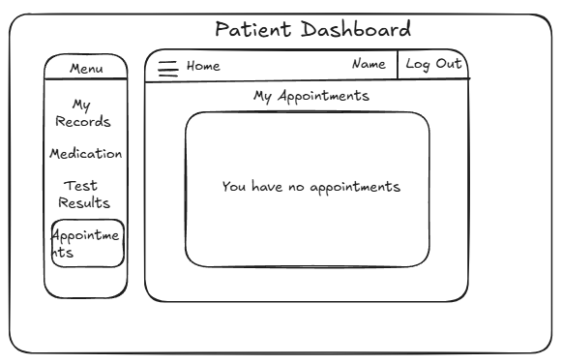

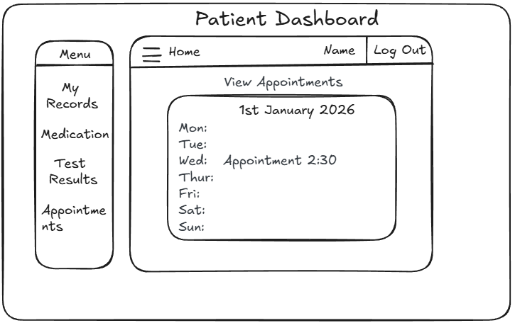
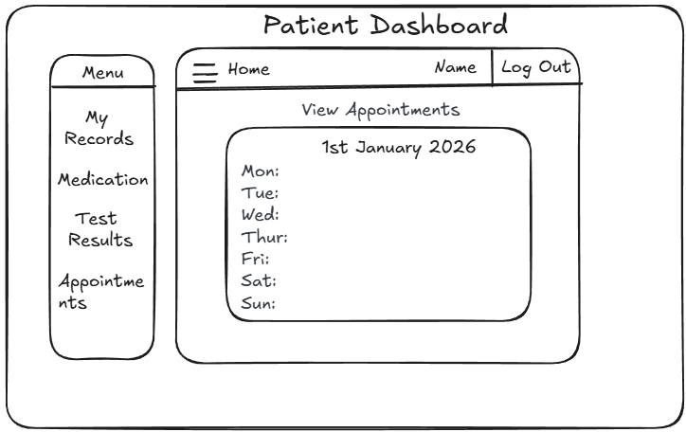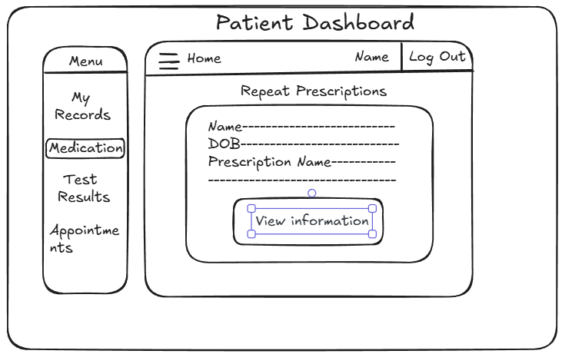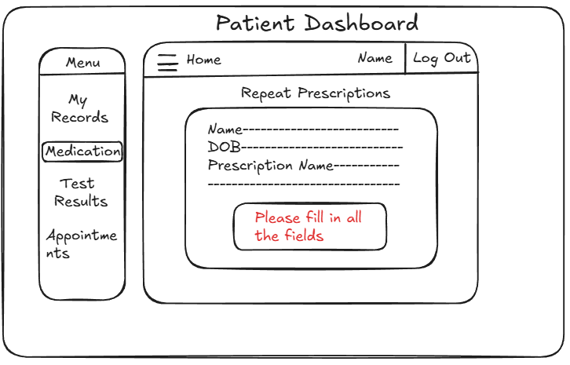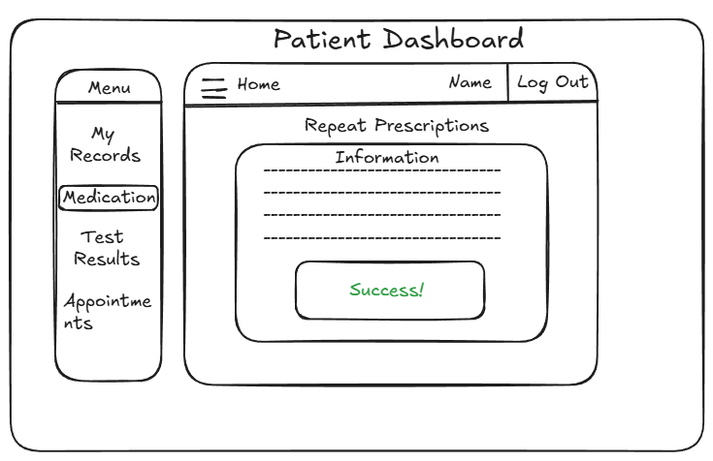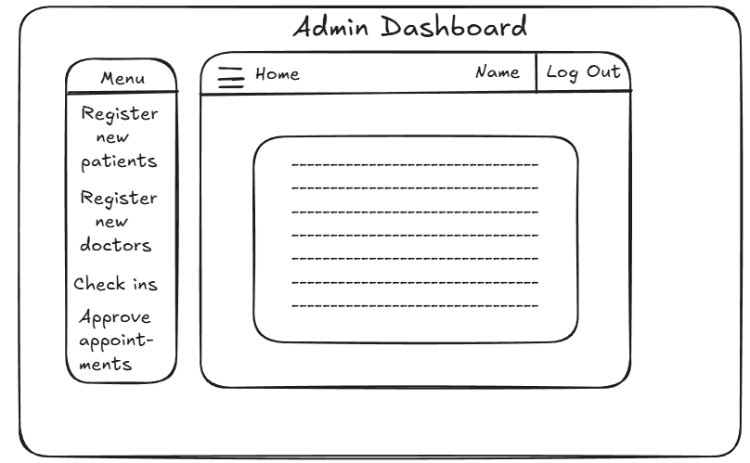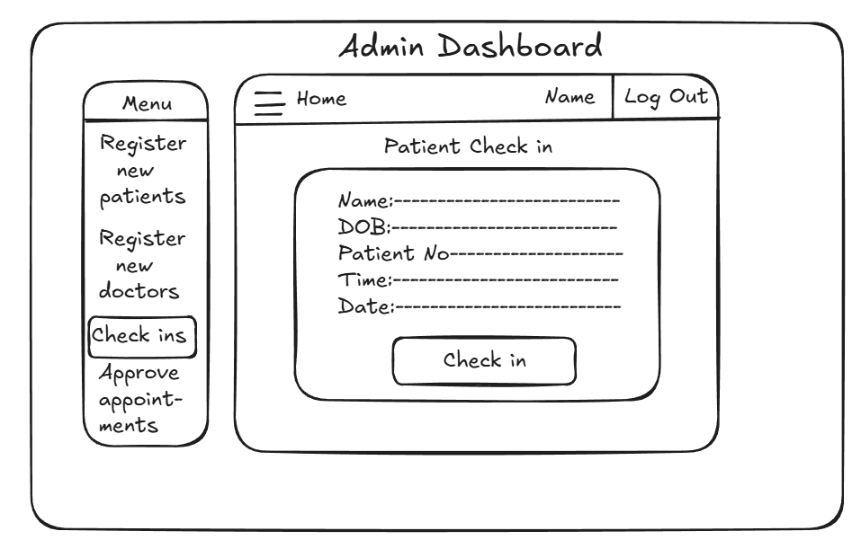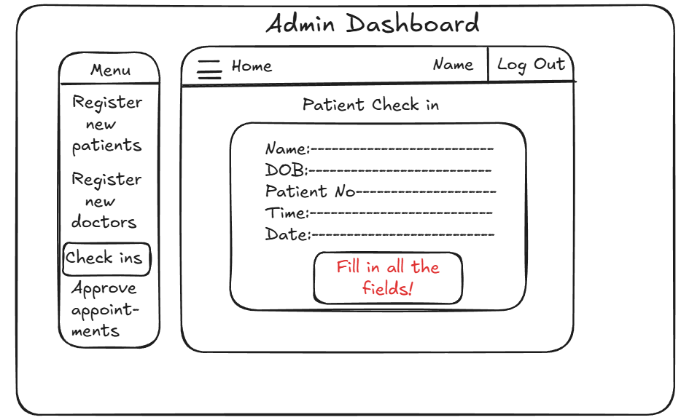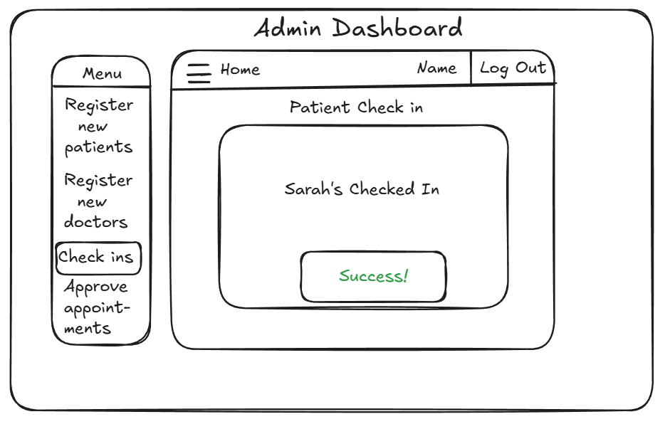
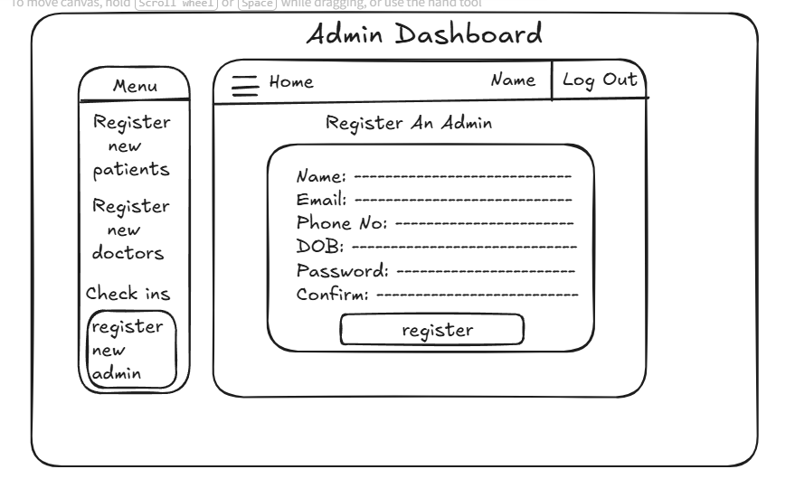
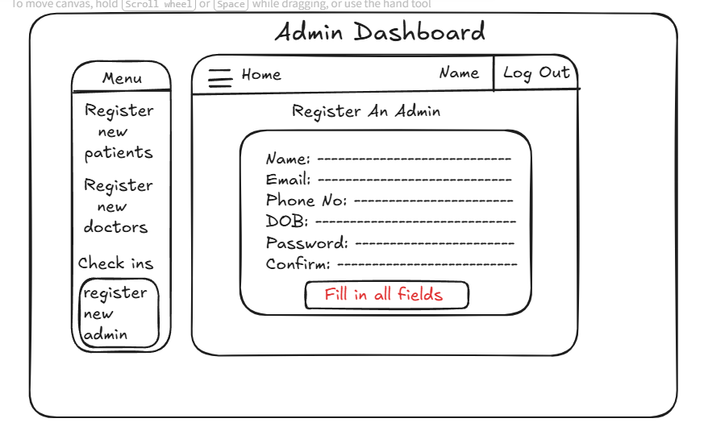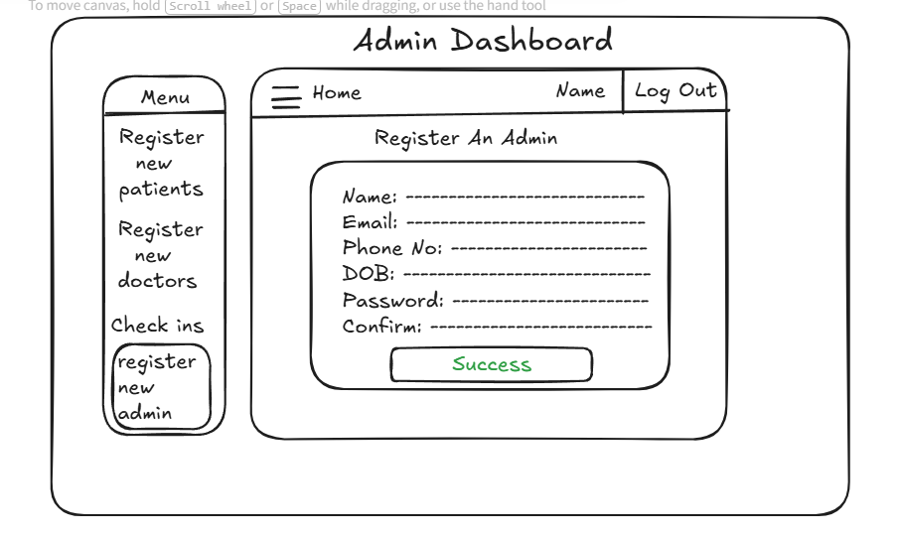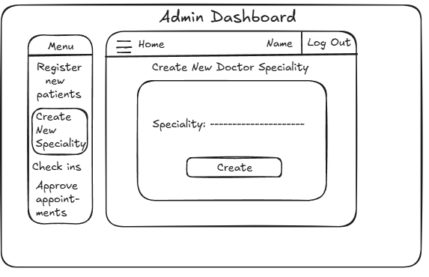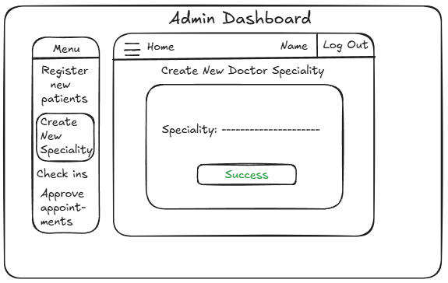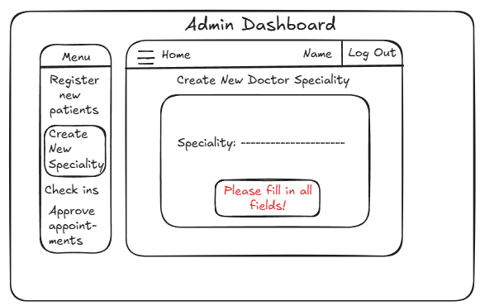

3. Development Stage

3.1 Transitioning a Prototype to Production-Quality Software

Provide evidence of how you transitioned your prototype to a production-quality (where possible) software system systematically. This may include use of a systematic approach to convert an entity-relationship diagrams to a corresponding database implementation. You can also include such details as how you interfaced to a database system within an application (if applicable to your project).

Front-End Transitioning

Before Applying CSS for Login, Create New Appointments and View All Patient Records pages.

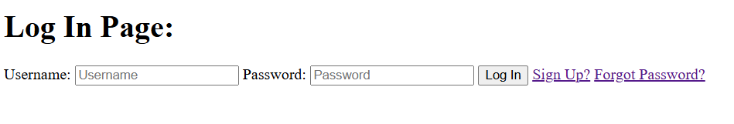 | 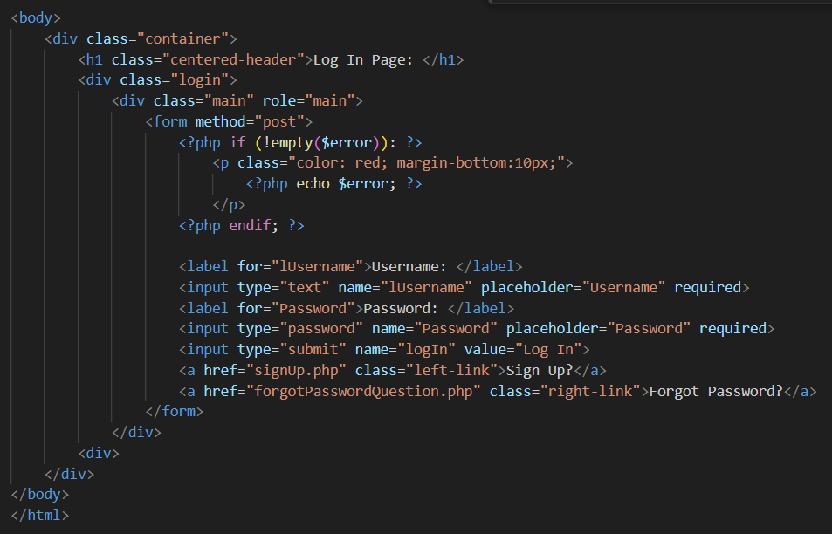
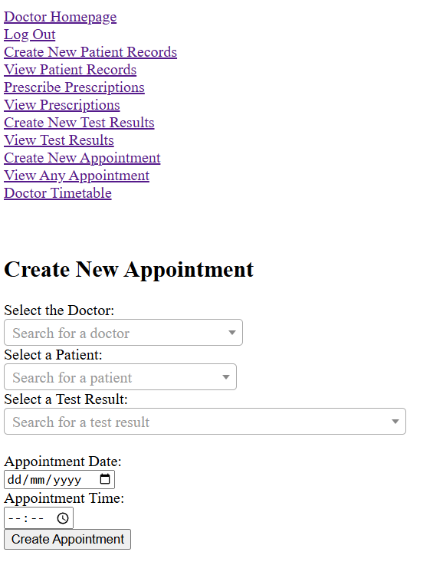 | 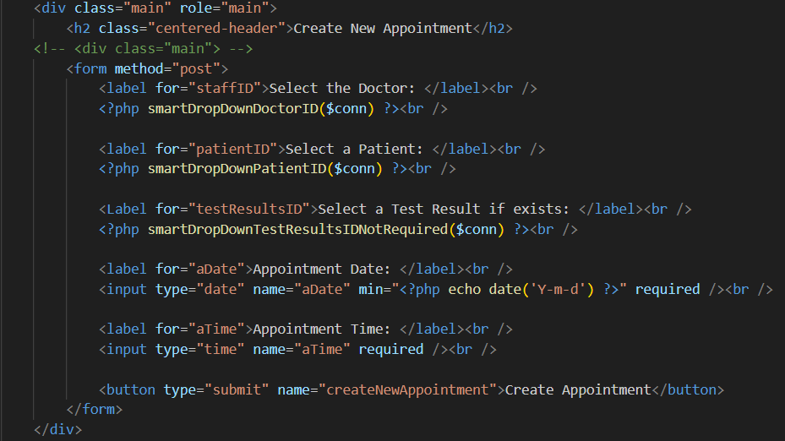
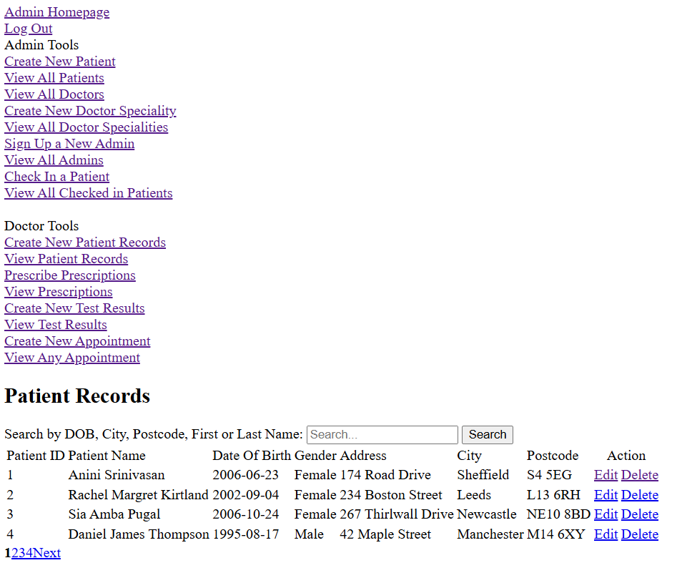 | 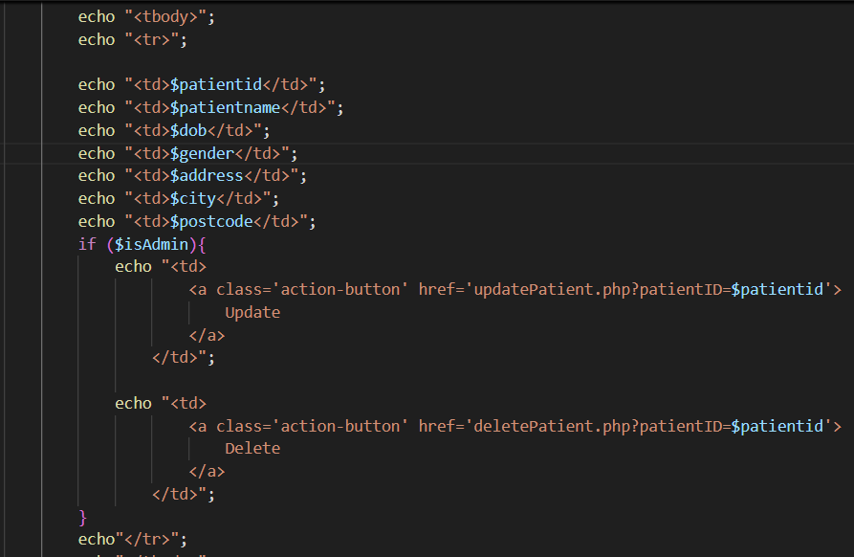  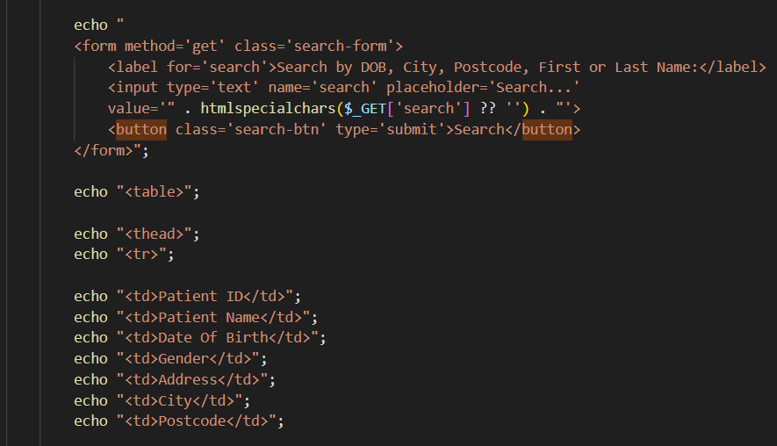

After applying CSS for Login, Create New Appointments and View All Patient Records pages.
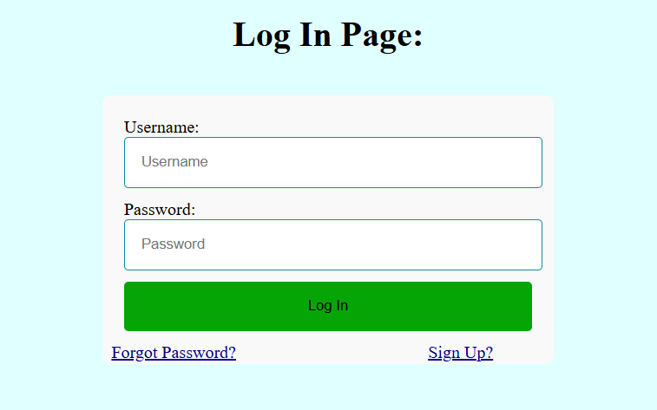 | 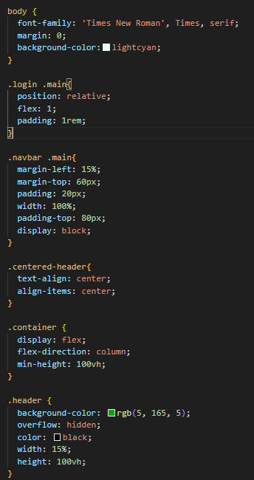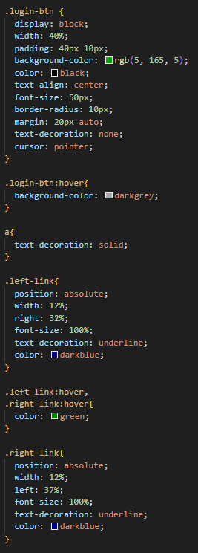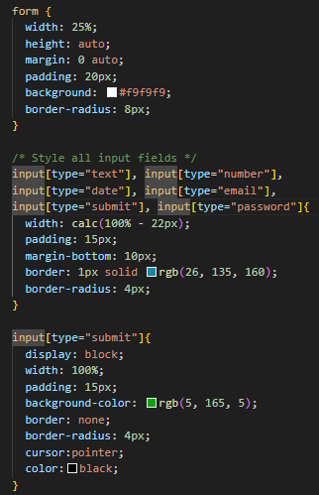
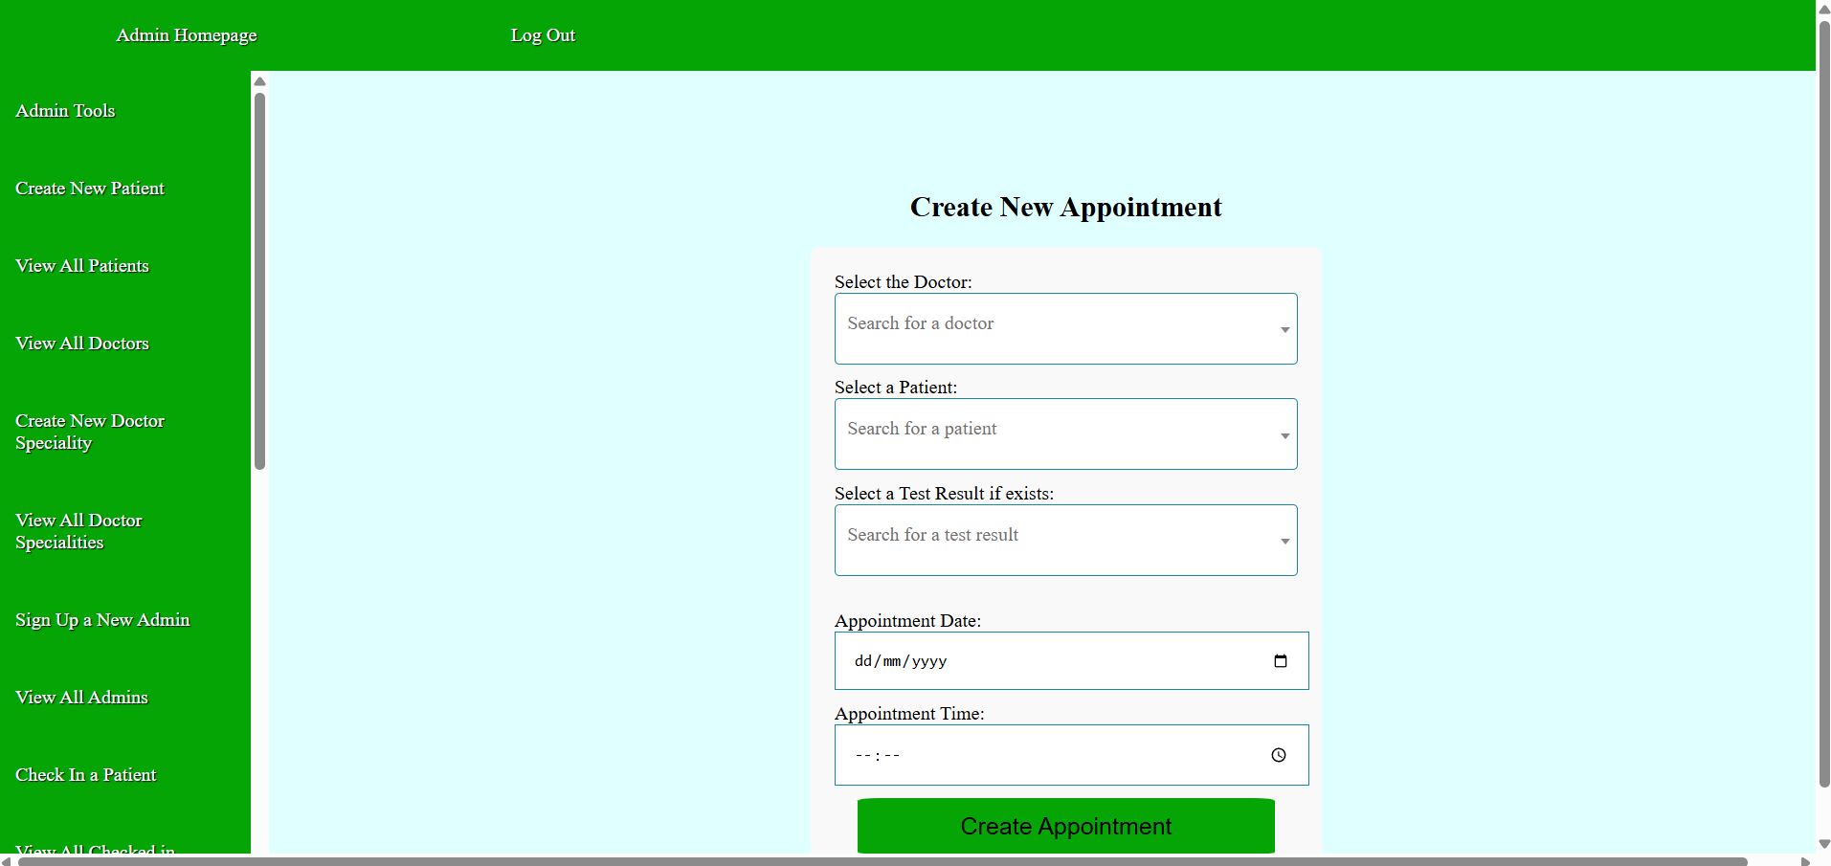 | 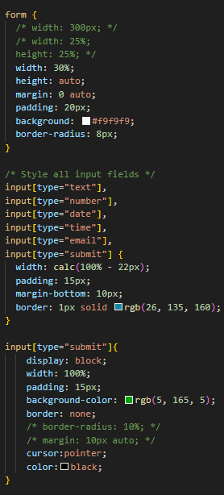  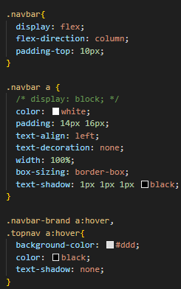  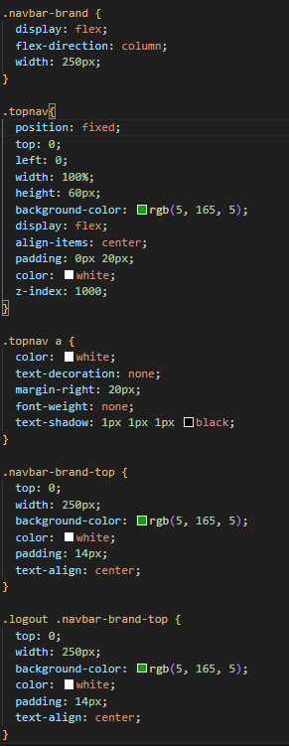
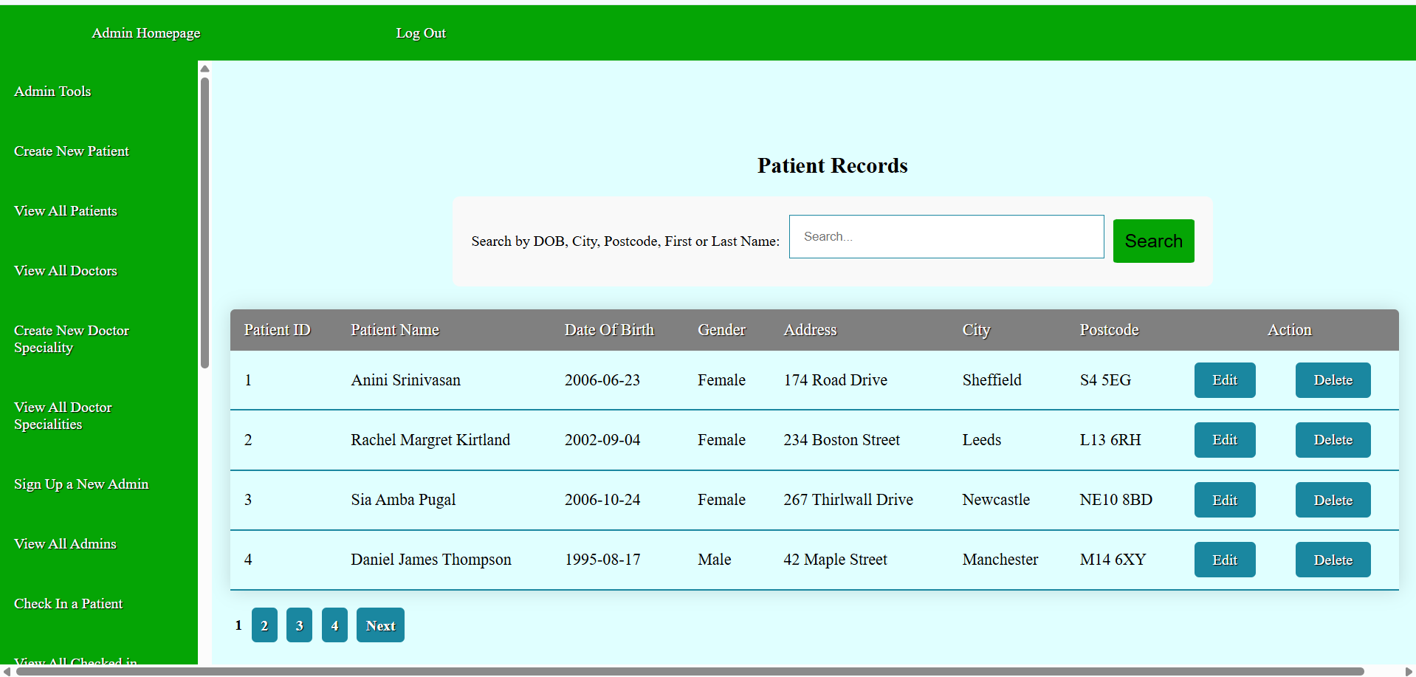 | 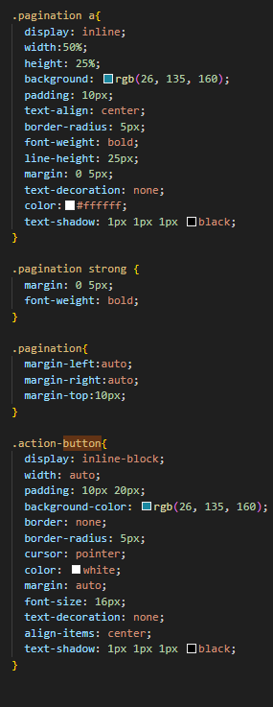  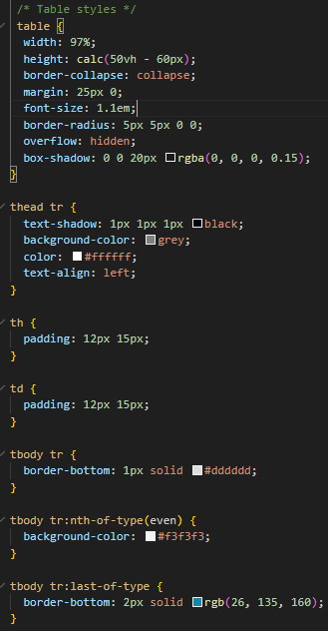

Back-End Transitioning
DDL for my project.
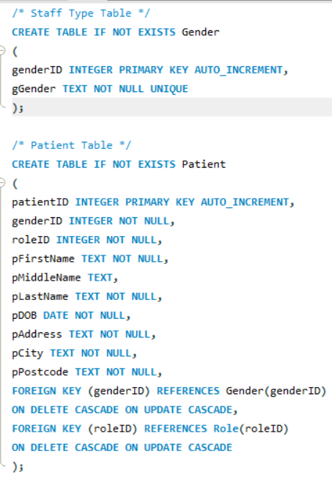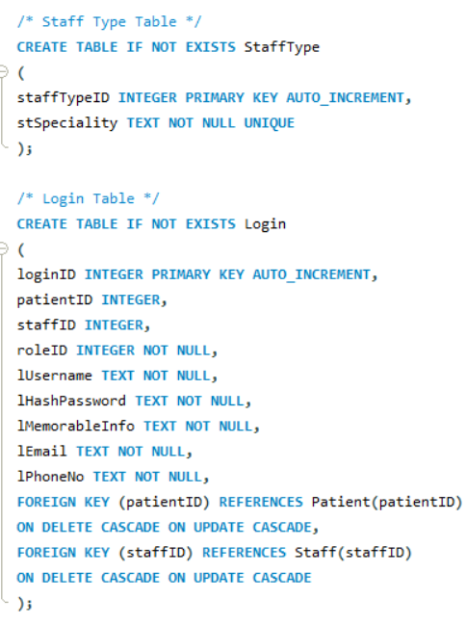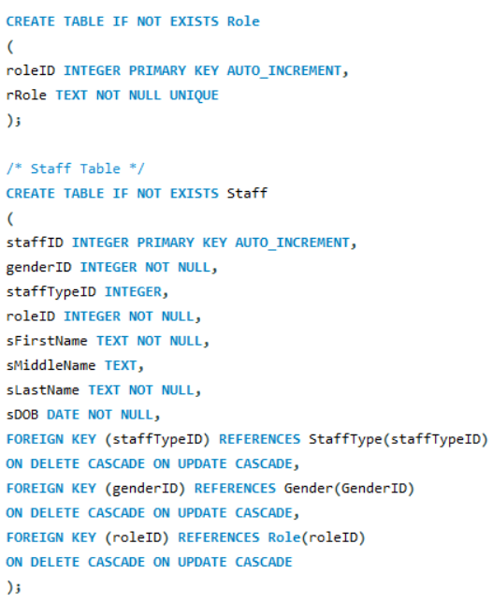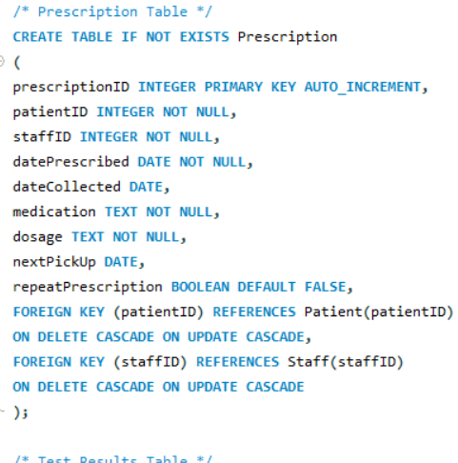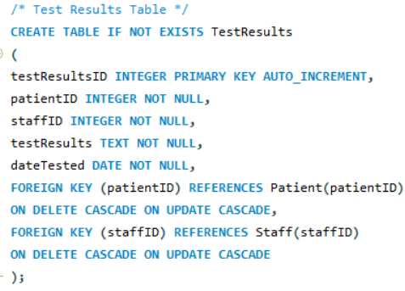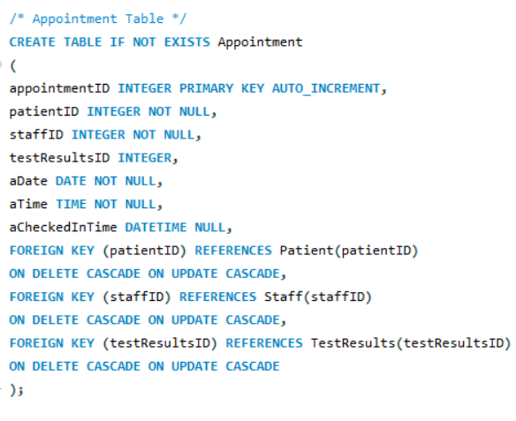

DML for my project where applicable.
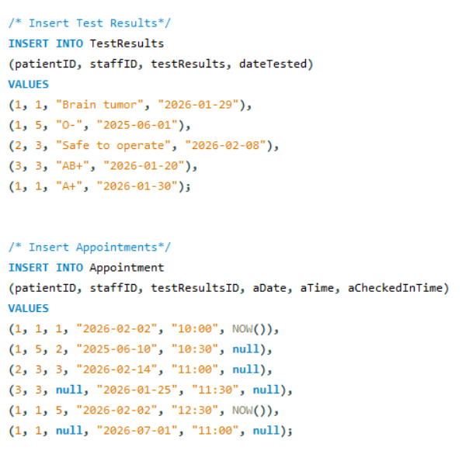

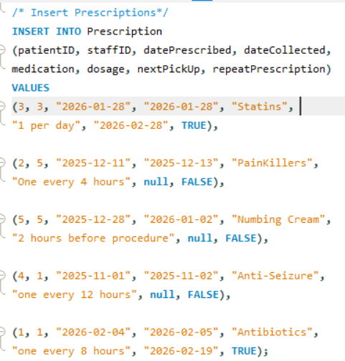

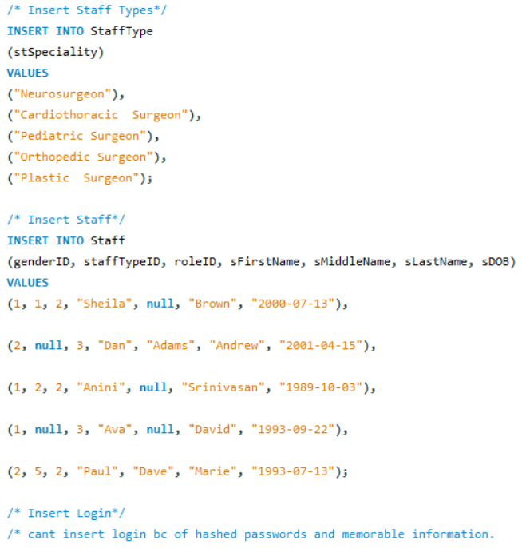
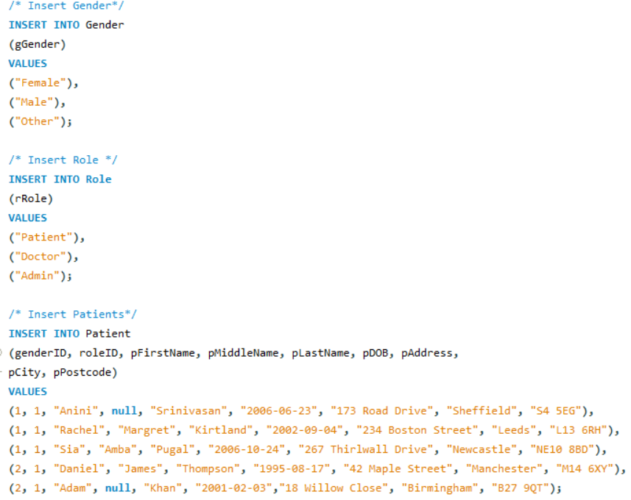

To connect between Front-End and Back-End, the following code has been utilised on Login, Create New Appointment and View Patients pages to verify user’s authenticity, create appointments for patients and view patient records to edit/delete them.
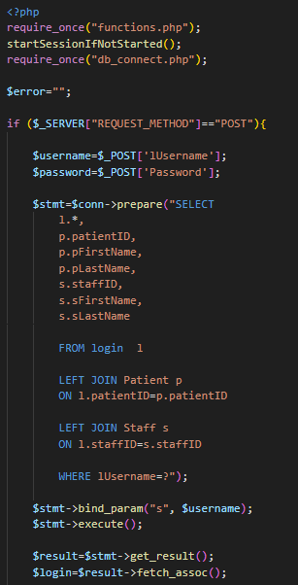

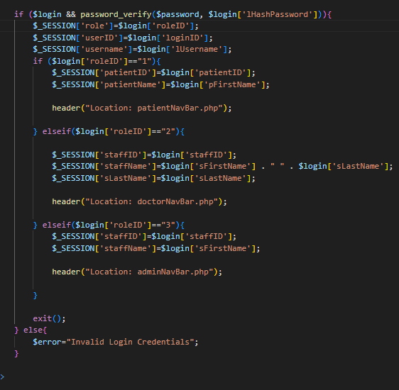

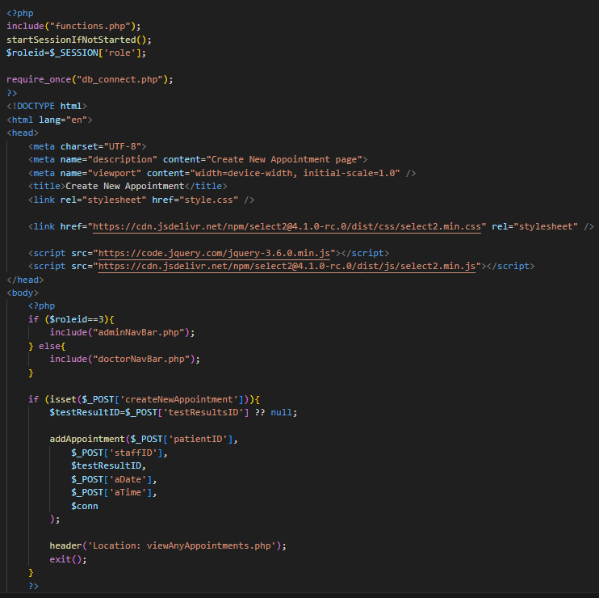

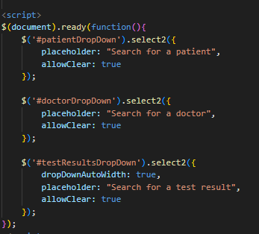

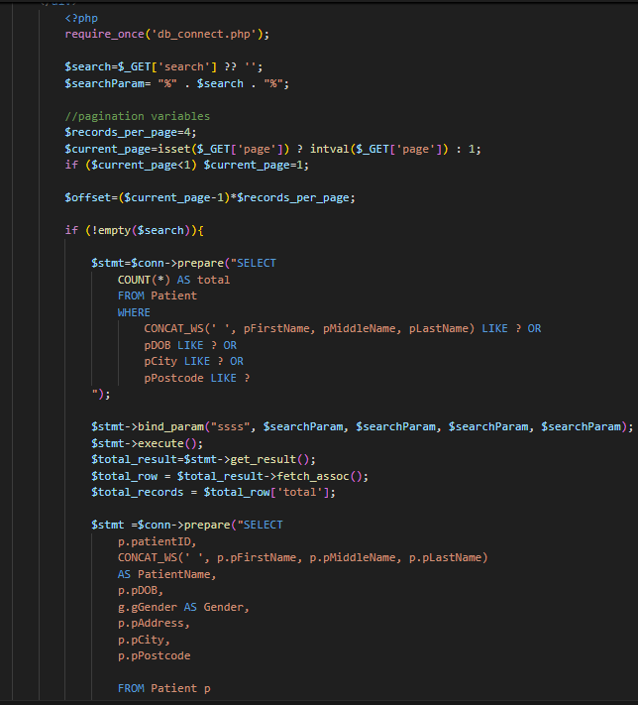

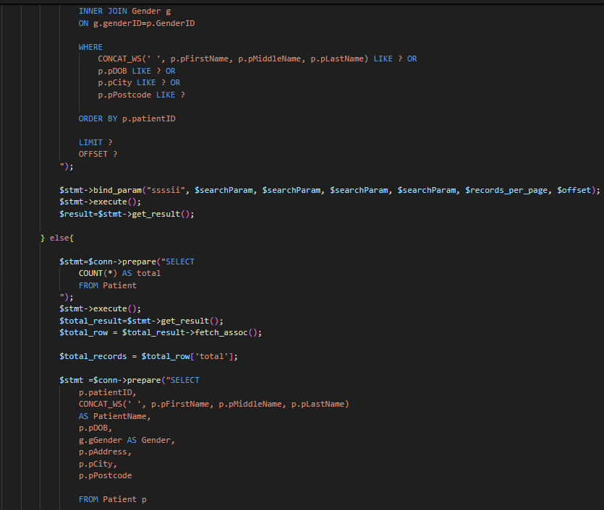
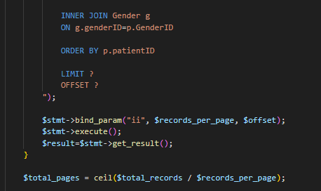

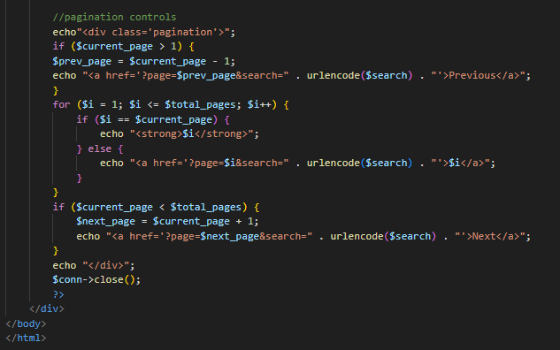

3.2 Test Description

User Story ID | Test ID | Acceptance Test | Test Description | Assumes | Expected Result | Test Result
PU-US-1 | T001-PU-US-1 | - Given the patient is on the view my medication page when they have a repeatable prescription, then the prescription should be repeated. | - Double click Chrome browser icon on desktop.  - Type localhost/hospital/  viewMyMedications.php on the URL address bar.  - The View My Medications page will be displayed.  - Click ‘repeat’ button.  - Then the Repeat Prescription page will be displayed.  - Click ‘repeat prescription’.  - A message will be displayed that says “Success!”. | Assumes patients logged in. | User will be able to repeat their prescription. | Pass
PU-US-1 | T002-PU-US-1 | - Given the patient is on the view my medications page, when they don’t have any repeatable prescriptions, then they should not be able to repeat a prescription. | - Repeat steps (1) through (3) in T001-RU-US-1  - There should be no ‘repeat’ button.  - Therefore, the user can not repeat the prescription. | Assumes patients logged in. | User will not be able to repeat their prescription | Pass
PU-US-2 | T001-PU-US-2 | - Given the patient is on the view appointments page, when they go to view their appointment, then they should be able to see the date and time of the appointment. | - Double click Chrome browser icon on desktop.  - Type localhost/hospital/  viewMyAppointments.php on the URL address bar.  - The Patient’s appointment page will be displayed.  - The patient should be able to see their appointments and information. | Assumes patients logged in. | User will be able to view their appointments | Pass
 | T002-PU-US-2 | - Given the patient is on the view appointments page, when they go to view their appointment and they don’t have any, then they should not be able to view any appointments. | - Repeat steps (1) through (3) in T002-PU-US-2  - The patient should not be able to see any appointments. | Assumes patients logged in. | User will not be able to see any appointments | Pass
PU-US-3 | T001-PU-US-3 | - Given the patient has a repeat prescription already, when they go on the view my medications page, then they should be able to view valid information about their repeat prescription. | - Double click Chrome browser icon on desktop.  - Type localhost/hospital/  viewMyMedications.php on the URL address bar.  - The View My Medications page will be displayed.  - The patient should be able to see information about their repeat prescriptions. | Assumes patients logged in. | User will be able to view information about their repeat prescriptions | Pass
 | T002-PU-US-3 | - Given the patient does not have a repeat prescription, when go on the view my medication page, then they should only be able to view information about normal prescriptions not repeat ones. | - Repeat steps (1) – (3) from T001-PU-US-3  - The patient should not be able to see information about their repeat prescriptions only normal ones . | Assumes patients logged in. | User will not be able to view information about their repeat prescriptions  only regular ones. | Pass
DU-US-1 | T001-DU-US-1 | - Given the doctor is on the view patients page, when they search valid information about the patient, then they should be able to access the patient’s record and information about them. | - Double click Chrome browser icon on desktop.  - Type localhost/hospital/  viewPatientRecords.php on the URL address bar.  - The View Patient Records page will be displayed.  - Search: ‘Sia Amba Pugal’  - Patient’s records will be showed. | Assumes doctor’s logged in. | User should be able to see patient’s records | Pass
 | T002-DU-US-1 | - Given the doctor is on the view patients page, when they search invalid credentials, then they should not be able to see the patient’s record and information about them. | - Repeat steps (1) – (3) from T001-DU-US-1  - Search: ‘Soa Amba Pugal’  - Nothing will be displayed. | Assumes doctor’s logged in. | User should not be able to see patient’s records | Pass
DU-US-2 | T001-DU-US-2 | - Given the doctor is on the prescribe medication page, when they enter valid information about the patient and medication, then they should be able to prescribe medicine to the patient successfully. | - Double click Chrome Browser icon on desktop.  - Type localhost/hospital/  createNewPrescription.php  on the URL address bar.  - The Prescribe Medication Page will be displayed.  - Enter details:  - Doctor: ‘Paul Marie (DOB: 1993-07-13)’.  - Patient: ‘Sia Pugal (DOB: 2006-10-24)’  - Date Prescribed: ‘1-1-26’  - Date Collected: ‘1-2-26’  - Medication: ‘Codeine’  - Dosage: ‘1 a day’  - Allow Repeats: ‘Yes’  - Click ‘Prescribe Medication’ button  - A message will be displayed that says “Success!” | Assumes doctor’s logged in. | User will be able to prescribe medication to a patient | Pass
 | T002-DU-US-2 | - Given the doctor is on the prescribe medication page, when they don’t fill in all the fields, then they should not be able to prescribe medicine to the patient. | - Repeat steps (1) – (3) from T001-DU-US-2  - Don’t fill in any fields.  - Click ‘prescribe’ button  - A message will be displayed that says “Please select an item in the list!” | Assumes doctor’s logged in. | User will not be not be able to prescribe medication to a patient | Pass
DU-US-3 | T001-DU-US-3 | - Given the doctor is on the timetable page, when they view their future appointments then they should be able to see everything scheduled that they have to do. | - Double click Chrome Browser icon on desktop.  - Type localhost/hospital/  timetable.php on the URL address bar.  - The Timetable Page will be displayed.  - Doctor should be able to see their timetable. | Assumes doctor’s logged in. | Doctor should be able to see their timetable. | Pass

 | T002-DU-US-3 | - Given the doctor is on the timetable page, when they try to add something to their timetable, then they should be able to. | - Repeat steps (1) – (3) from T001-DU-US-3.  - Click ‘Add An Appointment’ button.  - Enter details:  - Doctor: name of doctor who’s logged in  - Patient: ‘Adam Khan (DOB: 2001-02-03)’  - Test Result: nothing  - Appointment date: ‘08-09-2027’  - Time: ‘12:00’  - Click the ‘Create Appointment’ button.  - A message will be displayed that says “Success!” | Assumes doctor’s logged in. | Doctor should be able to add to their timetable | Pass
 | T003-DU-US-3 | - Given the doctor is on the timetable page, when they try to add something to their timetable for a day that already passed, then they should not be able to. | - Repeat steps (1) – (2) from T002-DU-US-3.  - Enter details:  - Doctor: name of doctor who’s logged in  - Patient: ‘Adam Khan (DOB: 2001-02-03)’  - Test Result: nothing  - Appointment date: ‘01-01-2026’  - Time: ‘12:00’  - Click the ‘Create Appointment’ button.  - A message will be displayed under appointment date that says “Value must be (current date) or later!” | Assumes doctor’s logged in. | Doctor should not be able to add to their timetable. | Pass
AU-US-1 | T001-AU-US-1 | - Given the admin is on the check-in page, when they enter valid information about the patient and appointment, then they should be able to check in the patient. | - Double click Chrome Browser icon on desktop.  - Type localhost/hospital/  checkInPatient.php on the URL address bar.  - The Check In Page will be displayed.  - Enter details:  - Patient: Sia Pugal (DOB: 2006-10-24)  - Make a corresponding appointment for today on create new appointment page.  - Click ‘Check In Patient’ button  - The View all Checked in Patients page will be displayed with the patient who just got checked in. | Assumes admin’s logged in. | Admin should be able to check in patient and view all checked in patients. | Pass
 | T002-AU-US-1 | - Given the admin is on the check-in page, when they enter valid information about the patient but the patient doesn’t have an appointment, then they should not be able to check in the patient. | - Repeat steps (1) – (3) from T001-AU-US-1  - Enter details:  - Patient: Sia Pugal (DOB: 2006-10-24)  - No appointment today for Sia Pugal  - Click ‘Check In Patient’ button  - A message will be displayed that says ‘Please select an item in the list’. | Assumes admin’s logged in. | Admin should not be able to check in patient | Pass
AU-US-2 | T001-AU-US-2 | - Given the admin is on the create new doctor speciality page, when they enter valid information, then they should be able to create a new speciality. | - Double click Chrome Browser icon on desktop.  - Type localhost/hospital/  createNewDoctorSpeciality.php on the URL address bar.  - The Create New Speciality Page will be displayed.  - Enter:  Speciality Name: ‘Dermatologist’  - Click the ‘Create Doctor Speciality’ button.  - You will be taken to view all Doctor specialities and speciality will be created. | Assumes admin’s logged in. | User should be able to create a new doctor speciality. | Pass
 | T002-AU-US-2 | - Given the admin is on the create new doctor speciality page, when they don’t fill in all the fields, then they shouldn’t be able to create a new speciality. | - Repeat steps (1) – (3) from T001-AU-US-2.  - Don’t fill in the fields.  - Click the ‘ Create Doctor Speciality’ button.  - A message will be displayed saying ‘Please fill in all the fields!’. | Assumes admin’s logged in. | User should be able to create a new doctor speciality. | Pass
AU-US-3 | T001-AU-US-3 | - Given the admin is on the sign up admin page, when they enter valid information about an admin, then they should be able to create an admin account. | - Double click Chrome Browser icon on desktop.  - Type localhost/hospital/  signUpAdmin.php on the URL address bar.  - The Sign Up Admin Page will be displayed.  - Enter details:  - First Name: Stephen  - Last Name: Bath  - Email: sbath123@example.com  - Phone No: 07666453577  - DOB: 19-03-2002  - Gender: Male  - Mothers Name: Anna  - Password: AnnaBath12  - Confirm password:  AnnaBath12  - Click the ‘Create Admin’ button.  - A message will be displayed that says “Success!” And will also display you username. | Assumes admin’s logged in. | User should be able to create an admin account and get admins username. | Pass
 | T002-AU-US-3 | - Given the admin is on the sign up admin page, when they enter don’t fill in all the fields, then they should not be able to create a new admin. | - Repeat steps (1) – (3) from T001-AU-US-3  - Enter nothing  - Click the ‘Create Admin’ button.  - A message will be displayed that says “Please fill in all the fields!” | Assumes admin’s logged in. | User should not be able to check in patient

4. Software and Its Presentation

4.2 The Production-Quality Software

You are expected to submit the project, including all its components (e.g., codebase), compressed in a zip file (or 7z). The file should be named “IndividualProject_StudentNo” and must be uploaded to Blackboard as directed in the relevant submission point. (e.g., IndividualProject_32212112.zip)

4.3 Video Presentation

https://shu.cloud.panopto.eu/Panopto/Pages/Viewer.aspx?id=4e49aebe-42a1-4976-a393-b442015ca50b

5. Evaluative Report on Legal, Social, Ethical and Professional Issues

5.1 Relevant Issues

One Legal issue in my project stems from how I handle and store user login information. Since I collected a user’s email, phone number, mother’s name and their own name, it must be processed in a lawful manner and should not be displayed to the public.

One of the social issues my project could face is waiting times in healthcare. This is because they can delay treatment to the correct people and even make negative impacts on patients’ health. Another thing is my website will be used by a variety of people, meaning that I need to make it widely accessible for many people.

An Ethical Issue in my project would be how patient information about medical records is displayed. I have not allowed other patients to modify or access it, only doctors and admins. It would also be unethical to have invalid information about patients in my project.

Making sure that only authorised users can access certain features is a professional issue. It’s important that only specific users can access sensitive information and perform specific actions.

5.2 Discussion
One way I have protected the Legal issues is by hashing all passwords and memorable information that is put through the system. One major example of passwords getting leaked was The Mother Of All Breaches (Early 2024) where 26 billion records were leaked across many popular social media platforms.⁵ This ensures that accounts won’t be hacked as the hashing algorithm is always improving and they say “Note that this constant is designed to change over time as new and stronger algorithms are added to PHP. For that reason, the length of the result from using this identifier can change over time.”¹ I make sure that themselves and admins are the only people allowed to modify their personal information, excluding passwords and memorable information.
One way I have overcome the social issues is by making sure that admins can only check in a patient if they have an appointment for that day, helping staff manage patient flow and reduce delays. This is done by including a check-in feature and appointment tracking. The NHS highlights the importance of reducing wait times and improving patient flow to ensure timely care². Accessibility issues were an important part when designing my website as well, as the ACM code of Ethics states “Technologies and practices should be as inclusive and accessible as possible”³ I aimed to make it quite accessible by using contrasting colours and making buttons and text a large readable font so that older people can easily read everything.
One way I have prevented ethical and professional issues is by making sure that only admins and doctor are allowed to view and modify other patients record. I have done this by using roleID to ensure that only doctors and admins have access to all patient records after logging in with staff credentials. This keeps patient information confidential and the General Medical Council say, “Our core guidance, Good medical practice, makes clear that patients have a right to expect that their personal information will be treated as confidential”.⁶ Checking roleID ensures that patient’s information is kept secure and only the correct people are able to access that information. This is inline with the NHS about how confidential patient information is protected.⁴

6. Incorporation of formative feedback

Individual Project
Week, Name and Date | Feedback Received | Action Taken
Week 1 – Mehmet  21/01/26  22/01/26 | Shorten acceptance stories to make them more readable.  Make excalidraw pages match my user stories and some acceptance tests. | Made them as short as possible whilst still getting the full message across.  Did a success and fail screen for both log in and sign up.  Also created a patient and doctor sign up page as follows my user stories.
Week 2 -Mehmet  28/01/26  29/01/26 | Add login table. Correct some relationships.  Make link between TestResults table and Appointment table | Added a login table, corrected the relationships in my table that were wrong.  Made relationship between the two tables.
Week 3 – Mehmet  05/02/2026 | Use AI to help with coming up with dummy data | Used AI to generate the rest of my dummy data for database.
Week 4 -Mehmet  12/02/2026 | Research more about social, ethical and personal issues. | Researched more about SEPI.
Week 5 -Mehmet  18/02/2026  19/02/2026 | Focus on completeing the system.  Do test descriptions | Made a lot of progress with completing the system.  Did all test descriptions.
Week 6 –Mehmet  25/02/2026 | Do Video and LSEPI and rest of acceptance test results. | Completed LSEPI, acceptance test results and video.

7. Use of AI declaration

No AI has been used throughout my project except for when I declared it in week 3 on the feedback section where I was advised to do so.

8. References
¹ PHP, https://www.php.net/manual/en/function.password-hash.php
² NHS, https://nhsfitforthefuture.campaign.gov.uk/?gclsrc=aw.ds&gad_source=1&gad_campaignid=23492403356&gbraid=0AAAABCq2dITLgmVUlKZYThygp4xEE_JOt&gclid=CjwKCAjwtcHPBhADEiwAWo3sJnTicoHhjDx-qkDpVhEOJfxVD_jHafGKHTEtssrjN3qwBhtUwdZr8BoCPAYQAvD_BwE
³ACM Code Of Ethics Section 1.4, https://www.acm.org/code-of-ethics
⁴ NHS How confidential patient information is protected,
https://www.nhs.uk/your-nhs-data-matters/where-confidential-patient-information-is-used/
⁵ The MOAB https://cybernews.com/security/billions-passwords-credentials-leaked-mother-of-all-breaches/ (Published: 22 January 2024, Last Updated: 30 June 2025, Author: Vilius Petkauskas Deputy Editor)
⁶ General Medical Council https://www.gmc-uk.org/professional-standards/the-professional-standards/confidentiality/about-this-guidance

