### **Programmable-Video Bot (a Slack App)**

Type "help" into the @Programmable-Video Bot - an app you need to add in slack. Use the commands based on your own video logs based on SIDs from the video react demo app.

Please use every command at least twice with various switches. Take screenshots and/or send the pop-out shareable (make sure you allow it) URLs; add these to the GH Repo and file.

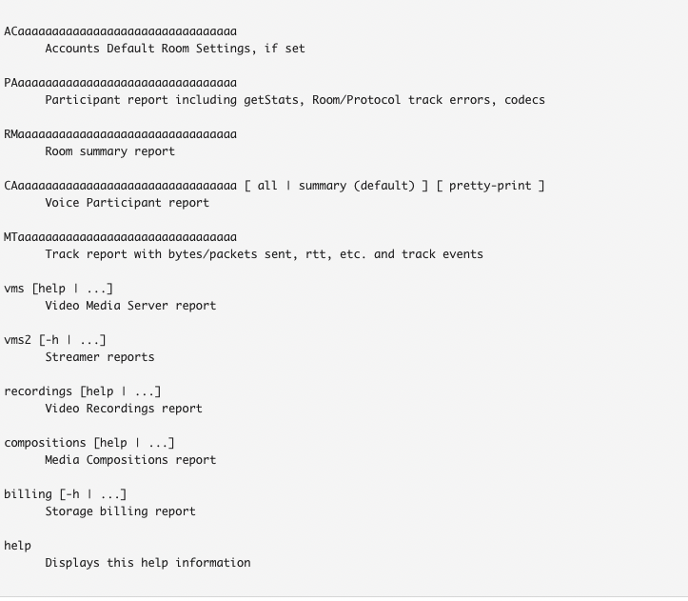

**Room SID : RMb8029e34bd793091c86ccbb8b04411df**

<https://twilio.enterprise.slack.com/files/WJ2S02S02/F046QRAH3FS/rmb8029e34bd793091c86ccbb8b04411df-summary.log>

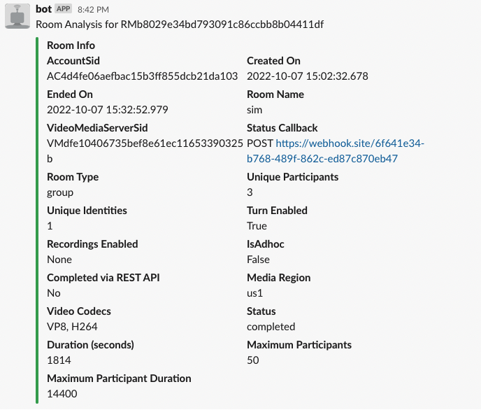

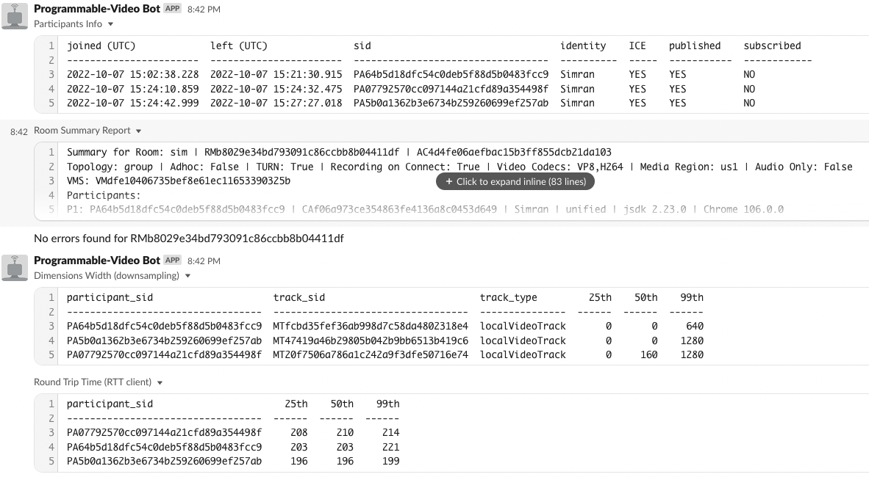

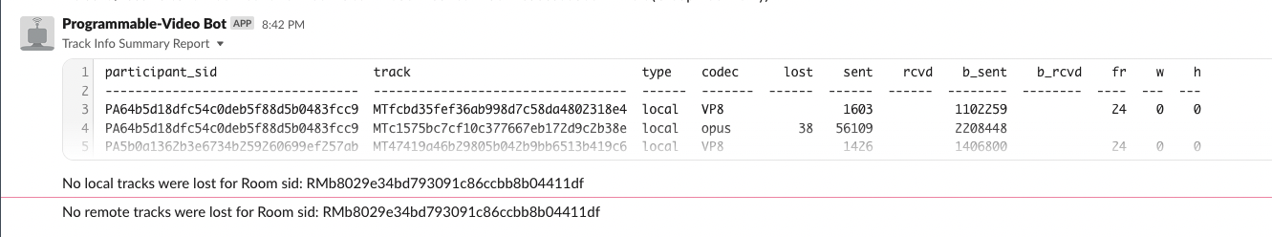

+++++++++++++++++++++++++++++++++++++

**Account SID : AC4d4fe06aefbac15b3ff855dcb21da103**

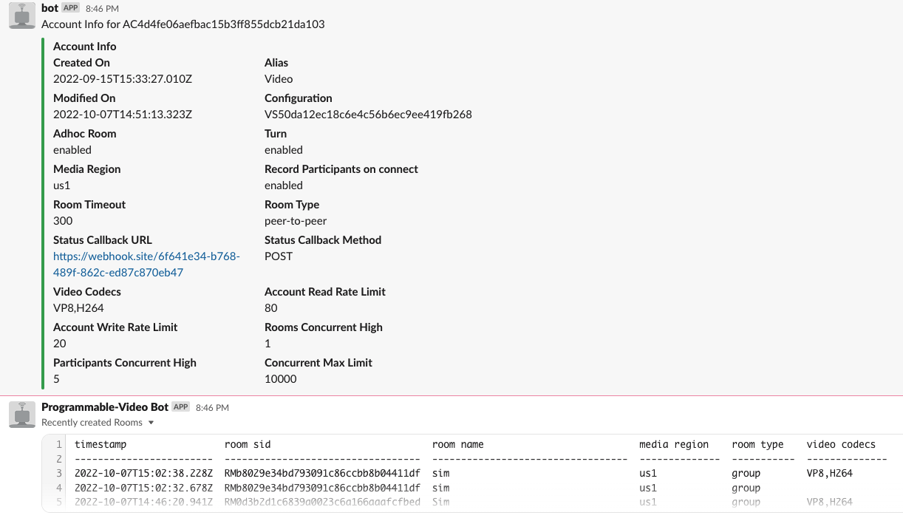

+++++++++++++++++++++++++++++

**Participant sid : PA64b5d18dfc54c0deb5f88d5b0483fcc9**

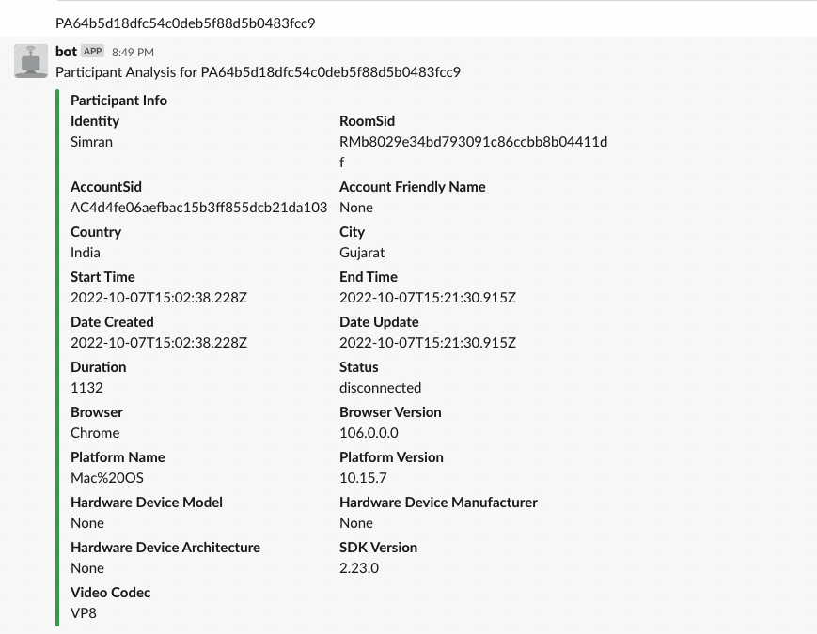

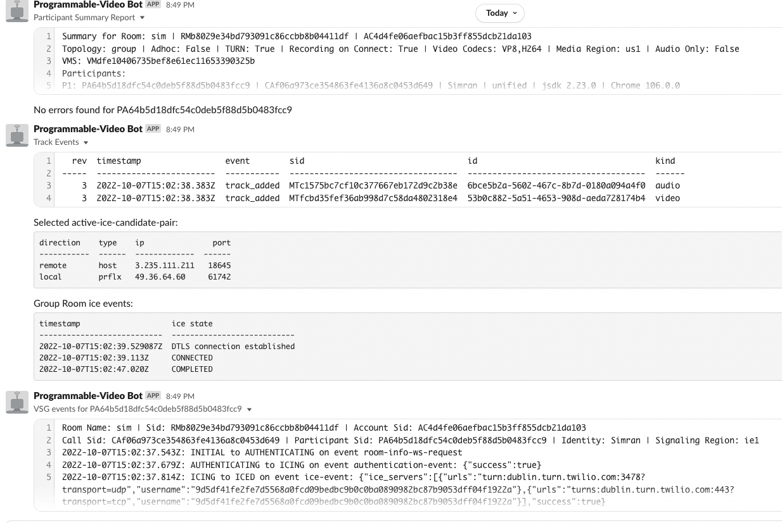

+++++++++++++++++++++++++++++++++++++

**Call Sid: CAf06a973ce354863fe4136a8c0453d649**

Room Name: sim | Sid: RMb8029e34bd793091c86ccbb8b04411df | Account Sid: None

Call Sid: CAf06a973ce354863fe4136a8c0453d649 | Participant Sid: None | Identity: None

+++++++++++++++++++++++++++++++++++++

**Media track : MTfcbd35fef36ab998d7c58da4802318e4**

event enabled priority timestamp

-------------------- --------- ---------- ------------------------

connected with track True standard 2022-10-07T15:02:38.383Z

removed track 2022-10-07T15:02:50.998Z

++++++++++++++++++++++++++++++++++++++

Recordings --room-sid RMb8029e34bd793091c86ccbb8b04411df

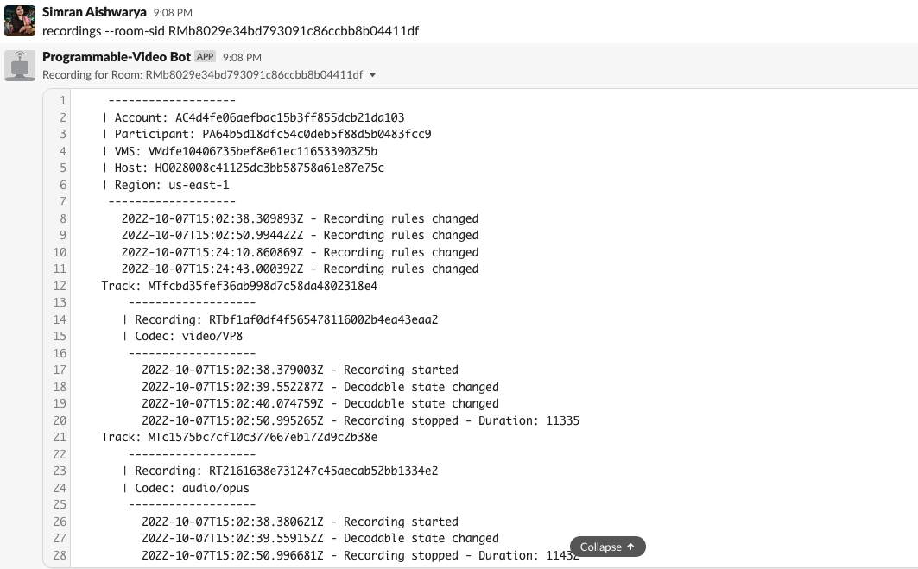

+++++++++++++++++++++++++++++++++++++++++++

**recordings --recording-sid RTbf1af0df4f565478116002b4ea43eaa2**

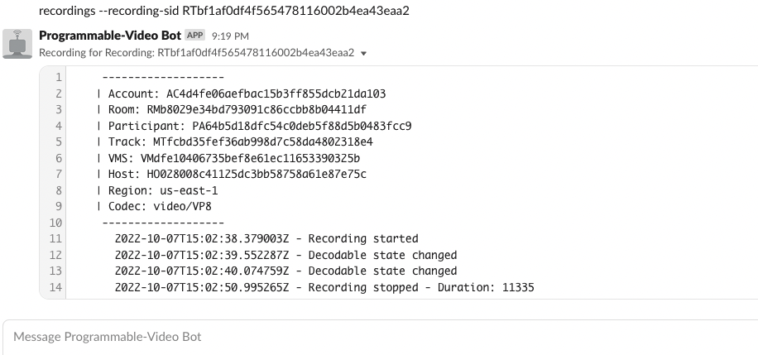

+++++++++++++++++++++++++++++++++++++++++++

compositions --sid CJe4a466ab0d1f79a99246478def411f8f --account-sid AC4d4fe06aefbac15b3ff855dcb21da103

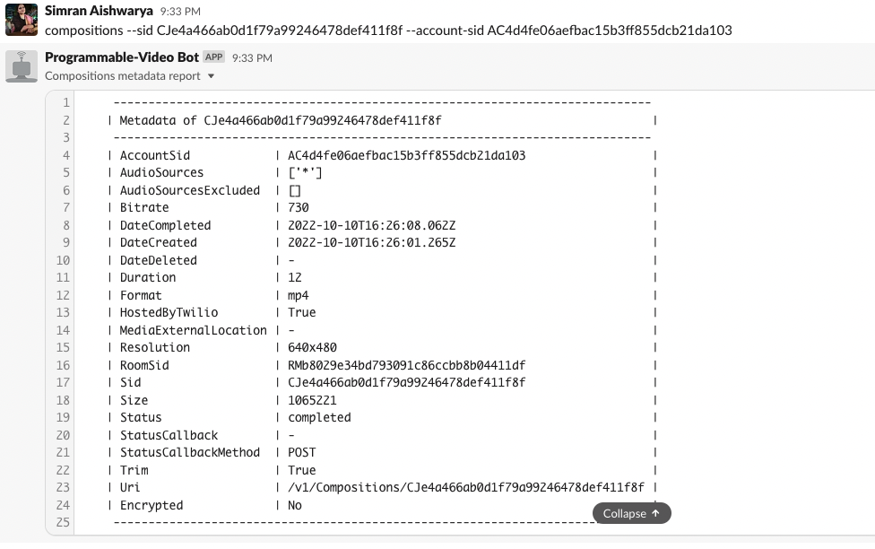

+++++++++++++++++++++++++++++++++++

**vms2 rooms summary subscribe --sid RMb8029e34bd793091c86ccbb8b04411df**

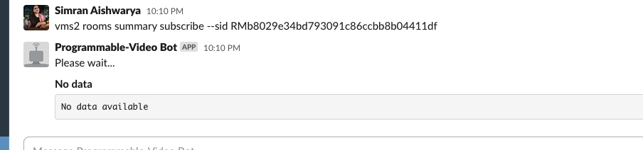

+++++++++++++++++++++++++++++++++++++++++

**vms --room-sid RMb8029e34bd793091c86ccbb8b04411df**

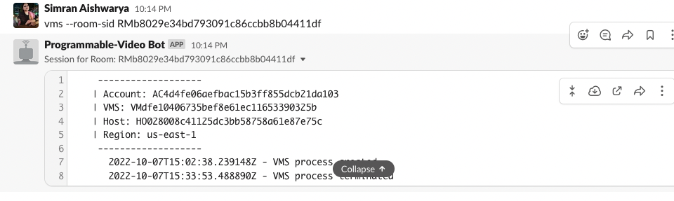

++++++++++++++++++++++++++++++++++++++++++

### **Media Recordings Bot (a Slack App)**

1> help

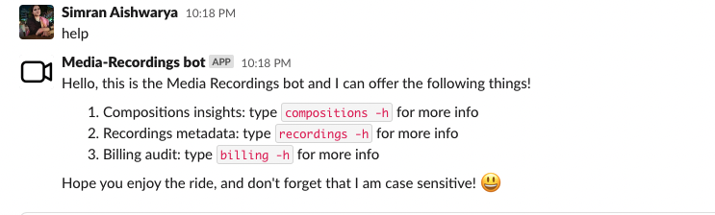

2> compositions -h

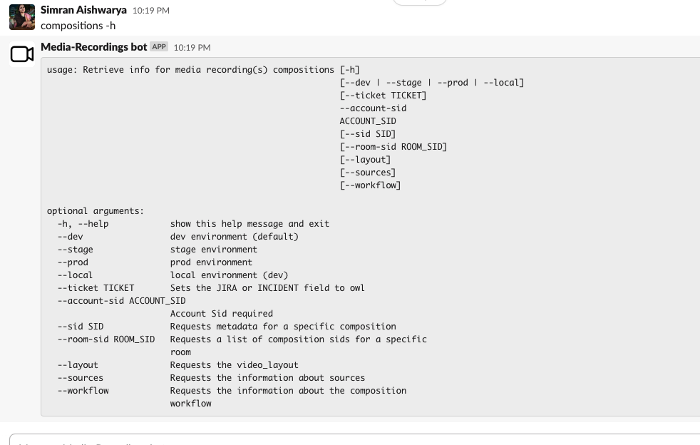

3> compositions --sid CJe4a466ab0d1f79a99246478def411f8f --room-sid RMb8029e34bd793091c86ccbb8b04411df --account-sid AC4d4fe06aefbac15b3ff855dcb21da103

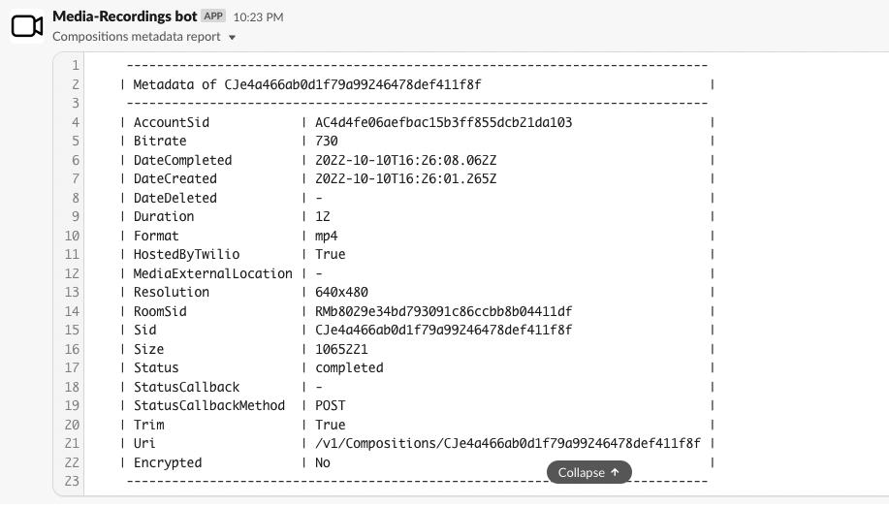

4>

recordings --account-sid AC4d4fe06aefbac15b3ff855dcb21da103 --room-sid RMb8029e34bd793091c86ccbb8b04411df

<https://twilio.enterprise.slack.com/files/W019YNYR5U0/F046AKF8LLC/recordings_metadata_report.txt>

