Task 1

Change Index to sdki-rooms\* create a "Discover URL" that displays media region, codecs, vms server sid, whether the participant was "recorded on connect" for all of the participants in one of your group rooms. Add shareable short URL for Kibana Link to Document.

<https://kibana.us1.eak.twilio.com/video/goto/e78213c6cb8c93bf303694b2d6e1e45c>

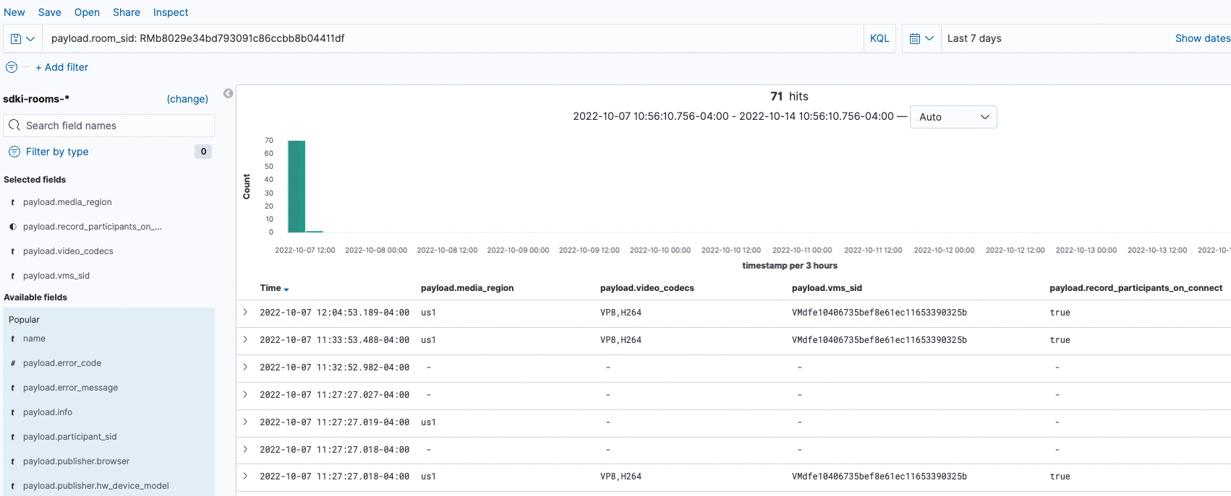

TASK 2

Change Index to video-insights\* create a "Discover URL" that displays all device, manufacture, OS, browser version, SDK version information for the participants. Add shareable short URL for Kibana Link to Document and take a screenshot of using Kibana and add to GitHub Document.

<https://kibana.us1.eak.twilio.com/video/goto/10a00ba996fdf1ae93dd4421743ba280>

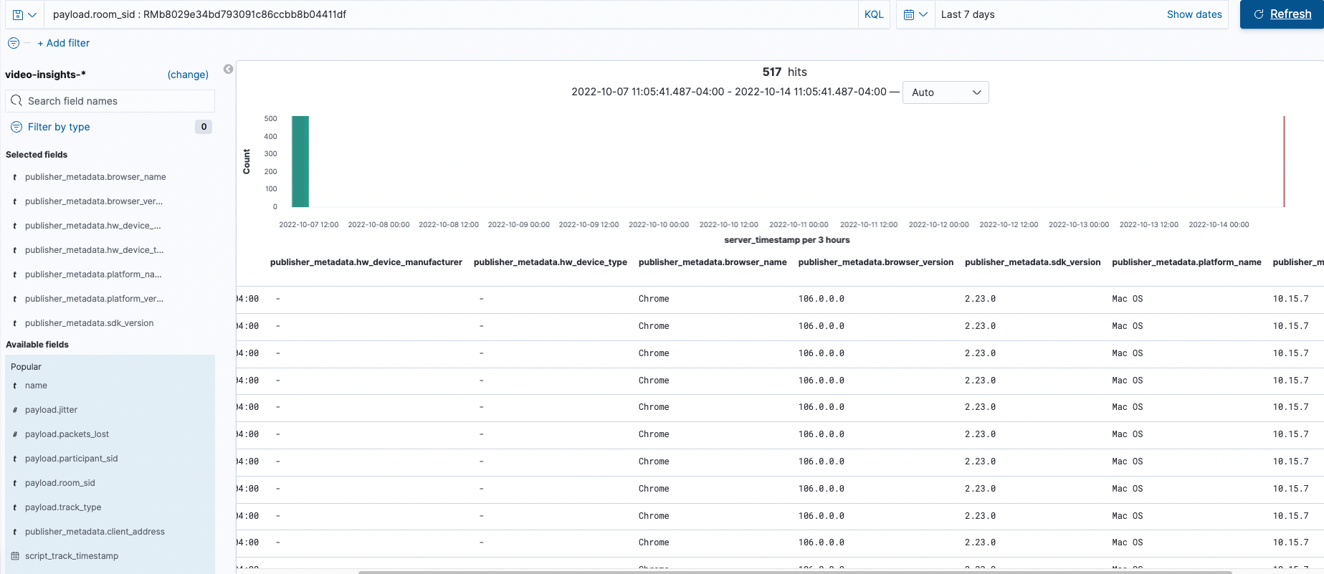

Task 3

Change Index to video-vms-reports\* create a "Discover URL" that displays all actual bandwidth for each participant in one room. Add shareable short URL for Kibana Link to Document and take a screenshot of using Kibana

P1: PA64b5d18dfc54c0deb5f88d5b0483fcc9

P2: PA07792570cc097144a21cfd89a354498f

<https://kibana.us1.eak.twilio.com/video/goto/a9dc6d21b038216c37630a777804539c>

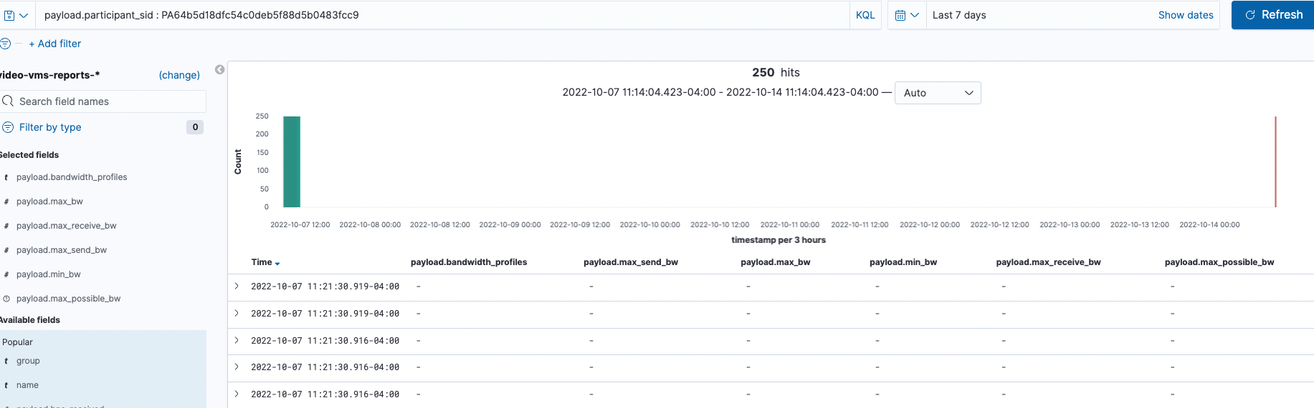

>>

<https://kibana.us1.eak.twilio.com/video/goto/d3a77c95f88a9730fc2522798eb4ce01>

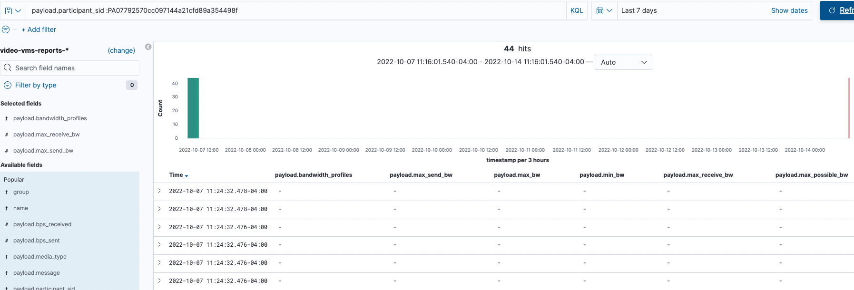

Task 4

Change Index to video-voice-signaling\* create a "Discover URL" that displays Participant SID, Call SID, Room SID, Identity, Room Name for the PSTN participant in one room. Add shareable short URL for Kibana Link to Document and take a screenshot of using Kibana and add to GitHub Document.

<https://kibana.us1.eak.twilio.com/video/goto/d4470340cce223f9de61c216eb027a79>

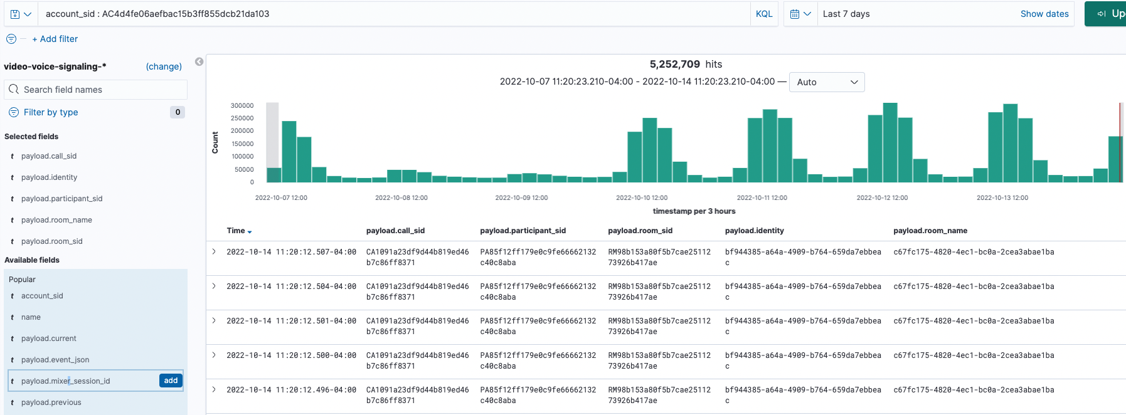

TASK 5

Create a "Discover URL" that displays all the Network Quality scores for all participants in one of your group rooms. Add shareable short URL for Kibana Link to Document and take a screenshot of using Kibana and add to GitHub Document.

<https://kibana.us1.eak.twilio.com/video/goto/c0d63fa4144333b05afa279fe15c5a49>

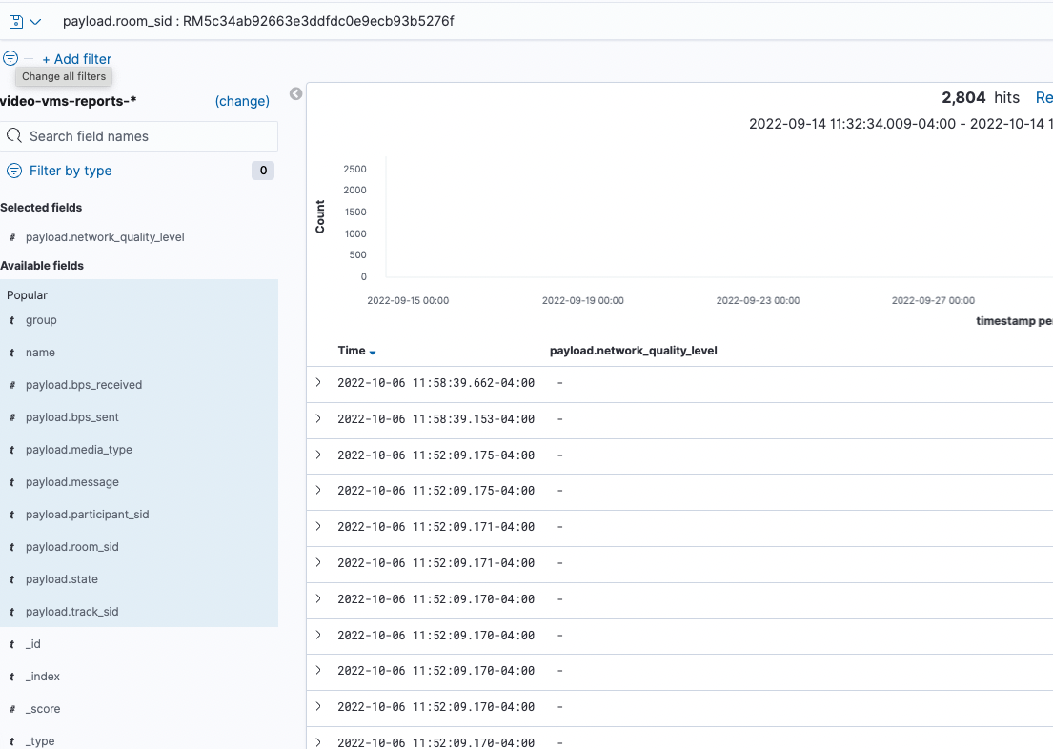

TASK 6

Create visualization for the Network Quality Scores. Add shareable short URL for Kibana Link to file and take a screenshot of using Kibana and add to GitHub Document.

<https://kibana.us1.eak.twilio.com/video/goto/346d6deb4e755127032e2445fab7ebc4>

