Task 1

**Using a SQL Query, find your API Request for the compositions you created. Add SQL Query and a shareable link to Google spreadsheet with the results from Quantico to a GitHub Document.**

SQL Query used :

select * from `qtco-customer-support.prod.app_api_access_last_7_days`

where account_sid = 'AC4d4fe06aefbac15b3ff855dcb21da103'

and uri = "/Compositions"

order by timestamp desc

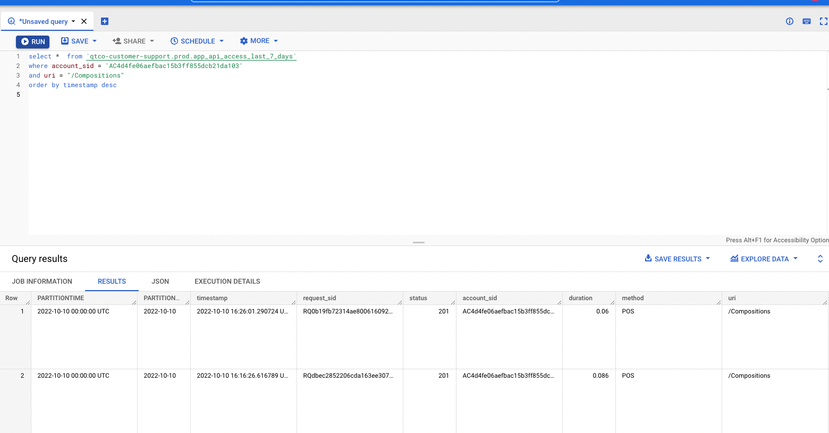

Sharable Link: <https://console.cloud.google.com/bigquery?sq=359385078535:f2d214a25f444d47ab2e41d6c9cd0c3c>