Task :

Take a screenshot with [XCode](https://developer.apple.com/xcode/) set up and the <https://github.com/twilio/twilio-video-app-ios> iOS SDK Ahoy! Demo App loaded. Taking screenshots as you go, launch the emulator, join a group room, and join the room created by the iOS app from your browser using the <https://github.com/twilio/twilio-video-app-react> JS SDK Ahoy! Demo App. Post SIDs and screenshots to the GitHub Document.

Step 1

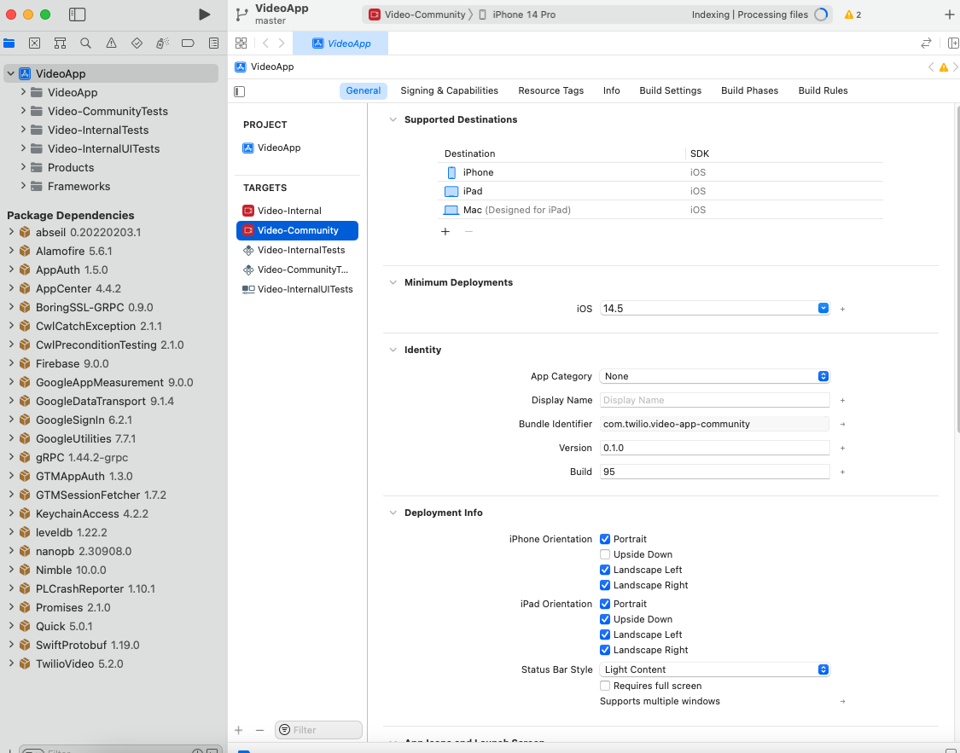

>>

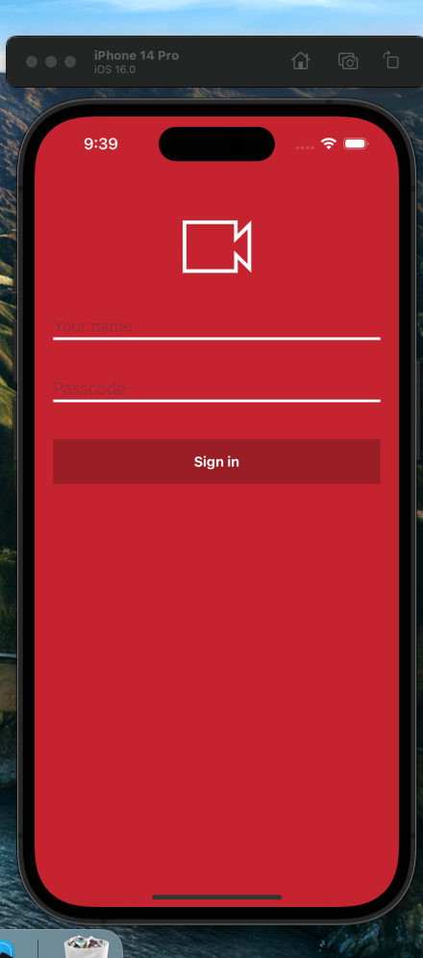

>>

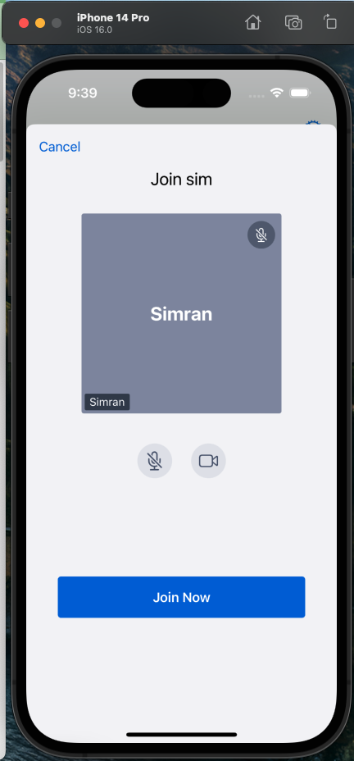

>>

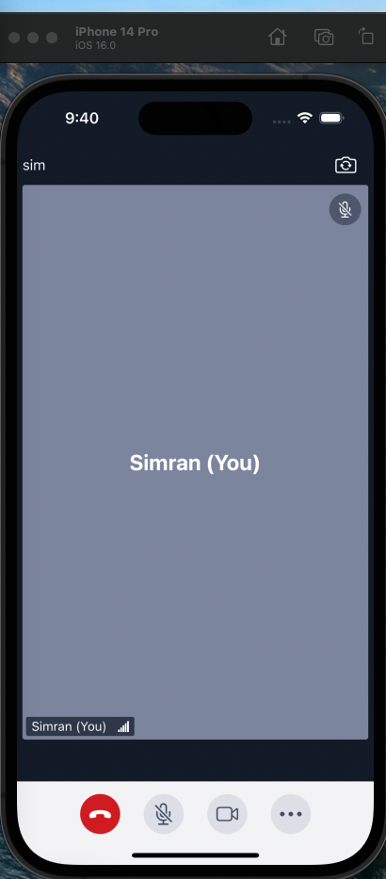

++++++++++++++++++++++++++++

Step 2

**Room Name: sim**

**SID: RMbc573f345790583223719ab1711c14bd**

