Assignment-1 Digital Alarm clock
COS 10004
Tuesday ATC-627 2:30 P.M
Name: Nur E Siam
Student ID: 103842784

Description of the circuit
The logic circuit is a Digital Alarm Clock. The whole circuit is consisted of 4 parts and divided into 4 circuits and connected with 4 switches. If we turn on the switch-1 and switch-2, in the circuit the minutes starts to count with the switch one it counts till 9 and with switch-2 it counts till 5. So, when in switch-1 circuit hits 9 switch-2 circuit switches to 1 and continue counts to 5, when both circuit counts to 59 which is an hour then circuit 3 starts working and starts to count till 0 to 9 which indicates hours, when the circuit 3 goes to 9th hour to make it 10th hour the circuit-4 starts working only gives us 0 and 1. Circuit-4 remains 0 up until circuit-3 counts 9, when the counts on circuit-3 hits 0 again that moment circuit-4 gives count 1 to give us the 10th hour and the moment the whole circuit gives us the 12th hour it all resets to 00 hour to give us A.M and P.M.
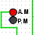
AM/PM

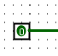
Switch
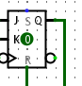
J-K flipflop
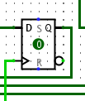
D-flipflop
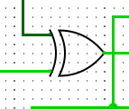
XOR- Gate
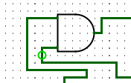
AND gate
An Outline of the design
To make this digital alarm clock logic circuit I had to use 3 basic types of gates those are AND Gates, OR Gate and XOR Gates. And, to build this circuit I had to use 2 types of memories, those are D- FLIPFLOP and J-K FLIPFLOP and to indicate the A.M and P.M I had to use LED as outputs. Also, To show the time I used HEX digits. Moreover, I used a D-flipflop and an AND gate to connect circuit-3 and circuit-4, And the whole is connected with an OR gate, an AND gate and with an XOR gate for setting time and also the clock is connected there too.
Assumption
How all the gates work was shown in the lecture videos. So, I have made the clock with no assumptions as far my knowledge goes.
UNSOLVED PROBLEMS
My set-alarm is not working properly, and I could not able to connect my P.M to LED as it was mentioned in the assignment outline that I must switch color.
SCREENSHOT OF THE CIRCUIT
