#!/bin/bash
yum update -y
amazon-linux-extras install -y lamp-mariadb10.2-php7.2 php7.2
service httpd start
yum install -y httpd mariadb-server php-mbstring php-xml
systemctl start httpd
systemctl enable httpd
usermod -a -G apache ec2-user
chown -R ec2-user:apache /var/www
chmod 2775 /var/www
find /var/www -type d -exec sudo chmod 2775 {} \;
find /var/www -type f -exec sudo chmod 0664 {} \;
echo "<?php echo '<h2>Welcome to COS80001. Installed PHP version: ' . phpversion() . '</h2>'; ?>" > /var/www/html/phpinfo.php

Steps:
1]create VPCs ---VPC only
- name properly = [1st-initial] [last]VPC
- Edit DNS enable both
- Subnet

Subnet | Ip | Availability zone
Public Subnet 1 | 10.0.1.0/24 | 1a
Private Subnet 1 | 10.0.3.0/24 | 1a
Public Subnet 2 | 10.0.2.0/24 | 1b
Private Subnet 2 | 10.0.4.0/24 | 1b

2] internet gateway --VPN gateway
- Name = internet gateway
- Attached to your VPC

3]routing table
- Only 2 is ok ---> one for 2 pub subnets/ 2for private subnets
- subnet association = explicit only***

4]security groups
- inbounds Rules only
**WebsvrSG
- policy: ICMP , custom = select TestInstance security grp manually (dont enter ip address)
- Outbound rules leave as default

5]create 2 EC2 instances

5.0 create ….
*public elastic IP for web server
**key pairs for both web server (.pem), test instances

5.1 create bastion/web server (select security grp)
5.2 create test instance (select security grp)

5.3 Web server instance--->new EIP**
- Public IP never changed = static IP--->assign to instance

5.4 download (1)putty (2) puttygen (3)pegeant
5.5 open puttygen
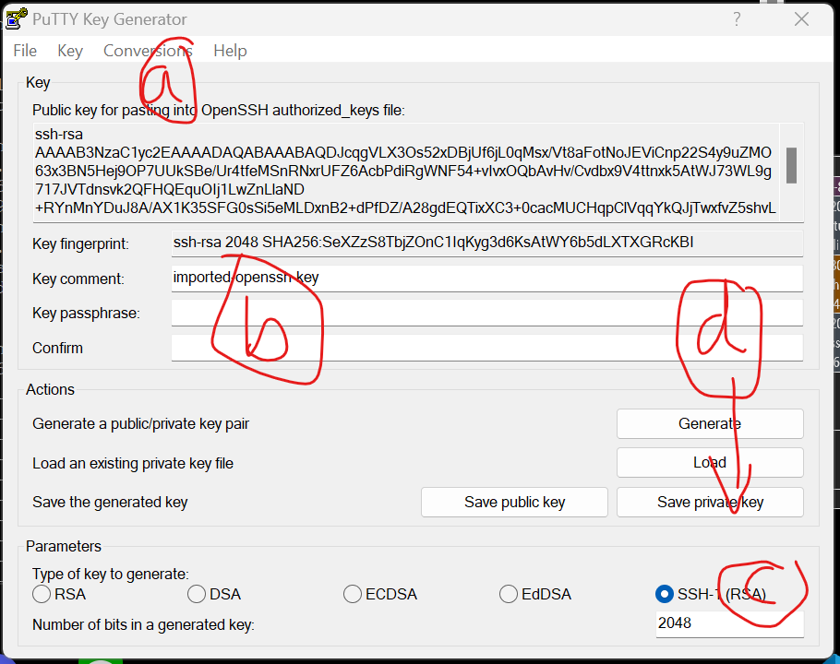
(a) conversion>>import key ------upload pem file
(b)enter pwd
(c ) select SSH(RSA)
(d)click save private key
5.6 double click pegeant
5.7 double click the VM
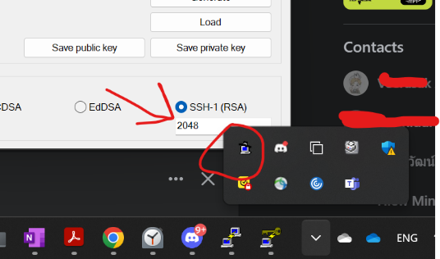

5.8 add key. Enter pwd. Click close
5.9 open putty
-host name = bastion/web server ipv4
-connection = 30
-ssh>>auth = select allow agent forwarding
-don’t upload private key file
-click open
5.10 login as ec2-user
5.11 ssh ec2-user@[Testinstance_privateipv4]
5.12 ping private IP of web server

6] create DB =RDS instance
--In RDS
- Create security group
  - Enter name and descri
- Select avai zone 1b, 1b
  - Select sec group = pri1, pub2
- Create DB
  - default
    - Standard
    - Mysql
    - 8.0.34
    - Free tier
  - Settings
    - Name, credential (admin + pwd)
  - Connect
    - Compute resrc= connect EC2 + Ec2 instance webserver
    - DB subnet grp =db_subnet_grp (one created bf)
    - Public access = no
    - VPC sec grp = choose existing (DBinstSG)
  - Addition
    - Initial database name: = anything (may be no/yes. depends)
    - Uncheck Enable automatic backups.
    - Uncheck Enable encryption

- Wait it create done
- Copy Endpoint = db-instance.cgxancfefc4w.us-east-1.rds.amazonaws.com

7)connect to phpmyadmin
- Follow steps in 'install phpmyadmin pdf'
- Ssh webserver like first time and enter install php command
- Open winscp (don't forget select allow agent forwarding and no upload)
- Eidt config.sample.inc.php
- Access to phpmyadmin--------URL = [websvr public DNS]/phpmyadmin

8)create table on phpmyadmin

- Enter user & pwd
- Create table in DB from your RDS setting
  - Create columns

Photo title (varchar(255) type)
Description (varchar(255) type)
Creation date (date type)
Keywords (varchar(255) type)
Reference to the photo object in S3 (varchar(255) type)

9)NACL
- ( Do it last or before S3 ok)
- VPC>>Network ACL - create
  - Name = PublicSubnet2NACL
  - VpC
  - Inbound rules = ssh ,http, https tcp (src = 0.0.0.0/0), ICMP= (10.0.4.0/24)
  - Outbound =all traffic 0.0.0.0./0-----------all same as inbound
  - Associated subnet = 2 privates
  - ?>> Edit net ACL association: network ACL = public subnet 2
10) S3
-create
- Create bucket
- Name = S3-bucket-for-photo
- ACL disabled recommended

-edit
- S3-bucket-for..>>edit block public access (permission) >>uncheck: block all public access
- Save

-add permission public access
- S3-bucket-fro…>> permission >> edit
-sid = public-read-permission
-effect =allow
-principal = *
-action s3:GetObject
-Resource = [copied bucket ARN from above--------arn:aws:s3…..]/*

-upload photo
- Upload photo and copied URL of photo
10.1) IN phpMyAdmin, insert new roles to ‘photos’ table. Paste copied URL of photo in last column

11) download “photoalbum_v3” and edit code in constant.php
- Action require = student name, stu ID, tuto session, bucket name, region
- Database name and table may not be the same
- Enter the copied endpoint from RDs
- PhpMyAdmin user and pwd
- Column name correct with no space

12) upload to WINscp
- In var/www/html folder, Create folder cos20019/photoalbum
- Upload edited “photoalbum_v3” + change name
- Test by entering= webserver ipv4/photoalbum/albubm.php

