**8TH SYMPOSIM ON**

**SIAM Student Chapter@NUS**

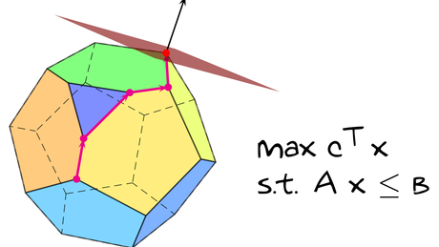**APPLIED AND COMPUTATIONAL MATHEMATICS**

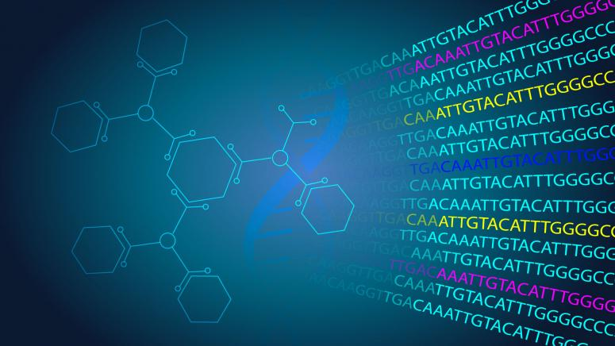

**Bioinformatics**

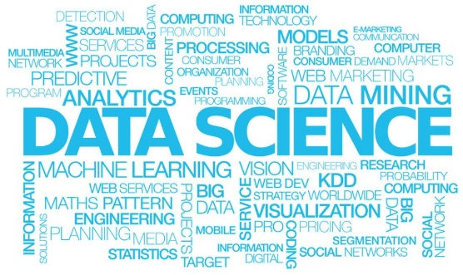

Linear Programming

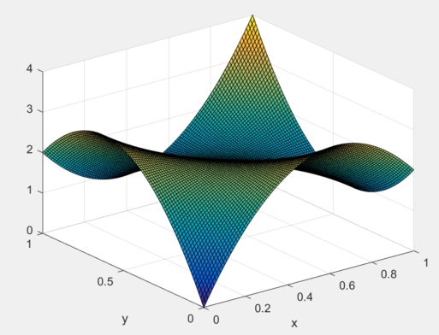

**Numerical PDE**

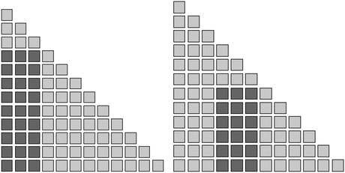

**convolution quadrature**

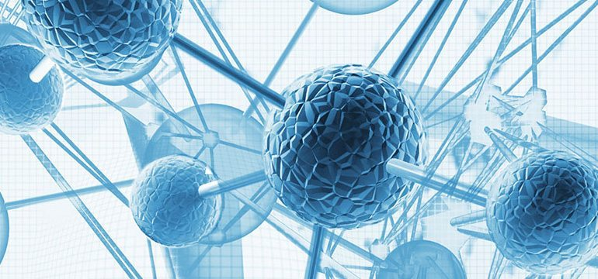

**Material Science**



**Electricity prices forecasting**

**Information Theory**



Full-Day Event 8 Talks

Lunch, Tea breaks & Dinner

Department of Mathematics S17 #04-06 & Lounge, NUS

Feb. 26 2019, Tuesday of recess week

9:00 AM. to 5:00 PM.

