Marine Benthic Habitat Data Management, QA/QC and Spatial Monitoring System
Excel • QA/QC • Marine Survey Data • QGIS-ready Spatial Outputs • Management Reporting
Data source: https://www.kaggle.com/datasets/thedevastator/underwater-video-assessment-of-benthic-habitats

1. Executive Summary
This project converts a 1,353-record NOAA marine benthic-habitat survey index into a documented, data-management workflow. The project preserves the raw source, standardizes an operational master dataset, applies transparent QA/QC rules, isolates records requiring human review, creates a formal issue log, prepares QGIS spatial outputs, and summarizes the monitoring data in Excel.
The QA framework classified 1,347 records as Pass and 6 as Review, with no Critical records under the project rules. The most important review case is site AA2017_149, which occurs twice intentionally according to the source notes. The two records also contain projected EASTING/NORTHING pairs that are inconsistent with their own latitude/longitude and appear cross-swapped. The project therefore retains both observations and preserves the source values rather than silently deleting or overwriting them.

2. Dataset and Source
The primary source is NOAA's National Centers for Coastal Ocean Science (NCCOS) dataset of underwater-video sites used for ground validation and accuracy assessment of benthic habitat maps south of St. Thomas and St. John, U.S. Virgin Islands. NOAA metadata describe 1,353 locations, with 1,005 sites used for ground validation and 348 sites used for accuracy assessment.
Characteristic | Value
Records | 1,353
Date range | 20 March 2010 to 10 February 2017
Ground Validation (GV) | 1,005
Accuracy Assessment (AA) | 348
Puerto Rico records | 293
St. Thomas, USVI records | 691
St. John, USVI records | 369
Mean depth magnitude | 40.73 m
Depth range | 21.32-74.25 m

3. Data-Management Architecture
The project follows a non-destructive pipeline: Raw source -> Standardized master -> Automated QA flags -> Human review queue -> Issue log -> Excel summary/dashboard -> QGIS-ready outputs -> Management reporting. Raw values are retained so that every transformation can be traced.
The cleaned master standardizes date format, strips whitespace from notes, stores habitat presence indicators as both source categories and binary variables, creates positive depth magnitudes for reporting while preserving original negative source depth values, and adds derived spatial QA variables.

4. QA/QC Framework
QA rule | Logic | Action
Required fields | Identifier, survey, coordinates, depth and video URL must be present. | Critical
Coordinate range | Latitude must be -90 to 90; longitude -180 to 180. | Critical
Category domain | Habitat fields must contain only Present/Absent. | Critical
Video URL format | Source URL should be HTTPS and point to an MP4. | Critical
Duplicate site ID | Repeated site identifiers require review, not automatic deletion. | Review
Index/FID consistency | Source index and FID disagreement is flagged. | Review
Projected-coordinate consistency | Recomputed EPSG:3857 coordinates compared with source EASTING/NORTHING; >5 m difference flagged. | Review
UNKNOWN class | UNKNOWN=Present requires source/expert review. | Review
No core substrate | No Present value across Coral Reef, Pavement, Rhodolith and Sand is flagged. | Review
Video usability note | Notes indicating no video or camera did not reach bottom are flagged. | Review

5. Review Records and Key Anomalies
Record | Reason for review | Data-management action
AA2017_149 (two rows) | Intentional duplicate; index/FID mismatch; projected coordinates inconsistent with lat/lon. | Retain both; verify projected coordinates before operational correction.
GV2011_265 | UNKNOWN present; no core substrate; camera never reached bottom. | Retain and request expert/source review.
GV2011_273 | UNKNOWN present; no core substrate; no underwater video. | Retain and request source review.
GV2011_308 | No core substrate; source note says two sites were combined into one video. | Retain; review source context.
GV2016_303 | UNKNOWN present. | Retain; review linked

A key methodological point is that QA flags are not treated as automatic corrections. The duplicate site demonstrates why: a simplistic duplicate-removal rule would have deleted a source-documented habitat transition.

6. Descriptive Monitoring Results

Benthic feature | Present N | Presence
Coral reef | 461 | 34.1%
Pavement | 216 | 16.0%
Rhodolith | 751 | 55.5%
Sand | 555 | 41.0%
Hard coral | 688 | 50.8%
Soft coral | 220 | 16.3%
Macroalgae | 1,229 | 90.8%
Sponge | 1,170 | 86.5%
Seagrass | 13 | 1.0%
Artificial | 15 | 1.1%
Unknown | 3 | 0.2%

Presence categories can overlap at a site, so the percentages are not compositional shares and should not be summed to 100%. Macroalgae and sponge are the most frequently recorded features, while seagrass, artificial features and UNKNOWN are rare in this survey index.
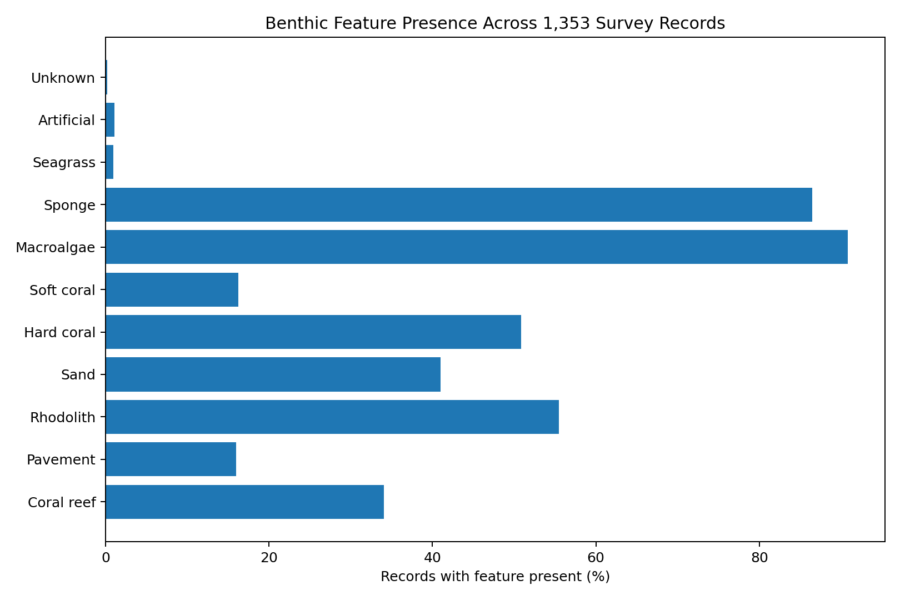
Figure 1. Benthic feature presence across all 1,353 survey records.

7. Spatial Data Preparation
The QGIS GeoJSON uses source longitude and latitude as point geometry in WGS84 (EPSG:4326). This avoids relying on the two source projected-coordinate pairs flagged for AA2017_149. The spatial output contains survey purpose, region, depth, binary habitat indicators, QA status, notes and video URL.
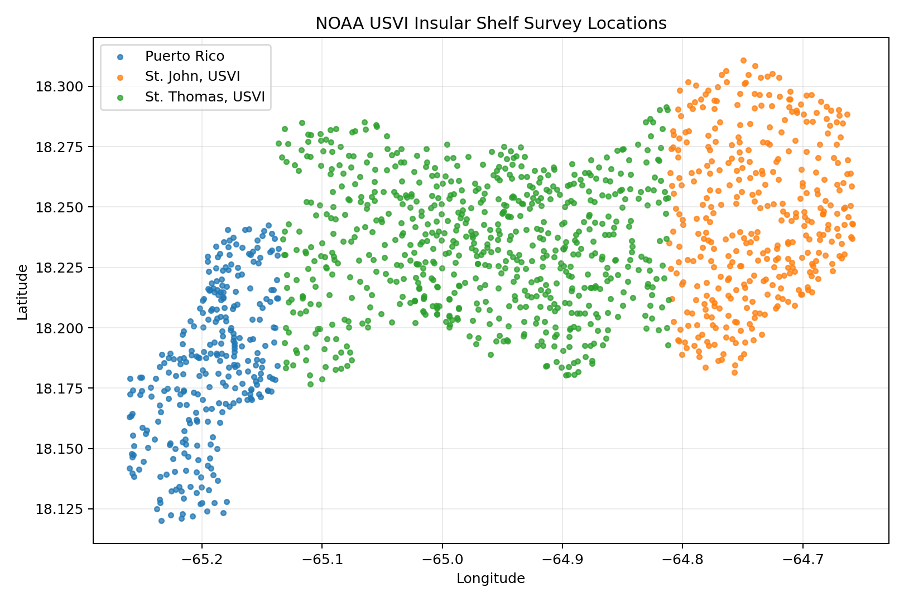
Figure 2. Spatial distribution preview based on source longitude and latitude.
The distribution naturally separates the source geographic-region categories from west to east. For a QGIS portfolio, useful map layouts include survey locations by geographic region, Ground Validation versus Accuracy Assessment sites, and the six QA Review locations.

8. Excel Deliverable
The Excel workbook is designed as a practical data-management artifact rather than a static analysis table. It contains controlled review-status dropdowns, a master table of job-relevant fields, a review queue, issue log, data dictionary, formula-driven summary statistics, and a dashboard.
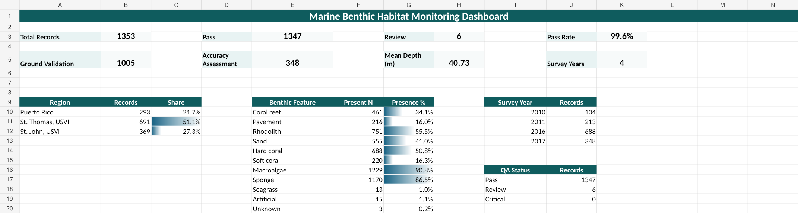
Figure 3. Excel management dashboard

9. Management Use and Field-Team Support
In an operational marine monitoring program, the same workflow can be used to provide structured feedback to data collectors. Records that fail required-field or domain checks can be returned immediately, while review-level issues can be escalated with the observation ID, the exact problem, the original value and a documented action. This avoids ambiguous feedback and protects the audit trail.
The separate Marine Field Data QA Guide in this package provides a concise protocol for identifiers, GPS coordinates, dates/times, media links, habitat categories, use of UNKNOWN, and pre-submission checks.

10. Limitations
- This project does not independently reclassify benthic habitats from the underwater videos.
- A Review flag means the record requires verification; it is not evidence that NOAA's source classification is wrong.
- The derived EPSG:3857 coordinates are used only to detect spatial inconsistency and are not presented as an authoritative correction.

