**Outline:**

1. Paper Title
2. Methodology Used
3. Problems solved in the paper
4. Problems in the given Paper

**Paper Link** [Deep Learning Based Technical Classification of Badminton Pose with Convolutional Neural Networks | Tukino | ILKOM Jurnal Ilmiah](http://103.133.36.110/index.php/ILKOM/article/view/1951)

**More Paper Summary** @ [Github Notebooks Repo](https://github.com/SianRods/IPD-Research)

**Motivation behind this study:**

*While many previous studies have employed image recognition techniques and CNNs to analyze athlete movements in various sports, the use of* ***BlazePose*** *and* ***Mediapipe Pose Solution*** *in the context of badminton has been relatively unexplored.*

**Solutions Offered in the Paper:**

1. The given study aims to solve the problem of Pose Estimation and Body Movements Detection using Convolutional Neural Networks (CNN’s) with BalzePose Architecture and Mediapipe Pose Solution Tools
2. BlazePose is a machine learning model architecture developed by Google, designed specifically for real-time human pose estimation, particularly focusing on high-precision keypoint detection for body joints and limbs. It is part of the Blaze family of models and is widely used in applications like fitness tracking, motion capture, and augmented reality.
3. The given study uses Mediapipe piplines for input data processing and drawing meaningful inference from the raw data using pretrained models .
4. After processing the input data by using above mentioned techniques the study makes use of various classification models like Logistic regression , Gradient Boosting , Random forest classifiers ,etc to effectively classify the body pose using the processed data.
5. The given study shows significant accuracy by using Blazepose Architecture and Mediapipe Pose Solutions Tools with Classification Models.

**Approach:**

1. **Two-Stage Pipeline in the Blaze-Pose Architecture**
   1. *First Stage Regional Proposal Network: In this stage, BlazePose uses a lightweight neural network, typically a MobileNet-based backbone, to detect the region of interest (RoI) where a person’s body is located in the frame. Instead of detecting all keypoints from the entire image, it localizes a bounding box around the person’s body. This localization step helps reduce unnecessary computations and focuses the model’s attention on relevant areas.*
   2. *Pose Keypoint Detection : Once the bounding box is identified, the second stage focuses on predicting precise locations of body keypoints within that region. The RoI is cropped and then passed through another network to estimate the 33 keypoints (Conventional 17 Keypoints ) representing different parts of the body (including face, upper body, and legs). This stage uses a regression-based approach to predict keypoint coordinates directly.*
2. **Keypoint Regression Method**

*BlazePose doesn't classify each keypoint location individually but uses a regression approach. This means it directly predicts the X, Y, and Z coordinates of the body joints in the 2D or 3D space. The Z-coordinate in 3D mode provides depth information, making it particularly useful for applications requiring spatial context (e.g., augmented reality).*

1. **Dataset used and Preprocessing**

*The given study has used Youtube Videos (single player) and different techniques in badminton (service, smash,forehand,etc). The dataset in the paper was divided in approx. 60-20-20 for Training , Testing and validation set to check the performance of the model .*

1. Handling outliers in the Dataset :

*There are several reasons why this study's findings are considered outliers, including:*

*a. If there are any prediction mistakes, the outliers will be taken out of the dataset.*

*b. Incorrect initial classification: After the data annotation process, each sample is classed against the database; if the samples do not fall into the same category, the samples are labeled as outliers*

***A second round of bootstrapping*** *is performed to* ***aggregate all the data from each distinct class into a single set once the outliers*** *have been removed from the data. This information was produced in order to train the categorization mode.*

1. **Use of Classification Algorithms**

Once all the data has been properly processed. Different Models are trained

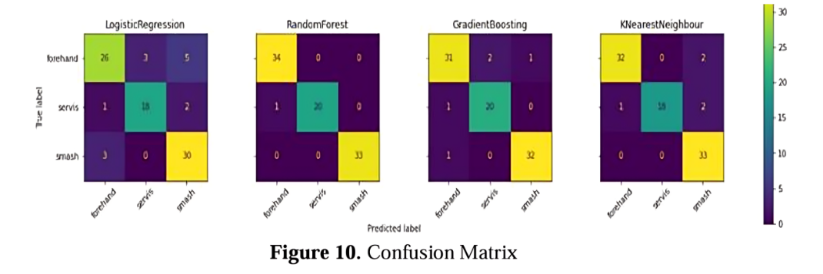

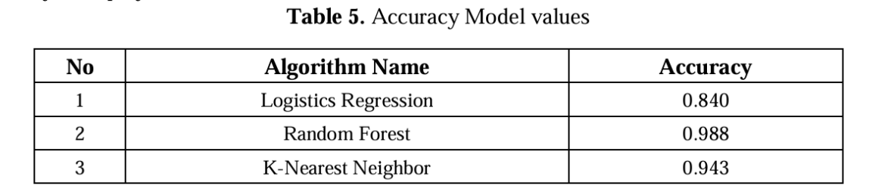

**Limitations:**

1. **One limitation is the challenge of collecting a large and diverse dataset to ensure comprehensive coverage of various badminton techniques and scenarios.**
2. **The model's performance may be impacted by outliers or unusual poses in the dataset, highlighting the need for further data preprocessing and refinement.**

**Recommendations:**

**To explore additional techniques to enhance the accuracy and efficiency of the classification model. This may include investigating advanced CNN architectures, incorporating temporal information from video sequences, and addressing the challenges associated with outlier poses.**