|  |  |
| --- | --- |
| SMUlogowWordmark | Peng Tao  Associate Professor  Department of Chemistry  Southern Methodist University  3215 Daniel Avenue  Dallas, Texas 75275-0314  TEL: 214-768-8802  FAX: 214-768-4089  Email: ptao@smu.edu |

June 4, 2021

Journal editor-in-chief name

Affiliation

Dear Professor XXX:

We are submitting the manuscript of original research, “*Paper Title*” by XXX and XXX for consideration as a research article in the journal *Journal Name*. By copy of this letter, we assert that all authors have approved this manuscript and that it is not under consideration for publication elsewhere and has not been published previously.

Introduction.

Therefore, we believe that this paper will be of interest to the readership of *Journal Name.*

Thank you for your assistance.

Sincerely,

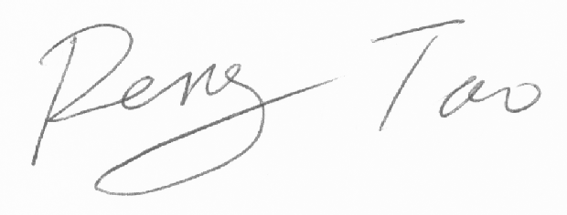

Peng Tao