|  |  |
| --- | --- |
| SMUlogowWordmark | Peng Tao  Associate Professor  Department of Chemistry  Southern Methodist University  3215 Daniel Avenue  Dallas, Texas 75275-0314  TEL: 214-768-8802  FAX: 214-768-4089  Email: ptao@smu.edu |

June 4, 2021

Journal editor-in-chief name

Affiliation

Dear Professor XXX:

We are submitting revised version of the manuscript, “*Paper Title*” by XXX and XXX for consideration as a research article in the journal *Journal Name*.

We would like to thank you and the reviewer for the time and criticisms in reviewing our manuscript. In the revised manuscript, we have made changes and addressed all the comments from the reviewer. The major changes include

We also uploaded a manuscript with all the changes highlighted in yellow. We would like to thank the reviewer for the helpful suggestions and hope that the revised version of the manuscript is now acceptable.

Thank you for your assistance.

Sincerely,

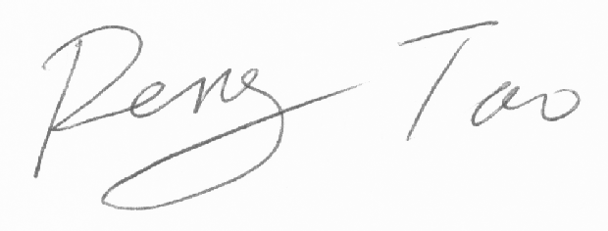

Peng Tao